The Illusion of Reality
By Stuart Anderson (P100450)
BA Hons Photography in the Arts

Module: MX601971

Table of Contents
Page
- Introduction………………………………………………………………………………………………………….3
- Application of Context and Interpretation…………………………………………………………….6
- The Optical Illusion…………………………………………………………………………………………..…10
- Spirituality and its Effect on Art…………………………………………………………………………..17
- Deconstruction of Reality in Art…………………………………………………………………………..23
- Conclusion…………………………………………………………………………………………………………..28
- Bibliography………………………………………………………………………………………………………..30

Introduction

This dissertation seeks to propose that the eye a is biased filter because it is limited to the human experience, therefore, our perception of reality is also limited.
Concerning the concept of reality, there is more than what meets the eye and what we define reality to be. We’ll explore how the eye interacts with physical reality as well as the power and limitations of the mind, in conjunction with sight and interpretation.
We will assess this theory through (multiple) accounts of critical thinking and analysis, taking into consideration ideas from John Berger and other notable authors of philosophy, such as Barthes, Dirkheim and Bergson.

The application of these philosophies will hopefully help us to begin to understand the subjectivity of reality, and in turn, reveal how it is implemented in culture.
Furthermore, these modes of understanding will be affected by larger domains that we know to be termed as ideologies, which are part and parcel of social development in the form of ideas and restrictive institutions that govern society.
These restrictions reflect how ideology affects context, understanding and interpretation as a collective, which are likely created to grasp onto a basis that gives humankind the crutch by which it survives.

Sociologist Emile Dirkheim postulated a similar notion of collective ideas:
The totality of beliefs and sentiments common to the average members of a society forms a determinate system with a life of its own. It can be termed the collective or common consciousness. — (Dirkheim, 1893)

Although very broad in scope, we must talk about this to lead onto the reasoning why we believe what we do upon seeing an image. Our interpretation is affected by collective ideologies which are based on and structured by many factors such as cultural, lingual, political, spiritual and philosophical tangents of evolutionary development, which are driving forces behind seeing and understanding.
The contextualised understanding also comes under the plane of art history and its psychoanalytical interpretations. It is the de-construction of these ideas that challenge what might be called the ‘norm’, and from this thought, we have an example to begin expressing these ideas through artistic forms of media.
Understanding the psychological mechanics of seeing, whether it be seeing a work of art or simply observing one’s surroundings, is a complex subject to comprehend. It is inherently, the relationship between the viewer and the physical environment.

These mechanics include the decoding of context via the individual’s belief system, which is derived from personal experience. With this said, a subjective ideology and understanding of what is being seen is prevalent, as is the inevitable evolution of the biased eye, which increasingly imposes itself upon a person as a confiscation of free will.
It would therefore be reasonable to state that ‘seeing’ is a conditioned state and acknowledged differently by each person.
To demonstrate the investigation for the thesis, four images will be examined and interpreted, to illustrate how these concepts can be applied to different forms of visual input.
The images are taken from different time periods and art movements, leading to contemporary imagery influenced by technological or cultural advances, highlighting their primary differences in application to context.

Application of Context and Interpretation

In this section, we’ll examine the objective quality of context and its effect on interpretation.
The work of Helen Sear has qualities that reflect alternate methods of perception, particularly shown in her 2017 Exhibition The Rest is Smoke, which lends some insight into the artistic point of view and intended meaning.
In a conversation with Curator Stuart Cameron, she talked about a Renaissance painting by Mantegna (St. Sebastian) and how it influenced her work: “The notion that perhaps our human presence on earth is an illusion, in a way…”, she continues: “…it took me to a world of illusion and looking and perception”. – (Sear cited in Connor, 2015:3).
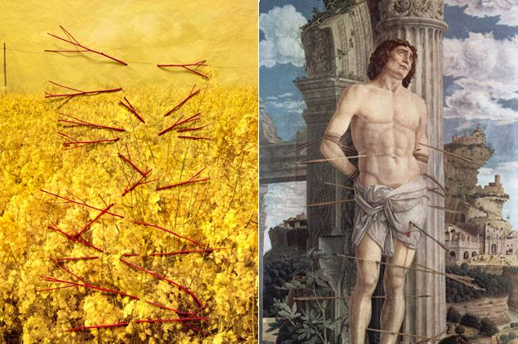
(Fig 1, Left): Caetera Fumus, Helen Sear, 2015.
(Fig 2, Right): St. Sebastian, Andrea Mantegna, 1480.
On face value, the painting of St. Sebastian is completely different to the parallel image of Sear’s Caetera Fumus, which is startlingly bright yellow and devoid of any human presence within the frame.
A visual interpretation of her work could be described as:
Suspended in mid-air, an assortment of cherry-red sticks and twigs bring the eyes’ attention to the centre of the autumnal scene. Layers upon layers of vibrant, golden tones immerse us in a state of euphoric, meditative entrancement. Gazing upward, the pylons in the distance seem shrouded in the sky that appears like crumpled tissue paper in texture.
The surreal quality that combines dimensions in a stacking order, leaves a sense of shattering of reality that emanates like a lost memory, reconnecting with the tranquillity of mother nature. Sear’s work, using nature as a backdrop, proves effective in terms of instilling mystery and bringing the detrimental relationship between human interaction and the environment into the foreground.

Upon learning the context of this piece, there becomes a visual similarity expressed in the topographical structure and layout of both the arrows (fig2) and the twigs (fig1). With the artist’s words and implied concept, a representation is formed.
However, without the images being presented alongside each other, that link is severed, and any meaning can then be applied by the viewer.
This is where the idea of subjective interpretation comes into action, and where a lack of knowledge about the context removes the intended meaning implied by the artist.
Bring these two images together, and not only does there emerge a visual likeness and context, but also a narrative, being that the work was influenced by the painting. This how we can see the value of meaning in the work.

This alternate state of seeing can be compared to a section from Rowland Barthes’ Camera Lucida. He recited a descriptive memory during a time when he looked at a painting of Emperor Napoleon: “I realized then, with an amazement I have not been able to lessen since: I am looking at eyes that looked at the Emperor.”— (Barthes 1981:3).
This might give us insight into how a detached view of an object might affect the viewer’s understanding of what is being seen. If Barthes only saw what would be recognized as the famous French Statesman, he may not have had the ability to recognize that the view he was perceiving was also pertaining to a previous view of another person (The Artist).
What he was saying, was that there is technically more than one mode of interpretation. In this case, an outside-of-the-box approach is adopted to Sear’s idea of her work and, ultimately, functions in juxtaposition with our idea of it.
What may be now realised is that there is a shift of consciousness, opening the doorway to a room full of doors, which are like layers or levels of interpretation. Seeing what is not apparent brings the idea of ‘reality’ into question.
To hypothesise, if it is a socially accepted belief that reality is a construction of what is visible, then it is uncertain where the invisible lies.
This can also be compared with a passage in John Berger’s Ways of Seeing:
The relation between what we see and what we know is never settled. Each evening we see the sun set. We know that the earth is turning away from it. Yet the knowledge, the explanation, never quite fits the sight. – (Berger, J. 2008:1)
Berger founded ground-breaking literature on the topic of the relationship between the spectator and the object. He acknowledges that vision is subjective to the constraints of cultural conditioning, particularly in the form of applied and perceived context through experiences.
The fabrication of reality is arguably a manifestation or a social projection of cultural development, to give meaning for the human mind. We interact with the surroundings, told it is real, therefore it is accepted as such. If a spectator is not present, it could be debated that the present reality does not exist, because the spectator is not available to apply meaning. Thus, if it is impossible for it to be perceived then scepticism arises, and enquiry for truth unfolds.
In retrospect, Philosopher George Berkeley once said: “If a tree falls in a forest and no one is around to hear it, does it make a sound?”.

The Optical Illusion

This section will examine the idea of reality expanding beyond human limitations in perception and its ability to deceive.
The thought of illusion is prevalent in this example of a photograph by Jerry Uelsmann. This work is a construct, or photomontage that is an amalgamation of layers that visually fit in a paradoxical appearance, acting as a non-sequitur (mismatched, nonsensical).
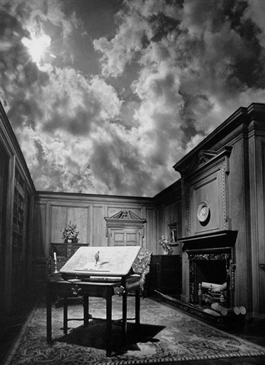
(Fig 3): Man On Desk, Jerry Uelsmann, 1976.
His technique involves several photographic enlargers and incorporates different negative images exposed onto one sheet of photographic paper, gradually building up a scene that has the feeling of absurdity with bizarre arrangements, forming optical illusions. The most profound fact is that this image is not involved with computer software, it is all hand-crafted in a darkroom, giving the work a certain authenticity, yet the image itself is inauthentic, artificial and not true to what we know as logical reality.
To visualise this in action with the above image, Man On Desk is a merging of two opposing environments. An interpretation of this could be:
The shadow from gloom filled clouds cascade down into a roofless living-room. The collision of domestic space and the outdoors divide the image centrally. Within it, stands a drawing board with a candlestick to the left and a miniature person seemingly pacing across the panel.
This is what is usually considered an evolutionary and accurate construction made by the eye, based on what culture might define as ‘common sense’. With close inspection, an apparent mismatch of scale is brought into the mix. What could be reasonable to state is that we are immediately seeing the landscape from the cultural understanding of what a living room looks like. On the other hand, the miniature person within the picture is arguably seeing the landscape from a much smaller perspective, figuratively transforming the domestic space into the illusion of a deceptively larger one.
Much like the alternate perspective that Barthes had, we have done the same, and applied a narrative to the person in the picture. This is based on our understanding of size and scale, and projected that reality onto it. The illusion reveals itself the moment it is discovered that the environment is entirely different upon closer inspection. It is this forgery of scales that conflict, which oppose our beliefs about our cultural understanding of this environment.
In the mindset of rationality, this scene is confusing to the eye and violates the rules of metaphysical placement that defines what we collectively accept as ‘realistic’ three-dimensional space and scale. Abstract thinking may be a key component of such work, but it is not a mode of thinking that would be considered common sense which is limited by rules that make it so.
Further exploring this trick of the mind, we dive into thoughts about how this may come about. To reference Philosopher Henri Bergson, he mentioned that the action of correlating the object with the perceived object is a ‘mistake’ governed by ‘common sense’ and that the two are, according to George Berkeley, separated between the extremes of realism and idealism, thus rendering reality to be neither true or false, but a state of consciousness (Berkeley cited in Bergson 2004:4).

An example of Bergson’s theory could be demonstrated by observing the drawing table within Uelsmann’s image. Common sense or idealism, as he put it, dictates that we are seeing a table, however, realism opposes this, and adopting this mode of perception would change the state of this input, resulting in something akin to:
This is a solid mass of atoms that represents a drawing table, made up of wood and metal.
The observed object is a representation by the idealist who uses ‘common sense’ and merely a ‘thing’ by the realist, who refuses to. The aggregate of images formed in the mind are said to be ‘cerebral disturbances’ by Bergson, enticing the layman to believe that objects exist independently from the mind, another form of ‘common sense’. However, he cited that Berkeley proposed that objects exist in the mind, for the mind. He asserts:
“The brain is part of the material world; the material world is not part of the brain.”
— (Bergson 2004:4)
This is where things become interesting.
Memory serves as the bank of information, with ethereal and fleeting remnants of their physical counterparts, which are arbitrarily shaped by the brain’s initial encounters with them. The body is termed a ‘centre of action’ in which there is an interconnection between the body and the surroundings, moving the image of objects and the image of the body itself within a field of space (Bergson 2004:4).
On another tangent, dream state essentially alters reality, and is composed more loosely, hence the common term ‘lucid dreaming’. This is comparable to waking reality, with the exception that there is an exclusion of a physical body, the body is eradicated from this state of mind, while consciousness continues to operate in the form of subconscious reality, or a collection of (often non-linear) narrative thoughts, as the state of awareness transcends from a realm of physicality to one of purely mental presence in quality.
Scientists and idealists would insist this proclamation implying the psychological mechanics merely shifting a gear, creating the illusion of an existence that appears to operate outside the confines of the cage of flesh. It cannot be ignored that, aside from a scientific platform of debate, reality is connected to the consciousness of the brain, for it is not unreasonable to say that our reality is held within the dream world for that period. Furthermore, that belief is equally capable of being applied to consciousness in waking state, being the flip-side of the coin.
If we look at reality as a spectrum of consciousness, it is a feasible postulation that reality is true for the observer, regardless of which state they are in. The waking state is deemed to be the default vehicle of observation and experience, but it is known that the subconscious mind also has underlying cognitive mechanisms that churn away quietly in the background, going unnoticed. It could be argued that the lower levels of consciousness are simply drowned out by the overstimulation of the waking state, perhaps being a ‘louder’ compartment of the spectrum.
During a ‘Ted Talk’, an educational science and philosophy presentation show found on the internet, Psychologist Donald Hoffman suggested that consciousness causes matter, therefore it could be argued that visual perception is a hallucination based on the eye’s survival duty to decipher and reconstruct objects as to what they appear to be to its host. “When I have an experience that I describe as a red tomato, that experience is actually an accurate reconstruction of the properties of a real red tomato, even If I weren’t looking.” — (Hoffman 2015).
The term he coined the ‘Umwelt’ also comes into play here, denoting that experience is solely dependent on the set of survival senses of any given life form, that it is pre-programmed to perceive with, thus, making the physical surroundings detrimental to the existence of that life form. This includes the ‘accuracy of reality’, as he put, to denote a species’ ability to detect reality. An analogy was brought forward, a bottlefly that cannot tell apart a female bottlefly to a beer bottle, which is the same colour, noting that its version of reality, or ‘Umwelt’ was one of survival instincts that limit its accuracy of perception that appears to be accurate to the host.
The main objection of this way of thinking may seem to undermine the thought of reality as being present only within the cognitive manifestation of the observer, as opposed to reality being ever-present, regardless. A possible component of this opposition may also suffice to quash the singular experience: the collective belief that just because one being dies, does not mean that reality dies along with them, rather, it continues to unfold before the eyes of other still-live beings across the world. Such theories are bold claims and delve into existential paradigms such as this, possibly termed Solipsism, being the theory that there is existence of only one being in the universe, perceiving the world and everyone in it as hallucination.
In another ‘Ted Talks’ video, Neuroscientist Anil Seth discussed a scientific exploration of the link between the brain and reality. He said that it remains a mystery as one of the biggest questions in science (Seth 2016). An interesting experiment was detailed, accounting the phenomenon of hallucinations.
The attendee was sat down with a false arm placed on the table in front of them. Their real arm was then to be blocked from sight with a panel obstructing their field of vision, and touched whilst simultaneously seeing the false arm being touched by the other hand of the person in front. The participant would gradually develop a physiological reaction in response to the mixed sensory stimuli, creating a neurological connection that manifested from believing that the false limb was a part of their own body.
The study showed signs of brain activity triggered by the discord between visionary and tactile sensations– the hallucinations might be also termed as ‘phantom’ sensations.
(Seth 2017).
Although more a physical illusion than an optical one, perhaps the blocked vision of the real arm and the sensations applied to the participant created a new belief system that changed the state of reality for the brain. This is essentially opposing the expected, the universal awareness that touch is associated with sensation, and it has been exploited in such a way that it dismantles common sense and recreates an alternate idealism or representation.
Spirituality and its Effect on Art

The next image, Nine Circles of Hell, is a painting by Sandro Botticelli which illustratively tributes the literary work of Dante Alighieri’s Inferno portion of his epic poem Divine Comedy.
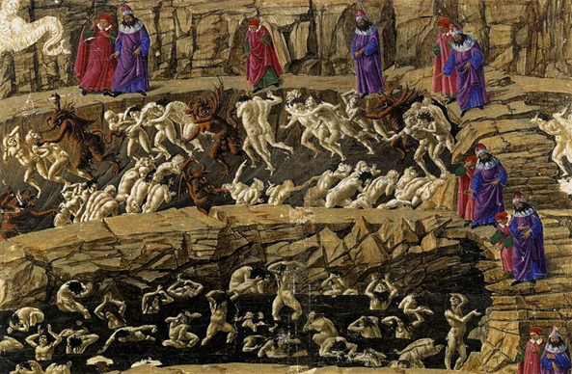
(Fig 4): Nine Circles of Hell, Botticelli, 1480.
With ideas about extended perception comes the theory of religious beliefs and the faith in a higher realm beyond human life on earth. This typically translates into older works of art, the injection of beliefs into visual representations that seek to tell stories about the unknown and invisible. The painting is an allegorical classic and pertains to the medieval mindset, perhaps indicating the tendency for the general populace of the time to be heavily influenced by religion. Such artefacts are a reminder of the opposition of sacrilegious behaviour during the Renaissance, including the freedom to question reality and the universe that would be deemed as such. This thought alone is evident that the religious doctrine was another example of socially constructed ideologies that shape thoughts and beliefs concerning reality in a hypothetical spirit realm.
Using science to oppose the unwavering and stern beliefs of the devout Christians was deemed criminal, perhaps reverting to the ridicule that people such as Galileo experienced, having the misfortune of judicial persecution when he dared to declare that the Sun did not revolve around the Earth, in fact, the opposite. In 1633, he stood trial for supporting Heliocentrism. He once professed: “I think that tastes, odours, colours, and so on… reside in consciousness. Hence if the living creature were removed, all these qualities would be… annihilated.” — (2015 cited Hoffman in Galileo:1632).

An interpretation of the painting above could be:
An unsettling scene that suggests danger and chaos, as hordes of naked beings flail in terror and pain. They are mercilessly savaged and abused by evil creatures that lurk in the belly of hell. This is a land of persecution and dominance that controls, oppresses and punishes. The use of symbolism through humanoid figures depict demons and body language that suggests struggle. All of this instils the fear of suffering as consequence of ‘sin’.
To provide further support for the thesis, it is somewhat inevitable that we discuss religious content that allow us to further explore the ideas of alternate reality, or ideas such as ‘heaven’. An example can be given in Buddhist teachings: ‘Samsara’ is the continuing cycle of birth and death of beings grasping onto the idea of self and the perception of experiences. Divided into six realms of suffering, it is said to be the reel of time that is inescapable, and that one can either chose to ride the cycle or to be trapped in the cycle. — (Choong, M. 1999)
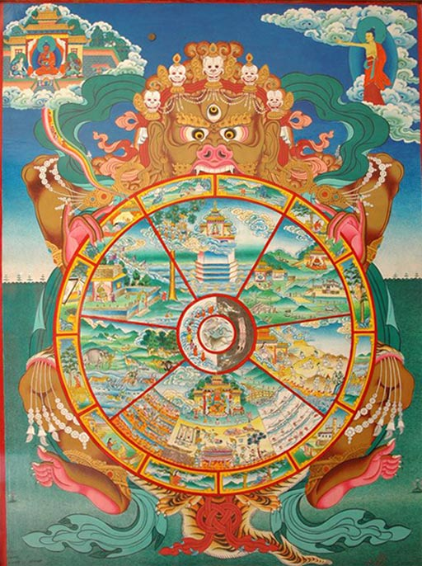
(Fig 5): A traditional Bhavacakra depicting Samara, Artist/Date Uknown.

In Buddhism, it is claimed that that all beings on earth relate to one another and the universe, as a collective consciousness. The idea of the self being a separate entity from other beings and the world is a mistake, an illusion caused by Samsara, also like Bergson and Berkeley’s theories with matter being connected, rather than separate entities.
Samsara is inescapable. This connects with the notion that we have no control over our free will regarding our freedom to be a part of the physical world, making us essentially trapped within the realm that is collectively known as the world. It seems that even death is not an ultimate escape from the cyclical reel of Samsara, giving rise to the afterlife and the rebirth into the next form of existence.
In meditation practice, a state of altered consciousness known as ‘Nirvana’ is said to be the alternate reality that embodies true happiness, where every cell of the body is intertwined with others in divine peace and harmony. In effect, humans are by default afflicted by ‘distorted’ states of mind, or as Bergson called ‘cerebral disturbances’ being the barrier to spiritual enlightenment, and that suffering is generated by these ‘attachments’ to the dependence of things.
Letting go gives us freedom, and freedom is the only condition for happiness. If, in our heart, we still cling to anything- anger, anxiety or possessions- we cannot be free.
— (Thich Nhat Hanh 1998:58)

This same attachment could be applied to the physical world. A relevant philosophy can be transcribed by the spoken words and writings of Ethnobotanist Terence McKenna, who advocated the use of ‘psychedelics’ as opposed to drugs, claiming them to be healing and natural liberation for the mind and soul.
He ingested psychoactive substances and became liberated from his physical body and physical attachment to the physical world. He spent much time travelling in his younger days across South America, particularly studying the Shamans, who cultivated Ayahuasca and whom consider it a divine plant.

(Fig 6): Weather, Alexandre Luiz Segrégio, 1993.

The Shamans said these plants are gifts that are portals to the spirit realm. The thought arises that psychoactive substances are either propagators of artificial consciousness, or invisible gateways to real alternate realities. McKenna professed this to be so, and considered that disillusionment of our reality is a journey to self-realisation.
In this sense, as these alternate planes of existence are not perceivable to the human eye due to our collective disillusionment, there is no way to disprove the existence of such realms.

Deconstruction of Reality in Art
In this final section, we’ll bring the previous ideas together and show how the deconstruction of reality in art is an effective method to support the idea of the thesis.
(Fig 7): The Tangle Of Mind And Matter, Rebecca Allen, 2017.
The last image we’ll assess is The Tangle of Mind and Matter by Artist Rebecca Allen, shown above. This a modern and technologically cultivated virtual reality image. She uses computers to create renderings in an artistic expression of conceptual ideas like this.
While our body stays grounded to the earth, the mind continues to explore beyond our horizon, leaving us to believe that there are other realities somewhere out there. Though virtual, the experience is visceral, as it engages our sensory perception and questions our understanding of reality — (Allen 2017).
This idea is adept to homage Berkley’s theory of matter and mind being separate. To interpret this image, the act of doing so becomes a ‘deconstruction’ in its own right. The title itself lends to the idea that mind and matter is a tangled, wiry mess of connective mechanisms within the brain, and the bizarre imagery aligns with this collectively accepted idea of ‘tangles’, depicting what would be a chaotic scene, and intended by the artist to convey it.
In a similar outlook, McKenna provided accounts of alternate and bizarre recreations of reality using psychedelic substances. He speculates: “What we call reality is in fact nothing more than a culturally sanctioned and linguistically reinforced hallucination.”
- (McKenna, 1988)
This also relates to the notion of culturally instilled understanding. Much like the construct of Samsara, it is worth mentioning that there is a tendency to clutch onto our reality, for the sake of keeping the ego in comfort as it feels safe with familiarity and known meaning. It could be said that this comfort has the propensity to manifest itself as entrapment by the very nature of Samsara.

McKenna takes quite a different approach to the notion of reality and touches on many introspective analyses that define the concept of perception and the unseen world beyond normal human ability. Much of his work talks about the use psychedelic substances such as Psilocybin, LSD and DMT as tools to unlock hidden realms and how the chemical induces and alternate state that influences the mind in such a way that it ‘spiritually’ aligns one with the universe. He talks about the compounds’ effect on human belief systems regarding societal ideologies and the concept of identity being broken down and stripped away, in a sense of liberation.
Ego is a structure that is erected by a neurotic individual who is a member of a neurotic culture against the facts of the matter. And culture, which we put on like an overcoat, is the collectivized consensus about what sort of neurotic behaviours are acceptable. — (McKenna 1995).

The eye, as deciphered at the beginning of this dissertation, is only the receiver of what is interpreted and reconstructed into data (Hoffman 2015), perceived space being a playground for matter to appear before our eyes (Bergson 2004). The eye is not always open, nor is it permanently fixed on one point out of a 180° frame of vision. The observer’s reality is made up of only what is present during the moments of time beside those which disappear in that fraction of a second when the eyes blink, or when the frame shifts into another point of the surroundings, creating a new plane of vision altogether.
The eyes close for a period of slumber, which is conceivably, a form of detachment from reality, destroying and recreating the fabric of reality within each microsecond of perceived time.
It could be argued that we cannot have any free will over our disengagement from reality while in slumber, because we know from scientific research and personal experience that the living body needs to disengage from waking state by reflex.
This reflex is a biological urge that is impossible to resist after a long period of time, when physiological reflexes come into action, forcing the observer to cease participation in the wilful perception of the surrounding space. When time is not perceived, reality ceases.
If the entire world population were in a state of deep sleep all at the same time, or even in the event of a hypothetical mass human extinction, it would be impossible to determine the existence of anything. With all this said, it could be possible that these hypotheses further perpetuate the power of consciousness over matter.
To argue against our thesis, saying that reality is false would be fundamentally futile, because without the consciousness of the observer there would be no sensory intake of any sort to speculate that the ‘world’ and its physical topography is also present.
Diving deeper, one could postulate that the solipsistic reality is a perfectly valid concept in relation to the argument. If every living being experiences their own Umwelt, then solipsism must surely be a fitting analogy. The enquiry of another’s general beliefs regarding the consensus of perceived reality is almost certain to be met with the vague response that governed by the laws of physics, and the history of human communication, it is dictated that we should all perceive the world in the same way and with the same characteristics.
However, one may also disregard the application of subjective reality in relation to their physical location within the three-dimensional plane. That said, the reality of someone in Spain is obviously physically different to that of someone in Antarctica. Solipsistic thinking imposes that an individual does not experience the laws of physics and perception of objects as collective, but as a singular experience. It also highlights that any recognition of an object or incident that appears to be simultaneously recognised and perceived by another, is an illusionary by-product of cognitive function, acting as an unfolding narrative.
The line between fact and fiction is inevitably blurred and out of tangible reach, to scientifically prove such an elusive concept is leaving only philosophical reasoning to have any measure of substance for future discoveries. For each being, nothing beyond their own senses is possible to experience. This then lends insight into the opposite of solipsism, a collective realm of individual realities, or even what could be termed ‘multiverses’.
Hypothetically speaking, this would likely comprise of a space-time topography, organically sporadic, with an infinity of possible outcomes and variables created within the universe. With each possible variation being a singular experience, it would not be unreasonable to say that this could operate within a network to form a collective consciousness that lives and interacts with each other.
“As with the physical world, psychic life need not, in reality, be how it appears to us.”
– (Freud, S. 54:2005)

Conclusion

The influence of the image on culture has instilled a whole spectrum of ideologies, in a sort of unspoken language. This language is detrimental to the way we respond and adhere to a universally accepted range of ideas, including belief systems that rule everything from beauty to the rawest form of communication, eye contact.
With the deconstruction of image and its influence comes the questioning of whether the function of sight really provides the observer with the truth. Reverting to Berger’s analogy of the setting sun demonstrates how this could be so, simply put, it is comparable to a broken link between fact and perceived fact. If it weren’t for advances in technology, it would be physically impossible to observe what is really going on in the bigger picture, the large scale of the planetary system that encompasses the Earth.
What we have so far realised, is that reality is an amalgamation of consciousness that maps out perceived space and context, under the recognition of its topography. The context consists of psychological narrative that relates to the physical plane where events unfold. The two must surely be connected, because taking one away from the other destroys the ability to perceive as well as reality, for reality can only be a paradigm for beings in which it serves as home. Therefore, the absence of perception ultimately nullifies any proof of reality situated within a location of space and time.
From past to the present, progressive interpretations in art have shown us the pathway of cultural understanding. All the proposed ideas by the authors mentioned support the argument that seeing is indeed subjective, mysterious and heavily governed by all the limitations of the human condition. We discovered that reality was factually different for humans versus other beings, and that reality was entirely composed of the biological systems that allow for sensory input and understanding, that each being has a set of limitations. We now know that there have been scientific studies that support the argument that different modes of seeing exist. We also know that ideas are biased, and that context is synonymous with experience.
Therefore, we can concur that that our accepted perception of reality is only a part of a much bigger one beyond our senses, there is more than what meets the eye.

Bibliography
Illustrations List:
(fig 7): Allen, R. (2017). The Tangle of Mind and Matter [Online]. Available at: http://www.rebeccaallen.com/projects/the-tangle-of-mind-and-matter, (Accessed: 14th November 2017)
(fig 4): Botticelli, S. (1485). Nine Rings of Hell [Online]. Available at: http://englishare.net/literature/POL-DC-Inferno.htm, (Accessed: 20th November 2017)
(fig 1): Sear, H. (2015). Caetera Fumus [Online]. Available at: https://ichef-1.bbci.co.uk/news/624/media/images/82803000/jpg/_82803595_caeterafumus.jpg, (Accessed: 11th November 2017)
(fig 6): Segrégio, A. (1993). Weather, [Online]. Available at: http://www.ayahuasca-info.com/art, (Accessed: 1st December 2017)
(fig 3): Uelsmann, J. (1976). Man On Desk [Online]. Available at: http://www.catherinecouturier.com/artists/jerry-uelsmann/gallery/untitled-desk/, (Accessed: 18th November 2017)
(fig 5): U. (Unknown). Bhavacakra [Online]. Available at: http://topten-online.net/psychicresearch/discussion/147/samsara.
(Accessed 1st December 2017)

Reading List:

Barthes, R. (1981). Camera Lucida. France: Hill and Wang.
Berger, J. ([2008], ©1972.). Ways of seeing. London: British Broadcasting Corporation and Penguin Books.
Bergson, H. (2004). Matter and Memory. Mineola: Dover Publications, Inc..
Choong, Mun-Keat. (1999). The Notion of Emptiness in Early Buddhism, Motilal Banarsidass.
Connor, S. (2015). Helen Sear ...the rest is smoke. Wales: Ffotogallery.
Durkheim, E. & Lukes, S. Halls, W. D. (2014). The Division of Labor in Society. New York: Free Press.
Freud, S. (2005), The Unconscious. London: Penguin.
Hanh, N.T. (1998). The Heart of the Buddha's Teaching: Transforming Suffering into Peace, Joy, and Liberation. New York: Broadway Books.
McKenna, T. (1988). Ethnobotany of Shamanism Workshop [Online]. Available at: https://terencemckenna.wikispaces.com/Ethnobotany+of+Shamanism

Video References:

Hoffman, D. (2015). Do we see reality as it is? Available at: https://www.ted.com/talks/donald_hoffman_do_we_see_reality_as_it_is?utm_source=tedcomshare&utm_medium=email&utm_campaign=tedspread--b.
(Accessed: November 10th 2017)

McKenna, T. (1995). A Crisis Of Consciousness. Available at:
https://www.youtube.com/watch?v=HokSElq5tRs
(Accessed: November 21st 2017)

Seth, A. (2017). Your brain hallucinates your conscious reality. Available at: https://www.ted.com/talks/anil_seth_how_your_brain_hallucinates_your_conscious_reality?utm_source=tedcomshare&utm_medium=email&utm_campaign=tedspread--b.
(Accessed: November 10th 2017)

