

Methods and Search Strategy Academic Poster

Student name: Jacqueline Riley-Lamb
Student ID: 2244727

Module name: Independent Project
Module code: (BMHP6020_BIRM)

Exploring The Impact of Parental Substance Misuse on Child Development in the UK
01 Introduction and Research Aim  This methodology poster will provide an overview of the key methods used to identify, evaluate, analyse and select secondary research linked with the research title. It outlines the search strategy, search process, source validation, inclusion and exclusion criteria, application of thematic analysis along with ethical considerations. These methods contributed to a structured and transparent approach implemented to explore what parental substance misuse looks like and its direct impact on child development in the UK.    Research Aim: To explore the impact of parental substance misuse on child development in the UK, with core consideration of acknowledging its effects on children’s emotional, cognitive, social and behavioural developmental. | 02 Search Strategy  University of Leeds Library (2026) suggests that a search strategy is an organised approach which consists of combining key words, concepts and patterns to search databases and find credible and relevant data. In this secondary research the application of a structured search plan was demonstrated by using Boolean operators. Key terms included: Parental substance misuse/ child development / parental addiction/ UK/ Child wellbeing The structured plan the researcher identified that worked well, they included six core steps:  - Identify the key concepts:  - Developing and understanding keywords  - Constructing key words  - Searching credible academic data  - Selecting data and sources  - Recording the search process and data:
03 Searching for Information  In this section you will explain to the reader how you have searched for information which has informed your research.  The next step is to break down step-by-step what you did to find the most relevant information for your topic and why you did this.  You can also include definitions here if appropriate.  - Develop keywords  - Search databases  - Refine results that are linked to research title  - Analyse and select key sources | 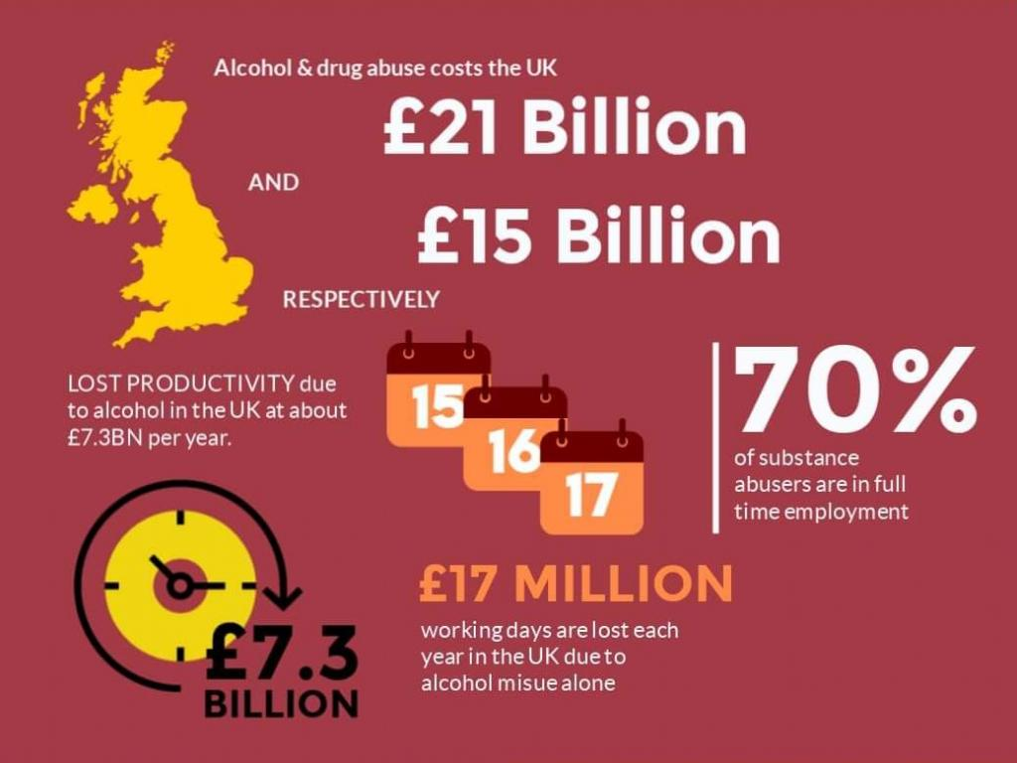  04 Picture / Graph / Visual Aid / Statistics  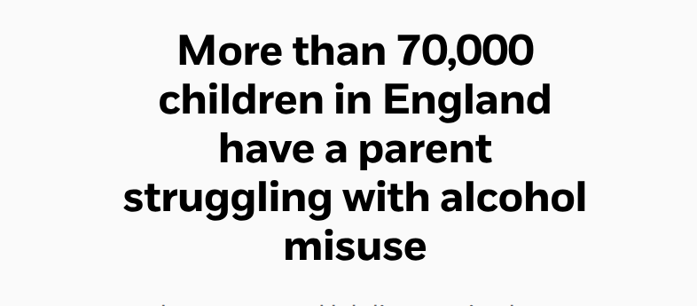  Wirral Safeguarding Children Partnership (2026) reports that National Serious Case Reviews have indemnified substance misuse as a significant factor in families where children have died or been seriously harmed.  Cognitive development / Emotional development / Social development - Behavioural development
05 Research Validation and Analysis
Research Validation: Research validation was applied to assess the relevance and credibility of secondary research. Sources was analysed using a CRAAP test. Currency , Relevance, Authority, Accuracy and Purpose. This influenced of how the selections of research were done along with reducing any information that did not meet the criteria.
Research analysis: This includes the application of research conducted by Braun and Clarke (2022), the research was evaluated using a thematic analysis to identify key patterns, findings and words. Codes were grouped and colour coded to develop and organised three key themes for Chapter 4. This analysis provided structure that the researcher maintained through the research process allowing research to be compared and linked to how parental substance misuse can affect children’s development.
Strength: Supported maintaining credibility and provided a structured approach.
Limitation: Research was conducted using secondary research meaning research gaps where identified.
06 Inclusion Criteria  Example of Inclusion: The application of the Working Together To Safeguard Children reported by the Department for Education (2026) was included at is a UK based government guidance that is accessible online and is linked to the research question demonstrating effective safeguarding acknowledgement and delivery.  Peter et al (2020) highlights that a clear inclusion criteria helps guide the research process and ensuring that selected sources are aligned with the research question. | 07 Exclusion Criteria  Example of Exclusion: Research focused on adult substance misuse outside the UK would be excluded as the research is UK based.
08 Ethical Considerations
- Aveyard, (2023) demonstrates secondary research ethics that include using existing data accurately, transparently and appropriately while maintaining a academic integrity. As this is secondary research no primary sources were involved.

Accuracy and integrity

Presenting key findings accurately without the researchers misrepresentation

Avoiding bias application

Avoiding a judgmental approach when considering and comparing findings

Transparency

Explain key points and findings while demonstrating how research was selected and analysed.

References

Acknowledging what a credible source looks like while aligning with both University Of Wales St David and Harvard references process along with proving a full reference list and linked in text citations.

Understanding Vulnerable populations

Discussing family and children research response and sensitivity while refining and analysing research.

References

Aveyard, H. (2023). Doing a literature review in health and social care : a practical guide (Fifth edition.). Open University Press. Available at: https://ezproxy.uwtsd.ac.uk/login?url=https://www.vlebooks.com/product/openreader?id=TrinityStD&accId=8886856&isbn=9780335251957&uid=^u (Accessed: 6 July 2026)
Braun, V., & Clarke, V. (2022). Thematic analysis : a practical guide. SAGE Publications. Available at: https://librarysearch.uwtsd.ac.uk/discovery/fulldisplay?docid=alma99100420302002421&context=L&vid=44WHELF_UWTSD:44WHELF_UWTSD_VU1&lang=en&search_scope=MyInst_and_CI&adaptor=Local%20Search%20Engine&tab=Everything&query=any,contains,Braun%20and%20Clarke%20Thematic%20Analysis&offset=0 (Accessed: 6 July 2026).
Peters, M.D., Marnie, C., Colquhoun, H., Garritty, C.M., Hempel, S., Horsley, T., Langlois, E.V., Lillie, E., O’Brien, K.K., Tunçalp, Ӧ. and Wilson, M.G., 2021. Scoping reviews: reinforcing and advancing the methodology and application. Systematic reviews, 10(1), p.263. Available at:https://link.springer.com/article/10.1186/s13643-021-01821-3
University of Leeds Library (2026) Develop a search strategy. Available at: https://library.leeds.ac.uk/info/1404/literature_searching/14/literature_searching_explained/4 (Accessed: 6 July 2026).
Wirral Safeguarding Children Partnership (2026 Parental Substance Misuse. Available at: https://www.wirralsafeguarding.co.uk/substance-misuse/ (Accessed: 6 July 2026).

