

MODULE TITLE: HOTEL PLACEMENT RESEARCH PROJECT

MODULE CODE: BMIH6008

Relationship between customer experience and integrated hospitality service in the tourism industry: A case study on Mercure Danum Doncaster Hotel

Student ID: 2246151
Student Name: Florentina Raluca Iamandi
Module Leader: Ka Po Chong
Date of Submission: 22.02.2026

Declaration
In this assignment, each of the contents that I have developed are completely my own contribution with relevant support from my tutors. I have not used any type of AI tools to generate the content, and I hereby declare that my document follows the constraints of integrity.

Acknowledgement
I would like to place forward my gratitude towards my peers and my tutors who have consistently provided me with required support with the help of which my assignment has been completed successfully at appropriate deadlines. I would also like to place forward a special thanks to the entire university that offered me with a platform where my academic growth is made possible.
Thank you

Abstract
The study examines the relationship between customer experience and integrated hospitality services within the UK tourism industry. There was a specific focus on the Mercure Danum Doncaster Hotel. The study is based on the growing importance of service integration in hospitality. Here accommodation, food and beverages, technology as well as customer support functions are increasingly interconnected. There is rising customer expectations, rapid digitisation and also operational complexity in the UK tourism market. The research aims to assess how integrated hospitality services influence customer experience and also how associated challenges can be strategically managed at the placement hotel.
The primary objective of the study is to analyse the impact of integrated hospitality services on customer experiences. The key challenges or strategic solutions relevant to Mercure Danum Doncaster Hotel have also been discussed. Specifically the investigation has various objectives. First the study attempts to identify factors influencing integrated hospitality services. Second, the research aims to evaluate the impact of integrated hospitality services on customer experience. Third, the investigation aims to assess challenges associated with service integration. Finally, the study aims to recommend practical strategies to improve service delivery as well as customer satisfaction.
However, the literature review identifies several challenges faced by Mercure Danum Doncaster Hotel as well as the wider UK hospitality sector. These challenges include increased operational complexity, dependency on integrated systems as well as cybersecurity issues. The workforce related issues include skill shortages and also high staff turnover. Being overly reliant upon digital systems without enough human interaction was found to be an issue. This would potentially weaken personalised hospitality experiences.
The study adopts a qualitative approach using secondary data. Academic literature, industry reports as well as organisational publications have been used as sources. They have been used as insights to develop a comprehensive understanding of the topic.
The findings indicate that integrated hospitality services play a critical role in shaping customer experiences. This is done by ensuring service consistency, convenience and also personalisation across the guest journey. Integration of such systems such as booking platforms, customer relationship management tools and so on improve guest satisfaction. They also enhance coordination between departments as well as reducing service gaps. The findings also suggest that customer experience is not solely driven by technological integration. It is also influenced by frontline employee performance, service responsiveness and also emotional engagement. These factors play a big role in creating positive experience outcomes. The theoretical frameworks such as customer journey mapping as well as 3E’s framework further demonstrate that an emotionally resonant service design is very important for sustained customer loyalty.
Based on these findings the study makes various recommendations. The study recommends that Mercure Danum Doncaster Hotel implements skill development programmes for its workers while also improving system integration as well as backup support. The study also recommends that the hotel enhances guest feedback. Finally, the study recommends that the hotel adopts a balance between human centric service deliveries with technology use.

Table of Contents
Chapter 1: Introduction 9
1.1 Background of the research 9
1.2 Research aim, objectives and questions 9
1.3 Overview of the case study 10
Chapter 2: Literature Review 11
2.1 Introduction 11
2.2 Factors affecting customer experience in the tourism industry 11
2.3 Theoretical aspects of customer experience management 11
2.4 Overview and Importance of integrated hospitality services in the tourism industry of the UK 13
2.5 Impacts of integrated hospitality services over customer experience strategy development 13
2.6 Challenges encountered by hotels to manage their integrated hospitality services 14
2.7 Conceptual Framework 15
2.8 Literature gap 16
2.9 Summary 16
Chapter 3: Methods 17
3.1 Introduction 17
3.2 Research Philosophy 17
3.3 Research Approach and design 17
3.4 Data Collection Methods 18
3.5 Data analysis techniques 18
3.6 Ethical considerations 18
3.7 Summary 19
Chapter 4: Findings and Discussion 20
4.1 Introduction 20
4.2 Findings (Data extraction) 20
4.3 Themes generation 23
4.4 Thematic analysis 24
4.5 Discussion 29
4.6 Summary 35
Chapter 5: Conclusion and Recommendations 36
5.1 Conclusion 36
5.2 Recommendations and Practical Strategies 38
5.3 Future scope of the study 40
References 41

List of figures
Figure 1: Customer Journey Map 13
Figure 2: Conceptual Framework 15
Figure 3: Relationship Between Operations and Customer Experience 24
Figure 4: Key Components of System Integration 25
Figure 5: Integrated hospitality service to promote customer satisfaction 27
Figure 6: How to redesign an integrated one-to-one guest journey 28

List of Tables
Table 1: Data Extraction table 23
Table 2: Thematic Table 24
Table 3: PESTLE analysis 34

Chapter 1: Introduction

1.1 Background of the research
The tourism market of the UK is observed to be highly volatile due to the fact that the revenue generated by organisations under this industrial domain has a major impact on the economic growth of the country. Statistical data shows that a total of £147 billion annually is contributed to the UK economy which forms about 5% of the national economy, emphasising on both direct and supply chain impacts (Edginton, 2026). Considering the current market environment of the tourism business of the UK, Mercure Danum Doncaster Hotel stands to be one of the most sophisticated hotels located in Doncaster, United Kingdom. Emphasising on the aspects of strategy development, this study explores the areas of improvement that Mercure Danum Doncaster Hotel can bring about in their hospitality services to enhance customer experience.

1.2 Research aim, objectives and questions
1.2.1 Research Aim
The aim of this research is to analyse the relationship between customer experience and integrated hospitality service in the tourism industry, with the identification of strategic solutions for Mercure Danum Doncaster Hotel.
1.2.2 Research Objectives
- To identify different factors of integrated hospitality service concerning customer requirements of Mercure Danum Doncaster Hotel in the tourism industry.
- To analyse the impact of integrated hospitality service on customers' experiences of Mercure Danum Doncaster Hotel in the tourism industry
- To assess challenges in the integration of the hospitality service of Mercure Danum Doncaster Hotel in the tourism industry.
- To recommend a strategic solution for the implementation of the hospitality service of Mercure Danum Doncaster Hotel in the tourism industry.
1.2.3 Research Questions
- What are the various factors that have a significant influence over integrated hospitality services in the tourism industry?
- What are the major challenges encountered by Mercure Danum Doncaster Hotel while enhancing customer experience through their integrated hospitality services?
- How can the challenges associate with integrating hospitality services be mitigated by Mercure Danum Doncaster Hotel in the tourism industry?
- What strategies can be recommended to Mercure Danum Doncaster Hotel for implementing integrated hospitality services as a part of the tourism industry?

1.3 Overview of the case study
The hotel Mercure Danum Doncaster is located in the United Kingdom and is in close proximity to various infrastructure buildings. The Mercure Doncaster Centre Danum Hotel is a midscale hotel brand that is owned by Accor (Hospitality Net, n.d.). The brand of the hotel Mercure is well known for its refined expression of the locality (Accor Group, 2025). The study aims to explore the factors that influence on the customer experience regarding the integrated hospitality services with a special focus on the Mercure Danum Doncaster Hotel. Following this the study aims to assess the challenges that the hotel faces in integration of the hospitality services and recommend appropriate solutions.

Chapter 2: Literature Review

2.1 Introduction
The literature review section of the study will discuss aspects of the tourism industry as a whole that have an effect on the experience of customers. This includes the importance of integrated services as well as theoretical aspects that affect customer experience. Integrated systems have a significant influence upon customer experience as they make the services interconnected and reduce complexity. On the other hand, they may also raise risks as local disruptions may become global within the system. The literature review touches upon the factors that have positive as well as negative effects on the customer experiences due to integrated services. These factors are extremely important to understand in order for more in depth analysis.

2.2 Factors affecting customer experience in the tourism industry
One of the most important factors that affects customer experience in the tourism industry is the service quality or the infrastructure. According to Jevtić, Tomić and Leković (2020), the quality of service that is offered by hospitality institutions affects the intention to buy for potential customers of the tourism industry. This shows that the human factor of the tourism industry is very important as the frontline employees mostly shape this service quality. On the other hand, technological integration is becoming very important for the tourism industry as stated by (Any, Four and Tariazela, 2024). Technological integration through the use of AI chatbots helps to respond effectively to customer requests (Car, Suman and Kliman, 2024). A study by Abdel‐Hamid et al. (2022) found that the use of digital tools for booking hotels or hospitality services was more preferred by customers. This shows a wavering balance between the human factor and the technology factor in the tourism industry in the UK. Another contrasting opinion by Irani, Athari and Hadood (2022) suggests that economic conditions such as exchange rates or inflation may affect the customer experience in the tourism industry of specific countries. These factors affect the affordability of the destination of the tourists. Affordability is a very big influencing factor for the stress level of travellers.

2.3 Theoretical aspects of customer experience management
Customer Experience Management or CEM focuses on designing as well as managing interactions between an organisation and its customers. According to Chi et al. (2024), customer experience management is a process-oriented idea which is linked to marketing management. It helps to create positive perceptions as well as long term relationships between the organisation and the customers. There are two widely used theoretical approaches applicable in this context.
Customer Journey Mapping: Customer Journey Mapping is a strategic tool which visualises the end-to-end journey that a customer takes when interacting with a brand. According to Okeke et al. (2024), Customer Journey Mapping is a critical concept to enhance the satisfaction of the customers. By mapping these interactions, the organisations may identify gaps in service. Customer Journey Mapping may also align internal processes with the needs of the customers (Homburg and Tischer, 2023; Reitsamer, Stokburger-Sauer and Kuhnle, 2023). This approach helps to achieve a customer centred mindset that views the experiences of the customer overall rather than isolated transactions.
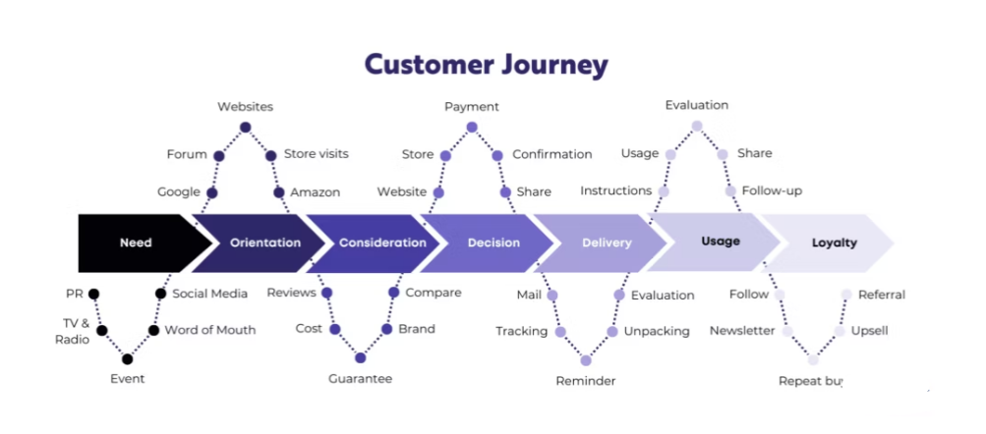

Figure 1: Customer Journey Map
(Source: Tanovic, 2024)
The 3E's Framework: The 3E’s framework, indicating Engagement, Ease and also Emotion, provides a structured way to evaluate the experiences of customers. Each E plays an important role in determining how customers see as well as interact with a brand. Ease refers to how simple or convenient interactions are for customers. Effectiveness measures how well the needs of the customers are met whereas emotion focuses on the feelings of the customer generated during the experience (Caruelle et al., 2024). The framework highlights that emotional engagement is just as important as functional performance. Positive emotions influence satisfaction, loyalty as well as advocacy.
McKinsey’s Consumer Decision journey model
McKinsey’s Consumer Decision Journey model explains how people make a purchasing decision. The consumer decision journey model is viewed as an ongoing process where experience-based expectations influence future behaviour (Vollrath and Villegas, 2022). First, the customer thinks about different brands. This is called the initial consideration stage. Then they search for information and compare options. This is the evaluation stage. After that they choose and buy a product which is the purchase stage. Finally, they use the product and share their experience. If they are happy, they may buy it again. McKinsey's consumer decision journey model focuses on customer experience as well as loyalty. It helps companies understand and influence customer decisions better.

2.4 Overview and Importance of integrated hospitality services in the tourism industry of the UK
Integrated hospitality services in the tourism industry of the UK offer the customers a unified guest experience. The UK tourism industry has the most expenditure from visitors from accommodation, transport as well as food (Massidda, Piras and Seetaram, 2022; Phan et al., 2024). This shows that the wider hospitality sector has a significant contribution towards the economy as well as the employment scenario of the UK. However, Bondarenko, Kalaman and Danilova (2025) argued that the core driver of the tourism industry in modern days is rapid digital innovation. There is an issue of potential job displacement in the tourism industry of the UK (Akamavi, Ibrahim and Swaray, 2022). The rapidly digitising tourism industry in the UK will have significant implications on customer experience.

2.5 Impacts of integrated hospitality services over customer experience strategy development
The integrated hospitality sector offers unified services to the customers of the tourism industry. The tourism businesses combine accommodation, food and beverage, leisure, technology and also customer support (Pilis, Kabus and Miciuła, 2022). In a positive sense this enhances customer experience strategy development by enabling seamless interactions across many touchpoints. According to John Agyekum Addae et al. (2024), customers benefit from the convenience as well as personalisation that comes from having interconnected booking or dining services. Integration allows organisations to analyse customer data which supports more accurate customer journey mapping (Ismail and Abdulkareem, 2024; Retkutė and Davidavičienė, 2021). This also leads to improved satisfaction among customers, stronger brand loyalty and also competitive differentiation in the hospitality sector.
However integrated hospitality services also present several challenges that can negatively impact customer experience strategies. Having services or departments that are highly dependent on each other raises operational complexity (Ala and Chen, 2022; Ledro, Nosella and Pozza, 2023). This makes it more difficult for various departments to coordinate amongst themselves. Critical infrastructure services are also often closely linked in a way such that communication, information technology, financial and also public services are dependent on each other (Watney, 2022). If there is a breakdown in booking services in a hotel then it may lead to costly compensations such as paying for alternative accommodations (Lee and Sharma, 2024). Finally, Aghaziarati and Rahimi (2025) state that relying too much on digital integration may lead to behavioural conditioning in which users develop habitual engagement patterns. This raises dependency on AI driven recommendations. Human interactions are a critical component in hospitality experiences; thus, it would have a negative impact overall.

2.6 Challenges encountered by hotels to manage their integrated hospitality services
The UK hotels face several challenges in managing hospitality services that are integrated in nature. Customer expectations for seamless or personalised experiences are on a rise (Celestin, 2024; Das, 2023). This raises the issue of rising operational complexity.
The integration of accommodation, food and beverage, leisure facilities and also digital platforms require close coordination across departments (Pilis, Kabus and Miciuła, 2022; Vitsentzatou, Tsoulfas and Mihiotis, 2022). This means that if there is any breakdown in communication it can negatively affect service consistency. This is very difficult for large hotel chains to manage, especially the ones that have multiple properties.
Another significant challenge is the large-scale integration of technology. However, many UK hotels do not have legacy systems that can integrate easily with modern customer relationship management. The manual nature of booking processes may add to the operational costs (Zeqiri, 2024).
Cybersecurity as well as data protection also pose concerns because hotels must comply with the UK GDPR regulations (Florido-Benítez, 2024; Gilbert and Gilbert, 2025). Workforce related challenges are particularly acute in the hospitality sector of the UK. There is skill shortage as well as high staff turnover in the hospitality sector in the UK (Innerhofer, Nasta and Zehrer, 2022; Minor, McLoughlin and Carlisle, 2024). This issue makes it more difficult to deliver services that are consistently high quality. Overall, balancing automation with personalised human interaction remains quite a challenge.

2.7 Conceptual Framework
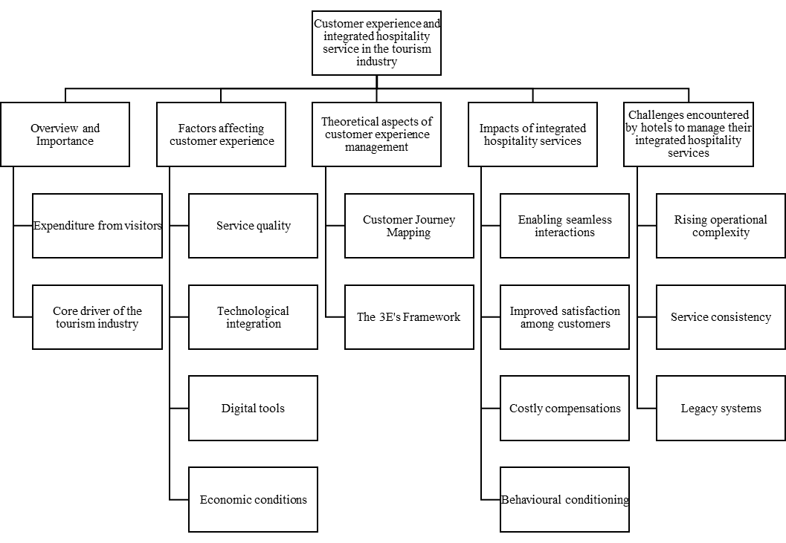

Figure 2: Conceptual Framework
The above figure demonstrates a conceptual framework showing the relationship between customer experience and integrated hospitality services within the tourism industry. It also highlights the key themes like overview and importance, factors affecting customer experience, theoretical models, impacts of integration and operational challenges. The sub-elements signifies service quality, technology, journey mapping, customer satisfaction and system dynamics.

2.8 Literature gap
The literature shows a major gap that lies within the evaluation of the technological advancements that play a major role in determining the improvements that can be brought about in the integrated hospitality services. The theoretical knowledge that has been developed from the literature sources shows significant evidence on how integrated systems can influence the development of customer experience across the tourism industry. Fulfilment of this gap can be attained by aligning the theories and concepts into practical application in context to Mercure Danum Doncaster Hotel such that their customer experience can be attained.

2.9 Summary
The literature review highlights the growing importance of integrated hospitality services. These integrated services are very important for shaping customer experiences within the UK tourism industry. The literature reveals that there are both positive as well as negative aspects to having integrated systems in the tourism industry. Various factors that influence customer experience in the tourism industry have been discussed as well. The literature shows that there is a gap to be filled within the evaluation of technological advancements in the integrated hospitality services. Overall, the literature review establishes a well-grounded foundation for assessing customer experience in integrated hospitality services.

Chapter 3: Methods

3.1 Introduction
In this chapter, a set of research methods have been identified which have further been applied in the data collection and analysis section to obtain relevant outcomes related to the research scenario and the objectives. To develop this section of the research, a reference to the research onion has been obtained which shows utilisation of suitable methods of collecting and interpreting data from available sources.

3.2 Research Philosophy
Research philosophy underpins the utilisation of a set of beliefs that helps define a researcher's ability to use assumptions and principles while determining the approach to the study (Jansen, 2023). The selection of the interpretivism research physiology showed significant relevance with the research area as it highlighted how qualitative methods help in understanding subjective meanings in a hospitality context. The positivism philosophy showed less relevance in application to this study as it offers quantitative methods to find objective meanings which are significant in generalisation of human behaviour. Since customer experience in hospitality content is mostly based on service-related improvements, the interpretivist physiology would show better insights into the contextual problem using qualitative methods rather than that of a numerically measurable one.

3.3 Research Approach and design
Research approaches underpin the ways through which data can be collected, interpreted and utilised to draw conclusions as a part of a research study. Kumar and Ujire (2024) stated that research approaches are categorised into two types, namely, the inductive and deductive research approach. The inductive research approach emphasises on defining facts from observed data whereas the deductive research approaches emphasis on using existing theories to draw inferences. Since customer experience and integrated hospitality services are effective to be understood from observable facts, using an inductive research approach showed significant relevance. On the other hand, an exploratory research design is applied to gain in-depth understanding on how hospitality services with respect to the chosen organisational context can be evaluated.

3.4 Data Collection Methods
Collecting data from relevant sources implies that the research proceeded towards attaining outcomes which intends to justify the research questions in context to evidence. Generally, Mazhar et al. (2021) stated that research data collection methods are categorised into two types, namely, the primary and the secondary data collection method. The primary data collection method utilises its application in the form of a survey or an interview that is, directly engaging patron-supports through a significant population group. On the other hand, the secondary data collection method underpins the utilisation of data sources from across the internet in the form of a desk-based research. In this study, the application of a secondary data collection method has been witnessed through the help of which news articles and similar websites have been utilised to gather information associated with hospitality context.

3.5 Data analysis techniques
Using a secondary data collection method enables the possibility to collect descriptive data that underpins the use of online articles with the help of which findings are extracted (Wickham, 2020). Similarly, while analysing the interrelationship between integrated hospitality systems and customer experience, it has been possible to develop knowledge using various news articles that were published in a hospitality context. For this purpose, qualitative data analysis has been carried out using thematic tables. This table provided inferences on the findings that have significant relevance with the aim and objectives of the study such that extraction of the outcomes has been possible descriptively.

3.6 Ethical considerations
For every research study, ethics play a major role in determining the compliances that are to be followed while collecting data from external sources. As this study deploys a secondary data collection method, it is evident that the ethical considerations would be followed concerning copyright issues. As per Legislation (2018), the guidelines embedded under the Data Protection Act 2018 and the GDPR offer relevant compliance that forms the foundation of selecting research methods and executing them practically. Thus, following these guidelines would enable the research to be carried out by mentioning the sources from where information has been gathered as a part of the secondary research. This would ensure that no copyright violations occur, preserving integrity of the study.

3.7 Summary
The chapter summarises the implications that associate the use of secondary data to gather information and analyse them using qualitative data analysis. The inferences also show that the utilisation of secondary data collection method prevails the hypothetical nature of interpretivist research philosophy that helps underpinning observations to deduce outcomes.

Chapter 4: Findings and Discussion

4.1 Introduction
In this chapter, an analysis has been carried out by applying a secondary data collection method, where information associated with the research objectives have been accessed from web sources. The chapter proceeded with the development of a data extraction table which listed the findings from the web sources in context to which the development of the themes has proceeded.

4.2 Findings (Data extraction)
Website author | URL | Findings
CONVOTIS (2025) | https://www.convotis.com/en/news/customer-experience-in-the-hospitality-and-tourism-sector-precisely-managing-digital-services/ | The hospitality and tourism sector is observed to possess a major importance towards underpinning the concepts of customer experience (CX) into their digital architectures. This is done with the help of Unified data models such as Customer Experience and System Architecture which enable personalised, seamless interactions across channels. Using this parameter, it is possible to undertake integration of CX systems to drive higher conversions, loyalty and operational efficiency.
Ehrlich et al. (2022) | https://www.mckinsey.com/capabilities/growth-marketing-and-sales/our-insights/how-the-operating-model-can-unlock-the-full-power-of-customer-experience | The concept of customer experience has been explained in context as an operating model that helps boost customer satisfaction and sales, across operations. Underpinning success from this aspect determines the need for a cross-functional collaboration that facilitates a clear design principle through which holistic integration of CX is done across functions.
Operations Council (2025) | https://operationscouncil.org/enhancing-customer-experience-through-operational-excellence/ | Operational excellence in organisations are determined in terms of the level of enhancement they are able to bring about in customer experience. Organisations are observed to have an emphasis on customer expectations that help them to adopt inventory management, and integrate technologies to boost customer satisfaction through faster, reliable delivery of services.
Schwarz (2025) | https://www.netsuite.com/portal/resource/articles/erp/system-integration-hospitality.shtml | In the hospitality context, the importance of Integrated systems are observed to help eliminate manual data duplication, reduce errors, and improve coordination across departments. Similarly, using shared data can help enhance resource optimisation, service accuracy, and operational efficiency. In context to hospitality, linking property management with housekeeping can help in increasing effectiveness of room readiness which creates a scope for synchronised billing and thus streamlining guest services.
Varela (2025) | https://hrsinternational.com/news-and-insights/seamless-technology-integration-revolutionising-the-hotel-industry | Technology integration activities that are carried out in the hospitality context are observed to utilise a combination of booking engines, CRM, revenue tools, and IoT. Using this credibility, it becomes possible to enhance guest personalisation and increase operational efficiency. For instance, integrating IoT can enable developing smart rooms and predictive maintenance, through automated systems that helps to optimise costs and elevate experiences.
Hospitality Net (2026) | https://www.hospitalitynet.org/opinion/4130720.html | The findings from Hospitality Net show that the integrated hospitality services play a critical role in improving customer satisfaction by ensuring consistency and reliability. The study also highlights that consumers analyse their experience holistically instead of individual service encounters. Thus, the effective service integration results in smoother guest journeys, higher satisfaction levels and positive service perception in the tourism industry.
Accor Group (2019) | https://group.accor.com/ | The findings from the Accor Group highlights that the customer satisfaction is empowered when the hospitality services are produced through an integrated service framework based on brand standards. The findings also suggest that such implementation reduces service breakdowns and improves guest comforts, trust and overall customer satisfaction. This addresses the importance of an integrated hospitality service in refining positive customer experience.
Deloitte (2026) | https://www.deloitte.com/in/en.html | The findings from Deloitte demonstrate that customer experience in the hospitality sector is predominantly shaped by the integration of services over the entire guest journey. The findings also show that when the hospitality services are integrated across the touchpoints, the guests get a seamless and well-maintained experience. This reinforces the relationship between integrated hospitality service design and improved customer experience in the tourism industry.
Forbes (2024) | https://www.forbes.com/councils/forbesbusinesscouncil/2024/02/15/addressing-rising-customer-expectations-in-hospitality/ | Forbes highlighted that the integrated digital and service infrastructure provide holistic guest journey management instead of fragmented service delivery. The findings highlight that end-to-end integration enhances emotional engagement with the customers and strengthens the relationship between customer experience and integrated hospitality services in the tourism sector.
Tripadvisor | https://www.tripadvisor.in/Hotel_Review-g187067-d193450-Reviews-Mercure_Doncaster_Danum_Hotel-Doncaster_South_Yorkshire_England.html | Mercure Danum Doncaster gives great central location and it helps in exploring the town which is included historic charm and modern comforts. The staffs are helpful, friendly in nature and they are attentive. The building is historic, yet it gives modern amenities.
Accor Group | https://all.accor.com/hotel/A099/index.en.shtml | Hospitality services are the best in Mercure Danum Doncaster, and it blends with cleanliness of hotel and behaviour of the staffs. The hotel has been refurbished in 2015 and guests like their Wi-Fi service and best dine-in experience in the hotel.

Table 1: Data Extraction table

4.3 Themes generation
Findings | Codes | Sub-themes | Themes
Integrating customer experience into system architecture enhances operational efficiency | Integrated customer experience | Customer experience-led operating model | Theme 1: Utilisation of Customer Experience and System Architecture as an operating model embeds a foundation to operational excellence
Centralised digital systems help in real-time, data-driven decision-making | Integrated architecture | Data-driven operations
ERP and PMS integration decrease the rate of manual errors and duplication | System integration | Operational efficiency | Theme 2: Key integrated hospitality services that enables seamless customer experience towards efficient and effective practices
Smart technologies enhance coordination across hotel operations | Technology enablement | Seamless service delivery
Integrated services provide personalised and consistent guest experiences | Personalisation | Enhanced guest satisfaction | Theme 3: Integrated Hospitality services play a major role in improving customer satisfaction
CRM-based platforms improve guest loyalty and service quality | Guest data integration | Relationship management
End-to-end system connectivity enhances journey continuity | Journey integration | Holistic guest journey | Theme 4: Integrated end-to-end guest journey in refining customer experience
Pre-, during-, and post-stay integration improves experience refinement | Touchpoint integration | Experience consistency

Table 2: Thematic Table

4.4 Thematic analysis
Theme 1: Utilisation of Customer Experience and System Architecture as an operating model embeds a foundation to operational excellence
The integration of customer experience (CX) in organisations requires upgrading system architecture which plays a major role in determining the core operating model on the basis of which operational excellence is perceived. According to CONVOTIS (2025), customer experience is observed to become a core goal for organisations that is enhanced with the help of digital technologies and organisational infrastructures. In the case of Mercure Danum Doncaster Hotel, it is observed that the company relies on third party service providers through which they are able to communicate with customers to attain bookings and transactions. With the integration of precisely managed digital services, it would be possible to facilitate the benefits of unified data architectures and integrated platforms (Ehrlich et al. 2022). This would enable the company to utilise real-time visibility across customer touchpoints thus allowing them to respond proactively to the needs and requirements of the customers alongside improving efficiency and consistency.
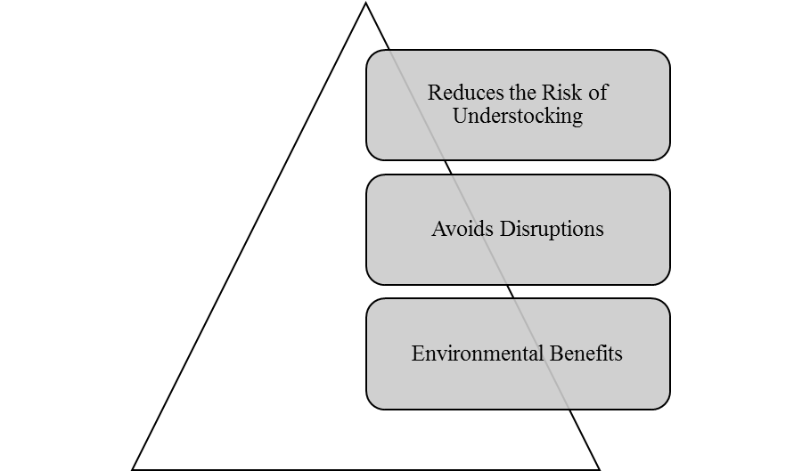

Figure 3: Relationship between Operations and Customer Experience
(Source: Operations Council, 2025)
Due to the fact that the utilisation of an operating model aligned with customer experience can strengthen the foundation of hospitality services, it would be necessary to emphasise on cross-functional collaboration. As per Ehrlich et al. (2022), using customer experience principles it would be possible for organisations to embed changes across their governance structures, workflows, and performance metrics. For Mercure Danum Doncaster Hotel, using this method to enhance operational experience would help in achieving greater agility, faster decision-making, and more reliable service delivery. Contrarily, Operations Council (2025) explained that, operational excellence can help demonstrate streamlined operations in an optimised way by emphasising on data-driven forecasting which significantly enhances customer satisfaction. Thus, by leveraging system architecture that integrates operational processes with customer experience, Mercure Danum Doncaster Hotel would be able to reduce disruptions occurring across their customer services and eventually improve reliability of their services.
Theme 2: Key integrated hospitality services that enables seamless customer experience towards efficient and effective practices
Thinking of enhancing customer experience in the hospitality services requires integration of technological advancements that play a critical role in delivering seamless customer services while maintaining operational efficiency and effectiveness. According to Schwarz (2025), system integration is observed to take place across core hospitality functions which includes property management systems (PMS), enterprise resource planning (ERP), customer relationship management (CRM), and revenue management. One of the key benefits that is associated with the use of system integration is that it helps eliminate data silos and reduces manual intervention. Mercure Danum Doncaster Hotel if plans to implement integrated systems within their hospitality services, they are expected to share real-time data thus, improving coordination between departments, which directly enhance guest satisfaction.
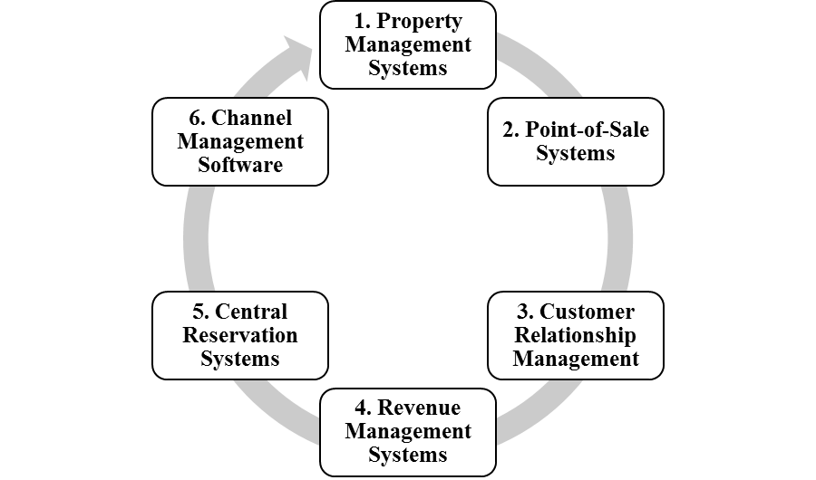

Figure 4: Key Components of System Integration
(Source: Schwarz, 2025)
The integration of seamless technology in hospitality content tends to improvise in smart management and data driven practices. As opined by Varela (2025), implementing IoT driven solutions can help in including personalised services that enhances optimisation in resource utilisation and increases guest experience. In the case of Mercure Danum Doncaster Hotel, integrating a digital infrastructure using concepts of IoT and AI can help in indulging productive maintenance such that service disruptions can be availed and consistency in service delivery can be maintained.
Theme 3: Integrated Hospitality services play a major role in improving customer satisfaction
This theme shows that the integrated hospitality services prominently improve customer satisfaction. But this relationship is not automatic or universally positive. The service integration improves consistency, speed and reliability but its effectiveness depends on employee capability, system usability and organisational alignment (Hospitality Net, 2026). According to Accor Group (2019), customer satisfaction is empowered when the hospitality services are produced through an integrated service framework based on brand standards. Mercure Danum Doncaster Hotel uses integrated front office, housekeeping and food services to minimise service gaps and contribute to higher customer satisfaction. However, the excessive standardisation may restrict flexibility and also reduce the capability of the hotel to respond to unique guest preferences. Moreover, some integration failures like system downtime or interdepartmental miscommunication can accelerate dissatisfaction instead of mitigating them. Thus the integrated hospitality services act as an enabler instead of a guarantee of customer satisfaction. Satisfaction outcomes are increased only when integration is promoted through employee empowerment, continuous training and responsive service recovery mechanisms within the tourism industry.
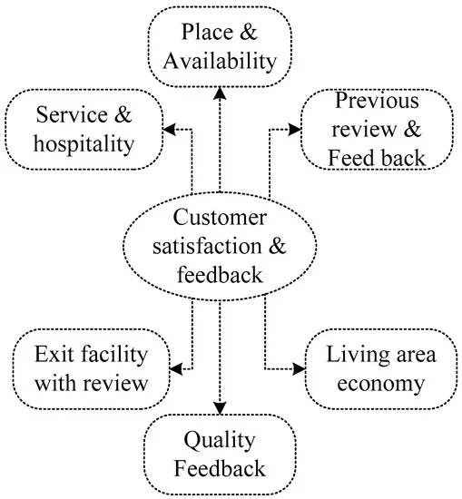

Figure 5: Integrated hospitality service to promote customer satisfaction
(Source: Narayan et al., 2022)
Theme 4: Integrated end-to-end guest journey in refining customer experience
An integrated end-to-end guest journey management plays a very important role in shaping customer experience by making sure that the interactions are seamless all over the touchpoints (Forbes, 2024). In the case of Mercure Danum Doncaster Hotel this journey integration produces coherent experiences from booking to post-stay communication and improves emotional engagement and perceived value. However, the reliance on an integrated system may overlook the experiential challenges that emerge through constant human interaction. Overemphasis on digital journey mapping can badly hamper depersonalisation if not maintained with empathetic service delivery (Deloitte, 2026). Moreover, poorly integrated touchpoints may create friction that negatively shapes overall experience perceptions (Hardcastle, Vorster and Brown, 2025). So while end-to-end integration improves experience coherence and convenience, its success is dependent on strategic alignment between technology, service design and also employee behaviour. The effective guest journey integration shapes customer experience only when it remains agile, human-centred and consistently evaluated within the competitive tourism environments.
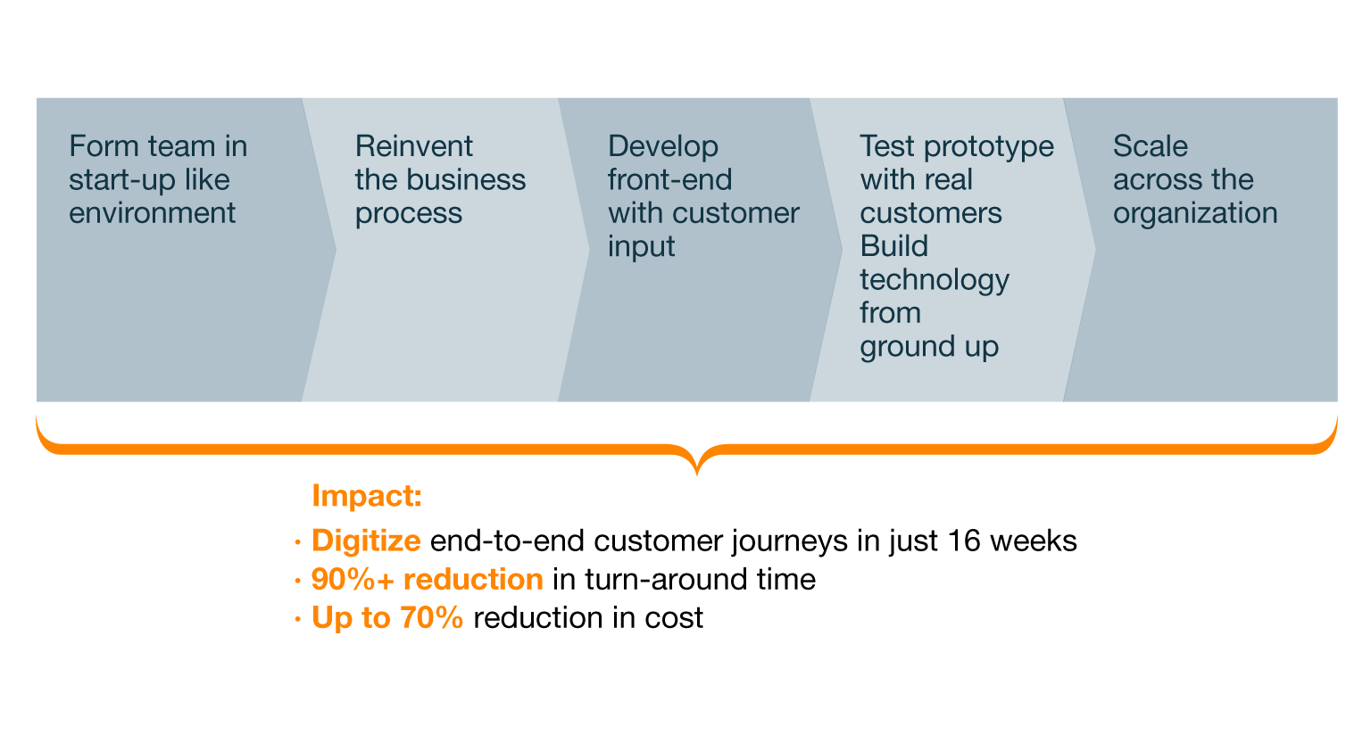

Figure 6: How to redesign an integrated one-to-one guest journey
(Source: McKinsey & Company, 2015)

4.5 Discussion
4.5.1 Critically analysing the research findings in relation to the existing literature
The research findings strongly align with this by showing enhanced customer satisfaction at Mercure Danum Doncaster Hotel when these services are correlated with each other. The existing literature by Massidda, Piras and Seetaram (2022) states that the UK tourism industry is dominated by accommodation, transport and food expenditure. This demonstrated the economic significance of integrated hospitality services. This strongly aligns with the findings from Hospitality Net (2026) and Accor Group (2019) that claim that service integration improves consistency and guest satisfaction at Mercure Danum Doncaster Hotel. However, the findings extend the literature by showing that the economic significance alone does not ensure experience without integration. This highlights the Customer Journey Model in which the coordinated pre-stay, during-stay and post-stay services shape the overall perceptions instead of isolated transactions.
The research findings provide this by highlighting that the integrated hospitality services improve customer satisfaction only when employee coordination and responsiveness are present at Mercure Danum Doncaster Hotel. Jevtić, Tomić and Leković (2020) argue that service quality and frontline staff strongly promote purchase intention in the tourism industry. This is also addressed by Tripadvisor and Accor platform reviews where employee responsiveness and coordination refine guest perception. The integration of Stimulus-Organism-Response (S-O-R) Model within systems as discussed by CONVOTIS (2025) and Schwarz (2025) act as stimuli that influence internal evaluations like trust and convenience and thus generate satisfaction and loyalty. The findings also suggest that the service quality is accelerated through integration. However, human performance remains the central tendency.
The findings show this by reflecting that breakdowns in integrated systems can disturb the entire guest journeys and hamper customer satisfaction. However, the research further shows that proactive coordination and recovery planning can eliminate these struggles. Varela (2025) and Deloitte (2026) highlight that implementation of technologies over the booking engines, CRM and IoT enhance customer journey and their continuity. This supports the 3E’s framework and mainly Ease. Forbes (2024) demonstrated the emotional engagement over touchpoints that strongly align with McKinsey’s Consumer Decision Journey Model. However, according to Ledro, Nosella and Pozza (2023), high service interdependence increases operational complexity and failure risk and so the integration needs to be strategically managed to gain long-term customer advocacy. To conclude, integrated hospitality services predominantly shape customer experience only when complexity is managed efficiently and consistently.
4.5.2 SWOT and PESTLE analysis
SWOT analysis
Strengths
The integrated hospitality services at Mercure Danum Doncaster Hotel provides seamless experience to the guests (All.accor, 2025).
This hotel provides good service quality and achieves maximum customer satisfaction through coordinated accommodation, dining and technical ecosystems.
Weaknesses
Mercure Danum Doncaster Hotel is highly dependent on integrated systems that increases vulnerability to service disruptions (City of Doncaster Council, 2024).
The hotel often faces staff coordination issues that result in reduced flexibility while addressing the unique guest preferences.
Opportunities
Mercure Danum Doncaster Hotel has growing demand for customised and technology-based experiences in the UK tourism industry.
The hotel with efficient integrated hospitality service has the potential to incorporate data-based integration to improve customer experience and competitive positioning in the hospitality industry (Abdou, 2025).
Threats
Rapid digitalisation, cybersecurity risks, rising customer expectations and also operational complexity may negatively affect service reliability of a hospitality company (Karadayi-Usta, 2024). The overall consumer experience of Mercure Danum Doncaster Hotel will also face this if it is poorly managed within the competitive hospitality sectors.
PESTLE analysis
PESTLE analysis is used here to systematically analyse the external macro-environmental influences that promote organisational performance and strategic decision-making. With regards to Mercure Danum Doncaster Hostel, this analysis will help to detect the political, economic, social, technological, legal and environmental factors that shape the integrated hospitality services and consumer experience. It will also help the hotel to identify threats, understand the emerging opportunities and strongly align operational strategies with the extensive industry trends within the UK tourism and hospitality industry.
 | Factors | Key indicators
Political | UK tourism support policies (Opportunity) | The UK government has aimed to reach the visitor count to 50 million by 2030 (Hutton and Murray, 2025).  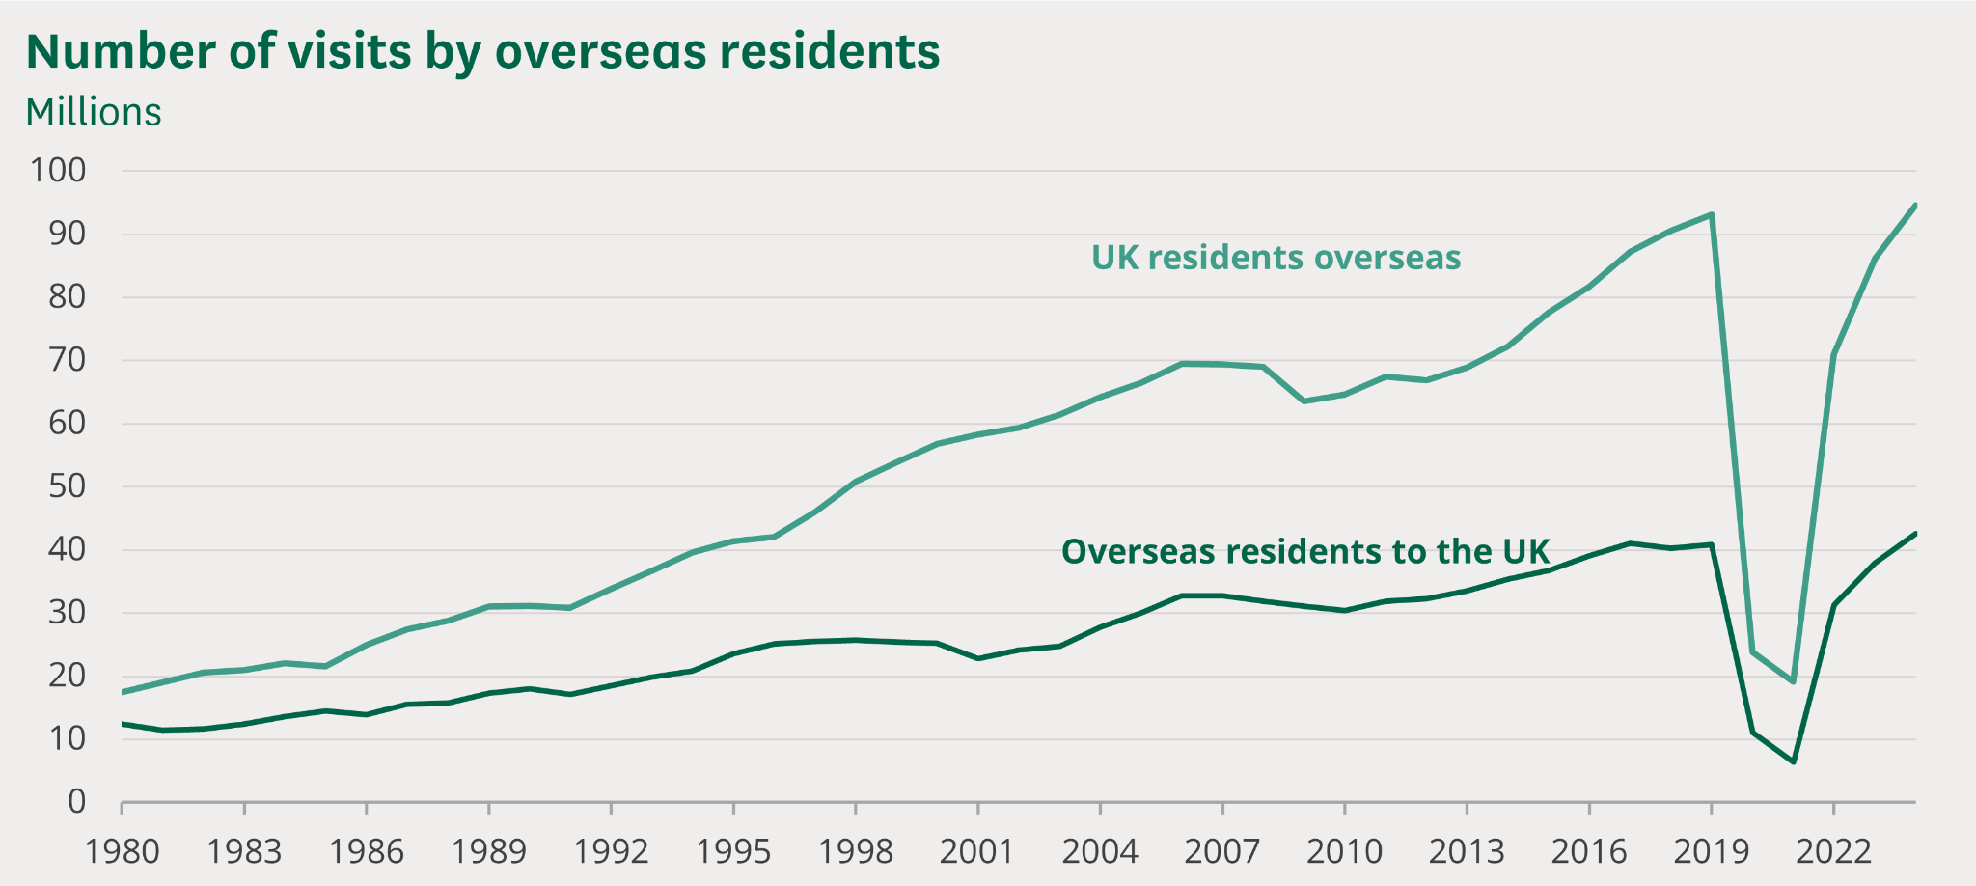  Figure: Number of visits by overseas resident  (Source: Hutton and Murray, 2025)
 | Regulatory uncertainty (Threat) | Post-Brexit labour and visa regulations.
Economic | Growth in domestic tourism (Opportunity) | British residents made 105.6 million overnight visits within Great Britain in 2024 (Hutton and Murray, 2025).
 | Inflationary rate (Threat) | The inflationary rate of the UK rose up to 3.4% in December 2025 (BBC, 2025).  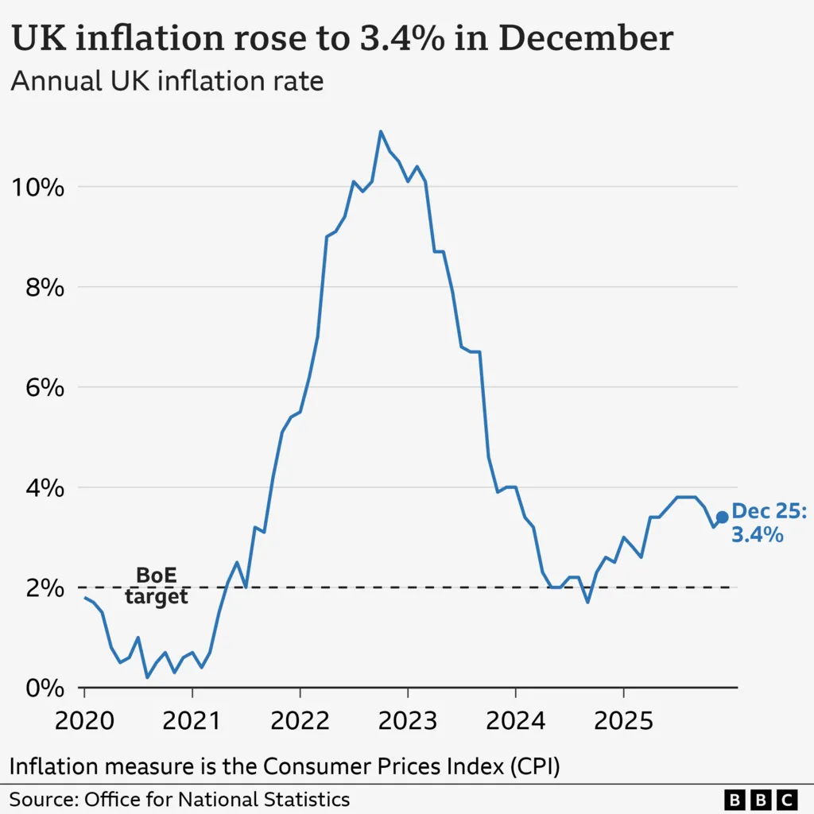  Figure : UK inflation rate  (Source: BBC, 2025)
Social | Demand for customised experiences (Opportunity) | Almost 71% of the UK consumers prefer companies to provide customised interactions (McKinsey & Company, 2021).
 | Changing workforce behaviour (Threat) | 28% of UK workers divide their time between home and the workplace (Office for National Statistics, 2025).
Technological | Digital service integration (Opportunity) | The U.K. digital transformation market is expected to grow at a yearly growth rate of 27.7% from 2023 to 2030 (Grand View Research, 2023).  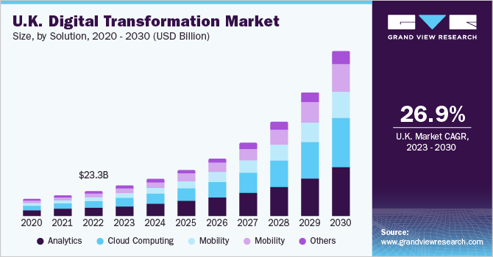  Figure : UK digital transformation market  (Source: Grand View Research, 2023)
 | System dependency threats (Threat) | The UK government suffers from IT outages and cyber security breaches.
Legal | Customer protection standards (Opportunity) | Transparent pricing strategy and service standards.
 | UK GDPR compliance (Threat) | The data protection is governed by the UK General Data Protection Regulation (UK GDPR) and the Data Protection Act 2018 (UK Government, 2025).
Environmental | Sustainable hospitality practices (Opportunity) | The UK makes 100% of plastic packaging which are reusable, recyclable or compostable (UKHospitality, 2024).
 | Climate and energy regulations (Threat) | The Climate Change Act 2008 provides a legally binding target to minimise the greenhouse gas emissions in the UK by at least 80% in 2050 (GOV.UK, 2014).

Table 3: PESTLE analysis
4.5.3 Pointing out valuable areas critical to the placement hotel operation
Identifying valuable regions which are critical to the operations at placement hotels demonstrates functions that directly influence service quality, efficiency and also customer experience. The integrated front office operations, digital booking systems and also coordinated food and beverage services at Mercure Danum Doncaster Hotel is mainly important as they refine the end-to-end guest journey. The effective employee coordination and communication over operational departments make sure consistency and timely service delivery (Honda et al., 2023). Customer data management and feedback systems are important for monitoring satisfaction and also shaping service strategies (Okeke et al., 2024). These operational areas provide seamless integration, improve customer satisfaction and also contribute to competitive performance within the UK hospitality and tourism industry.
4.5.4 Exploring implications and acknowledging limitations of research
The study demonstrates the vital implications but also acknowledges primary limitations. The integrated hospitality services face employee resistance because of increased dependency on technology and transformation in the workforce (Baquero, 2022; Fu, Zheng and Wong, 2022). The technical advancements provide improved consumer experience, but their utilisation is very restricted due to limited empirical research within the hospitality industry. The study is also dependent on a secondary qualitative research method which is yet another limitation as it restricts access to real-time operational insights. Moreover, the limited number of themes and objectives hampered in-depth analysis. These limitations provide scope for future research and comprehensive learning.

4.6 Summary
This chapter carried out an analysis by applying a secondary data collection method where information regarding the research objectives have been used from web sources. Few data were extracted from some prominent articles to gain four significant themes. However, these themes were aligned with the existing literature to find that integrated hospitality services predominantly shape customer experience only when complexity is managed efficiently and consistently. SWOT and PESTLE analysis are also performed to gain insight about the external and internal factors that influence the hospitality industry in the UK. Lastly, few limitations are being highlighted through thorough research so that there can be increased scope of future research.

Chapter 5: Conclusion and Recommendations

5.1 Conclusion
This present research focuses on understanding the relationship between customer experiences and integrated hospitality services in the tourism industry, mainly focusing on Mercure Danum Doncaster Hotel. The hotel is based in the United Kingdom and is renowned for projecting refined expression of the local aspects. The key aim of this research was to understand ways various hospitality services work collaboratively and their effect on the experience of the customers. In addition to this, this study also tries to exercise the challenges in terms of service integration and also provides strategies for improvement. From the above research, it is also clear that integrated hospitality services hold an important role, which helps in shaping the expectations of the customers, especially in modern hotels. One key finding of this research explains that experiences of the customers does not completely depend on a single service. Nowadays customers consider the entire process, starting from searching and booking a room to check-out and post-communication. Therefore, it is important for all departments of a hotel business, including reception, housekeeping, and digital services to work in a collaborative manner to ensure high customer satisfaction. Further, when services are effectively connected and shared in an effective manner it is important for reducing mistakes as well as delays. This is also crucial for creating a seamless experience for the customers, increasing their trust and loyalty towards the hotel.
Moreover, this present research also determined that technology is another important aspect that helps in ensuring integrated hospitality services. Various customers mainly prioritise online booking, effective and quick communication as well as digital check-ins. In addition to this, integrated systems, including property management systems, customer relationship management tools and booking engines are effective for a hotel business to manage the information of the guests and provide more personalised services. For instance, having effective knowledge about a customer helps the employees prepare better and provide much better services, eventually enhancing satisfaction and also ensuring that the guests feel valued. Therefore, it can be said that integrating technology is effective for fostering better decision-making, while reducing service errors or delays in hotels. On the other hand, this present research also found that integration is not always easy, there are several challenges that are associated with it. One key challenge is complexity in operations, which appear when more than one services are linked with each other, which might impact the journey of the guests in a negative way. For instance, if the booking system fails or crushes, which can also create problems in crucial areas, like check-in and room availability. This can contribute to reducing the satisfaction rate of customers; hence managing integration effectively is important.
Another challenge related to integration is the system compatibility. In the hospitality industry there are many hotel businesses that are using old systems, which do not effectively align with the present technologies. This issue can eventually cause some serious problems, such as slow services and can also cause errors. To upgrade these systems, it requires investment and training, which are quite expensive. In addition to this, data protection and cyber security risks are also vital to consider. It is important for businesses in the tourism industry, especially hotels, to adhere to data protection regulations, such as GDPR. Any type of data breach can negatively impact the reputation of the hotel, while it can also reduce the trust of the customers. Workforce issues are also important. The hospitality industry often faces programs regarding staff shortage and high employee turnover. To implement integrated services, it is important to train the employees and ensure that they are highly skilled and also have the ability to understand both technological adaptation and customer services in an effective way. If employees are not well trained, incorporating the best system cannot help and deliver good experiences to the guests. This report also highlights the importance of human interaction, especially in the hospitality industry. For instance, guests always prefer friendly behaviours and empathetic staff. Focusing too much on technology can reduce human touch. Hence, it becomes very critical for hotel organisations to keep a certain balance between digital tools and human service.
Moreover, in the case of Mercure Danum Doncaster Hotel, from the research it can be seen that the integrated services are able to enhance the satisfaction rate among guests as well as enhancing operational efficiency. The stated hotel also receives some advantages from its brand standards and integrated department, which helps in fostering a consistent experience. On the contrary, it is important for Mercure Danum Doncaster Hotel to avoid over standardisation. Further, service recovery is also crucial, especially when any problems take place, it is important to provide adequate services to resolve them. Furthermore, another strong conclusion of this report is that integration is an enabler, and not a guarantee. This means that only connecting systems is not effective for creating happy customers; however, success is highly dependent on the ways of using technology, and the collaboration among service design and employees. Lastly, this report also incorporates some gaps, such as it only uses secondary qualitative data from articles and reports, meaning that this study has been done solely on the basis of available information, and does not incorporate the real-life scenario of the hotel. In addition to this, the tourism industry is very volatile which means findings of this research might need updates.

5.2 Recommendations and Practical Strategies
Recommendation 1: Staff Training and Skills development
This recommendation focuses on fostering staff training and skill development. To do so, Mercure Danum Doncaster Hotel should provide regular training programs for the employees and also focus on customer service, communication and technology uses. Riesner et al. (2025) stated that providing training initiative helps in mitigating the skill gap within an organisation, while also providing employees with efficient tools that eventually motivate them and enhance their performance. In the case of the stated organisation, these training programs need to include the ways of using digital systems, handling the complaints of the guests and delivering personalised services.
The recommendation of staff training and skills development is suitable for Mercure Danum Doncaster Hotel, because integrated systems do not work in the proper manner without employees understanding and coordination. Various service problems take place due to lack of skilled employees. In addition to this, Tumi et al. (2022) also stated that effective skill development and training help in enhancing the confidence and motivation of employees. Therefore, skilled employees help in handling guests’ requests and also provide better services.
Recommendation 2: Improve System integration and backup support
It is also important for Mercure Danum Doncaster Hotel to improve and upgrade its digital systems, which can help in fostering smooth integration between various departments of the hotel, such as housekeeping, billing, booking and CRM system. In addition to this, it also needs to have IT support and backup systems, which helps in addressing technological failures in a more efficient and quick way. From the findings of this research, it has been already seen that the hotel is highly dependent on integrated systems, which might have some risks along with its benefits. Concerning this, Lopes et al. (2022) highlighted that the ineffective implementation of integrated systems or management can have the potential to create various problems, especially in the mid and long term.
System integration improvement is also necessary as if one integrated system fails it can have a negative impact on the entire guest journey. In addition to this, a strong integration system also helps in reducing manual work, avoiding duplicate data and improving coordination among departments. Focusing on this, Azzahra and Asshofi (2024) stated that in the hospitality industry, many departments work in a collaborative manner, such as the front office, marketing, housekeeping and management. This study also explains that any disconnect between these departments can impact the overall operations and customer satisfaction. Lastly, backup support is also quite crucial for the hotel along with fast technical support as it helps in resolving problems before anyone notices them.
Recommendation 3: Enhancing Guest feedback and service recovery
The hotel is also supposed to receive the feedback of its guests and act on it to make its services better and have a good service recovery strategy to respond to the complaints promptly and in a professional manner. In this context, Sokolovsky (2023) highlighted that customer feedback is an important aspect for an organisation, which helps in providing valuable insights that are effective for providing better service. The feedback may be gathered by means of survey, reviews on the Internet, or email surveys that will be sent to the guest after their stay.
Enhancing guest feedback or service recovery is of utmost importance. Listening to the guests can be effective for the hotel to spot the problems in their initial stages and rectify them before they escalate to bigger ones (Hayes, 2025). Service recovery is also highly important since the best hotels can do wrong. The most important thing is the way the hotel reacts in case something has gone wrong. Furthermore, feedback analysis will make the hotel visible to trends and patterns. Focusing on this, Shah and Rai (2022) stated that analysing customers’ feedback is important for businesses to understand their needs in a better way, while also encouraging them to provide their valuable feedback. Overall, continuous improvement and improved performance can foster good feedback and recovery systems.
Recommendation 4: Keeping a balance between technology and human interaction
The Mercure Danum Doncaster Hotel cannot only depend on digital tools and it should ensure that staff offer warm and friendly personal service to its guests. Service should be aided by technology rather than be a substitute for human interaction. As per Gonçalves et al. (2023), overdependency on digital implementations can cause problems in organisations as it always asks for the availability of the employees. Further, human interaction is helpful and is appreciated by the guests since they establish an emotional bond.
Finally, keeping a balance between technology and human interaction is also very important. Digital check-in, as an example, helps, but the employees should not ignore welcoming the visitors. The balance between technology and human service is beneficial in terms of satisfaction, reviews and revisions.

5.3 Future scope of the study
This study is primarily based on secondary data sources which includes academic journals, industry reports and also organisational publications. This limits the ability to capture real time customer perceptions and also employee experiences at the Mercure Danum Hotel. In future, this study would further strengthen the findings with incorporating primary data collection methods. These methods include customer surveys, in depth interviews and also focus groups with hotel staff as well as management.

References
Abdel‐Hamid, T.A., Ahmed, M.A. el A.S., Zohry, M.A.F., Elshabrawy, G.A. and Elgohary, E.M. (2022). ‘The role of digital transformation in improving customer satisfaction: An empirical study on Egyptian hotels.’ THE ELECTRONIC JOURNAL OF INFORMATION SYSTEMS IN DEVELOPING COUNTRIES, 88(6), pp.1–18.
Abdou, A.H. (2025). Smarter Technologies, Innovation, and Managerial Capabilities Driving Hotel Sustainability: The Integration of Resource-Based View and Dynamic Capabilities Perspective. Tourism and Hospitality, 6(5), p.2-5.
ACCOR (2019). Accor - Worldwide hospitality leader. Available at: https://group.accor.com/ (Accessed: 14 February 2026).
Accor Group (2025). Mercure. Available at: https://group.accor.com/en/brands-and-experiences/our-hotel-brands/mercure-hotels. (Accessed 14 February 2026).
Aghaziarati, A. and Rahimi , H. (2025). ‘The Future of Digital Assistants: Human Dependence and Behavioral Change.’ Journal of Foresight and Health Governance, 2(1), pp.52–61.
Akamavi, R.K., Ibrahim, F. and Swaray, R. (2022). Tourism and troubles: Effects of security threats on the global travel and tourism industry performance. Journal of Travel Research, 62(8), pp.1755–1800.
Ala, A. and Chen, F. (2022). ‘Appointment Scheduling Problem in Complexity Systems of the Healthcare Services: A Comprehensive Review.’ Journal of Healthcare Engineering, 1(1), pp.1–16.
All.accor (2025). Mercure Doncaster Centre Danum Hotel | Hotel in Doncaster - ALL. [online] all.accor.com. Available at: https://all.accor.com/hotel/A099/index.en.shtml (Accessed 14 February 2026).
Any, B., Four, S. and Tariazela, C. (2024). ‘Technology Integration in Tourism Management: Enhancing the Visitor Experience.’ Startupreneur Business Digital (SABDA Journal), 3(1), pp.1–8.
Azzahra, M. S., and Asshofi, I. U. A. (2024). ‘Study of the cooperation relationship between the front office and housekeeping departments through communication at hotel tentrem semarang.’ Journal of Gastro Tourism, 2(2), 75-92.
Baquero, A. (2022). ‘Job Insecurity and Intention to Quit: The Role of Psychological Distress and Resistance to Change in the UAE Hotel Industry.’ International Journal of Environmental Research and Public Health, 19(20), p.13-29.
BBC (2025). UK inflation rate: How quickly are prices rising? BBC. Available at: https://www.bbc.com/news/articles/c17rgd8e9gjo (Accessed: 4 February 2026).
Bondarenko, S., Kalaman, O. and Danilova, O. (2025). ‘Digital Transformation of the Tourism Business in an Open Economy: A Comprehensive Approach to Travel Planning and Partnerships.’ Social Development: Economic and Legal Issues, 1(4), pp.1–19.
Car, T., Suman, S. and Kliman, A. (2024). ‘Customer Booking Habits and Attitudes Towards AI-Powered Features in Online Travel Agencies.’ International Journal of Advances in Computer Science and Technology, 13(9), pp.111–117.
Caruelle, D., Shams, P., Gustafsson, A. and Lervik-Olsen, L. (2024). ‘Emotional arousal in customer experience: A dynamic view.’ Journal of Business Research, 170(1), pp.1–12.
Celestin, M. (2024). ‘How businesses create personalized experiences to boost customer retention: The role of technology and human interactions in customer satisfaction.’ International Journal of Applied and Advanced Scientific Research (IJAASR), 9(2), pp.75–80.
Chi, D.T.P., Van Thu, P., Van Hoa, N. and Tuan, N.A. (2024). ‘Customer experience management in retail business–a theoretical debate.’ International journal of advanced multidisciplinary research and studies, 4(5), pp.854–863.
City of Doncaster Council (2024). Report - Meetings, agendas, and minutes. Available at: https://doncaster.moderngov.co.uk/documents/s43118/Corporate%20Report%20-%20Funds%20for%20resettlement%20integration%20-%20060224%20decision.pdf.
CONVOTIS (2025) Customer Experience in the hotel and tourism industry, CONVOTIS. Available at: https://www.convotis.com/en/news/customer-experience-in-the-hospitality-and-tourism-sector-precisely-managing-digital-services/ (Accessed: 2 February 2026).
Das, M.P. (2023). ‘Technology and Guest experience: innovations reshaping hotel management.’ International Journal for Multidimensional Research Perspectives, 1(3), pp.76-95.
Deloitte (2024). Deloitte | Audit, Consulting, Financial, Risk Management, Tax Services. Available at: https://www.deloitte.com/in/en.html (Accessed: 10 February 2026).
Edginton, T. (2026) New report from VisitBritain/VisitEngland shows tourism worth £147 billion to UK economy, VisitBritain.org. Available at: https://www.visitbritain.org/news-and-media/industry-news-and-press-releases/new-report-visitbritainvisitengland-shows-tourism (Accessed: 10 February 2026).
Ehrlich, O., Fanderl, H., Malfara, D. and Mittagunta, D. (2022) How the operating model can unlock the full power of customer experience, McKinsey & Company. Available at: https://www.mckinsey.com/capabilities/growth-marketing-and-sales/our-insights/how-the-operating-model-can-unlock-the-full-power-of-customer-experience#/ (Accessed: 9 February 2026).
Florido-Benítez, L. (2024). ‘The Cybersecurity Applied by Online Travel Agencies and Hotels to Protect Users’ Private Data in Smart Cities.’ Smart Cities, 7(1), pp.475–495.
Forbes (2024). Council Post: Addressing Rising Customer Expectations In Hospitality. Available at: https://www.forbes.com/councils/forbesbusinesscouncil/2024/02/15/addressing-rising-customer-expectations-in-hospitality/ (Accessed: 4 February 2026).
Fu, S., Zheng, X. and Wong, I.A. (2022). ‘The perils of hotel technology: The robot usage resistance model.’ International Journal of Hospitality Management, 102(1), p.10-31.
Gilbert, C. and Gilbert, M.A. (2025). ‘Impact of General Data Protection Regulation (GDPR) on Data Breach Response Strategies (DBRS).’ International Journal of Research and Innovation in Social Science, 9(14), pp.760–784.
Gonçalves, L.L., Nardi, A.E. and King, A.L.S., (2023). ‘Digital Dependence in organisations: Impacts on the physical and mental health of employees.’ Clinical Practice and Epidemiology in Mental Health: CP & EMH, 19, pp. 1-3.
GOV.UK (2014). Climate Change. Available at: https://www.gov.uk/guidance/climate-change (Accessed: 9 February 2026).
Grand View Research (2023). U.K. Digital Transformation Market Size Report, 2030. Available at: https://www.grandviewresearch.com/industry-analysis/uk-digital-transformation-market-report (Accessed: 4 February 2026).
Hardcastle, K., Vorster, L. and Brown, D.M. (2025). ‘Understanding Customer Responses to AI-Driven Personalized Journeys: Impacts on the Customer Experience.’ Journal of Advertising, 54(2), pp.1–20.
Hayes, J. (2025). The theory and practice of change management. Bloomsbury Publishing.
Homburg, C. and Tischer, M. (2023). ‘Customer journey management capability in business-to-business markets: Its bright and dark sides and overall impact on firm performance’. Journal of the Academy of Marketing Science, 51, pp.1046–1074.
Honda, A., Rosana, Valéry Ridde, Zinszer, K. and Gautier, L. (2023). ‘Attributes and Organisational Factors that Enabled Innovation in Health Care Service Delivery during the COVID-19 Pandemic – Case Studies from Brazil, Canada and Japan.’ International Journal of Research Publication and Reviews, 9(2). pp.1-12.
Hospitality Net (2026). Why Do Chefs Leave? What a Global Survey Reveals About the Kitchen Retention Crisis. Available at: https://www.hospitalitynet.org/opinion/4130720.html (Accessed: 4 February 2026).
Hospitality Net (n.d.). Mercure by Accor. Available at: https://www.hospitalitynet.org/brand/23000072/mercure.html. (Accessed 9 February 2026).
Hutton, G. and Murray, A. (2025). Tourism: statistics and policy. commonslibrary.parliament.uk. Available at: https://commonslibrary.parliament.uk/research-briefings/sn06022/ (Accessed: 9 February 2026).
Innerhofer, J., Nasta, L. and Zehrer, A. (2022). ‘Antecedents of labor shortage in the rural hospitality industry: a comparative study of employees and employers.’ Journal of Hospitality and Tourism Insights, 7(1), pp.28–55..
Irani, F., Athari, S.A. and Hadood, A.Al.Al. (2022). ‘The Impacts of Country Risk, Global Economic Policy Uncertainty, and Macroeconomic Factors on the Turkish Tourism Industry.’ International Journal of Hospitality & Tourism Administration, 23(6), pp.1–24.
Irani, Z., Abril, R.M., Weerakkody, V., Omar, A. and Sivarajah, U. (2023). ‘The impact of legacy systems on digital transformation in European public administration: Lesson learned from a multi case analysis.’ Government Information Quarterly, 40(1), pp.1–14.
Ismail, A.A.H.E. and Abdulkareem, A.M. (2024). ‘Data-driven techniques for quantitative analysis of customer journey mapping in digital commerce.’ Emerging Trends in Machine Intelligence and Big Data, 16(4), pp.1–8.
Jansen, D. (2023) Research philosophy: Positivism, interpretivism & pragmatism, Grad Coach. Available at: https://gradcoach.com/research-philosophy/ (Accessed: 2 February 2026).
Jevtić, J., Tomić, S. and Leković, K. (2020). ‘Customer experience in the tourism industry: Determinants influencing complaint behaviour’. Management in Hospitality and Tourism, 8(2), pp.25–33..
John Agyekum Addae, Kwabena Gyasi Boakye, Oppong, G., Hod Anyigba, Majeed, M., Aidatu Abubakari and Kwame Simpe Ofori (2024). ‘The interplay between multichannel integration quality, service convenience, service experience, multichannel perceived value and e-WoM.’ International Journal of Quality & Reliability Management, 42(12), pp.1–22.
Karadayi-Usta, S. (2024). ‘Cybersecurity Risks Analysis in the Hospitality Industry: A Stakeholder Perspective on Sustainable Service Systems.’ Systems, 12(10), pp.397–397.
Kumar, S. and Ujire, D.K. (2024) Inductive and Deductive Approaches to Qualitative Research. Available at: https://ijmer.s3.amazonaws.com/pdf/volume13/volume13-issue1(4)/9.pdf (Accessed: 2 February 2026).
Ledro, C., Nosella, A. and Pozza, I.D. (2023). ‘Integration of AI in CRM: Challenges and guidelines.’ Journal of Open Innovation: Technology, Market, and Complexity, 9(4), pp.1–13.
Lee, S.W. and Sharma, A. (2024). ‘Beyond rate parity: Examining offer uniqueness and channel credibility in hotel pricing.’ Tourism Economics, 31(2), pp.309–331.
Legislation (2018) Data Protection Act 2018, legislation.gov.uk. Available at: https://www.legislation.gov.uk/ukpga/2018/12/contents (Accessed: 2 February 2026).
Lopes, A., Polónia, D., Gradim, A. and Cunha, J. (2022). ‘Challenges in the integration of quality and innovation management systems.’ Standards, 2(1), pp.52-65.
Massidda, C., Piras, R. and Seetaram, N. (2022). ‘Analysing the drivers of itemised tourism expenditure from the UK using survey data.’ Annals of Tourism Research Empirical Insights, 3(1), pp.1–9.
Mazhar, S.A., Anjum, R., Anwar, A.I. and Khan, A.A. (2021) ‘Methods of Data Collection: a Fundamental Tool of Research’, Journal of Integrated Community Health, 10(1), pp. 6–10.
McKinsey & Company (2021). The Value of Getting Personalisation right--or wrong--is Multiplying. Available at: https://www.mckinsey.com/capabilities/growth-marketing-and-sales/our-insights/the-value-of-getting-personalization-right-or-wrong-is-multiplying (Accessed: 15 February 2026).
McKinsey & Company. (2015). End-to-End Journey Redesign. Available at: https://www.mckinsey.com/capabilities/tech-and-ai/how-we-help-clients/end-to-end-journey-redesign (Accessed: 15 February 2026).
Minor, K., McLoughlin, E. and Carlisle, S. (2024). ‘The Digital Skills Gap – Is it Time to Rethink the Needs of Tourism and Hospitality Organisations in the UK?’ Journal of Hospitality & Tourism Education, 37(3), pp.1–12.
Narayan, R., Gehlot, A., Singh, R., Akram, S.V., Priyadarshi, N. and Twala, B. (2022). ‘Hospitality Feedback System 4.0: Digitalization of Feedback System with Integration of Industry 4.0 Enabling Technologies.’ Sustainability, 14(19), p.12158.
Office for National Statistics (2025). Who has access to hybrid work in Great Britain? Available at: https://www.ons.gov.uk/employmentandlabourmarket/peopleinwork/employmentandemployeetypes/articles/whohasaccesstohybridworkingreatbritain/2025-06-11 (Accessed: 4 February 2026).
Okeke, I., Alabi, A., Ngochindo, A., None Onyeka Chrisanctus Ofodile and None Chikezie Paul-Mikki Ewim (2024). ‘AI in customer feedback integration: A data-driven framework for enhancing business strategy.’ World Journal of Advanced Research and Reviews, 24(1), pp.2036–2052.
Okeke, I., Alabi, A., Ngochindo, A., Ofodile, N.O.C. and Ewim, N.C.P.-M. (2024). ‘Customer journey mapping framework for SMES: Enhancing customer satisfaction and business growth.’ World Journal of Advanced Research and Reviews, 24(1), pp.2004–2018.
Operations Council (2025) Enhancing Customer Experience Through Operational Excellence - Operations Council, Operations Council. Available at: https://operationscouncil.org/enhancing-customer-experience-through-operational-excellence/ (Accessed: 2 February 2026).
Phan, K.-T., Chen, S.-H., Lee, J.-M. and Pham, C.-V. (2024). ‘Expenditure decisions of international tourists to Taiwan: application of the Heckman two-stage approach.’ Cogent social sciences, 10(1), pp.1–15.
Pilis, W., Kabus, D. and Miciuła, I. (2022). ‘Food Services in the Tourism Industry in Terms of Customer Service Management: The Case of Poland.’ Sustainability, 14(11), pp.1–15.
Reitsamer, B.F., Stokburger-Sauer, N.E. and Kuhnle, J.S. (2023). ‘How and when effective customer journeys drive brand loyalty: the role of consumer-brand identification.’ Journal of Service Management, 35(6), pp.109–135.
Retkutė, K. and Davidavičienė, V. (2021). ‘Application of multichannel access and customer journey man in the context of innovative business projects.’ Journal of Service, innovation and Sustainable Development, 2(1), pp.100-120.
Riesner, S., Altnau, C., Berner, M.R., Skraba, A., Ajiri, D. and Kopac, L. (2025). ‘Employee Training as a Support for the Professional Development of the Company.’ Journal of Lifestyle and SDGs Review, 5(3), pp.1-17.
Schwarz, L. (2025) 6 Business Benefits of System Integration in Hospitality, Oracle NetSuite. Available at: https://www.netsuite.com/portal/resource/articles/erp/system-integration-hospitality.shtml (Accessed: 3 February 2026).
Shah, Z. and Rai, S. (2022). ‘A Research Paper on the Effects of Customer Feedback on Business.’ International Journal of Advanced Research in Science, Communication and Technology, 2(1), pp.672-675.
Sokolovsky, D. (2023). The Power Of Customer Feedback. Available at: https://www.forbes.com/councils/forbesbusinesscouncil/2023/06/30/the-power-of-customer-feedback/ (Accessed: 4 February 2026).
Tanovic, A. (2024). How to create a customer experience strategy: The 6 pillars of successful CX. Maze. Available at: https://maze.co/collections/customer-experience/strategy/.
Tumi, N.S., Hasan, A.N. and Khalid, J. (2022). ‘Impact of compensation, job enrichment and enlargement, and training on employee motivation.’ Business Perspectives and Research, 10(1), pp.121-139.
UK Government (2025). Data Protection Act. Available at: https://www.gov.uk/data-protection (Accessed: 4 February 2026).
UKHospitality (2024). Sustainability guide. Available at: https://www.ukhospitality.org.uk/work/sustainability-guide/ (Accessed: 15 February 2026).
Varela, M. (2025) Seamless Technology Integration Revolutionizing the Hotel Industry, Hrsinternational.com. Hospitality and Retail Systems GmbH. Available at: https://hrsinternational.com/news-and-insights/seamless-technology-integration-revolutionizing-the-hotel-industry (Accessed: 9 February 2026).
Vitsentzatou, E., Tsoulfas, G.T. and Mihiotis, A.N. (2022). ‘The Digital Transformation of the Marketing Mix in the Food and Beverage Service Supply Chain: A Grey DEMATEL Approach.’ Sustainability, 14(22), pp.152-28.
Vollrath, M.D., Villegas, S.G. (2022). ‘Avoiding digital marketing analytics myopia: revisiting the customer decision journey as a strategic marketing framework.’ J Market Anal 10.pp. 106–113.
Watney, M. (2022). ‘Cybersecurity Threats to and Cyberattacks on Critical Infrastructure: a Legal Perspective.’ European Conference on Cyber Warfare and Security, 21(1), pp.319–327.
Wickham, R. (2020) ‘Secondary Analysis research’, Journal of the Advanced Practitioner in Oncology, 10(4), pp. 395–400.
Zeqiri, A. (2024). ‘From Traditional to Digital: The Evolution of Business Models in Hospitality Through Platforms.’ Platforms, 2(4), pp.221–233.

