

STUDENT NAME: Adrian Merisan
STUDENT ID: 2226309
MODULE CODE: LCCB5014
LECTURE NAME: Ihsan Ul Haq

Table of Contents
Introduction 3
Data Cleaning and Preparation 4
Descriptive Statistics and Summary 5
Trend Analysis and Visualisation 7
Statistical Analysis 11
Insights, Recommendations and Limitations 13
References: 15

Film Popularity, Ratings and Viewer Behaviour

Introduction
This report finds out the predictors of movie popularity, engagement and average rating in the Letterbox movie classification dataset. All 10,000 movies in the dataset include their film title, director, genres, length, original language and studios, as well as behavioural measures such as watches, list additions, likes, fans and rating counts. Watches gauge exposure, likes to suggest positive engagement, and fans demonstrate stronger film attachment these measures differentiate reach, positive engagement, and loyalty. There is no reason to think that average rating is a direct effect on commercial success. Instead, it is a second outcome of interest measuring evaluative consequences. The analytical approach consisted of cleaning, profiling, visualization, and inferential tests. Cleaning techniques like those in Excel spotted upraised missing values, duplicate values, inconsistent category names and outliers. The subsequent step involved using descriptive statistics and frequency tables to profile each rating, length and engagement variable. SPSS inferential procedures will require an independent-samples t-test, bivariate correlations and multiple linear regression. The mentioned statistics are useful for comparing two groups, measuring association, and estimating the unique effect of a set of predictors. The goal of the business is to show how data from movie platform will help for content acquisition, recommendation design and audience segmentation.
Analytical capability improves the quality of decisions when data accurately represent reality or when they are rendered valid through context-dependent interpretation (Wieder and Ossi Mitz, 2015; Li et al., 2022). Consequently, the objectives are to construct an analytical dataset devoid of measurement errors, describe its basic features, test for differences in average rating between English and non-English films, analyse interrelations of runtime and engagement variables, and predict average rating.

Data Cleaning and Preparation
The Before analysis, the uniqueness, validity and completeness of the data set was first checked. 34 title-director duplication combinations were identified. Many films with the same title represent legitimate remakes, which means one must check the records against year of release or edition information before dropping them. So, the same 10,000 records that one provided were used for analysis while noting duplication risk. One title, ten director, twenty-four genre, three language and 307 studio records which were blank or unclassified. Average rating, runtime, watches, likes and fans did not have any formally missing values, so we did not need any numerical imputation. Yet, the rating mean and median being exactly equal motivates that the source may have already contained transformed or processed values which is a limitation to note. The text fields were cut off and standardised to consistent capitalisation. The same language was grouped into common labels and recoded as English and Non-English for the test hypothesis. The genres were a list and were assigned a string; they are broken down into individual genres so the movie can count towards each genre. The numeric variables were standardized to a consistent numeric format, ensuring impossible observations were examined. The duration varied between 2 to 907 minutes.
Such instances were retained as they may represent shorts, serials or a very long production but emphasis were on medians and robust visual interpretation. Businesses require clean data, free of duplicates or records that are incomplete or coded inconsistently, for business intelligence because these distort the aggregates. Data quality is defined as accuracy, completeness, consistency and fitness for use (Fu et al., 2024; Ridzuan and Zainon, 2024). The cleaning log makes the work more transparent and reproducible rather than a pre-commitment which is not visible but an invisible preparation step.

Descriptive Statistics and Summary
According to Table 1, the descriptive statistics of key numeric variables are shown. The average rating was 3.27 but showed some variance (SD = 0.53) between 1.08 to 4.71. Ratings are somewhat clustered below the average, as indicated by a skewness of -0.41. Mean running time is 103.17 minutes while median running time is 99 minutes. The highest score of 907 minutes together with a skewness of 5.65 tells us that runtime has some influential outliers (i.e., there are very long films that inflate the mean).
Variables related to engagement had a more skewed distribution. The average count of watches was 170,315 whereas the median was only 18,425. The overall mean number of likes was 43,735, with a median of only 3,394. The overall mean fans count was 1,653, with a median only 24. The skulking of 5.13 for warranted, 7.50 for diffidence and 14.62 for fans shows that a small group of very visible films dominates only activity on the Overall. Mean captures total platform scale.
Of all films, 8,074 (80.7%) had English as their first language. After English, Spanish, and Chinese, the next most common languages were Italian, Japanese and French. This skew is significant as it estimates performance for English language from a much larger more likely commercially mainstream population. Film one particular film can fall into many genres. Drama was the most popular (n = 4416), followed by comedy (n = 2932), thriller (n = 2312), action (n = 2074) and horror (n = 1812). Descriptive evidence showed that popularity and rating are not interchangeable. A popular movie might receive a lot of likes by chance, simply because it has been seen by many people. On the other hand, a film that is less exposed might find itself achieving a very high average rating simply because it has been watched by a selective audience. Business dashboards must independently report reach, conversion and loyalty instead of collapsing into a single success score.

Table 1. Descriptive statistics for principal numerical variables
Variable | N | Mean | Median | SD | Minimum | Maximum
Average rating | 10,000 | 3.27 | 3.27 | 0.53 | 1.08 | 4.71
Runtime (minutes) | 10,000 | 103.17 | 99.00 | 38.07 | 2.00 | 907.00
Watches | 10,000 | 170,314.82 | 18,425.00 | 458,532.92 | 2.00 | 5,195,503.00

Likes | 10,000 | 43,734.79 | 3,394.00 | 151,531.43 | 0.00 | 2,730,813.00
Fans | 10,000 | 1,652.55 | 24.00 | 9,368.26 | 0.00 | 326,000.00

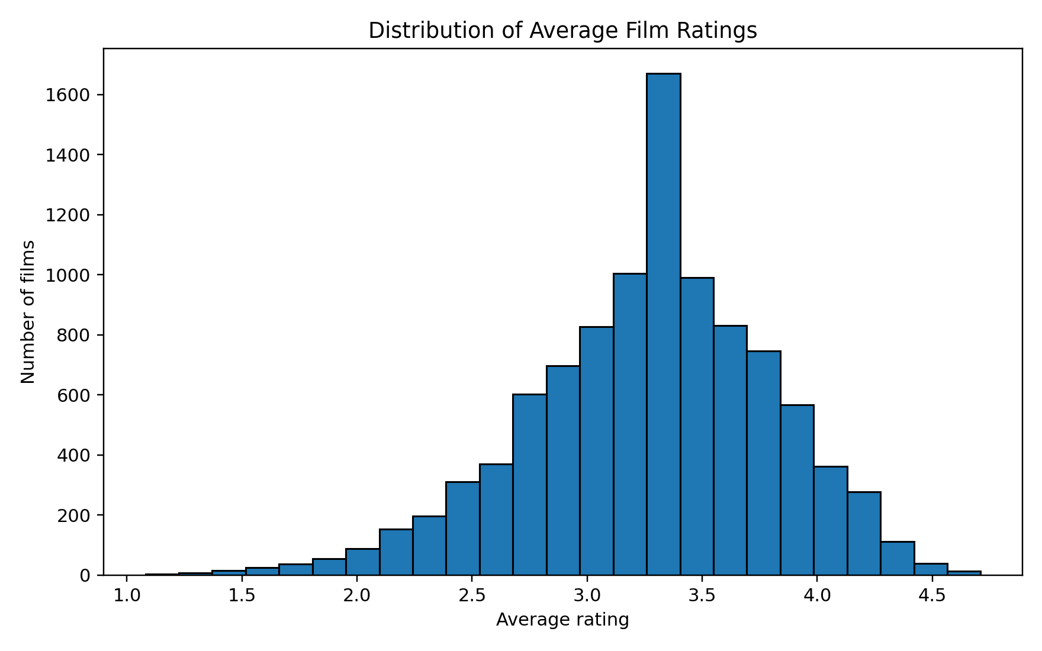
Figure 1. Distribution of average film ratings

Trend Analysis and Visualisation
The genre analysis revealed a significant gap between the top-rated specialist categories and the high-reach, more mainstream categories. The documentary program in which the country achieved the highest mean rating of 3.64, was followed by history when achieving a 3.53, war when achieving 3.50, music when 3.46, and drama achieving 3.45. Conversely, genres such as horror (3.01), science fiction (3.04) and action (3.07) all performed badly – they got mean ratings below 3.20 The less popular genres didn’t necessarily get weaker commercial attention in terms of volume. Adventure won the ratings battle around 334169 watches; animation 314699. 23 902 documentaries. Similarly, family films received 350,886 watches with an average rating of 3.18. As shown in Figure 2, the 10 most popular genres receive excellent quality ratings for drama and greater reach for adventure and family.
Similarly another comparison was done on languages. The average English language films had 196,530 watches, 49,385 likes and 1,772 fan. The average non-English films witnessed 60418 watch 20047 like and 1151 fan. Non-English films secured a higher mean rating of 3.51, compared with 3.21 for English films. The average assessment ratings are shown in Figure 3.
The dataset has more exposure in English, but that exposure is fully exploited (viewers will pick only globally famous non-English films which is a quality filter effect). As illustrated in figure 4, after the logarithmic transformation, the scatter plot between watches and likes clearly shows a near-linear relationship. This is not surprising because likes only to emerge after exposure. Nonetheless, this doesn't apply to the converse. This factor alone provides a compelling engagement-to-conversion metric that can be deployed in practice and in theory. Movies that feature above the trend line receive more than the number of expected likes for their volume of watches. Further, these may be candidate strong word-of-mouth opportunities. Films that score lower do get reach but not the same positivity. The finding of this paper might argue against mean rating-based programming. Genres such as drama, thriller, and comedy can attract a large audience. Documentary, history, and war can attract very specialized segments perhaps for prestige or satisfaction. Earlier investigations regarding film-analytics show that success is multi-dimensional and requires some mix of content, timing and social influence (rather than any one-off feature) (Lash and Zhao, 2016; Agarwal et al., 2021).

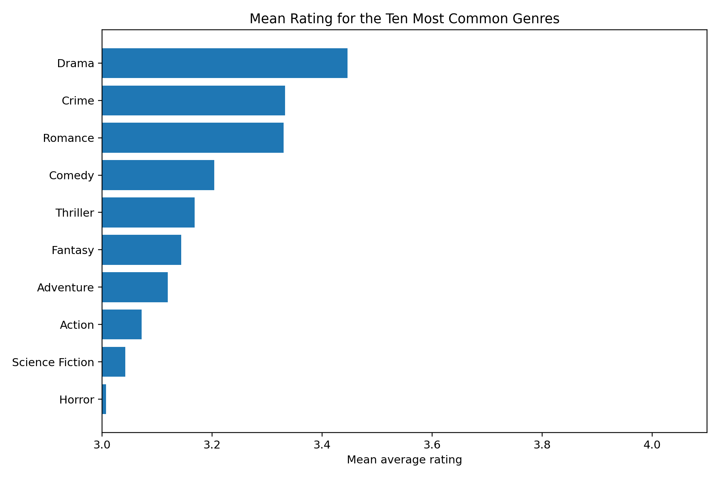

Figure 2. Mean rating for the ten most common genres

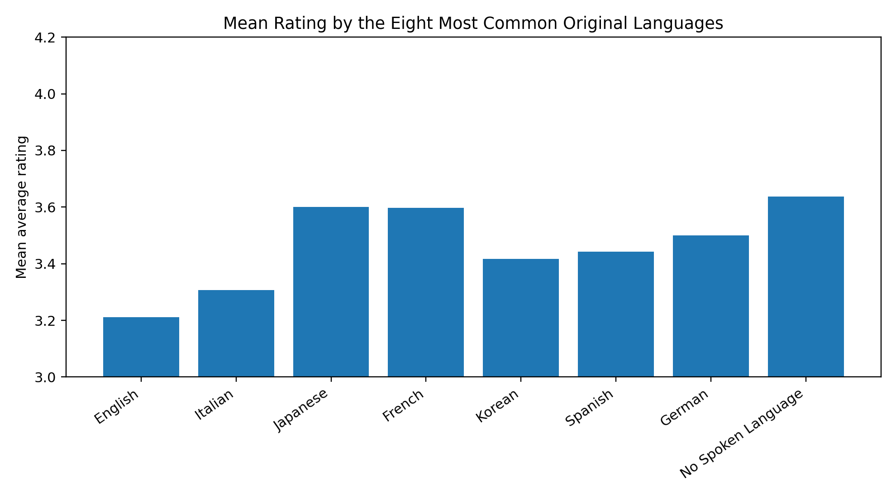
Figure 3. Mean rating by the eight most common original languages

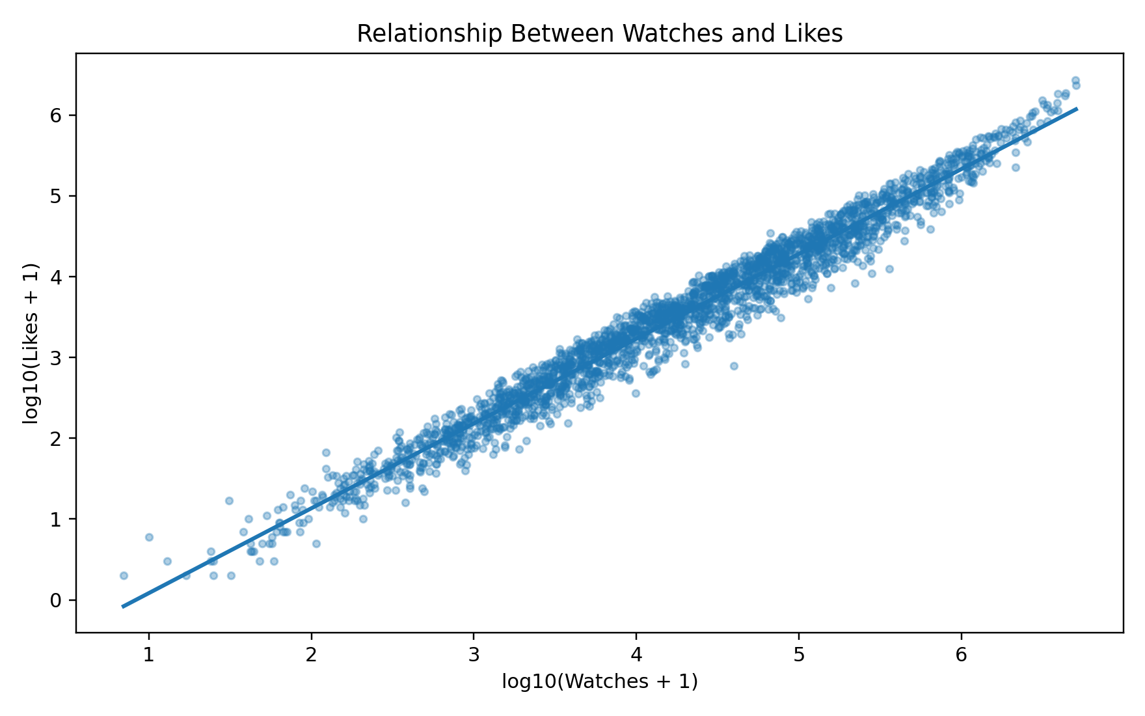
Figure 4. Log-transformed relationship between watches and likes

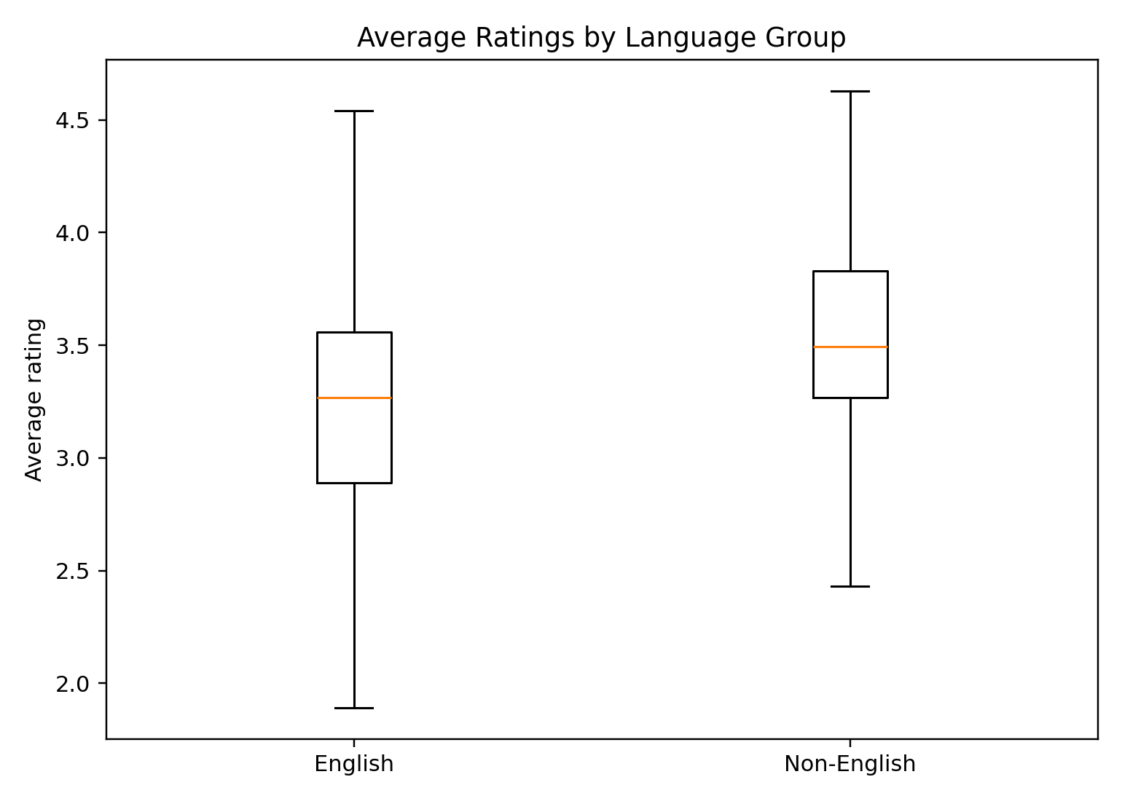
Figure 5. Average ratings for English and non-English films

Statistical Analysis
An independent-samples Welch t-test was used to see if the mean ratings differed for English versus non-English films. Welch’s test was employed as the size of the groups studied were unequal and it does not need equal variance. The average rating for English films is 3.21 while that of the other language films is 3.51. While the 48,088 English films were rated out of 5 on an average of 3.27, the 25,031 non-English films built up a score of 3.51 on an average. The difference was statistically significant, t(3219.60) = -24.88, p < .001. There was a moderate effect size (Cohen's d = -0.58). Consequently, we reject the null hypothesis: non-English films in the dataset receive ratings roughly .30 points higher. Statistical significance should not be dismissed as a by-product of a large sample, as effect size indicates a substantive difference although selection bias precludes a causal language interpretation. We used correlation analysis to look at the relationships between rating, runtime, watches, likes and fans. Due to the non-uniformity of the engagement variables, Spearman coefficients offer a robust interpretation. Watches and likes were almost perfectly associated (rhos = .984, p < .001); watches and fans were also very strongly associated (rho = .910), as were likes and fans (rho = .943).
The data revealed that the average rating was moderately positively correlated with fans (rho = 480) and likes (rho = 401). The correlation was weaker for watches (rho = 274) and runtime (rho = 229). There was a moderate correlation between runtime and number of watches (ρ = .362) and likes received (ρ = .357). Consequently, longer films tend to have more engagement, but the runtime itself is not a particularly strong correlate of.
Due to the skew of the ratings, a multiple regression predicted average ratings based on the log-transformed watches, likes and fans as well as the runtime and dummy for English language. The model explained a substantial percentage of the variance in ratings, with F(5, 9994) 4237.39, p <.001 and adjusted R2 = .679. Log likes were a significant predictor, B =.730, p <.001, as were log fans, B =.078, p <.001, and runtime, B =.0011, p <.001. After adjustment, the rating showed a negative association with the English language, B = -.101, p <.001. When likes and fans were controlled the log watches became negative, B = -.799, p <.001.
This doesn’t mean that viewing causes a dip in ratings. Rather, it shows suppression from the very high overlap in watches and likes, as can be seen by visualising their positive singular correlations.
Likes being there for fixed number of times, increase in watches means lower like to watch conversion. Multicollinearity should be considered. Engagement ratios' simpler models or separate models are likely advantageous for operational forecasting.

Table 2. Key inferential statistics
Analysis | Statistic | Result
Welch t-test | t(3219.60) | -24.88, p < .001
Effect size | Cohen’s d | -0.58
Spearman correlation | Watches–Likes | ρ = .984, p < .001
Spearman correlation | Rating–Fans | ρ = .480, p < .001
Multiple regression | Model fit | F(5, 9994) = 4237.39, p < .001
Multiple regression | Explained variance | R² = .679; adjusted R² = .679

Insights, Recommendations and Limitations
Successful titles should create blends of different types of value. Titles in the English language reach more audiences but non-English titles get more rating on average.
Documentaries, mysteries and war have strong ratings, while adventure, animation and family have broad engagement. As likes and fans are more connected to rating than raw watches, it follows that conversion and loyalty are better indicators of quality than sheer exposure. Distribution services and streaming platforms must use a segmented portfolio strategy.
Initially, the high-rated yet under-watched non-English and documentary titles should get better subtitling, dubbing, multilingual metadata and personalised recommendation placement. This can widen reach without assuming anything about English-language production being the only way to satisfy audiences.
Additionally, platforms should track the conversion rate from like-to-watch and fan-to-watch. Movies that have high volumes but low conversion need a different marketing strategy or recommendation position. On the other hand, movies that boast impressive conversion need to be promoted for a longer period. Third, genre dashboards should distinguish audience scale from satisfaction to avoid confusion between prestige, retention and acquisition objectives. Another operational suggestion is to create a balanced scorecard for each movie. Watch volume, like-to-watch conversion, fan-to-watch conversion, average rating and uncertainty based on number of ratings should be there.

It would stop a film with a limited number of viewers with enthusiasm from comparison with a mass-audience release. For acquisition processes, you could use language and genre filters to find comparable titles, making more relevant and fairer decisions. You should also consider engagement over time for campaign evaluation. If the number of watches is increasing rapidly, but the increase in likes is not matching this pace, it may indicate that people are becoming aware of the content but are not satisfied with it. On the other hand, increasing fan conversion might imply that the audience is valuable and resilient. These can influence destining, the homepage and the budget for localisation.
Analytics should be viewed as a supplement rather than a substitute for editorial judgment. We cannot always assume that an assessment of creative originality and cultural value will be derived from previous audience behaviour.
There are limitations to analysis. Because data are observational, correlation and regression do not prove causation. The movie release year, budget, spend on marketing, number of countries available in, number of awards, cast worth, and viewer age is missing. Future research should incorporate time, cost, and demographic variables; test for genre differences (ANOVA); and test models on a holdout sample. Analysis shows use of cleaned behavioural data can facilitate more focused acquisition, localisation and recommendation decision but still managers to combine judgement with analytics.

References:

Agarwal, M., Venugopal, S., Kashyap, R. and Bharathi, R. (2021) ‘A comprehensive study on various statistical techniques for prediction of movie success’, arXiv. Available at: https://arxiv.org/abs/2112.00395
Field, A. (2018) Discovering Statistics Using IBM SPSS Statistics. 5th edn. London: Sage Publications.
Fu, Q., Easton, J.M. and Janes, A. (2024) ‘Understanding data quality in a data-driven industry context’, Journal of Industrial Information Integration, 39, p. 100578.
Hair, J.F., Black, W.C., Babin, B.J. and Anderson, R.E. (2019) Multivariate Data Analysis. 8th edn. Andover: Cengage Learning.
IBM (2026) IBM SPSS Statistics Documentation: Independent-Samples T Test. Available at: https://www.ibm.com/docs/en/spss-statistics
Lash, M.T. and Zhao, K. (2016) ‘Early predictions of movie success: The who, what, and when of profitability’, Journal of Management Information Systems, 33(3), pp. 874–903.
Li, L., Lin, J., Turel, O., Liu, P. and Luo, X. (2022) ‘The impact of big data analytics usage on decision-making quality’, Technological Forecasting and Social Change, 175, p. 121355.
Ridzuan, F. and Zainon, W.M.N.W. (2024) ‘A review on data quality dimensions for big data’, Procedia Computer Science, 234, pp. 341–348.
Saunders, M., Lewis, P. and Thornhill, A. (2023) Research Methods for Business Students. 9th edn. Harlow: Pearson.
Wieder, B. and Ossimitz, M.-L. (2015) ‘The impact of business intelligence on the quality of decision making’, Procedia Computer Science, 64, pp. 1163–1171.

