Introduction to Physiology
BMHP5003_BIRM
Salema Alim 1913900
Tutor- Mumtaz Gulnaz

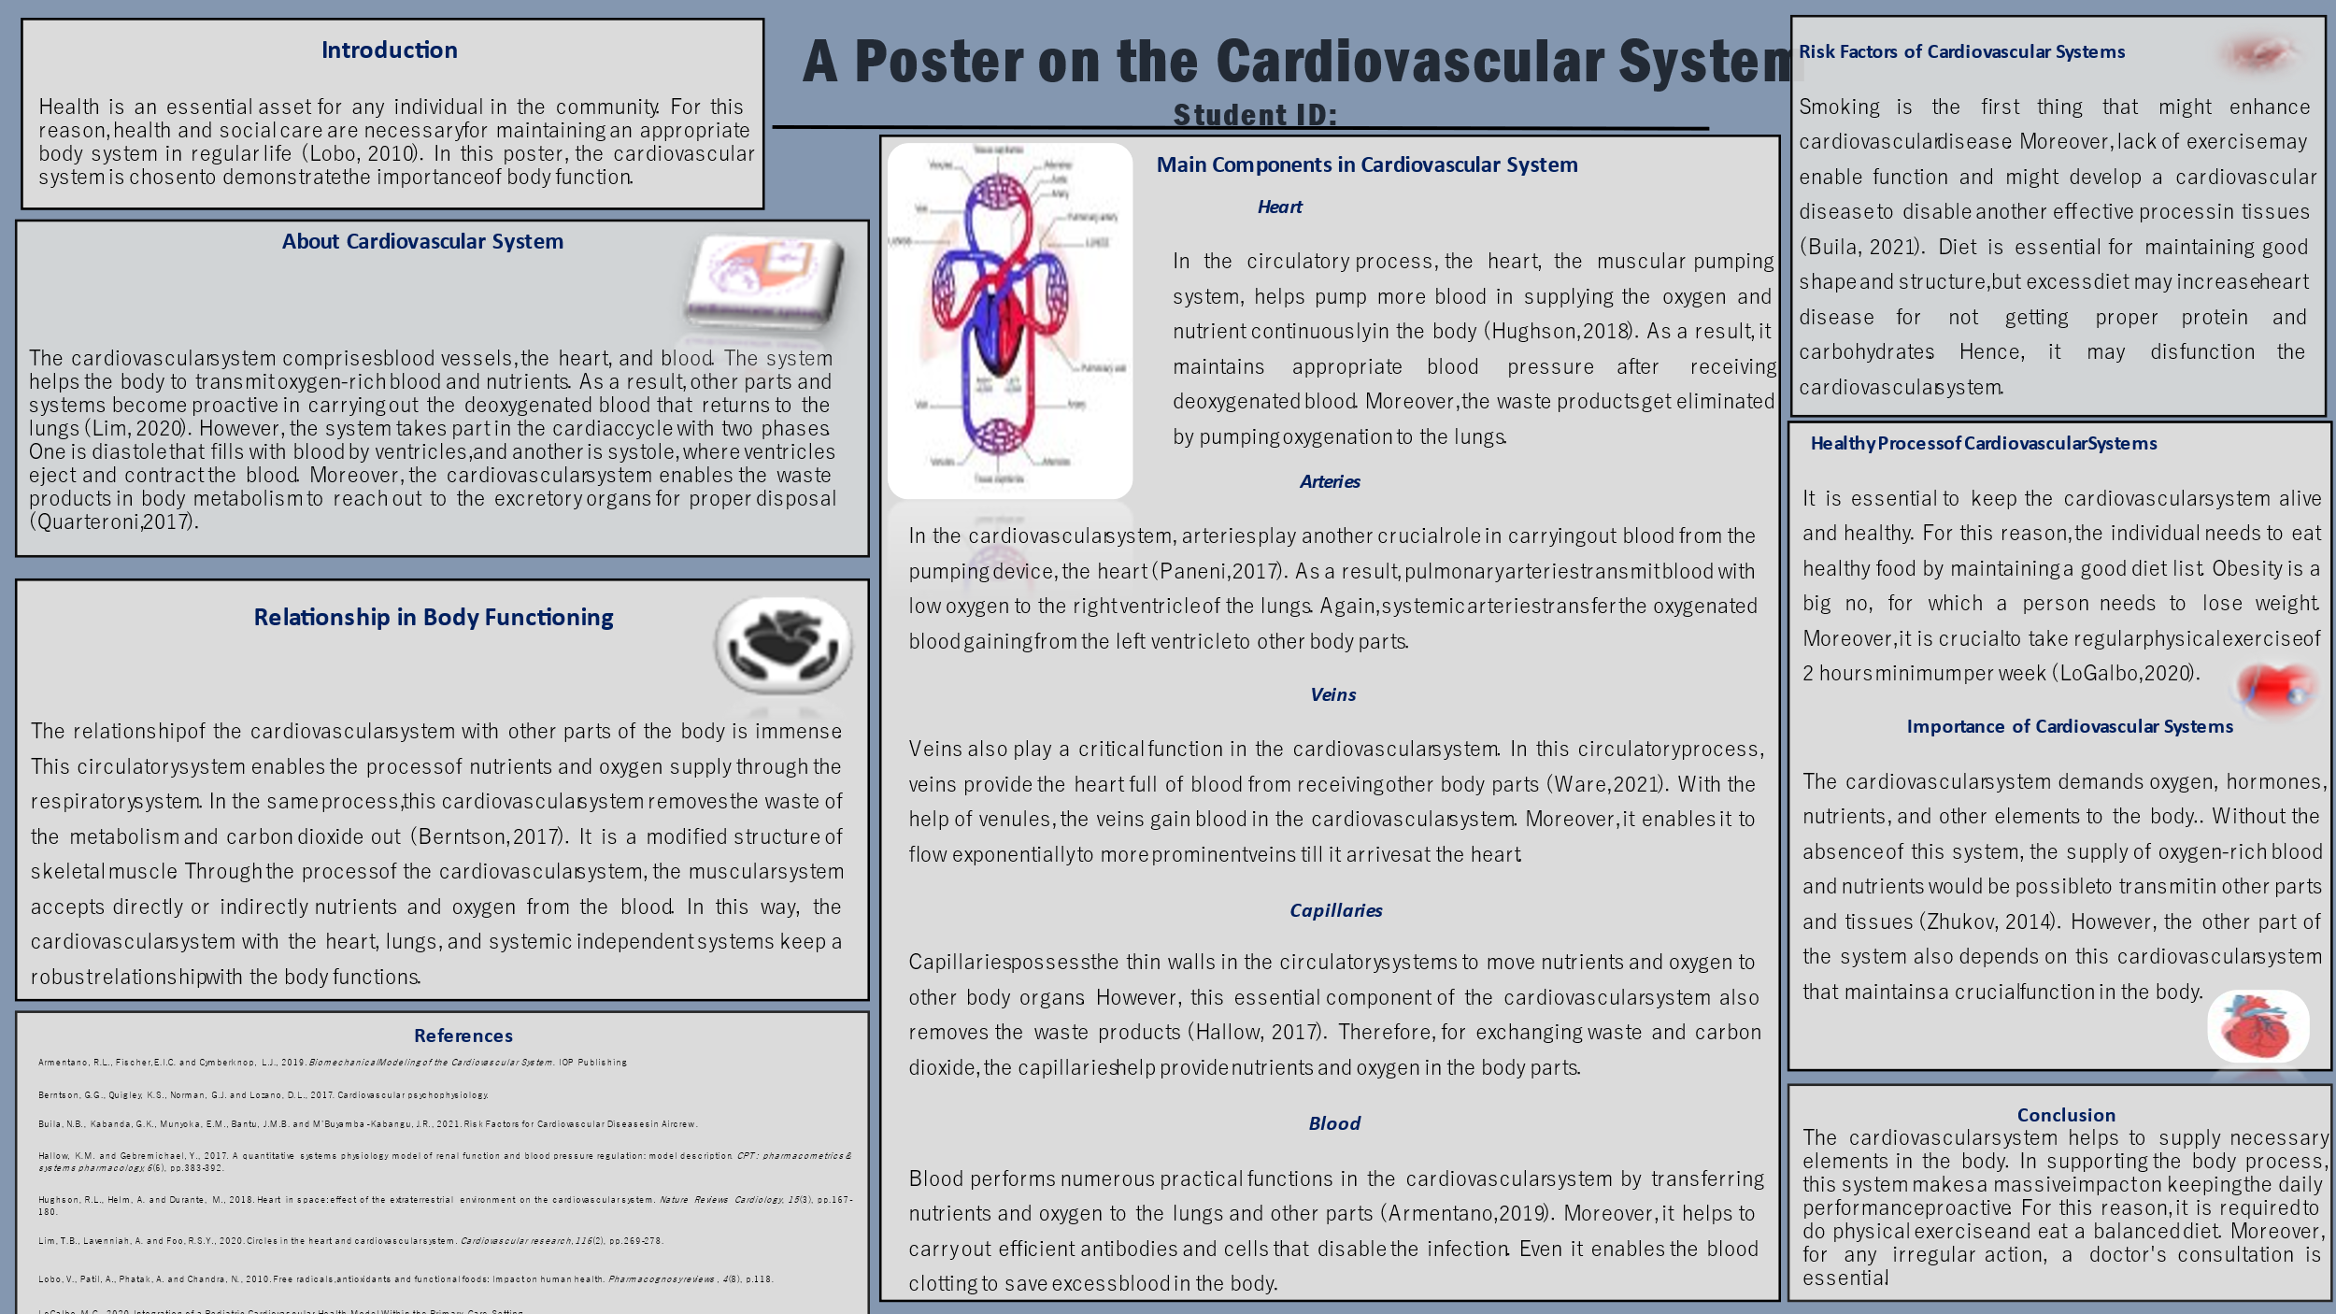

References
Armentano, R.L., Fischer, E.I.C. and Cymberknop, L.J., 2019. Biomechanical Modeling of the Cardiovascular System. IOP Publishing.
Berntson, G.G., Quigley, K.S., Norman, G.J. and Lozano, D.L., 2017. Cardiovascular psychophysiology.
Buila, N.B., Kabanda, G.K., Munyoka, E.M., Bantu, J.M.B. and M’Buyamba-Kabangu, J.R., 2021. Risk Factors for Cardiovascular Diseases in Aircrew.
Hallow, K.M. and Gebremichael, Y., 2017. A quantitative systems physiology model of renal function and blood pressure regulation: model description. CPT: pharmacometrics & systems pharmacology, 6(6), pp.383-392.
Hughson, R.L., Helm, A. and Durante, M., 2018. Heart in space: effect of the extraterrestrial environment on the cardiovascular system. Nature Reviews Cardiology, 15(3), pp.167-180.
Lim, T.B., Lavenniah, A. and Foo, R.S.Y., 2020. Circles in the heart and cardiovascular system. Cardiovascular research, 116(2), pp.269-278.
Lobo, V., Patil, A., Phatak, A. and Chandra, N., 2010. Free radicals, antioxidants and functional foods: Impact on human health. Pharmacognosy reviews, 4(8), p.118.
LoGalbo, M.C., 2020. Integration of a Pediatric Cardiovascular Health Model Within the Primary Care Setting.
Paneni, F., Diaz Cañestro, C., Libby, P., Lüscher, T.F. and Camici, G.G., 2017. The aging cardiovascular system: understanding it at the cellular and clinical levels. Journal of the American College of Cardiology, 69(15), pp.1952-1967.
Quarteroni, A.L.F.I.O., Manzoni, A. and Vergara, C., 2017. The cardiovascular system: mathematical modelling, numerical algorithms and clinical applications. Acta Numerica, 26, pp.365-590.
Ware, W.A., Bonagura, J.D. and Scansen, B.A., 2021. The normal cardiovascular system. In Cardiovascular Disease in Companion Animals (pp. 3-32). CRC Press.
Zhukov, M., 2014. Analysis of interconnection between central nervous and cardiovascular systems. Electronics and communications, (19,№ 1), pp.26-36.

