

SSP5078
Inclusion in Physical Education & Youth Sport
Workbook 2 – WK26

- This workbook is central to the completion of this module. It will support your lecture and consequently your understanding of the topic. It will also help you to address the completion of the Assessment 2 – 2500words essay.

- You must also bring the completed tasks to your lecture as they will form an important component of your lecture work (you can bring a laptop, iPad or tablet or print out the relevant pages).

- This will ensure that you are prepared to contribute to the lecture and that you are continuously engaged in tasks that will support your learning, develop your knowledge and improve your academic skills.

TASK 1: To be completed following week four of semester 2 (week 26) and taken to lecture session no. 5.
- Download the following research article, available on Moodle under the ‘Disability in Sport & PE’ tile.

Townsend, R., Smith, B. and Cushion, C. (2015). Disability sports coaching: towards a critical understanding, Sports Coaching Review, 4:2, 80-98

- Read pages 80-86, which includes the following sections: Introduction, Disability studies: models of disability, Medical model and Social model.

- Complete the questions below.

Please reference appropriately throughout.

- Identify the key characteristics of the Medical Model of Disability. You can use bullet points.
- Identify the key characteristics of the Social Model of Disability. You can use bullet points.
- Based on what you have read, critically explain what the picture below is portraying.

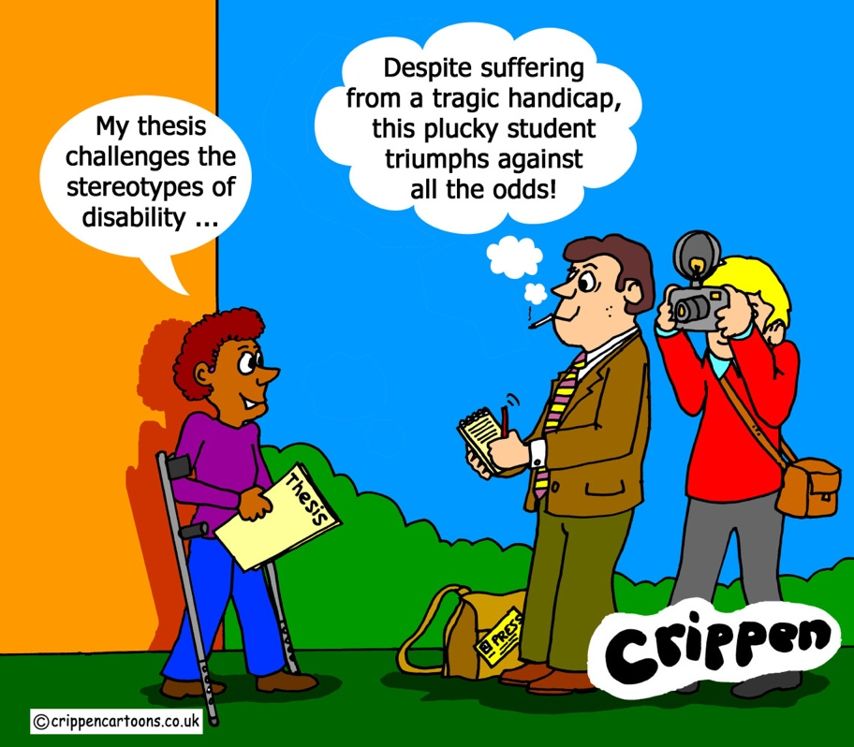

Please reference appropriately throughout.

- Read Crippen’s blog post about the Disability Models that can be found here: https://crippencartoons.com/2020/02/16/the-models-of-disability/.

- Take some time to reflect on what you have read: How does sport and PE contribute to replicate some of the stereotypes related to disability? What is your role/responsibility as an educator in addressing disability? Write your thoughts on the space below.

Please reference appropriately throughout.

Also, here is a picture to help you – how is this visible in sport? Don’t be afraid to provide examples.
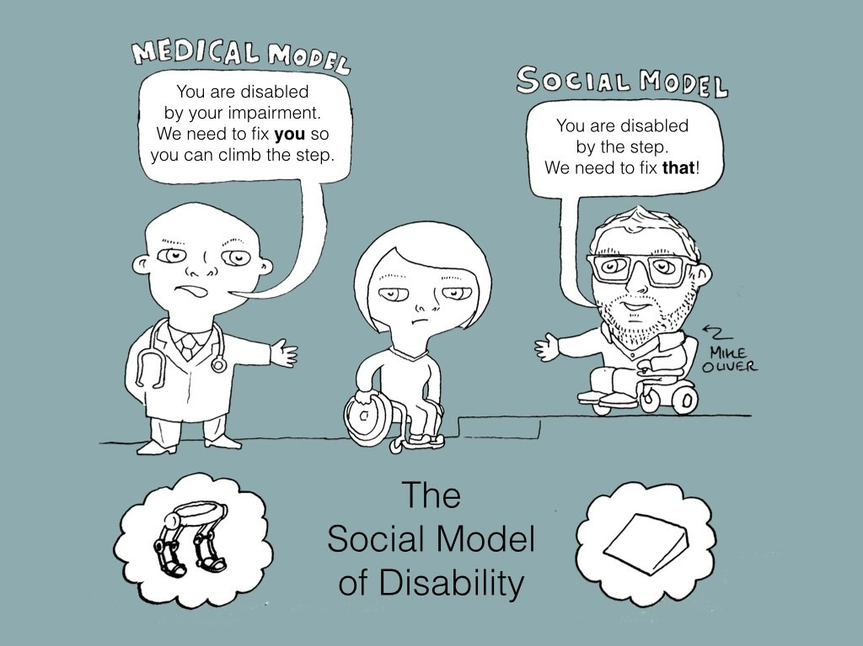

Thank you for completing the workbook. I hope that you found it useful! Please bring your work to next week’s lecture.
Mara Mata
END OF WORKBOOK 2

