Computing – cyber security and networking
Thomas Luke Smith 1900652
Internet Technology and Security

Contents
Introduction 1
Requirements 2
Implementation 2
Screenshots 2
Validation 5
Evaluation 6
Usability 6
Accessibility 6
Search engine optimisation 6
On-page techniques 7
Off-page techniques 7
Usefulness 7
Bibliography 8

Introduction
In this report I will discuss the website which I have created for my assignment, I will give an overview of the website as well as going into some of the details of it such as its accessibly. I will discuss the usability of the website and whether or not it is fit for purpose and research accessibility, search engine optimisation and usability of websites.

Requirements
The website which I have created is designed for a steak house which is based in Swansea, the website contains information such basic information on the restaurant, directions on how to get there, the menu and what they offer, there is also a page dedicated to the Christmas period which offers pricing and a separate Christmas menu, it also contains a page which has some recipes for cooking steak.
The website I created was for a small restaurant which is based in Swansea, the website was to be targeted towards adults. To overcome this, I designed a website which has a professional feel to it, the website has a colour scheme which makes the website more interesting but also makes the content easy to read. The website is also designed to be responsive to different size screens, so the content is readable no matter what device the website is on.

Implementation

Screenshots
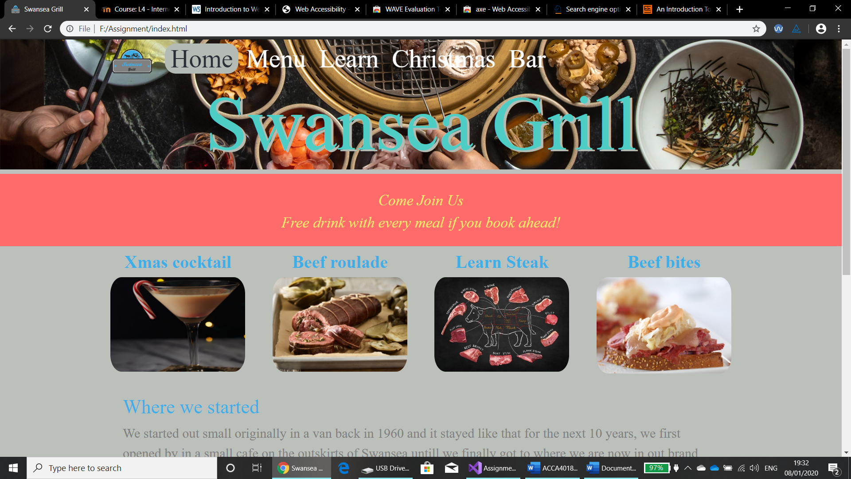
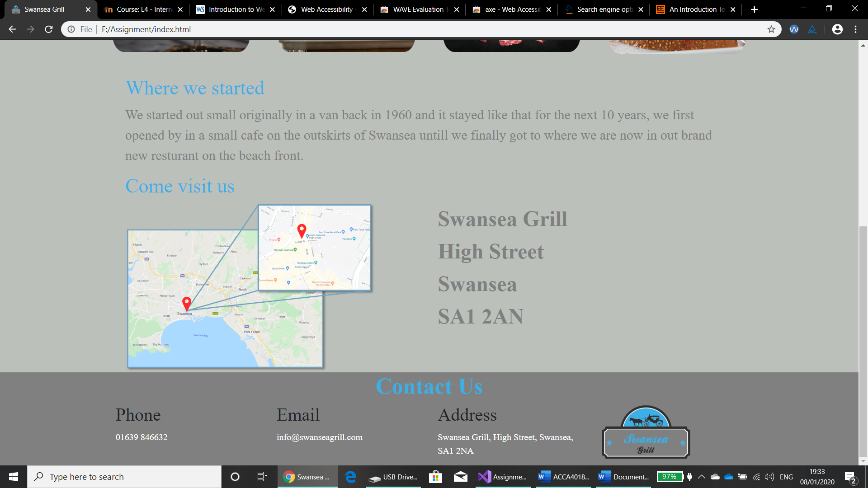
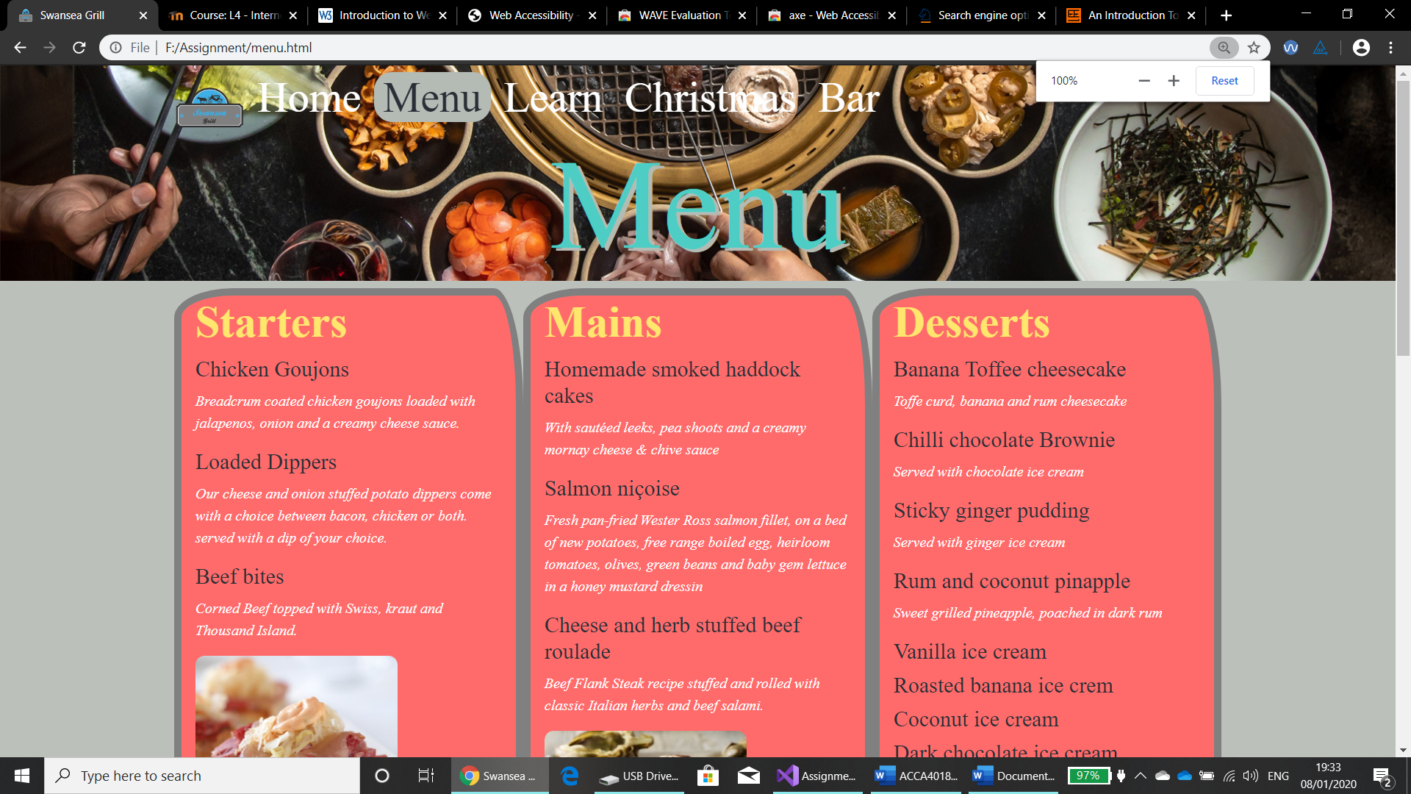
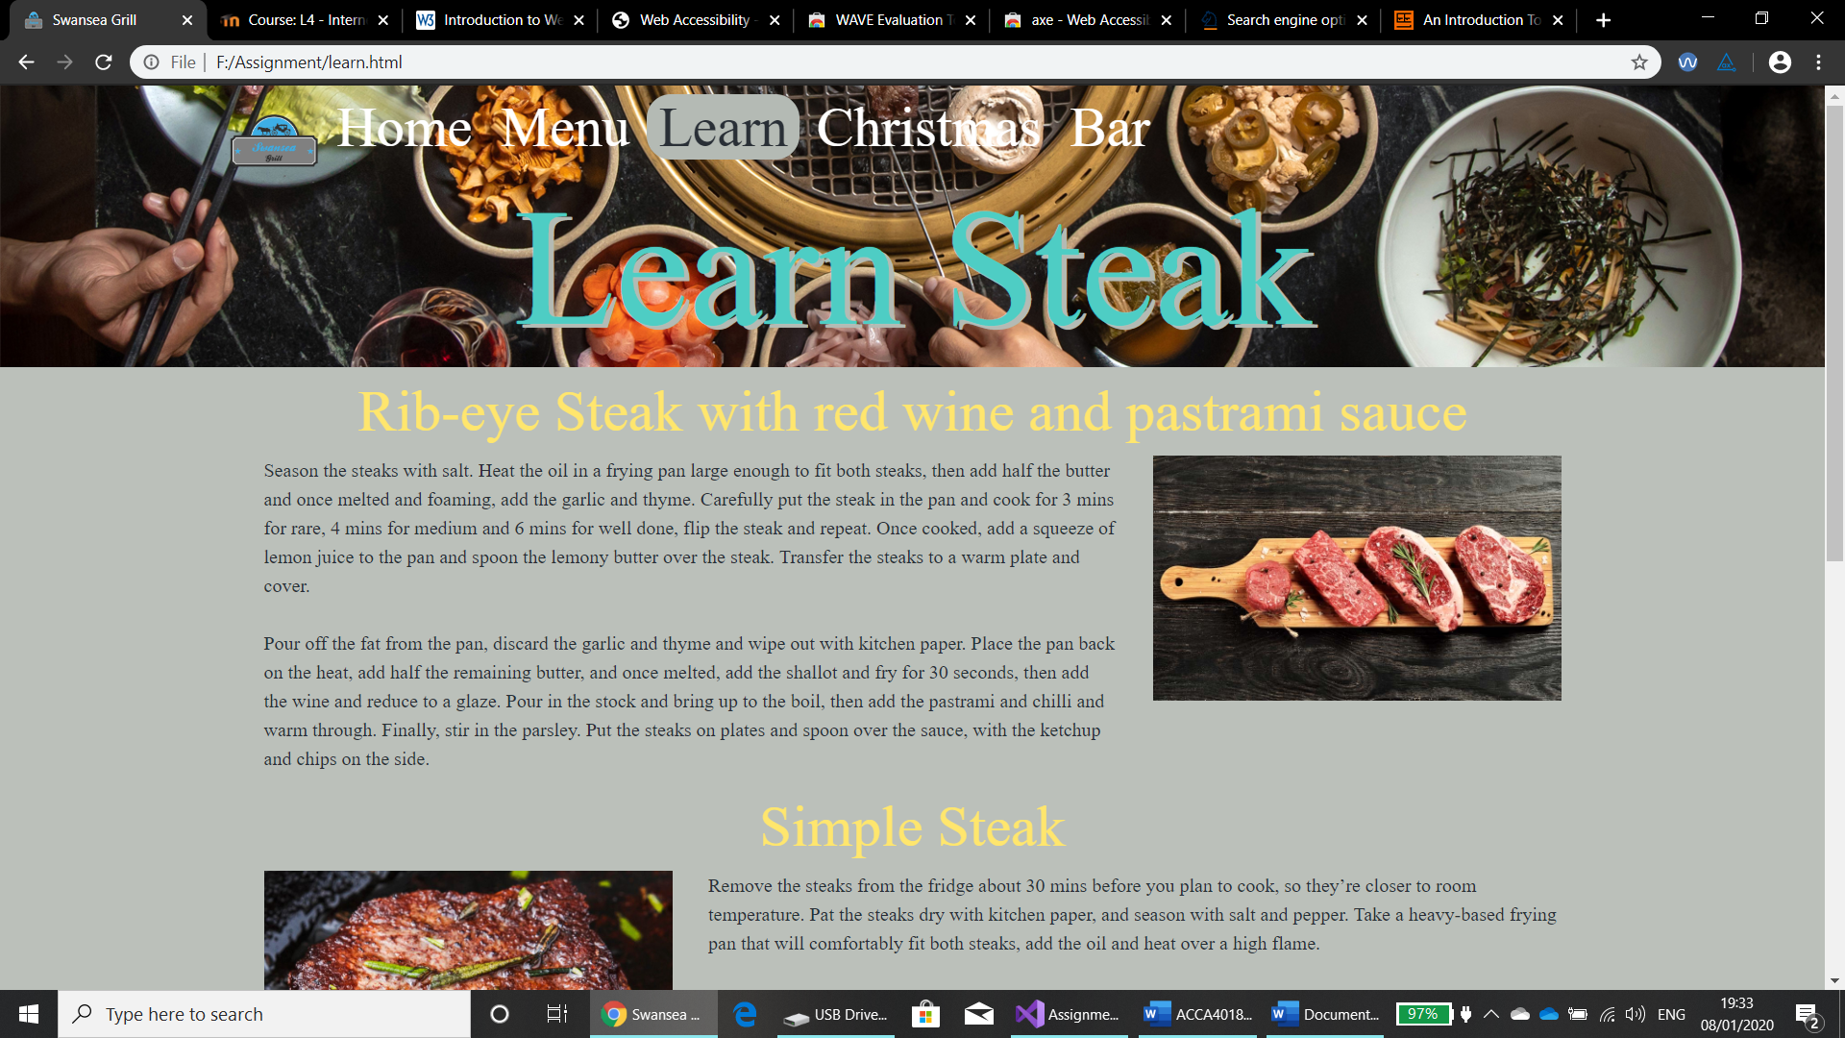
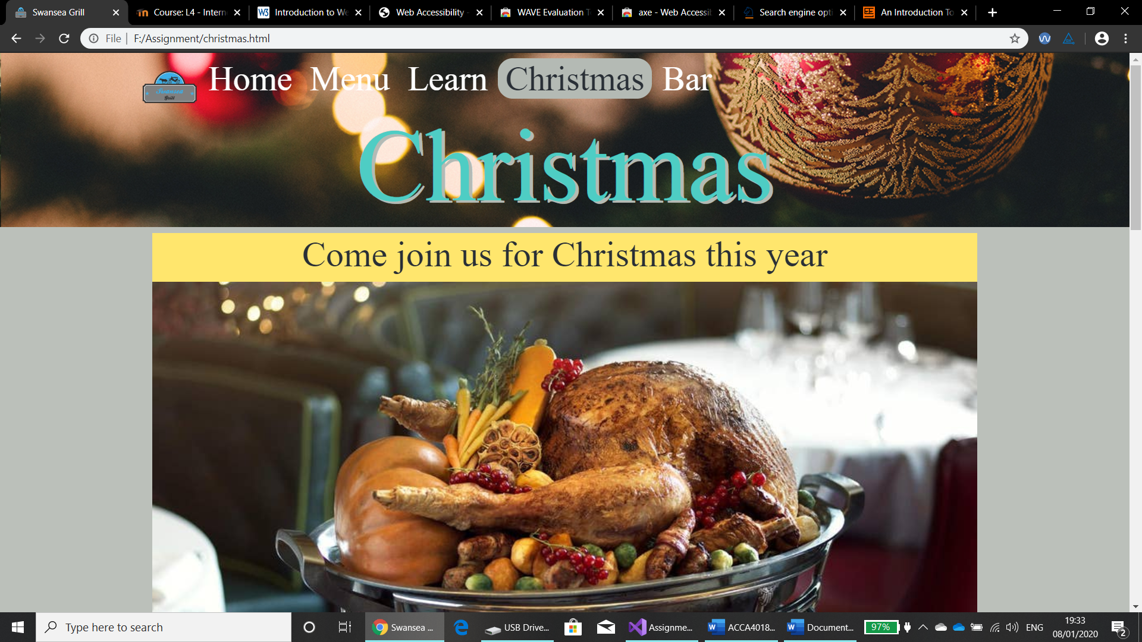
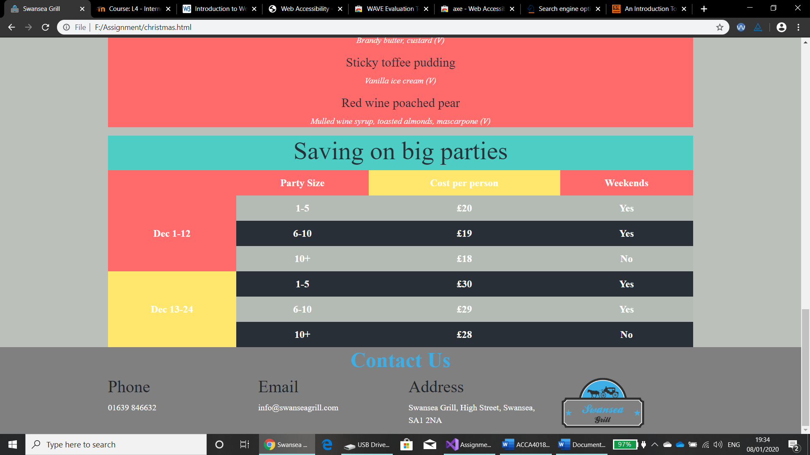
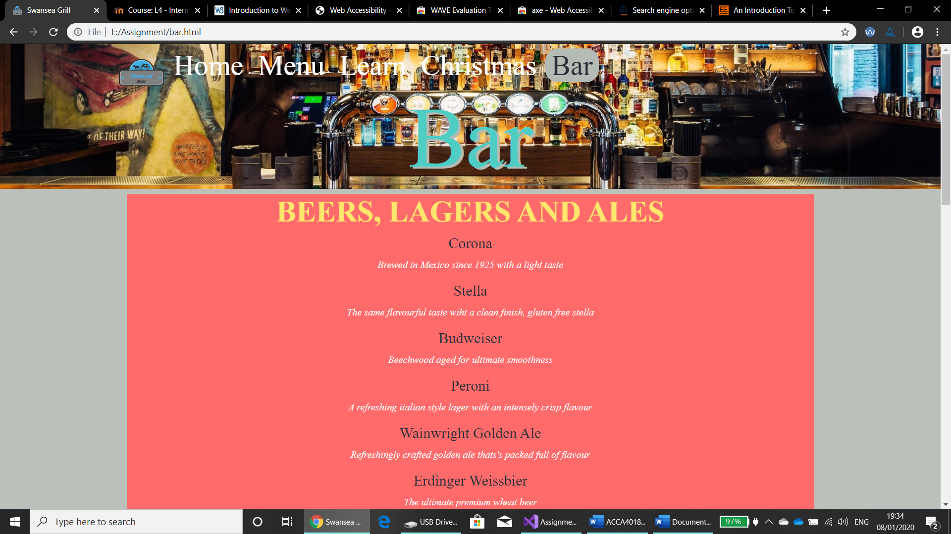

Validation
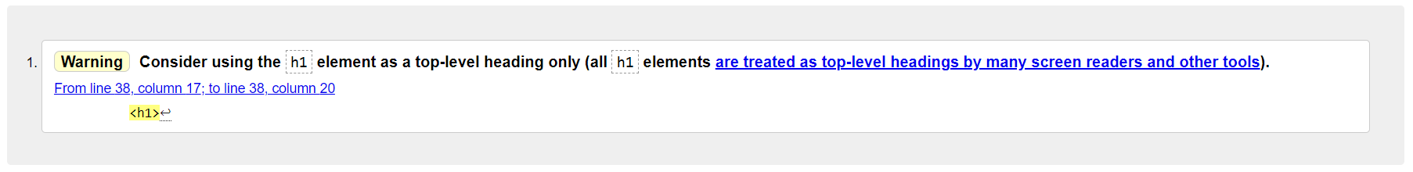
This is the final validation of the HTML code, there is one warning which I have not yet fixed which is the <h1> element. However one mistake that I kept making with the code was forgetting the end tag > which was causing errors on the website, this was easy to overcome and I used the HTML validation to find out which lines I had make the mistake on.

When validating the CSS code I found that I had used the same error a few times, I was attempting to use “position: Centre” to get an image in the centre which I found out to be wrong, instead I found out that you can use the code below to centre an image.
.center {
display: block;
margin-left: auto;
margin-right: auto;
width: 50%;
}

Evaluation

Usability
Usability Geeks state that usability is built up of four main components, Learnability; Memorability; Efficiency; Errors [1]. Learnability is how easy is it for a new user to complete a task on the website, this can be something like find clothes on a retail website, if the user can simply find it then the website is more user friendly. Memorability is how quickly someone can complete tasks on a website once they are familiar with it, people don’t want to have to be going through a lot of different drop-down menus to find what they’re after. Efficiency is how satisfied users are with the overall design of a website. Errors are the number of errors users make while using the website and how easy it is to recover from those errors and the severity of the errors [1]. If a website follows the Usability Geeks guide to making a website, then the website should be able to attract new users who are satisfied with the website and have those users return.

Accessibility
Accessibility of a website is very important because if someone is unable to get round a certain website then they are unlikely to revisit, this can be damaging to some organisations such as e-commerce because, these websites make their profit from people visiting and buying form the site and if people aren’t visiting them then they won’t be buying from it either. WCAG states that there are “four main principles of accessibility” [2], these principles are; Perceivable, this means that all content of a website must be presentable to users in ways that isn’t invisible to all their senses; Operable, the user must be able to navigate the website; Understandable, all information must be understandable; Robust, content must be able to be interpreted by a range of different user agents such as assistive technologies.

Search engine optimisation
Search engine optimisation is the process of allowing your website be more visible on a search engine such as Google or Bing by trying to get them at the top of the results, this allows your website to become more discoverable which can drive up traffic on the website [3]. The Interaction Design Foundation states that there are 6 main points to getting your website more visible these are; Research, business, competitor and keyword searching; Planning and strategy, links to the website and social media; Implementation, optimisation of the website; Monitoring, activity of traffic, search engine ranking; Assessment, the effects of the strategy you have used; Maintenance, both small and large problems of the website are handles immediately [3].

On-page techniques
On page techniques are the techniques you can use on your website to improve the rating in search engine. The main way of achieving this is by finding out which keywords the target audience of the website are likely to use when searching, once you find these words you need to include them in your code so that search engines know what your website has relevant content to what is being searched [4]. This method works well because search engines rely on the text of your website, the main places where the relevant text should be, page title; web address; headings; text; link text; image alt text; page description. Researching which words to include in your website is very useful and can help you maximise your results.

Off-page techniques
Off page techniques include getting other websites to link to yours this will help to improve the rank of your website. The more relevant the content on the other website which is linking your website is to your own then the higher the search engine will rank it. Search engine also look at the words between the <a> tag in links.

Usefulness
The design of the website is the same on every page and I have used the same colour theme too keep it looking neat and tidy, the layout of each page is slightly different but they all keep to the same theme of being clean and easy to read, the layout changes depending on the device type the website is being displayed on and is responsive so the content is still clear and easy to read or view. For the home page I used a header of the restaurant name, followed by promotions and at the bottom of the page is a map of where the restaurant is located the footer contains the contact information which is repeated on each page.
All the aspects of the website work as they are supposed to without any errors, each of the links on the website take you to the correct place. The content of the website is relevant to the page title and also to the overall website, each page title
To improve the website I would use different methods to get people attention on the website, one of these would be to have a slideshow on the home page of the different products offered, this improvement would draw people’s attention the different pages on the website. I would also include a queries form so who ever is viewing the website can ask a query without having to leave the website. By using http://contrastchecker.com/ I found out that some of the font colours over certain backgrounds within my website are not suitable for everyone, this is one area which I need to improve to make my website accessible for everyone.
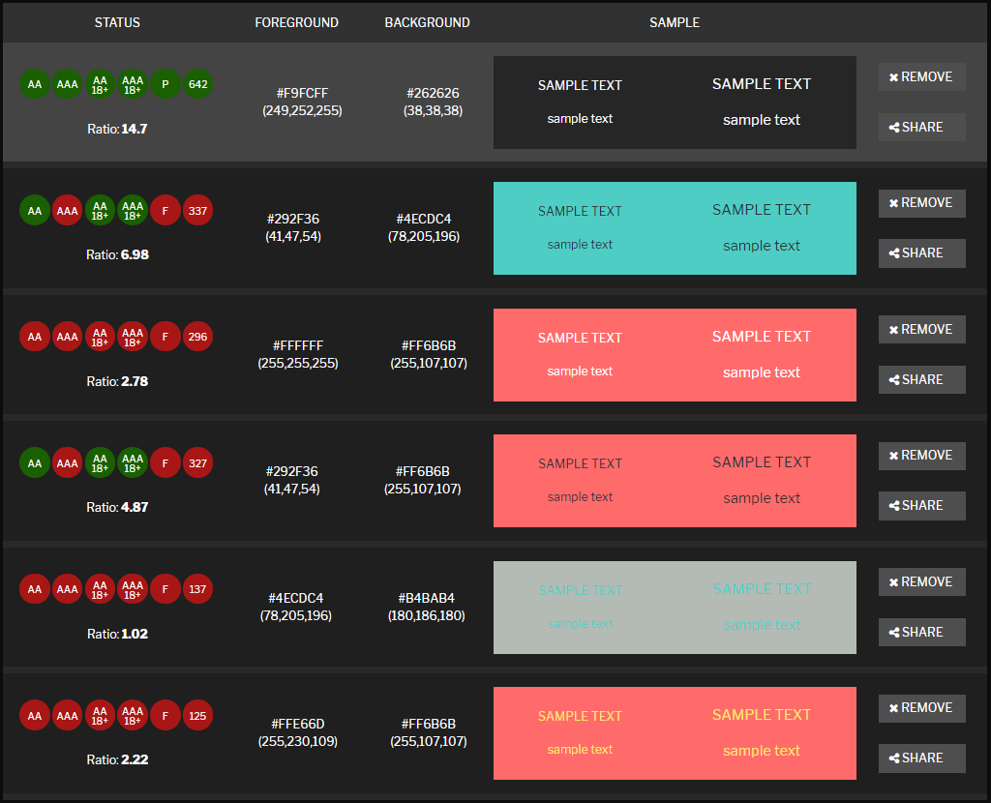 [5]

Bibliography

[1] | T. Churm, Usability Geek, 9 July 2012. [Online]. [Accessed 8 1 2020].
[2] | w3C, “Introduction to Understanding WCAG 2.0,” W3C Working Group Note, 2016. [Online]. Available: https://www.w3.org/TR/UNDERSTANDING-WCAG20/intro.html#introduction-fourprincs-head. [Accessed 8 1 2020].
[3] | I. D. Foundation, Interaction Design Foundation, [Online]. Available: https://www.interaction-design.org/literature/topics/search-engine-optimization. [Accessed 8 1 2020].
[4] | J. Duckett, HTML & CSS, C. Long, Ed., John Wiley and Sons, 2011.
[5] | Contrast Checker, [Online]. Available: http://contrastchecker.com/. [Accessed 8 1 2020].

