
Master of Business Administration
International Business pathway



Contemporary employability skills
Assessment 1: Individual report. Weight: 50%

A Strategic Analysis of Samsung's Smartphone Business
in the United Kingdom

Module Name: Strategic Management
Module Code: LCMB7003
Lecturer Name: Amare Desta / Zulf Khan
Student Name: AVADH LALJIBHAI KAVAD
Student ID: 2531867
Word Count: 5,000
Submission Date:

AI use acknowledgement

Note: One acknowledgement is needed for each used AI tool.

I acknowledge I used ChatGPT for proofreading, grammar checking, and improving the clarity of my work

Table of Contents
1 Organisational Context and Overview 3
2 External and Internal Analysis. 4
2.1 PESTEL Analysis (External Environment). 4
2.2 VRIO Analysis (Internal Environment) 6
2.3 SWOT Analysis 7
3 A comprehensive and holistic organisation view 9
3.1 Corporate Social Responsibility (CSR) 9
3.2 Balanced Scorecard 10
4 Strategic options and implementation 11
4.1 Business-Level Strategic Choices 11
4.2 Validating the Strategy: Porter's Five Forces 12
4.3 How the Strategy Delivers Optimum Performance 13
4.4 Challenges and Mitigation in Implementation 14
5 Section 2: Reflective Account 15
5.1 Description 15
5.2 Feelings 15
5.3 Evaluation 15
5.4 Analysis 16
5.5 Conclusion 16
5.6 Action Plan 16
6 References 18

Organisational Context and Overview
Samsung Electronics Co., Ltd is the mobile arm of the Samsung group, headquartered in Suwon, Gyeonggi Province, South Korea, and has been one of the leading global consumer electronics companies for decades. The company was established in 1969 and has been producing phones for the mobile market since the 1980s; Galaxy was its line of flagship smartphones launched in 2009, and continues to be its core product offering today (Statista, 2026a). In fact the size of the business is significant; Samsung Electronics' consolidated annual revenue was KRW 300.9 trillion in 2024 and the operating profit was KRW 32.7 trillion, which bounced back strongly from the memory downturn the year before (Samsung Electronics, 2025a). The company shipped 241.2 million smartphones globally in 2025, representing about 18.2% of the world's total shipments, and reaffirming its position as the global top vendor in terms of unit volume shipped (Statista, 2026a). The vision of Samsung is to “inspire the world with innovative technologies, products and designs that enrich people's lives” (Samsung Electronics, 2025b). It has two key pillars to its business model. The first is vertical integration; Samsung makes a number of its own key parts, such as displays and memory chips, which cuts down on the reliance on suppliers and lowers the input costs.
The second is portfolio, with Galaxy S and Z flagship devices and the Galaxy A entry devices, topping the list at the premium and entry level respectively, allowing Galaxy to span almost the entire price-point spectrum. This report will specifically concentrate on Samsung's smartphone lineup in the United Kingdom, and especially on their flagship Galaxy S25 Ultra. Within the module requirement of concentrating on one product in one geographical market, this allows for a more detailed and evidence-based strategic analysis than one might get from a global overview. The UK smartphone market is a well-established, high value market projected to contribute revenues of close to £11 billion in 2029 (Statista, 2025a). In fact, it's a duopoly: Apple held about 49% of the market as of November 2025, followed by Samsung's 33% share, with Google, Motorola and up-and-coming Chinese brands accounting for the rest (Accio, 2026; Vertu, 2025). In this context the Galaxy S25 Ultra was one of the most successful models in Great Britain in 2025, reinforcing Samsung's expertise in the high-end segment, and making it the leading competitor to Apple (Counterpoint Research 2025).
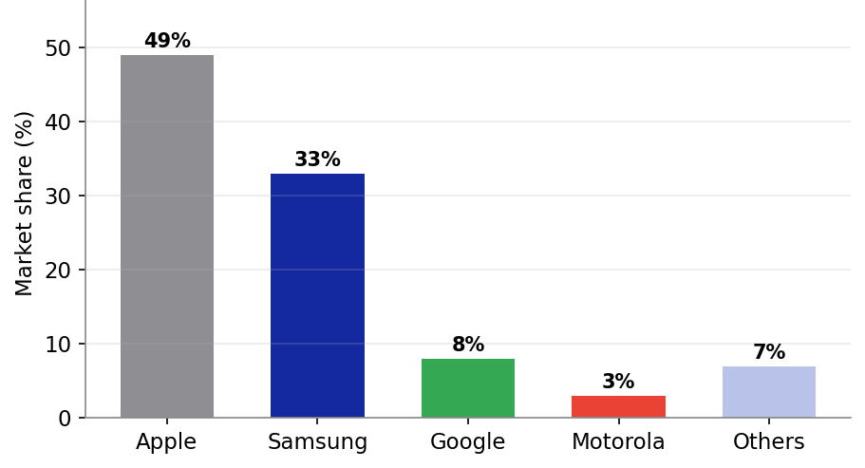
Figure 1: UK smartphone market share by vendor, November 2025 (Accio, 2026; Vertu, 2025).
The competitive landscape of the UK market is thus a fairly well-established duopoly, with Apple and Samsung seeing over 80% of sales with the remainder divided between the likes of Google's Pixel devices and Motorola and value-oriented Chinese manufacturers. In this structure Samsung plays the role of an established challenger: comfortable in its own global second place, it can set the technological agenda, especially in the foldables market where it has an overwhelming lead, and still be beaten from a brand loyalty and premium mindshare perspective by UK consumers (Vertu, 2025). This is an important positioning as it sets the tone for the entire analysis to follow: Samsung brings its loyal Android and switching customers up its own value chain and is taking Apple's market share. It's no accident that Samsung selected the Galaxy S25 Ultra as its flagship as the brand is looking to assert its presence in the premium market and challenge Apple head-on in the UK, and the flagship is the perfect prism through which to view the firm's strategic standing.

External and Internal Analysis.

PESTEL Analysis (External Environment).
A PESTEL analysis is used to identify the key external factors that present opportunity or threat to Samsung's UK smart phone business. PESTEL is an appropriate tool for macro-environmental scanning because it is useful for a market in a state of political, economic and technological disruption (Johnson et al., 2020).
Political. Trade tension after Brexit and a potential tariff on imported electronics adds uncertainty to the supply chain for a company that is highly reliant on manufacturing abroad. The first signs of tariff-driven consumer behaviour could be seen across European markets in early 2025, when consumers began to buy more than usual just before their prices increased (Kantar, 2025). This poses a real danger to Samsung's bottom line and price flexibility.
Economic. Samsung's Galaxy A series is becoming popular among value-conscious buyers as the UK cost-of-living squeeze has pushed these buyers away from the flagships. This is an obvious opportunity as IDC specifically pointed out that Samsung's excellent 2025 results were due to their “affordable AI-enabled Galaxy A-Series devices” and foldables, which Apple doesn't have (Android Central, 2026). The average selling price is now being driven up by memory chip cost inflation, however, which could lead to a reduction in the affordability advantage (IDC, 2026).
Social. Apple's brand loyalty amongst iOS users, and its relatively high disposable income in the UK, provides a serious challenge to Samsung's numbers and stands as a constant threat to its market share. UK consumers have some of the highest levels of Apple attachment in Europe perhaps due to the sense of belonging to the Apple ecosystem and status quo (Vertu, 2025). Samsung's big strategic problem is to overcome this cultural bias.
Technological. While 5G is increasingly adopted across brands, Samsung's early innovation in foldables and on-device Galaxy AI opportunities will provide a clear path to differentiation, and possibly extra value, in the future (Cecere, Corrocher and Battaglia, 2015). This Galaxy Z Fold 7 is also the fastest-selling Galaxy foldable in Western Europe, accounting for Samsung's 64% share of the global foldable market (Android Central, 2026). This technological advantage is supported by the record investment of R&D worth KRW 37.7 trillion in 2024 (Seoul Economic Daily, 2026).
Environmental and Legal. The increased regulatory requirements for e-waste in the UK and EU, recyclability and the right to repair, would continue to drive e-waste investment but also provide a viable green positioning, which Samsung is more advanced on with the use of recycled material and its commitment to RE100 (Samsung Electronics, 2023). So regulatory alignment is a compliance threat as well as a differentiation opportunity.

Factor | Key issue | Implication
Political | Post-Brexit tariffs, trade friction | Threat – cost & pricing risk
Economic | Cost-of-living shift to mid-range; ASP inflation | Opportunity & threat
Social | Strong UK iOS loyalty | Threat – hard to convert buyers
Technological | Foldables, Galaxy AI, high R&D | Opportunity – differentiation
Environmental | E-waste & recyclability rules | Opportunity – green positioning
Legal | Right-to-repair, EU regulation | Threat – compliance cost
Table 1: PESTEL summary for Samsung's UK smartphone business (Android Central, 2026; Vertu, 2025).
Technological and social are the main outside influences weighing against Samsung's UK smartphone venture, when considering the plus and minus sides. The technological dimension is the most promising opportunity – foldables and Galaxy AI are like the features that could make a meaningful difference in a space where specs have become the standard and 5G has become a given. The social dimension, on the other hand, is the greatest danger as it is culturally ingrained in the UK and hard to change, and this will always limit Samsung's share even if they sell the best product. The political and economic are real, but more manageable: tariff and cost pressures impact Apple, but also the industry as a whole, and Samsung's low-priced Galaxy A line actually makes these economic pressures a slight benefit. A prioritised reading of the PESTEL therefore suggests that Samsung should move in the direction of technological differentiation as the only way to overcome the social barrier of Apple loyalty. This idea is supported further by the internal analysis and the strategic-choice analysis below.

VRIO Analysis (Internal Environment)
Based on the view of the firm in the VRIO analysis (Wernerfelt, 1984, Grant, 1991, Barney, 1995), determining whether Samsung's internal resources are valuable, rare, costly to imitate and exploited by organisation, determines if the gained advantage is sustained, temporary or only at parity (Barney, 1991, Peteraf, 1993). Samsung's component manufacturing business is a vertically integrated value-adding enterprise, and its display and memory businesses, in particular, are world-leading operations with about 42% of the global market, the value of which is difficult to imitate and its operations are fully optimised by its organisation, which gives it a sustained competitive advantage that it is difficult to replicate by its competitors (Korea Times, 2025; Barney, 1991).
It's global brand equity and scale of manufacturing is valuable and rare but imitable over time, providing a temporary advantage. It has a few valuable features, such as being foldable and having Galaxy AI features, which are not as common as they were at one time, but are gaining momentum in the competition (Teece, Pisano and Shuen, 1997). The analysis reveals a weakness when resources are less differentiated: Samsung's software-ecosystem lock-in is not as strong as Apple's and running a dual premium/budget strategy presents it to brand dilution and margin squeeze.
The strategic power of the VRIO lens is its ability to separate those attributes of Samsung that can be maintained forever from those that can be rented ( critics note that the resource-based view has the potential for circularity in its reasoning and may be hard to operationalize (Priem and Butler, 2001)). The only real lasting competitive edge is vertical integration, as if a competitor could duplicate an in-house display and memory operation it would take tens of billions of dollars over many years; a requirement still too daunting for Apple, which continues to buy key components from outside sources. This provides Samsung with a structural cost and supply-resilience advantage, the foundation of all else (Prahalad and Hamel, 1990). In contrast, its foldable and AI leadership, though unique at the moment, is subjective and feasibly up for grabs: Other Android manufacturers are putting their products in the foldable category, and potentially, Apple will follow suit, meaning that the advantages will eventually be moot if Samsung does not continue to invest in the future to maintain its edge (Eisenhardt and Martin, 2000). For the Samsung board, the significant take-home would be the need for them to continue investing in foldables and AI, while leveraging their integration advantage as the bedrock of their strategy for the future. The biggest strength of Apple is the biggest weakness of Samsung — ecosystem stickiness — it is so sticky that Samsung is the most vulnerable as it is changing habits rather than hardware that will keep its premium customers.
Resource / Capability | V | R | I | O | Competitive implication
Vertical integration (display/memory) | Y | Y | Y | Y | Sustained advantage
Global brand equity & scale | Y | Y | N | Y | Temporary advantage
Foldable & Galaxy AI innovation | Y | Y | N | Y | Temporary advantage
Broad price-tier portfolio | Y | N | N | Y | Competitive parity
Software ecosystem lock-in | N | N | N | Y | Competitive weakness
Table 2: VRIO analysis of Samsung's key resources (Barney, 1991).

SWOT Analysis
Synthesising the external and internal analyses, the SWOT below consolidates the most material findings and translates them into a strategic implication.
Strengths | Weaknesses
• Vertical integration and component leadership • Broad product portfolio across all price tiers • Foldable and Galaxy AI leadership • Record R&D investment (KRW 37.7tn, 2024) | • Weaker ecosystem stickiness than Apple • Thin premium-tier margins vs. Apple • Brand dilution risk from budget presence • Weak Scope 3 emissions performance
Opportunities | Threats
• Foldable market growth (64% global share) • On-device Galaxy AI differentiation • Green positioning ahead of regulation • Value-tier volume growth (Galaxy A) | • Apple's 49% UK dominance and loyalty • Post-Brexit tariff exposure • Rising Chinese competitors (Xiaomi) • Memory-driven ASP inflation
Table 3: SWOT analysis for Samsung's UK smartphone business
The SWOT analysis shows that Samsung has a strong technological and operational advantage, but the real difficulty is to make this a lasting advantage in the UK smartphone market. Samsung's vertical integration, wide spectrum of products, dominance in foldables and Galaxy AI features, combined with significant R&D investments, offer a solid foundation for innovation and competitive differentiation. It's flexible enough to appeal to consumers of all budgets, too.
But Samsung's biggest drawback is the less sticky ecosystem. Apple's ecosystem of products incentivises customers to stay within the Apple product family, which helps to foster customer loyalty and minimise switching behaviour. In addition to margins on lower premiums, there is potential for brand dilution due to a large budget offering, and a lack of strength in scope 3 emissions performance are all pressures faced by Samsung.
Samsung has a number of opportunities in the external environment. Future growth may be bolstered by the foldable smartphone market, further progress on the on-device AI, and rising demand for sustainable products as well as growth of the value-oriented Galaxy A range. But at the same time these opportunities come with serious challenges, including Apple's competitive advantage and customer loyalty in the UK, the competition from China's manufacturers like Xiaomi, the possibility of being impacted by post-Brexit tariffs and ever rising component costs.
However, despite the SWOT analysis it seems that Samsung is not the right company to go in the direction of Apple by copying its strategy. Rather, Samsung must take advantage of its unique positioning in terms of technological innovation, foldables, AI and vertical integration to create a more robust and distinctive brand offering in the UK. The goal should be to leverage Samsung's technical edge to build deeper customer loyalty and engagement in its ecosystem and compete on differentiation, not on being a second Apple.
The key strategic takeaway is that Samsung will have to build a more robust brand in the UK, using its key strengths in technology and manufacturing – integration, foldables, AI – to offset its core weakness of ecosystem stickiness and its primary threat of Apple's dominance – not to be second-best.

A comprehensive and holistic organisation view

Corporate Social Responsibility (CSR)
This ambitious environmental plan is the cornerstone of Samsung's CSR strategy, and is closely connected with its business goals in a market where sustainability is playing an increasingly prominent role in purchasing decisions. Corporate social responsibility is recognized as the incorporation of social and environmental issues into the functioning of the company and its relationship with stakeholders in a voluntary way (Carroll, 1991; McWilliams and Siegel, 2001). While Carroll frames CSR as encompassing economic, legal, ethical and philanthropic responsibilities, Samsung places a strong emphasis on the economic and legal aspects of CSR and sees the environmental aspects as being closely aligned to regulatory requirements and/or commercial differentiation, with the ethical and philanthropic aspects then following. (Carroll and Shabana, 2010). Samsung has pledged to achieve net-zero carbon emissions for the Device eXperience division by 2030 and the entire enterprise by 2050, and has signed up to the RE100 renewable-energy initiative (Samsung Electronics, 2023).
Incorporating recycled content into an increasing percentage of plastic parts used in products, with a goal of 100% recycled or bio-based plastics by 2050, Galaxy S25 packaging is now made from fully recycled paper (Samsung Electronics, 2025b). Galaxy products are made with more and more ocean-bound recycled plastics, and Samsung has introduced its first internal cobalt recycling system in the smartphone industry to decrease reliance on new conflict minerals (The Sustainable Innovation, 2026).
This CSR positioning has three fronts to the business strategy. First, it distinguishes Samsung from Apple when it comes to packaging and the materials, and this is a trend that's becoming more prominent at the high end of the market. Secondly, it boosts the premium brand image for consumers in the UK who are conscious of their environmental impact. Third, it anticipates tighter regulation in the United Kingdom and in the European Union regarding e-waste and the right to repair, providing reputational benefit (Porter and Kramer, 2006, 2011). Independent analysis points to Samsung's scope 3 emissions (those from the down stream use of product sold) as a weak spot, though, with several commitments reported as comparatively vague and with no interim targets (NewClimate Institute, 2023). The level of alignment between CSR and strategy is therefore high in the operations and materials dimension and less so throughout the entire product life cycle, which is therefore a matter for board consideration.

Balanced Scorecard
The balanced scorecard (Kaplan and Norton, 1992, 1996) translates Samsung's UK smartphone strategy into four perspectives: Financial, Customer, Internal Business Processes, and Learning and Growth and brings together financial and non-financial measures to enable management to monitor the firm's performance from a comprehensive perspective, rather than just relying on lagging financial indicators. Each perspective is broken down in the analysis below by objectives, key performance indicators (KPIs), targets and initiatives, with these elements aligned to Samsung's mission and UK strategy.
Perspective | Objective | KPI / Target | Initiative
Financial | Grow UK premium revenue and margin | +2% UK market share; flagship margin growth YoY | Galaxy S25 Ultra push; trade-in offers; carrier deals
Customer | Raise loyalty and satisfaction vs Apple | Higher Net Promoter Score; lower churn rate | Galaxy AI features; ecosystem services; after-sales support
Internal Processes | Efficient, resilient supply chain | On-time delivery %; product defect rate | Vertical integration; RCS messaging; cobalt recycling
Learning & Growth | Lead in foldables and on-device AI | R&D spend (KRW 37.7tn); patents filed | Galaxy AI development; staff upskilling; foldable R&D
Table 4: Balanced scorecard for Samsung's UK smartphone strategy (Kaplan and Norton, 1992).
Financial perspective. The goal is to boost the premium revenue side of the business in the UK with a high-margin proposition. The relevant KPIs are UK market share growth and gross margin for the flagship and the target is to gain 2 ppts of market share and achieve year-on-year margin growth. The supporting initiative is a focused Galaxy S25 Ultra campaign that is backed by trade-in offers and a carrier subsidy that reduce the cost of a Galaxy S25 Ultra for switchers.
Customer perspective. The goal is to close the gap with Apple's loyalty. The KPIs are Net Promoter Score and churn; the goal is to drive an actual increase in NPS and decrease churn from existing Galaxy customers. Initiatives focus on differentiating Galaxy's AI features, increasing the number of applications in the Galaxy ecosystem (wearables, tablets, SmartThings), and improving after sales services to increase the switching costs.
Internal business process perspective. The aim is an effective resilient supply chain. The critical success factors are on-time delivery and defect rate. Along with the cobalt-recycling and RCS messaging investments, Samsung's vertical integration, which includes making its own displays and memory, is one of the biggest efforts that protects its delivery from external supplier shocks.
Perspective of learning and growth. The goal is to maintain technological competitiveness in the field of foldable and on device AI. The 2024 R&D expenditure totaling to a record KRW 37.7 trillion and a steady output of patents provide evidence of the delivery of KPIs (Seoul Economic Daily, 2026). This involves ongoing development of Galaxy AI and upskilling the workforce.
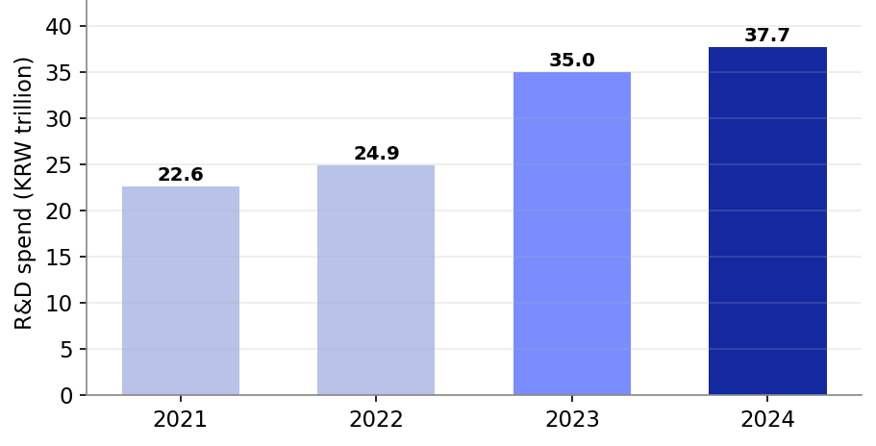
Figure 2: Samsung Electronics R&D expenditure, 2021–2024, evidencing the Learning & Growth perspective (Seoul Economic Daily, 2026; Korea Times, 2025).
Together, these four perspectives create a consistent causal sequence: investment in learning and growth (foldables and Galaxy AI) leads to an improvement in internal processes and customer loyalty, which leads to the financial goal of increasing premium UK revenue. It is this “cause and effect” logic that Kaplan and Norton (1992) wanted the scorecard to reflect and it remains the reason that Samsung's UK strategy will be measured not simply desired.

Strategic options and implementation

Business-Level Strategic Choices
In the business level, Porter's generic strategy means that Samsung has the choice between cost leadership, differentiation or focus (Porter, 1980). To compete on price only would be counter-productive to the margins in a two-firm premium market, because price competition is likely to result in value-destroying counter-retaliation from the other party. Broad differentiation around foldables and on-device AI, combined with a complementary value presence in the Galaxy A segment with its price range, is the way to go, and Samsung can do this in a way that Apple, which has no presence in the lower/mid-tier segment, can't through its structural positioning.
Applying Ansoff's Matrix, the strategy that is recommended is to use a combination of market penetration and product development. Market penetration would involve promoting and offering trade-in deals for Galaxy to ensure that it has a larger presence in the current UK market, while product development would involve the new foldable and AI models making their way to the UK market (Ansoff, 1957). This dual stance is a more conservative approach than diversification but provides growth potential. The BCG matrix clarifies this again: the Galaxy S/Z flagships are “stars” where continued investment is needed to continue to grow the premium segment, while the Galaxy A range is the “cash cow” that subsidises all the innovation in the Galaxy S/Z.
It is important to state clearly why the other generic strategies are not used. In the high-end premium segment of the UK market, Samsung has no hope of pure cost leadership because its brand will give it a higher price: a price war will crush Samsung's margins at a higher rate than it will hurt Apple, and Chinese players already have the real low cost game. A narrow focus strategy is also not recommended since Samsung's main strength is its breadth across segments; it is important to focus on serving a niche for other segments would be detrimental to the benefits derived from scale and integration in the VRIO analysis. The only way to capitalize on Samsung's unique resources and directly target Apple's weakness, that is, the lack of presence in the mid market, is to broad differentiate and that is the recommended business-level positioning, with the volume of the Galaxy A range making it cost competitive. This is also a “hybrid” or “integrated” strategy, a strategy in which a firm is going for differentiation and at the same time is cost disciplined, a strategy which the resource base makes credible for Samsung, and not as much for most others (Hill, 1988).

Validating the Strategy: Porter's Five Forces
Porter's Five Forces illustrates the forces at play in the UK smartphone industry, which confirms the attractiveness of a differentiation route (Porter, 1980). Competitive rivalry is high but concentrated into two players: buyer power is high due to ease of switching between Android handsets and ease of price comparison; threat of substitutes is moderate because the upgrade cycles are long, and the buyer does not have to purchase the device; supplier power is low – Samsung has its own vertical integration; threat of new entrants is low – due to scale economies, brand & distribution barriers. Here, differentiation that creates switching costs and perceived value is the greatest available shield as it directly attacks the two most significant forces — rivalry and buyer power.

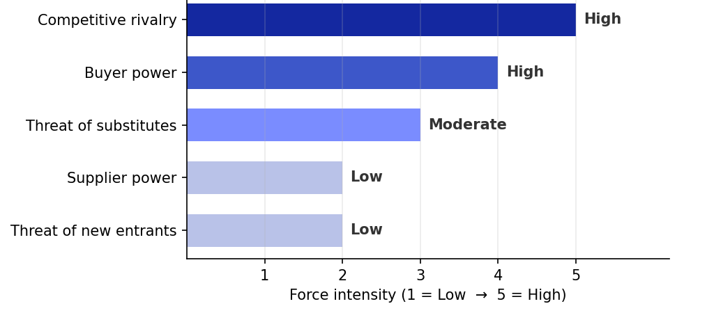
Figure 3: Porter's Five Forces assessment of the UK smartphone industry (Porter, 1980).

How the Strategy Delivers Optimum Performance
The right approach should focus on Galaxy AI capabilities, Galaxy services, and Galaxy foldable innovation to capture some of Samsung's much-needed Apple-loyalty. By making technological leadership the competitive leverage for customer retention, this enables maximum performance and optimization of the average revenue per user with an increase in switching costs due to the integration of the ecosystem and thus of the added AI features. The figures bear out the logic, with Samsung's Galaxy Z Fold 7 recording a record number of sales in Europe and the company accounting for 64% of global foldable sales (Android Central, 2026). This is in line with Apple's playbook—locking users into its ecosystem is the key to maintaining their loyalty, not cost (Kenney and Pon, 2011).
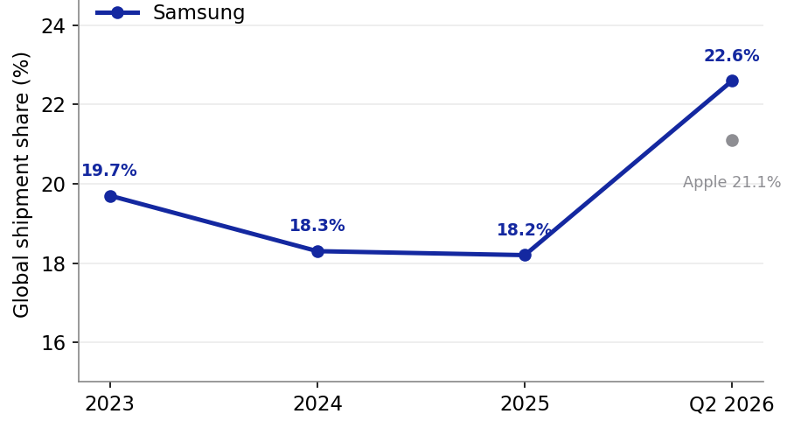
Figure 4: Samsung's global smartphone shipment share, showing recovery to market leadership (Statista, 2026a; Korea Times, 2025).

Challenges and Mitigation in Implementation
The main hurdle to implementation is getting the marketing and channel commitment to effect a change in the entrenched UK consumer preference. Another challenge is maintaining margins while maintaining a wide portfolio in an IDC (memory-driven cost inflation) environment (2026). A third is the risk to reputation associated with failure to deliver on the Scope 3 sustainability commitments mentioned above.
Challenge | Proposed mitigation
Entrenched UK Apple loyalty | UK carrier partnerships, aggressive trade-in incentives, concentrated Galaxy S25 Ultra flagship promotion
Margin pressure from ASP inflation | Disciplined cost control in the value tier; leverage in-house memory to offset chip cost rises
Scope 3 sustainability gap | Set interim Scope 3 milestones; extend recycled materials and repairability across the range
Rising Chinese competition | Reinforce brand and AI differentiation; protect the mid-tier Galaxy A position
Table 5: Implementation challenges and mitigation
If this differentiation strategy is done correctly, Samsung can safeguard and even increase its market share in the UK – which stands at 33% – and retain its competitive edge in terms of innovation, meeting the board's goals of strengthening longer-term competitive position.

Section 2: Reflective Account
This reflection is based on the Gibbs' (1988) reflective cycle which involves the following stages: description, feelings, evaluation, analysis, conclusion and action plan, as the process of researching, analysing and preparing the strategic report.

Figure 5: Gibbs Reflective Cycle

Description
I was tasked with becoming a strategic management consultant and deliver a strategic report to the board level on the Samsung Smartphone Product in the UK based on the following strategic frameworks – PESTEL, VRIO, SWOT, Balanced Scorecard, Porter's 5 forces and Ansoff's matrix. The challenge was to relate academic theory to the real and contemporary evidence, to narrow down a huge global company to a single product in a single market and to provide supporting evidence for all arguments using reliable sources cited in UWTSD Harvard style.

Feelings
At the beginning, I was pretty sure about the frameworks because I learnt them during the module... but I wasn't sure how I could narrow down a company as vast as Samsung to be able to do a defensible, focused analysis. I was also initially worried about sourcing – I didn't want to just write something down from memory and I didn't want to take a general statement and use it as if it applied to the UK. I felt daunting to find recent and reliable UK-specific data. When the numbers started to fall into place – market share and financial – we started to feel more in control and engaged, as the work progressed.

Evaluation
Overall the process was successful. The best results were getting up-to-date, reliable figures on the UK market share, Samsung's R&D spending, and its sustainability commitments and verifying the data across multiple sources such as Statista, IDC and company reports before accepting it. This provided the analysis with a frame of evidence and allowed me to write with confidence and not hedging. The second success was the visual presentation of evidence: original charts and tables for PESTEL, VRIO and balanced scorecard sections required me to go through each of these reports and boil them down to their essence, making the report noticeably clearer to follow. The challenge that did not go so smoothly was in developing breadth within the word limit; I felt that I needed to have covered all the frameworks in great detail, which could have resulted in a descriptive rather than a critical report; and I had to go back and edit some parts in order to reduce description and increase judgement within the word limit. It was also underestimated how time consuming it was to check each source and made a tight deadline for final proofreading.

Analysis
If I can rewind my thoughts, I had to choose the Galaxy S25 Ultra to focus on but, in the UK context, it had to be the one thing that needs to be done. It made the frameworks from abstract templates into pointed arguments backed by facts: the PESTEL analysis now had to address the real Brexit and cost-of-living factors, VRIO could question the specific resources of Samsung's DRAM leadership, and Five Forces could be based on the actual duopoly. I also learned that critical writing is not about quantity, it's about the argument, about why a resource is an advantage, or why differentiation is better than cost leadership, which is what makes a level-7 analysis different from description. The report really felt integrated when I found the elements of the four perspectives of the balanced scorecard linked in a causal sequence, instead of being listed as a list.

Conclusion
I realized from this experience that well done and well informed argument is more powerful than it is longer, and defined scoping and rigorous verification of sources. If I had tried to do a global analysis, the report would have been more wide-ranging, less deep, less credible and I would not have been able to build frameworks on to the specific and present evidence. I also decided that strategic frameworks that are explicitly connected to each other work best, for instance, whether the VRIO strengths are further linked to the SWOT and the implications of the SWOT are then linked to the choice of generic strategy, as opposed to just being used as a checklist. When the analysis is part of a connected argument, where each tool builds on the next and all lead to a single recommendation, you have taken a step from description of a company to a true piece of consulting advice.

Action Plan
Three practical lessons will be used in future strategic analyses. I'm going to draw the market and product boundaries first, so that all the frameworks will be marked consistently from the beginning and so I will not be tempted by sprawl. Second, I will create a source list that has been verified before writing, rather than seeking sources reactively, in order to save time and maintain academic integrity. Third, I will write with the assessment criteria on the side so I can clearly see it in my head and, intentionally, include more critical justification than description and use my word count on the parts of the draft that are the most analytical. These habits should improve my consulting analyses, both in terms of efficiency and of being analytically more rigorous. They also directly transfer to postgraduate practice; being able to define a problem so tightly, back up a recommendation with robust evidence and communicate it clearly is exactly what sets a good strategic adviser apart from a great one.

References
Accio (2026) UK mobile phone sales trends & stats 2026. Available at: https://www.accio.com/business/mobile-phone-sales-uk-statistics-trend (Accessed: 3 August 2026).
Android Central (2026) Global smartphone shipments rise 2.3% in Q4 2025: Samsung and Apple lead the market. Available at: https://www.androidcentral.com/phones/samsung-galaxy/global-smartphone-shipments-rise-2-3-percent-in-q4-2025-samsung-and-apple-lead-the-market (Accessed: 3 August 2026).
Ansoff, H.I. (1957) 'Strategies for diversification', Harvard Business Review, 35(5), pp. 113–124.
Barney, J. (1991) 'Firm resources and sustained competitive advantage', Journal of Management, 17(1), pp. 99–120.
Barney, J.B. (1995) 'Looking inside for competitive advantage', Academy of Management Executive, 9(4), pp. 49–61.
Carroll, A.B. (1991) 'The pyramid of corporate social responsibility: toward the moral management of organizational stakeholders', Business Horizons, 34(4), pp. 39–48.
Carroll, A.B. and Shabana, K.M. (2010) 'The business case for corporate social responsibility: a review of concepts, research and practice', International Journal of Management Reviews, 12(1), pp. 85–105.
Cecere, G., Corrocher, N. and Battaglia, R.D. (2015) 'Innovation and competition in the smartphone industry: is there a dominant design?', Telecommunications Policy, 39(3–4), pp. 162–175.
Counterpoint Research (2025) Leading smartphone models in the United Kingdom (UK) in September 2025, by market share. Available at: https://www.statista.com/statistics/700740/smartphone-market-share-in-the-uk-by-model/ (Accessed: 3 August 2026).
Eisenhardt, K.M. and Martin, J.A. (2000) 'Dynamic capabilities: what are they?', Strategic Management Journal, 21(10–11), pp. 1105–1121.
Gibbs, G. (1988) Learning by doing: a guide to teaching and learning methods. Oxford: Further Education Unit, Oxford Polytechnic.
Grant, R.M. (1991) 'The resource-based theory of competitive advantage: implications for strategy formulation', California Management Review, 33(3), pp. 114–135.
Hill, C.W.L. (1988) 'Differentiation versus low cost or differentiation and low cost: a contingency framework', Academy of Management Review, 13(3), pp. 401–412.
IDC (2026) Smartphone market share. International Data Corporation. Available at: https://www.idc.com/promo/smartphone-market-share/ (Accessed: 3 August 2026).
Johnson, G., Whittington, R., Regnér, P., Angwin, D. and Scholes, K. (2020) Exploring strategy: text and cases. 12th edn. Harlow: Pearson.
Kantar (2025) Smartphone market sees growth despite tariff uncertainty. Available at: https://www.kantar.com/inspiration/technology/smartphone-market-sees-growth-despite-tariff-uncertainty (Accessed: 3 August 2026).
Kaplan, R.S. and Norton, D.P. (1992) 'The balanced scorecard – measures that drive performance', Harvard Business Review, 70(1), pp. 71–79.
Kaplan, R.S. and Norton, D.P. (1996) 'Using the balanced scorecard as a strategic management system', Harvard Business Review, 74(1), pp. 75–85.
Kenney, M. and Pon, B. (2011) 'Structuring the smartphone industry: is the mobile internet OS platform the key?', Journal of Industry, Competition and Trade, 11(3), pp. 239–261.
Korea Times (2025) Samsung Electronics' investment in R&D, facility hits record high in 2024. Available at: https://www.koreatimes.co.kr/business/companies/20250311/samsung-electronics-investment-in-rd-facility-hits-record-high-in-2024 (Accessed: 3 August 2026).
McWilliams, A. and Siegel, D. (2001) 'Corporate social responsibility: a theory of the firm perspective', Academy of Management Review, 26(1), pp. 117–127.
NewClimate Institute (2023) Reaction: Samsung Electronics' joining RE100 and committing to net zero by 2050. Available at: https://newclimate.org/news/reaction-samsung-electronics-joining-re100-and-committing-to-net-zero-by-2050 (Accessed: 3 August 2026).
Peteraf, M.A. (1993) 'The cornerstones of competitive advantage: a resource-based view', Strategic Management Journal, 14(3), pp. 179–191.
Porter, M.E. (1980) Competitive strategy: techniques for analyzing industries and competitors. New York: Free Press.
Porter, M.E. (2008) 'The five competitive forces that shape strategy', Harvard Business Review, 86(1), pp. 78–93.
Porter, M.E. and Kramer, M.R. (2006) 'Strategy and society: the link between competitive advantage and corporate social responsibility', Harvard Business Review, 84(12), pp. 78–92.
Porter, M.E. and Kramer, M.R. (2011) 'Creating shared value', Harvard Business Review, 89(1–2), pp. 62–77.
Prahalad, C.K. and Hamel, G. (1990) 'The core competence of the corporation', Harvard Business Review, 68(3), pp. 79–91.
Priem, R.L. and Butler, J.E. (2001) 'Is the resource-based "view" a useful perspective for strategic management research?', Academy of Management Review, 26(1), pp. 22–40.
Samsung Electronics (2023) Samsung Electronics announces new environmental strategy. Available at: https://news.samsung.com/global/samsung-electronics-announces-new-environmental-strategy (Accessed: 3 August 2026).
Samsung Electronics (2025a) Samsung Electronics announces fourth quarter and FY 2024 results. Available at: https://news.samsung.com/global/samsung-electronics-announces-fourth-quarter-and-fy-2024-results (Accessed: 3 August 2026).
Samsung Electronics (2025b) Samsung Electronics releases 2025 Sustainability Report. Available at: https://news.samsung.com/global/samsung-electronics-releases-2025-sustainability-report (Accessed: 3 August 2026).
Seoul Economic Daily (2026) Samsung Electronics posts record $26B R&D spending in 2024. Available at: https://en.sedaily.com/finance/2026/02/14/samsung-electronics-posts-record-26b-rd-spending-in-2024 (Accessed: 3 August 2026).
Statista (2025a) Smartphones in the UK – statistics & facts. Available at: https://www.statista.com/topics/4606/uk-smartphone-market/ (Accessed: 3 August 2026).
Statista (2026a) Samsung's smartphone market share worldwide. Available at: https://www.statista.com/statistics/276477/global-market-share-held-by-samsung-smartphones/ (Accessed: 3 August 2026).
Teece, D.J., Pisano, G. and Shuen, A. (1997) 'Dynamic capabilities and strategic management', Strategic Management Journal, 18(7), pp. 509–533.
The Sustainable Innovation (2026) Samsung sustainability: the sustainable innovation. Available at: https://thesustainableinnovation.com/samsung/ (Accessed: 3 August 2026).
Vertu (2025) What phone brand is most popular in the UK? Complete 2025 market analysis. Available at: https://vertu.com/lifestyle/what-phone-brand-is-most-popular-in-uk-complete-2025-market-analysis (Accessed: 3 August 2026).
Wernerfelt, B. (1984) 'A resource-based view of the firm', Strategic Management Journal, 5(2), pp. 171–180.

