90p
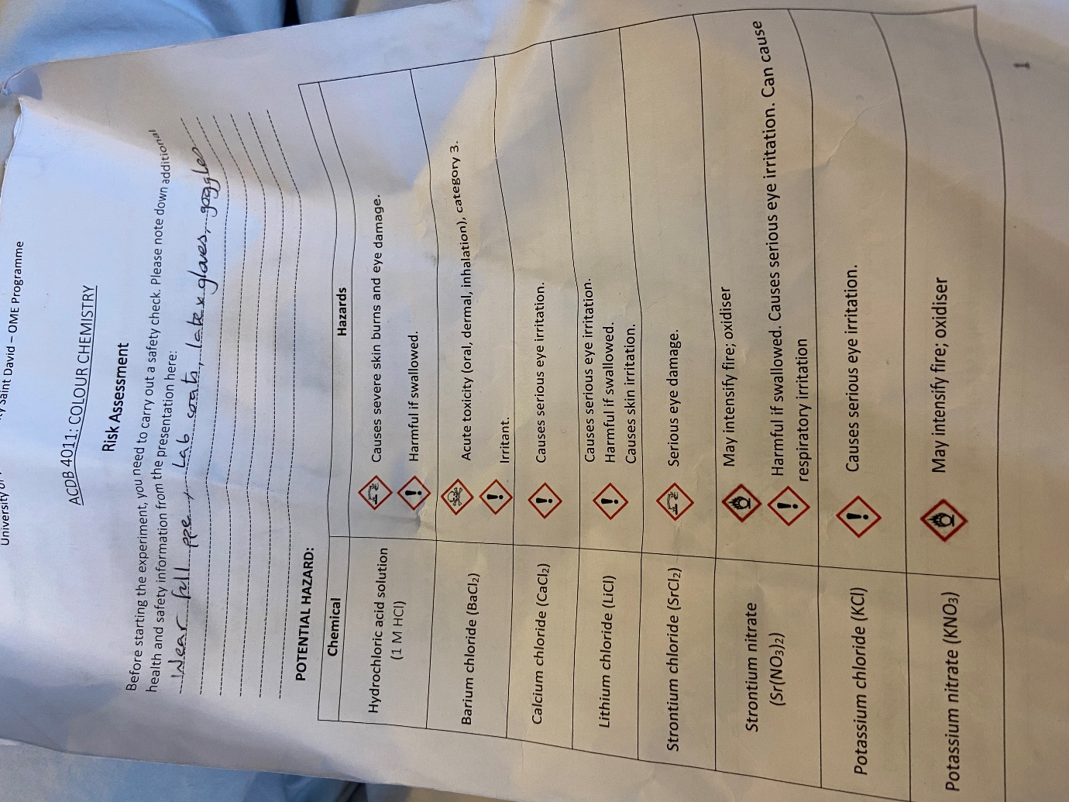

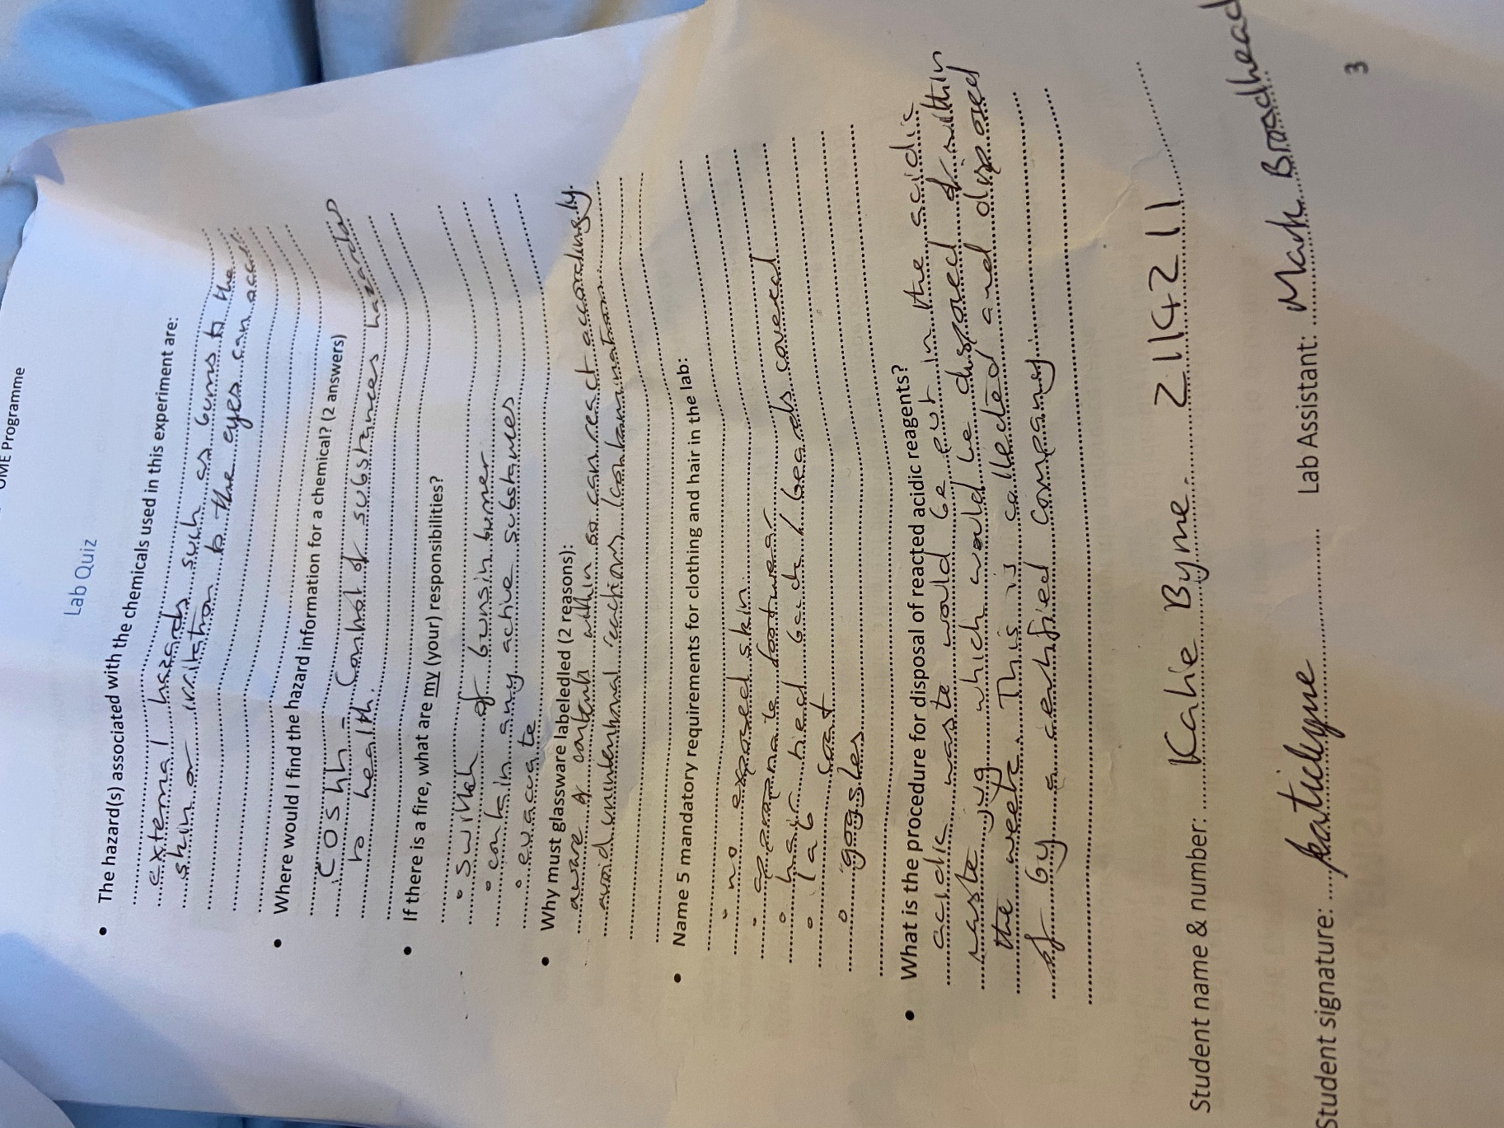

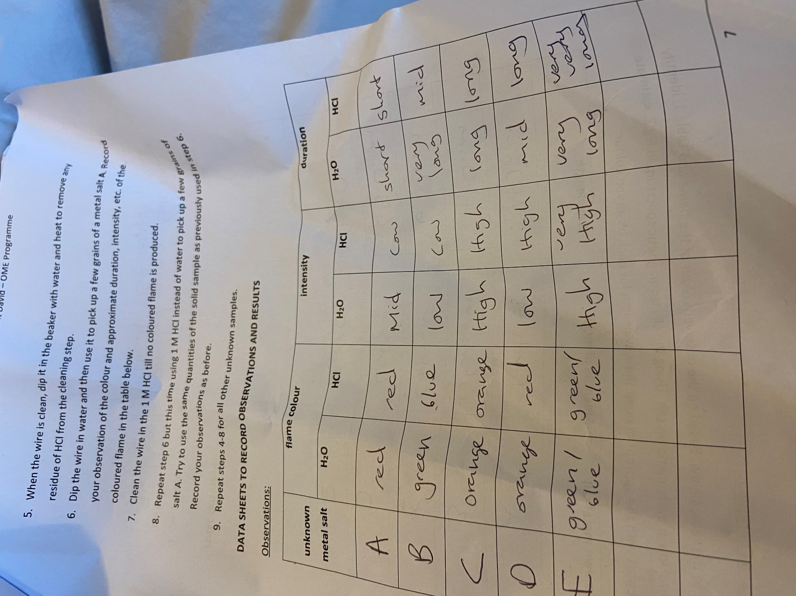

B: the wire must have been dirty if for the same salt you observed different colours (8p)
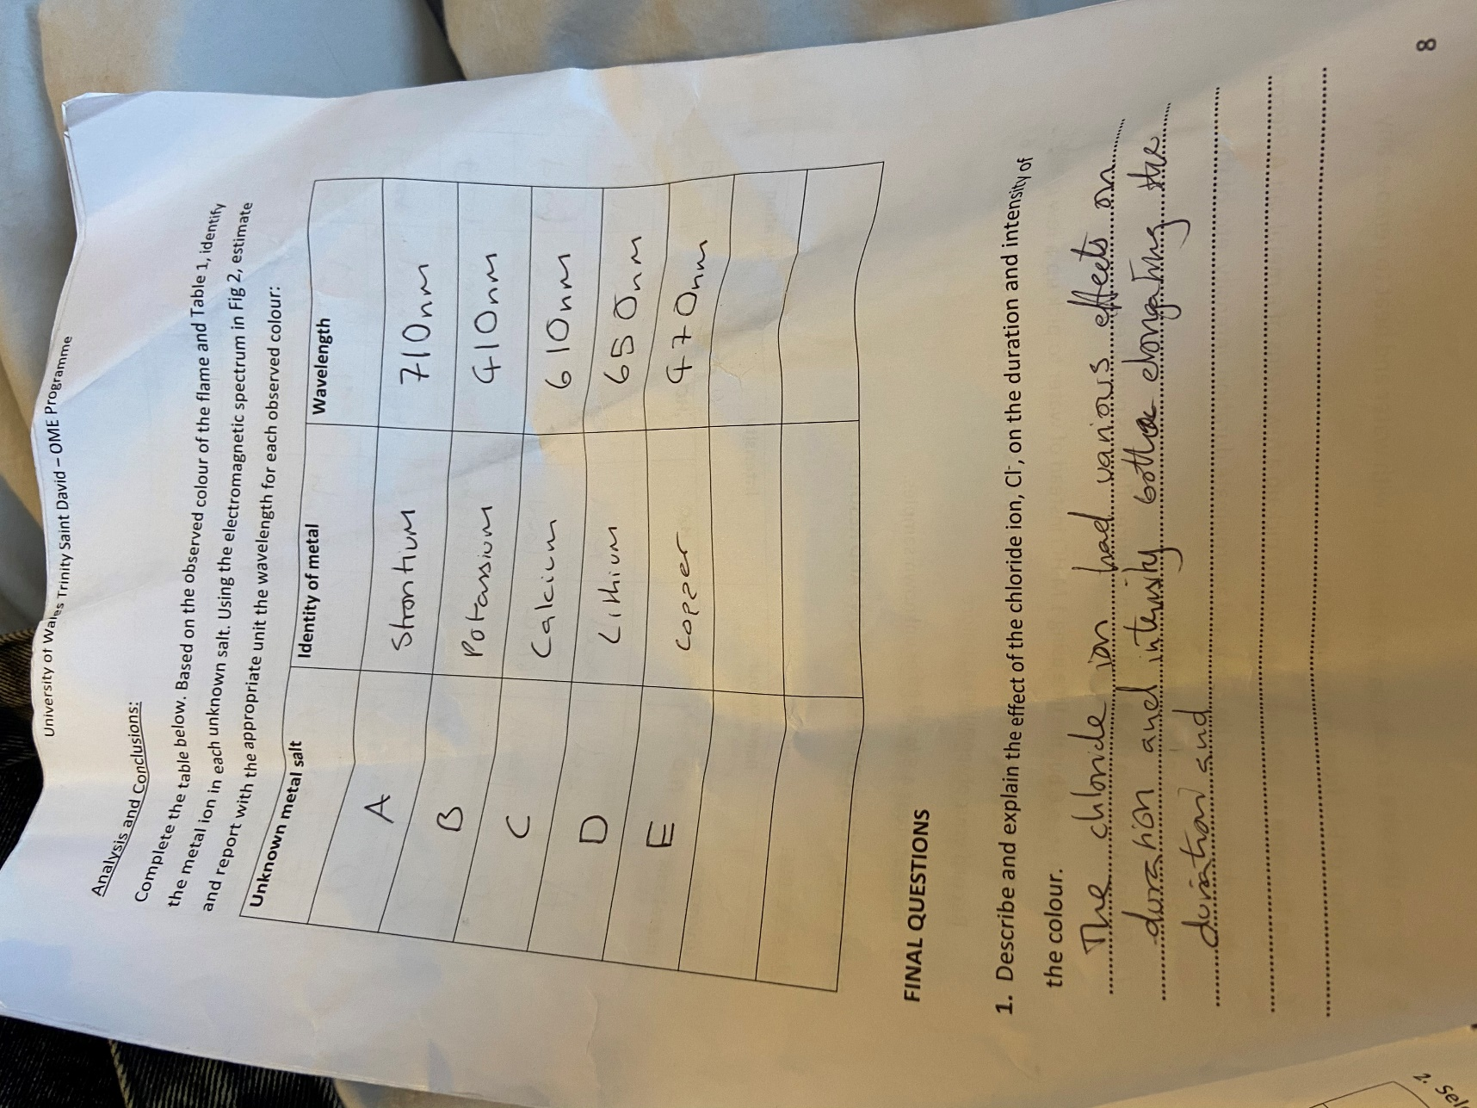
Correct identification based on observed colours (30p)
Q1. The answer is not finished. No explanation (2p)
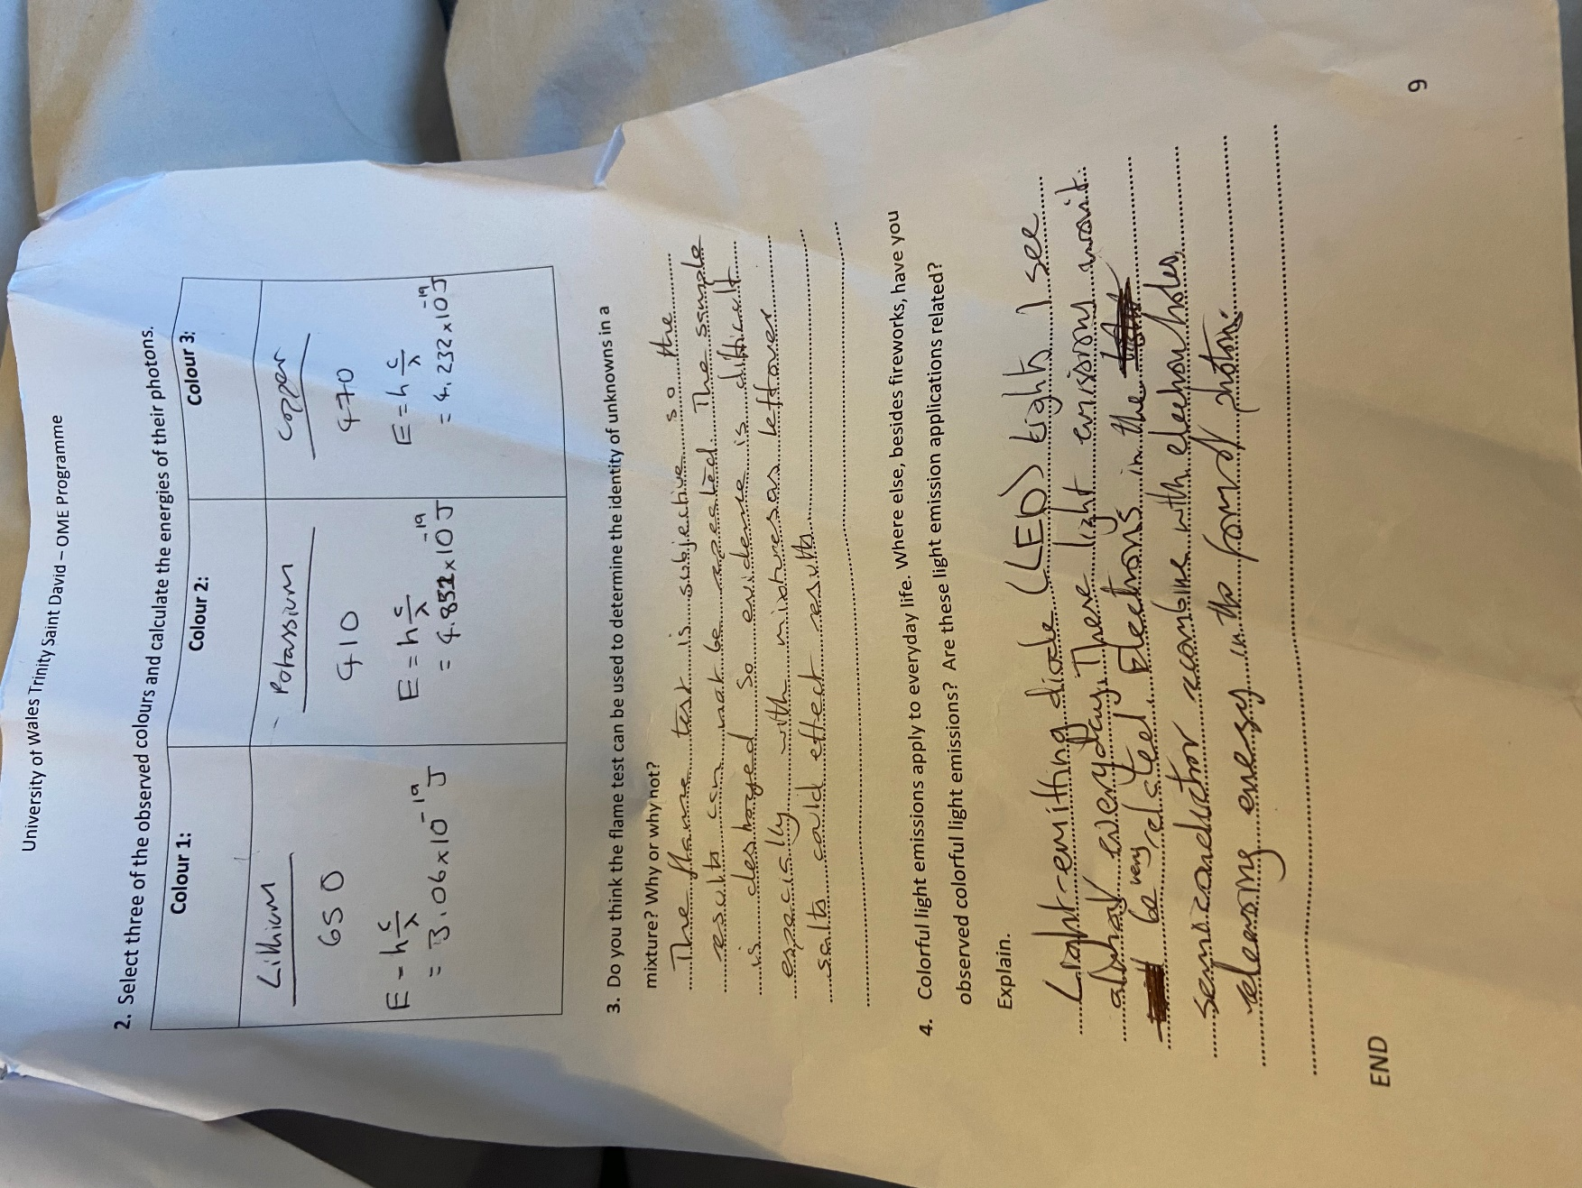
Q2: 30p
Q3: 10p
Q4: 10p
Please, make sure that your next report is tidier and less crumpled.

