

Assessment of Human Resource department development

Student Name: ANUJA VINODKUMAR
Student ID 2218255
Lecturer: Prof D G Pepple
Year 2023
Table of content
Introduction 3
Analyse the changes in the role of HR over time 4
Assessment of the main affecting factors of Sustainable global HRM 6
Investigation on sustainability agenda of HRM 9
Reflection 11
Description 11
Feelings 11
Evaluation 11
Analysis 12
Conclusion 12
Action plan 13
Conclusion 13
Reference 13

Introduction
Sustainable Human Resource Management is a continuation of the human resources development initiative, which focuses on the sustained growth of an organisation as well as its employees. Sustainable Human Resource Management (SHRM) is a management approach that seeks to improve the productivity, health, and well-being of employees while meeting the organisation's needs (Saeidi et al., 2021). SHRM is critical to the creation of a healthy work environment with an emphasis on safety and quality. Sustainable Human Resource Management (SHRM) is a management approach that aims to integrate human resources with society to meet its objectives (Chams and García-Blandón, 2019). It focuses on an employee's working conditions, compensation and benefits, organisational culture, job design and flexibility, and others. Human resource management involves all the activities that occur at the workplace in an organisational setting. It is a group of methods and principles designed to manage people who work with and for the organisation. Human resource management is expensive and time-consuming, but it has a significant role in a global society (Zehir, Karaboğa, and Başar, 2020). Factors affecting the implementation of sustainable HRM globally are the corporate sectors and regions. The factors mainly affecting a region can be climate and economy, diversity, culture and tradition, consumer trends, availability of resources for the development of a business model, location of strategic investment, and other factors.

Analyse the changes in the role of HR over time.
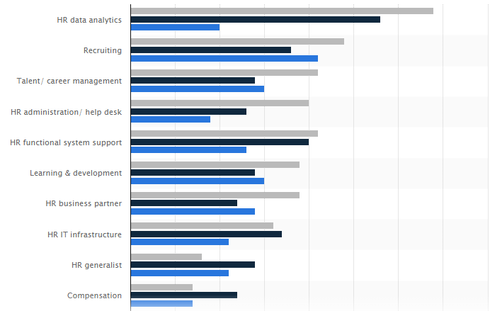
(Figure 1: Changes in Role of HRM)
Source: (Published by Statista Research Department, 2022)
HR is the organisation's human resource development specialist. An HR manager is responsible for hiring, training, and motivating employees, ensuring that the job tasks are performed ethically. Above all, a well-run HR department is vital to any company's success. HR professionals in the UK are responsible for overseeing the hiring and employee relations functions, including job analysis and recruiting, on boarding, compensation, benefits, and employment litigation (O'Donovan, 2019). HR's role is to help ensure that a company meets its goals by assigning and managing employees, managing pay and benefits, hiring, training, and developing staff, setting policies for all workers, including the ability to fire people, maintaining human resources records that include all employment procedures and files. In other words, The objective of a Human Resources Manager is to ensure that people are getting paid correctly and have their needs met based on their responsibilities within the companies of the United Kingdom. In UK companies, the role of HR has changed over time. In earlier times, HR was involved in hiring, training, and managing employees (Kim, Wang, and Boon, 2021). Nevertheless, today, most HR work occurs behind the scenes in companies, like recruiting talent for internal teams as well as attracting new vendors to the business. As technology evolves, the role of HR has changed significantly. Employees today have more access to at-work resources and social media than ever before, including the ability to ask for help from their colleagues on a range of issues at work. As HR roles have evolved, the need for greater specialisation and depth has become inevitable. The evolution of the role has affected individual behavior in several ways, including how employees became more career-minded, how employees became desirous of better opportunities, and in some cases, even how employees began taking on additional responsibilities (Akinloye, 2022). Recruitment is a complex process that involves many parties and organisations, including HR, the candidate, and the potential employer. The way recruitment works have changed significantly over the last decade due to technological advancements and socio-economic changes. The future of hiring and recruitment is with the expansion of mobile technology and its integration into hiring practices. Companies can recruit candidates on the go while never having to leave their desks (Wheeler and Buckley, 2021). Whether it is via an app or site, employers have new ways to find the right talent for their organisation. Recruitment and Hiring is a complex process that involves different decision-making tools and methods. One of the most critical tasks during the entire process is to assess the competencies and potential of candidates to make accurate hiring decisions. One of the significant functions of HRM management is employee management. Employee management can be influenced by various factors such as workplace culture, organisational communication, managerial style, trust and respect, and leadership (Wen, Wu, and Long, 2021).

HRM (Human Resource Management) can influence employee engagement through various strategies, including:
- It creates a positive work culture that fosters trust, transparency, and open communication.
- They are providing employees with opportunities for growth and development through training, coaching, and mentorship programs.
- They are offering fair compensation and benefits packages to attract and retain top talent.
- Encouraging work-life balance and flexible work arrangements that accommodate employee needs.
- It provides recognition and rewards to acknowledge employee contributions and achievements.
- They are promoting diversity, equity, and inclusion to create a more inclusive and welcoming workplace.
- They are implementing employee feedback mechanisms to gather insights and identify areas for improvement.
By implementing these strategies, HRM can help create a more engaged and motivated workforce, which can lead to increased productivity, improved job satisfaction, and decreased turnover rates.

Assessment of the main affecting factors of Sustainable Global HRM
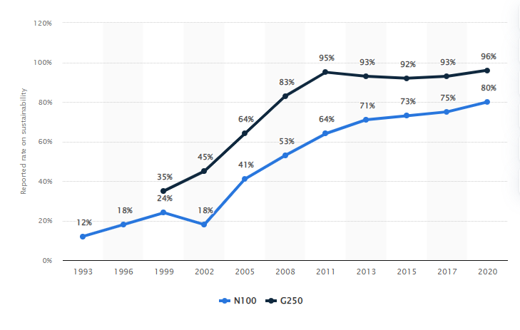
(Figure 2: Companies report on sustainability worldwide)
Source: (Jaganmohan, 2022)
Several factors affect sustainable global Human resource management, including Cultural differences, Legal and regulatory environment, Economic conditions, Political factors, Technological advancement, Labor market dynamics, and others (Cooke, Schuler, and Varma, 2020). Factors affecting Global HRM are the strengths in developing countries and the problems that global business faces concerning human resources. The factors will change from country to country, and therefore it is essential to know each country's specific situation before making any decisions on where best to place the business or staff. The factors affecting global HRM include globalization and technology, which allow companies to conduct business around the world (Vahdat, 2022). By integrating employees into the worldwide marketplace and taking advantage of new technologies, companies can quickly respond to changes in demand. Global HRM requires a deep understanding of these factors and a flexible approach to HRM practices to accommodate local differences while maintaining a consistent global approach.

- The availability of talent, labor supply and demand, and competition for skilled workers can impact HRM practices, such as recruitment, retention, and talent development.
- Different cultures have varying values, beliefs, and attitudes toward work, which can impact HRM practices such as recruitment, training, and performance management (Saleh and Atan, 2021). HRM practices must comply with local laws and regulations, which can vary significantly across different countries.
- The economic environment can affect HRM practices, such as compensation and benefits, as well as the availability of talent.
- Political instability, changes in government policies, and international relations can impact HRM practices, such as immigration policies and labor laws.
- Advances in technology can impact HRM practices, such as recruitment, training, and communication, as well as the need for new skills and competencies.
Sustainable global HRM is affected by various factors, including many understandings, such as the cultural differences between countries that can affect how HRM practices are implemented and the values and attitudes of employees towards sustainability. The regulations set by different governments can affect the extent to which HRM practices are sustainable.
The culture of the organisation and the values of its leaders can influence the extent to which sustainability is integrated into HRM practices. The expectations of stakeholders such as employees, customers, and investors can impact the extent to which sustainability is a priority in HRM practices. Globalization has led to an increase in the complexity of managing HRM sustainably across different countries and regions (Drolet, 2020). Technological advancements have provided new opportunities for sustainable HRM practices, such as remote working, e-learning, and online collaboration. Growing environmental concerns have put pressure on organisations to adopt sustainable HRM practices that reduce their impact on the environment. Overall, sustainable global HRM is influenced by a range of factors, including cultural differences, government regulations, organisational culture, stakeholder expectations, globalization, technology, and environmental concerns.
The main functions of global human resource management (HRM) that can be affected by sustainability considerations include several subjects Such as Recruitment and Selection, Training and Development, Performance Management, Compensation and Benefits, Employee Relations, and others (Paulet, Holland, and Morgan, 2021). The following points will be discussing the subjects:
- Recruitment and Selection: HRM must ensure that the recruitment and selection process includes screening for the values and attitudes of potential employees towards sustainability.
- Training and Development: HRM must provide training and development programs that foster sustainable practices and ensure that employees have the necessary skills to work sustainably.
- Performance Management: HRM must establish performance management systems that assess employees' sustainability-related behaviors and incorporate these into performance evaluations.
Overall, the functions of global HRM must be designed and managed in a way that reflects the principles of sustainability and balances the interests of all stakeholders.

Investigation on sustainability agenda of HRM
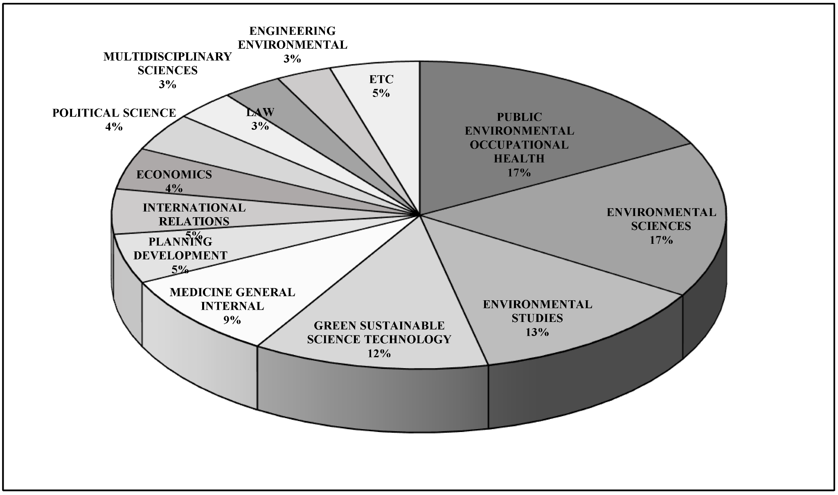
(Figure 3: Sustainability agenda of HRM)
Source: (Khoshnava et al., 2019)
The sustainability agenda of Human Resource Management (HRM) involves integrating environmental, social, and economic sustainability principles into the management of human resources. This includes initiatives such as promoting diversity and inclusion, ensuring fair labor practices, reducing waste and carbon emissions, and supporting employee well-being. The goal of a sustainability-focused HRM approach is to create a positive impact on the environment, society, and the organisation's bottom line by engaging employees in sustainable practices and embedding sustainability values into the company's culture (Bush, 2020).
The sustainability of HRM (Human resource department ) is essential for several reasons:
- Reputation: An organisation's sustainability practices can influence its reputation and brand image, which can impact customer loyalty and attract talent.
- Compliance: Many countries have introduced legislation related to sustainability, and HRM plays a critical role in ensuring compliance (Subramanian and Suresh, 2022).
- Cost savings: Sustainability-focused initiatives, such as reducing energy use or waste, can help companies save costs in the long run.
- Employee engagement: Employees are increasingly motivated by values-driven organisations, and HRM can play a crucial role in engaging employees in sustainability initiatives, which can improve job satisfaction and retention.
- Long-term viability: By integrating sustainability principles into HRM, companies can ensure their long-term viability by mitigating risks associated with environmental and social issues while creating positive impacts on society and the environment (Stahl et al., 2020).
Sustainable HRM (Human Resource Management) practices are those that prioritise the long-term well-being of both the organisation and its employees while also taking into consideration the impact on the environment and society. These practices include measures such as promoting work-life balance, employee empowerment, diversity and inclusion, ethical leadership, talent development, and reducing the carbon footprint of the organisation (Saeidi et al., 2022). The role of HRM (Human Resource Management) in sustainability is to ensure that the organisation's policies and practices align with sustainable principles and contribute to the long-term well-being of the organisation, its employees, and society. HRM can promote sustainability by Developing and implementing sustainable HR policies and practices, such as promoting work-life balance, employee empowerment, and diversity and inclusion (Adekoya, 2022), fostering an ethical culture and values that prioritise sustainability and social responsibility—attracting and retaining talent that shares the organisation's sustainability goals and values—providing training and development opportunities to help employees develop the skills and knowledge needed to advance sustainability initiatives—partnering with other departments to integrate sustainability into all aspects of the organisation's operations (Obrenovic et al., 2020)—reducing the environmental impact of the organisation by adopting sustainable practices in HR processes such as recruitment, training, and employee engagement. By integrating sustainability into HRM practices, organisations can create a culture of sustainability and contribute to a more sustainable future. Sustainable HRM practices such as work-life balance, employee empowerment, and a focus on well-being can increase employee satisfaction and reduce turnover, leading to a more stable and motivated workforce (Dorta-Afonso et al., 2021). By providing employees with a safe, healthy, and supportive work environment, sustainable HRM practices can improve productivity and performance.

Reflection

Description
A sustainable human resource practice is a practice that supports the long-term well-being of both the organisation and its employees while also considering the impact on the environment and society. Some examples of sustainable human resource practices include Work-life balance. Encouraging flexible work arrangements, such as telecommuting or flexible hours, can promote work-life balance and improve employee well-being (Shirmohammadi, Au, and Beigi, 2022). Employee empowerment, Giving employees more autonomy and decision-making power can increase job satisfaction and motivation. Diversity and inclusion Creating a workplace that is inclusive and diverse can lead to increased creativity, innovation, and better problem-solving—ethical leadership as well as encouraging leaders.

Feelings
In the case of understanding the topic of HRM development research, Firstly, I was very nervous and equally very excited. In the whole learning process, my seniors helped me very much. They taught me the importance of sustainable HRM and how the procedure works. After the learning procedure and training, I became confident, and I finally recognised that HRM could help to make informed decisions and develop effective HR strategies. By understanding HRM development ideas, I can better manage employee capital, improve employee well-being, and support the growth and success of the organisation.

Evaluation
As a stakeholder, after analysing sustainable HRM thoroughly, it has been observed that Sustainable HRM (Human Resource Management) is valid for companies in several ways, such as Improved employee retention and satisfaction. Sustainable HRM practices such as work-life balance, employee empowerment, and a focus on well-being can increase employee satisfaction and reduce turnover, leading to a more stable and motivated workforce (Rupčić, 2022). Sustainable HRM practices can improve employee well-being, which in turn can lead to improved productivity and performance. Sustainable HRM practices can help reduce costs associated with employee turnover, absenteeism, and workplace injuries. Adopting sustainable practices in HR processes can also lead to cost savings and improve the bottom line.

Analysis
Furthermore, I ascertained that sustainable HRM also presents benefits such as Enhanced corporate reputation by Prioritising sustainability in HRM practices can enhance a company's reputation as a responsible and ethical employer, which can attract customers, investors, and top talent. Reduced environmental impact through Sustainable HRM practices can help companies reduce their carbon footprint and contribute to environmental sustainability goals, which is essential for both the company and society as a whole. Research on sustainable HRM helped me develop a better understanding of the practices and strategies that can promote sustainable development in the workplace. By studying the latest research on sustainable HRM, I learned about best practices and innovative approaches that organisations are using to promote sustainability and social responsibility in HRM.

Conclusion
Thee research on the topic of Human research management development could have been more detailed and perfect if I had developed a straightforward research question, used other variety of sources, applied a more critical perspective, or Reviewed and refined my research. A straightforward research question will help me to stay focused on the topic and ensure that I am collecting relevant data. Reviewing and refining the research will ensure that my findings are accurate and relevant. This may involve revising the research question, adjusting my analysis, or incorporating new data sources.

Action plan

Skills | Methods | Resources | Time Taken
Developing a straightforward research question | They are learning Online and taking pieces of advice from seniors. | Laptop, Pen, Paper and others. | 2 weeks.
Using other variety of sources | They are checking the sources and their better replacements. | Laptop, Pen, Paper and others. | 3 weeks.
Adding more criticality to prospective | Taking advice from seniors and attending training. | Laptop, Pen, Paper and others. | 1 week.
Reviewing and Refining | Review and Refine with the help of professionals. | Laptop, Pen, Paper and others. | 5 weeks.

Conclusion
In summary, sustainable HRM practices can make a positive difference by promoting employee well-being, productivity, and retention, reducing costs, enhancing corporate reputation, and contributing to the organisation's and society's environmental sustainability goals. In summary, sustainable HRM can help companies improve employee retention and satisfaction, enhance productivity and performance, reduce costs, enhance their reputation, and contribute to environmental sustainability. These benefits can lead to competitive advantage and long-term success for the company.

Reference
Adekoya, O., 2022. Responsible Management: Promoting Work-Life Balance through Social Sustainability and Green HRM (Doctoral dissertation, University of East London). Available at: https://repository.uel.ac.uk/item/8qxvz (Accessed: February 14, 2023).
Akinloye, A., 2022. Talent Management Agenda in a Post Covid-19 World: Managing Careers and Career Transitions: Work, Workforce & Workplace. AuthorHouse. Available at: https://books.google.com/books?hl=en&lr=&id=Vu2fEAAAQBAJ&oi=fnd&pg=PT6&dq=how+employees+became+more+career-minded,+how+employees+became+desirous+of+better+opportunities,+and+in+some+cases,+even+how+employees+began+taking+on+additional+responsibilities&ots=t585Ue85wg&sig=mfzat61keYvtJntIoYT7AKJW9VI (Accessed: February 14, 2023).
Bush, J.T., 2020. Win-Win-Lose? Sustainable HRM and the promotion of unsustainable employee outcomes. Human Resource Management Review, 30(3), p.100676. Available at: https://www.sciencedirect.com/science/article/pii/S1053482218303188 (Accessed: February 14, 2023).
Chams, N. and García-Blandón, J., 2019. On the importance of sustainable human resource management for the adoption of sustainable development goals. Resources, Conservation and Recycling, 141, pp.109-122. Available at: https://www.sciencedirect.com/science/article/pii/S0921344918303719 (Accessed: February 14, 2023).
Cooke, F.L., Schuler, R. and Varma, A., 2020. Human resource management research and practice in Asia: Past, present and future. Human Resource Management Review, 30(4), p.100778. Available at: https://www.sciencedirect.com/science/article/pii/S1053482220300516 (Accessed: February 14, 2023).
Dorta-Afonso, D., González-de-la-Rosa, M., García-Rodríguez, F.J. and Romero-Domínguez, L., 2021. Effects of high-performance work systems (HPWS) on hospitality employees' outcomes through their organisational commitment, motivation, and job satisfaction. Available at: Sustainability, 13(6), p.3226. https://www.mdpi.com/1034688 (Accessed: February 14, 2023).
Drolet, C.A., 2020. Globalisation and the challenges of public administration: governance, human resources management, leadership, ethics, e-governance and sustainability in the 21st century: by Haroon A. Khan, London, Springer, 2018, 210 pp., US $126.09 (ebook), ISBN-10: 9783319695860. Available at: https://www.tandfonline.com/doi/full/10.1080/12294659.2020.1769325 (Accessed: February 14, 2023).
Jaganmohan, M. (2022) Global Sustainability Reporting Rates 2020, Statista. Available at: https://www.statista.com/statistics/1232295/global-sustainability-reporting-growth-rate/ (Accessed: February 14, 2023).
Khoshnava, S.M. et al. (2019) Aligning the criteria of Green Economy (GE) and Sustainable Development Goals (sdgs) to implement sustainable development, MDPI. Multidisciplinary Digital Publishing Institute. Available at: https://www.mdpi.com/2071-1050/11/17/4615 (Accessed: February 14, 2023).
Kim, S., Wang, Y. and Boon, C., 2021. Sixty years of research on technology and human resource management: Looking back and looking forward. Human Resource Management, 60(1), pp.229-247. Available at: https://onlinelibrary.wiley.com/doi/abs/10.1002/hrm.22049 (Accessed: February 14, 2023).
Obrenovic, B., Du, J., Godinic, D., Tsoy, D., Khan, M.A.S. and Jakhongirov, I., 2020. Sustaining enterprise operations and productivity during the COVID-19 pandemic: "Enterprise Effectiveness and Sustainability Model". Sustainability, 12(15), p.5981. Available at: https://www.mdpi.com/778806 (Accessed: February 14, 2023).
O'Donovan, D., 2019. HRM in the organisation: An overview. Management Science: Foundations and innovations, pp.75-110. Available at: https://link.springer.com/chapter/10.1007/978-3-030-13229-3_4 (Accessed: February 14, 2023).
Paulet, R., Holland, P. and Morgan, D., 2021. A meta‐review of 10 years of green human resource management: is Green HRM headed towards a roadblock or a revitalisation? Asia Pacific Journal of Human Resources, 59(2), pp.159-183. Available at: https://onlinelibrary.wiley.com/doi/abs/10.1111/1744-7941.12285 (Accessed: February 14, 2023).
Published by Statista Research Department and 6, J. (2022) Human resources: Expected increasing staffing changes 2019, Statista. Available at: https://www.statista.com/statistics/1040411/expected-hr-staffing-changes-worldwide/ (Accessed: February 14, 2023).
Rupčić, N., 2022. How can learning organisations support sustainability goals? The Learning Organization, 29(5), pp.586-596. Available at: https://www.emerald.com/insight/content/doi/10.1108/TLO-07-2022-286/full/html (Accessed: February 14, 2023).
Saeidi, P., Mardani, A., Mishra, A.R., Cajas, V.E.C. and Carvajal, M.G., 2022. Evaluate sustainable human resource management in manufacturing companies using an extended Pythagorean fuzzy SWARA-TOPSIS method. Journal of Cleaner Production, 370, p.133380. Available at: https://www.sciencedirect.com/science/article/pii/S095965262202964X (Accessed: February 14, 2023).
Saeidi, P., Mardani, A., Mishra, A.R., Cajas, V.E.C. and Carvajal, M.G., 2022. Evaluate sustainable human resource management in manufacturing companies using an extended Pythagorean fuzzy SWARA-TOPSIS method. Journal of Cleaner Production, 370, p.133380. Available at: https://www.sciencedirect.com/science/article/pii/S095965262202964X (Accessed: February 14, 2023).
Saleh, R. and Atan, T., 2021. The involvement of sustainable talent management practices on employee’s job satisfaction: Mediating Effect of Organizational Culture. Sustainability, 13(23), p.13320. Available at: https://www.mdpi.com/1385898 (Accessed: February 14, 2023).
Shirmohammadi, M., Au, W.C. and Beigi, M., 2022. Remote work and work-life balance: Lessons learned from the covid-19 pandemic and suggestions for HRD practitioners. Human Resource Development International, 25(2), pp.163-181. Available at: https://www.tandfonline.com/doi/abs/10.1080/13678868.2022.2047380 (Accessed: February 14, 2023).
Stahl, G.K., Brewster, C.J., Collings, D.G. and Hajro, A., 2020. Enhancing the role of human resource management in corporate sustainability and social responsibility: A multi-stakeholder, multidimensional approach to HRM. Human Resource Management Review, 30(3), p.100708. Available at: https://www.sciencedirect.com/science/article/pii/S1053482218303796 (Accessed: February 14, 2023).
Subramanian, N. and Suresh, M., 2022. The contribution of organisational learning and green human resource management practices to the circular economy: A relational analysis–evidence from manufacturing SMEs (part II). The Learning Organization, (ahead-of-print). Available at: https://www.emerald.com/insight/content/doi/10.1108/TLO-06-2022-0068/full/html (Accessed: February 14, 2023).
Vahdat, S., 2022. The role of IT-based technologies on the management of human resources in the COVID-19 era. Kybernetes, 51(6), pp.2065-2088. Available at: https://www.emerald.com/insight/content/doi/10.1108/K-04-2021-0333/full/html (Accessed: February 14, 2023).
Wen, Q., Wu, Y. and Long, J., 2021. Influence of ethical leadership on employees' innovative behavior: The role of organisation-based self-esteem and flexible human resource management. Sustainability, 13(3), p.1359. Available at: https://www.mdpi.com/977110 (Accessed: February 14, 2023).
Wheeler, A.R. and Buckley, M.R., 2021. The Current State of HRM with Automation, Artificial Intelligence, and Machine Learning. In HR without People? (pp. 45-67). Emerald Publishing Limited. Available at: https://www.emerald.com/insight/content/doi/10.1108/978-1-80117-037-620211004 (Accessed: February 14, 2023).
Zehir, C., Karaboğa, T. and Başar, D., 2020. The transformation of human resource management and its impact on overall business performance: Big Data analytics and ai technologies in strategic HRM. Digital Business Strategies in Blockchain Ecosystems: Transformational Design and Future of Global Business, pp.265-279. Available at: https://link.springer.com/chapter/10.1007/978-3-030-29739-8_12 (Accessed: February 14, 2023).

