University of Wales Trinity Saint David
School of Engineering
Analysis of power generation cycles & application of compression-vapour cycle
1801660
Energy & Environmental Engineering
19/01/2022
Thermofluid Mechanics

Contents page

Title page…………………………………………………………………….……1
Contents page……………………………………………………….……………2
Part A………………………………………………………………………….…..3
(a)........................................................................................................3
(i)................................................................................................3
(ii)...............................................................................................3
(b)....................................................................................................... 4
(c)........................................................................................................4
(d)........................................................................................................5
(e)........................................................................................................5
Part B………………………………………………………………………………6
Part C……………………………………………………………………………10
References………………………………………………………………………16

Part A

(i)
P1 = 100KpA = ${10}^{5}$N/$M^{2}$ T1 = 27+273 = 300K

Heat added = 1650kj/kg cv = 0.72 y = 1.4

$\frac{T2}{T1}$ = ($\frac{V1}{V2}$)${}^{y-1}$ = (r)${}^{y-1}$ = ${(8)}^{1.4-1}$ = 2.297
∴ T2 = 300 x 2.297 = 689.1K

Also, $\frac{P2}{P1}$ = ($\frac{V1}{V2}$)${}^{y-1}$ = ${(8)}^{1.4}$ = 18.379 bar

Heat Added, cv ( T3 - T2 ) = 1650

0.72 (T3 - 689.1) = 1650 Also, $\frac{P2}{T2}$ = $\frac{P3}{T3}$ $→$ P3 = $\frac{P2 T3}{T2}$ = $\frac{18.379 x 2980.76}{689.1}$= 79.5 bar

T3 = $\frac{1650}{0.72}$ + 689.1 = 2980.76K

$\frac{T3}{T4}$ = ($\frac{U4}{U3}$)${}^{y-1}$ = (r)${}^{y-1}$ = ${(8)}^{1.4-1}$ = 2.297
∴T4 = $\frac{T3}{2.297}$ = $\frac{2980.76}{2.297}$ = 1297.68K

Also, P3 V3 = P4 V4 $→$ P4 = P3 x ($\frac{V3}{V4}$)${}^{y}$ = 79.5 x ($\frac{1}{8}$)${}^{1.4}$= 4.326 bar

(ii) Thermal efficiency: Specific work = heat added + heat rejected
= cv ( T3 - T2 ) - cv ( T4 - T1 ) = cv $\left[(T3 - T2) -(T4 - T1 ) \right]$
= 0.72 $\left[(2980.76 - 689.1)- (1297.68 - 300)\right]$ = 931.67 kJ/kg
Thermal efficiency = ηth = 1 - $\frac{1}{{(r)}^{y-1}}$ = 1 - $\frac{1}{{(8)}^{1.4-1}}$ - $\frac{1}{{(5)}^{1.4-1}}$ = 0.0394 or 39.4%

(b)

P1 = 1.05 T1 = 50°C
Y = 1.4 Cv = 1005 J/kg k
Cv = $\frac{Cp}{y}$ = Cv = 717.86 = 718

Gas constant R = 287 J/kgK

V1 = $\frac{mrt1}{P1}$ = $\frac{1 x 287 x (50+273)}{1.05 x 10{}^{5}}$
V1 = 0.883$m^{3}$
Rk = 17.5 = $\frac{V1}{V2}$
V2 = $\frac{V1}{17.5} =$ 0.0504$m^{3}$
T2 = T1 $(\frac{V1}{V2}$)${}^{y-1}$ T2 $=$ 323 ( $\frac{0.883}{0.0504}$)${}^{0.4}$
T2 = 1015.3 K

Heat energy added at constant pressure = 1400kj/kg

T3 = T2 + ($\frac{heat added}{mcp}$)
T3 = 2408.3K

Cut off ratio = $\frac{T3}{T2}$ = 2.37
V4 = V1
T4 = T3 $(\frac{V3}{V4}$)${}^{k-1}$ = T3 $(\frac{rc}{r}$)${}^{y-1}$
T4 = 2408.3 $(\frac{2.37}{17.5}$)${}^{0.4}$ = 1082.4K

Efficiency = 1 + $\frac{Cv (T1 - T4}{Cp (T3 - T2)}$
= 1 + $\frac{718 ( 323 - 1082.4)}{1005 ( 2408.3 - 1015.3}$
= 0.61/61%
T1 = 323k
T2 = 1015.3k
T3 = 2408.3K
T4 = 1082.4 K
rc = 2.37
Efficiency = 61%

(c)

(d) Inlet temperature = 725°C
Exit temperature = 471.25°C
Mass flow rate = 3.25kg/s
Cp = 980 J/kgk
W = mcp (T1 - T2)
= 3.25 x 980 ( 725 - 471.25)
= 808,193.75 W
= 808.2 KW

800000 = 3.25 x 980 ( T1 - 471.25)

$\frac{800000}{3.25 x 980}$ = T1 - 471.25

$\frac{800000}{3.25 x 980}$ + 471.25 = T1

T1 = 722.43 °C

(e)

Part B

Gas Turbine Plant

In order to reach the highest efficiency when operating a gas turbine plant, multiple factors must be considered. The use of fog cooling or other types of evaporative cooling devices can be enforced in order to reduce air inlet temperature in hot climates. By implementing this, higher compression will be achieved leading to a more efficient system. By increasing the inner turbine inlet temperature as long as it can withhold the temperature can improve the overall efficiency of the gas turbine plant. Alongside this, increasing the pressure ratio is another way to increase efficiency depending on the turbine inlet temperature. Increasing the pressure ratio to a point that the increased part cannot be recovered because of the expansion throughout the gas turbine is inadequate. In order to reach this new efficiency, this process would more than likely require a new compressor.
Ultimately, the higher the compression ratio the higher the efficiency. This also means that the higher the compressor temperature the higher the turbine inlet temperature in alignment to reduced fuel load.. Augmentation of power via the steam injection site is an efficient way for the plant to run smoothly. The efficiency of a gas turbine plant can vastly increase effectively if the set temperature of heat input has been raised to the point where regeneration is a solution provided the compressor outlet temperature is variably lower than the temperature of the turbine outlet. If the temperature is not lower than the turbine outlet then the heat flow could possibly reverse leading to a lower efficiency in the gas turbine plant. Implementing inter-cooling in the gas plant compressors is a profitable move to the extent in which the set up cost of further stages is parallel to the rise in efficiency.
By introducing improved turbine blade materials into the plant will allow further increase in the turbine inlet temperature and therefore rapidly improve the levels of efficiency. For the method mentioned above, the plant will need exotic materials and active cooling of turbine blades. Another method which improves efficiency is water injection. When water is injected into the compressor stages it becomes vapourised leading to the reduction of temperature and increase in air mass. Water vapor has a higher thermal capacity than air therefore, temperature at the inlet can be reduced and more power can be generated for the same level of temperatures.
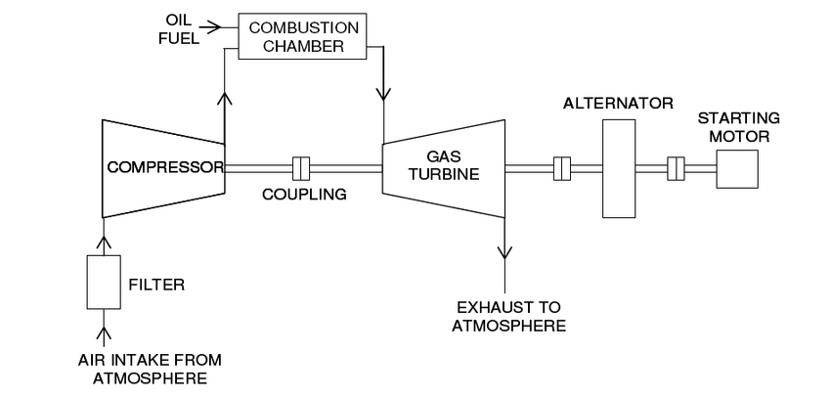

Steam Turbine Plant
Energy supply has been steadily increasing in recent years, according to global statistics. Despite this, it is widely assumed that existing energy generation plants are insufficient to produce the required power, necessitating the need to invest more in the construction of new power generation plants or to seek alternative sources of energy generation.
To stay competitive, power generation companies and private power operators must look for ways to optimize existing plants in order to increase efficiency and reliability while lowering the cost of plant operations and maintenance. Despite renewed interest in sustainable, renewable, and affordable energy technologies, the majority of energy producers continue to use turbomachines, with fossil fuels remaining the most versatile primary energy generation source on the planet.
Environmental restrictions resulting from fossil fuel combustion emissions are driving researchers and stakeholders to seek out more efficient electric energy generation systems. Internal combustion plants, nuclear power plants, gas turbine plants, and steam power plants are all examples of turbomachinery-driven thermal power plants for generating electricity from fossil fuels, accounting for about 80% of all electricity generated worldwide.
The performance and reliability of the turbine and its components determine the overall efficiency of a steam turbine power plant. As a result, even minor improvements can boost power availability, improve reliability, lower equipment and component costs, and save money in the long run. Given the widespread use of turbines in power generation, even minor improvements in efficiency can result in billions of dollars in savings and lower emissions per unit of energy generated.
In order to improve the efficiency of the steam plant, steam turbine inlet temperatures have been increased in recent years, with recent designs having up to 620 °C inlet temperatures, though this can still be increased in the near future. This increase necessitates a thorough examination of the heat transfer characteristics of the materials used in the turbine's design, particularly the turbine blades. Due to the high cost of setting up a steam power generation plant, it is critical to have an optimal design in order for power generation companies to get a good return on their capital investments.
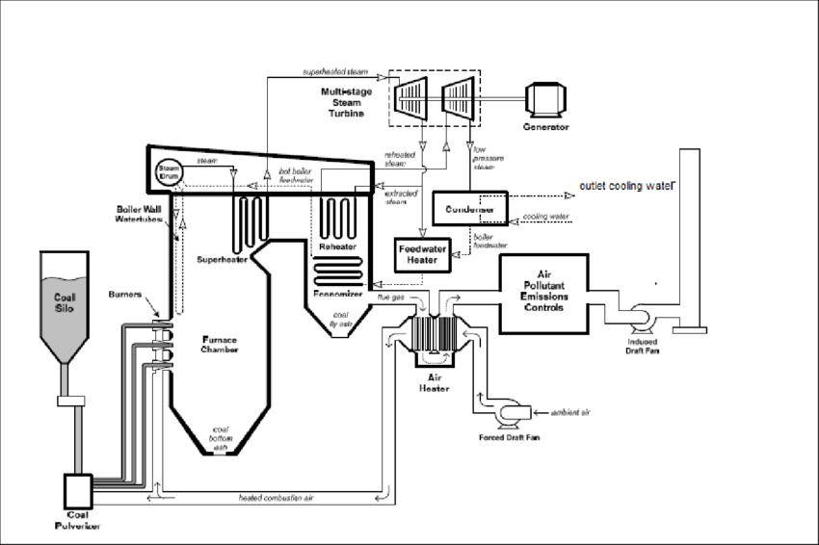
Schematic layout of steam turbine plant

The structural integrity of all rotating components, particularly the rotor and shaft, is critical to any turbomachinery's successful, efficient, and reliable operation. The integrity of the turbine is dependent on the moving parts' ability to withstand the constant and alternating stresses imposed on them, both internally by the heat transfer and externally by the steam pressure. Due to the high cost of setting up a steam power generation plant, it is critical to have an optimal design in order for power generation companies to get a good return on their capital investments.
Not realistic for the Carnot cycle to be ‘put into practice’, but a modified Carnot cycle is possible. This ideal cycle for steam plants is known as the Rankine cycle, which is a constant pressure flow process cycle; it operates between a high & low pressure. A simple steam plant is shown below.​

Diagram opposite shows 4 distinct elements of a steam power plant. For calculations it is usual to neglect the feed pump supplying water to the boiler. Each item in the closed system involves a steady flow process.​
​
Numbers on diagrams are used to represent the four processes in the plant and enthalpy is the property that is used in calculations. The feed pump acts as the compressor in the cycle.​
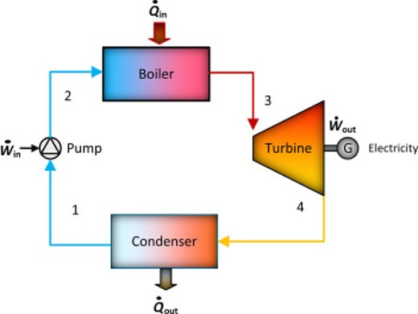

Part C

There are 2 main practical vapour-compression cycles, these 2 cycles are:
- Refrigeration cycle
- Heat pump cycle
Refrigeration cycle
The vapor-compression uses a circulating liquid refrigerant as the medium (usually R134a) which absorbs and removes heat from the space to be cooled and subsequently rejects that heat elsewhere. The most common vapor-compression systems consist of the four main components being the compressor, expansion valve, condenser and evaporator. The ideal cycle for the vapor compression cycle consists of a series of processes including isentropic process, singular throttling process alternated with double isobaric processes.
Compression in the pistons compressor also known as isentropic compression. A circulating refrigerant such as a R134a will enter the compressor in the body of a low pressure vapor variably below the existing temperature of the refrigerator interior. The gas medium is adiabatically compressed from state one just to state two via the piston compressor to take it to a high temperature and pressure level. During this, the surrounding components work on increasing the ga internal energy and compressing it by increasing its pressure. Meanwhile, the entropy remains unaltered and the work required for the compressor is given via Wc = H2 - H1. The isobaric heat rejection in the condenser is the next process. The heated vapor moves along the pressure via the coils that are part of the condenser. During this stage of the process, the refrigerant travels through the condenser where the refrigerant will condense whilst there is heat transfer taking place from the refrigerant to the cooler areas surrounding it. The total heat that has become rejected is given by Qre = H3 - H2. The refrigerant is still under pressure as it exits the condenser; however, it is only now above room temperature.
Expansion taking place in the expansion valve also known as isenthalpic process is the stage in which the refrigerant enters the expansion valve and expands to the pressure of the evaporator. Within this process, the enthalpy remains constant. H4 = H3. The vast decrease in the pressure will ultimately react in an explosive flash evaporation of a certain proportion of the liquid which is usually around half. This flash will absorb the latent heat and will be drawn from adjacent still-liquid refrigerant creating a phenomenon known as auto refrigeration. The final stage of the cycle known as isobaric heat addition is where the cold and slightly vaporized refrigerant will continue the course through the coils of the evaporator unit. During this phase, there will be a constant pressure heat transfer present to the liquid medium from external factors. This can take place as the chamber is open, allowing flow in and flow out. During the process of the refrigerant passing through the evaporator, the heat transfer coming from the refrigerated area will result in the vaporization to take place in the refrigerant. The net heat is given by Qadd = H1 - H4.

Heat Pump Cycle
The heating cycle of a heat pump works by taking heat in from air outside, warming it up further, and using this warm air to heat indoor air. It does so by the following process:
- In the "evaporator," liquid refrigerant absorbs heat from the outside air and turns into a gas.
- The refrigerant is forced through a "compressor," which increases the gas's pressure and thus its temperature.
- The hot gas passes through "condenser coils" within the heated space, and because it is hotter than the room, it transfers heat to it and condenses back into a liquid.
- Finally, the liquid passes through a valve that lowers its pressure, allowing it to cool down and repeat the cycle.

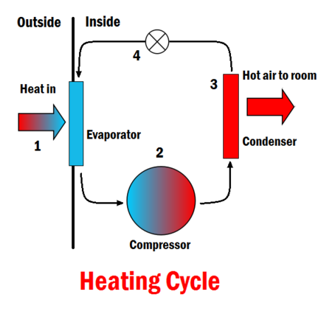

Cooling Cycle (heat pump)
The cooling cycle of a heat pump is used to cool a space by removing heat from it and expelling it to another area, usually to the outdoors for air conditioning or to the room for a refrigerator. To do this, the "evaporator" and "condenser coils" switch roles and the flow of refrigerant is reversed:
- In the evaporator, the cold refrigerant absorbs heat from the hotter room, causing the room to cool down.
- The temperature is then raised by passing it through a compressor.
- It travels through the condenser coils, where it is transferred to the outside air.
- To repeat the cycle, it expands to lower its pressure and cool down to below the room's temperature.

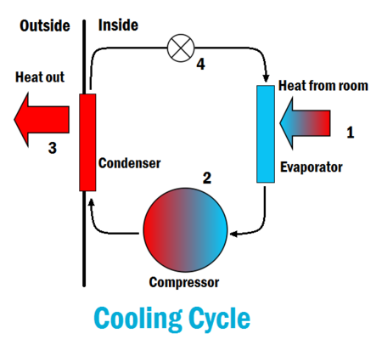

Coefficient of Performance

Refrigeration Cycle

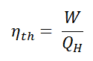
In general, the thermal efficiency, ηth, of any heat engine is the ratio of the work it does, W, to the heat input at the high temperature, QH.
The thermal efficiency, ηth, represents the fraction of heat, QH, that is converted to work. However, work is not an output in heat pumps and refrigerators. Thermal efficiency refers to the amount of energy added by work that is converted to net heat output in refrigeration or heat pumps. The best refrigeration cycle from an economic standpoint is one that removes the most heat from the inside of the refrigerator (cold reservoir) with the least amount of mechanical work or electric energy. As a result, the more this ratio is greater, the better the refrigerator. The coefficient of performance, abbreviated as COP, is the name given to this ratio.

In general, COP is highly dependent on operating conditions, especially absolute temperature and relative temperature between heat sink and system.

Heat Pump Cycle
The efficiency of heat pumps, refrigerators, and air conditioners is measured by the coefficient of performance (K or COP). Heating and cooling systems have different coefficients of performance. The coefficient of performance of a heat pump (heating system) is the ratio of energy delivered to the hot reservoir to the work input. As a result, it's known as a heating coefficient of performance (K heating ).
The coefficient of performance for a refrigerator or air conditioner (cooling systems) is a ratio of energy taken away from the cold reservoir to the work input. As a result, it's known as a performance cooling coefficient ( K cooling ).
When a heat pump is operated in reverse, it functions similarly to a refrigerator. The cooling coefficient of performance of a heat pump operating in reverse is referred to as the energy efficiency ratio (EER).
The thermal efficiency of heat engines is comparable to the coefficient of performance for both heating and cooling. This is due to the fact that they link the benefits you receive from the system (e.g., work, heating or cooling) to the amount you paid.
The coefficient of performance for heating is given by the equation: K heating = $\frac{Qh}{W in}$
There is a Carnot coefficient of performance, just as there is a thermal Carnot efficiency. The temperatures of the system's hot and cold reservoirs determine this maximum coefficient of performance. For a heating system (such as a heat pump), the Carnot coefficient of performance equation is different from a cooling system (like a refrigerator).

The equation for the Carnot coefficient of performance in heating is:
KH carnot$\frac{TH}{TH- TC}$

The Carnot coefficient of performance for cooling is given by the equation:
KH carnot$\frac{TC}{TH- TC}$

References

2022. [online] Available at: <https://www.explainthatstuff.com/steam-turbines.html> [Accessed 18 January 2022].

Singh, M. P. and Lucas, G. M. (2011). Blade Design and Analysis for Steam Turbines. The McGraw-Hill Companies, New York.

Fadl, M., Stein P. and He, L. (2017). Full conjugate heat transfer modelling for steam turbines in transient operations. International Journal of Thermal Sciences, 124, 240–250.

Ray, T. K., Datta, A., Gupta, A. and Ganguly, R., 2010. Exergy-based performance analysis for proper O&M decisions in a steam power plant. Energy Conversion and Management, 51(6), 1333–1344.

2022. [online] Available at: <https://energyeducation.ca/encyclopedia/Heat_pump> [Accessed 18 January 2022].

Thermal-engineering.org. 2022. [online] Available at: <https://www.thermal-engineering.org/what-is-vapor-compression-cycle-refrigeration-cycle-definition/> [Accessed 18 January 2022].​

2022. [online] Available at: <https://www.researchgate.net/figure/schematic-diagram-illustrated-steam-power-plant-components_fig1_311649720> [Accessed 18 January 2022].

Rice, I.G., (1995), Steam-Injected Gas Turbine Analysis: Steam Rates, ASME transactions, Journal of Engineering for Gas Turbines and Power, Vol. 117, 347-353.

