Consultancy Project

PID - Project Initiation Document

National Waterfront Museum

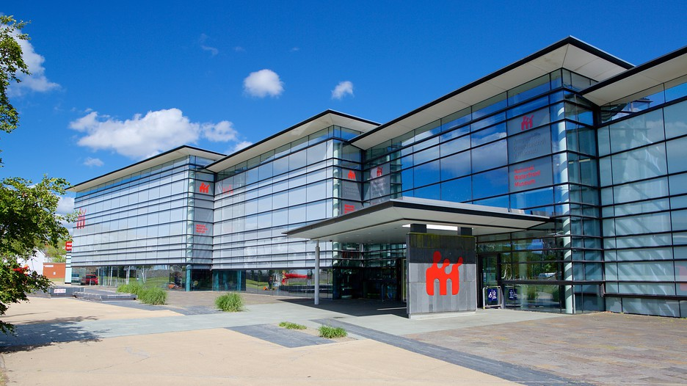

By Ffion Jones (P144611) & Ffion Merrick (P144697)

Executive Summary
This consultancy project is taking place as a client has been identified in have a problem within its organisation, and this project will help shed some light on the problem and provide some solutions on how to overcome it. The client is The National Waterfront Museum in Swansea, based in the marina of Swansea bay, and the problem identified is that they have problems with their marketing, who they are trying to marketing to, and not utilising the full extent of modern day marketing tools. Their current marketing suggests that they do not utilise social media as part of their marketing strategy, as they have very little to no presence on many social media platforms. Social media is a key part of marketing for companies, businesses, destinations and attractions as it reaches a wider audience, is cheaper and more effective way of achieving word of mouth marketing.

Contents

1.0 Introduction to the National Waterfront Museum PP 4
2.0 Project justification. PP 5
2.1 Project aims and Objectives PP 5
2.2 Project scope PP 5
2.3 Constraints PP 6
2.4 Other known parties PP 6
3.0 Project approach PP 7
4.0 Business case PP 8
5.0 Project management team PP 9
6.0 Quality management strategy PP 10
7.0 Communication management strategy PP 11
8.0 Project Plan PP 12
9.0 Project controls PP 13
10.0 Project Reporting PP 14
11.0 References PP 15

1.0 Introduction to National Waterfront Museum

The National Waterfront Museum is a non-profit organisation and is one of seven museums distributed around Wales. The museum is based in the marina of Swansea Bay, in a very populated area, not far from the shopping town. “Inspiring People, Changing Lives” (Visit Swansea Bay, 2018) is their vision for the future development of the museum and are working on improving the development up to the year 2025. The history consists of telling the human story of the Welsh industry and innovation, now and over the past 300 years. Its purpose is to tell the story of the traditional life and the agriculture of Wales. In order to tell a variety of stories, the museum has around 100 visual exhibits, which includes 36 interactive displays. Within the exhibition, the organisation also includes large historic objects from across the country, which includes the world’s first steam locomotive, a brick press and one of a few surviving coal wagons.

2.0 Project Justification

The reason marketing is the chosen issue for the client is because they present very little presence on social media, and in recent years it has become a key marketing tool for businesses and organisations. They provide a free entry to the museum, which means their marketing has to be effective in order to draw more people in, including via the gift shop or cafe for more secondary spending. There is also the potential problem of seasonality, with certain times of the year being more popular than others, so improvement through their marketing might be able to reduce the seasonality affect of when people come.

2.1 Project aims and objectives

The aim of this consultancy project is to review and analyse the Waterfront Museum’s current marketing strategy and tools that they use, and identifying the problems within it. The objectives of this project is to improve the marketing through social media in order to reach a wider audience, as current marketing suggests they do not utilise social media as a marketing tool. Another objective is to change any outdated and negative perceptions on museums, as this might be a key factor in the lack of popularity for them, and to investigate whether investment for marketing is worth it in things such as leaflets or if they should focus on online marketing as their main marketing tool.
The desired outcomes from this project include the museum receiving customers all year, with little affect from seasonality, to gain a wider audience through marketing on social media, and to provide the public with a more positive perception and experience of museums.

2.2 Project scope

Within the project, there are many tasks at hand for it to be successful and effective. Meetings with the client will take place frequently, to provide updates of the progress of the project and allows both the team and the client to ask any questions regarding the project. Research will be undertaken in order to substantiate the problem and to further solidify the solution provided. The research done will be primary research and secondary research. The primary research will include surveys on SurveyMonkey, that will be distributed through various social media platforms, like Facebook, Twitter and Snapchat, in order to get a wide variety of responses from a wide variety of people in different demographics. Interviews will also be taking place with some of the staff at the National Waterfront Museum, to find out their views from inside the organisation, and whether they find current marketing strategies are effective or not.
The secondary research will include looking at Trip Advisor reviews, because it is a key source for reviews on destinations and attractions, however there is a chance than some of the responses are biased, but this will be taken into account when analysing them. News articles, literature theory and statistics about the National Waterfront Museum will also be used as part of secondary research to verify how effective their marketing is and has been.
Following this research, evaluation of the findings will take place. Comparisons with other similar places will be done in order to truly see how their performance is doing and whether their marketing strategy is affecting this. Following the evaluation, a proposal of solutions will be written up, through a report, presenting what has been found through research and how the problems can be resolved.

2.3 Constraints

Constraints for the project include time limitations to get the project efficiently and effectively complete in the time frame provided, as the project is going to be very time consuming, so in order for it to be completed well, it needs to be managed and worked effectively in order to utilise the most of everyone’s time.

2.4 Other known parties

Other known parties will include the Marketing department at the National Waterfront Museum, as contact throughout this project will be with them, as marketing is the area that the project is focusing on.

3.0 Project Approach

The approach for the project will be continuous contact with the client, through face to face conversations and meetings, emails and phone calls when required, as frequently as required. It is unknown at this point how often contact will need to take place, but once a week is most likely the minimum for this.
There are many risks involved, including time and interference. Time is a risk that is difficult to manage, as there is a short amount of time for this consultancy to take place, but the consultancy team will manage their time effectively, in a way that will benefit both them and the client, in order to get the most effective results. The risk of interference refers to any marketing changes that are being made during the research of this project, which may affect the result of the project. However, if communication is kept frequent and up to date, this problem should be manageable.

4.0 Business case

Cheaper for the client if they apply our solutions if feedback shows thats what is most effective, as marketing online is cheaper, therefore the estimated costs to this project will be minimal, with any costs being in the potential retraction of their current marketing that they have already invested in. However, the anticipated outcome of this project should in the long run, make up for any money lost. The risks involved are primarily time, with a limited time frame, the consultancy team and the client will have to have effective time management in order for this project to be as successful as it can be. The benefits of the project in regards to cost and risk, is that hopefully the client will save money through their marketing by marketing through social media and online, which will ultimately be cheaper than through printed leaflets, and the risks should be manageable as long as communication between the team and the client is kept frequent and any up to date information is passed along, in order to save the most amount of time and money.

5.0 Project Management Team

Ffion Jones - consultant. She will primarily be focusing on the primary research, as she has more communication skills and communication experience to allow for more effective feedback.
Ffion Merrick - consultant. She will primarily be focusing on the secondary research for the project, as she has a good ability to find information quickly and effectively through literature and news articles, reducing the time management risk for the team and for the client.
Both consultants will then work together to analyse and evaluate the results from both types of research, in order to come up with a unified and simple solution to the problems found through the research.

6.0 Quality Management Strategy

Quality management of the project will be monitored through check lists, and quality meetings. Check lists will allow us to monitor progress of the project, as well as allowing the team to check that each task is completed to the highest quality and satisfaction of both the team and the client. The quality meetings will allow the consultancy team to meet with the client to monitor and check the quality of the work done and the work yet to do, allowing changes to the process to be made if needs be in order for the project to be completed efficiently. The quality expectations the project must achieve are high performance, from both the consultancy team and the client, by trying to work well together to solve a performance issue within their marketing department. These will be met through quality meetings and the check lists as mentioned above, in order to accurately assess the performance quality that is expected.
An ethics form will be completed in order for high standards of research to be undertaken. This will protect both the client and the consultancy team from any legal problems that might occur.

7.0 Communication Management Strategy

The parties interested are the marketing department at the National Waterfront Museum in Swansea. Communicating with the marketing department will most likely be through face to face meetings, phone calls and emails, wherever each type is deemed appropriate and most time effective, as the marketing team, and the consultancy team may be too busy for face to face meetings, so phone calls or emails may be able to suffice. The frequency of communication with the department will depend on what is required, initially it will most likely be once or twice a week face to face, and multiple times a week through emails, but as the project progresses further, communication will all depend on the kind of information is required from both the consultancy team and the client.

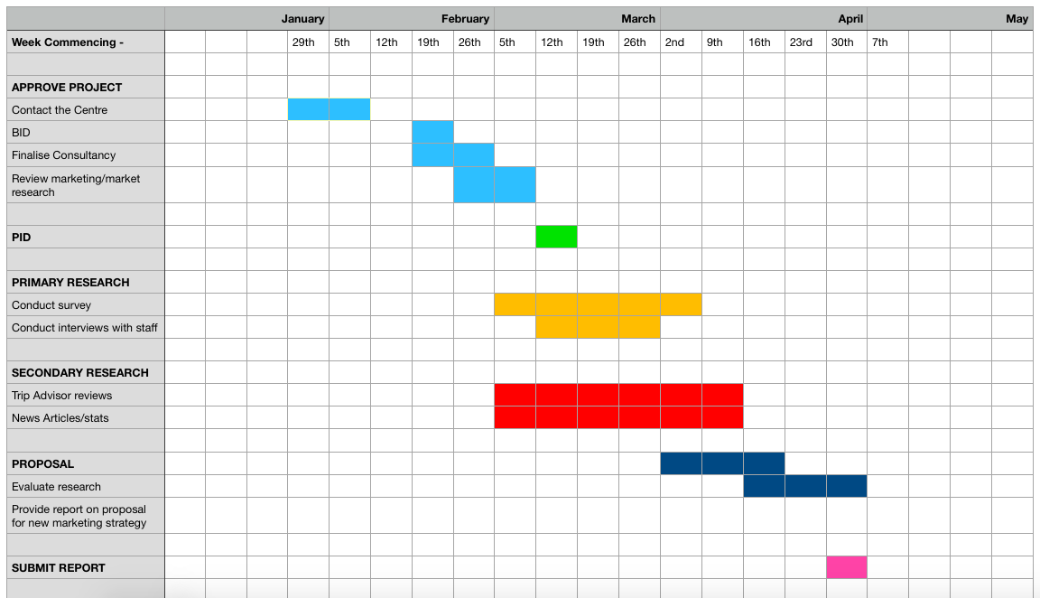
A Gantt chart will help both the consultancy team and the client keep track of how the project should be progressing, and being able to compare it to how the project is actually progressing in real time. Below is a copy of the Gantt chart, demonstrating the tasks that need to be undertaken to complete the project, and the weeks/months there are available to complete it, with boxes filled in as to what task will or should be completed when.

8.0 Project plan

In order to make sure we’re covering every aspect that needs to be completed within this project, a plan needs to be set in order to follow each step. By doing this, we’ll be able to complete tasks on time and make sure we’re covering every topic. The points below shows the different stages we’re going to take in completing the whole project.
- Identify the problem with their current marketing strategy - this has been completed
- Contact the potential client to see if this problem is worth solving for them
- Start looking into the problem in more detail, where it is going wrong and how
- Conduct primary research - surveys and interviews will be undertaken to identify who members of the public and staff members at the National Waterfront Museum view the current marketing strategy and what they think or would like changed to it. The anticipated amount of responses is between 80-100 respondents. The surveys will be dispersed across many forms of social media, including Facebook, Twitter and Snapchat, in order to get the most variety of demographics and results. The number of interviews will be dependent on the number of staff there.
- Conduct secondary research - news articles, looking at Trip Advisor reviews, and using some literature as theory will be used to back the research found, and to substantiate the ideas being put forward by the consultancy team.
- Analysis of both the primary research and the secondary research will be done in order to tie together a final understanding of the problem within the National Waterfront Museums marketing strategy, as well as providing some ideas towards a solution to these problems and issues.
- Present the findings to the marketing team at the National Waterfront Museum, in the form of a report, which will identify the problems and issues found, how the primary research and secondary research has confirmed these problems and issues, and provide some potential solutions for the Museum to put into place in order to market themselves more effectively and efficiently.
This project will be taking place from February 2018 to the end of April 2018. This will allow for effective analysis and research collection, to provide the best outcome for the National Waterfront Museum.

9.0 Project controls

Tracking our progress throughout the whole duration of creating and tackling all the tasks needed to complete the report is important as we’ll know how well we’re getting on and we’ll also see our ongoing progress. With the monitoring, we’ll be able to see if we’re able to continue with the work as planned, adjust what we’re doing or stop with what we’re doing. In order to find out if we’re meeting the requirements with our client, we’ll be meeting occasionally with the marketing department to see if they’re happy with what we’re doing and to see if our recommendations for improving their marketing is feasible enough for them to test out if it becomes a success. A report will be conducted throughout this project in order to show all of our findings and to also show how we’ve been progressing with all the tasks and to see if our strategy will be used within the company, so that they could improve on their marketing skills, which could potentially attract even more tourists. Within the report, we’ll be showing all of our findings from the primary and secondary research which’ve been conducted and will show how successful our strategy will be for the future of the organisation.

10.0 Project Reporting

Contact was made with the National Waterfront Museum, regarding doing the consultancy project there. Response was made via Jenny Walford, who is part of the marketing department at the National Waterfront Museum. Questions were asked regarding the project, for example, ‘Do you have any dates of when you would need to start/finish this project?’, to which the consultancy team replied with the appropriate dates for the project. A question was asked regarding supervision from them for the project or if they would be happy just point the team in the right direction, to which the team replied with not a major amount of supervision is required, just being pointed in the right direction should be enough for the project, but if the team have any questions we can just contact them. Other questions were asked regarding desk space at the Museum, if the team requires any, to which the reply is no, and how many days and hours are we expecting to be at the Waterfront per week, to which the answer is not going to be much as a lot of the focus is on their external marketing, so any information we require from the Waterfront itself is its current marketing strategy.
Meetings throughout the project will take place with the client in order to report project progress to them, reinforcing ideas and introducing new ones, which also allows for questions to be asked and for answers to be provided. There is yet to be a single mode of communication that works the most efficiently for both the consultancy team and the client, so during the beginning meetings, there will be confirmation on the most effective and reliable way to communicate with each other.

11.0 References

Visit Swansea Bay. (2018). National Waterfront Museum. [online] Available at: https://www.visitswanseabay.com/listings/national-waterfront-museum/ [Accessed 10 Mar. 2018].
Resources.hwb.wales.gov.uk. (2018). National Waterfront Museum Swansea. [online] Available at: https://resources.hwb.wales.gov.uk/VTC/2010-11/bob-holland-swansea/national-waterfront-museum/index04.html [Accessed 10 Mar. 2018].

