
uNDERStanding and engaging in the customer experience

June 29, 2019
UNIVERSITY OF WALES TRINITY SAINT DAVID

Executive Summary
The purpose of this report is to discuss the benefits of ethical trading and building sustainable resources to the customer relationship, as well as looking at the possible impacts on the organisation and the customer relationships. This report will include a variety of examples and theories to support views and conclude what policies are best for CRM, while being ethical and sustainable.

Table of Contents
Executive Summary 1
Introduction 3
Main Findings 4
Conclusion (average of 10% of word count) 6
Bibliography 7

Introduction

1.1 Ethics
Having ethics is about having basic concepts and fundamental principles of human conduct. It consists of universal values followed by everyone to achieve safety, equality and obedience of the law. Having ethics among the workplace is essential for an organisation to move forward. Almost every aspect of the business realm and the real world as well has ethics applied to it. It is widely used in business when making big decisions, leading back to the belief of the outcome being right or wrong. It involves the judgements for good and bad where the organisation can learn to grow and also be aware of what to avoid it is important in legal or religious aspects, as a way of conforming and not going out of boundaries. Strong ethical leadership means ethical conduct is a major component when identifying leadership, where most people expect their leader to have social morals. There are three types of ethics:
- Ethical egoism
- Utilitarianism
- Altruism
Ethical egoism is the belief that the highest good is to be self- serving and where no one has the moral obligation to promote someone else’s interests. Utilitarianism is the belief of the greater good, where there is no moral principle because the more people that are satisfied the better. Lastly, there is altruism which is completely opposite to ethical egoism, as this means that the highest good look to help others as well as themselves. Businesses that tend to follow ethical egoism find that their business may collapse, due to lack of support others and only self-seeking. Business executives look to follow general ethical principles such as honesty, integrity, fairness, respect and accountability. All these principles can ensure the maximum satisfaction of the organisation.
1.2 Sustainability
Sustainability is “meeting the needs of the present without compromising the ability of future generations to meet their needs”. It is essential for the prosperity of businesses and is likely to drive a business to success. It is about encompassing modern day affairs such as climate change, gender equality, water and health within the impacts of a business to ensure that whatever targets that have been set globally are achieved. Currently, sustaining a reasonable carbon footprint is a topic of discussion as investors have been gaining more interest. It is about looking at how a business can cooperate environmentally, socially and ecologically.

1.3 Quality
Quality is a “measure of excellence or a state of being free from detects, deficiencies and significant variations”. Quality products are a key component to maintaining customer satisfaction and for the customers to stay loyal, as well as reducing the risk and cost of replacing faulty goods. Firstly, meeting customers’ expectations means that they may pay a higher price for a better quality good. Poor quality will not suffice if the customers are loyal to the brand, since their first instinct of action is to find alternatives. By improving quality of goods, it helps to increase sales, thus more profits, which in the future could lead to lower costs for the business. It is also about reputation within the organisation. Higher quality goods means more positive recognition from customers, which will attract others to the business, increasing sales.

Main Findings

2.1 Impact on CRM Systems
Customer Relationship Management (CRM) is beneficial to both supplier and customer. The supplier passes on costs to customers, thus reducing the overall costs of the business. For this to work, the company must collect and store a lot of data from the customers. It is ethically necessary for this information to be heavily protected, as many scandals of companies leaking customer information causes a lot of distrust and loss of existing customers as well as potential customers. For example, the pharmaceutical industry in 1994 heavily exploited consumers by advertising drugs, for patients to then request and be given almost immediately by doctors. This is a hugely unethical approach of CRM, since it is targeting vulnerable people with needs and making profits from it. It also affects the physicians that are heavily pressured to prescribe these drugs that may not have best suited for the patient. Sustainability within a business can also be directly related to CRM. This is because it provides a better analytic view of individual clients. A CRM provides data that can be used to give useful information on clients individually. This focuses on demographics, source, and other useful information. Furthermore, sustainable businesses improve customer support. Customer satisfaction is a major role in profitable businesses that look to grow sustainably. CRM systems enable the marketing department to engage with the customers’ requirements and see areas of which customers are missing something. This would help to improve customer and loyalty and thus improve sales. CRM also helps to improve organisational efficiency. A CRM system gives employees of an organisation an effective platform of communication to keep track of ongoing projects. Managers can also use this to develop effective growth strategies for the businesses by coming up with different processes for maximum efficiency. Additionally, CRM system helps to improve targeted market efforts. These include reducing waste of resources. It is important to ensure that every resource is being used efficiently as it essential for a business to not waste, since that would create higher costs. CRM gives access to online and offline customers, which allows businesses to target specific target markets and save their resources. Quality is important in CRM systems because it may be a break or make for a company. The Gartner survey found that a major CRM system encompassed poor data quality which cost the company over 8 million dollars. These costs are due to the small business mistakes that have caused customers to be lost, poor service or not taking full advantage of opportunities. On average, 10-40% of data per year in the CRM is inaccurate. This inaccuracy may be because of fraudulent data entered by customers, duplicate moves or natural changes that occur in an organisation each year. A fishbone analysis can be used to show quality within an organisation, in this case, waiting times in A&E.

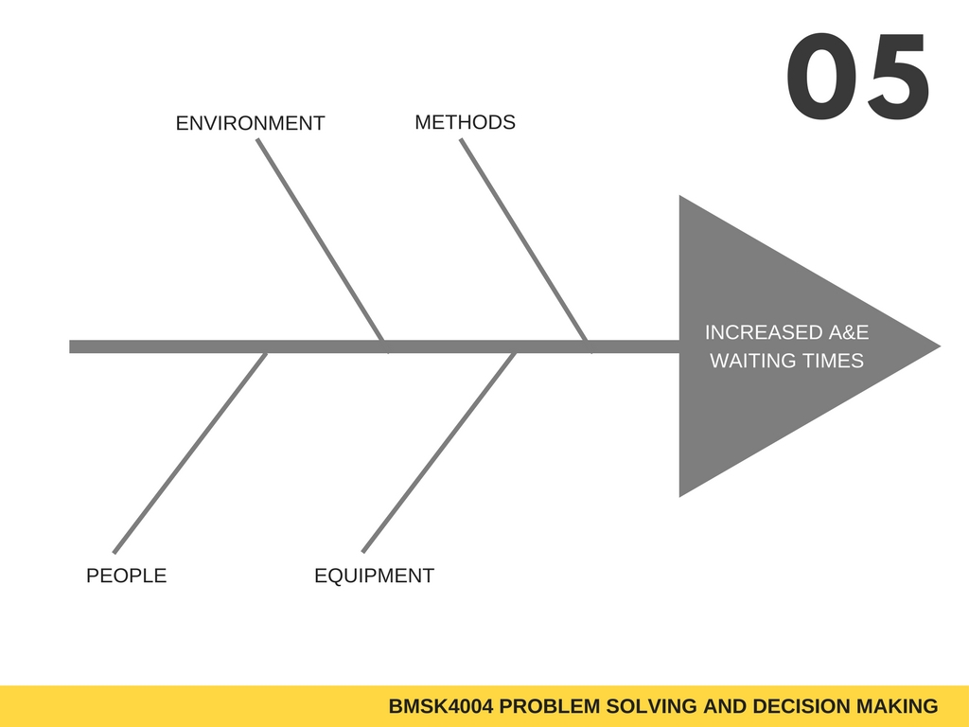
Furthermore, Juran’s model is used by organisations to look at the view point of the customer, analysing design, conformance, availability and safety. It does not look at pride and satisfaction, it looks more at technical methods and practicality. According to this model, there are 9 steps to quality improvement:
Sterilisation
Availability
Phone calls
Online
Not enough rooms
Long waiting times
Prioritising
Understaffed
Aging population
Sickness
- Identify who are our customers
- Determine the specific needs of those customers
- Translate those needs into our language
- Develop products that respond to those needs
- Optimise product features to meet our needs too
- Develop processes able to produce the products
- Fine tune and optimise the process
- Improve the process under operating conditions
- Transfer the process to operations

2.2 Organisations CRM Systems
The CRM system is considered very successful in global businesses. Tesco is an example of where CRM is effective for the business. Being the second largest retailer in the world, CRM strategies have played a strong role in its success and gaining high market shares. Tesco has a loyalty card, or more known as a ‘club-card’. This is where ethics come in. Data is securely protected by the Tesco Marketing team, tailoring every individuals needs using the ‘club-card’. This works as customers items are put into the system and the items that are frequently bought, Tesco can then give any discounts or deals on those items and customers will become loyal. Quality of goods is essential for customer loyalty too, Tesco specialise in promoting healthy living by providing over 400 products that are low in sodium and fat. They also have healthy snacks for children, encouraging a more sustainable and healthy future generation. This marketing shows that Tesco is not just about generating high profits, but that also the care it has for its customer’s health. This ensures the customer and brand loyalty. Tesco has many foundations to promote many objectives such as governance and ethics, health and safety and product safety. They have contributed significantly to achieving the Sustainable Development goals by for example, focusing on facilitating food surplus donation programmes in all stores in all regions to provide meals to those in need by 2020. They also plan to source 100% of their electricity from renewable energy sources.
A service that is very successful is EasyJet, with on average 88.5 million customers flying with the aircraft every year. It is evident that the air carrier does analyse its passenger’s data. According to CEO Johan Lundgren, they are looking at data to as it will be the “key to driving efficiency”. Loyal customers create the most value to the company, which creates big opportunities. It will also develop its appeal to customers by allowing business fare bundles and building online booking services available to all. It also looks at improving creativity. EasyJet has its own app, which uses technology recognition to match a passenger’s screengrab of location that EasyJet fly to. This is improving quality, making it easier for passenger’s to be access more information about the next destination they will choose.

Findings

2.3 Identifying within the organisations CRM system ‘gaps’ based around ethics and sustainability

Tesco faced a claim of £4bn in 2012, following a gender pay gap within the organisation. 200,000 employees had been affected. This goes against the company’s ethics such that not everyone is being treated equally. Also, large corporations such as Tesco need to roll out training schedules for all their employees. For large-scale CRMs, this can mean hiring professionals to train employees in groups. Training takes away time for productivity, so it is a disadvantage, and could have more costs to Tesco. The CRM training is also different for managers compared to regular staff, because most CRMs have specialized functions for managers and executives. These extra functions are also required learning. Training time can differ and takes away precious productive time.

3.0 Conclusion

To conclude, Tesco has already got a solid foundation of customer relations. It is able to engage with customers using its data, tailoring each individual’s needs. It also contributes to sustainable objectives, reducing its costs, and increasing customer satisfaction. EasyJet is also on the same wavelength, in terms of creating loyalty for the customers as it is seen as the most valuable to the business. It uses higher quality services such as the app to make information more accessible to customers.

Bibliography

Business Dictionary “Ethics- definition” http://www.businessdictionary.com [online] date accessed: 27th June 2019

Research Gate (2018) “ETHICAL THEORY & BUSINESS A study based on Utilitarianism and Kantianism” https://www.researchgate.net [online] date accessed: 27th June 2019

Investopedia (2019) “Why is Business Ethics Important?” https://www.investopedia.com [online] date accessed: 27th June 2019
Chron (2019) “Ethical theories in business” https://smallbusiness.chron.com [online] date accessed: 27th June 2019

Chron (2019) “Why is Quality important for a Business?” https://smallbusiness.chron.com [online] date accessed: 27th June 2019

Investopedia (2019) “Sustainability” https://www.investopedia.com [online] date accessed: 27th June 2019

GE Report (2014) “Why it Pays For Businesses to Boost Sustainability” https://www.ge.com [online] date accessed: 27th June 2019

Business Dictionary “Quality- definition” http://www.businessdictionary.com [online] date accessed: 27th June 2019
BizFluent (2017) “Ethical Issues in CRM” https://bizfluent.com [online] date accessed: 27th June 2019
CIO (2002) “Privacy and Ethics: Is CRM Too Close for Comfort?” https://www.cio.com [online] date accessed: 27th June 2019
Customer Think (2017) “7 Reasons Why CRM And Sales Are Correlated To Sustainable Business Growth” customerthink.com [online] date accessed: 27th June 2019
Service Objects (2016) “The Importance of Data Quality for CRM” https://www.serviceobjects.com [online] date accessed: 27th June 2019
Expert Market. “Tesco CRM Case Study” https://www.expertmarket.co.uk [online] date accessed: 27th June 2019
Marketing Week (2018) “Easyjet CEO: ‘We want to be the most data-driven airline in the world” https://www.marketingweek.com [online] date accessed: 27th June 2019
Marketing Week (2018)” EasyJet’s new CMO on using data to ‘supercharge creative judgement’ “https://www.marketingweek.com [online] date accessed: 27th June 2019

