
Programme Name: Master of Business Administration
Module Name: Strategic Management,
Module Code: LCMB7003
Assessment component - Individual report

Lecturer’s Name: Hoang Nguyen
Student Name: Dhrumilkumar Ketankumar Patel
Student ID: 2510610
Word Count: 4,974

AI Declaration
I declare that I have not used any form of Generative AI to produce the content for this assignment. All concepts and presentation are my own original work.

Table of Contents
Section 1: Report 3
1. Organisational Context and Overview 3
2. External and Internal Analysis 6
2.1 PESTLE Analysis 6
2.2 VRIO Analysis 9
2.3 SWOT Analysis 12
3. Comprehensive and holistic view of the organisation 15
3.1 CSR Strategy and Alignment with Business Objectives 15
3.2 Balanced Scorecard for P&G’s Ariel 17
4. Strategic Choices and Implementation 20
4.1 Business-Level Strategic Choices 20
4.2 Evaluation of the Recommended Strategy using Ansoff Matrix 20
4.3 Strategic Implementation and Competitive Advantage 22
4.4 Implementation Challenges and Mitigation 23
Section 2: Reflection (Gibbs' Reflective Cycle) 24
Description 24
Feelings 25
Evaluation 25
Analysis 25
Action Plan 26
Conclusion 26
References 28

Section 1: Report

1. Organisational Context and Overview
Procter & Gamble Company (P&G) is a multinational consumer goods company with its headquarters in Cincinnati, Ohio (P&G, 2026). It was established in 1837, when William Procter and James Gamble merged their candle and soap companies. It has been analysed that over more than 185 years, it has developed from these origins into a global leader in the fast moving consumer goods industry. In present the company operates in around 70 countries, exporting its products to around 180 countries and territories (SEC, 2025).
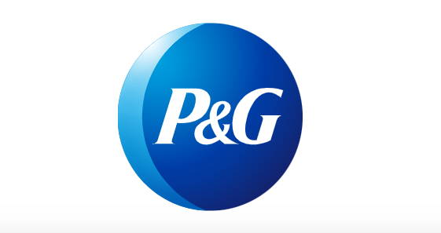
Figure 1: P&G Logo
(Source: P&G, 2026)
P&G's mission, as directed by its purpose, is to improve consumers' lives for present and future generations through the provisioning of branded products and services of superior quality and value (P&G, 2026). A wider vision of the company can be seen in its ambition to provide better services to its customers compared to those provided by its closest competitors in the areas where it operates. This orientation provides a framework for integration and enhanced product, productivity, innovation and effectiveness within the organisation.
The company P&G runs a brand-led business model in the consumer packaged goods industry. Its investment areas include R&D in connection with product development and improvements. Marketing investments result in creating brand awareness and consumer loyalty (P&G, 2025). Further, channels to consumers include supermarkets and mass merchandisers, pharmacies, membership clubs, distributors, e-commerce, and direct consumers. Its portfolio categories are grouped into five operating sectors such as Beauty, Grooming, Health Care, Fabric and Home Care, and Baby, Feminine and Family Care (P&G, 2025).
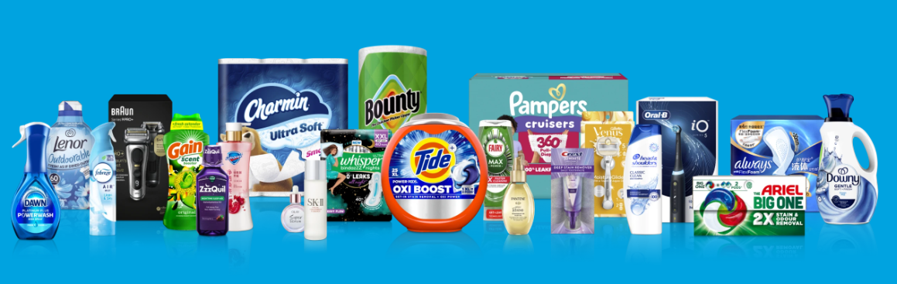
Figure 2:P&G Portfolio
(Source: P&G, 2026)
The industry is very competitive, and P&G has a number of branded competitors, both global, regional and local, as well as the retailers' own private labels. The key competitors across categories are Unilever, Colgate Palmolive, Reckitt and Kimberly Clark, and the competitive intensity varies from one category to the other and from one market to the other (Consultancy UK, 2021). Despite all this, P&G still holds a solid market position, as it has been analysed that its net sales for fiscal year 2025 were $84.3 billion, while nine out of its ten product lines saw organic growth (P&G, 2025). This indicates it as a global FMCG leader that holds leadership and substantial market share in numerous segments. This report focused on Ariel in the UK, as it supported the company with category growth and achieved 10% awareness independently.
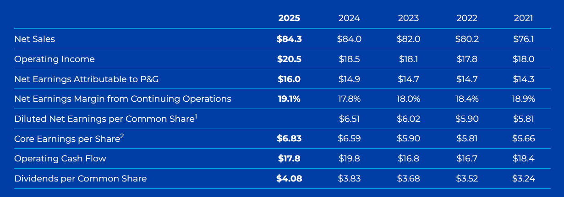
Figure 3: P&G Finacials
(Source: P&G, 2025)

2. External and Internal Analysis

2.1 PESTLE Analysis
Factor | Analysis of UK laundry detergent industry | Opportunity or Threat
Political | - UK packaging policy is shifting the burden from consumer to producer for waste generated by packages.  - The Extended Producer Responsibility for Packaging places a responsibility on the liable producers to contribute to the disposal of household packaging waste (Santana, et al., 2025)  - The base fee for plastic packaging was set at £423 per tonne for the period of 2025-26, and the fee from 2026 will be rolled up based on recyclability (GOV UK, 2025). | Threat: Additional packaging costs and compliance requirements.  Opportunity: More recyclable packaging can reduce future exposure and strengthen sustainability.
Economic | - Household spending is still being impacted by UK inflation. In June 2026, the CPI inflation rate was 2.6%, down from the 2.8% rate recorded in May (ONS, 2026).  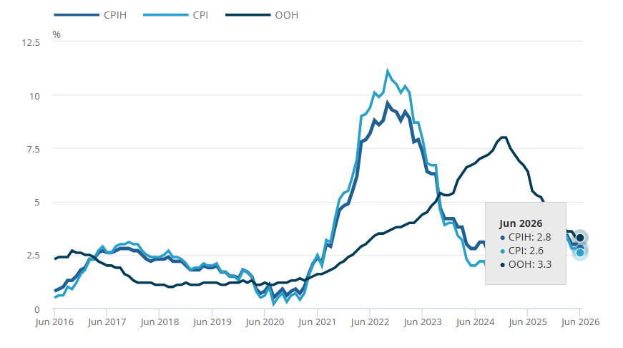  Figure 4: CPIH and CPI annual inflation rates  (Source: ONS, 2026)  - Household goods prices fluctuated over the year, indicating limited scope for manufacturers to depend on general market price increases (ONS, 2026).  - Laundry detergent is a staple household item, and when buying basic, consumers can compare brands, products and retailer options (Kholod, et al., 2023). | Threat: Price sensitivity can encourage switching towards cheaper alternatives.  Opportunity: Strong product performance can justify premium positioning.
Social | - Expectations of consumers are not limited to just the efficiency of cleaning alone. It has been analysed that 75% of UK consumers were not fully satisfied with their laundry experience in terms of stain removal, freshness and overall effectiveness (Fisher, 2024).  - Homeowners are also urged to wash clothes at cooler temperatures to save home energy (Shirani, et al., 2022). Such behaviours increase the need for detergents that continue to perform well even when the washing habit changes. | Threat: Brands that fail to respond to changing expectations may lose relevance.
Technological | - Detergent technology is gaining significance when it comes to providing more cleaning functionality in easy-to-use product formats.  - There is innovation in combining the concentrated ingredients of detergent in a larger POD format (Morán-Durán, et al., 2026).  - An improvement in technology can make branded detergents different from cheaper alternatives. | Threat: Competitors can develop alternative formulations and formats.
Legal | - The retained Detergents Regulation applies to detergents sold in Great Britain. Requirements range from biodegradability agents and ingredient details, to labelling and exposure to fragrance allergens (HSE, 2026).  - Domestic laundry detergents also have restrictions on their phosphates.  - Another legal issue arises when considering environmental marketing as this is subject to consumer protection law, and the CMA offers guidance on avoiding misleading green claims (GOV UK, 2021). | Threat: Compliance increases the need for testing, transparent information and careful marketing.  Opportunity: Strong compliance can support consumer trust.
Environmental | - In laundry, environmental pressure can be caused by either the material waste generated in packaging, or the energy consumed during the washing process.  - The UK Plastic Packaging Tax targets packaging made of plastic that is below 30% recycled plastic, and charges it £228.82 per tonne starting in April 2026 (GOV UK, 2026).  - There is also an urge to lower temperature washing among consumers (Shirani, et al., 2022). Therefore, sustainability in the detergent market may relate to product performance in consumers' washing machines. | Threat: Packaging regulation can increase costs.

2.2 VRIO Analysis
Resource or capability | Valuable | Rare | Difficult to imitate | Organised | Competitive implication
Ariel brand strength and established UK market position | Yes | Yes | Partially | Yes | Strong competitive advantage
P&G's R&D and proprietary detergent technology | Yes | Yes | Yes | Yes | Sustainable competitive advantage
Product innovation and consumer insight capability | Yes | Partially | Partially | Yes | Temporary competitive advantage
Retail distribution and execution capability | Yes | No | No | Yes | Competitive parity
Financial resources and global scale of P&G | Yes | No | No | Yes | Competitive parity
Strength and market position of Ariel brand: It has been analysed that as a reputed brand, Ariel has a significant competitive edge in the UK market. P&G defines Ariel as one of its key Fabric Care brands and states that it has good performance in its FY2025 annual reporting (P&G, 2025). The launch of Ariel The Big One generated more than 40% of Fabric Care category growth following its introduction (P&G, 2025). The company also claims the innovation achieved 10% unaided awareness in nine months (P&G, 2025). Brand recognition can be used to lower consumer uncertainty and help with the rollout of new products. However, since Ariel's brand position is believed to be partially difficult to imitate, major competitors can build strong brands over a period of time through marketing strategies and product performance. Therefore, this creates an advantage, however, the brand is not sufficient to create a sustainable advantage.
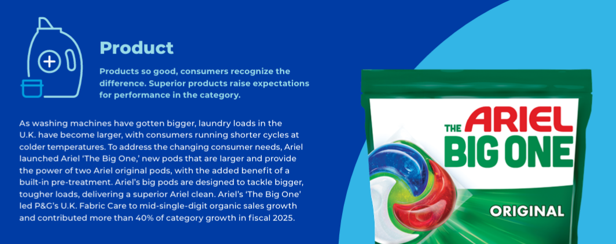
Figure 5: Ariel Performance
(Source: P&G, 2025)
R&D and proprietary detergent technology: It has been analysed that P&G's R5D capabilities support it in maintaining a sustainable competitive advantage. The capital expenditure for P&G's FY2025 R&D was around USD 2.1 billion, showcasing the company's dedication towards product development. Moreover, Ariel The Big One contains a patented fibre structure, which allows for more detergent without the slow dissolving issue. This ability is useful and relatively uncommon, and patents, technical knowledge and accumulated R&D experience make it more difficult to imitate. Additionally, P&G's manufacturing and commercial expertise is available to take these innovations to market. This indicates that proprietary detergent innovations can fulfill the VRIO criteria.

Product innovation and consumer insight: It has been observed that Ariel's ability to fulfil consumer needs provides a temporary competitive advantage. P&G conducted research prior to creating The Big One and found 75% of consumers were not happy with their laundry experience at all (P&G, 2025). The resulting product focused on cleaning performance, freshness and convenience. This is a valuable innovation as it relates consumer problems to innovation. However, the competitors may also do consumer research and come up with new formulations. Therefore, advantage is dependent upon its ability to identify needs and respond faster and better than other companies.
Retail distribution and execution: P&G has built strong relationships with established retailers, and they have been able to control product availability, merchandising and promotion for its products (P&G, 2024). This ability can be beneficial as it is essential for laundry products to have strong access to both physical and online retail networks. However, competitors such as Unilever already have wide distribution channels as their FMCG companies (Unilever, 2026). Therefore, the distribution network provides a partial competitive advantage.
Financial resources and scale: P&G's global footprint enables Ariel to invest in R&D, manufacturing, marketing and technology. It has been observed that its net sales and operating cash flow in FY2025 were $84.3 billion and $17.8 billion, respectively (P&G, 2025). Among this, 40% was contributed by the fabric care category. However, financial scale is common amongst the key multinational FMCG competitors, and is easily replicable in other large organisations. It therefore creates competitive parity, and provides added value when integrated with Ariel's brand and proprietary technology.

2.3 SWOT Analysis
Strengths | Weaknesses
- Established Ariel brand with strong UK presence  - Access to P&G's R&D and proprietary detergent technology  - Strong ability to convert consumer insights into product innovation  - P&G's financial resources support product development and promotion | - Premium value proposition can face pressure from price-sensitive consumers  - Dependence on continuous innovation to maintain differentiation  - Distribution and financial scale are not unique against major FMCG competitors  - Environmental impact extends into packaging and consumer product use
Opportunities | Threats
- Growing importance of effective low temperature washing  - Product innovation addressing unmet laundry needs  - Packaging redesign and concentrated product formats  - Digital retail channels for consumer reach and engagement | - Consumer switching towards lower priced branded or own label alternatives  - Increasing UK packaging costs and environmental requirements  - Strong innovation capability among established competitors  - Cost pressures affecting the ability to maintain consumer value
Strengths: The combination of being a well-established brand in the UK and P&G's R&D has been analysed as being the main strength for Ariel. The strategy is more significant than brand recognition alone because it enables Ariel to create products to meet evolving consumer trends and this strength is demonstrated by Ariel The Big One. The product launched after P&G had discovered dissatisfaction with the existing laundry experiences (P&G, 2025). Further, this was able to gain 40% share growth for the UK Fabric Care category (P&G, 2025). This means that Ariel has the ability to take consumer feedback and technical knowledge and turn it into commercial results.
Weaknesses: The competitive advantage of Ariel is highly dependent on creating differences between itself and alternatives available in the market. It has been analysed that distribution, financial scale and digital capability were assets but not uncommon, as other large FMCG firms have such assets. This indicates that the brand cannot rely only on the size of P&G to sustain its competitive advantage. The company's emphasis on improving the quality of its products may prove to be a liability when it comes to cost considerations (P&G, 2025). This is important in the UK today, with household budgets having an impact on purchases.

Opportunities: It has been analysed that sustainability could bring business opportunities where there is a connection between sustainability and consumer benefits (Hassan, et al., 2026). In this regard, cold washing is very appropriate here since it will lead to lower energy usage at home but still provide better performance for Ariel (P&G, 2021). It has been observed that innovations in detergent technology that deliver good performance at lower washing temperatures could bring environmental gains and savings to households. Further, UK packaging policies also create an opportunity to develop concentrated formats and more recyclable packaging (Santana, et al., 2025). This can help decrease package exposure rates, as well as strengthen Ariel's environmental positioning.
Threats: Price sensitivity represents an important threat because laundry detergent is an essential product with many substitutes. The consumer may switch from one premium brand to another and from the label of the product to the supermarket, without changing the basic purpose of the purchase (Ermecke, et al., 2026). This creates pressure on Ariel to justify the extra cost in terms of clear performance benefits. In addition, the UK's Extended Producer Responsibility (EPR) system forces packaging manufacturers to cover the costs of packaging disposal, and the Plastic Packaging Tax banned packaging with below minimum recycled content (Santana, et al., 2025). These can make packaging efficiency more important and result in cost increases.

3. Comprehensive and holistic view of the organisation

3.1 CSR Strategy and Alignment with Business Objectives
P&G's overall citizenship and environmental sustainability strategy contributes primarily to Ariel's CSR approach (P&G, 2024). P&G puts environmental sustainability within the four pillars that support its integrated growth strategy, besides supply chain, digital capability and employee value. The company sees responsible business as a means to enable sustainable growth and shareholder value. This results in a clear strategic alignment since its growth strategy is to build value for consumers, customers, employees, society and shareholders (P&G, 2026).
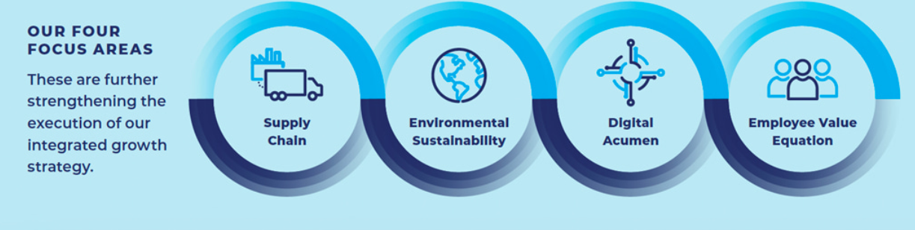
Figure 6: P&G Focused Area
(Source: P&G, 2026)
The environmental sustainability factor is important in the case of Ariel due to its production process along with packaging and usage processes that affect its impact on the environment. Ariel has been encouraging colder washing practices with its Wash Cold Challenge as reflected in the figure below (Ariel, 2026). This helps to achieve environmental objectives since lower washing temperatures may save energy. On the other hand, there is the competitive advantage that comes with reduced cost due to lower energy usage. However, that is dependent upon its ability to deliver consistent cleaning at the lower temperature. The consumer may not change their laundry habits if they feel that washing at lower temperatures decreases the efficacy of the wash (Saija and Daniotti, 2025). Thus, environmental value should not only be based on sustainability claims, but also on the functionality of the products.
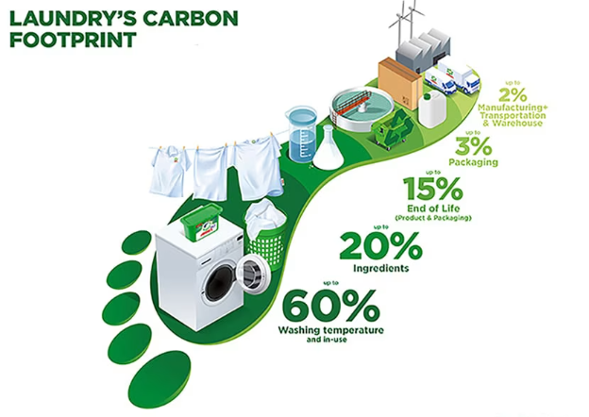
Figure 7: Ariel Empathisis on Laundry Footprint
(Source: Ariel, 2026)
Product and packaging responsibility also connects with Ariel's business goal of providing best value. P&G says it includes sustainability in its products, packaging and operations, and sustainable sourcing includes the use of resources over the whole life cycle of the product, from production to use (P&G, 2026). Concentrated detergent formats may offer good cleaning effectiveness, with reduced product and package usage, for Ariel (Ariel, 2026). However, the UK regulatory landscape is increasingly moving beyond using packaging sustainability as a CSR exercise to incorporating it as a commercial obligation (HSE, 2026; GOV UK, 2021). Considering this, the brand needs to ensure that environmental improvements fulfill legal obligations for creating differentiation as well as sustainability.
Consumers' responsibility and product safety should have equal consideration since Ariel products are commonly used in households. P&G has policies on Product Safety and Responsible Sourcing and Business Conduct (P&G, 2026). This helps with the business goals of Ariel, as trust is crucial for a well-known brand to gain consumer trust. However, to ensure trust constant transparency will be required when it comes to ingredients, product usage and environmental claims. If there is a gap between what is promised by the product and what is delivered in practice, the value of the brand may be undermined. Corporate social responsibility primarily occurs through P&G as opposed to Ariel individually. P&G brings citizenship to communities, employees and broader society (P&G, 2023). This would indirectly enhance the reputation of Ariel and thus attract skilled labour. However, there is no direct relationship between CSR investment and the competitive position of Ariel. Therefore, CSR investment will only create the most value for the brand when it helps improve the performance of its products as well as create environmental benefits.

3.2 Balanced Scorecard for P&G’s Ariel
The Balanced Scorecard is a helpful tool to evaluate whether the company's strategy is delivering value in each of the various areas of performance or just sales volume (Michalski, 2024). There are four perspectives in which financial outcomes are influenced by consumer acceptance, whereas the innovation process and employee competencies determine whether Ariel will be able to sustain its advantage.
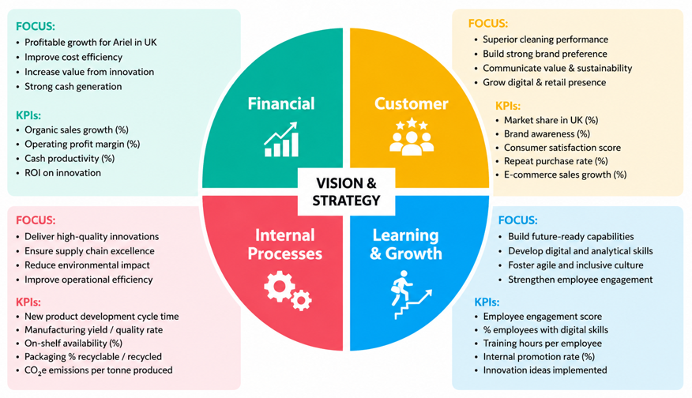
Figure 8: Balanced Scorecard for P&G Ariel
(Source: By Author)
Financial perspective: The financial goal should be to maximise value, productivity and growth as reflected in the figure above. For example, Ariel The Big One helped P&G's Fabric Care business increase organic sales by mid-single digits and accounted for over 40% of the category growth for FY2025 (P&G, 2025). Therefore, the target should be to maintain positive growth while increasing the contribution of successful innovations. However, the brand needs to consider the price sensitivity of UK consumers, and it should be achieved primarily by increased sales, not by increases in prices to maintain good relationships with consumers (Saija and Daniotti, 2025). Further, increases in productivity must help in investment and cost control.
Customer perspective: It has been evident that in today’s market dynamoc the consumer have multiple options to choose from in the FMCG industry. This highlights a key issue for Ariel as it perfromance will able to maintain consumer preference or not. In this context, the company has been examined to be active as it analyse consumer preferences and offers products as per that. For example, P&G discovered that 75% of consumers were not completely satisfied with their laundry experience when it comes to stain removal and freshness. This creates an opportunity, but initial awareness or trial does not demonstrate long-term success. Satisfaction, repeat purchases, and market share are factors that need to be looked at together to make any product successful in the market (Belhaj, et al., 2025). In addition, repeat sales are significant because they will also reflect whether or not consumers find enough value in Ariel's performance to continue buying it over other brands and lower prices.
Internal Business Processes: The goal should be to transform customers' needs into innovations as quickly as possible and with the highest possible efficiency. Automation and advanced algorithms are already in place at P&G throughout manufacturing, where they enhance product quality and productivity (P&G, 2026). The KPIs for Ariel should include innovation speed, quality, reliability of the supply, and improvement in packaging. This is crucial, as better performance must be accomplished without any extra cost or impact on the environment.
Learning and Growth: It should focus on measuring the capabilities that will ensure success in the future rather than solely focusing on employee behaviour. P&G is increasing digitalisation while moving towards smaller teams with broader skills and greater responsibility (P&G, 2025). In this regard, connecting consumer insight, R&D, sustainability, data, and commercial decision-making is the primary need for the brand. For instance, measures such as digital skills, implementation of ideas from employees, and internal development could determine whether the firm is developing capabilities that will support the development of future Ariel products.

4. Strategic Choices and Implementation

4.1 Business-Level Strategic Choices
At the business level, Ariel can adopt either a cost leadership or a differentiation strategy to compete in the UK laundry detergent market. Cost leadership is achieved by providing products at a lower price through lower production and operating costs (Jerab and Mabrouk, 2023). This approach can be effective for price-sensitive buyers but not for Ariel as supermarket own-label products and lower-price brands will already have significant market presence in the UK. Moreover, a rising trend in consumer value consciousness introduces a challenge for premium brands to compete on price (McKinsey and Company, 2026).
Differentiation is based on the idea of providing distinct value that customers are ready to pay for (Noor, et al., 2025). It has been found that Ariel enjoys the advantages of P&G's approach of ensuring product superiority through constant innovations of products to address changing consumer needs (P&G, 2025). Previous analyses have also highlighted innovation and sustainability as major opportunities whereas UK customers have become more demanding when it comes to efficient, convenient and eco-friendly products. Therefore, differentiation is the most suitable strategy for Ariel. Ariel can enhance their premium-market positioning and customer loyalty by optimising their product performance, sustainable packaging and washing with low temperatures. This approach will allow the brand to position itself in the UK market through value offered over price, thus reinforcing its competitiveness over the market.

4.2 Evaluation of the Recommended Strategy using Ansoff Matrix
The Ansoff Matrix helps organisations find opportunities for growth by analysing the combination of their existing or new products with their existing or new markets (Peterdy, 2022). The 4 strategic options for Ariel in the UK are Market penetration, Product development, Market development and Diversification.

Ansoff Strategy | Application to Ariel (UK) | Suitability
Market Penetration | Increase sales of existing Ariel products through promotions and retailer partnerships. | High
Product Development | Introduce improved detergent formulations, sustainable packaging and innovative product formats for UK consumers. | Very High (Recommended)
Market Development | Expand Ariel into new geographical markets. | Low
Diversification | Enter new product categories beyond laundry care. | Very Low
It has been analysed that product development is the most suitable strategy for Ariel. Continuous product development has become vital to the UK laundry detergents industry as a result of consumer demand for sustainability, convenience and innovation (Chaudhary, 2026). Similarly, a market development strategy is not feasible as this report is focused on the UK market whereas Diversification will entail Ariel entering into new markets which will involve more risk.
Product development closely matches Ariel's existing capabilities. As it was established during the VRIO analysis, the most valuable strategic resource of P&G is the ability to develop new products which are hard to replicate by rivals. Ariel The Big One exemplifies the concept of product innovation through its ability to satisfy changing customer needs through better cleaning effectiveness of heavier laundry loads (P&G, 2025). In addition, the PESTLE and SWOT analysis revealed that customer value, effective low-temperature washing and an increased demand for sustainable packaging were the potential growth drivers. Thus, by constantly continuing to innovate products, Ariel is able to meet those evolving demands and reinforce its high-market image. Ariel's ambition of becoming a leader in sustainable and innovative product solutions for current UK householders can boost customer satisfaction, retention and long-term competitive growth.

4.3 Strategic Implementation and Competitive Advantage
A proactively implemented product development can be a tool to support Ariel's competitive edge in the UK market by constantly improving product quality, sustainability and customer value. According to Barney, (1991), the Resource-Based View states that a firm is successful in the long run when management uses valuable and hard-to-imitate resources appropriately (Kero and Bogale, 2023). The capability of P&G in research and development, along with comprehensive detergent technologies and sustainable product solutions, has been analysed as Ariel's strengths.
In order to make sure that the strategy works well, Ariel needs to continue developing advanced formulas for detergents and producing recyclable products. These are designed to address consumer expectations in the UK for high-performance and environmentally conscious products (Whistl UK, 2026). Meanwhile, digital marketing and partnerships with retailers should be reinforced to raise consumer awareness and prompt product trial, especially with the launch of innovations. A successful implementation is expected to result in improved market share, better customer retention and premium pricing. These results will benefit Ariel financially and improve the company's competitive edge in the UK detergent industry.
The introduction of Ariel 'The Big One' in the UK provides an example of how product innovation leads to competitive advantage by satisfying changing consumer needs for greater cleaning (P&G, 2025). The value proposition is also continuously evolving, making it more challenging for competitors and supermarket own brands to keep up with Ariel. The VRIO analysis suggests that proprietary technology coupled with P&G research capabilities is a sustainable competitive advantage when supported with strong brand image and market implementation. Thus, a successful product development strategy will help Ariel build customer loyalty, gain a position in the premium market while creating sustainable long-term growth in the UK market.

4.4 Implementation Challenges and Mitigation
Implementation Challenge | Mitigation Strategy
High research and development costs may increase operating expenses. | Prioritise high-impact innovations and leverage the global R&D network of P&G for cost efficiency.
Consumers may be resistant to adopting new detergent products or formats. | Strengthen digital marketing using promotions and advertisements to improve awareness, engagement and decision-making (Kismo and Lahindah, 2024)
Competitors may quickly introduce similar innovations. | Continue investment in technologies and make regular product enhancements for differentiation (Gutterman, 2023)
Increasing environmental regulations may require packaging and product changes. | Invest in recyclable packaging and sustainable product development to ensure compliance and build brand reputation (Jain, et al., 2021)
Through continuous innovation and marketing, the problem mentioned above can be addressed in order for the product development strategy of Ariel to succeed. This will contribute towards sustaining the competitive advantage of the brand and its sustainable growth in the UK market.

Section 2: Reflection (Gibbs' Reflective Cycle)
The Gibbs' Reflective Cycle is a six-step model which includes description, feelings, evaluation, analysis, conclusion and action plan framework (McLeod, 2025). The model challenges people to consider what they have been doing in a critical way, what they have learned and how they can do better the next time. I have used Gibbs' Reflective Cycle to reflect on the process of researching, analysing and preparing this strategic management report on P&G in the UK market.
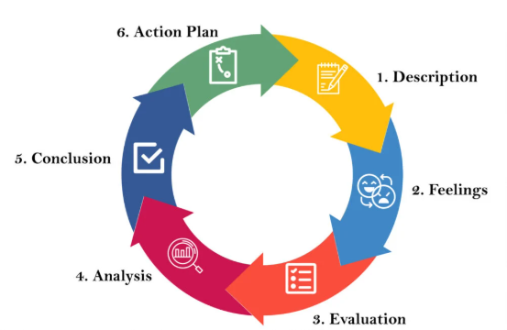
Figure 9: Gibbs' Reflective Cycle
(Source: McLeod, 2025)

Description
The first thing that had to be done was to understand what was required before requesting information to be gathered. My first idea was to examine the Procter & Gamble (P&G) organisation. However, after analysing the brief of the assignment, I found out that the report needed an analysis of a specific product in one geographical market. Therefore, I selected Ariel in the UK. The information was obtained from the P&G Annual Report, the P&G UK website, UK government publications and academic literature. Once I gathered the evidence, I used it to analyse Ariel's external environment, internal capabilities and strategic position using PESTLE, VRIO, SWOT, Balanced Scorecard and Ansoff Matrix. Finally, I combined the findings to propose a differentiation approach with product development.

Feelings
I initially had no reason to doubt the strategic management models as I had studied them in the past. I was not sure which evidence should be chosen that specifically referred to Ariel and not the broader P&G business. It was equally difficult to link several strategic frameworks together without repeating ideas along the way. The more I continued my investigation, the more I felt confident in my work, since I knew how each framework adds to the analysis. This enabled me to structure the report more effectively and come up with recommendations based on evidence rather than assumptions.

Evaluation
I considered my research and preparation to be successful as I used credible academic and organisational resources. Reliability and validity are recognised to be important in doing valid and useful research since they can ensure accuracy and consistency in the results obtained from measuring devices (Sürücü and Maslakci, 2020). The strategic frameworks also helped me to consider ariel different approaches rather than just one analytic framework.
Although I had these strengths, I faced many difficulties as well. I gathered more information than necessary regarding the global operations of P&G, but it was also hard to stay critical because innovation and sustainability came up multiple times in various frameworks. The review and revision of the report enabled me to exclude unnecessary details and ensure that the frameworks provide unique perspectives for the recommendation.

Analysis
Reflecting on the process, it became clear to me that strategic analysis is not only about applying the business models properly. The usefulness of each framework is dependent on how findings are interpreted and connected to organisations' objectives. Effective strategic management is said to necessitate an alignment of internal resources and external opportunities and threats in strategic decision-making (Alharbi, 2024). This enabled me to identify a connection by linking the findings of the VRIO, SWOT and PESTLE analyses rather than talking about them separately. Therefore, it suddenly became more reasonable and supported with evidence to work with differentiation strategies in product development.
I also developed my abilities to think critically as a result of the research process. Initially, I took the company's data for granted without realising its strategic value. However, comparing the company's reports to academic journals, I was able to assess Ariel's weaknesses and strengths in a more objective manner. Reflective practice is recognised as facilitating deeper learning within learning communities as they critically reflect on experiences and transfer that understanding to new ones (Bassot, 2023). This helped me to improve my analysis and gain confidence in guiding people to make strategic decisions.

Action Plan
In future tasks, I will set the range of my research before gathering the data. I will create a research plan that connects all the strategic frameworks to relevant academic and organisational resources. I also hope to look at multiple perspectives from academic sources to enhance critical thinking rather than focusing primarily on company sources alone. Additionally, I will give myself enough time to read my writing, edit, make better transitions from section to section and eliminate repetitions. These will improve quality, consistency and critical depth of my future strategic management reports.

Conclusion
This assignment helped me to understand strategic management and enhance my research, analytical and report writing skills. I was more confident in finding evidence relevant to the topic, using strategic frameworks and making recommendations based on theory and practical examples. Even though there were problems in determining the research focus and repeating myself, they made me develop my critical thinking skills and realise the significance of linking the results of analysis.

References
Alharbi, I.B. (2024) Strategic management: A comprehensive review paper. International Journal of Professional Business Review: Int. J. Prof. Bus. Rev., 9(3), p.8.
Ariel. (2026) About Ariel: Innovation and Ultimate Clean in Laundry Care [Online]. Available at: https://www.ariel.co.uk/en-gb/about-ariel/about-us [Accessed on: 29 July 2026]
Ariel. (2026) The life cycle assessment – the backbone of Ariel’s commitment to reduce its carbon footprint [Online]. Available at: https://www.ariel.co.uk/en-gb/about-ariel/sustainability/ariel-life-cycle-assessment [Accessed on: 29 July 2026]
Bassot, B. (2023) The reflective practice guide: An interdisciplinary approach to critical reflection. Taylor & Francis.
Belhaj, F.A., Hazaea, S.A., Mareeh, H., Saroha, S.K., Raid, M. and Hael, M. (2025) Management strategies to enhance the competitive advantage through customer satisfaction. TEM Journal, 14(3), p.2217.
Chaudhary, T. (2026) UK Laundry Detergent Pods Market. [Online]. Available at: https://www.marketresearchfuture.com/reports/uk-laundry-detergent-pods-market-46353 [Accessed on: 30 July 2026].
Consultancy UK. (2021) The world's 40 largest fast moving consumer goods companies [Online]. Available at: https://www.consultancy.uk/news/26874/the-worlds-40-largest-fast-moving-consumer-goods-companies [Accessed on: 29 July 2026]
Ermecke, K., Mergner, N., Brüggemann, P. and Olbrich, R. (2026) Mind the Gap—An Empirical Analysis of the Attitude‐Behaviour Gap in Grocery Retailing. Journal of Consumer Behaviour, 25(2), pp.785-799.
Fisher, A. (2024) UK public washing their clothes too often, says major laundry brand [Online]. Available at: https://www.theguardian.com/environment/2024/sep/21/uk-public-washing-their-clothes-too-often-says-major-laundry-brand [Accessed on: 30 July 2026]
GOV UK. (2021) Plastic Packaging Tax: steps to take [Online]. Available at: https://www.gov.uk/guidance/check-if-you-need-to-register-for-plastic-packaging-tax [Accessed on: 30 July 2026]
GOV UK. (2025) Extended Producer Responsibility for Packaging: 2025 base fees [Online]. Available at: https://www.gov.uk/government/publications/extended-producer-responsibility-for-packaging-2025-base-fees/extended-producer-responsibility-for-packaging-2025-base-fees [Accessed on: 30 July 2026]
Gutterman, A.S. (2023) Research and Development. Available at SSRN 4582785.
Hassan, B., Majid, M.B., Aslam, M.Z., Zaman, S. and Sabir, M.R. (2026) From concern to consumption drivers of green consumer behavior in the sustainability era. Discover Sustainability, 7(1), p.566.
HSE. (2026) Detergents in Great Britain [Online]. Available at: https://www.hse.gov.uk/detergents/detergents-guidance.htm [Accessed on: 30 July 2026]
Jain, P., Chou, M.C., Fan, F. and Santoso, M.P. (2021) Embedding sustainability in the consumer goods innovation cycle and enabling tools to measure progress and capabilities. Sustainability, 13(12), p.6662.
Jerab, D. and Mabrouk, T. (2023) Achieving competitive advantage through cost leadership strategy: Strategies for Sustainable Success. Available at SSRN 4574945.
Kero, C.A. and Bogale, A.T. (2023) A Systematic Review of Resource-Based View and Dynamic Capabilities of Firms and Future Research Avenues. International Journal of Sustainable Development & Planning, 18(10).
Kholod, M., Mokrenko, N., Celani, A. and Puglisi, V. (2023) Choice Modeling of Laundry Detergent Data for Sustainable Consumption. Sustainability, 15(24), p.16949.
Kismo, H. and Lahindah, L. (2024) Designing a Promotion Strategy to Increase Online Sales. Jurnal Manajemen Bisnis, 11(2), pp.1962-1975.
McKinsey and Company. (2026) State of the Consumer 2026: When tech acceleration and cost pressures collide. [Online]. Available at: https://www.mckinsey.com/industries/consumer-packaged-goods/our-insights/state-of-consumer [Accessed on: 30 July 2026].
McLeod, S, (2025) Gibbs Reflective Cycle. [Online]. Available at: https://www.simplypsychology.org/gibbs-reflective-cycle.html [Accessed on: 30 July 2026].
Michalski, D. (2024) Operationalization of ESG-integrated strategy through the balanced scorecard in FMCG companies. Sustainability, 16(21), p.9174.
Morán-Durán, A., Cortés-Robles, G., Juárez-Rivera, O., González-Rosas, M.K., Delgado-Maciel, J. and Grande-Ramírez, J.R. (2026) Integrating TRIZ, QFD, and Evolutionary Analysis for Eco Innovation: Redesigning a Laundry Detergent to Resolve Environmental Contradictions. Applied System Innovation, 9(6), p.129.
Noor, N.A.M., Till, B. and Hafeez, K. (2025). Differentiation Strategies in Competitive Markets. Copyright© 2025 Eurasian Research Institute, 184.
ONS. (2026) Consumer price inflation, UK: June 2026 [Online]. Available at: https://www.ons.gov.uk/economy/inflationandpriceindices/bulletins/consumerpriceinflation/june2026 [Accessed on: 30 July 2026]
ONS. (2026) Household Costs Indices for UK household groups: January to March 2026 [Online]. Available at: https://www.ons.gov.uk/economy/inflationandpriceindices/bulletins/householdcostsindicesforukhouseholdgroups/januarytomarch2026 [Accessed on: 30 July 2026]
P&G. (2021) Can washing your clothes on cold do a world of good? [Online]. Available at: https://us.pg.com/blogs/pg-sustainability-tide-ariel-cold-water-wash/ [Accessed on: 29 July 2026]
P&G. (2024) 2024 Citizenship Report [Online]. Available at: https://us.pg.com/citizenship/ [Accessed on: 29 July 2026]
P&G. (2024) Inside P&G’s Integrated Growth Strategy [Online]. Available at: https://us.pg.com/blogs/integrated-growth-strategy-series/ [Accessed on: 29 July 2026]
P&G. (2025) 2025 Annual Report. [Online]. Available at: https://s204.q4cdn.com/332108499/files/doc_financials/2025/ar/2025_annual_report.pdf [Accessed on: 30 July 2026].
P&G. (2025) A P&G Innovation: Ariel The Big One - Redefining Laundry in 2025 [Online]. Available at: https://www.pg.co.uk/blogs/a-pg-innovation-ariel-the-big-one-redefining-laundry-in-2025/ [Accessed on: 29 July 2026]
P&G. (2025) Accelerating Growth and Value Creation [Online]. Available at: https://us.pg.com/annualreport2025/accelerating-growth-and-value-creation/ [Accessed on: 29 July 2026]
P&G. (2025) Financial Highlights [Online]. Available at: https://us.pg.com/annualreport2025/financial-highlights/ [Accessed on: 29 July 2026]
P&G. (2025) Portfolio: Daily Use, Where Performance Drives Brand Choice [Online]. Available at: https://us.pg.com/annualreport2025/portfolio-daily-use-where-performance-drives-brand-choice/ [Accessed on: 29 July 2026]
P&G. (2026) P&G’s Portfolio [Online]. Available at: https://us.pg.com/annualreport2025/portfolio-daily-use-where-performance-drives-brand-choice/ [Accessed on: 29 July 2026]
P&G. (2026) Policies & Practices [Online]. Available at: https://in.pg.com/policies-and-practices/product-safety-and-compliance/ [Accessed on: 29 July 2026]
P&G. (2026) Purpose, Values & Principles [Online]. Available at: https://us.pg.com/policies-and-practices/purpose-values-and-principles/ [Accessed on: 29 July 2026]
P&G. (2026) The History of P&G’s Gardens [Online]. Available at: https://us.pg.com/cincinnati-hq/ [Accessed on: 29 July 2026]
Peterdy, K. (2022) Ansoff Matrix. [Online]. Available at: https://corporatefinanceinstitute.com/resources/management/ansoff-matrix/ [Accessed on: 30 July 2026].
Saija, M.E. and Daniotti, S. (2025) Assessing European Consumers’ Willingness to Pay for Sustainable Laundry Detergents: A Choice Experiment Approach. Sustainability, 17(8), p.3365.
Santana, J., Magrinya, F. and Maspoch, M.L. (2025) Closing the loop of flexible plastic packaging in Spain: A review of the role of extended producer responsibility and circular economy strategies. Journal of Cleaner Production, 504, p.145139.
SEC. (2025) THE PROCTER & GAMBLE COMPANY [Online]. Available at: https://www.sec.gov/Archives/edgar/data/80424/000008042425000076/pg-20250630.htm [Accessed on: 29 July 2026]
Shirani, F., O’sullivan, K., Henwood, K., Hale, R. and Pidgeon, N. (2022) Living in an active home: Household dynamics and unintended consequences. Buildings and Cities, 3(1), pp.589-604.
Sürücü, L. and Maslakci, A. (2020) Validity and reliability in quantitative research. Business & management studies: an international journal, 8(3), pp.2694-2726.
Unilever. (2026) WEF recognises business impact of Unilever’s supply chain tech investments [Online]. Available at https://www.unilever.com/news/news-search/2026/wef-recognises-business-impact-of-unilevers-supply-chain-tech-investments/ [Accessed on: 29 July 2026]
Whistl UK. (2026) Consumer Purchasing Grows Greener. [Online]. Available at: https://www.whistl.co.uk/research/consumers-grow-greener-their-purchasing-decisions [Accessed on: 30 July 2026].

