Can Inference Squares improve pupil outcomes in KS3 Science?

Contents
Can inference squares improve pupil outcomes in KS3 Science? 1
Literature review 5
School Policy and Practice 7
Methodology and Ethics 8
Results 10
Evaluation 13
Conclusions 15
Limitations and further developments 17
Bibliography 18

Figure 1 Form Time literacy activity 18
Figure 2Close the Gap system 18
Figure 3 Pupils Stop Think Action & Reflection (STAR) Task 19
Figure 4 On Track Review (OTR) 19
Figure 5 Inference square sheet 19

Introduction
Literacy levels in Wales have been described as low. This was highlighted following the outcomes of PISA testing in 2009 in which PISA described outcomes as low when compared to an international perspective, the report makes reference to English and Science results in which 24% pupils failed to achieve a level 2 qualifications. (Schleicher, 2014) This has led to the highlighting of literacy and scientific literacy as a national issue where again Wales fares worse, with significantly lower results, than the rest of the United Kingdom. (Dale, 2016) . Schools have sought to address this area recognizing the benefit of improving scientific literacy. The impact of poor scientific literacy has also been shown by pupils’ poor performance in Quality of Extended Response (QER) writing at GCSE level. Based on both of these pieces of information it is beneficial at a national, school and pupil level to develop pedagogical techniques to improve pupils’ scientific literacy skills to allow them to achieve good outcomes individually; at a school level due to the current categorization of the school and nationally in PISA Questions.
School X has recently been visited and inspected by ESTYN and within the report they reflected on pupils’ literacy levels and state that “few pupils produce well crafted, carefully structured writing, demonstrating a clear sense of purpose and audience. However, a minority of pupils make frequent basic errors in their written work. These pupils’ writing lacks control and they often make poor language choices. They often produce only brief and underdeveloped responses.” (ESTYN, 2019) Furthermore, the report goes on to say that “A few pupils use inference and deduction effectively”. The inference from both of these points is that the majority of pupils have or make poor use of their literacy skills, this could mean that pupils fare poorly when answering PISA or QER style questions. Therefore, if scientific literacy levels could be improved then GCSE outcomes in Science would improve.
In order to test a method to develop pupils’ scientific literacy skills, inference and deduction techniques, an inference square was used with a group of 32 learners. At the time of undertaking the testing the pupils were in School X’s upper 60% of pupils based on ability. Most of these pupils should be able to respond well to QER/PISA questions if they have strong skill set with good scientific literacy abilities. If they do not have strong scientific knowledge it is hoped the inference square will help them to achieve a better outcome.

Literature review

There has been a strong focus on literacy in Wales within recent years, during this period the National Literacy and Numeracy Framework was produced (Welsh Goverment, 2013). The aim of this document was to address the priority of raising standards of Literacy and Numeracy in schools in Wales. The importance of Literacy is also something that is being addressed and focused on in England (Ofsted, 2013) . Within Ofsted’s work they look at the importance of literacy in helping pupils succeed within a school environment and possible strategies that can be used. However, they conclude that of the schools that they have looked at there is no one strategy used in all schools but a range of approaches. This shows the need to find a method that will work within Science for school X.
The definition of literacy is wide and varied and being literate is a constantly evolving term which can vary from a narrow focus of being able to read and write to a wider area (Cambridge Assessment , 2013). However, Inglis and Aers (2008, p.32) widen that definition stating that the ability to read and write make someone literate. However, they go on to state that there is a range in fluency for the level at which someone is literate. This is backed up by the work of Blake and Hanley (1995) who also write about the levels of fluency. This definition is expanded on further by the National Literacy Trust which views literacy as “the ability to read, write, speak and listen in a way that lets us communicate effectively and make sense of the world” (The national literacy truct, n.d.).
The importance of high levels of literacy are shown as literacy skills build the ability to read for learning and therefore, allow pupils to identify, understand, interpret, create, and communicate knowledge (Schleicher, 2010) All these skills are essential if the pupils in School X are going to realize their potential. Research shows that improving pupils’ literacy levels has the ability to produce sustained improvements in outcomes for these pupils over their whole school career (Biancarosa, 2010) Improving literacy of pupils also has the ability to help improve the whole school outcomes (Estyn, 2013). In Blake and Hanley’s (1995) work they describe how literacy is one of the key aims of compulsory schooling making reference to the ability to read and write at an appropriate level of fluency. However, there is not a universal standard of literacy or of pupils’ fluency or level of being literate (Lawton, 1996). Therefore, creating high levels of literacy is important in allowing pupils to access and achieve in all their subjects including Science.
In the work of Norris and Phillips (2003) they make the link between literacy and scientific literacy noting that literacy underpins scientific literacy. As with the definition of literacy itself, there is a wide scope of definitions regarding scientific literacy. The term has been used over a large period of time but has not always had the same meaning (Bybee, 1995) . Durant (1994) notes that Scientific literacy is not having a large amount of scientific knowledge but understanding how science works. Norris and Phillips (2003) have tried to give clarity on the definition and set out eleven broad areas that could be encompassed within scientific literacy or have components that make up scientific literacy. It has also been suggested that instead of giving a clear definition of scientific literacy a broader conceptualization should be used to allow school to apply a content that suits their pupils. (DeBoer, 2000). PISA is a prominent assessment tool of scientific literacy, when analyzing the PISA definition of scientific literacy and how this aligns to the assessment approach PISA focuses on testing complex reasoning and the robust understanding of the nature of science. (Sadler, 2009) As the curriculum content is varied this testing assesses the Scientific literacy of the randomly selected pupils.
Program of International Student Assessment (PISA) is a testing model that tests randomly selected fifteen-year-old pupils from member countries in three areas Reading, Maths. and Science. The importance of PISA outcomes has grown to be a strategic tool having an impact on education policy in many member countries despite some evidence of its limitations. (Sjøberg, 2012) (Osborne J., 2017). It is accepted the performance of Welsh pupils in PISA tests are lower than the other home nations and the OEDC. In Science, Welsh pupils achieve scores of 488, below those of pupils in Scotland, (490) less than Northern Ireland, (491) less than England and is below the average score of an OEDC of 489. However, these outcomes represent an improvement over the previous set of results. These results reflect pupils’ ability to utilize their scientific literacy skills to answer questions, therefore scientific literacy is an area that requires national development if Wales is to compare more favorably and continue to increase performance in the PISA testing.

School Policy and Practice

Within the school there is a focus on improving the standards of pupils’ work in lessons which links to the school’s ESTYNS recommendations. Within the school pupils are taught in ability set groups with the highest 60% of ability pupils split into 3 even groups of approximately 33 pupils. The lower ability 40% are split into 2 teaching groups. Within Science lessons pupils are taught 6 one-hour lessons per fortnight. Pupils are taught 6 units over the year, the first is a skills unit and then they learn about Energy, Reparation and Digestion, Patterns of Behavior, Drugs and their Effect and Force, Work and Power. Each unit is concluded with an end of unit test. The units are taught using a standard format across the year from a class PPT backed up with worksheets and practical lessons.
Pupils’ work across the school is marked using two systems. A “Close the Gap” system, within Science this is based on the end of unit tests. Once pupils have completed the end of unit and it has been marked by the class teacher, up to 3 What Went Well (WWW) points are identified. These will be based on where pupils have performed well in the test and several Even Better If (EBI) points. Pupils will then revisit the EBI points by completing additional questions to improve their learning on the EBI points. The pupils’ revision area, where they performed poorly in the test, is called a STAR task. Currently pupils use their books to help them complete the STAR task

Work is also marked on an ongoing basis using an “On Track Review” (OTR) marking system this is an ongoing formative system. Within the context of school X there are two variations of the “On Track Review” marking, one is applied to all subjects except Science, the other is applied to the Science Department. The OTR aims to highlight areas of work that pupils need to revisit within their work. In the Science system a green dot is placed next to a good example of work and a red dot is placed where pupil action is required. Pupils then reflect on what needs to be done to action the red dot. The aim of the system is to ensure pupils knowledge is developed before pupils’ complete end of unit tests.

Within school X there are currently strategies employed to improve pupils’ literacy skills in line with Estyn’s recommendations for the school. All pupils within the school engage in two sessions of literacy-based activities per week, these take place in form time and are based on reading articles and then responding to them. Pupils respond in a number of ways to the articles they have read and then feedback as a group and this is recorded into a grid (Fig1). This is a whole school improvement target. However, it is also important to link improving scientific literacy to improving pupil outcomes. In KS4 scientific outcomes, pupils achieve an average points score of around 36 in school X compared to an average of 42 in the family of similar schools and so strategies to address this gap are important.

Methodology and Ethics
The method employed in this study was the use of an inference square to help improve pupils’ answers to PISA questions. An inference square that will be used will be made up with 3 sections. The inference square is designed to give pupils an opportunity to record everything they know on a subject and then process it down and refine it to answer the question. The 3 sections of the inference square used are; What Information is Given, What Do I Already Know and What Conclusions Can I Make Now. A copy of the inference square is shown in the appendix (Fig 5)
The first stage in the process was to allow pupils to answer a PISA style question on Energy, the topic pupils have been studying this term. Once the pupils have completed the first question, they will be given a second question of a similar level of challenge on the same topic. Pupils will be given some time to read the second question without attempting to complete an answer. Once pupils have read the question they completed the inference squares. The aim of introducing the inference square is to improve pupils’ performance when answering PISA questions. The first section, What Information is Given is to act as a tool to allow pupils to stop and analyze the question, this should increase the number of pupils who recall what knowledge is needed to answer the question later in the exercise. As well as extending the opportunity for pupils to fully analyze the information provided within the question this will allow pupils to select what information is required to produce a good answer to the question. This section of the inference square should support all pupils in the group as (Le Hebel F., 2016) shows that less able learners will pick superficial aspects from the given information whereas their more able peers are able to select and discard information. Based on both (Cerdán, 2011) and (Le Hebel F., 2016) one limitation of this work is that it is focused on pupils in the upper 60% of the ability range and potentially the use of inference squares has potential to have a higher impact in lower ability groups.
Pupils then worked to write down what they knew that they could use to answer the question and reflected on what conclusions they could draw.
Pupils worked to develop an answer using the information required and the knowledge they already had into in the conclusion section of the inference square, in this section they summarized the key points and information that they will include when answering the PISA question
The structure of the lesson was set up as an introduction and explanation work taking place followed by pupils taking the pre-test under test conditions. The inference square was then explained to pupils. The post test was given to pupils and after reading it they completed the inference square in a step by step style followed by completing the post test induvial under test conditions. In the introduction section of the lesson it was clearly explained to the pupils that completing the pre and post- tests along with the inference square was a compulsory learning activity. Any pupils who did not wish to have their test data included in the work could have it withdrawn if they did not consent to being part of the study. Setting the work up in this way was beneficial at it avoided spreading the work over two lessons which would have given potential for pupils to be absent for either the pre or post-tests.
As it was the first time that the pupils where using the inference square it was explained to pupils during the lessons and used in a step by step manor within the lesson, this is a limitation within this work as an alternative approach could have been to familiarize pupils with the inference square before they completed it and used it in the post test however this was not possible within the time constraints of the school curriculum.
Once pupils had completed the inference square, they complete a post-test question, this was again a PISA style question of a similar level as the first question to ensure a fair test. It was decided not to use the same question as pupils had not seen the pre-test question prior to answering it and this need to be repeated to ensure a fair test with the post test. In order to keep the test fair no revision was carried out in the lesson as this could have affected the outcome of the tests. If revision had taken place at the start of the lesson pupils may have retained this information for the pre-test at the start of the lesson but, by the time they had read the post test, completed the step by step inference square and taken the post- test they may have forgotten the revision material. The time constraints on the activity also made it hard to complete revision within the one-hour session. Pupils were not allowed access to their books at any point in the lesson as if they had used their books to complete the inference square which was then used in the post test this would be unfair as pupils would not have had the opportunity to look through their books after receiving the pre-test. This kept consistency of not looking at pupil books after seeing the question for both the pre and post-test.

To ensure the test was fair a standard mark scheme was used when marking the work and all marking was carried out by the same person.

Results
Of the 31 year 8 pupils who took part in the study 2 asked to have their data removed from the results so the outcomes are based on 29 pupils. The PISA sample tasks have a total of 5 marks available.
Across the 29 pupils whose data was used there was an increase in the performance when answering the post-test question. The average improvement was 0.34 marks however the improvement range span from -1 mark to 2 marks. In the post test 10 pupils managed to improve the post-test marks.

Evaluation
Overall the results show that the same set of pupils performed better in the post test than pre-test on the same day in the same lesson, however it is not completely possible to say that this is as a result of the inference square task. However, it is a reasonable assumption to make as no Science knowledge had been taught between the pre-test and post-test. It would be hard to argue that pupils scientific knowledge has improved therefore the assumption could be made that the inference square had allowed them to access and answer the PISA questions in a way that allowed them to achieve a higher mark in the post test. As can be seen from the results this is a small improvement in performance in a small sample, however, set against the context of School X if this strategy could be replicated through to GCSE it would show a positive shift for 35% of the co-hort. The one pupil (3.5%) whose result was poorer in the post test could be viewed as an anomaly as neither their scientific literacy nor scientific content knowledge could have become worse after completing the inference square., So it could be assumed that they had put less effort into the pos- test than the pre-test. As can be seen from the data the improvements made by pupils were modest, but this is against a single 5-mark question and if this modest improvement could be replicated across a whole GCSE paper to cumulative effect of achieving extra marks it could be seen as more positive.
Despite the pupils having already sat one end of unit test the skills covered by the inference square have never been taught to the pupils in Year 8 Science lessons, the study shows that having the scientific literacy skills to answer questions raises pupil performance. The inference square provided pupils with the scaffolding to analyze the information wit in the question in a way that allowed them to improve their performance.
One area of weakness in this study was the use of PISA sample questions, although both questions where of a similar level of difficulty and on the same topic area of Energy they assessed different parts of the unit. Therefore, this introduced an inconsistency into the work, and this is something that would need to be developed further in a larger scale project. This is a weakness as there are a limited number of sample questions available so two on the same topic area were selected to keep as much consistency as possible. The testing and use of the inference square had to be kept brief due to the fact the testing is not part of the normal program of study for Year 8 and used lesson time which had a knock-on effect on the delivery of the same curriculum as peers in the term.
The inference square used was one that was selected as a simple intervention to scaffold and support pupils when answering PISA style questions. Another area of weakness in this work was the time spent with pupils reflecting on how an inference square works. If this study was to be taken further time could be spent completing an example inference square with pupils. This was not possible due to time constraints in this initial work, however now the positive impact can be seen it could be successfully argued that it would be a worthwhile use of pupil learning time to complete worked through examples of inference squares. This could form a plenary activity at the end of the lesson, or a starter task based to recall knowledge of the previous lessons. This has the potential to be expanded with peer checking and improvements to inference squares and could still be effective even if pupils did not use the inference square to answer the question.
The use of an inference square was a rational decision when focusing on improving scientific literacy as research has shown it is of fundamental importance to raise literacy to improve scientific literacy (NORRIS SP, 2002). Given that the inference square has the ability to improve the outcomes for 35% of pupils it could be argued that further work needs to be done to support the development of scientific literacy to move School X towards the average points score performance of similar schools.

Conclusions
As a result of the work undertaken it is suggested that the use of an inference square improves pupils’ scientific literacy and as a result improves pupil answering and outcomes for pupils when completing PISA questions. It can be concluded that the inference square underpins the modest rise in performance as it supports pupils with scientific literacy skills which allow them to use their scientific knowledge more effectively when answering questions. It has been concluded that the inference square was the driver for improved pupil performance as it is the only intervention activity between pre and post-test.

Based on the ability of intervention to improve pupils’ performance in testing it is important for School X to look at ways this could be used to support pupils to improve their outcomes in tests and their GCSE outcomes. One area where it may be possible for school to develop and improve is during the form time literacy activities. Currently pupils read given texts and answer/ respond as a class, this current system could be evaluated and compared to an alternative where pupils in Years 9,10 and 11 work to complete questions using a scaffolding method such as inference squares. In time pupils could be given a question and work in vertically aged groups to complete the inference square and produce an answer, these could then be peer marked. This would improve the pupils’ ability to use the inference square and improve the pupils’ exam techniques. A limitation to this strategy would be that pupils would have to focus on core subjects over the orbital subjects as these are areas of commonality. However, the skills being learned and refined are transferable and likely to have a positive impact on outcomes across the students range of subjects. This could be of particularly high importance in the context of school X as ESTYN have identified improving literacy as a key part of school improvement (Estyn, 2013). The benefit of this, would have to be measured against the loss of the current form time literacy strategy. In order for this to take place School X would need to evaluate if the current strategy is effective or if it was used as a vehicle to implement form time literacy which is now imbedded into School X and can these foundations be built on to provide a better experience for pupils and improve their outcomes.

It could be concluded that within AoLE’s where end of unit tests are used as part of the Close the Gap marking scheme and pupils complete a STAR task based on areas of the test where they performed poorly, the inference square has the ability to be used to scaffold how pupils’ work in the STAR task. Le Hebel F., (2016) states that the inference square has the potential to be more effective with lower ability pupils however this has not been tested in this work, but it shows its potential for use across the school. Pupils could use their own book or a peer’s high-quality notes to complete the inference square. This could then be reflected on either at a class or a peer level using a strategy such as think pair share to ensure that the mistakes made in the original test have been resolved and knowledge gained. Then pupils could work independently to re do the question or a similar question covering the same knowledge. This could be of significant benefit to school X as currently the majority of pupils make superficial responses to marking or do not respond at all to marking (ESTYN, 2019) this strategy would ensure that pupils are engaging with the feedback they are given but also scaffold improvements in their performance and allow them to make these improvements through peer and independent working.

If it is decided that inference squares are not an appropriate to be used as a form time literacy task School X could review how pupils are taught the literacy skills to access exams and, if this is prevalent enough within the school, as outcomes at GCSE are below that of similar schools. School X will also need to carry out research into the most effective methods of improving subject literacy such as scientific literacy as this work has been limited to inference squares and there may be more effective methods to improve scientific literacy. These need to be identified, trailed and compared to inference squares to ensure an effective way forward is planned and implemented. To look at examples of good practice and effective methods and tools to raise scientific literacy School X may need to look outside of Wales as there has limited success in introducing methods to improve Science literacy among young learners. (Dale, 2016) equally if the success of the inference square can be replicated it would appear to show how effective it is against a negative trend.

Limitations and further developments

Throughout this report and in particular when evaluating the data and concluding the report has acknowledged the limitations of the small scale study both in time and pupil numbers and that the test has not been repeated to see if it replicable as well as several other limitations within the methodology used.

The first area of the methodology that has limited the confidence in the result is the use of two different questions for the pre and post-test. As these were taken from the PISA documents some pupils may have had greater knowledge when answering one of the questions, however as the test are for scientific literacy and not subject content this should not have affected the pupils ability to answer either the pre or post-test question but could have affected their attitude to answering the question. An alternative approach of using two questions on the same focus could have been deployed however this would have not allowed authentic PISA questions to be used which could also of negatively affected the work.
The second area of the methodology that was limited was the completion of both questions in the same lesson, some pupils marks went down when completing the second question this could be due to having completed the first question they may not have applied themselves in the same way for the second question. This could have been avoided by completing the question in the first half of two consecutive lessons, however this could have created comparability issues if pupils had been away for either the first of second test.
A further limitation may have been allowing pupils to access their exercise books before both tests. In the pre-test pupils read through and re-caped on the Energy section in the post test pupils completed the Inference Square with their books, in some cases the quality of work in pupils’ books may have affected how effectively they could revise or complete the inference square. If this test was to be repeated on a larger scale, pupils could be given performance revision packs to remove this bias.

Another limitation is the limited sample size which did not feature across the ability spectrum, the focus was on just 32 pupils in the higher end of the ability spectrum and further work would need to be undertaken to see if this work is replicable both within the upper ability groups with this year groups and other year groups and in lower ability groups.

Bibliography
Biancarosa, G. B. A. a. D. E., 2010. Assessing the value-added effects of literacy collaborative professional development on student learning. The elementary school journal, 111(1), pp. 7-34.
Blake, D. a. H. V., 1995. Dictionary of Educational Terms, Arena: s.n.
Bybee, R., 1995. Achieving scientific literacy.. The science teacher, 62(7), p. 28.
Cambridge Assessment , 2013. What is literacy? An investigation into definitions of English as a subject and the relationship between English, literacy and ‘being literate’, s.l.: s.n.
Cerdán, R. G. V.-A., 2011. Selecting information to answer questions: Strategic individual differences when searching texts. Learning and Individual Differences, 21(2), pp. 201-205.
Dale, G., 2016. The Current State of Scientific Literacy in Wales. [Online]
Available at: https://research.bangor.ac.uk/portal/en/theses/the-current-state-of-scientific-literacy-in-wales(cf1ed798-0c12-4f5a-8e52-2365a30d7c4d).html
[Accessed 29 02 2020].
Dale, G. J., 2016. The Current State of Scientific Literacy in Wales. s.l.:Prifysgol Bangor University.
DeBoer, G., 2000. Scientific literacy: Another look at its historical and contemporary meanings and its relationship to science education reform. Journal of Research in Science Teaching: The Official Journal of the National Association for Research in Science Teaching, 37(6), pp. 582-601.
D, R., 2007. Handbook of Research on Science Education. 1st Edition ed. s.l.:Routledge.
Durant, J., 1994. What is scientific literacy?. European Review, 2(1), pp. 83-89.
Estyn, 2013. Twelve secondary school improvement journeys, Cardiff: s.n.
ESTYN, 2019. Report following monitoring Level of follow-up: Significant Improvement The Greenhill School, s.l.: Estyn, Her Majesty’s Inspectorate for Education and Training.
Gormally, C. B. P. H. B. a. A. N., 2009. Effects of inquiry-based learning on students' science literacy skills and confidence.,. International journal for the scholarship of teaching and learning, 3(2), p. 2.
Hughes, M., 2003. . Exchanging knowledge between home and school to enhance children's learning in literacy and numeracy.. The Home School Knowledge Exchange Project Team.
Hurd, P., 1998. Scientific literacy: New minds for a changing world. Science education, 82(3), pp. 407-416.
Inglis, F. a. A. L., 2008. Key Concepts in Education, London: Sage.
Lawton, D. a. G. V., 1996. Dictionary of Education, Hodder and Stoughton: s.n.
Le Hebel F., M. P. T. A., 2016. Which Answering Strategies Do Low Achievers Use to Solve PISA Science Items?. Insights from Research in Science Teaching and Learning, Volume 2, pp. 237-252.
McGregor, D. & Kearton, G., 2010. What Do Researchers Say about Scientific Literacy in Schools?. Education in Science, Volume 240, pp. 22-23.
NORRIS SP, P. L., 2002. How Literacy in Its Fundamental, s.l.: University of Alberta, Edmonton, Alberta, Canada.
Ofsted, 2013. Improving literacy in secondary schools: a shared responsibility, s.l.: s.n.
Osborne J., O. M. S. M. S. S., 2017. he PISA Science Assessment for 2015 and the Implications for Science Education: Uses and Abuses. Cognitive and Affective Aspects in Science Education Research. Contributions from Science Education Research, Volume 3.
R.W., B., 1997. Towards an understanding of scientific literacy.
Sadler, T. a. Z. D., 2009. Scientific literacy, PISA, and socioscientific discourse: Assessment for progressive aims of science education.. Journal of Research in Science Teaching: The Official Journal of the National Association for Research in Science Teaching, 46(8), pp. 909-921.
Schleicher, A., 2010. Assessing literacy across a changing world. 328(5977), pp. 433-434..
Schleicher, A., 2014. Improving Schools in Wales: An OECD perspective. [Online]
Available at: http://www.oecd.org/education/Improving-schools-in-Wales.pdf
Sjøberg, S., 2012. PISA: Politics, fundamental problems and intriguing results. Recherches en Education, Volume 14, pp. 1-21.
Tanner, H. a. J. S., 2013. Developing Mathematical Literacy in Welsh Secondary Schools. Cylchgrawn Addysg Prifysgol Cymru/University of Wales Journal of Education, 16(1), pp. pp.21-36.
The national literacy truct, n.d. What is literacy. [Online]
Available at: https://literacytrust.org.uk/information/what-is-literacy/
[Accessed 29 02 2020].
Welsh Goverment, 2013. National Literacy and Numeracy Framework, s.l.: s.n.

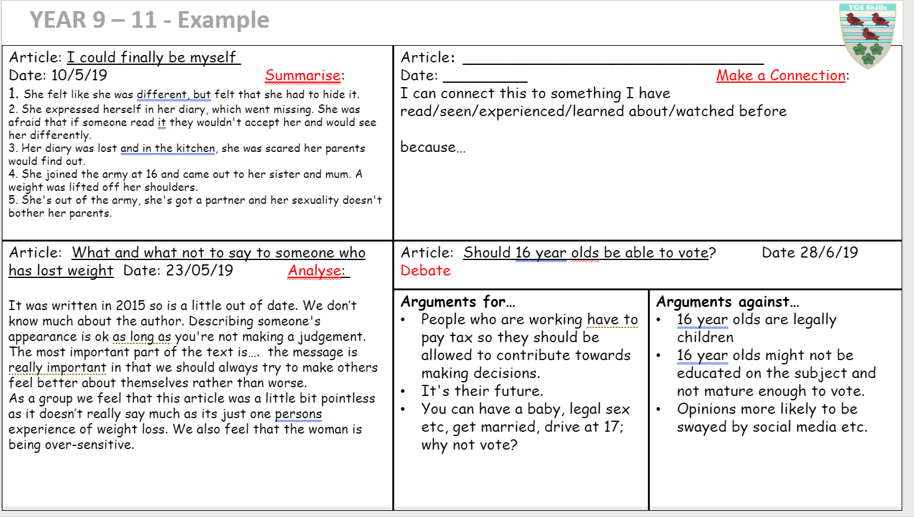
Figure 1 Form Time literacy activity

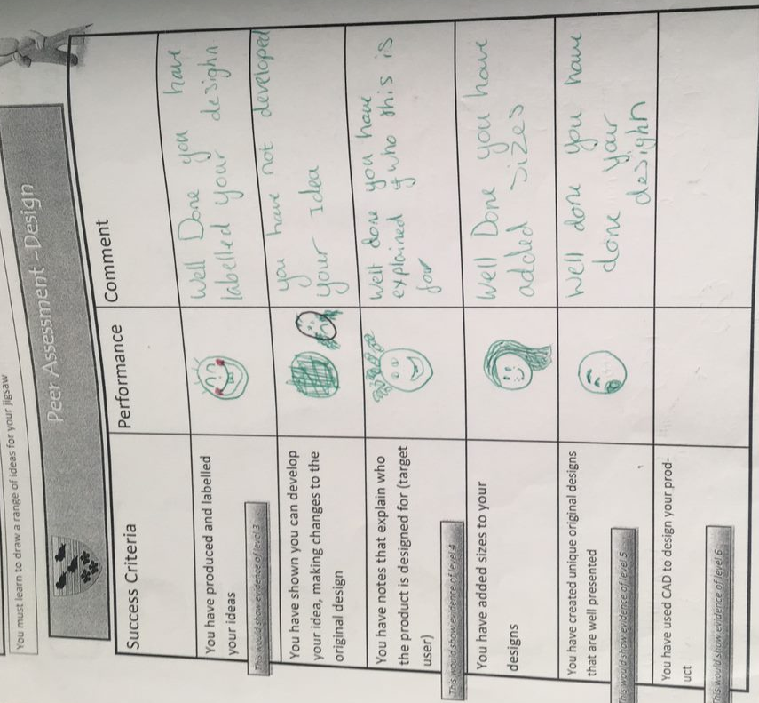
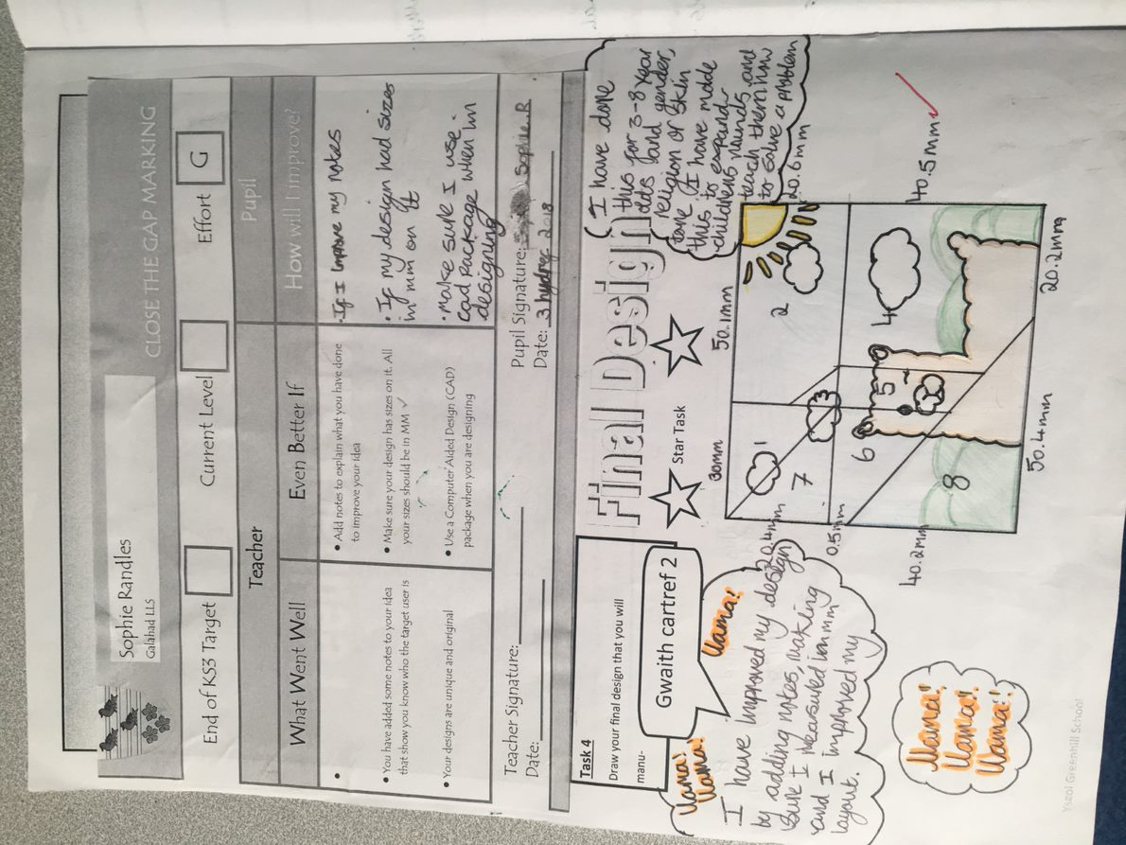
Figure 2Close the Gap system
Figure 3 Pupils Stop Think Action & Reflection (STAR) Task
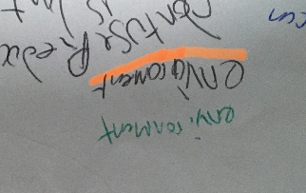
Figure 4 On Track Review (OTR)
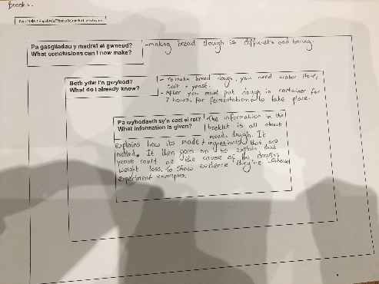
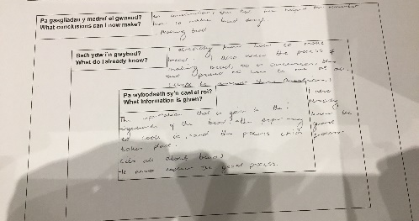
Figure 5 Inference square sheet
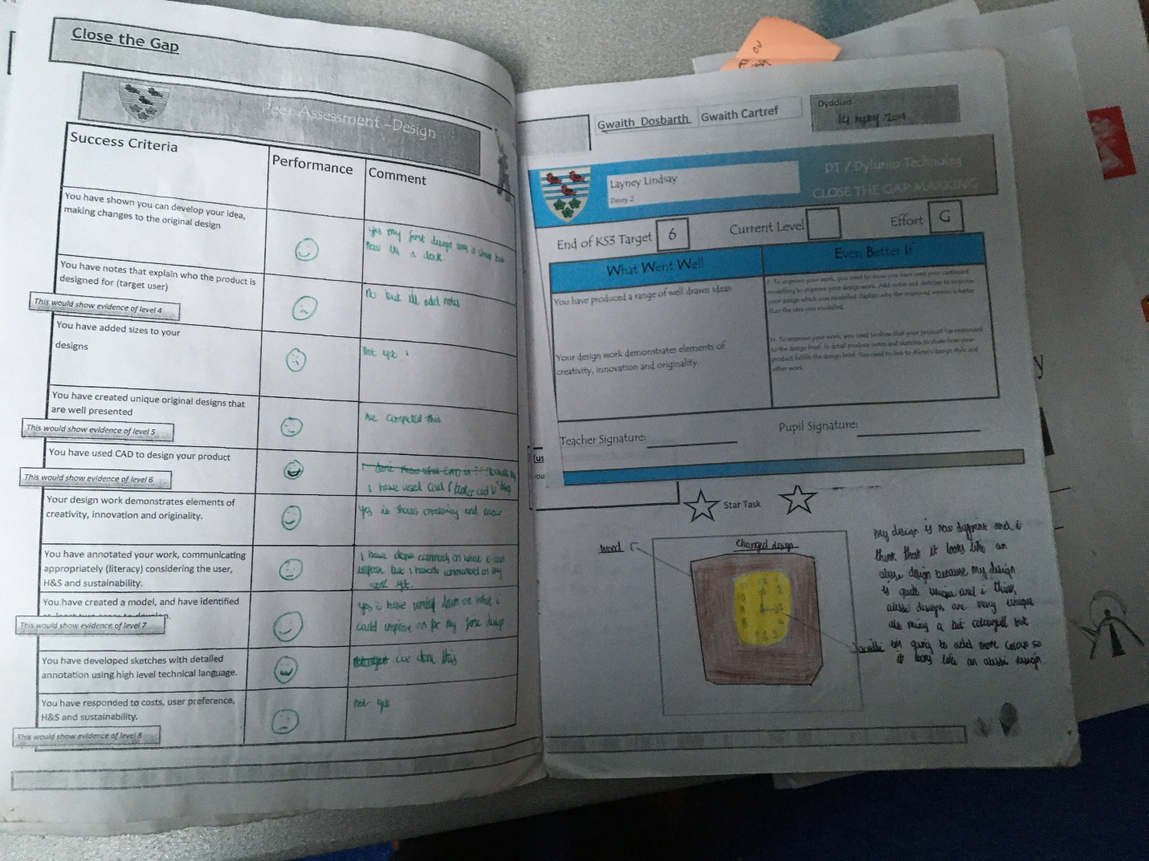

Figure 6 Example of pupils work

