Assignment Title: An Essay: A comparison of the marketing methods of two multinational hotel brands.
Name: Mindruta Persida Ciurar
Student ID number: 2118661
Module: Marketing Essentials BMIH4005
Lecturer name: Luciana Suardi
Word count 1491

Table of Contents
1 Introduction 3
2 Main Body 3
3 Conclusion 6
4 References 7
5 Appendices 9
5.1 Appendix A: Geographic Distribution of the two hotels 9
5.2 Appendix B: Comparison of the two Hotels 10
5.3 Appendix C: Six Senses Demographic Distribution 10
5.4 Appendix D: Six Senses Marketing using Facebook 11
5.5 Appendix E: Moxy marketing via Instagram 12

Introduction
In the modern era, the word “Marketing” has gained significant attention and refers to the attempt a company makes to learn and engage with the target audience (Desai and Vidyapeeth 2019). It is also a way to disseminate information about the product and services being offered and to tailor the specific needs and wants of the customer. The aim of the essay is to shed light on the marketing activities of the two hotel brands, Six Senses and the Moxy Hotel and compare their marketing strategies. Six Senses was established in 1995 with the vision to provide customers with a beyond destinations experience and disconnect them from worldly stresses and reawaken their senses. The brand, over the years, has gone through rigorous expansion and delivered holistic treatment to integrate a wellness philosophy into its operations (Six Senses, 2023). Contrary to this, Moxy Hotel is a relatively new brand of Marriott, established in Milan, Italy, in 2014. The brand serves with a combination of approachable services, contemporary and stylish designs, affordable pricing and the latest technology. It provides a new way of travel and tourism to the customer (Moxy Hotel 2023). Both these multinational hotel brands differ in their services and marketing tactics which will be analysed throughout the essay.

Main Body
The marketing mix of Six Senses Hotels and Moxy Hotels varies in several aspects. In terms of product, Six Senses has a more luxurious and exclusive offering with a focus on wellness, service, and sustainability. Their rooms feature natural materials and organic amenities, while their spas offer a variety of treatments and services (Zhang et al., 2020). This is slightly different compared to Moxy’s more budget-friendly and modern spaces. Their rooms feature modern decor and amenities, while their restaurants and bars provide a fun and lively atmosphere. In terms of pricing, Six Senses is more expensive than Moxy, although both offer customer-friendly payment options. Six Senses focuses on creating a memorable customer experience, whereas Moxy focuses on fast, efficient service. In terms of distribution, Six Senses has a global presence, located in some of the most desirable destinations in the world, including Turkey, with a traffic share of 13.63%, the US- 9.8%, Brazil-5.47% and the UK- 5.23%. In comparison, Moxy is mainly found in the United States, with a traffic share of 30.2% and in the UK, with a share of 15.09% (Refer to Appendix A).
Lastly, considering the promotional aspects, Six Senses uses print and digital ads, while Moxy is heavily focused on digital advertising. Six Senses also has a larger presence on social media than Moxy. According to Similar Web (2023a), the marketing channel overview has been provided in Appendix B. from the comparison graph; it is evident that the majority of the traffic for Six Senses and Moxy comes from organic search. For Six Senses, the organic search traffic has grown by 22%, whereas for the Moxy Hotel, the organic search is trending down. Besides this, for the Six Senses, the traffic source from Google search Engine is approximately 56.15%, whereas slight traffic also comes from the social media channels such as Facebook.
In terms of the segmentation, targeting and positioning of the two brands, the use of the STP model is made. Segmentation is the process of dividing a market into distinct, homogeneous subgroups of customers (Akkaya 2021). Six Senses Hotels and Resorts employ segmentation strategies such as targeting travellers who are looking for luxury experiences and who have disposable income. They focus on providing a unique experience that is tailored to each individual guest. Based on the findings of the Similar Web (2023b), the target audience of Six Senses comprises 52.41% of male participants, whereas 47.59% of females. In addition, about 36.23% of the people visiting Six Senses Hotel belong to the age group 25-34 (Appendix C). This is indicative of the fact that the majority of the customers of Six Senses belong to a younger age group who travel to enjoy their life or for business purposes. Comparatively, Moxy Hotels target travellers who are budget-conscious and looking for a "fun and vibrant" experience. In terms of positioning, Six Senses positions itself as a luxurious and sustainable hotel, while Moxy positions itself as a fun and affordable hotel. They strive to create a unique and memorable experience for their guests.
Besides this, Sharma (2021) provided that there is a significant boom in sustainable choices, and consumers prefer to make their purchase decision with a responsible and sustainable brand. Therefore, the sustainable approaches of the two brands are also discussed to shed light on their marketing strategies and approaches. Six Senses, in 2017, took the initiative to launch Earth Lab at each of its hotels. The focus of the Earth Lab is to showcase the ways in which the brand is reducing consumption and emphasising producing locally by extending the utmost support to the ecosystem and the community. In 2018, the brand launched Grow with Six Senses to allow young adults and kids to learn via natural play and enjoy mindfulness, yoga, physical activities, sustainability, local culture and social experiences (Stombelli 2020). In 2020, when travel was at a standstill, Six Senses focused on a solution-oriented approach and supported mental and physical resilience via in-house experts. They made use of digital content to connect with people. The use of Facebook, Instagram and Twitter helps the brand to keep the customer engaged and connected with the latest update. The majority of the marketing communication of Six Senses is to promote sustainable approaches and a focus on reducing packaging waste (Appendix D).
Contrary to this, according to Core Hospitality (2021), Moxy Hotel has been awarded a sustainability certificate based on responsible resource consumption and having a positive impact on the personal health and well-being of the customer. The focus of the hotel brand is to be a recognised brand that lowers global carbon emission and offer a better quality of life. However, the marketing communication channels used by Moxy Hotel are limited as it entirely focuses on word-of-mouth marketing (Cismaru and Iunius 2019). The parent company of Moxy, Marriott Hotel, is enough for the popularity of the hotel brand. The hotel has an active presence on Instagram, Facebook and YouTube. From the Instagram page of Moxy (Refer to Appendix E), less engaging content is visible. This can be witnessed through the number of likes and comments on the post of the brand.
Additionally, Manishimwe et al. (2022) provided that for the success of a hotel, employing a customer-centric approach is important and should be kept at the heart of every decision and function. However, this has been reflected in the services of Six Senses hotel, which specifically tailors the needs of the guest and ensure that they feel respected, valued and heard. The hotel allows the customer to raise their opinions and ensure that they cater for their needs as per their demand. This is an effective part of marketing. Padma and Ahn (2020) provided that a guest that leaves a hotel satisfied is likely to talk to others about their experience boosting the word-of-mouth marketing of the hotel. This helps elevate consumer traffic to a health and creates positive word-of-mouth. Moxy, on the other hand, ensures to provide the guest with adventure, style and affordability and ensures they capture their memories to be shared with the world. This is a better way of marketing as the guest sharing their experience on social media is more captivating. Moxy has also launched a digital guestbook which allows guest to post their stories on social media. The use of the hashtag #AttheMoxy is an excellent marketing strategy for the brand. Thus, the hotel makes use of a personal approach by keeping the guests at the centre of marketing, allowing them to have control over the content (Backaler 2018).
Nevertheless, based on the identified marketing strategies of the two hotel brands, it is recommended that the two brands should focus on elevating their digital presence. This can be achieved via the use of influencer marketing tactics and by running social media campaigns. The marketing needs to be tailored around the target audience, ensuring that they get obsessed with the beautiful images and the unfiltered guest experience. This will help the brand boost its online presence and create a mesmerising guest experience.

Conclusion
From the overall findings of the essay, it can be said that the two hotels differ significantly, as one focuses on providing a luxury experience, whereas the other emphasises affordability. This means that the Six Senses Hotel consumers possess a higher disposable income, whereas the Moxy Hotel target budget-conscious consumer. The popularity of the Moxy hotel is mainly due to its parent company, Marriott Hotel and is, therefore, more popular amongst UK and US consumers. Contrary, Six Senses mainly generate high traffic from Turkey, US and Brazil. The value of sustainability is equal for both brands, and it is reflected through its operations and services.

References
Akkaya, M., 2021. Understanding the impacts of lifestyle segmentation & perceived value on brand purchase intention: An empirical study in different product categories. European research on management and business economics, 27(3), p.100155.
Backaler, J. and Backaler, J., 2018. Working with influencers: Potential paths to take. Digital Influence: Unleash the Power of Influencer Marketing to Accelerate Your Global Business, pp.119-135.
Cismaru, L. and Iunius, R., 2019. Bridging the generational gap in the hospitality industry: Reverse mentoring—an innovative talent management practice for present and future generations of employees. Sustainability, 12(1), p.263.
Core Hospitality 2021. Moxy Copenhagen is awarded the prestigious sustainability certificate LEED Platinum. [Online] Available at https://www.corehospitality.dk/nyheder/moxy-copenhagen-is-awarded-the-prestigious-sustainability-certificate-leed-platinum/ [Accessed on 4 February 2023].
Desai, V. and Vidyapeeth, B., 2019. Digital marketing: A review. International Journal of Trend in Scientific Research and Development, 5(5), pp.196-200.
Manishimwe, T., Raimi, L. and Azubuike, C.J., 2022. Customer-centric influence of entrepreneurial marketing on business performance of hotels in Nigeria during the COVID-19 crisis. Journal of Revenue and Pricing Management, 21(6), pp.668-683.
Moxy Hotels 2023. Explore Moxy. [Online] Available at https://moxy-hotels.marriott.com/explore/ [Accessed on 4 February 2023].
Padma, P. and Ahn, J., 2020. Guest satisfaction & dissatisfaction in luxury hotels: An application of big data. International Journal of Hospitality Management, 84, p.102318.
Sharma, A.P., 2021. Consumers’ purchase behaviour and green marketing: A synthesis, review and agenda. International Journal of Consumer Studies, 45(6), pp.1217-1238.
Similar Web 2023a. Marketing Channels. [Online] Available at https://pro.similarweb.com/#/digitalsuite/websiteanalysis/traffic-overview/*/999/3m/?category=no-category&webSource=Desktop&key=sixsenses.com,moxy-hotels.marriott.com [Accessed on 4 February 2023].
Similar Web 2023b. Demographics. [Online] Available at https://pro.similarweb.com/#/digitalsuite/websiteanalysis/audience-demographics/*/999/3m?webSource=Total&key=sixsenses.com [Accessed on 4 February 2023].
Six Senses 2023. About Us. [Online] Available at https://www.sixsenses.com/en/about-us/history [Accessed on 4 February 2023].
Stombelli, V.M., 2020. Corporate Social Responsibility in hospitality: are sustainability initiatives really sustainable? Case examples from CitizenM, Lefay and Six Senses. Worldwide Hospitality and Tourism Themes, 12(5), pp.525-545.
Zhang, Y., Xiong, Y. and Lee, T.J., 2020. A culture-oriented model of consumers’ hedonic experiences in luxury hotels. Journal of Hospitality and Tourism Management, 45, pp.399-409.

Appendices

Appendix A: Geographic Distribution of the two hotels
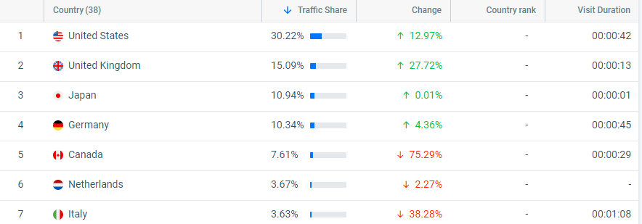
Figure 1: Geographic Distribution of Moxy Hotel
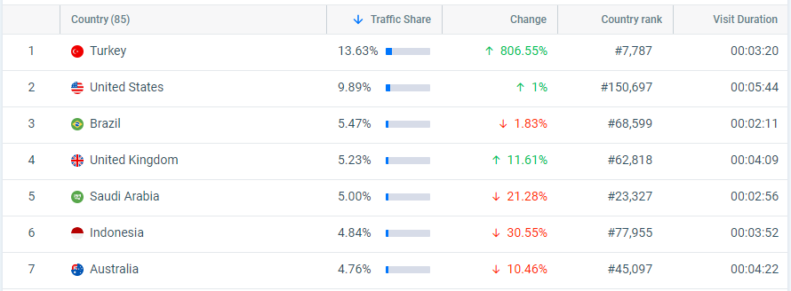
Figure 2: Geographic Distribution of Six Senses

Appendix B: Comparison of the two Hotels
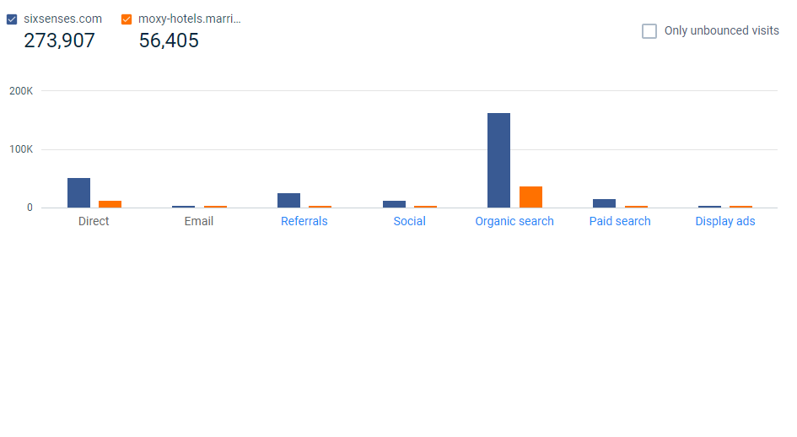

Appendix C: Six Senses Demographic Distribution
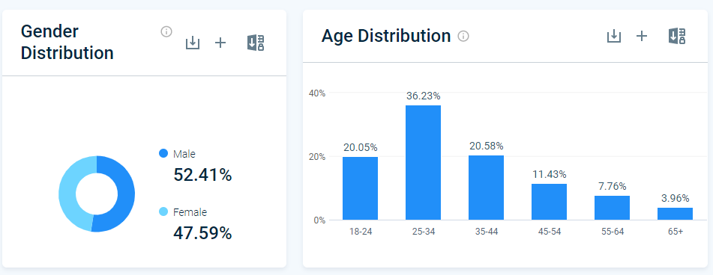

Appendix D: Six Senses Marketing using Facebook
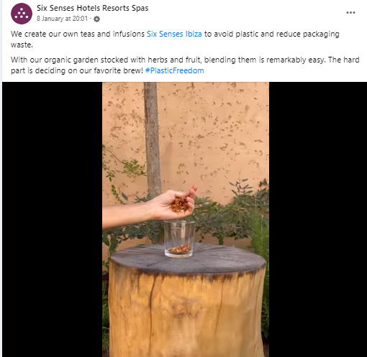

Appendix E: Moxy marketing via Instagram


