9/15/2020
Priyank Patel
University of wales trinity saint david
IOS-BASED MESSAGING APP
BSc Cloud Computing

Table of Contents
1. Abstract 5
2. Introduction 6
2.1 Aims 6
2.2 Objectives 6
2.3 Motivation 6
3. Background reading or Literature Review 7
3.1 Research on the problem domain 7
3.2 Analysis of Tools required 8
3.3 Evaluating existing examples 12
3.4 Software Development Life Cycle 14
4. Analysis 16
4. Requirement Analysis 16
4.1 Functional Requirements 16
4.2 Non-functional Requirements 17
4.3 UML Diagrams 17
4.4 System Requirements 19
4.5 Risk Analysis…………………………………………………………………………..19
5. Design 20
5.1 APP interface/Website CSS template 20
5.2 Storyboard 24
5.3 Database Design 28
6. Implementation 29
7. Testing 36
8. Evaluation 37
8.1 Personal Evaluation 37
8.2 System Evaluation 37
9. Further Enhancement 38
10. Conclusion 39
11. References 40

List of figures
Figure 1: Use case diagram 12
Figure 2: ERD diagram 13
Figure 3: Main Screen Interface 14
Figure 4: Register Screen Interface 15
Figure 5: Login Screen Interface 15
Figure 6: Channels Screen Interface 16
Figure 7: Job Screen Interface 16
Figure 8: Study Screen Interface 17
Figure 9:General Screen Interface 17
Figure 10: Accommodation Screen Interface 18
Figure 11: Linking between main and register Screens 18
Figure 12: Linking between main and login Screens 19
Figure 13: Linking between register & login Screens 19
Figure 14: Linking between login and channels Screens 20
Figure 15: Linking between channels and study Screens 20
Figure 16: Linking between channels and job screens 21
Figure 17: Linking between channels and general screens 21
Figure 18: Linking between channels and accommodation screens 22
Figure 19: Main Screen 23
Figure 20: Register Screen 23
Figure 21: Login Screen 24
Figure 22: Channels Screen 24
Figure 23: General Screen 25
Figure 24: Study Screen 25
Figure 25: Job Screen 26
Figure 26: Accommodation Screen 26
Figure 27:All screens of Mobile chat app 27
Figure 28: Account Screen 27
Figure 29: Database Screen 28
Figure 30: Database design Screen 28
Figure 31: Authentication Screen 29
Figure 32: Code 29

List of tables
Table 1: Database design 21
Table 2: Test Plan 29

Abstract
This assignment presents an iOS-based mobile chat app that is known as the “UWTSD” chat app. This app is related to a chat application that allows users to transfer and get a lot of information regarding different fields. This assignment is separated from various sections in which including literature review, analysis, design, implementation, testing, evaluation and future enhancement. The purpose of this UWTSD chat app is to provide a platform where users can get various details of different fields such as job, general, study as well as accommodations. This assignment presents the agile methodology that should be utilised in the SDLC process.

Introduction
This report is based on an IOS-based messaging application. This application enables users to send documents, texts, photos, contact information, and many more details. This application is utilised alternative to SMS & MMS messaging for users with devices. Messaging application is cell phone-based software application that permits users to receive and send information with the use of internet connection of phone. This messaging application is based on IOS not android. For developing this application, Firebase database is utilised. This application is also based on agile methodology. This application is different from other messaging applications. The aim of this report is to develop a messaging application based on IOS and provides information regarding this application. For developing this messaging application swift programming paradigm is utilised. The whole information can be understood by providing literature reviews.

2.1 Aim
The aim of this project is to develop a messaging app using iOS.

2.2 Objectives
The objective of this assignment to collect relevant information regarding messaging app based on iOS. Various objectives are also included for this assignment that is defined below: -
- To research on necessary tools required to develop an iOS application.
- To improve necessary skillset thar are required
- To analyse functional, non-functional, and system requirements.
- To design app interface and database design.
- To provide testing processes related to mobile applications.
- To develop mobile chat application.

2.3 Motivation
This assignment is related to an application related to chat and based on iOS platform. This provides information about iOS platform and swift language which is utilised to develop this mobile app. This assignment is utilised as users get various information about mobile chat app.

Background reading or Literature Review

3.1 Research on the problem domain
1) Why mobile chat application?
The cultural and ubiquity acceptance regarding mobile chat apps has made them is one of best commonly utilised communication channels. However, communicating emotions & context, awareness, understanding, and achieving intimacy during mobile chat apps are still challenging issues. To express feelings, users may send images, emotions, as well as other media that can be viewed and understood differently by mobile chat apps. According to (Hassib, et al., [1]) using mobile chat apps, users can also exchange information with another user in actual-time. These exchanges include voice messaging, text messaging, file, or image sharing. Users can generate, update, spread content and download application related to mobile chat in their smartphones. The interactive feature regarding chat applications means that people can post hyperlinks, text, videos, and images that can be utilised by those people with connectivity to the community where content has been posted.
In the opinion of (Agur, [2]), Nowadays various applications regarding mobile chat are available in which including WhatsApp, Snapchat, Telegram, Facebook Messenger, and WeChat. These are instant messaging apps on cell phone electronic devices like tablets or smartphones. The applications related to mobile chat are apps in which users can send their emotions and feelings, important details, and they can communicate with another person. The applications related to mobile chat are different from standard social media. Users are mobile-first & provide many-to-many & one-to-one messaging options excluding the digital exploration of social media sites including Facebook or Twitter. The application related to mobile chat is useful in reporting and is often tied to the law of government. Most of the significant application related to mobile chat in work experience comes from their success in wider social life.
As per (Andujar [3]), mobile learning splits time and space, putting education tools at the disposal of students. By way of mobile cells, internet users have the ability to access internet from various points and to provide access to internet. Application related to mobile chat is also important as they reduce expenses, improve customer loyalty and service, increase sales, discover pain points regarding users, and increase market reach. Application related to mobile chat provides customer convenience and solve the user’s problems faster. Mobile interaction is defined as key element in which interaction establishes a basic aspect where students build knowledge in an efficient manner. Although of their actual-time existence, text messages & face- to- face conversation can be done by these types of applications. Participants may send messages concurrently on abandoned or unrelated topics, thereby generating a conversation series that is distinct form face- to- face experience where they talk switch to single subject. Such messages will appear on their screen of interviewees within seconds and each text turn includes the language of the learner as well as typographical errors.
Applications related to mobile chat can be defined as a service of online communication that allows users to involve with company or brand directly. This is highly beneficial service for customers to clear up their questions on app itself. Mobile chat app provides various features such as job features, accommodation features, minimize negative reviews, increase value regarding conversation, improve marketing and refines customer experience. The feature related to mobile chat allows transactional support without the need for customers to exit the app [3]. To boost the experience of users, owner of application can utilise the mobile chat features to obtain in-depth customer activity knowledge and monitor browsing history of visitors to move forward personalized shopping recommendations. The application related to mobile chat is also utilised to gather feedback from users without any survey that can be more utilised to increase user experiences regarding applications.
In the opinion of (Tsai, et al., [4]), recently mobile social applications play an important role in transferring information. The main benefit regarding mobile social chat application includes allowing communication under high conditions of networking where the internet is unavailable or unstable. Mobile chat apps ae utilised as evaluation environments and sample scenarios for proposed algorithm. Various applications related to mobile chat provide free messaging application which offers both private as well as public messaging no links to the cellular data or internet in which including Fire Chat, Water chat etc. These types of applications provide unique functions to offer with introduction of community chat rooms where users can communicate. Single chat room person will send message to another party. These applications also allow short-range instant messaging wireless communications. The benefits regarding mobile chat aren’t limited so, applications related to mobile chat are used.
2) Why Swift programming language?
Swift programming paradigm is mostly utilised by developers for developing mobile applications such as UWTSD. Swift is defined as general purpose programming paradigm designed with modern approach to performance, software design styles as well as safety. The purpose of this Swift language is to develop the best possible language for utilising ranging from device programming to desktop and mobile applications, increasing to cloud regarding services. Swift language is created to ensure writing as well as managing correct and proper programs simpler for developers. Swift language includes various features that make program or code simper to write or read while allowing developers the control required in programming language of the real system. APIs in Swift language easy to maintain as well as read. For message chat app, Message. swift type format is utilised for sending message to another device. Applications can be created for iOS devices using either native iOS SDK with Swift or Objective C or with several cross-platform frameworks.
Swift programming paradigm provides assurances to avoid errors & improves readability which is compiled programming paradigm for macOS, iOS, tvOS, Linux applications, and watchOS. An expressive and clean language with simplified grammar and syntax, Swift is simple to write and read and this is concise. It means less code or program is needed to execute same function compared to a language of Objective C. Swift language take less period of time to develop iOS application [5]. The importance and uses of Swift language can be understood with different and various authors’ reviews. As per (Rebouças et al., [6]) Application related to Mobile chat, swift programming paradigm will be beneficial as to write swift code is fun and interactive. Swift has safer programming patterns & incorporates modern aspects to make programming simpler, more enjoyable, and more versatile. Swift is developed to work with Cocoa Touch technique & a wide body of presenting Objective C code for Apple devices. Swift is multiple paradigms, and compile programming paradigm. The market related to mobile is facing unprecedented production with Android and iOS platforms have a key role to play in these sectors. Recently, Apple launched Swift which is modern programming program designed to be Objective C successor.
Swift is an intuitive and powerful programming program and the code related to Swift provides fun and interaction. Apple launched Swift language combines object-oriented, imperative & functional programming. Swift language is considered one of top twenty most famous programming programs in world. Swift language is proposed to be secure and safer related to Objective C. Swift is being dynamically tested, preventing any utilise of nil & supports error handling. Swift has been created to be language that adapts the best services regarding objective C and C and utilised on each Apple platform in which including OS X, and iOS. Swift language provides the concept of error handling. This is an act of recovery from incorrect conditions which are running on the program. Swift also provides some basic concepts regarding Objective C in which including late binding, extensible programming and dynamic dispatch. Swift language also provides similar memory management and its features are more same to modern languages such as Python and Java.
In the opinion of (Fojtik, [7]), the process of developing of information & communication technologies develops development tools and programming languages. Swift programming program is considered as one of a variety of new languages. This language is initially designed for emerging applications for macOS and iOS. Swift becomes main language to develop iOS mobile applications such as chat applications. Swift language provides simple syntax & some constructions compared to other programming languages such as Java. For instance, Java provides various collections while Swift provides only important collections. Swift language is important for mobile application and this language is utilised by various developers as this language provides latest, cleaner and simpler syntax. More basic syntax results in faster code control and creation. This language reduces various reference level SDK class that has contributed to more effective use of memory. Swift language also provides latest features like Optional, Tuples, Generics, and Closures. Optional types feature support to verify the presence of an entity within the program that makes it easier to prevent further problems.
Swift is also considered as open-source program and this language isn’t for only iOS but also has been optimized for Linus & utilised on Android. Other major corporations are going to start to develop and support Swift systems in which including IBM, LinkedIn, Lyft and Airbnb. An important benefit of Swift language is shorter code and more apparent. When comparing with Swift and Objective C, the developer who writes program in Swift language wrote a 25 % average of code which is less than for Objective C. More codding typically means more mistakes. But some significant drawbacks are observed regarding Swift language in which Swift is rapid and constant development. The basic Swift environment development of is Xcode. This includes all important tools and techniques for generating mobile applications. Another generally utilised Swift environment of development is AppCode of JetBrains. IDE utilises SDK and Xcode which is stable as well as safe. Other tools involve Sublime Text, Atom and Swift Sandbox of IBM. A newly built SCADE tool that is working on Eclipse. Swift language can be utilised in this SCADE tool, not only for developing mobile apps for iOS platform but mostly for Android. Developers can produce multiple platforms regarding mobile applications [7].
According to (Cassee, et al., [8]), Swift language is also utilised for handling errors. Error handling mechanisms are general in modern computer languages. They give a range of benefits over error programs used in languages like C. Swift provides various ways of handling and specifying errors. Swift developers utilise catch errors, throw or/and determine error types and call methods to handle errors in program. It is also considered that Swift language is appropriate for both programming teaching and application development. This language includes modern features, simplicity, correct outcome, clear as well as simple libraries. Another benefit is that this language belongs to Open Source. Therefore, this Swift language is utilised for developing mobile chat app and this language supports iOS platform.
3) Why iOS and not android?
Both iOS and Android platforms are utilised for installing mobile applications. But it is considered that iOS platform is best in comparison to Android platform. For this UWTSD mobile chat application, iOS platform is utilised as iOS is super easy to utilise and this is faster. iOS platform has better software as well as hardware integration. iOS devices update when users want. iOS is iPhone operating system which is also mobile OS which is created and developed by Apple Inc. iOS works on iPhone, iPod Touch, Apple and iPad. iOS is mainly remembered for serving as underlying program that enables users related to iPhone to communicate with their phone with the use of gestures like swiping, pinching and tapping. Android is open system whereas iOS is closed system. iOS regarding applications are obtained in the app store of Apple while Android applications are available in and gotten from Google Play store. It is considered that integration with another device is good in iOS based on Apple as compared to Android which is based on Google. More information can be achieved by some authors’ reviews.
In the opinion of (Aljedaani et al., [9]), the developers related to mobile app want to increase their revenue. For doing this, they require to develop applications for various platforms such as iOS which is based on Apple and Android-based Google. iOS provides more security, control and privacy over applications but Android doesn’t. iOS isn’t just operating system but it’s also ecosystem. People can generate viruses for the platform of Android, but not for iOS. iOS applications are not permitted to access items directly external the directory in which they are loaded. But in platform related to Android, applications can write and read to the whole file system. iOS applications are written in Swift or Objective C (complete) languages. Both languages are faster compared to Kotlin and Java in which applications related to Android are written. Mostly applications related to iOS can operate faster compared to applications related to Android with same setup as iPhone devices including less heat, longer battery life and user experiences.
According to (Lazareska and Jakimoski, [10]) iOS regarding platform is easier and simpler to utilise as it is similar in all devices of iOS, unlike the platform of Android is dissimilar on every device from dissimilar manufacturers. The platform of iOS is more fashionable and less cumbersome compared to most Android cell phones. The protection of iOS devices is high as personal data of users is encrypted as well as cannot be read, stored or utilised by Apple, whereas Android devices are less encrypted as well as privacy is stronger unprotected. Thus, Apple allows the best security for the protection of the consumers. But finally, in case of publishing and creating applications, Play Store and Android are winning due to cheaper registration and greater freedom. iOS gives more multiple media support. If the application deals with multiple media, generating on iOS platform this is much simpler compared to generating for Android. Applications are created with the use of APO which is provided by operating system. APIs of iOS has been more consistent compared to Google.
In the opinion of (Hu, et al., [11]), nowadays various programmers make their applications of mobile available on several platforms such as iOS and Android. It is also observed from this article that iOS is mostly utilised by developers for developing messaging applications. Google is more cautious than Android when it comes to what applications it’s going to include in its application store. It is also observed that battery life & charging point of view, iOS is better utilised as compared to Android. iOS platform has various advantages such as filtered audience, better ROI, enhanced security, secured transactions, scalable experience of user and increased user experience. Therefore, iOS platform is utilised of this mobile chat app.

3.3 Evaluating existing examples
4) How this app differs from other messaging apps?
The messaging apps & platforms that allow instant messaging. Various apps have designed into wide range platforms allowing chatbots, status updates, payments & conversational commerce. Nowadays, various messaging apps are available such as WeChat, WhatsApp, Telegram, Facebook Messenger, Snapchat, and Line. These apps are based on both Android as well as iOS. The application related to UWTSD is based on only iOS platform. It means this application is secure and protects the details of users. This application is a messaging and chatting application in which users can send images, videos and files to other users. People can also chat through this application. This application has some same as well as different features from other existing applications. This application has same functions such as register and log-in. First of all, people will register in application within appropriate email id. After that, the system will verify the details of user and then user can log in in application. These processes are considered as same as other messaging apps [12].
This messaging app is different from other messaging apps as this messaging app provides various different channels such as General, Study, Job, and Accommodation. The General channel provides a screen in which people can communicate with general talks and this channel provides general information. The study channel provides a study regarding information. The job channel provides a job regarding information as well as the accommodation channel provides accommodation regarding information. Thus, this messaging app is different from other messaging apps. This application also provides a logout functionality. For developing this application, swift language is utilised as this programming language is faster, safer, more readable, less error-prone and open-source language. This programming language has interactive and less code. Less coding typically with fewer mistakes. This messaging app has various features including payments, private, public & prioritized chats. This app provides voice notes and conference calls and transfers files in a secure manner. This app is based on iOS platform thus is application is encrypted messaging app.
5) How this app is useful for people?
The application related to mobile chat such as UWTSD is very useful for people as this app provides various channels as well as features. People do not always scroll at their imbox of email all the time. A series of emails can achieve long & hard to manage. Thus, this chatting app will be useful and great medium to transfer and get information through direct message & group chant. The members of team can send back & forth information’s short snippets without closing their inboxes. This chat app must deliver more text messaging does. Real-time feature of communication in chat app allows employers to remain on track without requiring to schedule, unnecessary meetings, and wasting valuable time.
In the opinion of (Marçal, et al., [13]) the applications related to smartphones are commonplace in modern digital world. Each person has various apps on their smartphone and each notification can be another one thing to address. Various asps are hinder and distracting productivity of work in which including social media applications. However, simplifying the project processes and coordination within the chat app will increase efficiency as well as enhance time management. The chat platform provides low-cost, accessibility, simplicity, efficiency as well as utilise of natural language. This app provides QR code feature that includes an extra parameter. Extra parameters are encoded as easy text & are easily appended to start command. This feature is very useful for people. Using this feature, people can connect the app with other devices such as laptops, computer etc.
According to (Agur, [14]), the chat app provides ability in order to share project-related, files, and store them in cloud. This chat app that is UWTSD provides various channels in which including general, job, study, and accommodation. These channels will help people to provide a lot of information regarding different fields with different channels. The files can easily be searched within the chat app. The chat apps make the process of viewing emails easy to access significant details from iOS devices. Chat applications are apps in which people can exchange details with other people in actual-time period. These exchanges include text messaging, image sharing, voice messaging, as well as file sharing. This UWTSD application related to mobile chat is different from traditional apps of social media as mobile chat applications are utilised in routine coverage includes different political systems, users and languages. Mobile chat application is also utilised in reporting which is also secured to government laws. Therefore, this application related to mobile chat is useful for people.

3.4 Software Development Life Cycle
There is defined life cycle related to software development (SDLC) which is a procedure that includes detailed plan defining how to maintain, develop, alter, replace, or enhance particular software. For the application of mobile chat, Agile methodology should be utilised in the process of life cycle related to software development as Agile methodology is based on the concept of iterative and incremental development, where various stages within life cycle of development are re-entered over & over again. Agile methodology improves software by utilising feedback of users to meet on solutions.
According to (de Vicente Mohino, et al., [15]), the environment related to software development is emphasized on functional products. Nowadays, agile methodology is growing. This is characterized by a way in which this achieves the integration as well as interaction of everyone included in life cycle of software. The benefits of a rapid reaction to implementation and change of deliverables or artifacts showing the progress achieved at any period. Agile methodology presents an ideology based on teamwork between shared values and people that strive to achieve satisfaction of customers during fast as well as short iterations from which requirements are obtained & progress from the early stages is generally seen. The scope recognized by agile methodology is defined with four values. The first value in which Agile platform is interactions and individuals over tools and processes. The second value in which Agile platform is operating software over understanding documentation. The third value in which Agile platform is collaboration of customer over contract cooperation. The last value in which Agile platform is responding to transform over plan.
Various benefits and principles are connected to methodology of agile. To develop an application such as chat, Agile methodology is utilised as this provides good priority management, cost reduction, reduction in threats, improve productivity and team morale. Agile methodology also provides reduction in time required for maintenance and installation, visibility from staring, improve software quality as well as maintenance and good alignment between business and IT. Agile methodology has various principles such as simplicity, frequent delivery process regarding working software, and allow face-to-face communication. In addition, related to artifacts and roles, security is expressed during the phase of SDLC. Agile methodology is also utilised in SDLC to manage variation in design and requirements especially those which impact securities [15]
In the opinion of (Rovira Sánchez, [16]), Agile methodology is a connection of approach to managing the project related to software development. It includes teamwork, individuals & their communication over tools. Agile methodology also includes operating software generation over widespread documentation and this is capable of responding quickly to change & new requirements. For developing an application, stories of users are one of main development creations when operating with Agile approach. A story of user is a high-level requirement definition that contains enough information to make a reasonable estimation for developers of the efforts required to accomplish it. SDLC regarding Agile methodology is based on cooperative decision making between solutions team and requirements and also iterative progression of generating working software.

Analysis

4.1 Requirement Analysis

Functional Requirements
There are defined some functional requirements based on mobile chat application that is UWTSD.
- Register: - This mobile application provides register feature. If users aren’t members of this application then users should register in application with the use of proper email id as well as password.
- Login: - After registration in the app, users can log in to the application. They should enter the same email id as well as password at the time of registration.
- Channels: - The mobile app related to chat provides various channels in which including general, study, job, and accommodation. These channels provide various information and users can communicate during this app.
- General feature: - This mobile app related to chat provide general channel in which users can get general information and provide a feature of file sharing.
- Study feature: - This chat application also provide study feature in which users and students can get the information regarding study. This channel provides any type of study regarding details based on daily basis requirements.
- Job feature: - This chat application also provide job feature in which users and students can get the information regarding job. This channel provides any type of job regarding details based on daily basis requirements. Using this channel users can communicate and solve their queries regarding jobs.
- Accommodation feature: - The UWTSD mobile chat app also provide accommodation feature in which users can get the details regarding accommodation. Using this channel users can communicate and solve their queries regarding accommodation.
- Navigation Controller: - This UWTSD mobile chat app has a feature of navigation controller. This feature manages navigation bar which is at the top of application or interface & presents all channels that are utilised for mobile chat app.
- Logout: - This mobile chat app also has logout feature with each channel screen. Using this requirement, users can successfully log out of the application.

4.2 Non-functional Requirements
There are defined some non-functional requirements based on mobile chat application that is UWTSD.
- Simplicity: - This mobile chat app is simple to utilise. Anyone can operate this app and can communicate as well as get details in an easy manner.
- Security: - This application related to chat includes security from several vulnerabilities because this app protects the details of users. This application should more secure against cyber threats.
- Scalability: - This requirement assesses the maximum workloads under the application that can continue to meet efficiency criteria. This app provides up-to-date information with the requirements of users.
- Availability: - This non-functional requirement defines how likely an app is accessible for users at the provided point in period. With this requirement, the system makes available all the features for their users.
- Performance: - This application related to chat has the requirement of performance in which including response time, utilization. It also needs to react easily that will make it utilise easier for all users [20].
- Compatibility and Portability: - This app is based on iOS platform which runs on operating system, hardware as well as other several software.
- Maintainability: - This application requires to be well maintained in which any type of feature in the application can change and be implemented in future.

4.3 UML Diagrams
1. Use case diagram: - There are defined a use case diagram that is related to an application of mobile chat. This diagram provides high-level presentation of system as well as conveys the necessities of the customers. Use-case (UML) diagram is initial form of software or system requirements for the latest software application underdeveloped. This specifies expected behaviour as well as not an exact approach regarding making it. The purpose of provided use case is to capture all the features as well as requirements of application that is related to chat. The provided use case specifies the context regarding the chat application. Use case also validates the architecture of system. This derives implementations & creates test cases. The defined use case has two actors including admin and user with their functionalities. Some activities can be done by users in the mobile chat application in which including register, login, write message, send messages, ask queries and logout [18].
The UWTSD chat app provides various channels that can be managed by the admin of system. Some activities can be managed by admin for this app in which including verify user details, provide general channels, provide a job channel, provide a study channel, provide an accommodation channel, and set database. Admin verifies the details of user and after that user can log in in the system. Both actors play an important role in this app related to mobile chat with various use cases. Use case shows link between actor and use cases that present communication between them.
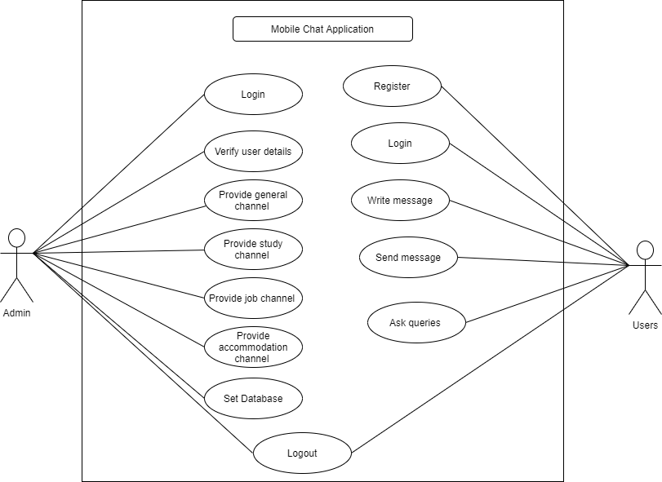
Figure 1: Use case diagram
2. ERD diagram: - An ERD diagram is also presented regarding the app of mobile chat that is UWTSD. ERD diagram is utilised to create models of data faster, quicker, and easier. This is structural diagram type for utilising in design of database. ERD includes various connectors and symbols that visualize two significant details: fundamental entities within application scope and inter-relationship amid these entities [19]. The presented ERD has three entities in which including admin, users, and system. These entities present various attributes with different data types such as user has email_ id and password and has some methods including write message and send message.
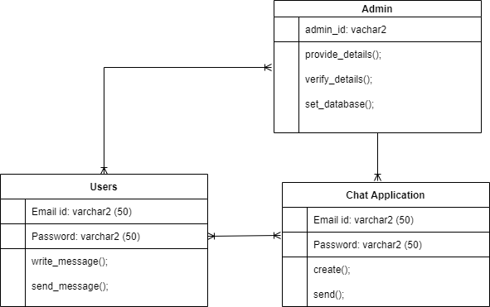
Figure 2: ERD diagram

4.4 System Requirements
- Hardware Requirements: - To develop the mobile chat application based on iOS, some hardware requirements are needed in which including 2.3 GHz dual-core, 4GB memory, i5 Intel core processor, and 1GB RAM. iOS version will be 8.0-11.0. This mobile application has some features such as camera, accelerometer, and push notification.
- Software Requirements: - To develop this UWTSD mobile chat app, some software requirements are also needed in which including Mac OS (operating system) device. Developers require Mac system operating the new XCode version. XCode is graphical interface and utilised for both iOS and Mac.

4.5 Risk Analysis
Table 2: Risk Analysis
S. No. | Risks | Impact | Effect | Mitigation
 | Academic Skills | Medium | This risk may be expressive, receptive, and can include grammar error. | Proof reading the report while writing and improve report writing with Academic Support.
 | Technical Skills | Medium | This type of risk may end up with low level of coding and may put system in safety risks. Also, not having technical skills end up with not finishing project on time. | To mitigate this type of risk, developers should use the proper tools and technologies to develop mobile applications. Also, developers should take online courses to develop their technical skills.
 | Malicious information exfiltration flaws | Low | This type of risk can be done during digital transfer regarding data or by an automated process. | This type of risk can be mitigated by using tracking data in the OS to aggregate removable media behaviour on the device.
 | Time management | Medium | This type of risk occurs when developer is unexperienced and haven’t set the time period for each task to complete and in the end, it causes incomplete work. | The developer should create the plan chart and set the deadline for each task in order to complete the project on the time.
 | System Failure | High | This type of risk can be occurred due to many reasons such as virus attack or overload or sometimes it could happen due to electricity failure. | This type of risk can be mitigated by maintaining system protected against virus and always keep checking on space left on device.

Design

APP interface/Website CSS template
There are presented some APP interfaces regarding the mobile chat application based on iOS platform.
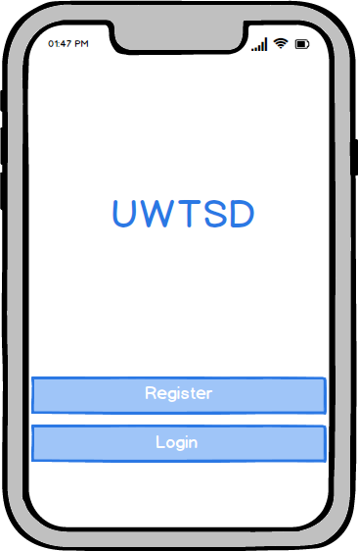
Figure 3: Main Screen Interface
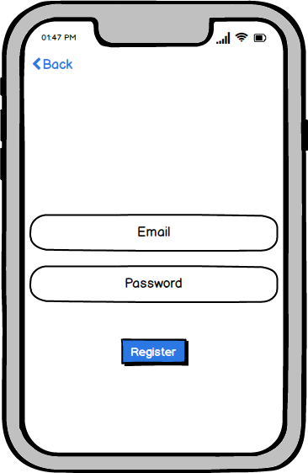
Figure 4: Register Screen Interface
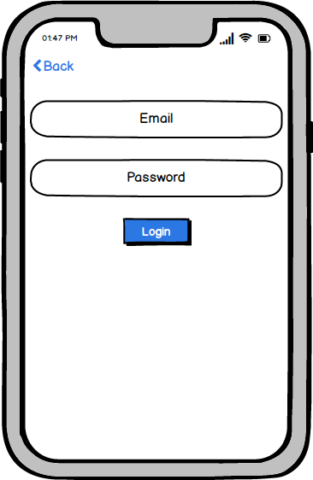
Figure 5: Login Screen Interface
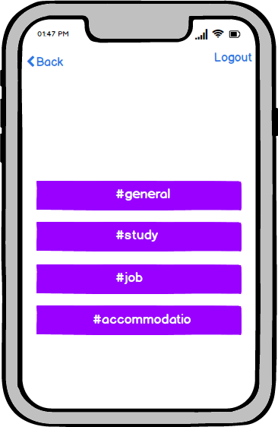
Figure 6: Channels Screen Interface
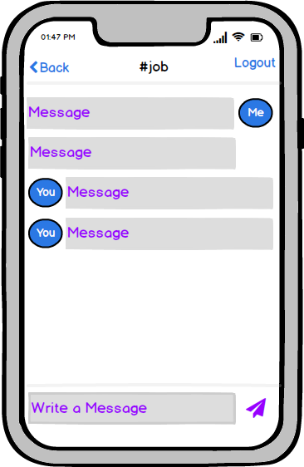
Figure 7: Job Screen Interface
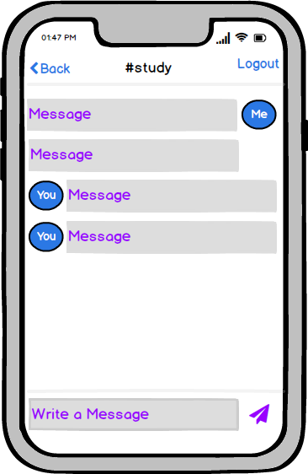
Figure 8: Study Screen Interface
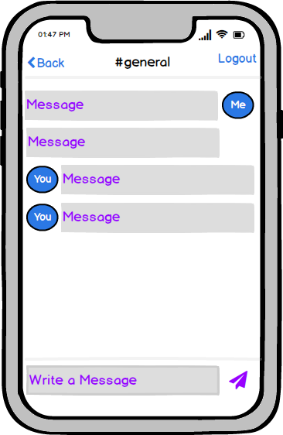
Figure 9:General Screen Interface

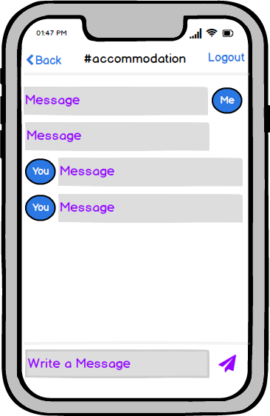
Figure 10: Accommodation Screen Interface

Storyboard
Some storyboards are also developed for the mobile chat app.
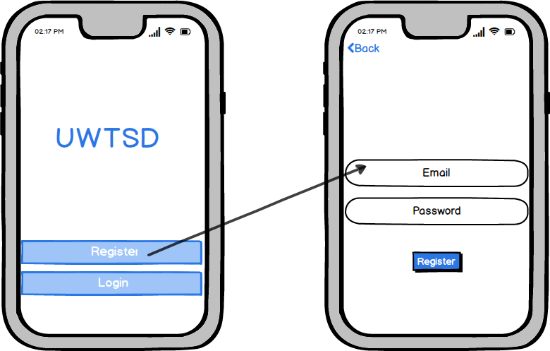
Figure 11: Linking between main and register Screens
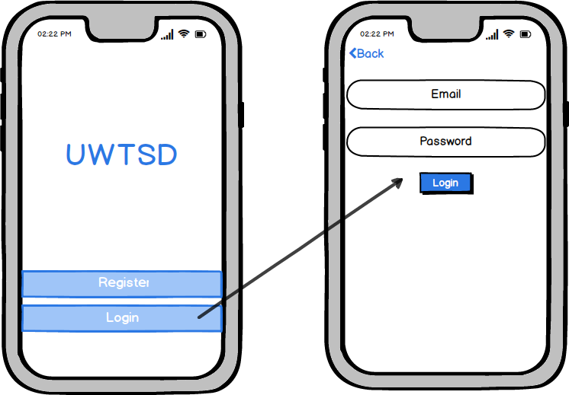
Figure 12: Linking between main and login Screens
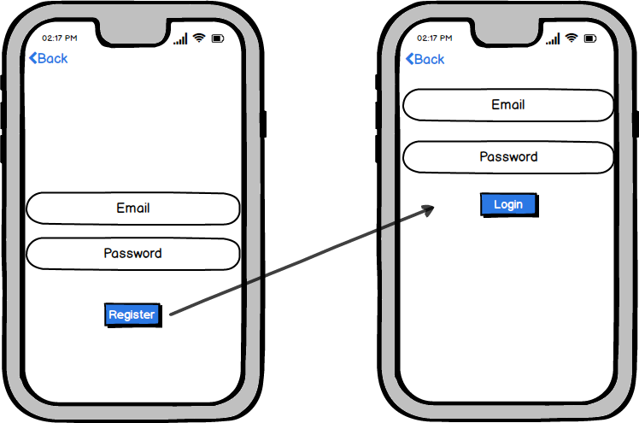
Figure 13: Linking between register & login Screens

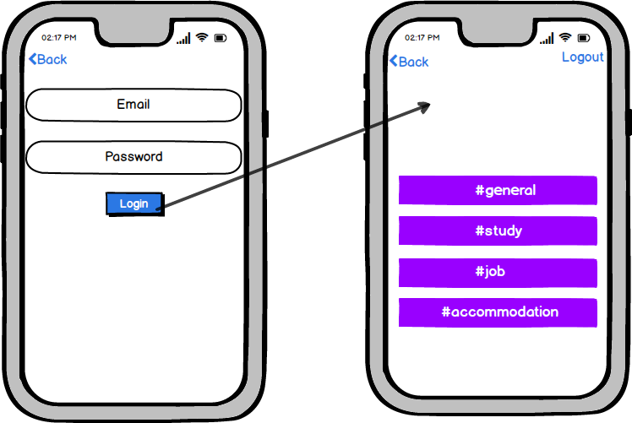
Figure 14: Linking between login and channels Screens
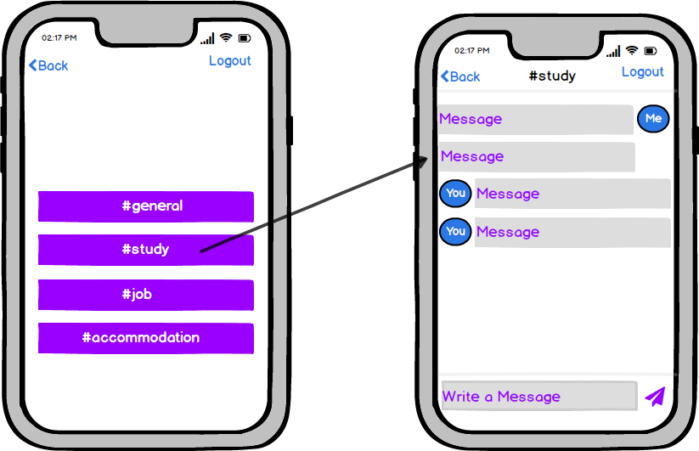
Figure 15: Linking between channels and study Screens
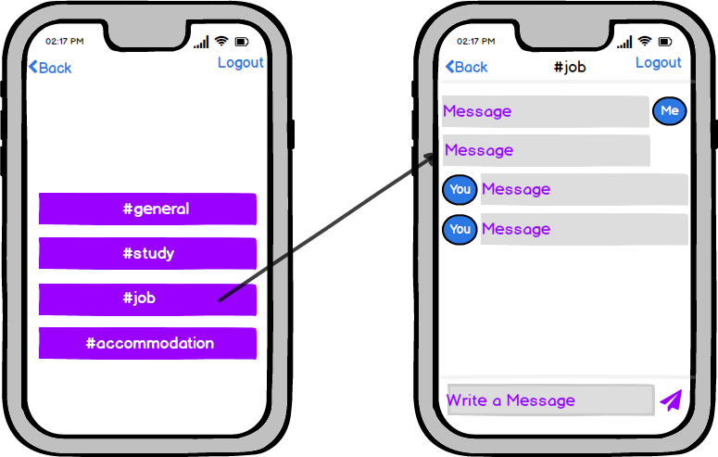
Figure 16: Linking between channels and job screens

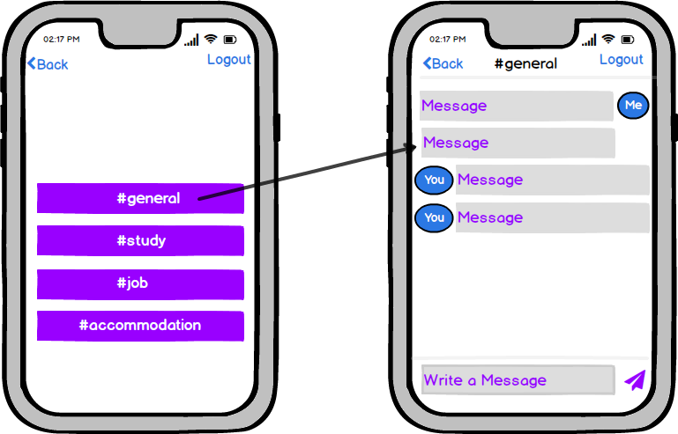
Figure 17: Linking between channels and general screens
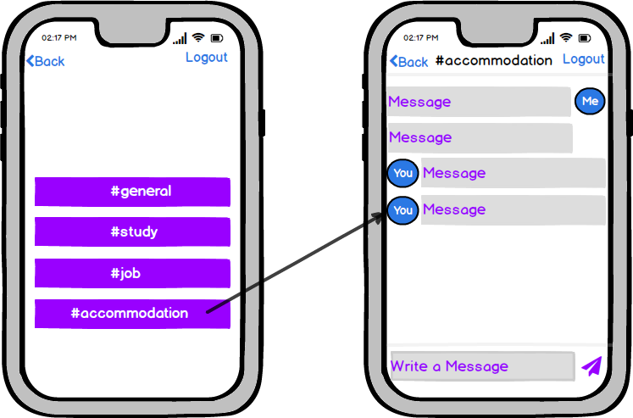
Figure 18: Linking between channels and accommodation screens

Database Design
There is presented a design table of database that is based on the app related to mobile chat.
Table 1: Database design
S. No. | Actors | Attributes | Data types | Value
 | User | Email_Id | Varchar 2 | 50
 | User | Password | Varchar 2 | 50
 | Admin | Admin_Id | Varchar 2 | 50
 | System | Email_Id | Varchar 2 | 50
 | System | Password | Varchar 2 | 50

Implementation
There are presented the screenshots of the UWTSD mobile chat app based on iOS platform.
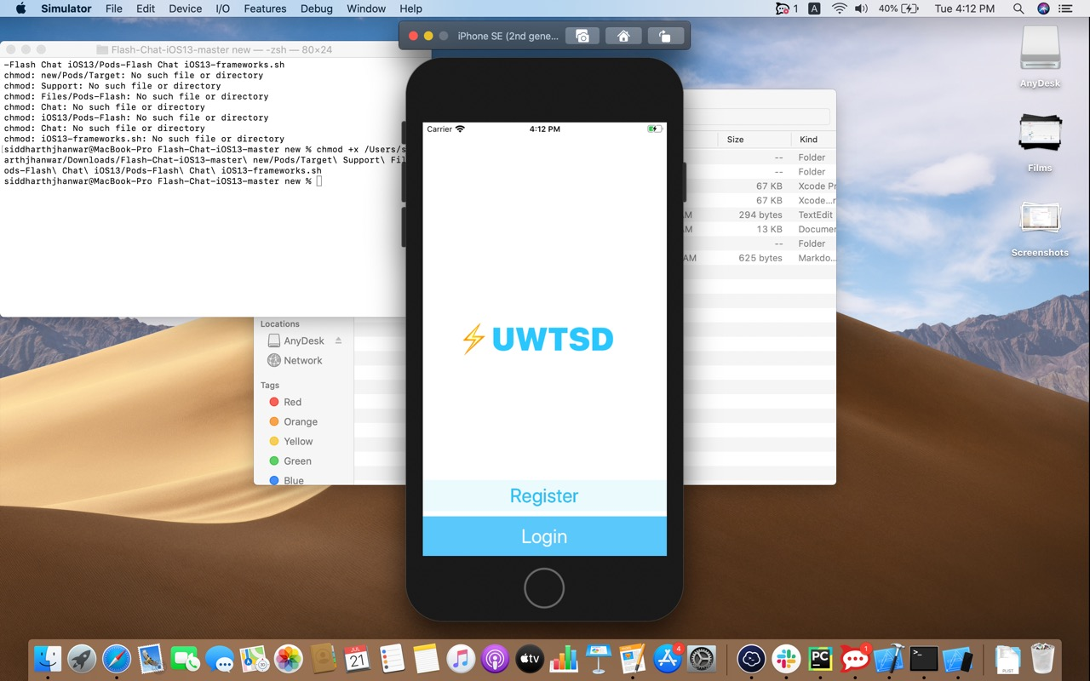
Figure 19: Main Screen
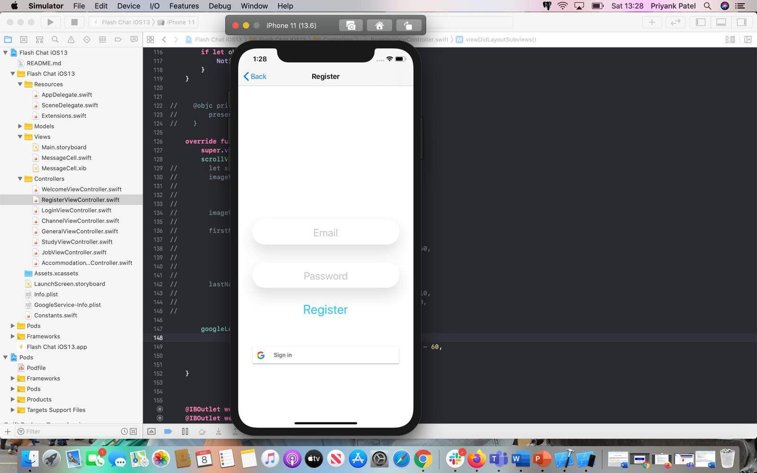
Figure 20: Register Screen
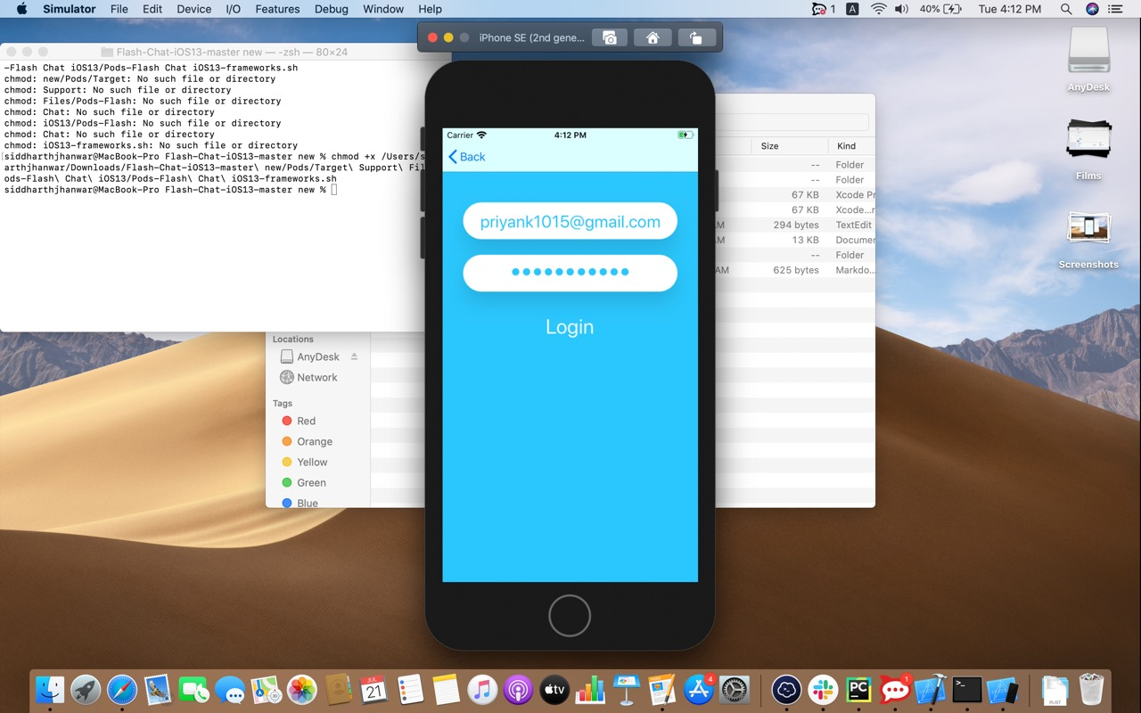
Figure 21: Login Screen
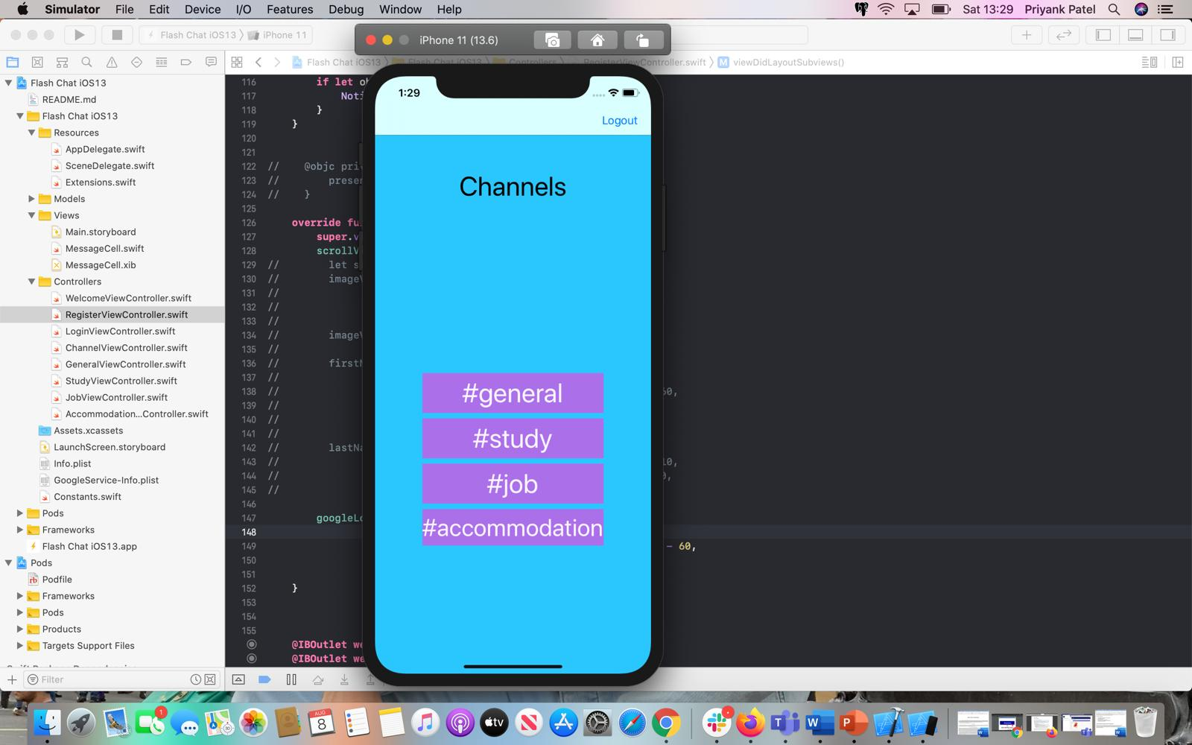
Figure 22: Channels Screen
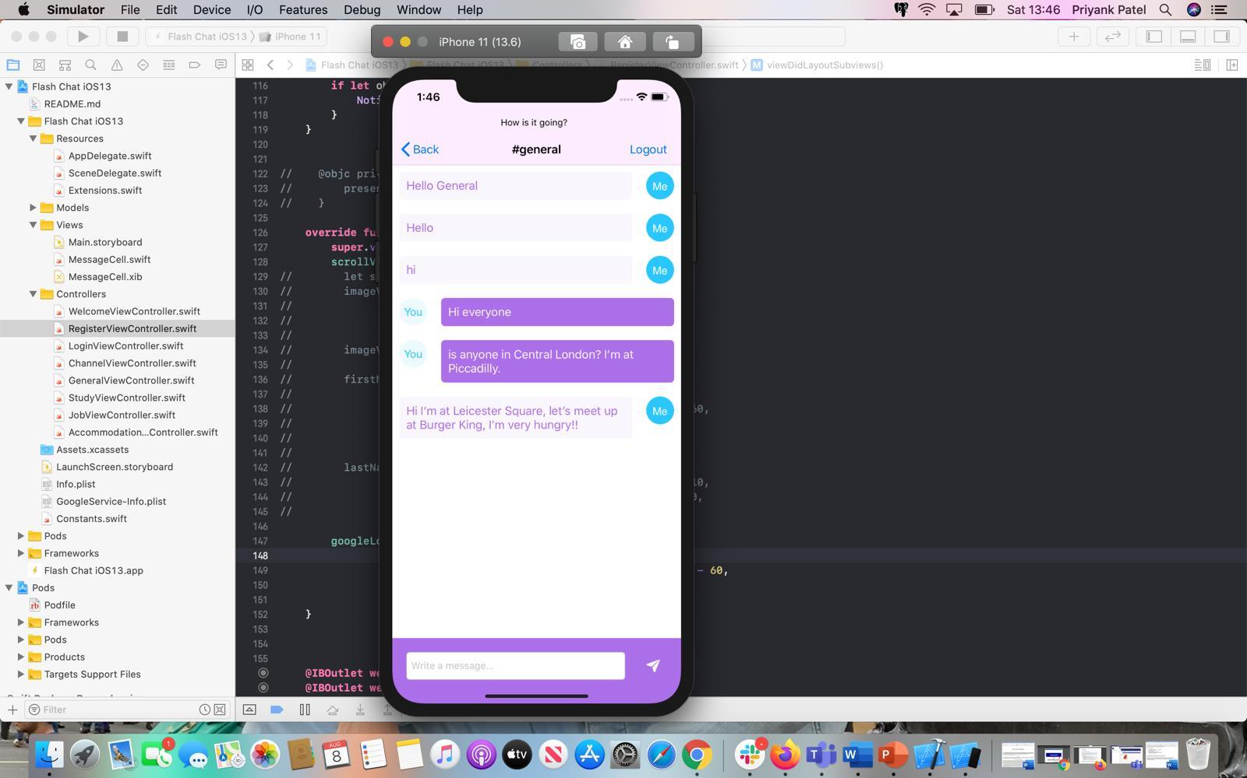
Figure 23: General Screen
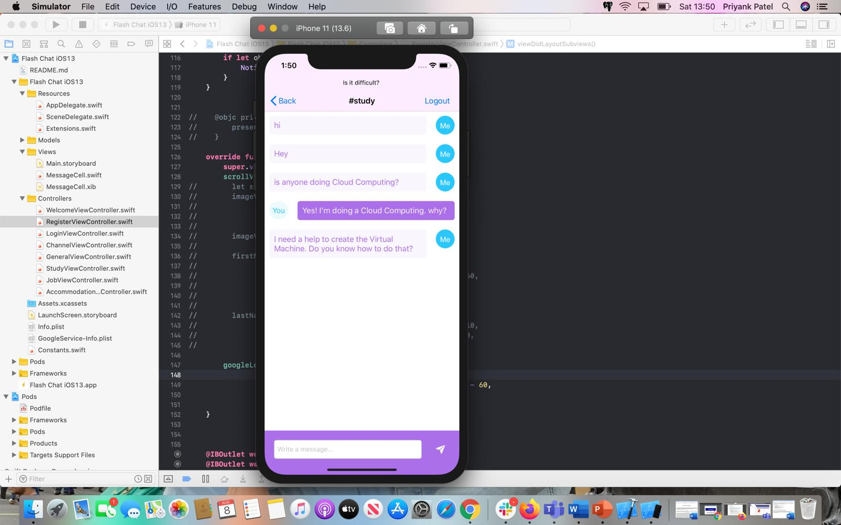
Figure 24: Study Screen

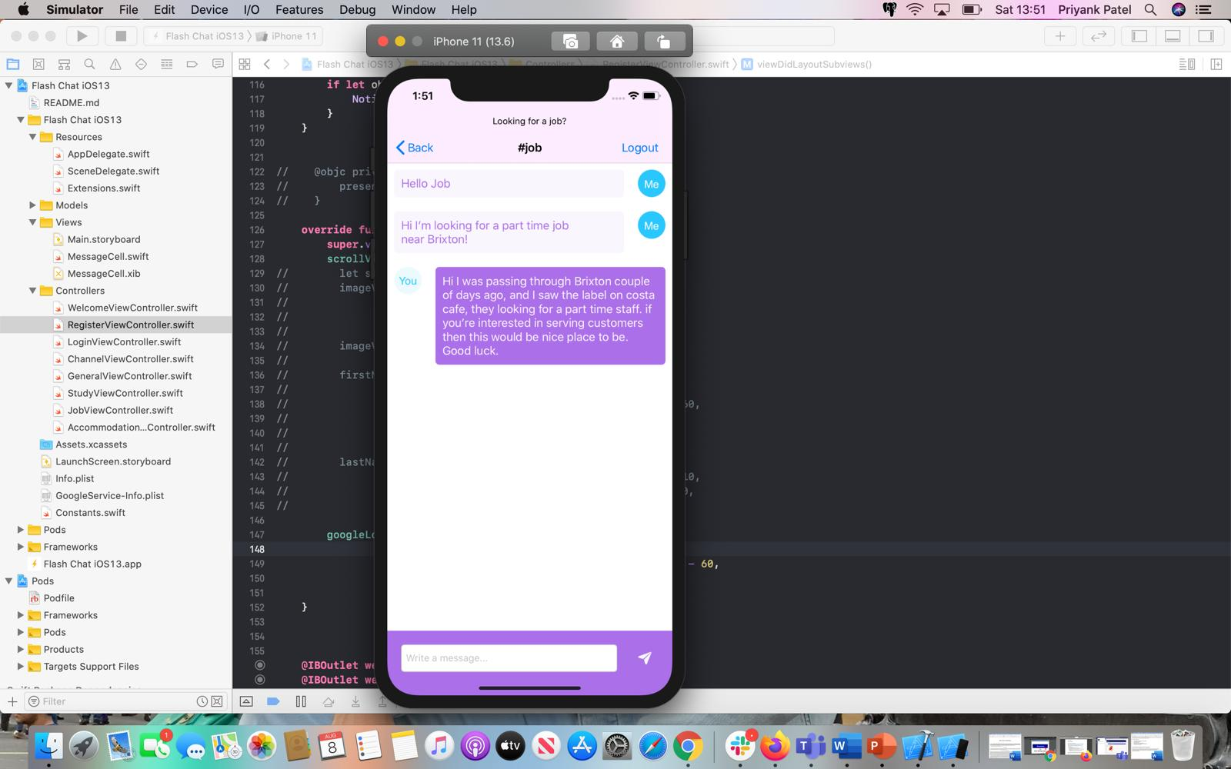
Figure 25: Job Screen
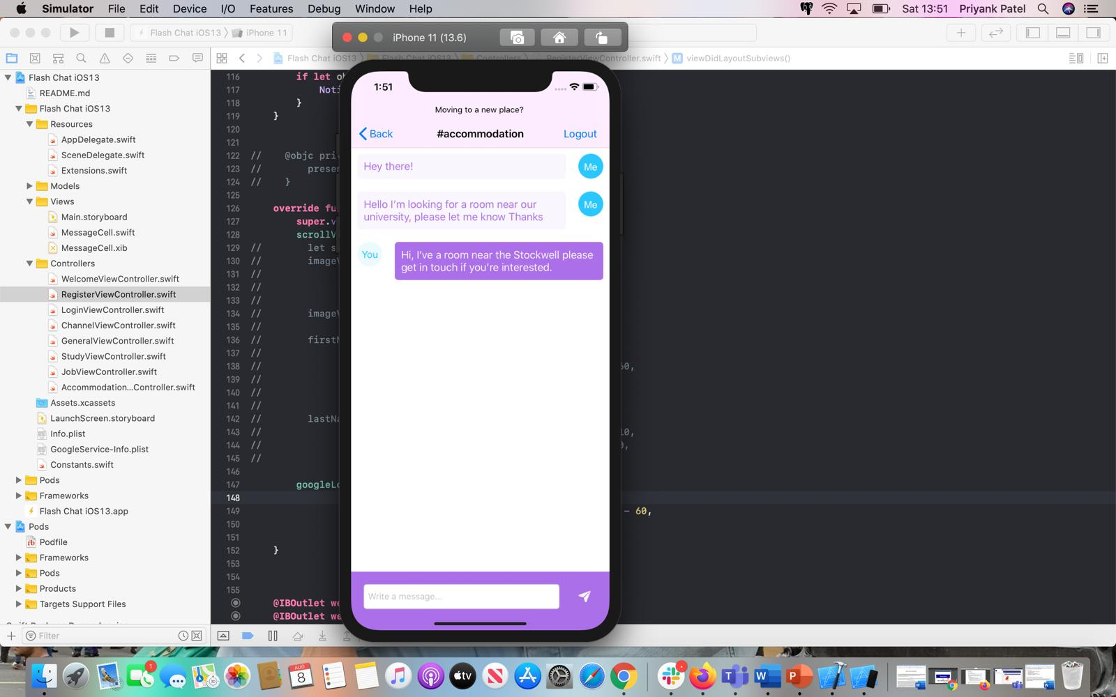
Figure 26: Accommodation Screen
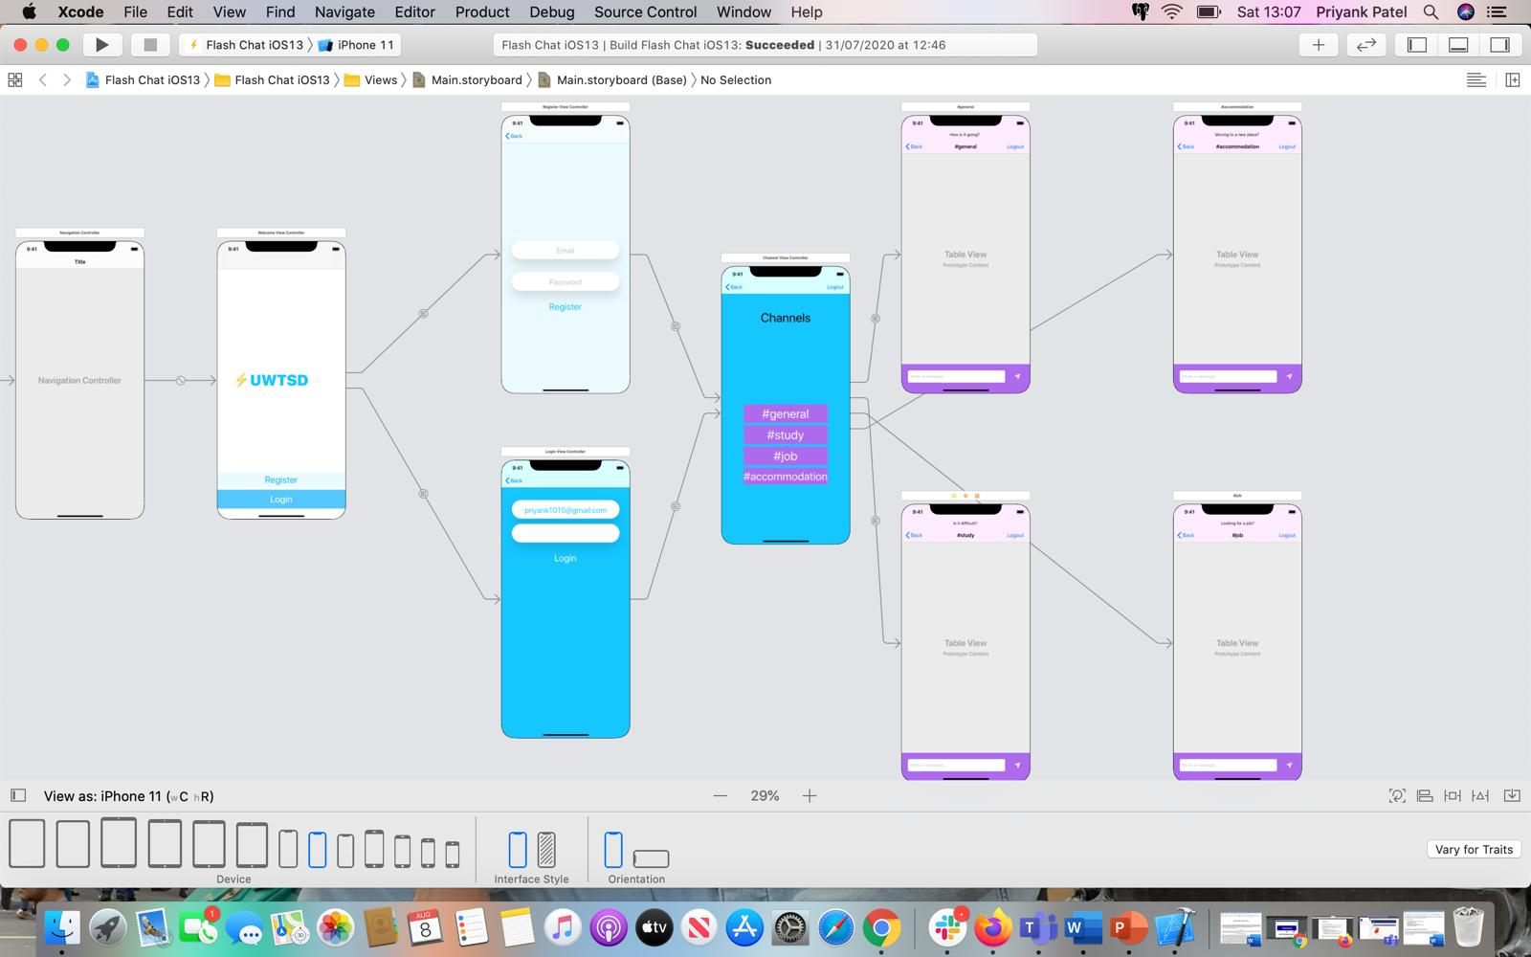
Figure 27:All screens of Mobile chat app
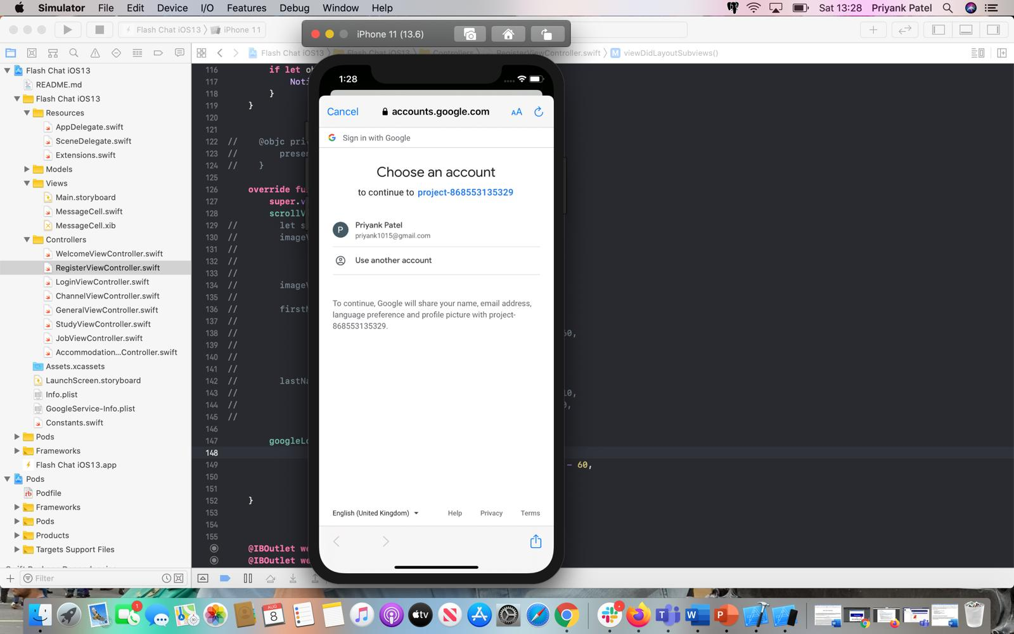
Figure 28: Account Screen
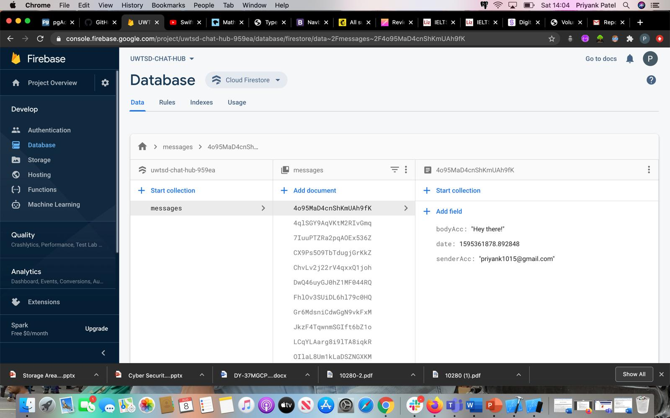
Figure 29: Database Screen
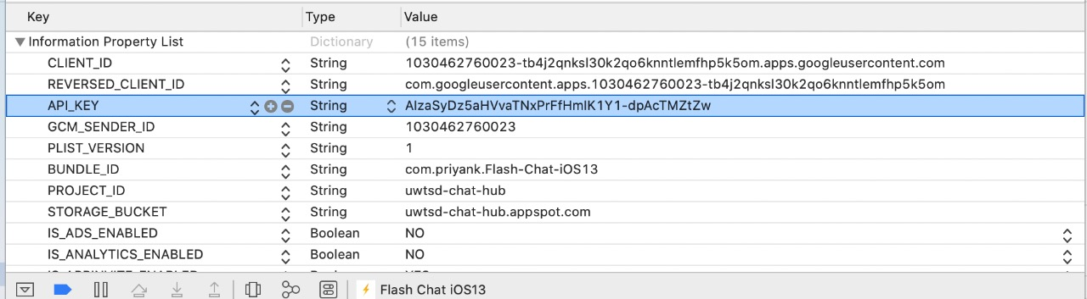
Figure 30: Database design Screen
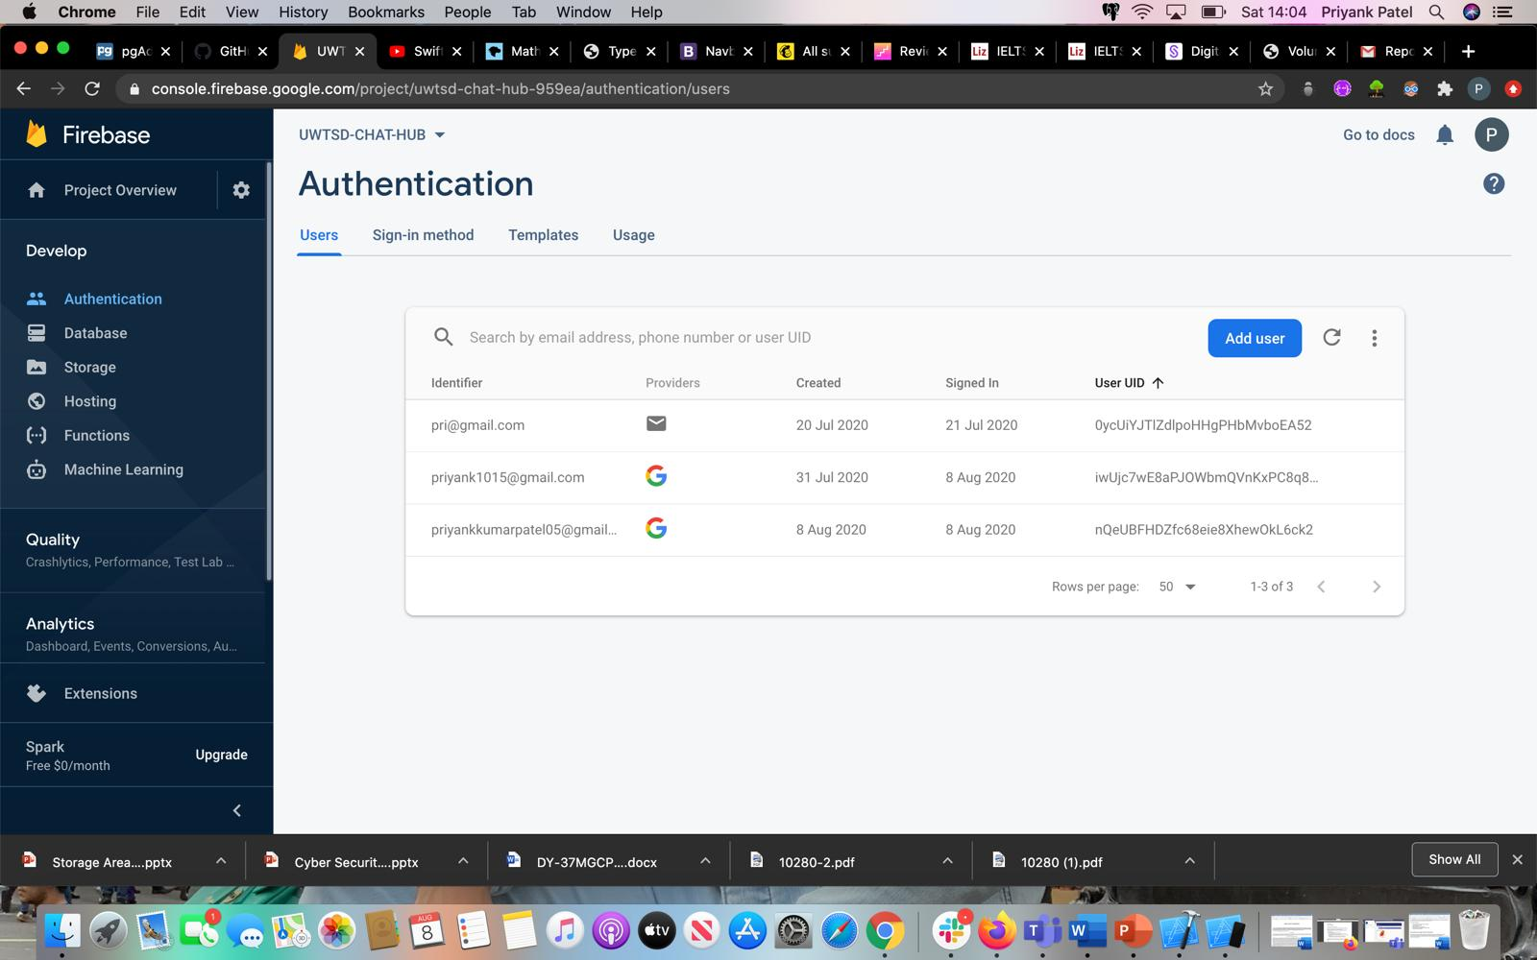
Figure 31: Authentication Screen
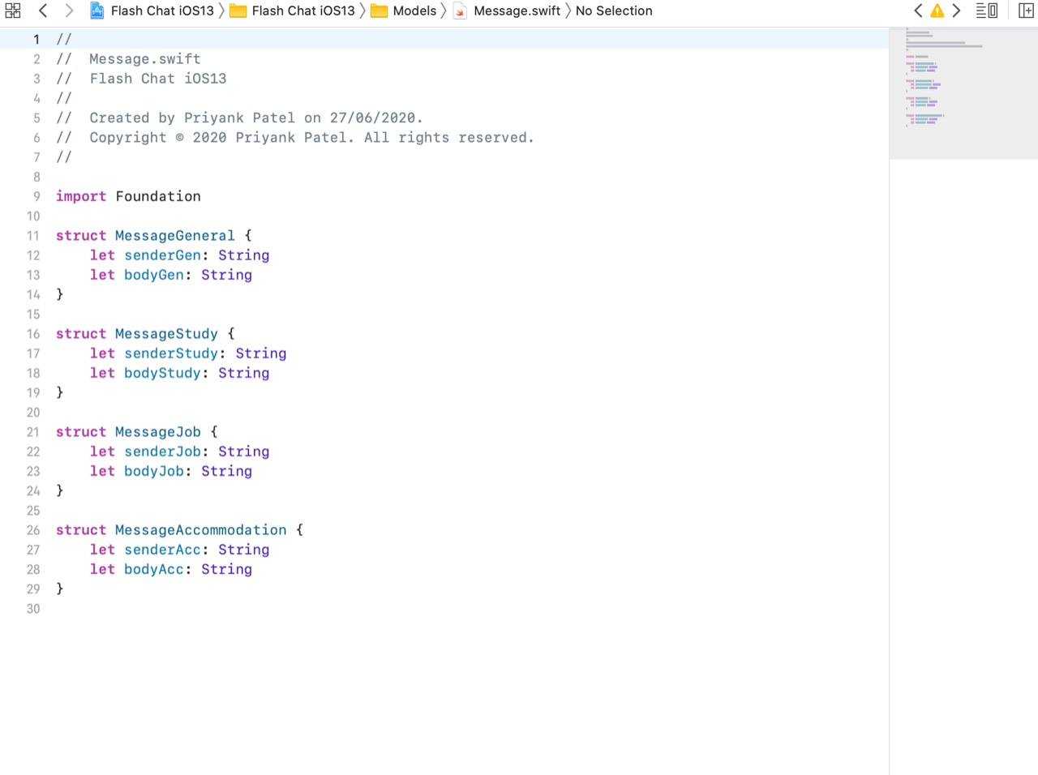
Figure 32: Code

Testing
There are defined some test cases based on the UWTSD mobile chat app with expected and actual results and test results. Test plan contains various tests for application performance including performance test, interface test, database test, usability test, security test and compatibility test [17].
Table 2: Test Plan
S. No. | Test Cases | Expected result | Actual Result | Test Result  (Pass or Fail)
 | To enter the register button without filling the email id field. | An error occurs that please fulfil all fields. | Error notification | Pass
 | To fill invalid password & email id. | The user is not able to log in. | The user is not able to log in. | Pass
 | If provided email Id does not include @ symbol and dot (.). | Email-id is invalid. | Email-id is invalid. | Pass

Evaluation

8.1 Personal Evaluation
This section presents the personal evaluation after developing the app related to mobile chat. This app related to mobile chat is based on iOS and for developing, swift language is utilised. This assignment presents the importance and usefulness of chat applications. Therefore, I learned various information and achieved a lot of details about this application. At the time of developing, I learned the difference between iOS and android platform. I also learned the importance and better outcome of swift language that is utilised for developing this chat application. I also gathered understanding about system through various interfaces, and storyboards.

8.2 System Evaluation
This section presents the system evaluation of developed apps related to mobile chat. The process of system evaluation is based on measuring the performance regarding entire system to determine how it will likely compete under condition of the live market. This system application is useful as this provides various and different channels including general, job, study and accommodation. This app related to mobile chat provides separate information on channels. This app is based on iOS so this app is secure and provides high-quality content and standards. All the requirements regarding the users are fulfilled by this mobile chat app.

Further Enhancement
This section presents some enhancement in the future related to the UWTSD chat app. There are defined the usefulness and importance of this app. This UWTSD app is based on iOS and utilised swift programming language. But some enhancement will be needed that will help this app in future. Artificial real estate intelligence will help boost service speed, service quality as well as efficiency by giving automated matching between users and employees. By providing various functionalities such as download, video call, voice call etc. will improve the quality of app. Some more features such as QR code, dark mode, sharing messaging post on social media and ranking of contacts will help this app to increase value in the market.

Conclusion
From the above-mentioned assignment that is related to a mobile chat application “UWTSD”. This app is based on iOS and Swift programming is utilised. There are described the importance, benefits and why this iOS platform is utilised for this app. There is also described some system requirements and description of UML diagram in this assignment. Some mock-ups are also provided related to app and a test plan is also done in this assignment. Some future enhancements are also discussed in this assignment.

11. References
[1] M. Hassib, D. Buschek, P. W. Wozniak and F. Alt, “HeartChat: Heart rate augmented mobile chat to support empathy and awareness,” In Proceedings of the 2017 CHI Conference on Human Factors in Computing Systems (pp. 2239-2251), May 2017.
[2] C. Agur, “Insularized connectedness: Mobile chat applications and news production,” Media and Communication, vol. 7, no. 1, pp.179-188, 2019.
[3] A. Andujar, “Benefits of mobile instant messaging to develop ESL writing,” System, 62, pp.63-76, 2016.
[4] T. C. Tsai, T. S. Liu and C. C. Han, “Waterchat: A group chat application based on opportunistic mobile social networks,” J. Commun, vol. 12, no. 7, pp.405-411, 2017.
[5] AltexSoft (2017). The Good and the Bad of Swift Programming Language. [online] Available at: https://www.altexsoft.com/blog/engineering/the-good-and-the-bad-of-swift-programming-language/#:~:text=Swift%20provides%20safeguards%20to%20prevent,8.4x%20faster%20than%20Python. [Accessed 1 Aug. 2020].
[6] M. Rebouças, G. Pinto, F. Ebert, W. Torres, A. Serebrenik and F. Castor, “An empirical study on the usage of the swift programming language,” In 2016 IEEE 23rd international conference on software analysis, evolution, and reengineering (SANER) (Vol. 1, pp. 634-638). IEEE, March 2016.
[7] R. Fojtik, “Swift a New Programming Language for Development and Education,” In The 2018 International Conference on Digital Science (pp. 284-295). Springer, Cham, October 2019.
[8] N. Cassee, G. Pinto, F. Castor and A. Serebrenik, “How swift developers handle errors,” In 2018 IEEE/ACM 15th International Conference on Mining Software Repositories (MSR) (pp. 292-302). IEEE, May 2018.
[9] W. Aljedaani, M. Nagappan, B. Adams and M. Godfrey, “A comparison of bugs across the iOS and Android platforms of two open source cross platform browser apps,” In 2019 IEEE/ACM 6th International Conference on Mobile Software Engineering and Systems (MOBILESoft) (pp. 76-86). IEEE, May 2019.
[10] L. Lazareska and K. Jakimoski, “Analysis of the Advantages and Disadvantages of Android and iOS Systems and Converting Applications from Android to iOS Platform and Vice Versa,” American Journal of Software Engineering and Applications, 6(5), pp.116-120, 2017.
[11] H. Hu, S. Wang, C. P. Bezemer and A. E. Hassan, “Studying the consistency of star ratings and reviews of popular free hybrid Android and iOS apps,” Empirical Software Engineering, vol. 24, no. 1, pp.7-32, 2019.
[12] V. Belair-Gagnon, C. Agur and N. Frisch, “Mobile sourcing: A case study of journalistic norms and usage of chat apps,” Mobile media & communication, vol. 6, no. 1, pp.53-70, 2018.
[13] E. Marçal, R. Andrade, R. Melo, W. Viana and E. Junqueira, “Using mobile message to improve student participation in blended courses: a Brazilian case study.” ACM SIGAPP Applied Computing Review, vol. 16, no. 3, pp.15-25, 2016.
[14] C. Agur, “Insularized connectedness: Mobile chat applications and news production.” Media and Communication, vol. 7, no. 1, pp.179-188, 2019.
[15] J. de Vicente Mohino, J. Bermejo Higuera, J. R. Bermejo Higuera and J. A. Sicilia Montalvo, “The application of a new secure software development life cycle (S-SDLC) with agile methodologies.” Electronics, vol. 8, no. 11, pp.1218, 2019.
[16] G. Rovira Sánchez, Implementation of a chat application for developers (Bachelor's thesis), 2017.
[17] M. Petersen and N. F. Hempler, “Development and testing of a mobile application to support diabetes self-management for people with newly diagnosed type 2 diabetes: a design thinking case study.” BMC medical informatics and decision making, vol. 17, no. 1, pp.91, 2017.
[18] A. Kane, ITHub Chat Application (Doctoral dissertation, Dublin, National College of Ireland), 2016.
[19] A. Setiawan, I. P. Hadi, D. Yoanita and A. I. Aritonang, “Virtual application technology of citizen journalism based on mobile user experience.” In Journal of Physics: Conference Series (vol. 1502, no. 1, pp. 012057). IOP Publishing, March 2020.
[20] L. Corbalán, P. Thomas, L. Delía, G. Cáseres, J. F. Sosa, F. Tesone and P. Pesado, “A study of non-functional requirements in apps for mobile devices.” In Conference on Cloud Computing and Big Data (pp. 125-136). Springer, Cham, June 2019.

