
Applied Leadership and Management in the Workplace
Module Assignment Submission
Student Name: | Zoltan Balog
Student Number: | 2028534
Module No: | BMSK5012
Module Title: | Understanding and Engaging Customer Experience

Table of Contents

Introduction 3
Understanding Customer Relationship 4
Customer Value 4-5
Customer Relationship Management (CRM) 6-7
Customer Centrality 8
Customer Loyalty 9-10
Managing Customer Expectations 11-13
Quality Management Processes 14
TQM 14
Six Sigma 15
Juran model 15
Deming's 14 points 16
Quality assurance /control 17
Conclusion 18
Recommendation 19
References 20-24
Appendices 25-26

Introduction
Success in today's cutthroat business environment depends on knowing and interacting with customers. Strong customer relationships are associated with higher customer loyalty, more profitability, and a more reputable brand for businesses (Eads, 2023).
Getting knowledge about the requirements, tastes, and behaviours of our clients is essential to understanding them (Danao, 2023). Techniques, including customer feedback surveys, customer data and interaction analysis, and active listening to customers across several touchpoints, can be used to accomplish this.
Developing deep relationships and encouraging two-way communication are essential components of engaging with customers. According to Paton (2022), numerous avenues, such as social media, email marketing, tailored recommendations, and first-rate customer service, are available for businesses to interact with their clients. To provide value beyond merely transactional relationships, effective engagement tactics cultivate emotional connections and establish a feeling of community around the company.
According to Shaw (2023), engaging customers successfully prolongs their customer lifetime, improves firms' ability to predict their expectations, and eventually increases client acquisition and retention. Businesses can build devoted client connections, raise brand awareness, and obtain a competitive edge in the market by putting strong customer engagement strategies into practice.
Businesses must comprehend and interact with consumers if they hope to create enduring bonds, encourage client loyalty, and succeed over the long haul (Paton, 2022). Using consumer data, personalised experiences, and meaningful relationships, companies may establish a robust emotional connection with their clientele, resulting in heightened profitability and a durable competitive edge.
In this report, we will analyse Amazon, considering the history of the company. Not only is Amazon the richest corporation in the world, but it also prioritises its customers more than anything else (Folio3, 2020). We will explore Amazon's strategy, how they develop and maintain a relationship with their customers. We will use several theories and models to find out their business success.
Understanding Customer Relationship
- Customer Value
The outcome of a client's happiness with the good or service is customer value. By improving the customer experience and raising customer retention, this can be raised. Understanding customer value is crucial for organisations because it enables them to build experiences and products that will win over customers (Williams, 2022). Developing a thorough awareness of the demands and desires of their clients is the foundation of customer obsession.
By getting to know each client personally, Amazon is better able to fulfil their expectations, whether they are for quick digital content delivery, faster shipping, or more product details (Chaffey, 2023).Amazon can deliver exceptional customer service and high-quality products that entice customers to return for more by having a thorough understanding of their needs (Slater, 2024). Amazon uses a number of crucial techniques to increase customer value:
- Competitive Pricing: In comparison to physical stores, Amazon strives to provide competitive, frequently lower costs. Customers see Amazon's offerings as having more value because of this decreased cost to them. The emphasis on "good value" and "low prices" at Amazon.
- Personalization and Product Discovery: Amazon uses user data to offer customised shopping experiences and individualised product recommendations. By speeding up the process of clients finding suitable products, this personalisation offers value. According to "the 'discovery' factor...makes the buying experience really special."
- Loyalty Programs and Subscriptions: Customers encouraged to stay loyal and see Amazon Prime and other subscription programmes as having greater value by providing extra rewards like free shipping, streaming services, and access to special bargains.
- Customer Reviews and Social Proof: Customers see Amazon's customer review system as having additional value before making a purchase decision since it offers social proof and product quality data.
- Fast and Reliable Delivery: Customers can take advantage of quick and dependable shipment thanks to Amazon's investments in organization and delivery infrastructure, which include services like Prime and same-day delivery. As seen by the fact that "convenience" is one of the main benefits, this improves the customer experience and perceived value.
- Continuous Innovation and Customer Obsession: Amazon's "obsession" with using constant innovation to create value for its consumers. Because of its focus on the needs of its customers, Amazon is willing to take chances and create novel products that improve the value proposition and overall customer experience.
One critique of Amazon's strategy, though, is that it places too much focus on automation and data, which may result in a lack of human interaction and one-on-one relationships with customers (Gill, 2023). Beyond simple transactional exchanges, Amazon should prioritise educating its consumers and building closer relationships.
Furthermore, despite the fact that Amazon is excellent at providing value to customers through its e-commerce platform, questions have been raised regarding how its employees are treated, which may have an effect on how customers view the firm as a whole and how they perceive its values.
Amazon appears to use the (CLV) technique to measure and understand customer value and behaviour (Garg, 2023). Customer Lifetime Value (CLV) Calculation: This method estimates the overall income a customer will contribute over the course of their association with Amazon by measuring variables including average order frequency, average order value, and annual customer value.
Amazon keeps track of repeat orders and examines which things buyers order most frequently. According to Malachard (2021), to boost retention and lifetime value, Amazon uses this data in conjunction with CLV to identify its most valued customers and target them with tailored offerings and improved customer care.

- Customer Relationship Management (CRM)
Businesses use customer relationship management, or CRM, as a tactic to handle communications with both current and prospective clients. CRM facilitates process optimisation, customer connection building, sales growth, enhanced customer support, and profitability for companies (Hargrave, 2023). In today's customer-centric corporate environment, effective customer relationship management is essential for fostering customer loyalty, revenue growth, operational efficiency, and a long-term competitive edge.
According to Binns (2023) personalised experiences, faster interactions, automatic marketing, and continual development based on customer feedback are all made possible by Amazon's CRM system, which serves as a central repository for consumer data.
Amazon's success and devoted client base can be attributed in large part to this customer-centric strategy. The following describes the general operation of Amazon's customer relationship management (CRM) system:
- Customer Feedback and Satisfaction Monitoring: Through surveys, comments, and data like order defect rates, cancellation rates, and response times, Amazon's CRM process keeps track of customer happiness. The customer experience is continuously enhanced and opportunities for optimisation are identified with the use of this input. The reliance on customer reviews is subject to manipulation, which might result in biassed or phoney reviews that could mislead other customers.
- Centralized Customer Data: Comprehensive customer data is gathered and kept in a centralised database via the CRM system. This covers past purchases, browsing habits, preferences, financial information, and personal data. Because all this data is in one place, Amazon is able to offer a smooth, customised experience across all channels. On the other hand, serious privacy concerns are raised by the massive data collecting. Consumers may be concerned about the volume of data that Amazon gathers and how it is utilised.
- Automated Marketing and Retention: Numerous marketing and client retention initiatives are automated by the CRM system. Personalised email campaigns are sent, related products are recommended throughout the checkout process, and customers are targeted with appropriate specials and discounts based on their purchasing histories and preferences.
- Personalized Customer Experiences: For every user, Amazon offers highly customised product recommendations, focused advertising campaigns, and customised purchasing experiences. To make recommendations for appropriate goods and deals, the system examines user preferences, browsing habits, and past purchases (Chakrawarty, 2017).
- Streamlined Customer Interactions: Customers can self-serve for numerous transactions with the CRM system, eliminating the need to contact customer service, including tracking orders, updating payment information, and cancelling orders. If assistance is needed, the CRM gives agents immediate access to the customer's data, facilitating prompt resolution.
- Loyalty Programs and Subscriptions: Amazon's loyalty programmes, such as Amazon Prime, are managed in part by its CRM. The CRM can identify high-value consumers to target with Prime membership offers by monitoring customer data and purchasing habits. This would encourage the customers to stick with Amazon because of the extra rewards and savings. The focus on Prime has the potential to alienate non-Prime members by making them feel inferior, which may have an adverse effect on their general level of satisfaction and loyalty.
Amazon's success is based on its strong customer focus, which made possible by the company's astute use of CRM. However, it does not make use of standard CRM programmes like HubSpot or Zoho (Marks, 2022). Utilising in-house developed CRM software, Amazon is able to obtain a comprehensive picture of the customer journey and instantaneously modify its consumers' online experience at the point of purchase (Binns, 2023).
Based on the customer's e-commerce behaviours, it decreases returns or even cart abandonment, learns about their patterns, and enhances connections from the first transaction. With Amazon's excellent help centre, we can manage our account, examine our orders, read FAQs, and contact customer support all from a single, easy-to-use interface (Channelreply, 2016). If the solution to our query is not immediately apparent, we can alternatively search for themes. a

- Customer Centrality
According to Ramich (2022), the ability of individuals inside an organisation to comprehend the circumstances, viewpoints, and expectations of its consumers is known as customer centrality. To generate customer pleasure, loyalty, and advocacy, customer centrality necessitates that the customer be at the centre of all choices pertaining to the delivery of goods, experiences, and services.
- Developing a dynamic, customer-focused culture involves four steps:
Recognising the requirements and expectations of customers.
Matching client demands to company strategies.
Enabling staff to put the needs of the customer first.
Keeping an eye on and enhancing the client experience all the time.

But it is crucial to remember that reaching true customer centrality is a big task that calls for an organisational culture change and sustained dedication.
A common example of a company that values its customers is Amazon.
According to Max (2021), the organisation combines data mining, personalisation, and ongoing innovation to relentlessly focus on comprehending and meeting the demands of its customers.
Amazon, which holds more than 5,000 patents, is always launching new products and services to improve the user experience. Deeply rooted in its customer-centric culture is a "working backwards" methodology that begins with the demands of the consumer.

Organisational commitment is necessary for the implementation of client centricity, but it is a worthy endeavour for organisations in all sectors due to the potential benefits of creating enduring customer relationships, stimulating innovation, and attaining competitive distinctiveness (Habel et al., 2019).
However, the companies also face potential problems like cultural resistance, problems with data integration and quality, and the need to strike a balance between automation and human interaction. Successful client centricity depends on addressing these issues through effective communication, stakeholder involvement, and reliable processes.

- Customer Loyalty
The willingness of a client to do business with a company repeatedly is known as customer loyalty (Szaniawska-Schiavo, 2024). According to Freedman (2024), it is the outcome of satisfied customers, satisfying customer experiences, and the total value of the products or services a customer purchases from a company.
Customer retention and loyalty are mutually beneficial. According to Chambers (2022), a customer that is disposed to interact with and make purchases from our business is said to be loyal. A statistic called retention is used to monitor client involvement and the sales that follow. Strategies for keeping customers are created to provide and take more from our current clientele.
Profits can increase by 25–95% only by 5% more client retention. An effective customer retention strategy is essential to the long-term viability of e-commerce businesses and should not be disregarded (Rodriguez, 2019). We will save a tonne of money by concentrating on customer retention, as it is between five and twenty-five times more expensive to attract new consumers.
Developing a solid brand identity is the first step towards gaining client loyalty. To create an emotional bond, our brand needs to speak to our target market. Organising promotions is a great approach to draw in new clients, maintain the interest of current ones, and foster client loyalty.
Lightning Deals and Coupons: Make use of Amazon's Lightning Deals and Coupons to provide temporary discounts on our merchandise. These can be effective instruments for increasing sales.
Amazon organise frequent sales occasions, particularly on the busiest shopping days of the year, such as Cyber Monday and Black Friday. Consumers value a good bargain.
Join in on Amazon Prime Day to take advantage of the enormous influx of Prime members searching for sales. Building a loyal client base on Amazon requires active audience engagement.
Interact with both positive and negative customer reviews to demonstrate that Amazon values customer input and is dedicated to making improvements to its goods (Danziger, 2018). Amazon is well known for its relentless commitment to providing outstanding customer service. This entails easy returns, timely assistance, and a dedication to always enhancing the client experience in response to input.
Amazon produces product listings with thorough information, excellent photos, and an eye-catching aesthetic. Amazon creates an email list and sends updates, specials, and tailored product recommendations to its consumers to entice them to return for more. Subscribe and Save discounts are available on Amazon for products that customers frequently use.

Customer loyalty over the long term may result from this convenience. According to Profound (2021), by concentrating on developing brand loyalty, holding successful promotions, interacting with their audience, introducing Sponsored Brands campaigns, and promoting repeat purchases, Amazon has built a devoted customer base that has helped them succeed.
Even though Amazon has a great history of overall consumer loyalty, they can run into problems in certain product categories where niche brands or shops have more emotional ties to their customers.

- Managing Customer Expectations
Professor Noriaki Kano created the Kano Model, a theory for product creation and consumer satisfaction, in the 1980s to assist organisations in understanding and prioritising items that would increase customer happiness (Moorman, 2012).
- Basic needs: Must-Have Features are the fundamental specifications that buyers look for in a product.
- Performance needs: The characteristics that customers immediately link to their level of pleasure are known as performance features.
- Excitement needs: Customers do not anticipate attractive features, yet they can increase value and improve customer happiness.
- Indifferent needs: those that have no impact on the happiness or discontent of customers.
- Reverse needs: are the features that, although adding them, may make customers unhappy, at first look appealing.
Amazon may strategically improve its Prime membership offering by implementing the Kano Model. This will help to ensure that the offering meets basic expectations, enhances performance features, and delivers exciting new advantages that will thrill customers and encourage loyalty.

Giving users access to Prime Video is just another fundamental requirement. Consumers anticipate that their membership will include a wide selection of films and TV series.

Providing more delivery choices, such two-hour or same-day delivery, can improve customer satisfaction right away (How Amazon Plans Its Customer Retention Strategy?, 2022).Customers will be happier with delivery alternatives that are quicker and more adaptable.

Giving Prime subscribers early access to the debut of new products can thrill and delight customers. Although unexpected, this feature has the potential to improve the clientele's experience.

Several business disciplines apply the MoSCoW approach. According to Collins (2023), this technique involves ranking every feature or need according to how urgently and critically important they are to the project and then grouping them together.
Amazon may focus its attention and resources on the Must-Have and Should-Have elements that are essential for consumer engagement and satisfaction by employing this MoSCoW model.
The things marked "Could-Have" are creative suggestions that have the potential to improve the consumer experience but are not necessary. The Won't-Have list aids in focusing on what is feasible at this stage and setting reasonable expectations.
Amazon prioritises always providing a high standard of service to all its customers. This includes prompt customer service, simple returns, and quick shipment. Amazon constantly meeting and often beyond expectations, customers learn to rely on them.
Amazon uses user data to offer customised experiences and individualised product suggestions. This facilitates satisfying unique consumer preferences and wants.
Loyalty increased by programmes like Amazon Prime, which clearly outline expectations for benefits (such free shipping) and continually fulfil them (Schwarzbaum, 2023).
The customer-centric culture at Amazon places a strong emphasis on establishing and continuously exceeding high standards for customer service in all facets of the company.
Amazon develops a thorough strategy for customer loyalty that speaks to customers' hearts and minds by fusing emotional and intellectual factors. By fostering long-lasting relationships with clients, this tactic promotes brand advocacy and repeat business.
Broad categories of interactions between customers and sellers on Amazon can deduced:
- Transactional interaction: In this type of interaction, buyers and sellers exchange one-time purchases without necessarily forging a lasting bond.
A loyal customer relationship is one in which a customer consistently makes purchases from the same brand or vendor, demonstrating their preference and loyalty over time.
- Relationship of Brand Follower: Amazon provides a tool called "Brand Follow" that allows customers to follow their preferred brands to stay informed and get the newest sales.
- Subscription-based Relationship: Customers can establish recurrent delivery schedules and build a relationship with the supplier by using services like Subscribe & Save.
Customers that purchase from a brand but also interact with it through social media, content, and reviews are considered engaged customers.
- Promotional Relationship: Buyers drawn to vendors by their offers of discounts, deals, and promotions.
- Brand Advocate Relationship: Devoted consumers who serve as brand ambassadors by not only making recurring purchases but also spreading the word about the company.
Amazon keeps an eye on seller behaviour and product quality to guarantee high-quality items. Customers can make educated judgements and given transparency through the system of reviews and ratings from previous users.
Amazon prioritises timely, individualised customer service as well as effective problem solving. This focus on detail improves the relationship with clients. Amazon's search function is like that of Google, but it also allows us to sort products by brand, availability, average customer review, price, and brand-specific categories (Hunersen, 2019).

Quality Management Processes
- TQM
The goal of total quality management (TQM), an all-encompassing approach to organisational management, is to raise the calibre of goods and services by enlisting the help of all staff members in ongoing improvement initiatives (Barone, 2023). Improving organisational performance and customer happiness are the two main objectives of TQM. Key principles:
- Customer Focus: Giving the demands and expectations of the customer top priority across the board for the organisation.
- Continuous improvement refers to the ongoing search for methods to enhance procedures, goods, and services.
- Employee Participation: Including every worker, no matter what level, in the process of improving quality.
- Process-centered: Putting more of an emphasis on streamlining procedures than on solving specific issues.
- Seeing the company as a networked system of interconnected processes is known as an integrated system.
- Linking quality control to the strategic objectives of the company through a systematic and strategic approach.
- Making decisions based on analysis and objective data rather than conjecture is known as "data-driven decision making."
- Effective Communication: Keeping lines of communication open and transparent within the company.
- Leadership Support: Unwavering dedication to the highest standards of excellence and strong leadership support.
- Training and Education: Continuing education and training staff members to support quality initiatives.

- Six Sigma model
In the 1980s, a scientist at Motorola created the model. According to Kumar (2023), businesses use the Six Sigma quality-control methodology to drastically cut down on errors and enhance workflows. The Six Sigma concept widely used by businesses to improve productivity and raise revenue. The Six Sigma methodology, also referred to as DMAIC, comprises five distinct phases: defining, measuring, analysing, improving, and controlling.
Fulfilment centres, or Amazon's warehouses, are examples of how well Lean principles can apply. Amazon has reduced process waste by making ongoing improvements (Six sigma, 2017). By optimising the layout of its fulfilment centres, for instance, the company has drastically decreased waiting times in its packaging and delivery process. Products arranged in a common order to reduce the amount of time workers must spend getting things. The "5S" methodology (Sort, Set in Order, Shine, Standardise, and Sustain) is an essential Lean technique that significantly boosts productivity (Punam, 2020).

- Juran model
Dr. Joseph M. Juran introduced the Juran Trilogy, commonly known as the Quality Management Trilogy, to manage for quality (McGowan, 2010). At the time, quality control was the cornerstone of the conventional approach to quality; but, in the modern day, the Trilogy has emerged as the foundation for the majority of best practices in quality management worldwide.
The Juran Trilogy is a global framework for managing for quality leadership that works at all levels, all functions, and all product and service lines. The fundamental idea is that companies need to employ three standard procedures:
- Planning for Quality (Quality by Design)
- Quality Control (Regulatory & Process Control)
- Enhancement of Quality (Lean Six Sigma)

- Deming’s 14 points
According to The Deming Institute (2022), Dr. W. Edwards Deming proposed 14 essential management guidelines that can greatly increase an organization's or business's efficacy.
Deming's ideas are applicable to all sizes and kinds of businesses. Just like manufacturing organisations, service companies also need to maintain quality control. Furthermore, the same holds true for big, international firms, several departments or divisions within a larger business, and even one-person companies. Every one of the transformative principles emphasises leadership and places a higher value on quality than on cutting costs (A, 2015).

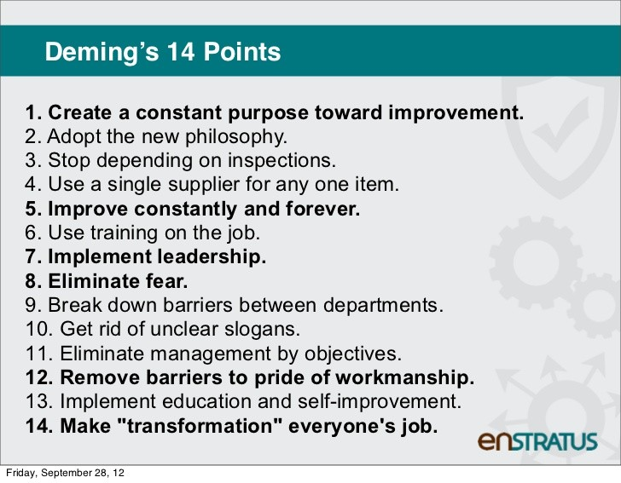
(Maheshwari, 2020)

- Quality assurance/control
The phrases quality assurance (QA) and quality control (QC) sometimes used synonymously. The two ideas are not the same, but they are clearly different.

According to Shah (2017), quality assurance is the establishment of standards for processes, materials and finished products that meet applicable regulatory requirements. Quality assurance covers all aspects of product development and manufacturing from raw material control to process validation and final product release.
According to Hayes (2023), a technique or series of procedures known as quality control (QC) designed to guarantee that a product or service that created or rendered satisfies the needs of the client or customer or conforms to a specified set of quality criteria.

Conclusion

Amazon has become a leader in customer relationship management by utilising data-driven personalisation, continual innovation, initiative-taking support, smooth procedures, and a customer-centric culture. In addition to fostering enduring customer relationships, the company's CRM strategy has boosted its overall success and given it a competitive edge in the e-commerce market. Success in the realm of Amazon selling requires good feedback management and first-rate customer service. Through the cultivation of trust and loyalty, the mitigation of unfavourable feedback, and the continuous enhancement of our customer service tactics, we can establish a favourable seller image that draws in more customers and boosts revenue (Yousuf, 2023). We must remember that maintaining engaged and satisfied customers is just as important to success as acquiring new ones through customer loyalty. We may become a brand advocate for life by converting one-time buyers into devoted followers with perseverance and effective marketing techniques.

Recommendation

1.Leverage AI and Automation: To deliver quicker, more individualised service, Amazon could make greater use of AI and automation in its CRM system.
- AI-powered chatbots for early client inquiries are one example.
- Automated suggestions derived from previous exchanges.
- Using predictive analytics to foresee client requirements.
2.Boost the integration of customer data.
Even though Amazon gathers a tonne of customer data, the customer experience may be further improved by more effectively integrating and using this data across all touchpoints. This might entail:
- Smooth data exchange between various Amazon platforms and services.
- Enhanced individualization of recommendations using thorough consumer profiles.
- Proactive client service based on anticipated problems or requirements.
3. Extend Omnichannel Support.
By adding more support channels to its existing roster, Amazon may make an investment in offering a fully omnichannel customer service experience. This can involve messaging or live chat assistance.
- Support for complex challenges via video calls.
- Monitoring and assistance with social media.
4.Put Relationship Building First.
Even though Amazon is very good at completing transactions quickly, it should focus more on developing enduring relationships with its clients. Strategies that could be used are subscriptions with special perks or loyalty programmes.
- Outreach and personalised communication that goes beyond advertisements.
- Opportunities for customers to co-create experiences and offer feedback.
5.Continuous Training and Quality Assurance: Through regular training and staff upskilling, Amazon can make sure that its customer service agents and CRM systems are consistently providing high-quality experiences.
- Strict monitoring and procedures for quality assurance.
- Utilising consumer input to pinpoint areas in need of development.

References

Shaw, C. (2023, May 9). Let’s really understand what Customer Engagement is and how to improve it. Www.linkedin.com. https://www.linkedin.com/pulse/lets-really-understand-what-customer-engagement-how-improve-shaw
Eads, A. (2023, April 11). 12 Approaches To Thoughtfully Engage With Customers. Indeed Career Guide. https://www.indeed.com/career-advice/career-development/engage-with-customers
Paton, J. (2022, November 27). What is customer engagement and why is it important? - Dotdigital. Dotdigital.com. https://dotdigital.com/blog/what-is-customer-engagement-and-why-is-it-important/
Danao, M. (2023, September 12). Customer Engagement In 2023: The Ultimate Guide – Forbes Advisor. Www.forbes.com. https://www.forbes.com/advisor/business/customer-engagement/
Williams, K. (2022). Study.com. https://study.com/learn/lesson/customer-value-overview-examples.html
Slater, D. (2024). The Imperatives of Customer-Centric Innovation | AWS Executive Insights. Amazon Web Services, Inc.; aws.amazon.com. https://aws.amazon.com/executive-insights/content/the-imperatives-of-customer-centric-innovation/
Chaffey, D. (2023, February 27). Amazon.com marketing strategy 2023: E-commerce retail giant business case study. Smart Insights. https://www.smartinsights.com/digital-marketing-strategy/online-business-revenue-models/amazon-case-study/
Garg, mehak. (2023, May 5). Amazon Customer Lifetime Value | Calculation Formulas. Sellermobile.com. https://sellermobile.com/amazon-customer-lifetime-value/
Malachard, V. (2021, December 15). Mastering Amazon Customer Lifetime Value [Updated for 2022]. Www.nozzle.ai. https://www.nozzle.ai/insights/customer-lifetime-value-on-amazon
Jordan, F. (2019, December 10). Why Is Amazon So Successful? – Factors Explained | Perpetua. Perpetua.io. https://perpetua.io/blog-why-is-amazon-so-successful-amazon-success-story/
Hargrave, M. (2023, July 31). Customer Relationship Management - CRM Goes beyond Just Software. Investopedia. https://www.investopedia.com/terms/c/customer_relation_management.asp
Binns, R. (2023, February 22). How Do They Do It? Amazon’s CRM Success Story. Expert Market. https://www.expertmarket.com/uk/crm-systems/amazon-crm-case-study
Folio3. (2020, June 4). Amazon CRM – How to master the Amazon CRM Strategy? Folio3 Dynamics Blog. https://dynamics.folio3.com/blog/amazon-crm/
Chakrawarty, A. (2017, December 13). AMAZON’S CUSTOMER RELATIONSHIP MANAGEMENT STRATEGY. Linkedin.com. https://www.linkedin.com/pulse/amazons-customer-relationship-management-strategy-atul-chakrawarty
Channelreply. (2016, February 12). Channelreply.com. https://www.channelreply.com/blog/view/amazon-crm-strategy
Yousuf, R. (2023, October 2). Amazon Customer Service and Feedback Management. Www.linkedin.com. https://www.linkedin.com/pulse/amazon-customer-service-feedback-management-rizwan-yousuf
Gill, L. (2023, June 27). The critical importance of accurate, real-time Amazon data. Venture Forge. https://ventureforge.co.uk/the-critical-importance-of-accurate-real-time-amazon-data/
Marks, G. (2022, July 1). On CRM: Have You Ever Considered Buying Amazon’s CRM System? Forbes. https://www.forbes.com/sites/quickerbettertech/2022/07/01/on-crm-have-you-ever-considered-buying-amazons-crm-system/?sh=58df845f5d7a
Ramich, A. (2022, January 20). Council Post: What Is Customer Centricity? Forbes. https://www.forbes.com/sites/forbesagencycouncil/2022/01/20/what-is-customer-centricity/?sh=43aee152ade9
Max, D. (2021, July 29). Top 5 Customer Centricity Examples From 5 Aspirational Brands. Netomi. https://www.netomi.com/customer-centricity
Habel, J., Kassemeier, R., Alavi, S., Haaf, P., Schmitz, C., & Wieseke, J. (2019). When Do Customers Perceive Customer centricity? the Role of a Firm’s and Salespeople’s Customer Orientation. Journal of Personal Selling & Sales Management, 40(1), 1–18. Tandfonline. https://www.tandfonline.com/doi/full/10.1080/08853134.2019.1631174
Szaniawska-Schiavo, G. (2024, March 7). What Is Customer Loyalty? [Definition, Tips & Examples]. Tidio. https://www.tidio.com/blog/customer-loyalty/
Freedman, M. (2024, April 1). Your Best Asset: What Makes Customer Loyalty So Important? Business.com; business.com. https://www.business.com/articles/what-makes-customer-loyalty-so-important/
Chambers, S. (2022, August 30). The Importance of Customer Loyalty. Customer Happiness Blog. https://www.nicereply.com/blog/the-importance-of-customer-loyalty/
Rodriguez, M. (2019, August 5). How Amazon maintains over 90% customer retention - Updated... Beamer; Beamer. https://www.getbeamer.com/blog/how-amazon-maintains-over-90-customer-retention-year-over-year
Danziger, P. N. (2018, January 10). Amazon’s Customer Loyalty Is Astounding. Forbes. https://www.forbes.com/sites/pamdanziger/2018/01/10/amazons-customer-loyalty-is-astounding/
Profound. (2021, November 16). How to retain customers in the age of Amazon. Profound Digital. https://www.profound.digital/blog/digital-transformation/how-to-retain-customers-in-the-age-of-amazon/
Moorman, J. (2012, October 12). Leveraging the Kano Model for Optimal Results. UX Magazine. https://uxmag.com/articles/leveraging-the-kano-model-for-optimal-results
Collins, D. (2023, June 20). MoSCoW Prioritization Model. ProdPad. https://www.prodpad.com/glossary/moscow-prioritization-model/
Schwarzbaum, J. (2023, August 28). Increasing Customer Loyalty on Amazon: Retention Strategies That Work. Velocity Sellers, Inc. https://velocitysellers.com/2023/08/28/increasing-customer-loyalty-on-amazon-retention-strategies-that-work/
How Amazon Plans Its Customer Retention Strategy? (2022, July 29). Https://Sarasanalytics.com/. https://sarasanalytics.com/blog/customer-retention-strategy-by-amazon/
Hunersen, C. (2019, July 15). Why Amazon is A Leader in Customer Experience. Qualtrics. https://www.qualtrics.com/blog/amazon-customer-experience-leader/
Barone, A. (2023, March 28). What Is Total Quality Management? Investopedia. https://www.investopedia.com/terms/t/total-quality-management-tqm.asp#:~:text=What%20Is%20Total%20Quality%20Management%20(TQM)%3F
Kumar, P. (2023, March 13). What is Six Sigma: A Complete Overview. Simplilearn.com; Simplilearn. https://www.simplilearn.com/what-is-six-sigma-a-complete-overview-article
Punam. (2020, May 30). Amazon Lean Management: The Six Sigma Case Study. Henry Harvin. https://www.henryharvin.com/blog/amazon-lean-management/
Six sigma. (2017, June 13). Six Sigma Case Study: Amazon.com. 6Sigma.com. https://6sigma.com/six-sigma-case-study-amazon/
A, L. (2015, January 6). Deming’s 14 Principles: what do they mean for Today’s Business. Linkedin.com. https://www.linkedin.com/pulse/demings-14-principles-what-do-mean-todays-business-lyes-allalou
Maheshwari, V. (2020, July 9). Deming’s 14 points for better and effective Management. Www.linkedin.com. https://www.linkedin.com/pulse/demings-14-points-better-effective-management-varun-maheshwari
McGowan, G. (2010, February 10). Management Theory of Joseph Juran. Business.com; business.com. https://www.business.com/articles/management-theory-of-joseph-juran/
Hayes, A. (2023, March 30). Quality Control. Investopedia. https://www.investopedia.com/terms/q/quality-control.asp
Shah, K. (2017, March 23). Quality Assurance BrandVoice: WHAT ARE QUALITY ASSURANCE AND QUALITY CONTROL? Forbes. https://www.forbes.com/sites/qualityassurance/2010/03/23/what-are-quality-assurance-and-quality-control/

Appendices

KANO Model
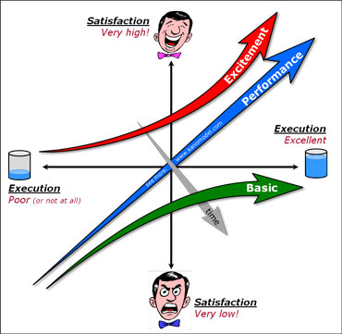
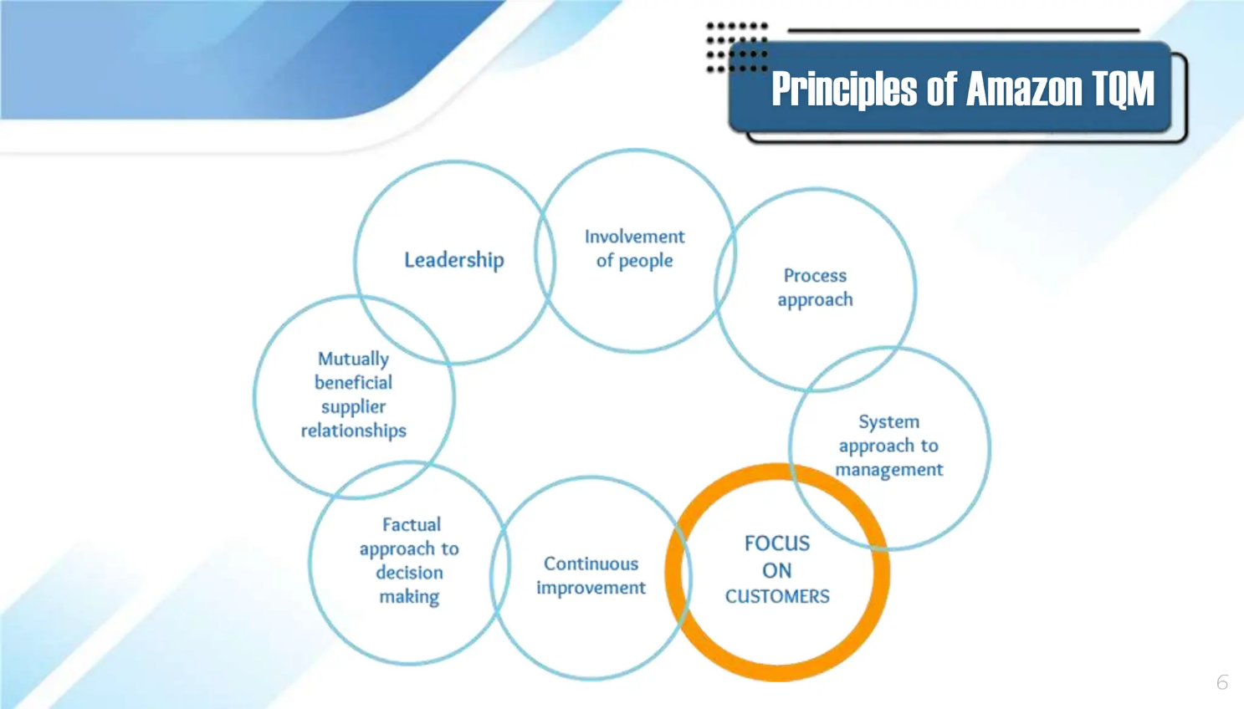
Six Sigma Model
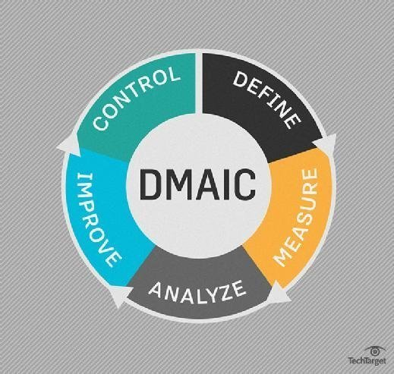
Juran Model


