Student number – 2228093

Module Title- Intercultural Competence Report

BMIH5003

Lecturers Name – Heidi Prosser

Executive Summary

This comprehensive report delves into the cultural dynamics between England and Germany within the context of the Inclusivity Hotel & Spa in the Anglo Cluster. It explores not only key cultural differences but also highlights significant similarities. The GLOBE Project's insights and potential intercultural leadership challenges are thoroughly examined, leading to well-crafted recommendations for fostering inclusivity and harmony among the diverse team.

Content Table

1. Key Differences and Similarities Between England and Germany
- Culture and Customs
- Hospitality Practices
2. GLOBE Project's Culture and Leadership Study
- Practices and Values
- Leadership Styles
3. Intercultural Leadership Challenges
- team dynamics
- conflict resolution
- Work life balance
- feedback and recognition
- project management
4. Recommendations for Overcoming Challenges
- Cross-Cultural Training
- Leadership Development Program
- Open Communication Channels
5. Conclusion

6. Recommendations

7. References

Introduction
The Inclusivity Hotel & Spa functions within a diverse cultural landscape, necessitating an appreciation of both unique traits and shared principles. This report seeks to offer a detailed examination of the cultural intricacies between England and Germany, underscoring not only their differences but also the significance of acknowledging shared ideals to facilitate successful team leadership.

Main Body

Key Differences and Similarities Between England and Germany

Culture and Customs
In England, the cultural landscape thrives on diversity, fostering a welcoming and inclusive atmosphere characterised by politeness and indirect communication (Hofstede,2001). Conversations often involve subtle nuances and politeness is highly valued, contributing to a courteous and respectful social environment. On the contrary, Germany adopts a more structured and direct approach to communication, prioritising clarity, and efficiency (Hampden-Turner & Trompenaars, 2006). Punctuality is highly esteemed in German culture, reflecting a disciplined and organised mindset. Despite these contrasting communication styles, both cultures share a common goal of creating positive guest experiences through their respective approaches, emphasising hospitality and attentiveness.

Hospitality Practices
In English hospitality, personalised service is paramount, aimed at creating a cosy and intimate atmosphere for guests (Hofstede, 2015). Staff members strive to establish a warm rapport with guests, often going above and beyond to cater to individual needs and preferences. The emphasis is on creating a homely environment where guests feel comfortable and cared for. On the other hand, German hospitality is characterized by meticulous attention to detail and adherence to established processes (GLOBE Project, 2020). Efficiency and accuracy are prioritised, with a focus on delivering seamless and flawless service. Despite these differences in approach, both cultures share a dedication to maintaining high standards of service, ensuring that guests receive exceptional experiences during their stay.

GLOBE Project's Culture and Leadership Study

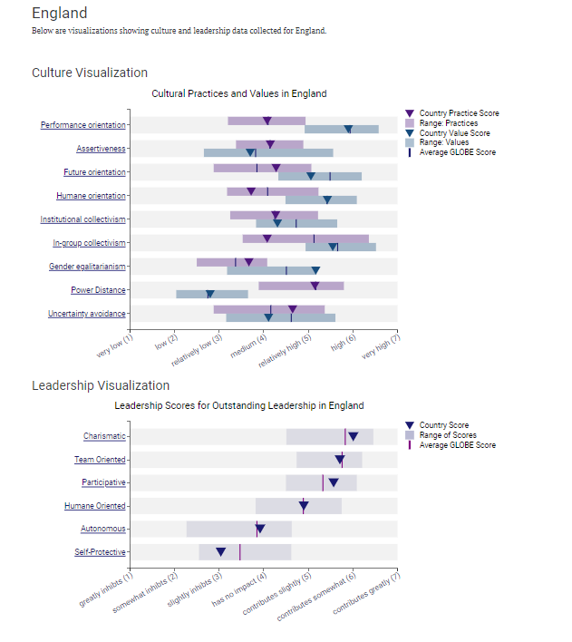
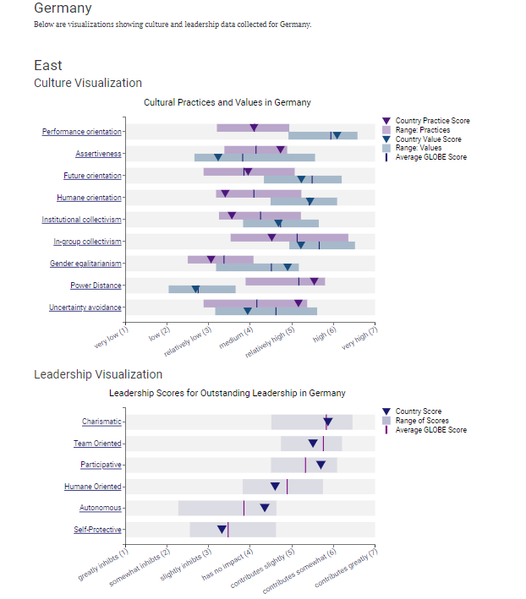
(GLOBE Project 2020)

Practices and Values
In England, the culture is characterised by a high level of uncertainty avoidance, indicating a preference for clear rules and structure in social and professional settings. This emphasis on certainty and predictability influences various aspects of English society, including decision-making processes and organisational structures. Moreover, professionalism and excellence are highly valued in English culture, reflecting a commitment to high standards and quality outcomes (Venaik & Brewer, 2010). On the other hand, Germany exhibits a high score in performance orientation, emphasising a strong commitment to achievement and continuous improvement. This cultural trait underscores the importance of setting and striving for ambitious goals, as well as maintaining a focus on efficiency and effectiveness in all endeavours. Despite these differences, both cultures share a common emphasis on professionalism and excellence, indicating a mutual respect for high-quality work and dedication to achieving success. (Bortolotti et al., 2015)

Leadership Styles
In England, participative leadership is prevalent, emphasising collaboration, creativity, and shared responsibility among team members. Leaders in this context are encouraged to involve their subordinates in decision-making processes and foster an environment where diverse perspectives are valued. This leadership style aligns with the cultural preference for inclusivity and open communication (Song et al., 2019). Conversely, Germany tends to favour assertive, task-oriented leadership, where leaders provide clear direction and prioritise productivity and efficiency in achieving organisational goals. This leadership approach reflects the cultural value placed on precision, thoroughness, and goal-oriented behaviours. While the style may appear, more directive compared to the participative approach in England, it aims to ensure clarity and decisiveness in driving performance (Miller, 2016). Despite these differences in leadership styles, both cultures recognise the crucial role of effective leadership in achieving organisational objectives. Whether through collaborative engagement or assertive direction, leaders in both England and Germany are expected to inspire and guide their teams towards success while embodying the values of professionalism and excellence inherent in their respective cultures.

Intercultural Leadership Challenges

Team dynamics
In a multicultural team consisting of members from England and Germany, there may be challenges in team dynamics. English team members might prefer a more casual and egalitarian approach, while German team members might value hierarchy and formalities. This can lead to misunderstandings and tensions within the team, affecting collaboration and productivity.

Conflict Resolution
When conflicts arise between team members from England and Germany, there may be differences in how they approach conflict resolution. English team members might prefer to address conflicts openly and directly, while German team members might value maintaining harmony and avoiding confrontation. This can lead to unresolved conflicts and simmering tensions within the team.

Work life balances
In a multinational company with offices in both England and Germany, there may be differences in work-life balance expectations. English employees might prioritise flexibility and work-life balance, while German employees might adhere more strictly to traditional working hours and boundaries. This can lead to misunderstandings and dissatisfaction among employees, affecting morale and productivity.

Feedback and recognition
When giving feedback and recognition to employees from different cultural backgrounds, there may be differences in expectations and preferences. English employees might appreciate praise and recognition in public settings, while German employees might prefer feedback to be given privately and in a more reserved manner. Failing to understand and adapt to these differences can lead to disengagement and demotivation among employees.

Project Management
In a cross-cultural project involving teams from England and Germany, there may be challenges in project management styles. English project managers might favour a more flexible and adaptive approach, while German project managers might prefer a more structured and methodical approach. This can lead to clashes in decision-making processes and project execution, affecting the overall success of the project.

Conclusion
Managing a team comprised of individuals from diverse cultural backgrounds within the hospitality industry entails the acknowledgment of both dissimilarities and commonalities. By embracing and integrating these aspects, the Inclusivity Hotel & Spa can foster a dynamic and inclusive work environment, facilitating the seamless integration and collaboration of employees originating from England and Germany.

Recommendations for Overcoming Challenges

- cross-cultural training Implementing a robust cross-cultural training program will significantly contribute to enhancing the understanding and appreciation of varied work styles, thus nurturing a sense of unity among employees from both English and German backgrounds (Trompenaars & Woolliams, 2020). By prioritising the identification and emphasis of shared values, the team's cohesion will be further fortified, creating a more harmonious and collaborative work environment conducive to productivity and mutual respect.

- leadership development program Establishing a leadership development program that integrates elements from both cultures will contribute to a hybrid leadership approach aligned with diverse team dynamics and organisational goals (Crevani et al., 2015). Recognising shared leadership principles and values will enhance collaboration and foster a cohesive and high-performing team environment.

- open communication channels encouraging open communication channels, regular feedback sessions, town hall meetings, and team-building activities will create a culture of mutual respect, promoting effective collaboration (Mabey, 2012). Emphasising shared goals and values in communication will strengthen team dynamics.

References
Mabey, C. (2012) ‘Leadership development in organizations: Multiple discourses and diverse practice’, International Journal of Management Reviews, 15(4), pp. 359–380. doi:10.1111/j.1468-2370.2012.00344.x.
Bortolotti, T., Boscari, S. and Danese, P. (2015) ‘Successful lean implementation: Organizational culture and soft lean practices’, International Journal of Production Economics, 160, pp. 182–201. doi:10.1016/j.ijpe.2014.10.013.
Crevani, L. et al. (2015) ‘Leadership cultures and discursive hybridisation’, International Journal of Public Leadership, 11(3/4), pp. 147–165. doi:10.1108/ijpl-08-2015-0019.
Global leadership and organizational behaviour effectiveness (globe) (no date) Global leadership and organizational behaviour effectiveness (GLOBE 2020) - Human Resource Management and Organisational Behaviour. Available at: https://www.uni-bamberg.de/en/bwl-pm/research-chair-hrm/flexibilisation-of-work-and-work-behaviour/globe/ (Accessed 13th February 2024)
Hampden-Turner, C. and Trompenaars, F. (2006) ‘Cultural intelligence’, Group &amp; Organization Management, 31(1), pp. 56–63. doi:10.1177/1059601105276942.
Hofstede, G. (2001). Culture's Consequences: Comparing Values, Behaviors, Institutions, and Organizations Across Nations. Sage Publications.
Hofstede, G.J. (2015) ‘Culture’s causes: The next challenge’, Cross Cultural Management, 22(4), pp. 545–569. doi:10.1108/ccm-03-2015-0040.
Miller, P. (2016) ‘Cultures of educational leadership: Researching and theorising common issues in different world contexts’, Cultures of Educational Leadership, pp. 1–23. doi:10.1057/978-1-137-58567-7_1.
Song, Z., Gu, Q. and Cooke, F.L. (2019) ‘The effects of high‐involvement work systems and shared leadership on Team Creativity: A Multilevel Investigation’, Human Resource Management, 59(2), pp. 201–213. doi:10.1002/hrm.21988.
Trompenaars, F. and Woolliams, P. (2020) ‘Marketing research across cultures’, Handbook on Cross-Cultural Marketing [Preprint]. doi:10.4337/9781788978545.00023.
United Kingdom results (no date) GLOBE Project 2020. Available at: https://globeproject.com/results/countries/GBR%3Fmenu=list.html#list (Accessed: 12 February 2024).
Venaik, S. and Brewer, P. (2010) ‘Avoiding uncertainty in Hofstede and Globe’, Journal of International Business Studies, 41(8), pp. 1294–1315. doi:10.1057/jibs.2009.96.

