Steve Cope 2134156
Steve.cope@fsgtoolanddie.co.uk
Abstract
Χριτιχαλλψ εϖαλυατε τηε μανυφαχτυρινγ σψστεμσ, ατ α στρατεγιχ λεϖελ, ωιτηιν ΦΣΓ το ιδεντιφψ οππορτυνιτιεσ φορ νεω ανδ εμεργινγ Ινδυστρψ 4.0 τεχηνολογψ εναβλερσ, ωηιλστ ιδεντιφψινγ τηε χυλτυραλ ανδ ωορκφορχε φαχτορσ τηατ μαψ χοντριβυτε το δελιϖερινγ αυτηεντιχ εχονομιχ ανδ σοχιεταλ βενεφιτ.
Assignment 2 - Introduction to Industry 4.0
ACPA7004

Table of Contents
Introduction 2
Evaluation of the Manufacturing System 2
Current State 2
Organisation 2
Structure Management 2
Operations and Supply chain 3
Automation 3
Digital Simulation 4
Data Collection and Processing 4
Visualisation through Immersive Digital Technologies 4
Connected intelligence. 5
Moving from current state to future state 6
Sample workflow 6
Enablers and Barriers to industry 4.0 7
Problems industry 4.0 thinking can solve. 8
Data capture 8
Justification 8
Machines on stop on afternoon shifts. 9
Reduce Setup Times 9
Consumable Costs 9
Summery 9
Plan, Do, Check, Act 10
5’s Principles 10
Offline Programming 11
Phase Two Pre-Setting 11
Investing in Technology 11
Foil Simulation 12
Conclusion 13
References 14
Appendix 15

Introduction
This paper will critically evaluate the manufacturing system at FSG Tool and Die Ltd. to scope out the current state and using lean methodologies and industry 4.0 thinking suggest how the company could grow to its future state.
From analysing the results of the industry 4.0 readiness exercise and gap analysis there are certain areas of the business that were highlighted as areas for improvement. Using industry 4.0 enablers three main projects were pinpointed to reduce bottlenecks, increase flow, and reduce constrains within the business.

Evaluation of the Manufacturing System
Before any improvements can be made its vitally important to benchmark exactly where the company is as a starting point and where it would like to be in a given time scale. To do this the manufacturing system is broken up into smaller sections, Organisation, processes, and technology. Each of these sections are asked a series of questions to score of where they think they are and where they want to be. Applying a gap analysis framework around the results will not only breakdown the changes into more manageable steps but also ensure that the changes are targeted and more likely to succeed.

Current State

Organisation
There is a long-standing tradition of training and upskilling within FSG. Five out of six of the team leaders and the operations director are ex-FSG apprentices. All new staff are trained and mentored within their rolls during the on boarding stage. FSG use external partners and universities to train and upskill the staff with the latest knowledge. The management team look for the most recent trends and technologies to continually improve processes and efficiencies.
To stay competitive FSG would like its management team to be able to independently adapt and change based on its own data being fed directly from the customer, market forces and production KPI’s while planning ongoing training programs to continuously upskill its employees to meet the ever-changing demands on the business.

Structure Management
FSG is split into three main areas sales, design, and production. Then design is split into three more departments CAD, technical planning, and production control. Production is also sub divided into five more teams CNC Milling, CNC Turning, Assembly, Grinding and QA. There is a good informal sense of teamwork between each of these departments, but they mostly work in silos without a lot of cross functional collaboration. The management team are investigating how to move from the current state to a SMART factory setup where the teams will be encouraged to share resources and knowledge in a collaborative way.

Operations and Supply chain
The value of having and being part of an integrated supply chain is clear to the management team but there is a need to rely on individuals’ knowledge and experience to make critical decisions. As not only FSG but its customers and suppliers invest in technologies and connectivity it will be faster and accurate to access live data to automate the processes to move away from people relying on their expertise to analyse reports to make decisions. This could free up time to continually improve processes and procedures.

Automation
Due to the nature of the markets FSG are in there is a need for some of the processes, such as Computer Aided Design (CAD) modelling, Computer Numerical Controlled (CNC) machining and Computer Aided Manufacture (CAM) programming to be done using computerised systems but these are stand alone and operated exclusively by the employees. There is one automated cell within the factory where a polar co-ordinate robot feeds two Electro Discharge Machines (EDM). Even with the robot it still takes the knowledge of the employees to decide what components to produce and when. To stay competitive and alleviate the pressure of the current skills shortage FSG are in, production processes that can be carried out by the computer-based systems with minimal input from the employees would be beneficial.
The business and financial processes are manually done by employees using basic computer systems. All the data is input and analysed manually, and the outcomes decided and executed by the experienced employees. Investment in SMART ERP systems would mean the system could analyse the data and reports in more detail, in real time and make its own decisions based on the outcomes.
FSG’s site is quite a modern facility with good access to power and communications. Some of the facilities management is automated such as the lighting, heating, and air compressor. All the cyber security and data is automatically handled and backed up off site. There are plans to reduce energy costs and make the plant sustainable by installing renewable energy sources like solar and heat recirculation for the air compressor cooling.

Digital Simulation
Even though FSG’s production schedule is very tight and demanding. All the production planning is carried out by skilled employees, constantly reacting to the needs of the customer and problem-solving issues on the shop floor or with the supply chain. There is a clear goal set by the management team to move towards a SMART ERP system where the customer orders are fed into the system, and the system will work out what materials and machine tools are required and when components need to be completed. There will also be an option to virtually drop large projects into the system to evaluate how that will affect the current workflow.
The sales and financial departments use Excel spread sheets and a lot of manual input to try to predict and forecast up and coming sales opportunities. FSG are in the very early stages of looking into a system that can simulate and model the business operations to support top level decision making and continuous improvements.

Data Collection and Processing
The current data collection methods in FSG are manually collected and then entered on to a computer-based Excel spread sheets for analysis. This is a labour-intensive process and can be inaccurate due to human error. This has been highlighted as the first and most important area to be updated. A SMART automated system will provide accurate, real-time data through machine sensors. This data will form the basis of all the decision making and evaluation of new procedures.
Business operation data is manually handled through paper purchase orders and invoices. This data is then manually entered on to a computer-based ERP System that can generate basic reports. There are aspirations to invest in a system that will connect customer orders to production capacity and down through the supply chain to procure materials.
Site health safety and environment information is manually entered into a companywide compliance register where every piece of legislation is recorded and through Microsoft Excel, email notifications are sent out to the relevant departments informing them of up-and-coming Audits, maintenance, or training requirements. There is a desire within the company to have this linked to a health and safety cloud where all new changes are updated automatically and the relevant stakeholders informed.

Visualisation through Immersive Digital Technologies
At the time of the questionnaire the shop floor is processing data manually and evaluating paper drawings and route cards. There have been discussions within the company regarding the advantages of AR/VR technologies. There could be a lot of efficiency savings utilising the products such as the Microsoft Holo lens to have heads up displays for SOP’s, Tool Data, Speeds/feeds and breakdown information instantly at the machine. AR technologies could also be used to speed up the assembly process and training.
The sales and production planning departments are using a computer-based system to produce paper plans graphs and KPI’s. The next step in the digital transformation process is to move towards a SMART system that takes data from the shop floor and market forces to generate reports, update displays and strategies autonomously.

Connected intelligence.
FSG are right at the beginning of their connectivity journey. All their computer systems and machinery work independently of each other and don’t communicate in any way. All data is duplicated between each process and manually downloaded. The management team are looking into integrated systems that can communicate and share data and information between themselves with very little human input. The design software could understand the machining capabilities of the shopfloor to ensure all designs can be produced with the current assets. Production would know when the components could be produced based on the capacity already loaded on to the shop floor and Consumables would be procured based on the design.

Moving from current state to future state

Timeline/project plan of how it could happen.
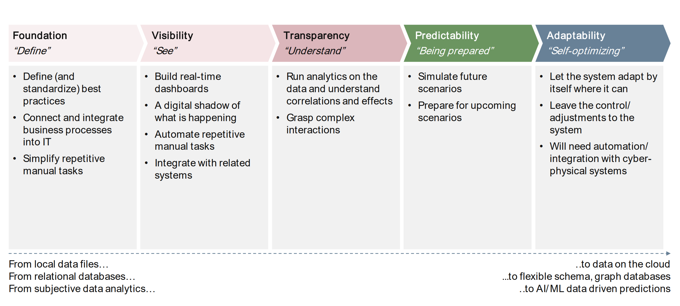

Sample workflow
Figure 2.1 shows FSG’s current workflow, which is quite a traditional SME business model. The customer’s engineering department would decide what components are required and the purchasing department would email a quote to FSG’s sales. FSG would evaluate the technical specifications and email back a price and delivery. When the customer approves the quote a purchase order would be sent back to FSG to proceed with the work. The confirmed order is entered into FSG’s ERP system where it is added to the production schedule. The design department produces digital CAD models, materials and consumables procured by the purchasing department. After waiting for the materials to be delivered production produces CAM programs and the places the components in the queue for the machines. Skilled operators set the machines to produce the components and get them inspected by the quality department. If the components meet the specification the parts are sent to the customer via dispatch. Dispatch informs purchasing that the order was fulfilled by producing a delivery note, this in turn lets purchasing know they can send out the invoice. The invoice is received by the customer and paid after 30days, FSG’s accounts department will check that the items have been paid for and close out the order. Depending on the complexity or the size of the order this process could take between 10 to 12 weeks, its very labour intensive and inefficient due to the amount of time waiting for the different companies and departments to communicate with each other.
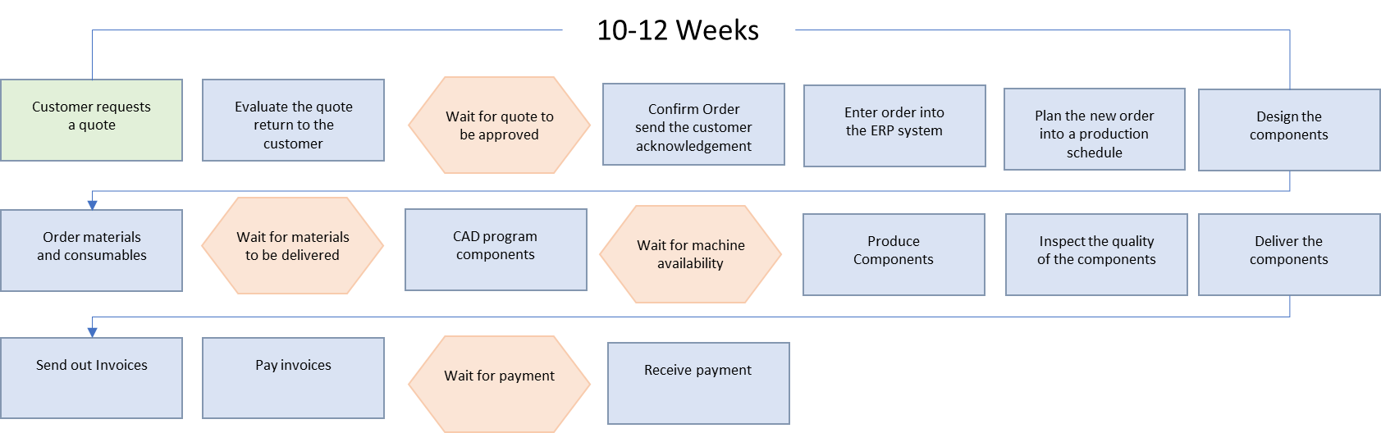
Figure 2.1

Figure 2.2 gives an example of how a SMART factory could work. This is a huge leap from where most companies are now and would need all stakeholders in the supply chain to evolve to the SMART factory level for the system to work to its full potential. FSG’s customer’s factory would need a digital twin to optimise its processes and the whole production line to be CAD modelled and linked to FSG’s CAD library. When it becomes time to replace parts for maintenance the system will inform FSG in advance which will in turn inform FSG’s suppliers to deliver materials. FSG’s production would have already planned in the components because it would know the maintenance cycles of its customers. FSG’s SMART system would be able to CAM program the customer components from their information. The materials could be robot fed into an automated machine that produces and quality assure the components. The components are dispatched and to ensure traceability and security the payments are sent immediately via a block chain system. This would be a big advancement from where FSG is now but the technology to allow this to happen is readily available.
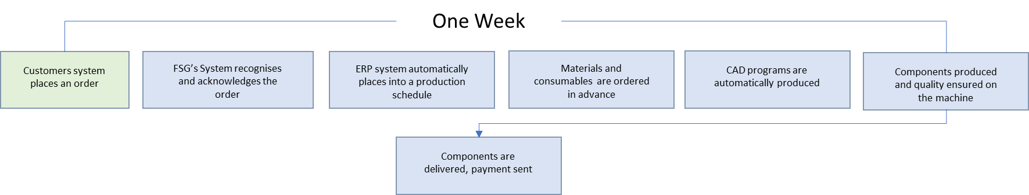
Figure 2.2

Enablers and Barriers to industry 4.0
To move not just individual companies but whole supply chains towards industry 4.0 there are barriers caused by current thinking but some enablers to help move towards the future state.
Figure 2.3 describes these barriers and how the enablers can navigate around them.
Barriers | Enablers
Companies working in silos | System integration, cloud computing
Departments working in silos | System integration, cloud computing
Suppliers not knowing what customers need | IOT big data
Production bottleneck | Simulation, digital twin
Skills shortage | Automation, AR, VR
Unsecure data and payments | Cybersecurity, block chain
 | Figure 2.3

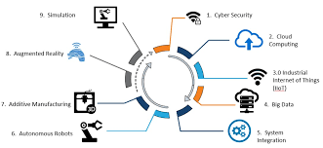

Problems industry 4.0 thinking can solve.
FSG’s 2023/2025 business plan showed an increase in turnover of 25% and an increase on the bottom line of 30%. A top-level strategy to achieve this was suggested and increasing production using existing assets was considered to have the biggest impact. It was up to the Production Management team to define the details of how this could be achieved. Before starting to change anything, several KPI’s were identified as important, Downtime, Setup time and Run time, to benchmark the current state and how best to move to a future state.

Data capture
It soon became clear that asking the operators to manually record the data was both time consuming and inaccurate, giving false results and making the production cells even more inefficient. Identifying this as a problem and using technology as a solution Mazak Smart Boxes were identified as an enabler to overcome the issue.

Justification
After taking the average booked hours booked on the CNC sections over a 3month period FSG currently run at the hours below: -
CNC Milling = 1621 hours
CNC Turning = 1619 Hours
Total Hours = 3240 Hours £178200 @£55/Hour
Total Hours +5% = 3402 Hours £187110 @/Hour
Increase = 162 Hours £8910 @55/Hour
Looking at the testimonials from Mazak and some other web sites they are indicating between a 5-10% increase in productivity just by having the operators knowing the machines are monitored.
The hourly numbers above indicate the amount of time an operator has worked on a component but not whether the machine is being run or set up. The Smart Box will be able to analyse the machine usage to not only tell if they are on stop but if they are in setup mode, had and alarm/error and even which cutters we use the most, from this data we can form strategies to improve productivity. For example: -

Machines on stop on afternoon shifts.
If the software confirms what we think, and our production drops throughout the afternoon and night shift, it might be possible to plan long running components on these shifts, swap shift patterns, employ more staff or even have the justification to invest in automation.

Reduce Setup Times
Again, the software could indicate that to improve production we will need to reduce setup time by implementing the 5’s system or investing in work holding and tool setting.

Consumable Costs
The Smart Box software will monitor and record every cutting tool that’s loaded into the machines, and we could then analyse the cutting tool usage to ensure maximum tool life, isolate the most used cutting tools and get the suppliers to analyse its performance and if it’s the correct application. This could not only reduce consumable cost but make sure we are using the carbide as sustainably as possible.

Summery
With an initial cost of £18939.84 minus the funding, we could see a return on our investment in 2 to 3months. The increase in production the smart box gives is a very small part of why FSG should invest in this type of technology. The main advantage it would offer is accurate, live data on demand to identify areas of improvement and allow us to come up with evidence-based strategies to exploit our assets.

Plan, Do, Check, Act
Using the Mazak Smart box data an accurate picture of the current state was visible. With the new reliable data, the question was asked again, how to increase production by 30% using the existing assets?
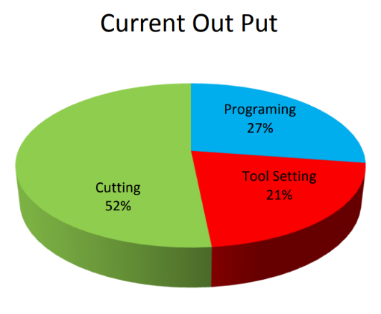
The results came in with the OEE of the CNC Machine section of 52% efficient. 26.5% programming, 21% Tool/Machine setting and 0.5 % machine errors. Working with these figures several A3’s sessions and gap analysis exercises were carried out to drill down on why the cutting time was 52% and how we could increase by 30%.
By involving all the stakeholders and getting them to come up with solutions and suggestions meant that there were lots of options to choose from. To prioritise these a RICE score was given to each solution and the ones with the highest score prioritised 1st e.g.
$$\frac{Reach x Impact x Confidence}{Effort}=RICE Score$$
5’s Principles
$$\frac{100 x 30 x 90}{50\%}=54$$
Pre-Setting
$$\frac{100 x 70 x 30}{90\%}=23$$
Offline Programming
$$\frac{70 x 80 x 50}{90\%}=31$$

5’s Principles
The way the shop floor and machines and tooling are laid out was deemed one of the quickest and easiest ways to make an impact to the production. Using SORT, SET, STANDARDISE, SHINE and SUSTAIN these principles lay down the foundation for all the other steps going forward.

Offline Programming
Several of the conventional 3 axis CNC machines were programmed using the controls on the machine itself. It was deemed quicker and easier by the operators on the shop floor. By evaluating the skills matrix and carrying out some root cause analysis, it turned out there was a skills shortage on the CAM software. This gap was plugged by using local universities to up skill apprentices and TECH Valley funding to support 50% of the cost of training new CNC programmers. The time to program each component didn’t change much but as it was done concurrently while the machines were cutting other components it had an impact on the output.

Phase Two Pre-Setting
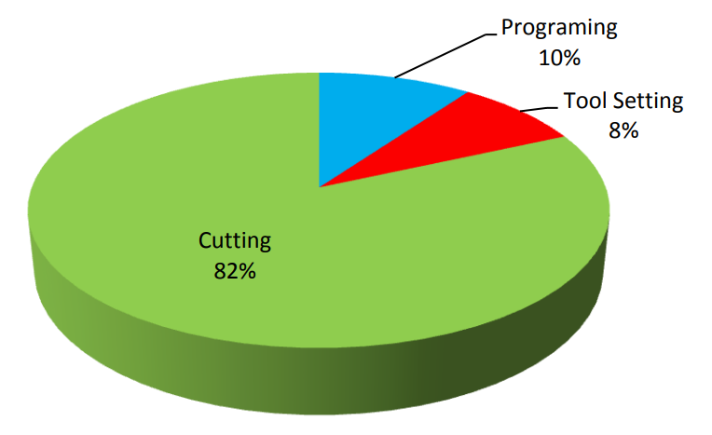
With the small batches of complex work that FSG produce, the machines could be on stop while being set for a large amount of the shift. Evaluating the smart box data and carrying out SMED exercises it was determined that the machines were on stop over 20% of a shift being set up. To dramatically increase the efficiency, an offline tool pre setter would allow tooling to be prepared and measured while the machines are running. These machines can be connected to the cutting tool supplier via the cloud to re stock and monitor cutter usage to map trends.

Investing in Technology
By investing in the latest technology to capture data in real time a structured evidence-based strategy was mapped out. Changing the mindset, layout and training the CNC section has increased its output from 3240 hours to 3568 hours. This is only a 10% increase in the number of hours booked into the section but having the OEE increase 30% means that components are being produced more efficiently, reducing lead times, and freeing up constraints to increase flow.

Foil Simulation
The information gathered from the digital data made it clear that there was a bottle neck around the production of the foil tray forming tools. The tools can be between a 1 and 6 out tool, working on cutting and forming the tray in a single stroke, at 60 strokes per minute. To establish the size of the cut edge only 1 head of the tool gets produced in a metal safe condition before trialling. All modifications are made to this trial head until the foil tray meets the customer specifications. Only then can the designs be updated, and all the CNC Machines be set back up to cut the remaining heads for the tool. This was identified as an inefficient way of working and after brainstorming the problem it became clear better estimating methods were needed to predict how the foil would bend and stretch in the tool. FSG worked in collaboration with the Astute program within local universities, to carry out a program of work to produce a digital twin replica of a forming tool. They analysed hundreds of finished tools from FSG’s design vault and were able to accurately replicate exactly what was happening within the tool. Not only did this allow the components of the tool to be produced ‘right 1st time’ but because the design department had more confidence in the final shape of the cut edge, they could place the heads closer together in the tools, resulting in less foil wastage.

Conclusion
The paradigm shift from where most companies are today to where is possible to get with the future technologies is difficult to grasp for a lot of management/shareholders. “61% of Industry 4.0 projects fail to achieve their desired goals” (McKinsey Industry 4.0 Global Expert Survey, 2018). If FSG fail to reach its industry 4.0 goals, I think it would be caused by a lack of incremental continuous improvements because the company doesn’t take small frequent steps towards a goal. The changes needed to reach SMART factory status seam colossal. Therefor the amount of investment and possibility of disruption to normal working practices would, for some people within the business, outweigh the benefits.
Probably the most negative reaction to industry 4.0 is that it will put people out of jobs, but I think it can only be good for the county. If a lot of the SMEs in Wales could reach the industry 4.0 SMART factory status it would become an exponential curve of improvement up and down the supply chain. As companies lower down the chain can produce and deliver product and services efficiently to the higher companies who in turn can supply higher value goods to larger markets creating more demand back down the supply chain. There will be a greater need for higher paid jobs with more of a focus on wellbeing over targets.
The industry 4.0 revolution is even more important within small countries such as Wales because we don’t have the vast natural resources and large labour markets of some of the big countries we are competing against. So, by being SMART and efficient in our manufacturing processes we can exploit new markets, technologies, and opportunities to gain advantage over the international competition.
I do think it’s important for SMEs to leverage as much as possible from the assets they have invested in. If they embrace industry 4.0 technologies and lean thinking, they can reduce lead times and increase Gross Value Added (GVA). With the increase in efficiency and profitability there hast to be a grater emphasis put on the wellbeing of the employees and local areas as stated by Welsh government “GVA can no longer be the dominant measure of success and prosperity. We are focussed on seeing progress on the national indicators for Wales which reflect the vision for well-being as our central pillar.” (A Manufacturing Future for Wales p.32)
For any industry 4.0 initiative to be a success most of the energy should go into scoping out the problem in depth. Lean manufacturing tools and thinking should be used to find the exact route cause and the best solution for the company at that time. Just because there are new technologies on the market, the solution shouldn’t be distorted to fit.
Choose Problems That Suit Your Organization’s Capabilities, Culture, and Strategy In his delightful memoir Surely You’re Joking, Dr. Feynman!, legendary physicist Richard Feynman devoted the final chapter to what he called “cargo cult science.” He took the name from a peculiar phenomenon that emerged in islands of the South Pacific after World War II. Many natives on the islands observed soldiers build airstrips and soon after saw planes appear with valuable cargo. After the soldiers left, they built their own improvised airfields, with makeshift antennas protruding out of coconut helmets, improvised headphones, and guys waving sticks to signal airplanes in the hopes that valuable cargo would drop from the sky for them, too. Anthropologists called the islanders who did this “cargo cults.” (G Sattel Mapping Innovation p189)

References
Satell, Greg; Satell, Greg. Mapping Innovation: A Playbook for Navigating a Disruptive Age (pp. 189-190). McGraw Hill LLC. Kindle Edition.
McKinsey Industry 4.0 Global Expert Survey, 2018
A Manufacturing Future for Wales p.32


Appendix


