4/20/2026
Student: Elena Magher (2426374)
s
Lecturer: Sadeque Iman Shaikh

Configure and Manage the Virtualized Enterprise Network

Module: Network Operating Systems and Services (ACCA5023)
Assignment: Coursework 2 – Task 1

Table of Contents
1. Introduction 1
2. Laboratory Environment and Topology 1
3. Routing Configuration 2
4. Domain Controller and DNS 3
5. Site-to-Site Encrypted Tunnel 3
6. Bulk User Provisioning 4
7. Domain Membership 4
8. DHCP Server and Relay 4
10. Shared Storage Configuration 5
11. Internal Web Service 6
12. Remote Desktop Services 6
13. Professional Reflection 7
14. Conclusion 8

1. Introduction

This report presents the design, implementation, and evaluation of a virtualized enterprise network across two separate sites. The objective is to simulate a realistic organizational infrastructure and demonstrate control over core services including routing, identity management, secure communication, and service delivery. The approach focuses not only on configuration, but also on justification of technical decisions and security considerations.

2. Laboratory Environment and Topology
The environment consists of a Windows Server acting as a domain controller and a Debian-based system supporting routing and relay functions. Two logical networks 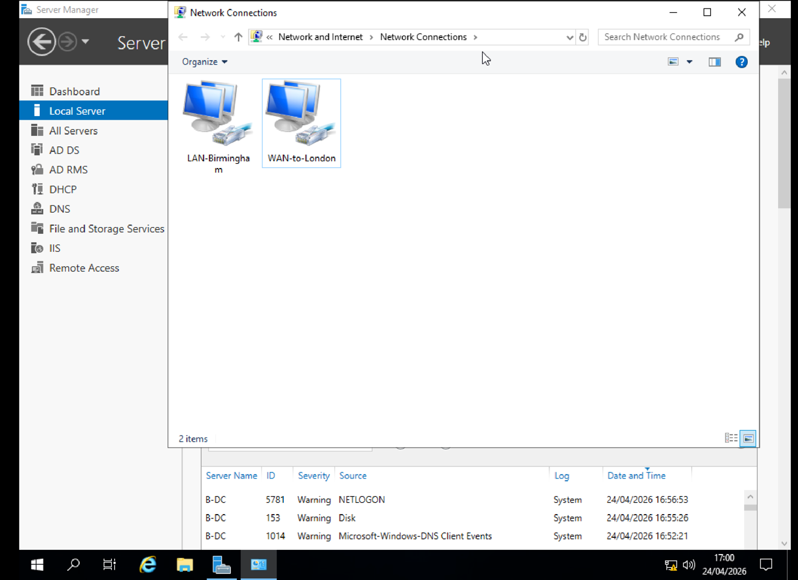
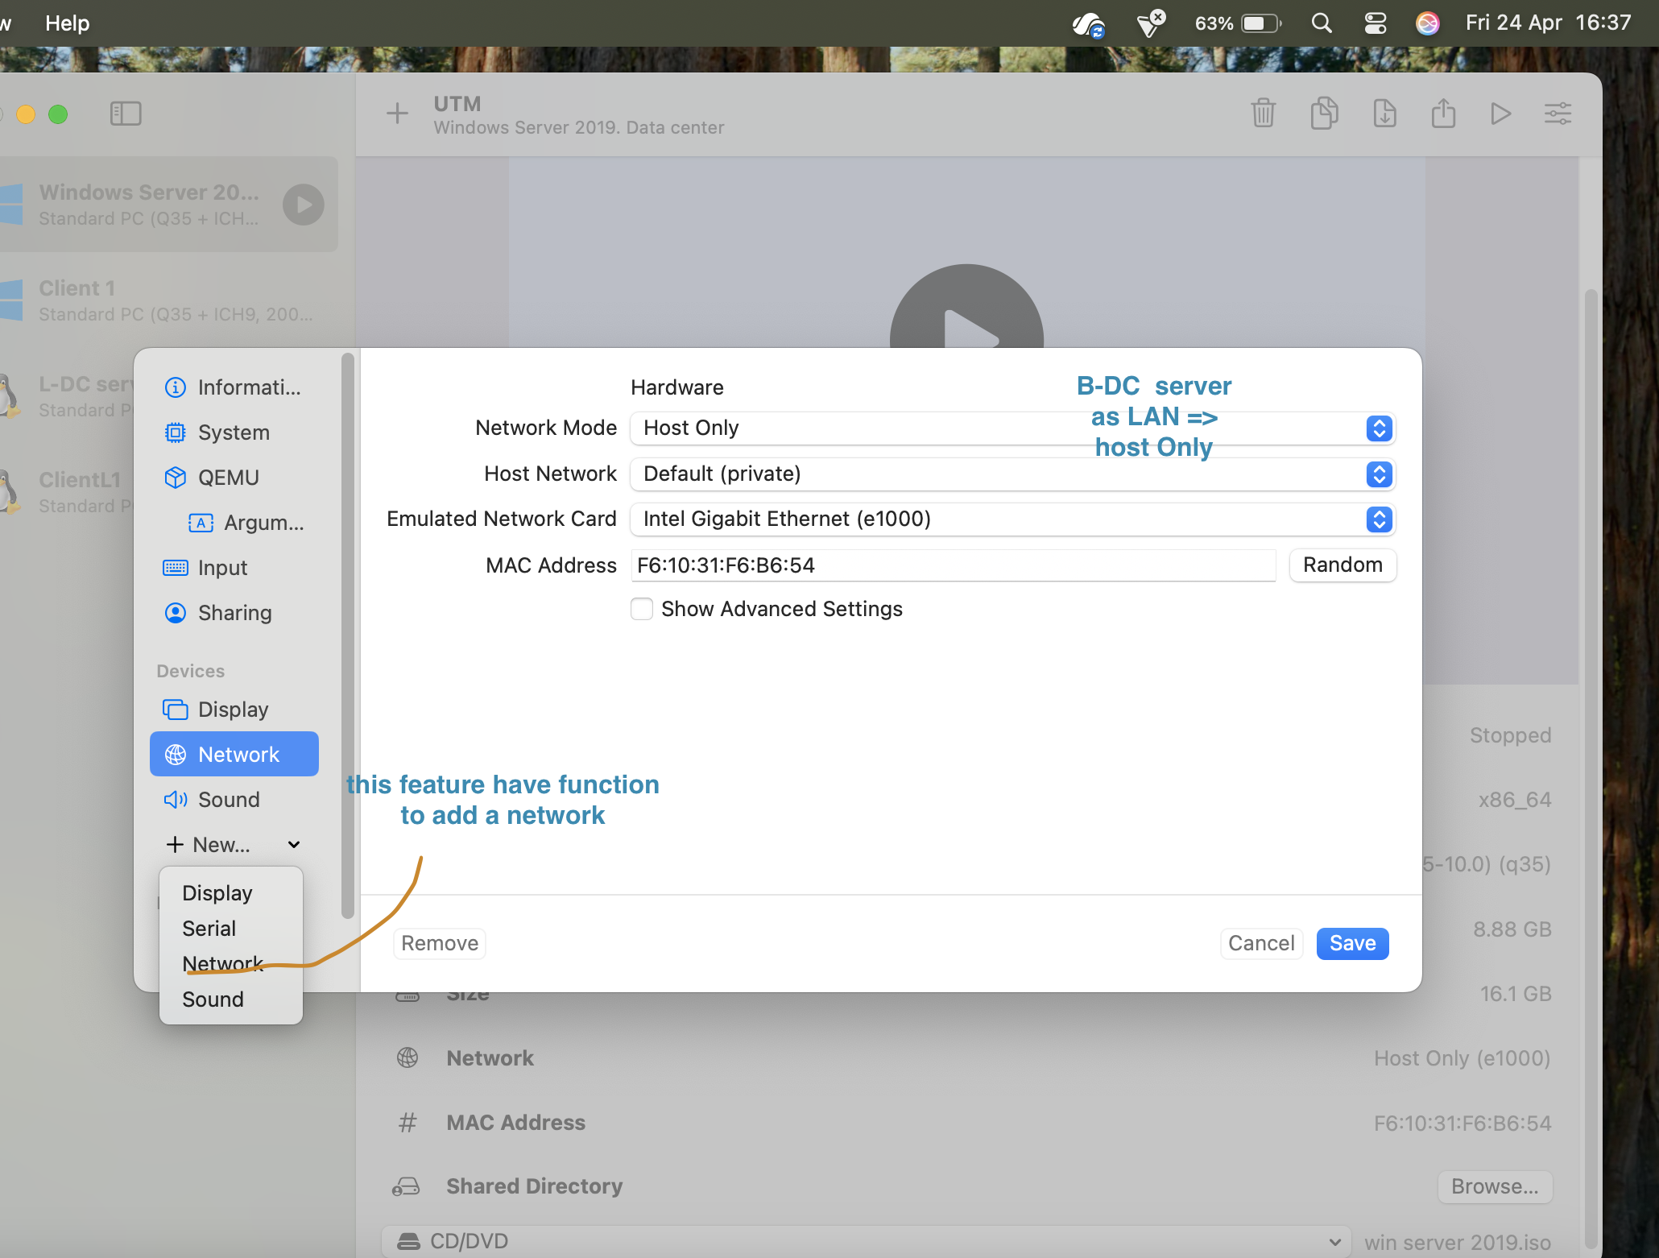

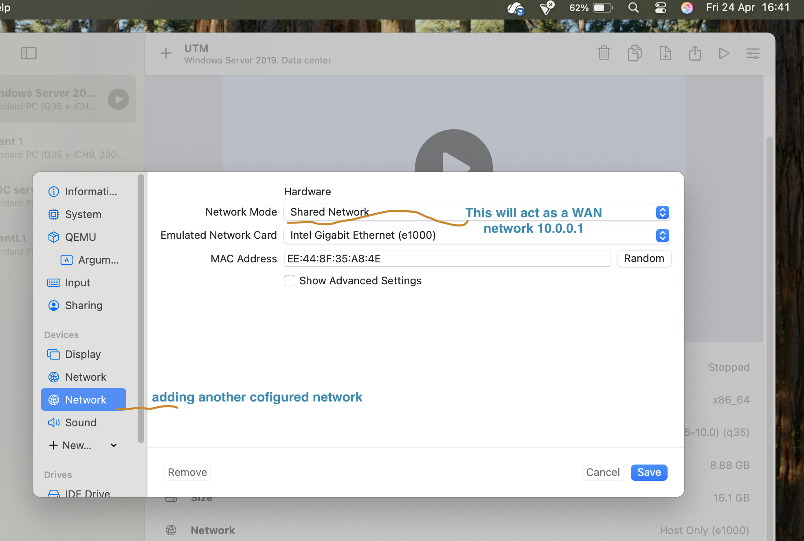represent separate sites and are connected through a routed link.

This design reflects a simplified enterprise model where services are centralized while still supporting distributed users. 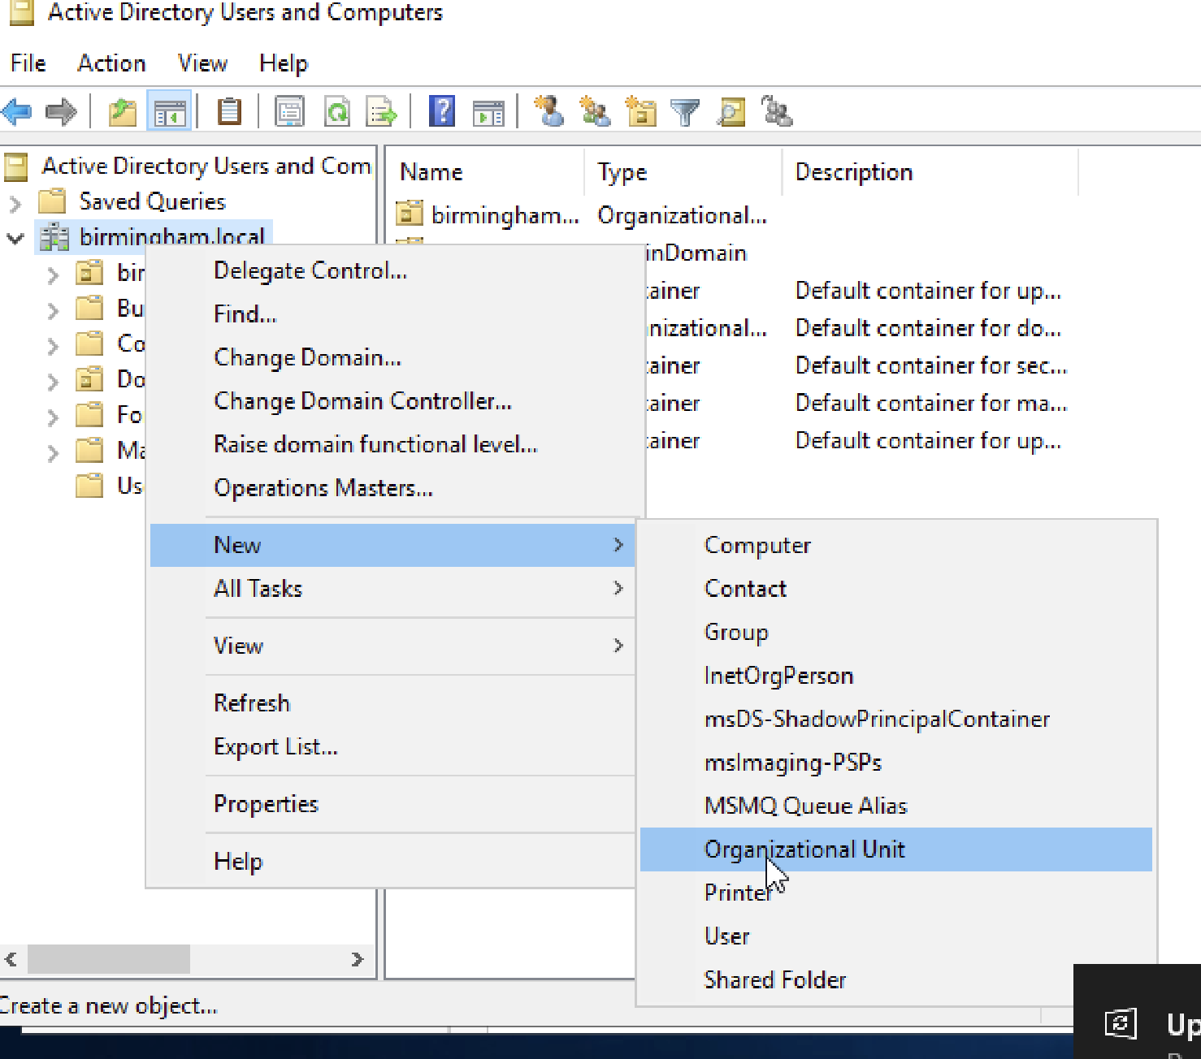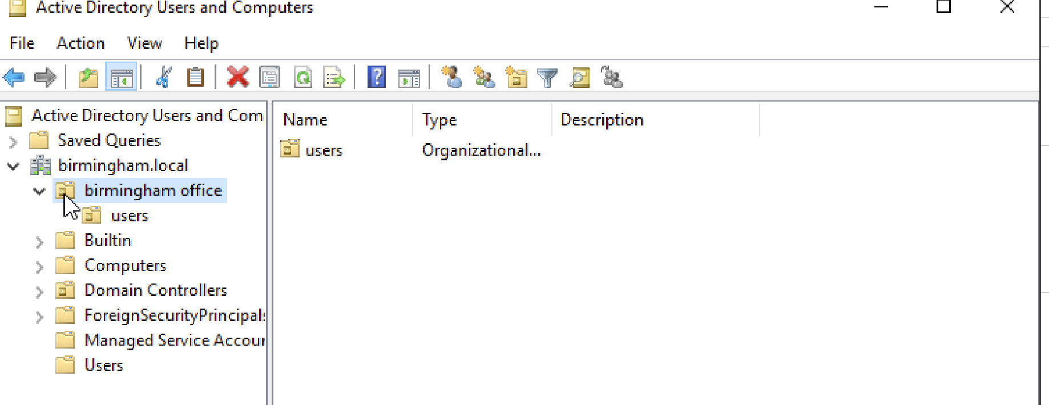 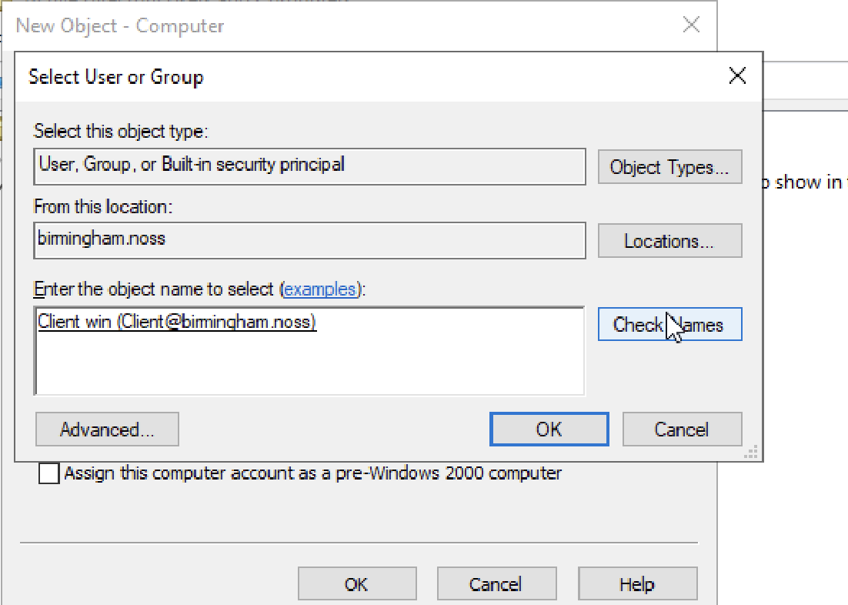
Static addressing was applied to infrastructure components to ensure consistency, while client systems rely on dynamic configuration through DHCP.
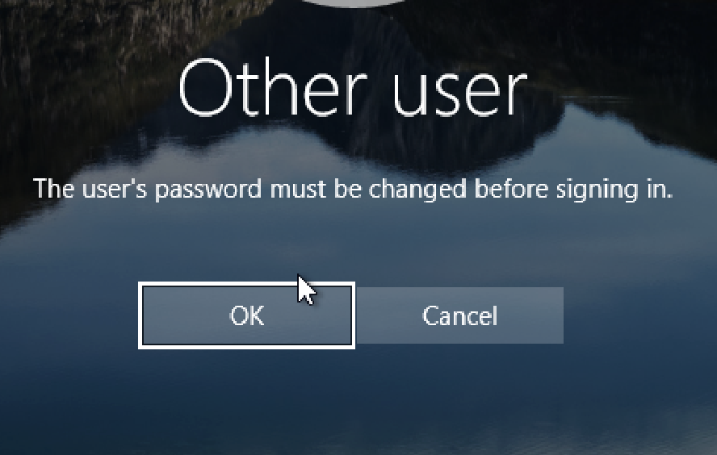
The separation into subnets improves traffic management and allows clear validation of routing and security boundaries.

3. Routing Configuration
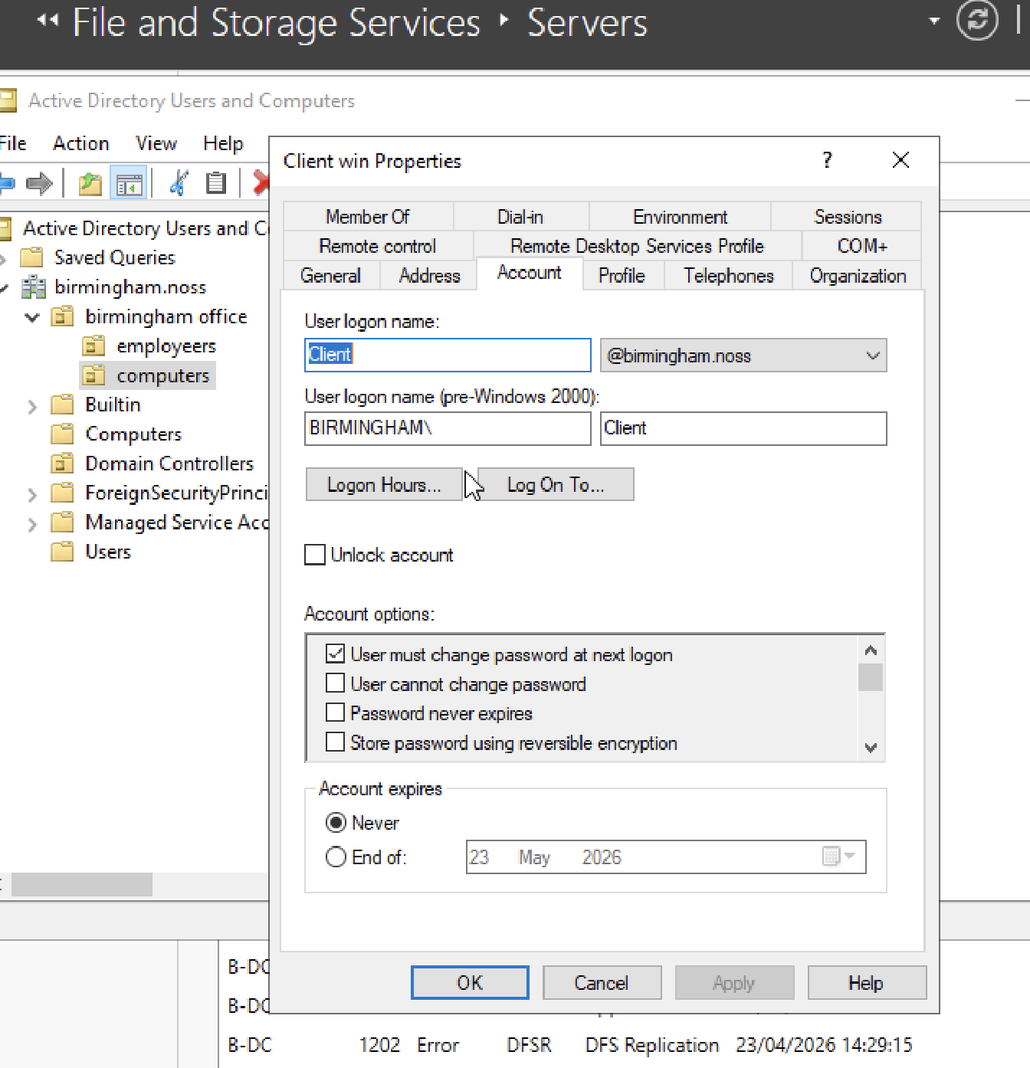
Routing was implemented using the Remote Access role on the Windows Server. This enables communication between network interfaces and supports inter-site connectivity. 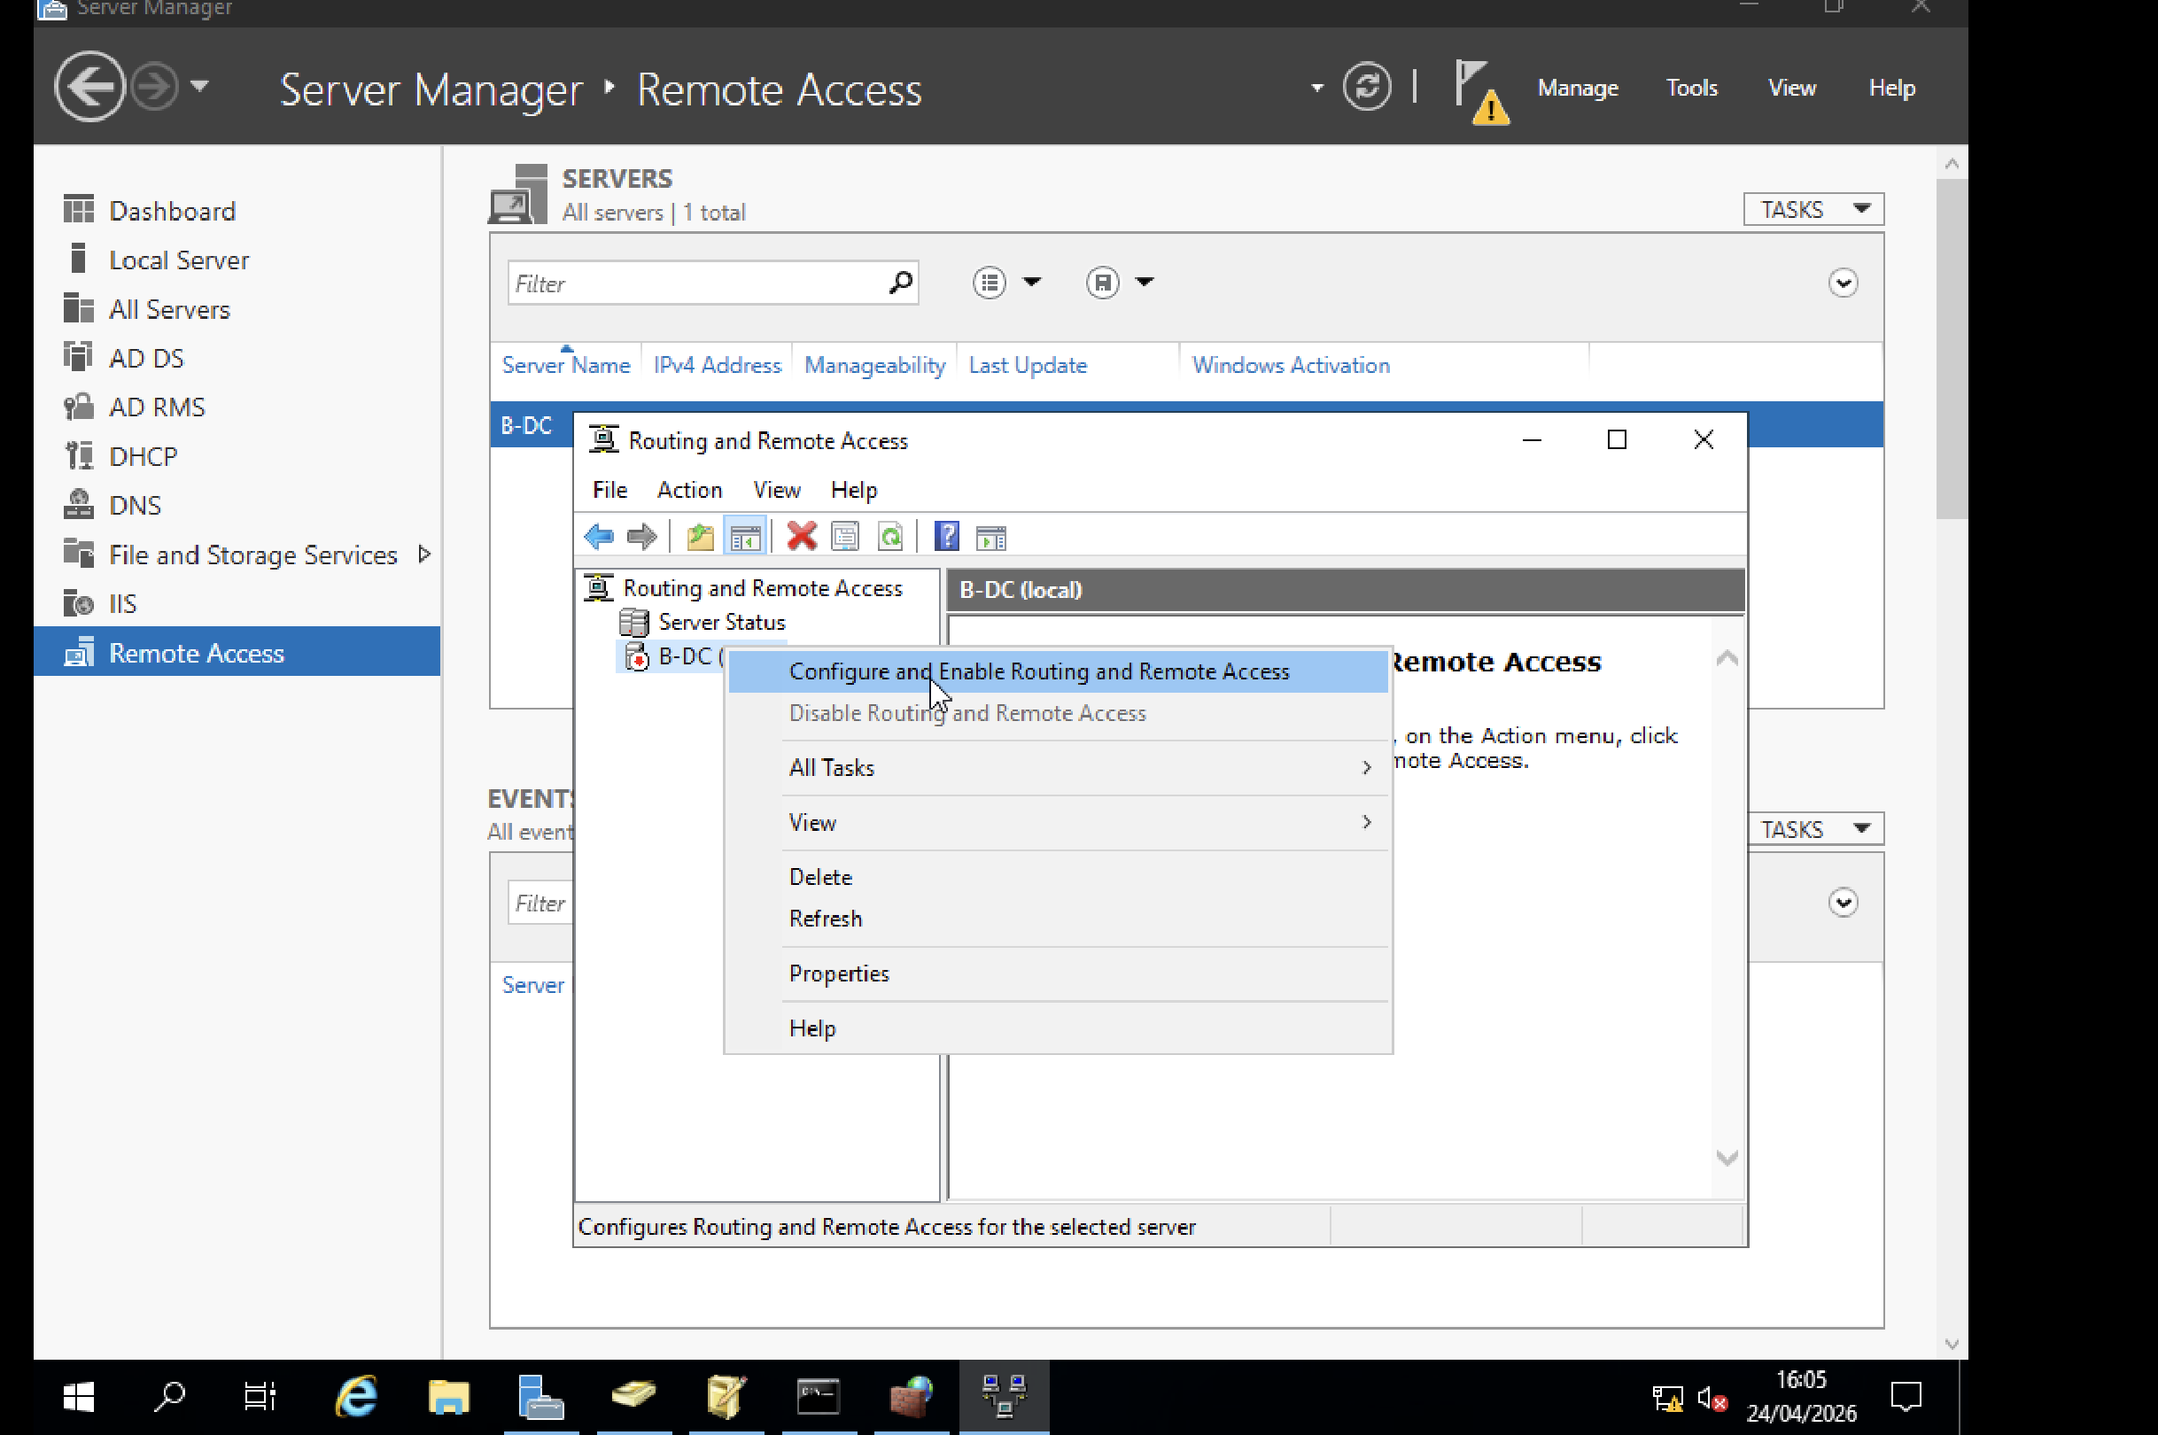

On the Debian system, IP forwarding was enabled to allow packet traversal between interfaces. Persistent static routes were configured to ensure consistent behaviour after system restart.

The decision to use static routing instead of dynamic routing protocols reflects the small scale of the environment. This reduces complexity and improves transparency during testing.

Firewall configuration was restricted to essential services. This follows the principle of minimising exposed services and reduces potential attack vectors.

4. Domain Controller and DNS

The Windows Server was promoted to a domain controller, creating a new Active Directory environment. DNS was integrated during setup to provide centralised name resolution.

Forward and reverse lookup zones were configured to support both hostname resolution and network diagnostics. This is critical for troubleshooting and service discovery.

A password policy was applied to enforce minimum length and complexity. Account lockout settings were configured to prevent repeated unauthorised access attempts.

These controls align with standard enterprise security practices and reduce common risks such as weak credentials.

5. Site-to-Site Encrypted Tunnel

A site-to-site VPN was implemented using IKEv2. This protocol was selected due to its support for modern encryption standards and efficient key exchange.

Encryption and integrity algorithms were configured to ensure confidentiality and data integrity. The tunnel was set to establish automatically, ensuring continuous connectivity between both sites.

This design ensures that traffic between locations is protected, even when transmitted over untrusted networks.

6. Bulk User Provisioning

User accounts were created using a scripted method based on structured input data. This ensures consistency across all accounts and significantly reduces manual effort.

The naming convention was standardized to improve usability and maintain predictable identity structures.

This approach reflects enterprise practices where automation is used to manage large numbers of users efficiently and reliably.

7. Domain Membership

Client systems were joined to the domain to enable centralized authentication and management.
The Windows client was integrated using native tools, while the Debian system used realms and SSSD. This allows Linux systems to authenticate using Active Directory credentials.
This cross-platform integration demonstrates interoperability and reflects real-world enterprise environments where multiple operating systems coexist.

8. DHCP Server and Relay

A central DHCP server was configured on the domain controller. Separate scopes were defined for each subnet, ensuring correct IP allocation based on location.

A DHCP relay agent was deployed on the Debian system. This allows clients on remote subnets to obtain configuration from a central server.

This design reduces administrative overhead and maintains consistent configuration across the network.

9. Connectivity Testing and Troubleshooting

Testing was performed after each configuration stage. Tools such as ping and DNS queries were used to validate connectivity and resolution.

Key checks included:
- Communication between subnets
- Correct IP assignment
- DNS functionality

Issues encountered were resolved by reviewing routing paths and firewall rules. This structured approach ensures reliability and reduces configuration errors.

10. Shared Storage Configuration

A shared storage resource was created on the server and made available across the network.

Permissions were configured using a least-privilege approach. Users were granted only the access required to perform their tasks.

Access was successfully tested from both Windows and Linux clients, confirming compatibility and correct permission handling.

11. Internal Web Service

An internal web service was deployed using a secure configuration. HTTPS was implemented to protect data in transit.

Authentication was restricted to domain users, ensuring that only authorised individuals can access the service.

This reflects standard internal service deployment practices where security and access control are enforced.

12. Remote Desktop Services
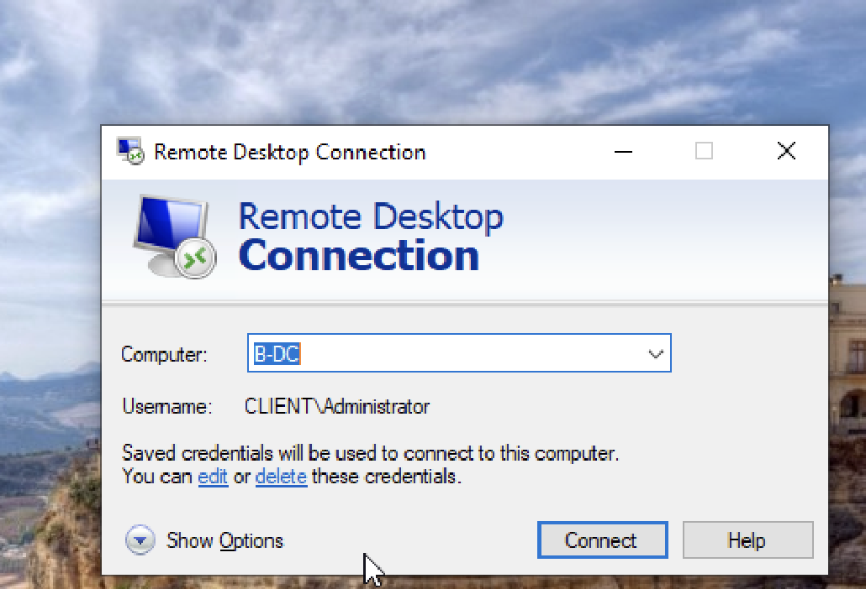
Remote Desktop Services were configured to allow controlled remote access to the server environment.

Certificates were applied to establish trust and eliminate security warnings. This ensures that connections are both secure and user-friendly.

This service supports remote administration and user access, which are essential in dist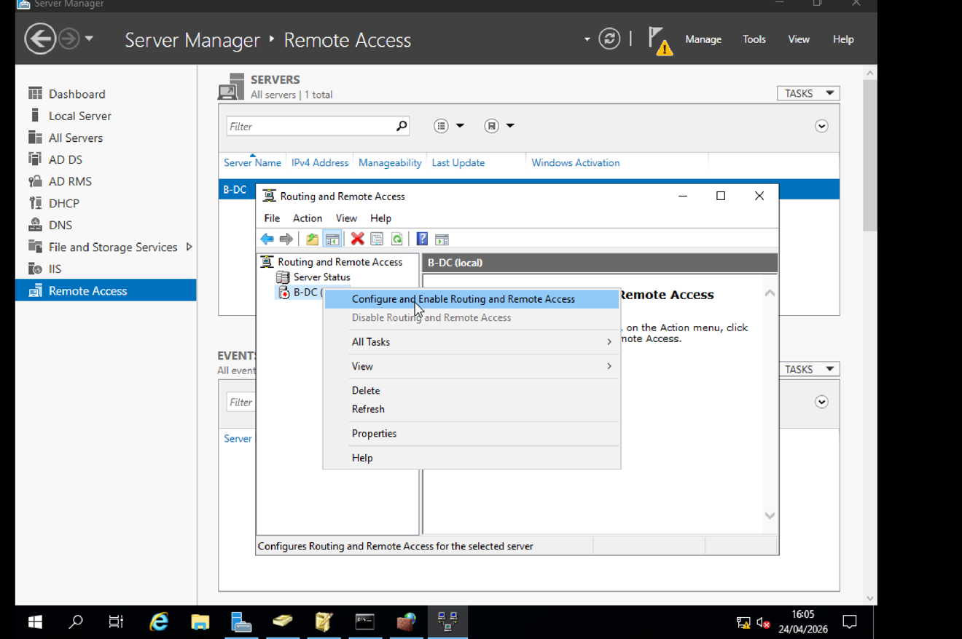ributed environments.

13. Professional Reflection

The implementation required adapting to a non-standard virtualization platform. This introduced challenges related to compatibility and configuration differences.

Each issue required investigation and testing before resolution. This improved problem-solving skills and strengthened understanding of system behaviour.

The process highlighted the importance of planning, validation, and flexibility when working in unfamiliar environments.

14. Conclusion

The virtualized enterprise network was successfully designed and implemented. All required services are operational and integrated across both sites.

The solution demonstrates not only correct configuration, but also clear reasoning behind design choices. Security, scalability, and maintainability were considered throughout.

The result reflects a practical and structured approach aligned with enterprise-level expectations.

15. References/ ATTACHEMNTS
SHARE POINT MY LAB https://uowtsd-my.sharepoint.com/:f:/g/personal/2426374_student_uwtsd_ac_uk/IgB6c6WN1rlWQafA6anax-gkAbvfo_bNithtXyqMasV_oMQ?e=uc0AuM
SOUCES LEARNING:
https://mac.getutm.app
Microsoft Learn documentation on Active Directory, DNS, and Remote Access
Debian Administrator documentation
General networking and security best practice resources

