Name: Sharon Cuthbert
Student No: 2409782
Word Count: 3,250
CIPD 5CO03
Organisational Performance and Culture in Practice

(AC 1.1) - Understand the purpose and value of the people profession.
Q: With reference to the CIPD Profession Map, appraise what it means to be a people professional. (AC 1.1)

Being a People Professional (PP) entails supporting organisations in achieving their strategic objectives by ensuring that people are treated ethically, fairly, and with respect This involves the design, management, and implementation of HR policies, practices, and interventions that cultivate a positive workplace culture where employees are engaged, supported, and empowered to perform at their best. The value of the people profession is evident in its ability to drive organisational success through people, which is achieved by fostering an environment that promotes equality, diversity, inclusion, and respect for individual rights. This, in turn, improves employee morale, productivity, and retention. People professionals also play a crucial role in helping organisations navigate workforce management challenges, such as employee relations, performance management, and organisational change, while ensuring compliance with legal and ethical standards. By doing so, they contribute to the overall success and resilience of the organisation and help individuals to achieve their potential and physical and psychological needs (Waite et al., 2021).

The role of a People Professional is multifaceted, encompassing key functions such as strategic partnering, advising and influencing, employee advocacy, leadership and change management, and people development. People professionals are strategic partners who align HR strategies with business goals. By understanding the business context, they ensure that talent management, learning, and development initiatives contribute directly to organisational success.
According to Suff (2023), the purpose of HR is to support an organisation in achieving its organisational objectives through its people and, therefore, ensuring ethical behaviour, fairness, and consistency. Our ability to influence, deal with conflict, and balance perspectives is critical. People professionals must both champion the workforce and support the business and management pragmatism and priorities. This requires critical thinking and a deep understanding of business goals (CIPD, 2021).

(AC 1.2) – Recognise how personal and ethical values can be applied in the context of people practice.

In any workplace, decisions should be grounded in clear principles and values, especially during periods of significant change. If these principles are not applied correctly, it can lead to unintended and negative consequences. To ensure that our actions are aligned with these principles, it is essential to focus on three key areas: Work, People, and Professionalism.

- Work: A successful workplace is one where employees feel a sense of purpose and safety. It is essential to support their professional growth, provide opportunities for skill development, and ensure that their contributions are recognised. Balancing economic and social accountability is key to ensuring that both organisational goals and employee well-being are prioritised.
- People: People are the heart of any organisation. It is crucial to invest in their development, care, and emotional well-being, particularly those from diverse backgrounds. I am committed to ensuring that all employees are treated with fairness and respect, and that their rights and legal protections are upheld. In addition to promoting a supportive and inclusive environment, I actively participate in employee development by ensuring that training and career progression opportunities are available to all, recognising that everyone’s growth is vital for the success of the organisation.
- Professionalism: Professionalism in people practice is about fostering better working lives through continuous development and well-informed decision-making. It is crucial to make decisions that are fair, transparent, and informed by respect for diverse perspectives. I ensure that all policies, procedures, recruitment practices, performance management, and career development opportunities are built on these values of fairness, transparency, and respect. I recognise the importance of cultural sensitivity, which significantly influences how I approach communication, collaboration, and conflict resolution. By embracing cultural differences, I aim to create an environment where everyone feels heard, respected, and understood (CIPD, 2025).

As an HR officer, I am fully aware of the responsibility to balance professionalism with fairness and transparency, all while respecting the diverse perspectives within the workplace. Whether I’m working with colleagues from the UK or other countries, I strive to create an environment that values each individual and fosters inclusivity. I recognise that cultural differences can impact communication and expectations, and therefore, I make a conscious effort to understand and adapt to these differences. By doing so, I help ensure that all employees feel supported, respected, and valued in their roles. In HR, where I often work with people from a wide range of backgrounds, promoting fairness, emotional well-being, and cultural sensitivity is essential to maintaining a positive and thriving workplace culture (Cuthbert, 2025).

Below I have created a model to demonstrate how people should see fit in their workplace:

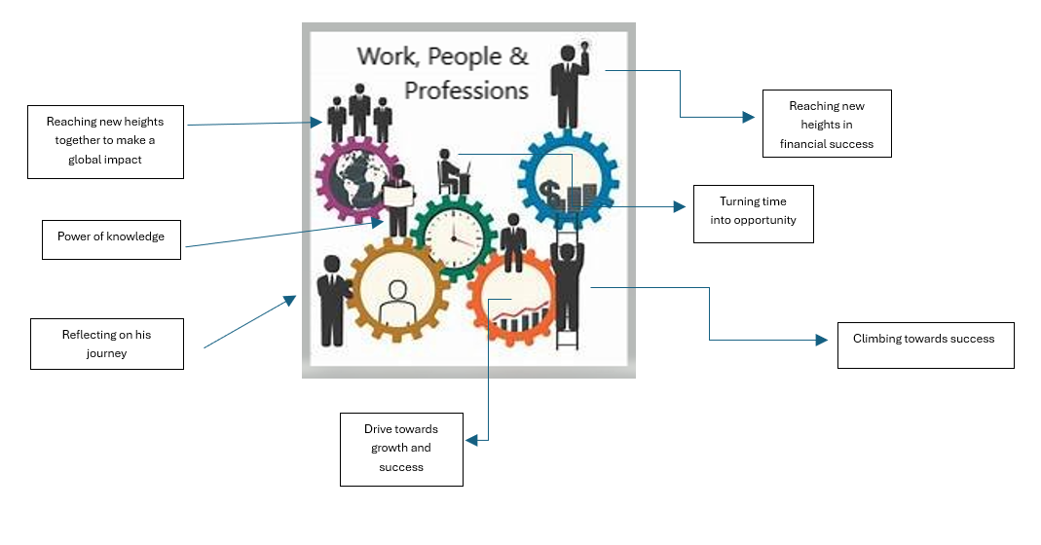

(AC 1.3)-Consider the importance of people professionals contributing to discussions in an informed clear and confident way to influence others.

People professionals play a pivotal role in shaping organisational culture and driving strategic objectives. Their ability to engage in informed, clear, and confident communication ensures that the 'people practice voice' is effectively heard, aligning human resource initiatives with broader business goals and fostering a positive workplace environment.​
Key Aspects of Influence for People Professionals:

- Strategic Communication: Effectively conveying ideas and policies necessitates a deep understanding of organisational dynamics and the ability to present information compellingly. This involves not just sharing data but also articulating how HR strategies align with and support overall business objectives, fostering stakeholder buy-in and promoting cross-departmental collaboration.​
- Building Credibility: Establishing trust is fundamental to influence. People professionals who demonstrate expertise, integrity, and consistency are more likely to be respected and listened to, enabling them to advocate effectively for policies that benefit both employees and the organisation.​
- Emotional Intelligence: Understanding and managing one's own emotions, along with empathising with others, enhances interpersonal relationships within the workplace. People professionals with high emotional intelligence can navigate complex social dynamics, resolve conflicts, and foster a supportive environment, all crucial for influencing positive change.​
- Advocacy and Representation: Serving as advocates for employees, especially those from diverse backgrounds, ensures that all voices are heard in decision-making processes. By championing inclusivity and fairness, people professionals can influence policies that promote diversity and equity, enriching organisational culture and enhancing employee satisfaction.​
- Adaptability and Continuous Learning: The ability to adapt to changing business landscapes and continuously update one's knowledge base allows people professionals to remain relevant and effective. This adaptability enables them to introduce innovative solutions and guide the organisation through transitions smoothly.​

Research indicates that high levels of employee engagement are positively associated with organisational commitment (Saks, 2006), customer satisfaction, employee loyalty, productivity, and even safety (Kanter et al., 2002). Employees who perceive themselves as engaged typically experience greater job satisfaction, irrespective of their roles (Schaufeli et al., 2008; Alfes et al., 2010). These findings underscore the importance of fostering engagement to achieve organisational success.​
Failing to speak up can lead to silence, resulting in unresolved problems, disengagement, decreased productivity, and a breakdown in trust (Taylor & Woodhams, 2022). Therefore, it is crucial for people professionals to actively contribute their perspectives to foster a culture of open communication and continuous improvement.

(AC 1.4)-Recognise when and how you would rate matters which conflict with ethical values or legislation

Unethical behaviour goes against widely accepted moral principles or professional standards, often involving dishonesty, unfairness, disrespect, or violations of laws and workplace policies such as discrimination or harassment. For example, Suff (2019) discusses a situation where an employee was asked by a leader to wear inappropriate clothing to impress a client. This request violated professional standards and raised potential legal concerns, such as dress code violations or anti-discrimination laws.

In such situations, I would first assess if the action conflicted with my personal ethics, organisational values, or legal standards. If the request contradicts my values, I would take several steps to address it. I would start by evaluating whether it breaches company policies or legal standards and consider if it could lead to discriminatory practices.

Next, I would address the issue directly, seeking clarification and explaining why the request is unacceptable. Communication is key, and addressing concerns early could resolve misunderstandings. If the issue remains unresolved, I would refuse the request, explaining why it conflicts with professional standards. If the behaviour continues, I would escalate the matter to HR or a senior leader, ensuring proper channels are followed and finally, I would reflect on the experience, learning from it to better handle future ethical challenges. Cuthbert, S.

To illustrate the distinction between actions we consider legal and illegal, I will use the example of borrowing company property. Such as a company car is an agreement between the employee and employer, but if the employee refuses to return it, can transition from unethical to illegal behaviour. If an employee takes a company vehicle without permission and fails to return it, this act may constitute theft, which is both unethical and illegal. The severity of the action can lead to disciplinary measures within the company, including termination, and in serious cases, legal action may be pursued. The strategy would be to:

- Immediate Communication: Reach out to the employee promptly to discuss the situation. Clearly outline the company's expectations regarding the use and return of company property, referencing any relevant policies. Seek an explanation for the vehicle's unauthorised retention and attempt to resolve the matter amicably.
- Formal Written Request: If informal communication doesn't lead to the return of the vehicle, issue a formal written request. This document should reiterate the company's policies, specify the expected return date, and outline potential consequences for non-compliance.
- Assess the Severity: Determine whether the employee's actions constitute gross misconduct. In the UK, gross misconduct can include theft or serious insubordination, which may justify immediate dismissal if substantiated.
- Initiate Disciplinary Procedures: If the vehicle remains unreturned, commence formal disciplinary proceedings. Ensure adherence to the company's disciplinary policy, providing the employee with an opportunity to respond to the allegations. Suspension from work may be considered during this process, typically with pay, unless the employment contract stipulates otherwise.
- Consider Legal Action: Should internal measures fail, I would seek legal advice. This may involve reporting the vehicle as stolen, notifying insurance providers, and pursuing legal actions.

(AC 2.1)-Argue the human and business benefits of people feeling included, valued, and fairly treated at work linking to related theory.

References:
Cuthbert, S. (2025) 'Recognising how personal and ethical values can be applied in the context of people practice'. (Unpublished).
Taylor, S. and Woodhams, C. (2016) Human Resource Management: People and Organisations, 2nd edn. London: CIPD.
Green, M. (2019) 'Creating Ethical Workplaces', CIPD Podcast. Available at: Creating Ethical Workplaces | Podcast | CIPD (Accessed: 21 March 2025).
People Management (2025). Peter Cheese: How HR can use challenging times to make a positive impact.
Waite, C., Brown, K., and Smith, M. (2021). The People Professional's Role in Strategic Organisations. Journal of Human Resource Development, p. 76.
CIPD (2025) Ethics and the role of HR. Available at: https://www.cipd.org/uk/knowledge/factsheets/ethics-role-hr-factsheet/ (Accessed: 21 March 2025).
June 2024 - 5CO03 Professional behaviours and valuing people - YouTube
Ethical practice and the role of people professionals | Factsheets | CIPD

