Improvement of an HR priority area

BMMB7007
HUMAN RESOURCE MANAGEMENT
NAME：Xinke Gong
Number：2230419

March 2023

Executive summary
Human resources play an important role in the development path of modern enterprises and even enterprise collectivization. The worldwide competition is ultimately the competition for talents (Mahapatro, 2010). Modern human resource management regards people as "resources" and focuses on production and development, which to a great extent refutes the immature view of traditional human resource management that regards people as "tools". In the modern enterprise system, we say what is the core competitiveness of the enterprise, is people. Only talent has irreplaceable advantages that cannot be replicated.
The realization of enterprise performance is reflected through the effective provision of enterprise products and services to customers. One of the important objectives of human resource strategy is to implement activities that are beneficial to the improvement of corporate performance, and to exert its contribution to the success of the enterprise through these activities.Performance can truly reflect the internal management activities of enterprises, so it is an important part of human resource management. The application of performance management can test the working attitude and ability of employees, and promote the sustainable development of enterprises.
There are relatively many issues and elements involved in the HRM model, and a lack of science in the customisation of HRM measures, which can also have a direct impact on business development (Wang, 2023).
After understanding that performance management is a priority field in human resources, combined with the actual application of human resources in Alibaba, the advantages and disadvantages of this field are analyzed and reasonable suggestions are given.

Contents
Executive summary 1
Contents 2
Introduction 3
Organizational overview 4
Main Discussion 5
1.The current situation and crisis of Alibaba's performance appraisal. 5
2.The significance of performance appraisal. 8
Conclusions 10
Recommendations 11
1.How can the HR function improve problems in this area 11
2. Needs and Challenges 11
Reference list 12

Introduction
In this report, I have framed the content of the report and the direction of my research as follows:
I believe the priority area for improvement is performance appraisal, which in recent years has seen the rapid development of the Internet market and intense competition between companies. People are one of the most important resources and core competencies in the development of a company (Wang, 2023). With the changes in Alibaba's internal performance appraisal, there have been massive active layoffs and passive talent loss. This is directly related to the internal performance appraisal of the company. The issue of paying or the fairness of competition is directly affected by performance management.
Performance management is the process of identifying, measuring and developing individual and team performance and aligning this performance with the strategic objectives of the organisation, and includes a cycle of performance planning, performance coaching, performance appraisal and performance feedback around organisational objectives. It includes a cycle of performance planning, performance coaching, performance appraisal and performance feedback around organisational goals (Huang and Gu, 2022).
Alibaba's performance management model focuses on standardisation and procedures. The failure to implement reasonable policies can have serious consequences. Making reasonable suggestions to solve the problem will be much less resistant to employee motivation, business development efficiency and the reliance of relevant users of the business (Huang and Gu, 2022).

Organizational overview
Alibaba Group Holding LTD,Abbreviation: Alibaba.Founded in 1999 in Hangzhou, Zhejiang Province, China.Alibaba Group operates a variety of businesses and also receives support from the business and services of its affiliates to run the business ecosystem. Business and affiliate businesses include: Taobao, Tmall, Juhuasuan, AliExpress, Alibaba International Marketplace, 1688, Ali Mom, Ali Cloud, Ant Financial, Cainiao Network, etc.Alibaba ranks 89th in the 19th annual list of the World's Top 500 Brands for 2022, compiled exclusively by World Brand Lab.
Alibaba has a chief human resources officer, currently held by Tong Wenhong.By 2022, Alibaba has more than 30,000 employees. Alibaba has invested in human resources training, including the establishment of Ali Academy, which aims at train employees and customers to grow.
Alibaba provides induction training for new employees, and through off-job training, Alibaba provides centralized training for employees, mainly through speech method and behavior model method.
In Alibaba, values are the criteria that determine everything. We firmly and thoroughly implement this principle in what kind of people we recruit, how we train them and how we evaluate them. Therefore, Alibaba's human resource management plays a supportive role in corporate strategy.

Main Discussion
1.The current situation and crisis of Alibaba's performance appraisal.
As a functional department, the human resources Department participates in the formulation of the company's strategic objectives and the determination of the overall performance indicators (Luo, 2022). However, the specific completion of the decomposed performance indicators still depends on the whole organization. The human resources Department only improves the overall administrative efficiency of the organization through the technical tools of the six modules of human resources (Sun, 2023). such as planning, personnel training and allocation, salary performance, labor relations and so on. It's more of a coordination function. In a narrow sense, if performance is taken as an indicator as a measurement standard, it is not only the responsibility of the human resources Department, but also the participation of other departments (Chen, 2023). From the decision-making level to the grassroots level of production, it is often restricted by the teams of other departments in terms of operation and initiative. In fact, the role of the human resources Department is more to establish the system and standardize the process, and to constrain the efficient operation of the organization with mechanisms. In a straightforward and narrow sense, performance means that the degree of completion of the expected goals depends on the degree of difficulties in paying for the expected goals and the amount of returns (Yang, 2023). he biggest feature of Ali's performance appraisal is value appraisal. Jack Ma has instructed HR departments to be strict in hiring, recruit good people and attract those who "tastes like Alibaba". "People who taste like Ali" are those who share Ali's values. Ali's value assessment is very in-depth. There used to be a salesman who could generate more than 20 million yuan of performance for the company a year. However, he violated integrity by making false information on the records of visiting customers. The client flew in to explain and interceded, but the man was fired. The values thing may sound hollow, but it tells employees what the company's bottom line is and what the rules are for us internally. It is like the function of traffic lights and zebra crossings, regulating you to the left or right in the process, ensuring that you do not deviate from the direction, but giving you a certain degree of flexibility, which is the biggest feature of Ali's performance appraisal work. Values must have consensus, consensus must abide by, want to abide by constraints, this is Ali's overall assessment orientation.Only when there are performance appraisal results that can be fed back between employees and the company in a timely manner can they play a series of roles in the management of human resources in the company, such as restraint, motivation and guidance (Yang, 2023).
General overview of Ali performance appraisal: performance and values accounts for 50% of the appraisal frequency, quarterly appraisal is mainly a departmental ranking: 2-7-1 ranking, individual ranking: 3-6-1 ranking appraisal tool, KPI leading elimination criteria: 10% of the bottom ranking for two consecutive quarters, promotion conditions: last year's KPI reached 3.75, with KPI, divided into four quarters, each quarter is further divided into Months, weeks and days, with weekly meetings and weekly reports. Everyone reviews how well they have achieved their targets. If the target is not completed, a plan evaluation form needs to be produced, according to the completion of the target: little or no basic bonus and bonus if the basic standard is met; if the expectations are met, bonuses and bonuses are given, and promotions and salary increases are given to the top 20% of the team. If expectations are exceeded, large bonuses and bonuses are given and the top 20% of the department is definitely promoted or given a pay rise.
Alibaba's value assessment is very strong: everyone knows that value assessment is important. If it's just performance, it's no performance at all. Mandatory appraisal of non-performance factors is taken seriously by the whole company. The value of evaluation lies in: self-evaluation and other evaluations. Three criteria are used: Level A: goes above and beyond, has an impact on the team, integrates with the organareation and are widely appreciated. Belongs to the benchmark B level: words and actions meet the requirements of Alibaba values, the overall is qualified Alibaba C level: lack of basic qualities and requirements, break the value bottom line, according to different degrees of improvement or leave two consecutive assessment cycles are C level, inevitably eliminated. When conducting value assessments, departments pay particular attention to the details of their daily work and those small behaviours.(Alibaba Performance Appraisal System)
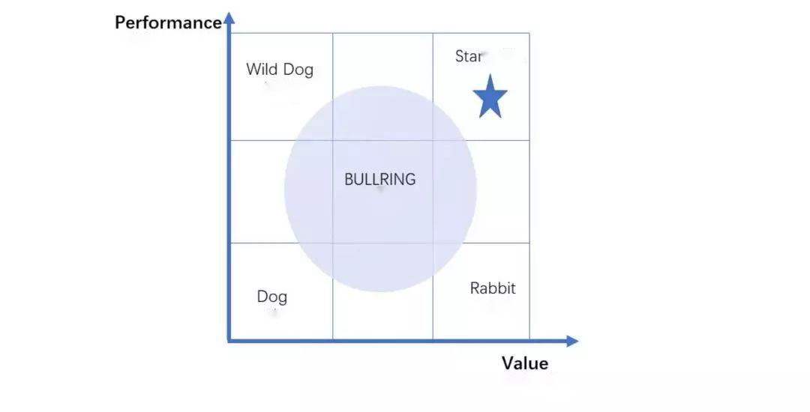
(New Business Senior Management, 2021)
Alibaba's strict performance appraisal and tough cultural requirements make it more difficult to promote ranks. Meanwhile, in terms of fairness, although there is a unified standard, the real fairness cannot be maintained in the hands of executors.
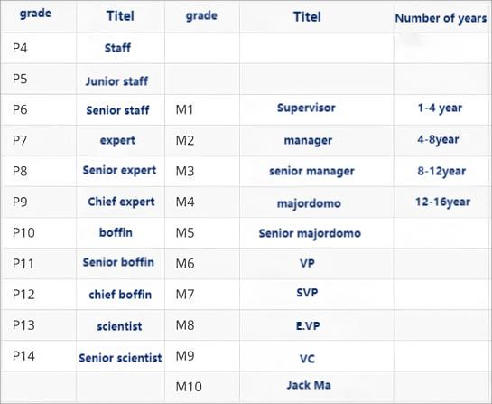
(New Business Senior Management, 2021)
As of March 1, 2023, Alibaba has laid off 19,576 employees, among which the number of P7-P10 employees is the largest.
In a hierarchical management promotion system like Alibaba's, where rewards and punishments are clearly defined, performance appraisals determine the development of employees. However, almost all employees who have resigned or are in employment consider that they are undoubtedly lucky to survive such a performance appraisal. No company can develop without employees in any position. Therefore, their motivation and strengths should be used wisely, rather than making them feel pressured under high pressure. When an employee cannot hold out and is fired or resigns, the company's interests are also damaged. Alibaba's performance appraisal is a double-edged sword. Although the company's short-term goals are achieved under high pressure, in the long run, a large number of employees are pressured by the performance appraisal and related promotion and development, and the company is unable to retain employees who voluntarily resigns or are fired due to the financial burden, which is certainly the beginning of a disgusting cycle (Shi, 2023).
- The significance of performance appraisal.
I would suggest that the performance appraisal criteria be implemented in a more rational context. As a world-class company, Alibaba's performance appraisal standards are scientific to a certain extent. However, the massive attrition and brain drain, as well as the failure of Alibaba's development goals in recent years, undoubtedly proves whether those implementing performance appraisals can be fair and just as they should be under the right performance appraisal system, which ignores the human factor, over-emphasizes individual performance and lacks the human resource perspective that affects the company's development, rather than a single layer of downward requirements.
HR priority areas include: recruitment and selection, training and development, performance management (Yang, 2022).
Compensation and benefits, employee relations. These fields are directly related to performance management (Jia, 2022). Performance management directly affects the competition between employees and the development of employees, and also tests the training results of employees, which in turn affects the performance, and the performance of each employee in an enterprise directly affects the development and profit of the enterprise. The good development earnings of the enterprise will bring about generous salaries and benefits, which will encourage employees to continue to achieve better performance standards. Meanwhile, the enterprise itself will improve the ability of staff training, better personal development, harmonious employee relations, and generous salaries and benefits will make it easier to recruit talents in the recruitment process. This is the sound development of human resources, and all these are inseparable from performance management, so a set of clear performance management methods is the core part of an enterprise.This is also an issue that is often overlooked by most companies in China (Xu, Zhang and Wang, 2019).

Conclusions

Enterprises should pay attention to the importance of human resources and seek the cycle of conscience at the cost of slowing down the development speed, instead of persisting in the pursuit of development and taking human resources and performance appraisal as the standard of squeezing employees (Zhang, 2022).
Through the above research, it can be concluded that Alibaba relies too much on data in its priority field of human resource performance management: Alibaba's performance appraisal system attaches great importance to data, but sometimes the data can not fully reflect the performance of employees, which may lead to some unfair situations. Lack of humanization: Alibaba's performance appraisal system focuses too much on performance, while ignoring employees' personal situations and needs, which may lead to excessive pressure on employees and affect their work enthusiasm and quality. Easy internal competition: Alibaba's performance appraisal system encourages competition among employees, but this may lead to vicious competition and contradictions among some employees (Guo, 2015).

Recommendations
1.How can the HR function improve problems in this area

Scientific performance management should not be obsessed with whether employees meet the standards. In addition to being responsible for improving enterprise efficiency, discovering the nature of problems, and providing appropriate pressure to increase employees' enthusiasm, performance management should also be correctly implemented (Li, 2022). Human factors should be taken into account, and the most essential and important resource of the enterprise, people, should not be lost due to the persistent pursuit of performance. Otherwise, it will lead to massive brain drain and increase enterprise risks.
- Needs and Challenges
Alibaba is a large e-commerce company, with about 60 percent of the e-commerce market in China, according to the latest figures.Tencent, Alibaba's biggest rival with its own e-commerce platforms, payment systems and social media businesses, is fiercely competitive with Alibaba. At the same time as the largest shareholder in China's second largest e-commerce platform JD.com.This is undoubtedly the biggest challenge Alibaba has encountered in the Chinese market in recent years. Rigorous performance management will bring unprecedented benefits, but large-scale layoffs and employees who quit or change jobs under the pressure of performance will lead to greater workload for the current employees, which saves the cost of employing people and at the same time brings high-intensity work and lower fault tolerance rate. It will be a vicious cycle. But in order to solve this problem at the moment, we must adjust the methods and standards of performance management, which will certainly affect the efficiency of enterprises, and in the future will affect the market share.This is also Alibaba in addition to the existing problems, the emergence of risk.

Reference list
Mahapatro, B.B. (2010) Human resource management. New Delhi: New Age International (P) Ltd.
Wang, Y. (2023) ‘Strategic HR performance management and employee motivation in a big data environment’, Industrial Innovation, (3), pp. 164-166.
Huang, Y. and Gu, H. (2022) ‘Research on the optimization of enterprise HR performance management in the context of big data’, Technology and Industry Across the Straits, 35(10), pp. 69-71.
Luo, Y. (2022) ‘Analysis of the misunderstanding of human resource performance evaluation in enterprises’, Trade Fair Economy, (5), pp. 141-143.
Sun, H. (2023) ‘A study on the construction of internal control in enterprise human resources management’, China Market, (3), pp. 151-153.
Chen, Y. (2023) ‘Innovation of human resources performance management in institutions in the era of big data’, Times of Fortune, (2), pp. 82-84.
Yang, Y. (2023) ‘Reflections on building an enterprise HR performance management system’, Business News, (4), pp. 191-194.
New Business Senior Management (2021) How to manage “stars, wild dogs, bulls and white rabbits” type employees. Available at: http://www.hudapx.com/ArticleDetail-I522.html (Accessed: 22 March 2023).
Shi, Y. (2023) ‘Problems of enterprise HR performance management and countermeasures to solve them’, China Market, (4), pp. 88-90.
Yang, H. (2022) ‘Research on human resource performance management of units in the era of big data’, Business Observation, (36), pp. 49-52.
Jia, Y. (2022) ‘Organic countermeasures for enterprise pay and performance management in the new era’, Talent Resource Development, (20), pp. 86-88.
Xu, X., Zhang, X. and Wang, X. (2019) ‘Analysis of performance management in Chinese companies’, Tax Paying, 13(13), p. 271.
Zhang, X. (2022) ‘Improving performance management and promoting human resource efficiency’, Human Resources, (12), pp. 124-125.
Guo, Y. (2015) ‘Correlation analysis of employee self-efficacy and competitive attitudes’, New West, (7), pp. 54-55.
Li, X. (2022) ‘Deficiencies in the management of enterprise performance appraisal and evaluation and countermeasures’, Investment and Entrepreneurship, 33(23), pp. 110-112.

