

Programme: Master of Business Administration
Module: International Business Concepts
Module Code: LCMB7034
Lecturer: Akshay Narayanan
Student name: Naima Nadimahmed Arab.
Student ID number:2503320

TABLE OF CONTENTS
Section 1 1
1. Introduction 1
2. Industry and Country Overview 2
2.1 Introduction to the Ultra-Luxury Automobile Industry in the USA 2
2.2 Size, Scope, and Economic Importance of the Industry 2
2.3 Major Domestic and Multinational Firms: Competitive Positioning 5
3. Porter's Diamond Model of National Advantage-Global Competitiveness of the Ultra-Luxury Automobile Industry in the USA 7
3.1 Factor Conditions 7
3.2 Demand Conditions 9
3.3 Related and Supporting Industries 9
3.4 Firm Strategy, Structure, and Rivalry 10
3.5 Government and Chance 11
4. Critical Evaluation of Rolls-Royce Motor Cars' Operations in the USA 13
4.1 Overall Market Attractiveness: Benefits, Costs, and Risks 13
4.2 Political Environment 14
4.3 Economic Environment 16
4.4 Legal Environment 18
4.5 Cultural Environment 20
4.6 Technological Environment 21
4.7 Environmental and Sustainability Factors 22
5. Conclusion 24
Section 2: Reflective Account-Gibbs Reflective Cycle 25
References 29

Section 1

1. Introduction
Rolls-Royce Motor Cars (RRMC), a wholly owned subsidiary of BMW Group, has been manufacturing its own exclusive Goodwood, West Sussex facility since 2023, and holds a significant global position in the ultra-luxury automobile industry. With the vehicles priced from USD 350,000 to over USD 20 million for bespoke Coachbuild commissions, RRMC strategically competes in the global luxury market not in terms of volume but also in terms of interreducibility. The luxury cars of RRMC well articulate each vehicle’s singular expression of its owners’ identity. In this report, USA has been selected as the target market for RRMC as it is RRMC’s most prominent market globally, accounting for one-third of the brand’s overall global car deliveries. This country’s market offers contextual significance in terms of growth potential, with the revenue growth of USD 287 million in the US. The US luxury automobile market itself demonstrates the most commercial possibility of an ultra-luxury automobile demand environment, with the related factors such as the largest UHNWI population.

2. Industry and Country Overview

2.1 Introduction to the Ultra-Luxury Automobile Industry in the USA
In this section, industry and target country overview has been discussed for understanding its current status and areas of opportunity. The USA luxury automobile market is projected to expand rapidly with the attribution of strong demand among wealthy consumers. According to Boston Consulting Group (2025), the sector could grow to $180–$215 billion by 2035 (BCG, 2025). Sales of vehicles are driven by the changing consumer behaviour as 80% of the luxury buyers browse online weekly or daily, and 75% are willing to purchase vehicles entirely online articulating on the digitally driven and expanding luxury automotive market (Carscoops, 2025).
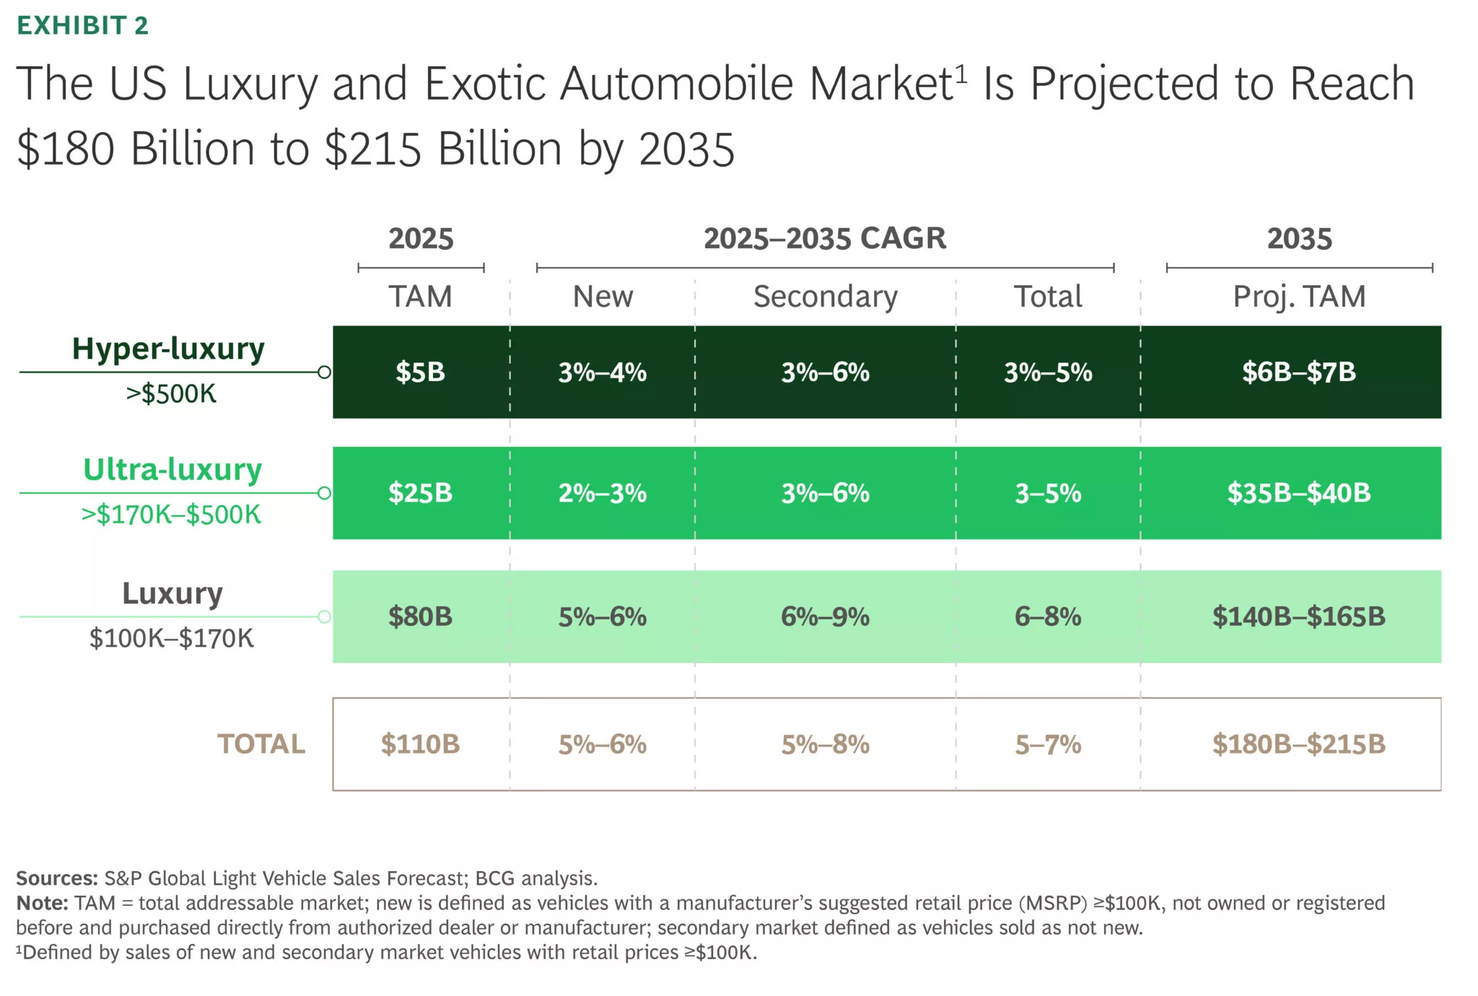
Figure 1: US luxury automobile market potential
(Source: Carscoops, 2025)

2.2 Size, Scope, and Economic Importance of the Industry
Critical evaluation of US luxury automobile market is crucial for understanding consumer behaviour, market trends, digital advancement and key drivers. US luxury automobile market demonstrates the contextual potential of growth. In 2024, the market generated about $117.4 billion in revenue, and it is forecasted to reach about $166.8 billion by 2030, with a potential growth rate of 6.1% in compounded annual growth rate from 2025 to 2030 (Grandviewresearch, 2025). Sports utility vehicles (SUVs) dominate the segment and represent the fastest-growing vehicle type, highlighting rising consumer demand for premium, high-performance luxury SUVs.
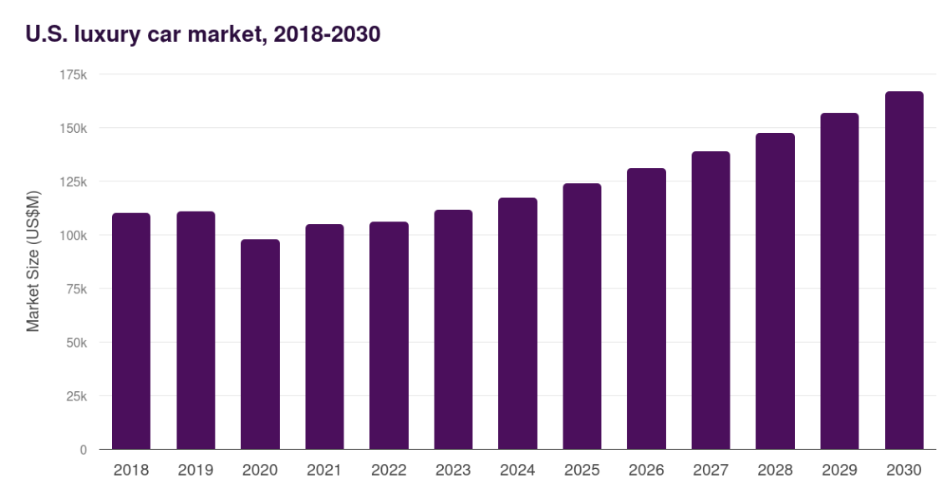
Figure 2: Market size of the luxury car market in the US
(Source: Grandviewresearch, 2025)
According to the report of Presence Research (2025), the North American luxury car market holds about 31% of the total global market share. This strong growth is driven by the higher disposable income, affluent consumers and the rapid technological transformation. North America remains a key contributor, considering the strong demand in the US and Canada, where luxury vehicles are associated with prestige and advanced features.
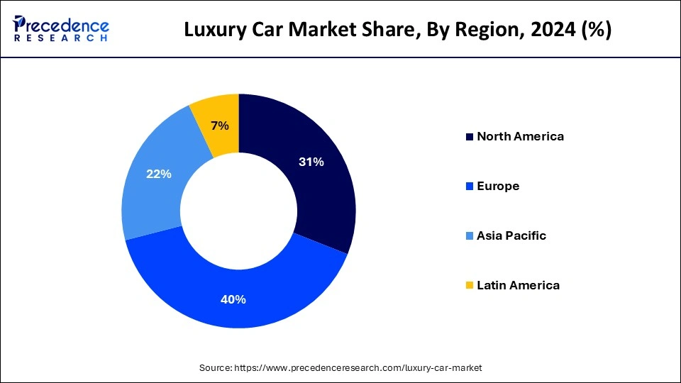

Figure 3: Luxury car market share in America (Region wise)
(Source: Precedenceresearch, 2025)
The U.S. automobile industry is a critical economic pillar with the generation of extensive employment, investment and export value. According to the AAPC report (2025), automakers strategically employ 436,000 workers, while the broader supply chain supports about 9.6 million jobs, including 1.07 million dealership employees and 907,000 parts-supplier workers, articulating the strong ‘multiplier effect’. The sector has strategically exported $1.2 trillion in vehicles and parts over the past decade, contributing to it as the largest U.S. manufacturing exporter (American automakers, 2025). Automakers have strategically committed towards $75 billion in new investments in the past two years to support EV and autonomous vehicle development, with the reinforcement of long-term economic significance.
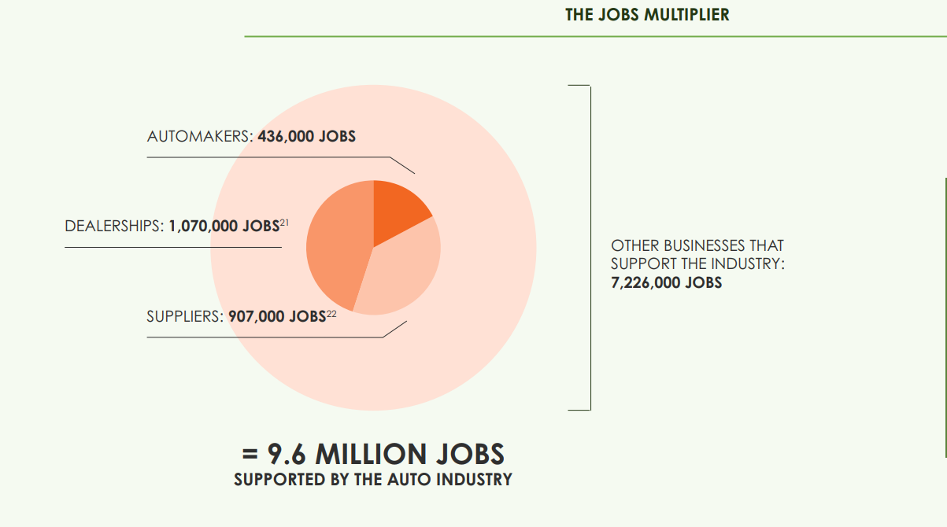
Figure 4: Employment opportunity of luxury car market in the US
(Source: Americanautomakers, 2025)

2.3 Major Domestic and Multinational Firms: Competitive Positioning
Brand | Parent Group | Positioning | Key Models | Strategy
Rolls-Royce Motor Cars | BMW Group (Germany) | Ultra-luxury / bespoke craftsmanship | Phantom, Ghost, Cullinan, Spectre EV | Rolls-Royce produces around 6000 vehicles globally per year, with about one-third delivered to North America.  The brand focuses on the highly personalized Bespoke customization strategy, enabling premium pricing.  Launch of Rolls‑Royce Spectre and delivery of ~500 EVs in the Americas since 2023, signalling a shift toward sustainable ultra-luxury mobility.
Bentley Motors | Volkswagen Group (Germany) | Ultra-luxury / performance heritage | Bentayga, Continental GT, Flying Spur | Bentley differentiates itself with the emphasis on handcrafted quality, premium materials and attention to detail.  Launching luxury SUVs such as Bentayga and planning electrification under the Beyond100+ strategy targeting full electric vehicles by 2035 (Bentleymedia, 2025).
Ferrari N.V. | Independent (Italy, NYSE: RACE) | Ultra-luxury / performance/exclusivity | Roma, SF90, 296 GTB, Purosangue | Ferrari intentionally limits products, creating waiting lists and sustains customer desire.  It sold only 13,752 cars in 2024, yet generated €6.677 billion in revenue, emphasizing exclusivity.
Cadillac (US) | General Motors (USA) | Premium domestic luxury | Escalade, CT5-V Blackwing, Lyriq EV | Cadillac integrates innovative systems such as Super Cruise hands-free driving.  Models such as the Escalade, LYRIQ, and XT5 combine bold styling, premium materials, and modern aesthetics, reinforcing Cadillac’s luxury heritage (GM, 2025).  Cadillac's US sales have increased from 160,204 units in 2024 to 173,515 units in 2025, demonstrating the steady brand expansion in the luxury segment.
Lincoln (US) | Ford Motor Company (USA) | Entry-luxury domestic | Navigator, Nautilus, Aviator, Corsair | Lincoln demonstrates strong growth in the US luxury automotive supported by the rising SUV demand.  In 2024, Lincoln’s U.S. sales increased by 28.1% to 104,823 units, reflecting strengthening brand performance.  SUV-focused strategy: Models such as Navigator, Aviator, Corsair, and Nautilus anchor Lincoln’s luxury SUV lineup for 2025–2026 (Lincoln International, 2025).
Table 1: Competitive positioning of luxury brands
(Source: Self-created)

3. Porter's Diamond Model of National Advantage for Global Competitiveness

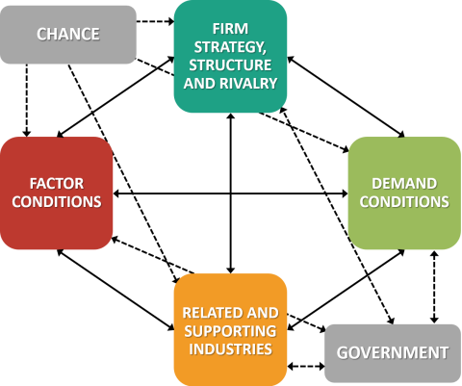
Figure 5: Porter’s Diamond Model
(Source: Self-created using Draw.io)
Michael Porter’s Diamond Model of National Advantage provides the most contextual analytical framework for a better understanding of why certain nations develop globally competitive industries (Godpower et al. 2022). This model identifies the four interacting determinants, which include “Factor Conditions, Demand Conditions, Related and Supporting Industries, and Firm Strategy, Structure, and Rivalry” — with Government and Chance acting as external variables that can reinforce or disrupt national advantage. With the application of the luxury automobile industry in the United States, the Diamond framework

3.1 Factor Conditions
The model distinguishes between the basic factors and advanced factors, which are proven to be difficult to imitate and create a durable competitive positioning. The basic factors include natural resources, unskilled labour, and geography, which are widely replicable and fail to offer a sustainable advantage. Whereas the advanced factors such as specialised knowledge, sophisticated infrastructure and capital markets have been proven to be difficult to imitate and create the strategic competitive positioning. So far as the USA ultra-luxury automobile industry is concerned, the decisive advanced factors are attributed to the demand-side in nature.
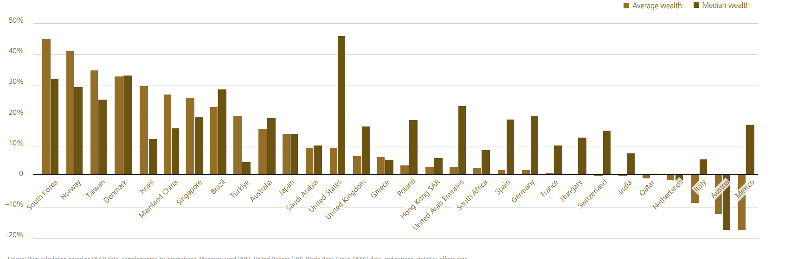
Figure 6: USA wealth market growth
(Source: UBS, 2025)
According to the study of UBS (2025), the United States demonstrates the largest wealth market globally, by shaping the strong demand for luxury goods and high-end automobiles. The U.S has over 24 million millionaires, which accounts for 39.7% of the global millionaires, with 379,000 new millionaires included in 2024. The country also holds around 35% of the global personal wealth, while average wealth per adult accounts for $620,654 and median wealth $124,041 (UBS, 2025). Further, the sophisticated financial infrastructure in the USA leverages ultra-luxury vehicle transactions at scale. These advanced factors collectively constitute demand-side advantages, not a supply-side one, with the greater implications for RRMC’s competitiveness positioning in the vulnerable tariff market of the USA (Yahoo, 2025).

3.2 Demand Conditions
The US ultra-luxury automobile market demonstrates the precise qualities in association with demand conditions which confer a strong national advantage, such as scale, sophistication and segmental specificity.
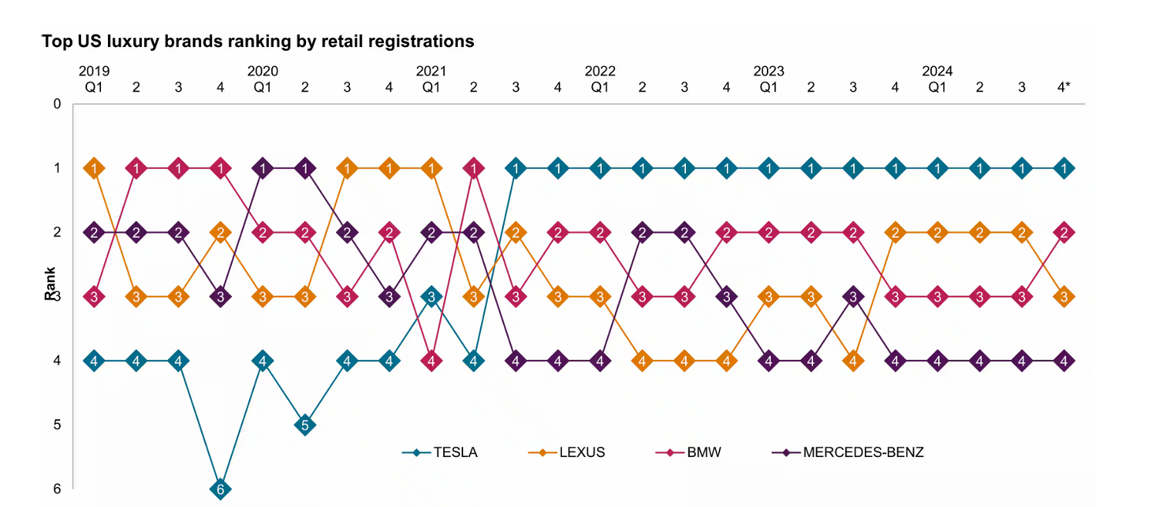
Figure 7: Top US luxury car brands
(Source: Spglobal, 2025)
In terms of the scale, the US luxury automobile market is one of the largest globally, but it represents a niche segment within the overall vehicle demand. According to the S&P Global Mobility report (2025), Lexus ranks no.2 in the U.S luxury market behind Tesla in the sales of luxury car brands. In this context, SUVs dominate the segment. The upper midsize luxury utility vehicle accounted for 22% of luxury car registrations in 2024 (S&P Global, 2025). Whereas. Lexus held 51% market share, far exceeding BMW (19.4%) and Mercedes-Benz (16.8%). In terms of sophistication, the US demand is not only driven by scale, but rather it is also emotionally and experientially driven. The Cullinan SUM well articulates the consumer appetite for the luxury SUM format, constituting RRMC’s best-selling model globally.

3.3 Related and Supporting Industries
This determinant is required for the nations possessing clusters of related and supporting industries for the enhancement of competitiveness through knowledge sharpening (Yardım and Pedgley, 2023). The US well demonstrates a remarkably deep ultra-luxury supporting ecosystem that amplifies RRMC’s commercial performance.

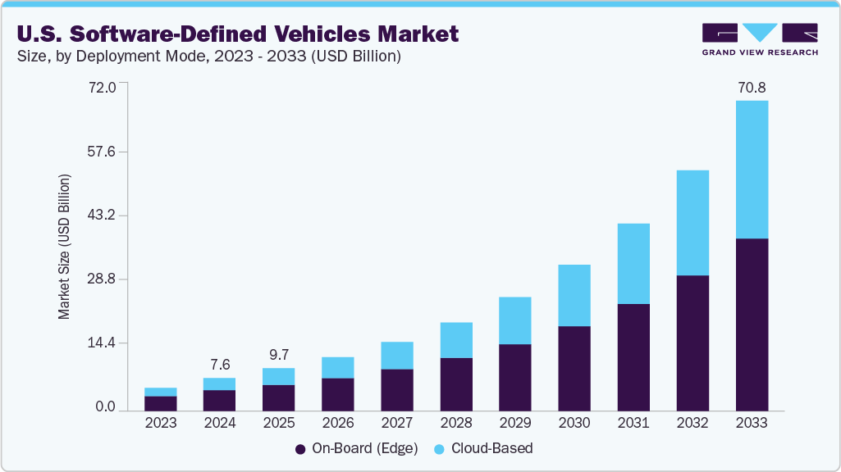
Figure 8: U.S software-defined vehicle market
(Source: Grandviewresearch, 2025)
The US technology sector is considered the most commercially significant industry for RRMC’s competitive position. The U.S. software-defined vehicle market is expanding rapidly as automakers integrate AI and advanced software into vehicles. According to Grandviewresearch (2025), the market is valued at $7.63 billion in 2024 and is projected to reach $70.82 billion by 2033, growing at a 28.2% CAGR (Grandviewresearch, 2025).

3.4 Firm Strategy, Structure, and Rivalry
This determinant evaluates whether the domestic competitive environment is sufficient in driving the organisations to continuously innovate, differentiate and improve (Kudapali et al. 2024). In the US ultra-luxury automobile market, rivalry has proven to be intense in any luxury goods segment.

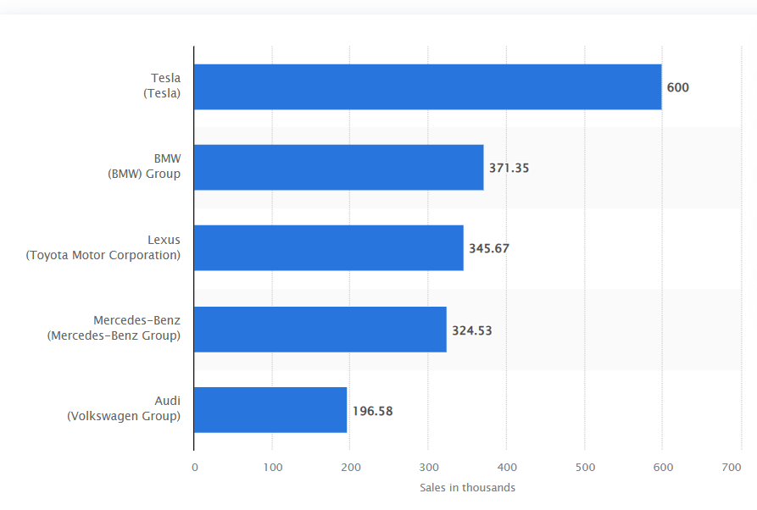
Figure 9: U.S luxury car market competitors sale
(Source: Statista, 2025)
The study of Statista (2025) articulates that the US luxury car market generated approximately $8.5 billion in revenue. BMW, the parent group of Rolls-Royce, faces strong competition in the USA, such as Tesla. High reliability perceptions for Lexus (65% reliability rating) further increase competitive pressure (Statista, 2025). RRMC’s competitive response has been pure differentiation, which is associated with Bespoke Coachbuild craftsmanship heritage and the Spectre EV’s technological statement. Rolls-Royce has strengthened its position in the luxury car sector with an investment of over £300 million towards the expansion of its Goodwood facility in response to the growing demand for Bespoke models.

3.5 Government and Chance
The external variables, such as governance and chance, have contextually proved to have a significant impact on RRMC (Naqvi et al. 2025). The Trump administration’s levied 10% tariff under Section 232 on UK vehicles import demonstrates the chance or political disruption for RRMC in the domestically manufactured competitors. Further, the 2022 Inflation Reduction Act (IRA) contextually strengthens the U.S electric vehicle sector through a $369 billion climate investment (Era-environmental, 2025). This strengthens the EV charging infrastructure, which reduces range anxiety for Spectre buyers.
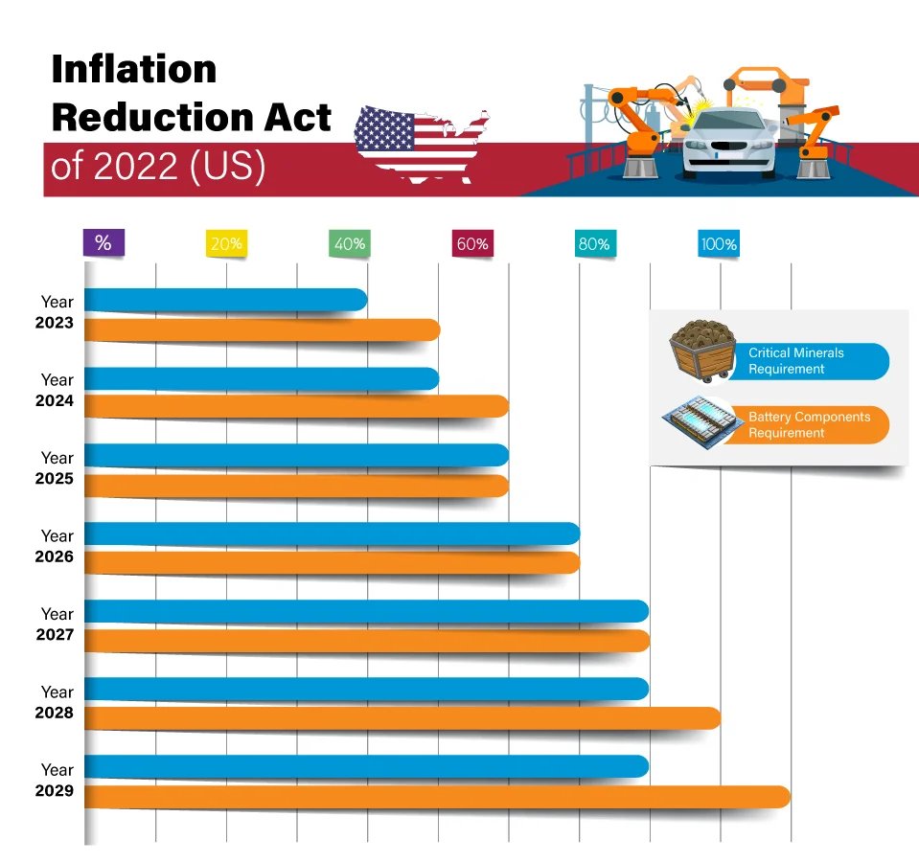
Figure 10: IRA act in the USA
(Source: Era-environmental, 2025)

4. Critical Evaluation of Rolls-Royce Motor Cars' Operations in the USA
Identification of factors affecting market operation of RRMC in USA have been discussed in this section, which is supported by cost benefit analysis.

4.1 Overall Market Attractiveness: Benefits, Costs, and Risks
Market Attractiveness Framework: Balance Benefits, Costs, and Risks
Benefits
The United States demonstrates the key international market for Rolls-Royce Motor Cars (RRMC) in terms of volume and revenue. According to BCG (20250, the US luxury and exotic car market is projected to grow from $110B.The U.S. is the largest market for Rolls-Royce, accounting for approximately 30 per cent of its sales. In FY2024, Rolls-Royce delivered 5,700 cars, which shows the short-term demand normalisation after the record sales in 2023 (Statista, 2025). This performance in the USA market reflects Rolls-Royce’s product-cycle effects instead of structural market presence.
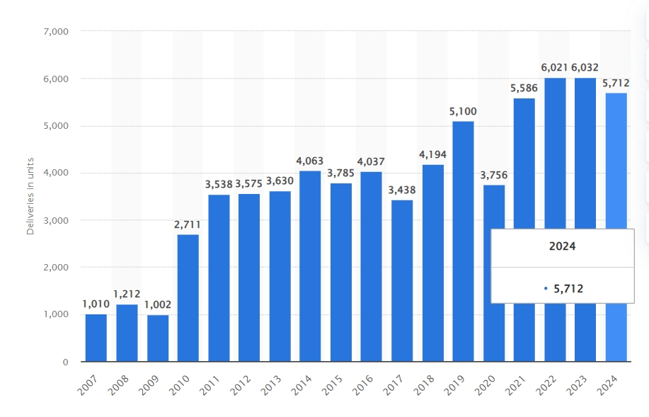
Figure 11: Rolls-Royce total deliveries of cars
(Source: Statista, 2025)
Costs
The key structural cost challenge facing RRMC in the US market relates to the import tariff exposures (Zhang et al. 2023). Rolls-Royce cars have been 100% UK-built at Goodwood since 2003, so all US deliveries are imports. These US deliveries face US tariffs reduced after the trade negotiations. This cost structure articulates the supply exclusivity and trade policy influence, reinforcing Rolls-Royce’s ultra-luxury positioning while exposing US sales. Rolls-Royce pricing thrust illustrates the extreme luxury segmentation (Thisismoney, 2025). The Phantom starts at about £450,000, but Coachbuild aircraft can cost up to £20 million and take up to five years to build, and individual customisation frequently drives prices beyond £1 million. This demonstrates a low-volume, high-margin model.
Risks
The key dominant risk includes the US trade policy environment. US tariffs could strategically impact Rolls-Royce's overall demand in its largest market, the USA (Lin, 2023). The levied tariff on imports of luxury cars could add $50,000–$100,000 to a $1M bespoke vehicle, with the raised final prices. Despite the growth in the bespoke orders and $370M investment in customisation, the increased prices could reduce the overall demand, considering the greater price elasticity.

4.2 Political Environment
The political landscape of the United States constitutes the most consequential aspect for RRMC’s overall operational progress, with the encompassed trade policy volatility, regulatory compliance obligations and broader geopolitical stability. In the context of the immediate political risk, RRMC is facing the Trump administration’s sweeping and transformative trade policy restructuring. The significant imposed tariff of 25% on all automobile imports to the US is undertaken in targeting the non-USMCA manufacturers. Given that the U.S. imported 8.1 million vehicles worth $249.1B in 2024, tariffs may lower UK export demand and profit margins (Congress, 2025). British manufacturers such as Rolls-Royce, which operates 100% of its manufacturing in the United Kingdom, have all their exports to the USA subject to tariff imposition.
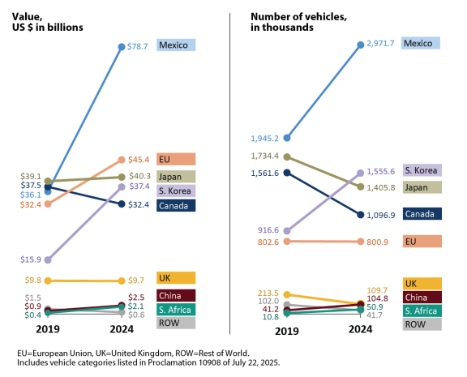
Figure 12: Imposed tariffs of the USA on imported cars
(Source: Congress, 2025)
RRMC must navigate through the complex dual-layer regulatory environment governed by the federal and state authorities. The Trump administration’s protective decision contextually benefits the domestic US manufacturers (Hartoyo et al. 2023). The USMCA vehicle regulations, which call for 75% North American content and 40–45% regional components for tariff-free trade, are being reviewed by the U.S. ITC. To safeguard local supply chains, automakers such as Ford, GM, Toyota, Tesla, and Stellantis encourage extension (Reuters, 2025). This policy thus forces RRMC's pricing upwards, making it unfair competition.
The study report of Visualcapitalist (2025) further articulates the higher exposure to U.S auto tariffs on BMW, the parent company of Rolls-Royce. The care company faces an estimated 19% of price impact on its vehicles, placing it more vulnerable amongst the global brands. This reflects BMW’s reliance on the imported models in comparison to organisations such as Tesla or Jeep, which have strong U.S.-based production facilities (Visualcapitalist, 2025).
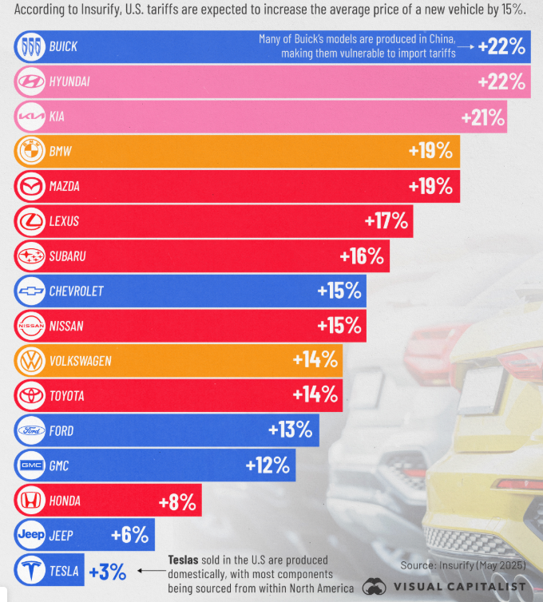
Figure 13: Vulnerability of price for BMW
(Source: Visualcapitalist, 2025)

4.3 Economic Environment
The most contextual decisive economic factor for RMMC in the USA market includes the concentration and growth of the ultra-high-net-worth individual wealth. According to the report of Capgemini (2025), the U.S wealth effect in 2024 significantly boosted the luxury demand. Strong markets with High-Net-Worth Individual (HNWI) wealth grew 9.1% and population 7.6%, the fastest globally. Wealth concentration is further intensified as Ultra-HNWIs have seen the growth of 6.3% in wealth and 6.2% of the population, though only HNWIs holding 34% of the total wealth (Capgemini, 2025). This reflects on the higher budget for luxury goods with the rising RRMC’s US demand cycle.
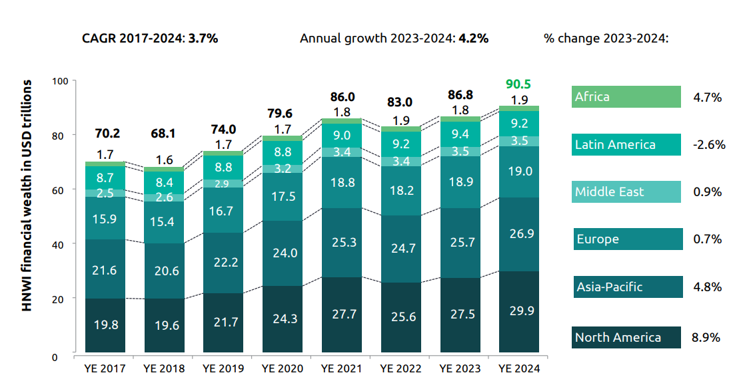
Figure 14: HNWI wealth growth
(Source: Capgemini, 2025)
Another contextual economic fact for RRMC in the US operations includes its foreign exchange exposure. As RRMC vehicles are manufactured within the UK and sold in the USD in the USA, the brand is exposed to fluctuations in the exchange rate. According to the report of Tradingview (2025), the GBP-USD shows the short-term depreciation but the modest long-term recovery. The rate is about $1.336, falling 0.22% daily, 1.15% weekly, and 2.68% monthly, indicating recent dollar strength (Tradingview, 2025). But in the longer period, the pound is reflected in structural volatility.

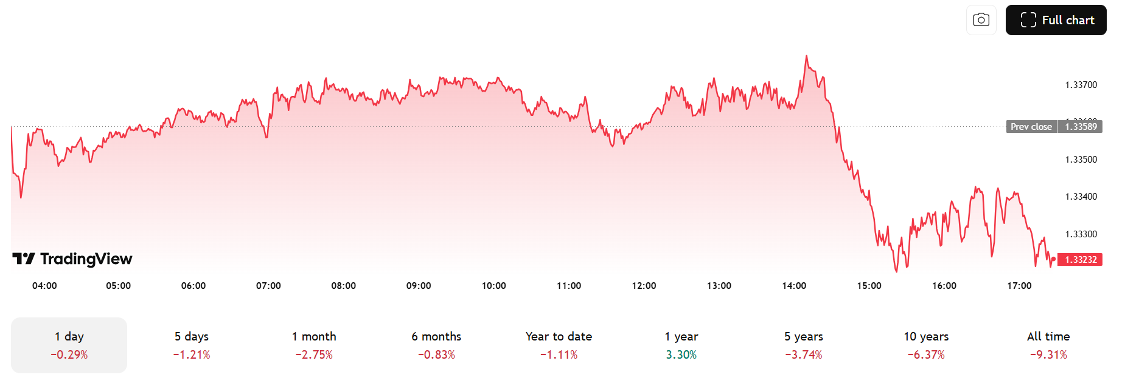
Figure 15: GBP and Dollar fluctuations
(Source: Tradingview, 2025)
The wider macro-economic factors, such as inflation and unemployment, have a negligible direct impact on RRMC’s UHNWI clientele. The Misery Index of the USA, with the added inflation and unemployment rates, articulates the key economic hardship. The Misery Index score of 6.69%, with the inflation of 2.39% plus unemployment of 4.30%, defines the rising cost (Inflation data, 2025). For RRMC, this high-income inequality is commercially proven to be advantageous, but it proves to have a negative impact on societal aspects.
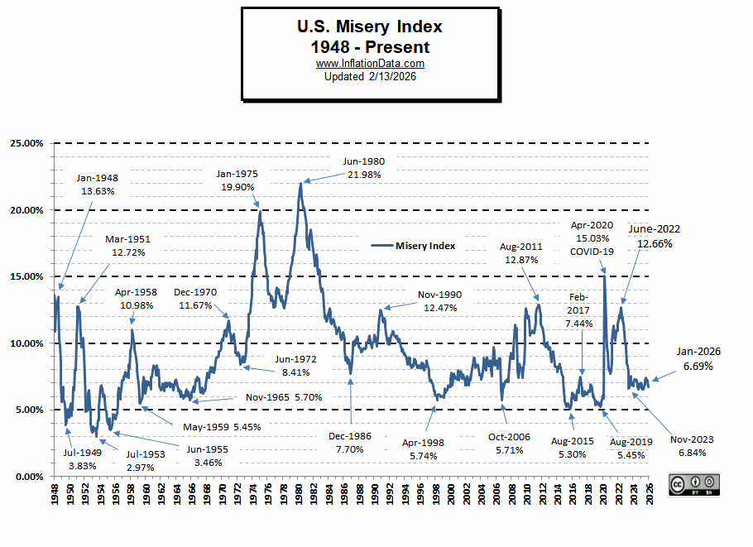
Figure 16: U.S Misery Index
(Source: Inflationdata, 2025)

4.4 Legal Environment
The United States is consistently ranked as the most business-friendly regulatory environment. The World Bank B-READY (2025) shows that the United States, with the regulation, supports business competitiveness (World Bank, 2025). The U.S scores 78.67/100 in terms of Regulatory Framework above the 66.32 global average, placing the organization at the top quartile. These stronger sector-wise scores and an efficient business environment offer tangible commercial benefits in terms of dealership partnership, allowing the flexible staffing of specialist bespoke.
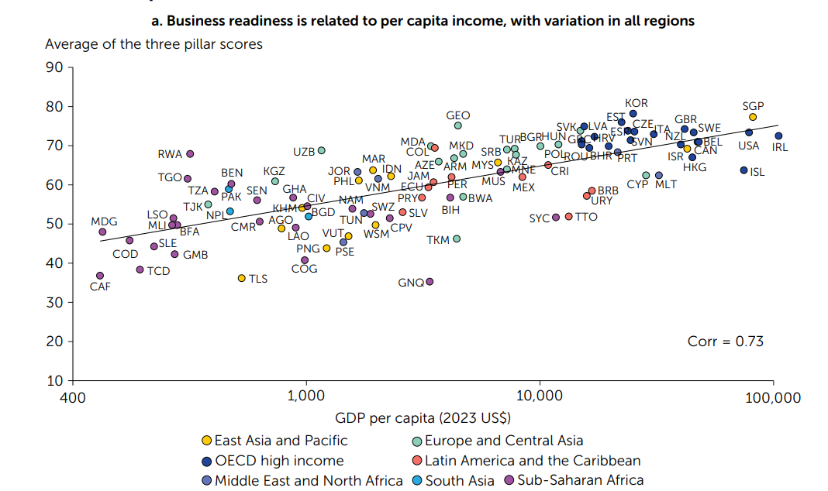
Figure 17: USA business readiness
(Source: World Bank, 2025)
The United States operates in the most plaintiff-friendly product liability legal environment. All vehicles sold in the US market must comply with the Federal Motor Vehicle Safety Standards (FMVSS), which are monitored by the NHTSA. For RRMC, as the UK manufacturer's imprint vehicles into the US, compliance applies to every aspect of the process. Updated standards such as FMVSS 305a extend electric-vehicle powertrain safety rules to vehicles over 10,000 pounds, reflecting adaptation to technological change (NHTSA, 2025). RRMC must comply with the NHTSA’s Early Warning Reporting (EWR) system that requires manufacturers to submit quarterly data on fatalities, injuries and damage claims and field reports under 49 U.S.C. 30166(m).
Furthermore, the U.S. The Department of Commerce has introduced strict new regulations regarding "Connected Vehicles" that directly impact high-tech luxury brands. The Federal Trade Commission monitors the automakers for any kind of deceptive data practices regarding the sale of location and driving behaviour data. Stronger protections exist under the California Consumer Privacy Act and the related amendment, the California Privacy Rights Act, which grants consumers the right to personal data handling (Lexology, 2025). Rolls-Royce must ensure its telematics and autonomous driving components, often sourced across the global supply chains, align with compliance with the U.S national security audits. RRMC's ultra-low volume, Goodwood quality standards, and BMW Group's centralised legal infrastructure significantly mitigates but do not eliminate this exposure.

4.5 Cultural Environment
For RRMC in the USA market, the commercial proposition is mostly associated with the cultural differences and personal expression and cultural alignment of brand relevance and commercial success. Hofstede’s six cultural models show that the United States has a moderately egalitarian and highly achievement-oriented culture. These dimensions continually formulate the overall brand positioning and commercial strategy for RRMC.
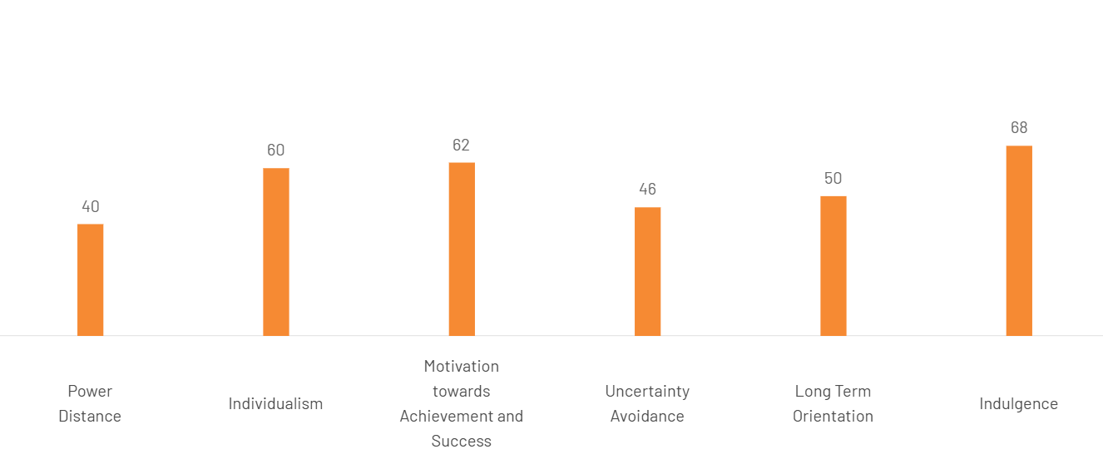
Figure 18: Hofstede’s cultural dimension of the USA
(Source: Theculturefactor, 2025)
The US scores at 60 on Individualism with the strategic attribution of a strong individualist society where people prioritise personal initiatives, merit-based promotion and self-reliance instead of group dependence. This cultural architecture has proven to be a powerful aspect for RRMC in driving success in the US market (Gillingham et al. 2023). It suits Rolls-Royce Motor Cars’ Bespoke warranty. In 2025, RRMC produced 5,664 Bespoke cars globally with the demand of personalized commissions more than doubling the year-on-year through its Private Office network, including New York. With a Power Distance score of 40, the U.S demonstrates relatively low acceptance of hierarchical inequality, supporting the value of liberty and justice. The country also demonstrates a score of 62 in the ‘Motivation for Achievement and Success’ dimension, which highlights the competitive culture driven by performance (Theculturefactor, 2025). The ownership of Rolls-Royce has long functioned as the definitive symbol of achievement in American culture. A moderate Uncertainty Avoidance score of 46 suggests Americans are relatively comfortable with risk and innovation, fostering new technologies. With the Long-Term Orientation score of 50, the US balances short-term results with pragmatic thinking. RRMC’s vehicles are often purchased as long-term heritage assets and generational status symbols (Rolls-Royce Motorcars, 2024). Even the strong indulgence score of 68 articulates the ideal cultural architecture for RRMC. UHNWI buyers are likely to be more motivated by the persistent prestige and immediate desirability of the AI-assisted bespoke design.

4.6 Technological Environment
The United States is considered the global leader in technology innovation. Advanced Driver Assistance Systems (ADAS) and autonomous driving represent the most complex and nuanced dimension of the US technological environment for RRMC. The central technological innovation enables RRMC for the commercial operations in the US market through its digital personalisation infrastructure. Digital adoption and omnichannel retailing are progressively influencing the U.S. automobile technology landscape. Online channels are essential for customer research, as 72% of purchasers use dealerships (Coxautoinc, 2024). Compared to hybrid (80%) and internal combustion engine (78%) consumers, EV buyers are leading this technological transformation, with 26% categorised as largely digital and 82% rating excellent satisfaction.
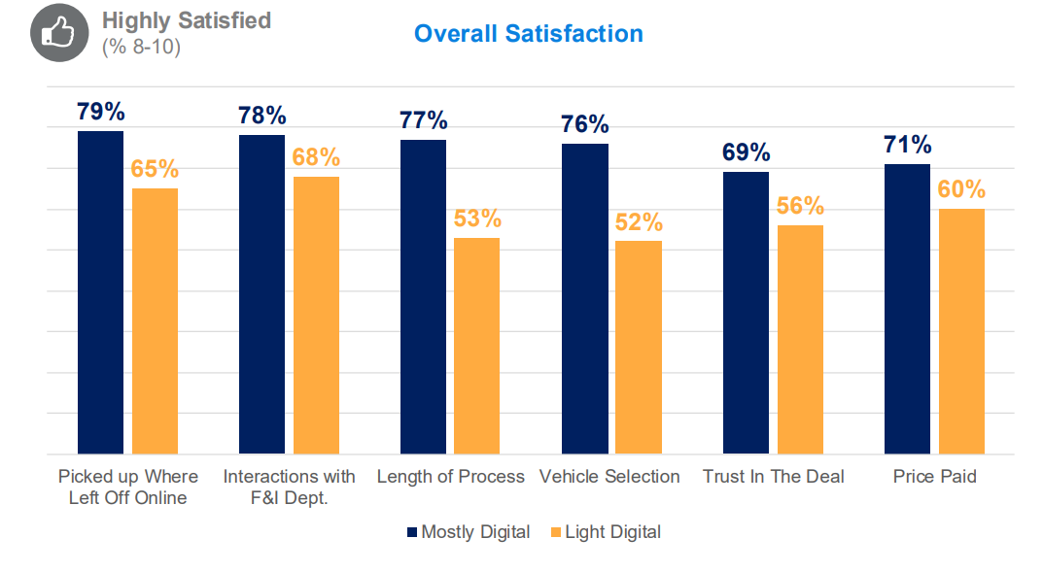
Figure 19: Technological vehicle purchase in the USA
(Source: Coxautoinc, 2024)
Rolls-Royce’s digital ecosystem intersects personalisation, connectivity and exclusivity or the facilitation of the luxury market strategy. The Bespoke Online Configurator leverages the customers for the designing of the highly personalised vehicles with the usage of over 44000 exterior colours and countless interior combinations. Complementing this, the SPIRIT digital system and Whispers owner app contribute towards the personalised services and the overall engagement.

4.7 Environmental and Sustainability Factors
The environmental dimension contextually impacts the luxury automotive manufacturers in the United States. The automobile market is strongly influenced by the emission regulations and the transition to zero-emission vehicles (ZEVs). California’s Advanced Clean Cars Program integrates Low-Emission Vehicle (LEV) and ZEV rules, aiming at reaching 100% by 2035. Several other states, such as New York, Oregon, and Massachusetts, have also included ACC II. This regulatory trajectory directly accelerates the commercial timeline for RRMC's all-electric product transition. Further, the study of Pew Research (2025) shows that about 33% of Americans would seriously consider purchasing an EV (PewResearch, 2025). Interest in hybrid vehicles is higher at 45%, suggesting consumers may prefer transitional technologies.
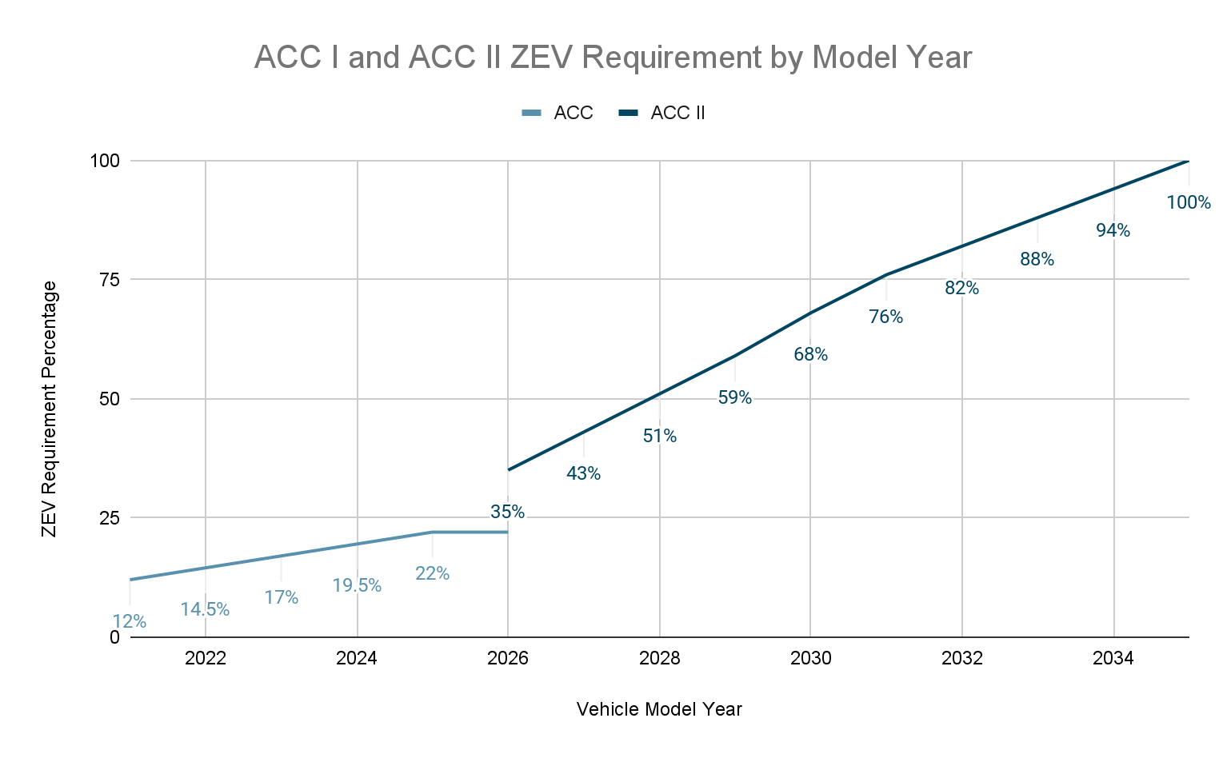
Figure 20: ACC I LEV and ZEV regulations
(Source: Desireinsight, 2025)

5. Conclusion
This report provides an extensive analysis of the United States, representing the most significant commercial and critical international market for Rolls-Royce Motor Cars. Considering the analytical dimensions, the country offers the most favourable operating environments available to any ultra-luxury consumer goods brand globally. The application of Porter’s Diamond Model suggests that the US market operates as the demand-dominant aspect, with its UHNWI wealth concentration and sophisticated and emotionally driven bespoke luxury care demand. With the offerings of its two globally transitive products, such as the Cullinan SUV and Spectre EV, RRMC contextually shapes the US consumer preferences.
The external environmental analysis offers the critical evaluation of the identified trade policy volatility as the single most contextual near-term risk. The economic environment is favourable in structural terms. RRMC’s addressable market and the brand’s volume strategy confirm that pricing power remains intact. Culturally, the US profile constitutes a near-ideal cultural architecture for RRMC’s Bespoke proposition. Technologically, the Spectre EV’s confirmation as RRMC’s second most globally demanded model in 2025 is the most powerful empirical evidence of this cultural alignment.
The most significant strategic imperative is the continued navigation of trade policy uncertainty through BMW Group’s exploitative and financial resources. This is combined through the maintenance of the product's freshness and bespoke relevance for a market whose low long-term orientation depends on continuous innovation. RRMC is well positioned to sustain its US market leadership and technological ambition that the US ultra-luxury buyer demands. RRMC should pursue a transnational strategy in the US, maintaining global brand consistency.

Section 2: Reflective Account-Gibbs Reflective Cycle

Figure 21: Gibbs Reflective Cycle
(Source: Self-created)
Description
In the context of performing extensive research and analysis on the international business, I selected Rolls-Royce Motor Cars (RRMC) as the key case study, which has commercial operations in the United States. The selection of the USA as the key host country for the brand offers a rich pairing in terms of the analytical progressions. I structured my research process across the varied distance phases (Praveena et al. 2025). I began with the analysis of the module’s key areas for the identification of the theoretical frameworks which are most relevant to the assignment, such as Porter’s Diamond Model, the PESTLE frameworks and Hofstede’s Six Cultural Dimensions, the Market Attractiveness (Benefits, Costs and Risk) framework (Ma et al. 2026). In the evaluation process, I included a wide range of secondary research phases, sourcing data from annual reports, Statista, Grand View Research, the BCG, Capgemini World Wealth Report, and UBS Global Wealth Report to get the most recent information.
Feelings
I felt a genuine sense of engagement during the research as I found the subject matter more compelling. I have always been aware of Rolls-Royce’s brand identity as a culturally rich icon, but I had never recognised the precious mechanics behind its global operations (Wang et al. 2025). As I began to explore RRMC’s global competitiveness with its ownership structure, Goodwood manufacturing facility and the Bespoke personalisation approaches, I felt confident in terms of the wider exploration and detailed understanding of the subject with more analytical exploration for supporting the findings (Trimasse, 2025). The Trump administration’s changing tariffs on imported vehicles, norms and related changes in rulings proved challenges in framing a single, clean and authoritative source for capturing the complete timeline. I even felt intellectually stretched by performing the Hofstede cultural dimension. As the score dimension of the cultural aspect had a significant impact on the overall RRMC’s Bespoke value proportion, I made a very careful and systematic explanation of the triangulation of the sources.
Evaluation
I recognise that the most effective and strongest aspect of my research proceedings was the extent of commitment of using the various research sources and secondary data sources of recent times and the consistency in the interconnection of the empirical evidence for forming a better application of theories and exercise (Sow et al. 2025). I am pleased with the aspect of how I engaged and applied the BCG report data in the application of Porter’s Diamond Demand Conditions analysis and the industry overview section. This report, with the comprehensive recent study on the US luxury and exotic car market, provided the various analytical significance of RRMC (Ekarina and Engliana, 2025). The various sources of data identify that one in three luxury items cite emotional factors as the primary motivation, and buyers' experiences enhance the brand satisfaction. Weaving the digital findings strategically contributed towards the quality of my argument. On the negative aspect, I recognise that most of the contextual weakness lies in my process in terms of time allocation across diverse sections.
Analysis
In the entire process of performing each section, I learned important lessons regarding the distinction between the descriptive evidence and analytical argument. In my overall analysis and application of the key theoretical frameworks, the related data requirements were defined, the explicitness in-depth understanding. I found myself well aligned with the listing statistics, data, and information in terms of sufficient connection with the module’s understanding of RRMC's specific strategic situation (Cook and Sambell, 2025). The detailed exploration of the U.S UHNWI clientele and the strategic demand for the luxury goods consumption make the inclusion of the data sources of RRMC in the luxury automobile sector well justifiable. I recognised the significance of the descriptive analysis and improved the quality of my argumentation. I now understand that through practice, instead of the theoretical application, it extensively emphasises the evaluation of factual reporting. The experience even deepened my overall value proposition and knowledge attribution in terms of the interconnectedness of various framework dimensions (Wang, 2025). The cross-dimensional connections contributed towards the final section's discussion and developed considerably in terms of analytical aspects, and I believe, more academically convincing.
Conclusion
Through the extensive exploration and approach of performing the assignment, I recognise the key aspect of potential areas of change which could make substantive changes to my process. In the future such assignment tasks, I would begin the source research on retailers and more systematically for better exploration and value-based discussion before undertaking tasks (Shrestha, 2025). This would significantly reduce the uneven quality misalignment and reduce the time for revision. I found that the BMW Group 2025 Annual Results, the RRMC January 2026 bespoke press release contained the most commercially specific and analytically distinctive RRMC data. In the prospect of various other performing tasks, I would allocate more time to the cross-reference for getting a nuanced understanding instead of relying on a particular source. At a deeper level, this assignment has permanently changed how I understand international business as a discipline (Koch et al. 2026). I entered the module thinking of international business as primarily a subject about trade flows, market entry modes, and tariff structures. I leave it understanding that culture, identity, and human psychology are at least as commercial.

Action Plan
Goal | Action Steps | Resources Needed | Success Measure | Timeline
1. Time Management | Create a weekly study planner at the start of each module | Google Calendar | Zero late submissions in the next academic year. | Implement from next module. Review adherence after each submission throughout the academic year.
2. Reference Management | Adopt a dedicated reference manager | Zotero (free) | Reference list submitted with no formatting errors | Set up Zotero account
3. Pre-Research Planning | Build a structured research matrix before writing any assignment section | Research matrix template | Completed research matrix submitted to self as a pre-writing checkpoint. Assignment section quality assessed against matrix | Apply to the next module assignment. Review and refine the matrix template after each submission based on what was missing.
Table 2: Action plan
(Source: Self-created)

References
Americanautomakers (2025). STATE OF THE U.S. AUTOMOTIVE INDUSTRY. Available at: https://americanautomakers.org/sites/default/files/2025%20AAPC%20Economic%20Contribution%20Report_1.pdf [Accessed on: 04.03.2026]
BCG (2025).US Luxury and Exotic Car Market Set to Reach Up to $215 Billion by 2035—Nearly Twice Its Current Size. Available at: https://www.bcg.com/press/12december2025-us-luxury-exotic-car-market [Accessed on: 05.03.2026]
Bentleymedia (2024). Bentley announces its 2024 half-year financials. Available at: https://www.bentleymedia.com/en/newsitem/1612-bentley-announces-its-2024-half-year-financials [Accessed on: 06.03.2026]
Capgemini (2025). North America high-net-worth individual population surges, while Europe and Middle East shrink. Available at: https://www.capgemini.com/news/press-releases/north-america-high-net-worth-individual-population-surges-while-europe-and-middle-east-shrink/ [Accessed on: 07.03.2026]
Carscoops (2025). America’s $100,000 Luxury Car Sales Set to Nearly Double By 2035. Available at: https://www.carscoops.com/2025/12/luxury-car-market-growth-2035-trends/ [Accessed on: 01.03.2026]
Congress (2025). Section 232 Automotive Tariffs: Issues for Congress. Available at: https://www.congress.gov/crs-product/IN12545 [Accessed on: 02.03.2026]
Cook, E.J. and Sambell, R., (2025). Exploring how nutrition students used the relational employability framework to reflect on their micro-placement experiences.
Coxautoinc (2025). 2024 Cox Automotive Car Buyer Journey Study. Available at: https://www.coxautoinc.com/wp-content/uploads/2025/01/2024-Car-Buyer-Journey-Study-Research-Summary.pdf [Accessed on: 03.03.2026]
Dsireinsight (2025). The Advanced Clean Cars II Controversy: Where are States Adopting or Blocking California's Zero-Emission Vehicle Rules? Available at: https://www.dsireinsight.com/blog/2024/5/28/the-advanced-clean-cars-ii-controversy-where-are-states-adopting-or-blocking-californias-zero-emission-vehicle-rules [Accessed on: 05.03.2026]
Ekarina, E. and Engliana, E., (2025). Exploring reflective learning for a design thinking class. Journal of English Language Teaching and Linguistics, 10(1), pp.61-78.
Era-environmental (2025). What the Inflation Reduction Act Means for OEMs and Auto Suppliers. Available at: https://www.era-environmental.com/blog/inflation-reduction-act-automotive-industry [Accessed on: 06.03.2026]
FTC (2025). FTC Acts Against General Motors for Sharing Drivers’ Precise Location and Driving Behavior Data Without Consent. Available at: https://www.ftc.gov/news-events/news/press-releases/2025/01/ftc-takes-action-against-general-motors-sharing-drivers-precise-location-driving-behavior-data [Accessed on: 04.03.2026]
Gillingham, K.T., van Benthem, A.A., Weber, S., Saafi, M.A. and He, X., (2023), May. Has consumer acceptance of electric vehicles been increasing? Evidence from microdata on every new vehicle sale in the United States. In AEA Papers and Proceedings (Vol. 113, pp. 329-335). 2014 Broadway, Suite 305, Nashville, TN 37203: American Economic Association.
GM (2025). GM leads U.S. industry, 2025 sales up 6%. Available at: https://news.gm.com/home.detail.html/Pages/news/us/en/2026/jan/0105-gmsales.html [Accessed on: 05.03.2026]
Godpower, O., Ndubuisi, N.P., Eze Nkeiruka, C. and Ogechukwu, O.R., (2022). THE COMPETITIVE ADVANTAGE OF NATIONS. BW Academic Journal, pp.11-11.
Grandviewresearch (2025). U.S. Luxury Car Market Size & Outlook, 2025-2030. Available at: https://www.grandviewresearch.com/horizon/outlook/luxury-car-market/united-states#:~:text=U.S.%20luxury%20car%20market%20highlights,Japan%20%2C%20Brazil%20%2C%20Canada%20%2C%20Germany [Accessed on: 06.03.2026]
Grandviewresearch (2025). U.S. Software-Defined Vehicles Market (2025 - 2033). Available at: https://www.grandviewresearch.com/industry-analysis/us-software-defined-vehicles-market-report [Accessed on: 07.03.2026]
Hartoyo, H., Manalu, E., Sumarwan, U. and Nurhayati, P., (2023). Driving success: A segmentation of customer admiration in automotive industry. Journal of Open Innovation: Technology, Market, and Complexity, 9(2), p.100031.
Inflationdata (2025). Misery Index. Available at: https://inflationdata.com/articles/misery-index/ [Accessed on: 01.03.2026]
Koch, G.G.V., Moosa, H., Smith, J. and Davidson, F.E., (2026). Learning through play: Educators and students reflect on a gamified assessment. Journal of Medical Imaging and Radiation Sciences, 57(1), p.102139.
Kudapali, J., Sathvik, S. and Gouda, A.T., (2024). Luxury and fashion marketing: A new wave in the sea of marketing. Asian Journal of Management, 15(1), pp.72-78.
Lexology (2025). FTC sends warning to auto industry over connected cars and data privacy. Available at: https://www.lexology.com/library/detail.aspx?g=d57ff615-d92b-4a29-a512-a6545d7ec139 [Accessed on: 02.03.2026]
Lin, J., (2023). Analysis of luxury brand marketing strategies based on consumer psychology. Advances in Economics, Management and Political Sciences, 24(1), pp.240-245.
Lincolninternational (2025). Intelligence Report. Available at: https://www.lincolninternational.com/wp-content/uploads/Nov-2025-Vehicle-Aftermarket-Intel-Report.pdf?x42567 [Accessed on: 01.03.2026]
Ma, W., Jiang, L., Zhuang, W., Cai, J., Xie, X. and Zhang, C., (2026). Reflective writing in higher education: A systematic review of pedagogical approaches, research trends, and assessment practices. Educational Research Advances, 1(1), pp.1-15.
Naqvi, S.R., Sareen, P., Sharma, T. and Naqvi, A., (2025). Humane Approach of e-learning Utilization: Case Study of Rolls-Royce. Emerging Economies Cases Journal, 7(1), pp.14-18.
NHTSA (2025). Early Warning Reporting. Available at: https://www.nhtsa.gov/vehicle-manufacturers/early-warning-reporting [Accessed on: 02.03.2026]
Pewresearch (2025). One-third of Americans interested in purchasing an EV. Available at: https://www.pewresearch.org/science/2025/06/05/americans-views-on-energy-at-the-start-of-trumps-second-term/ps_2025-6-5_energy_00-07/ [Accessed on: 05.03.2026]
Praveena, K.S., Juslin, F., Patil, C.M. and Bhargavi, K., (2025). Using gibb's reflective model approach for enhancing project-based learning among students through reflective assessment. Journal of Engineering Education Transformations, pp.148-155.
Precedenceresearch (2025). Luxury Car Market Size and Forecast 2025 to 2034. Available at: https://www.precedenceresearch.com/luxury-car-market [Accessed on: 06.03.2026]
Reuters (2025). US trade commission launches review of USMCA automotive rules of origin. Available at: https://www.reuters.com/business/autos-transportation/us-trade-commission-launches-review-usmca-automotive-rules-origin-2026-02-19/ [Accessed on: 07.03.2026]
Rolls-roycemotorcars (2025). ROLLS-ROYCE MOTOR CARS UNVEILS PRIVATE OFFICE NEW YORK. Available at: https://www.press.rolls-roycemotorcars.com/rolls-royce-motor-cars-pressclub/article/detail/T0445287EN/rolls-royce-motor-cars-unveils-private-office-new-york?language=en [Accessed on: 03.03.2026]
Shrestha, K., (2025). First-year composition multilingual students’ academic writing practices: the impact of reflective reading response journals. Reflective Practice, 26(5), pp.728-741.
Sow, C.F., Rasiah, S. and Er, H.M., (2025). A critical exploration of theoretical frameworks for reflective learning: Reflections from a faculty development workshop. Medical Science Educator, 35(1), pp.503-507.
Spglobal (2025). US luxury car market: Lexus outperforms rivals. Available at: https://www.spglobal.com/automotive-insights/en/blogs/2025/01/luxury-car-market-lexus-outperforms-rivals [Accessed on: 04.03.2026]
Statista (2025). Global deliveries of Rolls-Royce automobiles from FY 2007 to FY 2024. Available at: https://www.statista.com/statistics/267243/worldwide-sales-volume-of-rolls-royce-automobiles/?srsltid=AfmBOoptFTwauLur8ZRjRUDO-l3_-S5b1wfwZpKmIj5EUH_g2NnL8tTI [Accessed on: 03.03.2026]
Statista (2025). Leading luxury car brands in the U.S. in 2024, based on unit sales. Available at: https://www.statista.com/statistics/681399/luxury-vehicles-united-states-premium-vehicle-market-unit-sales/?srsltid=AfmBOoq71nC29yr6OspR4HpGFVvKBg_gHhNbSAUe7Ub4a5yQpEnaLrfW [Accessed on: 01.03.2026]
Theculturefactor (2025). Cultural dimension of the United States. Available at: https://www.theculturefactor.com/country-comparison-tool?countries=united+states [Accessed on: 07.03.2026]
Thisismoney (2025). Will Rolls-Royce's super-rich clients in the US soak up tariff rises? Available at: https://www.thisismoney.co.uk/money/cars/article-14567153/Will-Rolls-Royces-super-rich-clients-US-soak-tariff-rises.html [Accessed on: 06.03.2026]
Tradingview (2025). British Pound / U.S. Dollar. Available at: https://in.tradingview.com/symbols/GBPUSD/ [Accessed on: 01.03.2026]
Trimasse, N., (2025). The use of reflective reports in higher education. Reflective Practice, 26(1), pp.154-171.
UBS (2025). Global Wealth Report 2025. Available at: https://www.ubs.com/global/en/wealthmanagement/insights/global-wealth-report.html?bulkredirectlink=/global/en/wealth-management/insights/global-wealth-report.html [Accessed on: 04.03.2026]
Visualcapitalist (2025). How Tariffs Will Impact U.S. Car Prices, by Brand. Available at: https://www.visualcapitalist.com/how-tariffs-will-impact-u-s-car-prices-by-brand/ [Accessed on: 03.03.2026]
Wang, C.W., Hazell, A. and Scanlon, S., (2025). Reflective writing. In English for Medical Communication (pp. 97-118). Routledge.
Wang, Z., (2025). Reflective journal writing and interpreting anxiety: insights from a longitudinal study. Frontiers in Psychology, 16, p.1671239.
World Bank (2025). Business Ready (B-READY). Available at: https://openknowledge.worldbank.org/server/api/core/bitstreams/87da3605-74ec-48c0-ad83-0d9be0db1475/content [Accessed on: 02.03.2026]
Yahoo (2025). Rolls-Royce CEO: Tariffs will have some impact on luxury goods, but don't weep for the luxury car maker. Available at: https://finance.yahoo.com/news/rolls-royce-ceo-tariffs-will-have-some-impact-on-luxury-goods-but-dont-weep-for-the-luxury-car-maker-145146447.html [Accessed on: 01.03.2026]
Yardım, S. and Pedgley, O., (2023). Targeting a luxury driver experience: design considerations for automotive HMI and interiors. International Journal of Design, 17(2), pp.45-66.
Zhang, Q., Ariffin, S.K., Richardson, C. and Wang, Y., (2023). Influencing factors of customer loyalty in mobile payment: A consumption value perspective and the role of alternative attractiveness. Journal of Retailing and Consumer Services, 73, p.103302.

