
Student Name: Vasilica Gutue
Student Number: 2216455
Lecture Name: Akash Puranik
Module Title: LCLM6002-BIR

Innovation & Customer Journey
Waterstones in the Digital Era: Strategic Growth and Customer Experience Transformation

Contents
1. Summary
2. Introduction
3. Discussion
4. Conclusion
5. References

Part 1. Analyse for waterstones
Key Consumer and Industry Trends
Innovation Analysis (Innovation Ambition Matrix)

Part 2.Current Customer Journey Map
Proposed new digital transformation initiative and how it will add value to the organisation
Observations / Opportunities

1. Summary

With a distinct emphasis on community involvement, customer experience, and decentralised store management, Waterstones holds a dominant position in the UK book market. Though there are still gaps in digital integration, the company has effectively balanced the growing demand for online shopping with its physical store presence.
While transformational ideas, such as AI-driven recommendations or a marketplace for independent authors, remain high-potential but require careful testing, Waterstones is actively improving its core offerings and exploring adjacent opportunities, according to the Innovation Ambition Matrix analysis of innovation.
Several issues are highlighted by the current customer journey, including discrepancies between online and in-store inventory, a lack of integrated recommendations, and limited digital follow-up. Positive in-store experiences, staff recommendations, and community events set Waterstones apart from its online rivals.
Although Waterstones has a strong basis for expansion, it must fill in the gaps in its digital capabilities and incorporate cutting-edge solutions that improve the customer experience if it hopes to remain competitive in the digital era. Part 2 follows naturally from these insights, where a digital transformation.
Part 1 – Analysis for Waterstones

2. Introduction

Evolution and Historical Context

According to what I've read about the company's history in books and documentaries, Waterstones began as a single store in 1982 and has since expanded to become the largest book retailer in the United Kingdom. Among the challenges it has encountered over the years are economic downturns, the rise of digital media, and changing consumer preferences. Despite these difficulties, Waterstones has consistently made adjustments, focusing on enhancing the in-store experience and expanding its reach. I am aware of the company's everyday activities and the modifications it has made to adapt to the evolving retail environment.
I decided to write this report about Waterstones because I have worked there for more than 8 years, during which time I have grown as an employee, developed several leadership, problem-solving, and strategy implementation skills, and learnt how to build a productive team with individuals from all over the world. As a result, I can create all of Waterstones' fundamental operational requirements. In addition to the vast array of books that the Waterstones company owns, you can find a variety of kid-friendly games, clocks, greeting cards, cups with the periodic table on them, the globe, and much more.
Waterstones is the largest book shop in the UK, with over 300 stores across the country as well as outlets in Ireland and other parts of Europe. It was founded in 1982 by Tim Waterstone and has lately made a strong comeback under CEO James Daunt. Store managers are free to make local decisions on events and merchandise since the company uses a decentralised management model. Using this approach, Waterstones has increased profitability and consumer loyalty in recent years (Waterstones, 2025; The Bookseller, 2023).

3. Discussion
The state of the book retail industry today:

Based on my own experience in this company, the retail book business in the UK is undergoing a significant change. The market is still influenced by digital platforms and internet merchants, but physical bookshops are becoming
more and more popular. Younger adults, who are increasingly looking for real-world experiences that digital platforms cannot offer, are especially affected by this trend.
The Report's Objective

My idea to improve Waterstones' position in the market this report examine the company's present tactics, evaluate the effects of current market trends, and suggest a digital transformation project. Through an analysis of consumer behaviour, technological developments, and operational efficiency, the report will offer practical suggestions for Waterstones to sustain its success in a competitive environment.
Key Consumer and Industry Trends
The desire for physical books has increased, particularly among younger readers, thanks to BookTok and other social media communities. This explains why Waterstones decided to open about ten new locations a year (The Guardian, 2025).
Omnichannel expectation: Customers want the convenience of online shopping in addition to in-store features like click-and-collect and personalised recommendations (Rigby, 2011).
Economic pressures: Inflation, rising rent, and labour expenses all have an effect on margin. Expansion needs careful management even as it is supported by additional finance (£125 million growth capital) (Business Weekly, 2025). Community and in-store experiences: The company distinguishes itself from its online competitors with social spaces including cafés, author events, and staff recommendations (Butler, 2017).
In my opinion, our company's progress is what makes it unique in the retail industry. Knowledge, research, and talents come to mind when I say "Waterstones."
Every working day in this company is different; we are flexible across all departments, we are familiar with almost all cultures of other countries and what is unique is that we have the possibility to access any information thanks to the copies of books we possess.

Part 1 – Innovation Analysis (Innovation Ambition Matrix)
Innovation analysis is the process of looking at and understanding the different parts of innovation, such as its types, levels, and effects.
It entails determining how innovation may contribute to the expansion of the economy and society, particularly in the digital era, and how it can increase the adaptability and resilience of organisations. In short, I understand innovation analysis as a process where you look at what is currently done and you improve it. I observed this directly in the store when we switched from SAP to Blue Yonder, as it can change the entire workflow.
When you conduct an innovation analysis, you examine what you already have, seek ways to make it better, and discover how various forms of innovation, such as organisational, process, and product innovation, interact.
Organisations can use the Innovation Ambition Matrix as a framework to classify their
Core, Adjacent, and Transformational are the three categories of innovation initiatives.

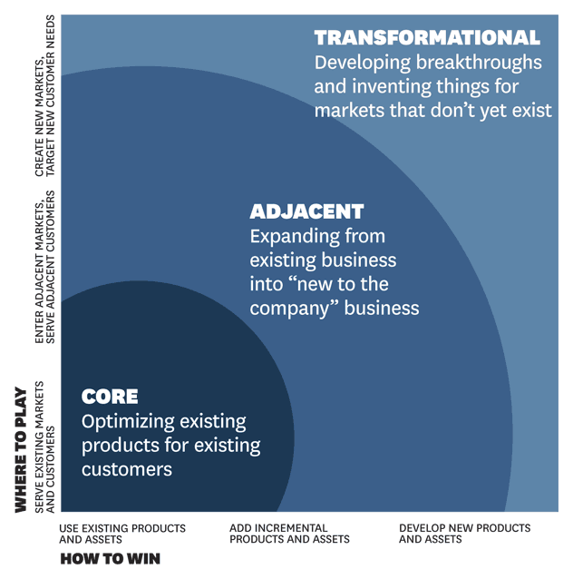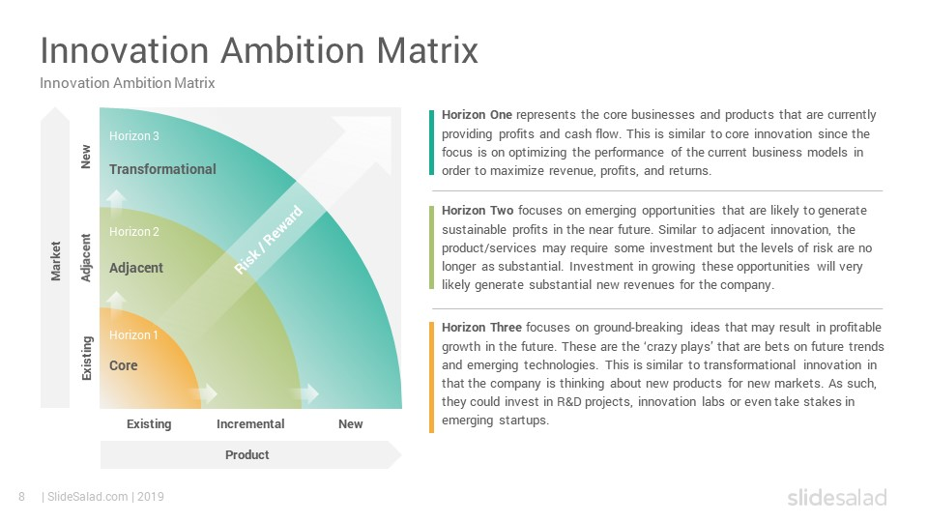
These diagrams that I have added below help to accurately highlight the entire work process, ideas, development, and initiatives of ours as workers. When work is done as a team, the company's progress is seen very soon. The Innovation Ambition Matrix divides the projects into three categories:
Core (defend and extend), Adjacent (grow from current capabilities), and Transformational (breakthrough/new business).
Core (Protect & Extend)
Author events, staff suggestions, and shop design to enhance the in-store experience.
Close by Website updates, shipping, and click-and-collect are all optimised for omnichannel commerce.
Reason: These are small-scale enhancements that bolster already-existing benefits.
Retail partnerships: smaller stores run by bigger partners, like John Lewis.
Related items include exclusive editions, merchandise, and subscription boxes.
Reason: raises brand recognition and product offerings without necessitating completely new business methods.
From my position inside the company, I can see that we have adopted a very pragmatic approach to innovation, with the majority of the modifications we have made up to this point being little improvements to existing processes and products.
Even though this constant pace of optimisation is essential for maintaining our core business, we have fewer efforts that explore new markets or create whole new business models. I saw how our activity was broken out using the Innovation Ambition Matrix as follows:

Modernising our current items and optimising our tried-and-true procedures are two important advancements. Adjacent innovations are attempts to extend our existing capabilities into slightly new markets or channels.
Transformational innovations are bold, entirely original ideas or corporate strategies meant to open up new markets.
The four main stages of the client journey—awareness, purchase, usage, and loyalty—have been plotted.
Through touchpoints including our website, phone centre, physical store, and mobile application, customers engage with us at every level. However, I've also discovered several significant challenges that typically occur, especially when transitioning between online and offline channels, as well as issues brought on by inadequate data integration and a lack of personalisation expertise.
I think to improve our competitiveness and give our clients a more seamless, worthwhile experience, these issues must be resolved.
Transformation
AI-driven book recommendations and subscription services, such as audiobooks, are instances of customised digital platforms.
A marketplace with integrated logistics for local or independent authors.
Reason: These could create new sources of income even as they demand greater risk and investment.
It is recommended to focus on Core and Adjacent activities throughout the next 12 to 24 months, using pilot projects to test transformational concepts (Grant, 2019; Johnson et al., 2020).Current Customer Journey Map
Step | Channels | Gains | Pains | Digital Opportunities
Awareness | Social media, website, store windows, friend recommendations | Trend inspiration, visible titles | Inconsistent info between the site & the store | AI-curated suggestions push via app; real-time stock info
Search & Decision | Website, apps, in-store | Personalised advice | Limited filters, missing reviews | Hybrid AI + staff recommendations; integrated reviews
Purchase | In-store checkout, online, click & collect | Convenient pickup, special editions | Queueing, delivery issues | Click & collect scheduling via app
Post-purchase | Emails, loyalty, in-store events | Invitations, personalised recommendations | Loyalty is not fully integrated | App notifications, subscription tracking
Engagement & Community | Social media, events, app | Connection with authors, book clubs | No centralised digital engagement | App forums, event RSVP, Q&A with authors

A customer journey map is a graphic depiction of each action a consumer performs when engaging with your business.
It could be a more intricate layout or a straightforward sequence of touchpoints. The objective is to assist you in comprehending every encounter during the purchasing process, creating better experiences, and achieving better results.
I think the organisation takes a cautious, pragmatic, and exploratory approach to innovation.
For instance, most of the adjustments made thus far have been incremental improvements to already-existing items rather than significant revisions.
I've noticed using the Innovation Ambition Matrix that:
Process optimisation and improvements to existing products are examples of core innovations. A few examples of adjacent innovations are breaking into new markets or somewhat different market sectors. revolutionary innovations, such as wholly original business plans or concepts.
For instance, over the past two to three years, the organisation has given priority to Core efforts, but Adjacent and Transformational areas have gotten less attention, which may point to areas for improvement.
I've identified the four main stages of the consumer journey: awareness, purchase, usage, and loyalty. Through a range of channels (including our website, call centre, physical shop, and mobile app), customers interact with us at every stage, and certain touchpoints are more optimised than others.

Additionally, I've observed that obstacles typically arise primarily during the shifts between online and offline channels, as well as a result of inadequate data integration and personalisation.
The main stages of the consumer journey—awareness, purchase, usage, and loyalty—have been mapped out by me.
Through touchpoints like our website, call centre, physical store, and mobile application, customers engage with us at every level.
However, I've also discovered several significant challenges that typically occur, especially when transitioning between online and offline channels, as well as issues brought on by inadequate data integration and limited personalisation experience. In order to increase our competitiveness and give our clients a more seamless, worthwhile experience, these issues must be resolved. Observations / Opportunities
1. Real-time stock updates between physical and virtual retailers.
2. A hybrid recommendation engine combining AI and staff.
3. A smartphone app for curated subscriptions, click & collect, and event booking.
4. In-store reviews that are integrated (QR codes).
5. Customised marketing driven by CRM and based on past purchases.

Part 2 – Proposed Digital Transformation Initiative
The company's history and current state demonstrate advancement in digital development; in the eight years I have been employed there, the system has undergone two changes. We utilised SAP for a while before switching to Blue Yonder. SAP costs more, but it processes data far more quickly. Consider that I have firsthand knowledge of the important elements in this organisation, thanks to my internal experience. Our clients' demands for greater digital, self-service, and engagement put us in a difficult position. 1.

1. Proposed Initiative: Waterstones AI-Powered Mobile App
Overview:
The suggested project is a smartphone app that integrates click-and-collect, event scheduling, AI-powered book recommendations, and subscription box curation. By connecting Waterstones' physical locations and digital services, this app will improve the in-store and online experiences.
Key Features:
AI Book Recommendations: Tailored recommendations based on staff selections, user preferences, and history.
2. Click and Collect + Real-Time Stock: Customers can make online reservations, view the current inventory at their neighbourhood store, and conveniently pick up their books.
3. Event Booking: Use the app to reserve seats for workshops, book clubs, and author signings.
4. Curated Subscriptions: A monthly box of books selected based on the user's preferred reading style.
5. Community & Reviews: Staff suggestions and customer reviews are integrated and available in-store through QR codes.
Rationale:
Addresses pain points in the current customer journey (stock inconsistencies, limited digital recommendations, loyalty integration).
Enhances gains already appreciated by customers (personalised advice, community events).
Position Waterstones competitively against online retailers like Amazon by combining
Enhanced Customer Journey Map
Step | Channels | Gains | Pains | Digital Solutions
Awareness | App notifications, social media, store windows | Trend inspiration, visible titles | Previously inconsistent info | AI-curated suggestions push; stock info integrated
Search & Decision | App, website, in-store | Personalised recommendations, staff advice | Limited search filters | Hybrid AI + staff recommendations; integrated reviews
Purchase | In-store, click & collect, online | Convenience, access to special editions | Queues, delivery limitations | Click & collect scheduling, app notifications
Post-purchase | App, email, loyalty, events | Invitations, subscription boxes | Loyalty is not fully integrated | Loyalty points, push notifications, subscription tracking
Engagement & Community | App, social media, events | Connection with authors, book clubs | No centralised digital engagement | App forums, RSVP, Q&A

6. Impact on Organisation
Advantages: • An increase in client loyalty and repeat business.
• Extra revenue from subscriptions, events, and app promotions.
• Real-time stock updates improve operational efficacy.
• Better data for inventory, marketing, and event planning.
• Improved the brand's standing as a community-oriented, tech-savvy company. Risks & Mitigation:
• A prototype scheme in 20–30 outlets can reduce high IT investment.
• Employee training is essential. Hold training sessions and provide in-store assistance.
• Adoption risk: Use email and social media to highlight the benefits of the app. Success
Measurement (KPIs)
KPI | Target | Measurement
App adoption | 40% of existing customers in the first year | Downloads, registered users
Subscription boxes | 5,000 active subscriptions | Subscription management system
Repeat visits | +15% in-store or online purchases | Sales analytics
Customer satisfaction | 85% positive feedback | Surveys & app ratings
Event participation | +25% bookings | Event registration data
Revenue growth | +10% from digital channels | Financial reports

Suggestions to Enhance Waterstones
1. Develop Your Digital Skills:
a..Create a mobile application driven by AI that provides curated subscription boxes, click-and-collect, event bookings, real-time stock visibility, and personalised book suggestions.
b. To remove inconsistencies and lessen customer annoyance, incorporate real-time inventory tracking into both online and in-store systems.
c. Use QR codes on bookshelves to create interactive digital reviews that provide customers with fast access to staff suggestions and community reviews.
d. Establish a forum for independent writers so that Waterstones may promote

2. Enhance the In-Store Customer Experience:
a.To improve community involvement, regularly host themed events like author meet-and-greets, children's storytelling sessions, book clubs, and writing workshops.
b. Introduce interactive areas, such as reading nooks, digital discovery screens, or augmented reality experiences for popular books, at a few chosen stores.
c. Improve in-store customisation by giving employees access to consumer preferences (with permission) through the app so they may make customised suggestions.
d. To boost foot traffic and strengthen Waterstones' community-focused identity, form local alliances with cafés, educational institutions, and small cultural.

3. Innovation and Strategic Development:
a.Create recurring revenue streams and increase consumer loyalty by introducing themed subscription services, such as monthly mystery, fantasy, or non-fiction boxes.
b. To raise average transaction value, expand supplementary product lines such as educational games, stationery, special merchandise and gift items.
c. By coordinating online and offline advertising and providing cross-channel benefits (such as discounts for customers who attend events or make combination purchases), you may improve omnichannel integration.
d. Boost sustainability measures, such as eco-friendly packaging, book recycling programs, and collaborations with green suppliers, to enhance the brand's.

4. Investigate Creative Possibilities:
a.Provide augmented reality-enhanced book previews so that readers may access summaries, reviews, and sample chapters by scanning the cover.
b. To draw in younger, tech-savvy listeners, develop a Waterstones podcast with author interviews, staff selections, and genre debates.
c. Offer regular readers special early access to limited editions, private events, or pre-release content by creating a digital VIP club.

4. Conclusion
From what I have observed, we've seen that cookbooks account for a significant portion of our company's revenue. I have to peruse books from a number of publishers every day, but I always have to have cooking in mind.
Waterstones, the leading physical book retailer in the UK, is well-known for its extensive network of stores, amiable staff, and commitment to giving every client a distinctive and engaging shopping experience. Over the years, it has successfully navigated significant market challenges such as evolving customer behaviour, the rise of e-books, and competition from online retailers. The company's decentralised management structure, which allows store managers to adjust merchandise and events to fit local tastes, has helped to maintain customer loyalty and revitalise the brand under CEO James Daunt. In practice, things are different from the models.
Using frameworks like the Innovation Ambition Matrix and customer journey mapping, the strategic analysis highlights both strengths and areas for improvement. Waterstones excels in fostering meaningful in-store experiences and community involvement, but its digital integration has flaws, including inconsistent stock visibility, a lack of personalised online guidance, and partially fragmented reward systems. These differences provide the business both chances and obstacles to increase its competitiveness in the modern retail market.
.
What I have seen personally is that the proposed AI-powered mobile app addresses these issues by providing customised book suggestions, real-time stock updates, integrated click-and-collect services, subscription boxes, and a platform for event booking and community interaction. This effort enhances Waterstones' present strategic orientation by combining digital innovation with the company's human-centred strategy. Utilising current advantages, it creates new revenue streams, boosts operational efficiency, and provides useful information for future decisions.
Implementing this strategy can also increase online and in-store sales, increase customer retention, and differentiate Waterstones from rivals like Amazon that solely sell digital goods. KPIs, including app adoption, subscription uptake, customer happiness, and repeat purchase behaviour, allow the company to effectively monitor the impact of the digital transformation. By introducing the app gradually and providing staff with training, Waterstones can lower potential risks like low acceptance or technical issues.
The change I would bring to our company is illustrated by this year's example: people were promised a Christmas shopping card, but they were very disappointed as that card could only be used in Waterstones stores. Here I would suggest an idea: people work hard, and the shopping card is a motivation, so this card should be flexible and usable in other stores or supermarkets as well. I believe people would be much more satisfied if they were not restricted to company stores only. A shopping card is a choice of joy.
In conclusion, Waterstones is at a pivotal point in its history where integrating digital innovation with its core skills is essential to long-term growth. By adopting technological solutions while maintaining the human touch and community-focused attitude, the company can thrive in a competitive retail market, meeting the evolving requirements of customers and maintaining its position as a leader in UK book retail.

5. References
- Waterstones (2025) About Us. Waterstones.com. Available at: https://www.waterstones.com/help/supply-bout-us/44 [Accessed 14 Oct. 2025].
- The Bookseller (2023) Waterstones: Company Profile. Available at: https://www.thebookseller.com/profile/waterstones [Accessed 14 Oct. 2025].
- Business Weekly (2025) New chapter as Waterstones secures £125m growth capital. Available at: https://www.businessweekly.co.uk/posts/new-chapter-as-waterstones-secures-ps125m-growth-capital [Accessed 14 Oct. 2025].
- Rigby, D. (2011) The future of shopping. Harvard Business Review, December 2011. Available at: https://hbr.org/2011/12/the-future-of-shopping [Accessed 14 Oct. 2025].
- Grant, R.M. (2019) Contemporary Strategy Analysis. 10th edn. Wiley.
- Johnson, G., Whittington, R., Scholes, K., Angwin, D. & Regnér, P. (2020) Exploring Strategy: Text and Cases. 12th edn. Pearson.
- The Guardian (2025, August 17) Waterstones sees strong sales amid resurgence of physical bookstores. Available at: https://www.theguardian.com/books/2025/aug/17/waterstones-strong-sales-younger-adults-book-buying [Accessed 14 Oct. 2025].
- Freeman, R.E. (1984) Strategic Management: A Stakeholder Approach. Boston: Pitman.
- Mendelow, A.L. (1991) ‘Environmental Scanning – The Impact of the Stakeholder Concept’, Proceedings of the Second International Conference on Information Systems.
- Project Management Institute (PMI) (2017) A Guide to the Project Management Body of Knowledge (PMBOK Guide) – 6th Edition. Newtown Square, PA: PMI.
- Storey, D.J. (2016) Understanding the Small Business Sector. London: Routledge.
- Butler, S. (2025) Waterstones expands with 10 new stores a year in the UK. The Guardian. Available at: https://www.theguardian.com/books/2025/aug/17/waterstones-new-stores-expansion [Accessed 14 Oct. 2025].
- Waterstones (2024) Sustainability Report. Available at: https://www.waterstones.com/sustainability [Accessed 14 Oct. 2025].
- Euromonitor International (2025) Books and Online Retail in the UK. London: Euromonitor.
- Kotler, P., Keller, K.L. (2020) Marketing Management. 16th edn. Pearson.
- Butler, S. (2017) Waterstones made its first year of profit since the 2008 financial crash. The Guardian. Available at: https://www.theguardian.com/books/2017/feb/01/waterstones-first-year-of-profit-since-2008-financial-crash-bookseller-amazon-rise-sales [Accessed 14 Oct. 2025].

