Lily May Lewis
2501492
Tourism, Events, and Leisure Industry (BMTP4018)
Assignment 1 - report
Deborah Jenkins
28/11/25
1500 words

A Report reviewing a tourist destination that hosts a tourist event.

AI Acknowledgement Statement.
I confirm that I have not used any AI tools in the research and creation of this assignment.
I confirm that I have not presented any AI generated materials as my own work. I confirm
I have copies of my drafts, notes, and other resources I used, which I may be asked to provide in evidence.

Table of Contents

Introduction 1

Destination and Event Overview 2

Aims and Objectives………………………………………………………………………………..….3

Impacts of the Event………………………………………………………………………..………….4

Visitor Typologies and Experiences………………………………………………………………..5

Contemporary Trends and Challenges…………………………..……………………………….6

Conclusion…………………………………………………………………………………………………7

Recommendations………………………………………………………………………………….…..8

Reference List………………………………………………………………………………….………..9

Appendix…………………………………………………………………………………………………10

Introduction.
This report will consist of a review of a recurring festival within a UK tourism destination. The festival that will be discussed is the Green Man Festival that is held in Brecon, Wales.
Brecon is a destination that is most known for the Brecon Beacons National Park (Mid Wales My Way, 2025). Adventure tourists are the most common tourists in Brecon as there are multiple opportunities to participate in adventurous activities including hiking, cycling, and other forms of exploration.
This report will discuss how the destination attracts customers into the festival.
The Green Man Festival is significantly involved in one industry trend which is sustainability. The following report discusses the festivals sustainability and its impact on the destination. Similarly, this report will analyse the aims and objectives of the event as well as the short-term and long-term impacts.
Destination and Event Overview.
The Green Man Festival aims to support green sustainability issues with its main indication being that it is a “Green” festival. Inspiration of this festival came from the fictional figure of a ‘Green Man’, which symbolises transforming into the spring season (VisitWales, n.d, para 1). The Green Man Festival positively encourages sustainability within the festival as well as the local area.
Additionally, the Green Man Festival is known for presenting a unique line up with a variety of music genres. According to Visit Monmouthshire (2025, para 3), the festival showcases a range of other events including comedy, science activities, and spoken word artists. Event tourism is driven by customer desires to attend specific events and is a key motivator for travel. Events boost the appeal of a destination as well as contributing a valuable amount to the local economy.
The Green Man Festival focuses solely on creating opportunities for upcoming artists and promotes the importance of caring for the environment.
Green Man Festival offers multiple transport links (Green Man Festival, 2024). Attendees can travel into the festival via coach or rail with free shuttle bus access from the train station. Similarly, Green Man Festival offers car parking tickets and it highly recommended for customers to share lifts to keep emissions down. The most recommended mode of transport into the festival is cycling due to it being the most eco-friendly way to travel.
The Green Man Festival encourages attendees to enter the festival sustainably by supporting a 2-day cycle from Bristol into the Festival (Red Fox Cycling, n.d.). Promotion of this event supports the sustainability of the festival and ensures that the needs of attendees are met. Adventure and exploration tourists are influenced by this additional event due to specific motivation types.
Aims and Objectives.
In Wales there are legislations put in place to meet sustainable development goals by 2030 (Welsh Government, 2019). The report published by the Welsh Government states that there is a requirement for Wales to follow a more sustainable path by following the Well-being of Future Generations (Wales) Act 2015. The Green Man Festival is in keeping with these legislations to ensure a positive impact on the destination.
Festivals are known to preserve culture in local communities by showcasing history and art within the event (Yozukmaz, Bertan, & Alkaya, 2020). Information from this source states that festivals can generate many positive social outcomes within a local area. For example, Green Man Festival causes an influx of tourists each year that require additional amenities including transportation, food and drink facilities, and often accommodation providers. The needs and wants of tourists attending the festival provide job opportunities for locals. As well as this, the festival opens multiple job opportunities within the event itself.
Impacts of the Event.
In relation to Doxey’s Irridex Model of Tourism (1975), the long-term impacts of the Green Man Festival may leave locals in a state of annoyance. Appendix 2 suggests that the attitudes of locals may decline from enthusiastic, to antagonistic because of the increase in tourism.
Locals of this festival are likely to experience economic impacts due to rising costs caused by the festival. According to Tourism Teacher (2022) local attitudes often change from positive to negative after reaching a threshold, meaning that locals are left in a state of annoyance and irritation.
Butler’s Tourism Area Life Cycle Model (TALC) is a clear indication of the long-term impacts that the Green Man Festival has on the local area (Butler, 2024). The area surrounding the festival entered a stage of development when the festival begun. More money was brought into the local community, and the environment faced many benefits due to the sustainability of the festival. In relation to TALC, this destination is now in the state of consolidation and is continuing to improve the area by following sustainable practices.
According to Appendix 1, a report found that in 2018, Green Man Festival contributed £10.4 million to the Welsh Economy (BOP Consulting, n.d., p.g. 9). This is one of the short-term positive impacts that the festival has on the destination. Green Man Festival brings in a large sum of money to the local area which is a positive economic impact. This will positively impact the local area by supporting small businesses and encouraging an increase in tourism to continue improving the destinations economy.
In 2022, a plan was obtained to create an expansion for the Green Man Festival that would cost just over £4 million (The Guardian, 2022). This raised concerns among locals due to there being a possibility that the environment would suffer. However, the owner of the festival confirmed that the preservation of the environment is the main priority, and only sustainable projects would take place.
Visitor Typologies and Experiences.
A theory produced by Kotler et al (2003) explains that tourists go through five stages when making a purchase decision. Attendees of the Green Man Festival are motivated to attend by knowing that the required needs will be met. There are different factors that go into influences a customer’s decision-making process including social, cultural, and psychological factors. In relation to the festival, customers that attend are influenced by the sustainability of the festival and its benefitting opportunities.
In relation to Torkildsen’s Axioms of Leisure (1983), leisure can be referred to as time, activities, and a state of wellbeing. Tourists attend the Green Man Festival travel due to the need and want for attending a specific event. Information from this source suggests that leisure tourists attend events to experience a freeing, relaxed environment, with leisure being a state of mind.
Attendees of the Green Man Festival are mostly adventure tourists with the desire for exploration. Referring to Plog’s Tourism Typology (1974), the Green Man Festival attracts allocentric customers that are curious and independent. It is important that the festival acknowledges factors of why customers attend the festival to gather an understanding of target markets.
Maslow (1943) suggests that there are five basic needs that tourists require when planning a trip. Attendees of the Green Man Festival firstly consider psychological, and safety needs to ensure that the idea to attend is feasible. According to Appendix 3, this stage of the hierarchy of needs pyramid includes necessities such as food, water, and sleep, as well as security in the unfamiliarity of the destination.
Contemporary Trends and Challenges.
Research implies that the festival is heavily based around tackling sustainability issues within the events and festivals sector (Green Man Festival, n.d, para 1). Information from this source has stated that the festival has links with the Vision for Sustainable Events organisation and has promised to ensure that a sustainable service will be provided.
Sustainability practices at the Green Man Festival have an important impact on the local area and surrounding communities. The area surrounding the festival is mountainous with outdoor activities that are enjoyed by adventure tourists. By following environmentally friendly practices the festival has a positive impact on the local area by reducing the strain that is put on the nearby land (Green Man Festival, n.d, para 5).
In Wales, there is an increased demand for activities that are landscape-based and that attract adventure tourism. An online survey was created to support the growing trend of adventure tourism in Wales (Plan, 2025). This survey was put in place to promote adventure tourism in an environmentally friendly and culturally sustainable manner. This shows that adventure tourism is a growing trend in Wales, and the Green Man Festival will contribute significantly to this.

Conclusion.
The Green Man Festival plays a crucial role in supporting the sustainability in Brecon as well as improving its tourism appeal. An increase of adventure tourists travel to Wales to attend the festival while also contributing to the sustainable focus of the festival. Green Man Festival follows a range of sustainable protocols to ensure a positive impact on the local area.
When deciding to attend an event of festival, tourists discover their needs and wants to ensure that the correct purchase decision is made. Once purchase decisions are made, income is generated for the local area and there is an increase in employment opportunities for the destination.
Overall, the Green Man Festival and its sustainability standards create a balance between the preservation of the environment, the growth of the economy, and an improvement in social well-being.
Recommendations.
- Provide ‘sustainable awards’ for those that attend the festival in the most sustainable way.
- Incorporate the use of immersive technologies to promote sustainability within the area and enhance festival experience (storytelling sessions with immersive technology).
- Collaborate with local businesses throughout the year to benefit the local area as well as promoting the festival.

Reference List.
BOP Consulting (n.d.) Welcome to Green Man. Available at: https://www.gov.wales/sites/default/files/publications/2022-08/atisn16494doc1_0.pdf (Accessed 24/11/25).
Butler, R. (2024) ‘Tourism destination development: the tourism area life cycle model’, Tourism Geographies, 27(3–4), p.g. 599–607 doi: 10.1080/14616688.2024.2325932.
Doxey’s Irridex Model of Tourism (1975).
Government, W (2019) Y Cymru a Garem The Wales We Want. Available at: https://www.gov.wales/sites/default/files/publications/2019-07/supplementary-report-to-the-uk-review-of-progress-towards-the-sustainable-development-goals-2030_0.pdf (Accessed 24/11/25).
Green Man Festival (n.d.) Being Green, Green Man Festival. Available at: https://www.greenman.net/information/being-green/ (Accessed 31/10/25).
Green Man Festival (2025) Green Man Festival - Music Festival in Crickhowell, Crickhowell Visit Monmouthshire. Available at: https://www.visitmonmouthshire.com/whats-on/green-man-festival-p1506481 (Accessed 31/10/25).
Green Man Festival (2024) Getting to Green Man Festival. Available at: https://www.greenman.net/information/getting-here/ (Accessed 16/11/25).
Kotler et al (2003).
Maslow, A.H (1943) Maslow’s Hierarchy of needs, A Theory of Human Motivation, In Psychological Review.
Mid Wales My Way (2025) Mid Wales My Way: Towns | Powys | Brecon. Available at: https://www.midwalesmyway.com/brecon (Accessed 25/11/25).
Plan, A (2025) Adventure Tourism Action Plan for Wales (2025-2030). Available at: https://docs.google.com/forms/d/e/1FAIpQLSck-KDr9xIWKvIX8Pc-oK0xY9crYA49iBCGbQQJ2k-m8opI2g/viewform?pli=1 (Accessed 25/11/25).
Plog’s Tourism Typology (1974).
Red Fox Cycling (n.d.) Bristol to Green Man. Available at: https://www.redfoxcycling.co.uk/festivals-bristol-to-green-man (Accessed 25/11/25).
Shahzad, I (2023) Importance of Maslow’s Hierarchy of Needs Explained Simply - Psyvanta. Available at: https://psyvanta.com/importance-of-maslows-hierarchy-of-needs/ (Accessed 27/11/25).
Torkildsen, G (1983) Leisure and Recreation Management.
The Guardian (2022) Green Man festival expansion raises concerns over protected habitats. Available at: https://www.theguardian.com/music/2022/jul/22/green-man-festival-owners-accused-endangering-protected-habitats-usk-valley-wales- (Accessed 25/11/25).
Tourism Teacher (2022) What Is Doxey’s Irritation Index and How Does It work? - Tourism Teacher. Available at: https://tourismteacher.com/doxeys-irritation-index/ (Accessed 22/11/25).
Visit Wales (n.d.) Green Man festival - what to expect. Available at: https://www.visitwales.com/things-do/events/festivals/green-man-festival-what-expect (Accessed 25/11/25).
Yozukmanz, N., Bertan, S. and Alkaya, S., (2020) ‘Festivals’ social impacts and emotional solidarity.’ International Journal of Event and Festival Management, 11(2), p.g. 239-253.

Appendix.
Appendix 1:
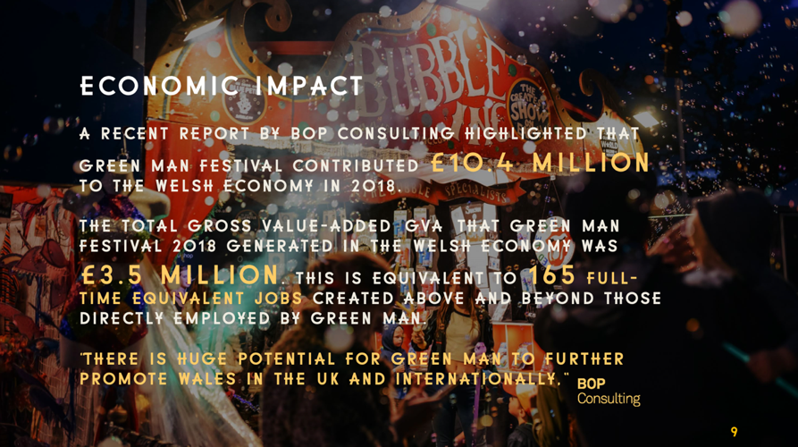
BOP Consulting (n.d., p.g. 9)
Appendix 2:
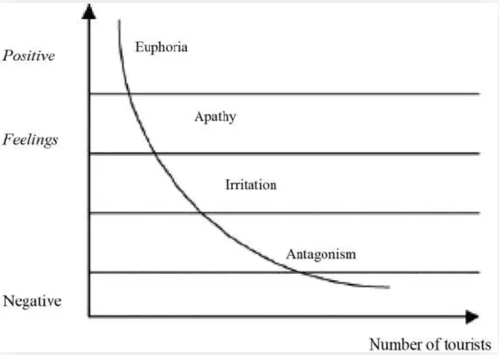
Doxey’s Irridex Model of Tourism (1975) Tourism Teacher (2022).
Appendix 3:
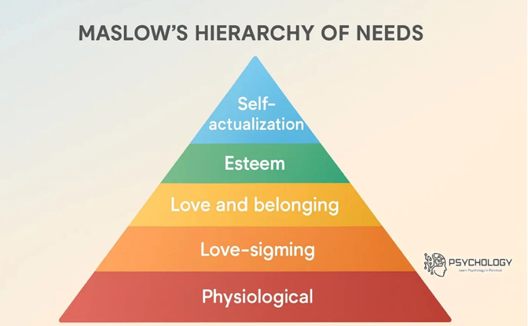
Shahzad (2023).

