Summer Gomes P150401
Provide an auditory scene analysis of a film/TV/animation/game scene of your choosing.
Creative Computer Games Design
Word Count- 2144
Lecturer- Robert Jones

This essay will look at two different media with similar scenes and sequences. One will be a movie-Resident Evil and the second will be the game- Resident Evil HD Remaster 2015. The essay will explore the auditory scenes between the two platforms and how they compare to one another. Are there many differences between the two and if so just how much of a change is there? Does watching the movie provide and different auditory experience compared to when a player is actually interacting with the game?
The Resident Evil franchise began with the games in 1996, long before the first movie was made, so it will be interesting to explore how the tone and atmosphere of the game is translated into a movie experience and just how much of an effect this had on sound and music within production.

Resident Evil HD Remaster was released in January 2015; the content was simply a visual remaster with the gameplay being the same as the original release. The Resident Evil remake game was released the same year as the first movie in 2002, this will make comparing the two media more effective because there is less of a time gap between the production of both of these. The genre of the game is, survival horror. It will be interesting to explore how sound is manipulated for an experience of this tone and atmosphere.
Resident Evil the movie was too released in the early months of 2002, it is branded as a “Action, Horror, sci-fi” (IMDB, Resident Evil 2002).
The essay will explore if the change or adjustment in genre has any effect of the auditory outcomes compared to the game itself, or whether it doesn’t change the content at all. Does the movie try to mimic the themes and atmosphere of the game through sound or does it take a different approach through the media of film?

The movie puts the viewer on a linear experience, therefore the audio is translated to the audience and listened to in a certain order from start to finish. There is no way for the viewer to change the arrangement of sounds being presented to them unless they physically manoeuvre through the story by adjusting the navigation slider. But this is not something people do when watching a movie as the plot will no longer make sense to them; they need to see the events in a certain order to gain understanding and context. This is one factor in which the sound designers have been able to have full control of audio within the scenes. The only control viewers have over sound manipulation is through volume control, but that still does not affect the auditory content itself, the content is still there just at different volume levels.
The movie process allows for the viewer to easily create an audio-visual between the information being fed to them. As viewing the movie is simply a passive process the viewer does not overthink how the container and the auditory information relate and just accept them as forming one single entity.

The game however allows the player to explore around the scene and gives them more freedom over events. Whilst there may be ambient sound throughout the experience the players actions bring about certain events and sound cues. This unique difference between the two media means that the player acts as a ‘composer’ of sorts, where their actions lead to certain audio outcomes. The audio-visual contract still applies to the player, but they are much more aware of the presence of cause and effect.

The first scene in the movie shows a science facility full of workers. Between 3:00mins-8:00mins there is already a lot of auditory information delivered to the audience. The action dramatically increases with the sounds cues, this indicates effective scene progression. The workers are going about their business and then a sudden change in audio cues and atmosphere indicates a change of pace is about to begin in the scene.
At 3:00 there is general background chatter and territorial noise, then a man is shown holding a drink, walking towards an elevator. He is then bumped by another man causing the drink to spill everywhere, the emphasis on the sound of the drink spilling sets the tone for the rest of the scene. It is loud and naturally unpleasant indicating that things are only about to get worse.
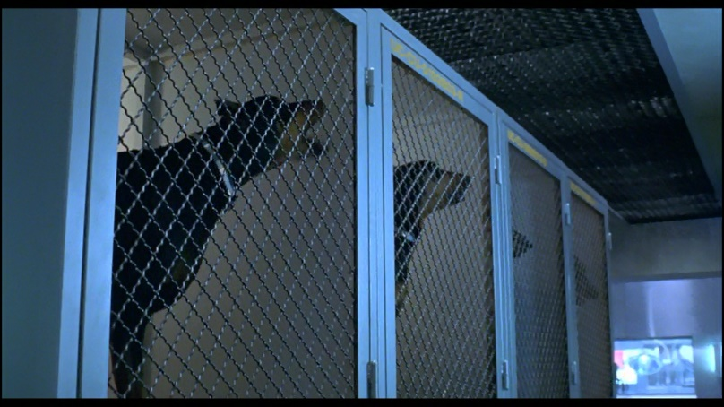
At 3:20 dogs are shown sniffing and begin barking at something ‘unseen’ as there is only a low hissing noise, this create a negative image where sound is present without a source, which creates mystery for the audience. At this point a sound track begins to play at a low volume. The music is fast and slightly erratic, giving the audience an indication that the pace of the scene is about to intensify.

At 3:45 the scene begins to introduce negative sounds belonging to what the audience would assume are cameras. This is an interesting way of showing the scene through a different perspective and utilising mechanical sounds to emphasise the ‘image or container’ that they may belong to. The sound design also utilises pitch, in this instance the pitch of the mechanical sounds is used to direct the audience as the ‘camera’ pans across a room and zooms in to an object low on the floor.
4:16 is the moment where the sprinklers go off, the sound is emphasised over character dialogue and other territorial sounds. This is just one example of how the sound production uses ‘added value’ to create a more effective and believable scene by sound infusing some images more than others. This focused the audience’s attention to where the director intends at that point.
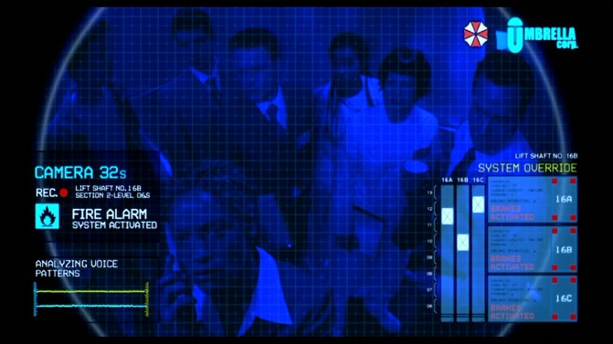
Around 4:30 is when the movie utilises character dialogue which enforces psychoacoustics, to create emotional underscoring within the scene. “Psychoacoustics is essentially the study of the perception of sound. This includes how we listen, our psychological responses, and the physiological impact of music and sound on the human nervous system.” (Joshua Leeds, cited in The Power of Sound)

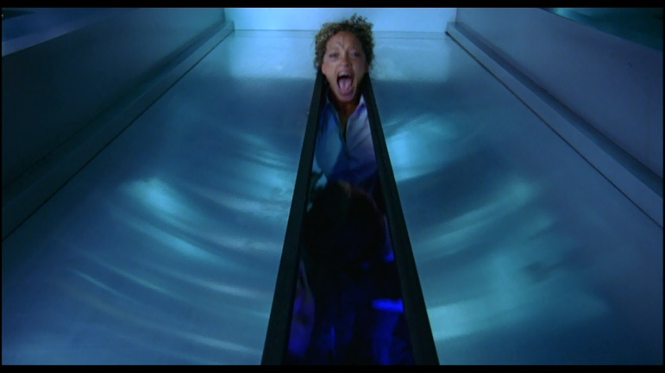
The use of people’s voices and dialogue between them causes the audience to connect and analyse what the characters are saying and feeling, the characters’ emotions are projected onto the audience through the sound and tone of the language that they are using. This human sound creates a connection and allows the audience to understand the pace and atmosphere of the scene. The music fades out after the first four minutes, leaving only low territorial sound and human dialogue for the rest of the scene. The sudden absence of sound doesn’t indicate a positive change in the scene but rather it adds tension, by leaving the audience waiting to see what will happen with the change.

The events that unfold at 8:00 show another great example of how sound production utilises pitch to add tension to the scene. As the elevator drops whilst the woman’s head is between the doors the pitch reduces an even volume, but as it suddenly moves again the pitch abruptly increases indication the ascension of the elevator. This dramatically increases tension and gives the audience an indication of what is about to happen net without visually contextualising the outcome.
Just the opening scene alone shows examples of different audio approaches and techniques that have been used to set the tone for the start of the movie. This auditory scene gives the audience a base line of what to expect throughout the progression of the movie and indicates that as action increases so will sound design and implementation.

Once the Game is loaded it begins with an opening cutscene. It starts with a lot of character dialogue explaining the outset of the game. This is then accompanied by some negative sound that suggests that the character is travelling in a helicopter. Although this helicopter audio is loud and clear, the dialogue automatically takes dominance as it is the most relatable and recognizable sound to the player. As the scene continues, more sounds are introduced to further contextualise the events that the character is explaining. These sounds however, don’t act as a distraction, the players attention remains on the character’s voice. This can be explained by the ‘Cocktail Party Effect’.
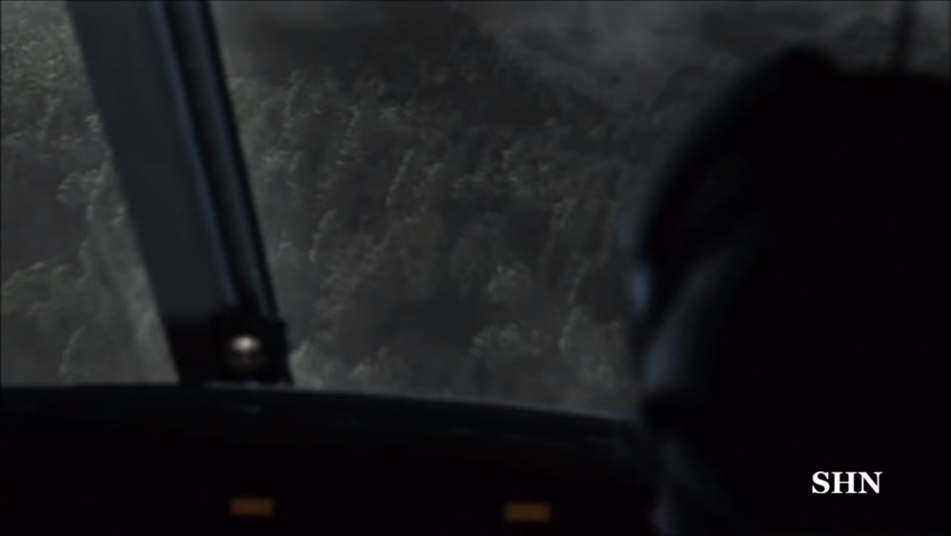

This is a theory explaining the “ability the human brain has to locate a single specific sound source within a sound environment with multiple sources/noises”. (Dr Jeremy Dean, cited in PSYBLOG, The Cocktail Party Effect)
The scene ends with a fast-paced music track as the action reaches a climax and then cuts to a black screen with no sound. This gives the player a break from the energy and auditory information that has already been fed to them.
When gameplay begins, a tense soundtrack starts being played as the player navigates the rooms of the mansion. The only territorial sound being produced comes from a large grandfather clock that has a constant rhythmic ticking; this indicates a time factor for the player as this is not a passive experience but an interactive one. The character’s movements are synchronised well with the ‘footstep’ audio, creating a believable experience for the player.
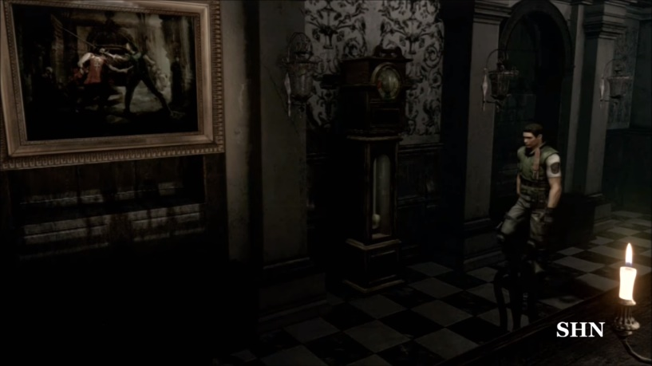

As the player continues to progress through the initial rooms, it is clear that the ‘soundtrack’ playing in the background is actually a ‘thematic hook’ that is being utilised to create and build tension during game navigation. The use of this thematic hook is very valuable in the games sound production as it can be continuously used throughout the duration of the game to keep the base tone constant. Unlike the movie, this hook is played throughout almost the entire game.
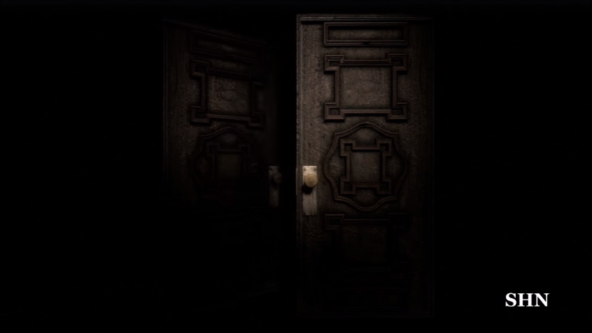
Entering new locations is transitioned through cutscenes of a simple door opening and closing. The thematic hook continues to play in most of these transitions which helps to not disturb player immersion. The visuals are also accompanied by synchronised sounds, that make the door animation seem more natural; this helps solidify the audio-visual contract. The player does not question that the audio and image are a single entity.

A cutscene is then used to introduce the player to a new enemy; the hook is stopped momentarily before the cutscene begins, creating a pause in the atmospheric sound and halt immersion if only for a moment. This malfunction in sound production is something that the player can utilise to identify key moments in gameplay. When this interruption in the soundscape occurs, the player knows that it is probably wise to act rather than wait for a result.
The player can react to sound cues and act accordingly, this is something that differs massively from the passive movie experience.
Sound production within gameplay is quite simple as this not as important as it would be in a movie.
The games inventory system allows the player to access their characters belongings, navigating the system is accompanied by swiping and clicking sound effects. These are also used when the player is interacting with certain objects in the environment. As for character sound only the footsteps and interaction with objects is audible. Enemy sounds are simple with general grunts and growls being used to indicate that an enemy is nearby.
When the player comes across certain objects this is sometimes indicated by subtle territorial sounds that are easily overlooked if the player isn’t paying close attention. And basic ambient noise such as thunder and rain is implemented through the different stages of gameplay. The use of weapons generates their own individual sounds, but these are simple sound samples that are duplicated when in use.

Although sound was implemented using different method and approaches between the two media, the key similarity is that the soundscapes both had dark foreboding undertones. The movie’s soundscape was subtler whilst the game used a more direct approaching in translating events and changes in the pace. This may be due to the fact that throughout movie production sound would have been considered and utilised throughout the entire process whereas with game creation, this would only have been an afterthought as functionality would have been the main concern in production.
Movies create a passive experience for the viewer, they just listen to the sounds presented to them the way that the director/ sound production team intended. Whereas in gameplay players learn and adapt according to the sound information given to them, making them more alert. This leads to them avoiding certain actions because they become aware of the consequences and how they are connected to audio cues. Movies allow the viewer to appreciate the way sound is produced as an artform and means the sound can be translated exactly as intended. Gameplay allows the player to have a bit more control of the audio elements within the game, player action cause an equal effect so without this the soundscape can only develop so far; this gives the player a secondary role of ‘composer’.

References
Online Sources
SHN Survival Horror Network. [Online Video]
(2014). Resident Evil HD Remaster ★★★★★ Horror Game 1080p Video Walkthrough Longplay No Commentary.
14 December 2014.
Available from: https://www.youtube.com/watch?v=2_dn-L9hPLM.
[Accessed: 6 December 2017].

IMDB. 2002. Resident Evil (2002). [Online]
Available at: http://www.imdb.com/title/tt0120804/. [Accessed 6 December 2017].

The Power of Sound. 2010. Psychoacoustics, defined. [Online]
Available from: http://thepowerofsound.net/psychoacoustics-defined/
[Accessed 6 December 2017].

The Cocktail Party Effect. [Online]
Dr Jeremy Dean
Published, March 12, 2009.
Available at: http://www.spring.org.uk/2009/03/the-cocktail-party-effect.php
[Accessed 6 December 2017].

DVD Sources
Resident Evil, 2002. [DVD]
[DVD] Paul W. S. Anderson,
England: Constantin Film.
[Accessed: 6 December 2017].

