Module: Data Handling and Business Intelligence
Data Analysis and Visualisation:
Student’s Name: Petya Petrova Zlatkova
Student ID: 2028785

Table of Contents
Introduction 3
Part 1: Analysis of Superstore data using Microsoft Excel 3
Pivot Tables 3
Using SUMIFS FUNCTION 6
Data visualisation 8
Part 2: Data analysis using SPSS 11
Quick Cluster 15
Relationship between the three flavors with video game scores (video), puzzle scores (puzzle) and gender. 17
Most common data mining and text mining methods 18
Advantages and disadvantage of using SPSS and Excel 19
Conclusion 20
References 21

Introduction
Data analysis is the process of organising and structuring gathered data. It aims at transforming into a meaningful form or knowledge that can be utilized by teams when making decisions (Wickham, 2016). Systematic approaches are used in analysis to seek for patterns, clusters, or other connections among various types of data. The practice of presenting data in a chart, graph, or other visual format to support analysis and understanding is known as data visualisation. Data visualisations make the examined data engaging and accessible to a variety of stakeholders. In order to address the demands of important stakeholders, data visualizations are frequently employed to convey actual outcomes. For data utilization and to comprehend the bigger change process, several visualizations will probably be required. As such, this report employs PivotTables and SUMIFS functions in the Excel software to carry out required data analysis and further provides visualisation of the data using graphs and charts. The usage of SPSS data mining software to analyse data has also been demonstrated herein.

Part 1: Analysis of Superstore data using Microsoft Excel
PivotTables and SUMIFS have been used in this section to demonstrate how excel functions can be used to analyse data.

Pivot Tables
It is often essential and significant to do data analysis on a huge quantity of data. The data must be summarized, the necessary values must be obtained, and the findings must be presented (Zhou, 2022). Excel's PivotTable feature enables analysts to rapidly and simply summarize hundreds of data variables in order to provide the desired results. The pivot table function has been utilised in this section to determine the decline in sales over years using the superstore sales data set provided. From this data, the total sales for each year have been summarised by creating a pivotable that dynamically modifies to summarize the results as intended.
Creating the PivotTable
When creating the pivot table, it was ensured that the first row has headers. Upon opening the excel sheet, the INSERT tab on the tab was selected. A group of tables was displayed and PivotTable was selected. The PivotTable dialog box appeared in which the source name of the current workbook was entered. A new worksheet where the PivotTable report would be placed was chosen.
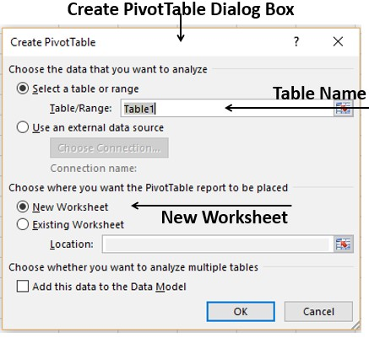
Upon clicking “ok” a blank PivotTable and a PivotTable fields list appeared.
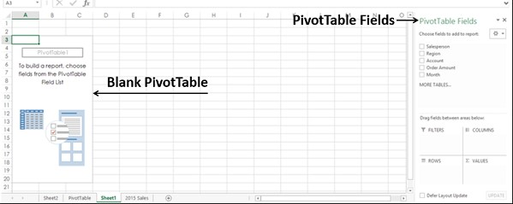
Recommended PivotTables
Recommended PivotTables are good in presenting data in different formats and gives the analyst several options from which they can choose the most preferred format. To access the recommended PivotTables, the data table was highlighted, then the INSERT tab was selected upon which a group of tables were displayed.
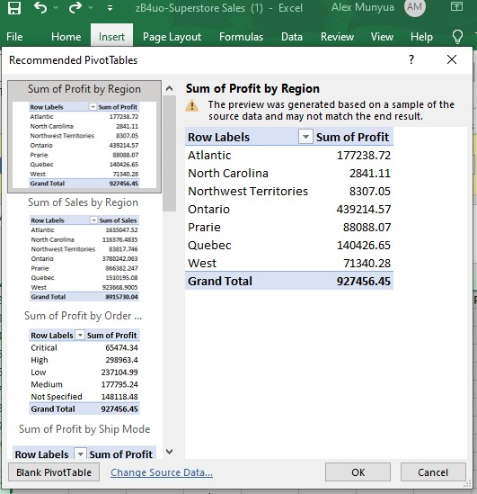
Since the question required comparison of either profits or sales over the years, the PivotTable that displayed relevant data was selected. However, the selected customised PivotTable displayed unnecessary elements and therefore there was need to further customise it further in the PivotTable Fields to display just total sales, total profits and in the years provided.
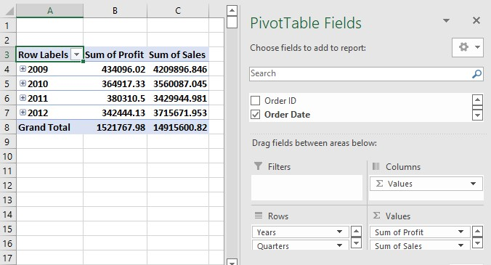
Fig 4
From the private area, the fields to be displayed as rows as well as columns were selected and the PivotTable was updated as illustrated in the fig4 above. The decline of both the sales and the profits was computed by subtracting the sales of the later year from the preceding year across all the years as illustrated in fig5 below.
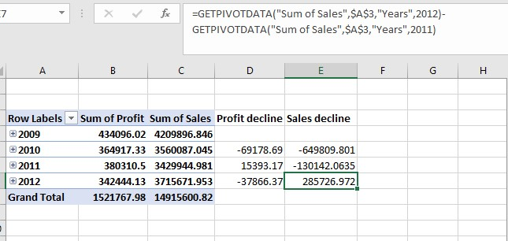
Fig 5
From Fig 5 above, the total sales declined between the year 2009 and 2010 by a margin of 649809.801. The sales further declined in preceding year 2011 by 130142.0635. However, the sales for 2012 increased by 285726.972 in comparison to the total sales of 2011. The same procedure was applied for profits. Between the years 2009 and 2010, the profits declined by 69178.69 while between years 2012 and 2011 the profits increased by 15393.17. Between years 2011 and 2012, the profits again declined by 37866.37.

Using SUMIFS FUNCTION
SUMIFS is a function that adds up cells that satisfy many requirements. When related cells match requirements based on dates, figures, and text, SUMIFS can be used to total data (Finau and Prasad, 2015). For partial matching, SUMIFS supports wildcards (*,?) and logical operators (>,,>,=). Using provided criteria, the SUMIFS function adds up the cells in a range. SUMIFS, in contrast to the SUMIF function, can combine several sets of criteria with multiple ranges. It is necessary to sum the first set of ranges. Only the first pair of the criteria—which are provided in pairs—is necessary. Give us other range/criteria pair to apply extra criteria. The number of range/criteria pairs is limited to 127.SUMIFS, divide logical criteria into two pieces (range + criteria). Because SUMIFS requires a cell range for range parameters instead of an array, the syntax for creating criteria is different. For example, in order to be able to effectively compare the sales decline for the superstore sales data provided in the case study using SUMIFS function, at least two criteria would be used. The criteria would involve specification of the sales variables and the year in which the sales were made. However, the sales have been arranged in dates, months and year in the order which they were made and therefore this would necessitate creation of ‘years column’. Upon entering a new column adjacent to the dates of sales, the years are written by entering (=text, date provided, “yyy”) and the year appears. 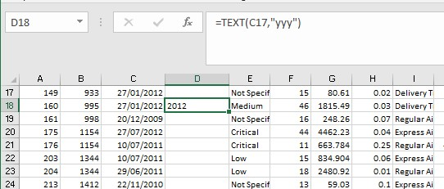
The rest of the ‘years column’ can be filled up by drugging down the cursor after which the respective years appear automatically.
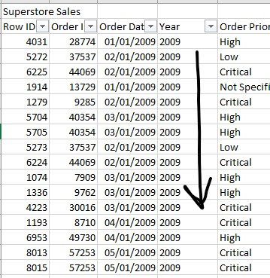
Upon inserting the years column, the SUMIFS function can be successfully applied to determine the total sales of each provided years as illustrated in the screenshot below.
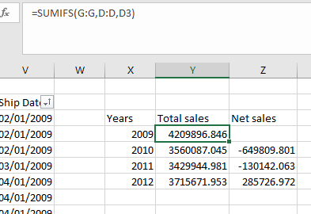
In the function displayed in the screenshot (=SUMIFS (G: G, D:D, D3), G: G represents the first criteria which is column of sales, D:D represents the second criteria which is the year column and D3 specifies the particular year in which sales are being summed. The same procedure is repeated for all the four years to get the total sales made in each year separately. Net sales are obtained by subtracting the sales made in the previous from the total sales made in the ensuing year. The negative sign in the net sales values indicates a decline in sales meaning there was a decline in sales between the year 2009/2010 as well as 2010/2011 while there was a sales increment between the years 2011/2012.

Data visualisation
Data visualization is the process of displaying data using popular images like infographics, charts, and even animations (Waskom, 2021). These clear visual representations of information convey intricate data relationships and data-driven insights. The information or observation made during data analysis can further be presented in visual representations such as graphs, bar chats or pie frequency tables intentionally to enable a more convenient data interpretation.
Bar chart
In Excel, data analysis reports may be shown in a variety of ways. Audience can easily understand what one want to project in the data, though, if the data analysis findings can be shown as charts that emphasize the important points in the data. It positively influences the presentational manner as well. Any set of data may be graphically represented in Excel using charts (Pandey et al, 2014). Clustered column chart has been used herein t represent decline in both profits and sales for the provided superstore data.

Line graphs
Line graphs are helpful in that they clearly display data factors and patterns and may aid in forecasting the outcomes of yet-to-be-recorded data. A line graph has been used herein to visualize the decline of both the sales and the profits of Superstore between the years 2009 and 2012.

From the line graph displayed in the screenshot above, it is visible that the sales trend sharply declined between 2009 and 2010 as indicated by the change in steepness of the gradient. However, the rate of declining reduced between 2010 and 2011. The change of gradient direction between 2011 and 2012 indicates that sales increased.
Pie Chart
A pie chart is a visual representation of data that allows viewers to see the connections between a variable's component portions and its overall pattern (Masoodian et al, 2013).

The percentages displayed in each segment of the pie chart represents the portion that the sales of each year contribute to the total sales made between 2009 and 2012. For example, the sales made in 2009 represents 28% of the total sales made in the four years. In 2010, the sales dropped to 24% and further to 23% in 2011. In 2012, the sales increased by a small percentage to 25%.

Part 2: Data analysis using SPSS
The data being analysed in this section relates to a survey conducted on some 200 high school students with an intention to examine their respective scores on various tests including video game and puzzle. The student's preferred ice cream flavour, such as vanilla, chocolate, or strawberry, will serve as the outcome variable in this research. From there, the correlations between gender, video game and puzzle scores, and ice cream flavour preferences have been examined using SPSS.

Frequencies

Statistics
 |  | female | ice-cream | video | puzzle
N | Valid | 200 | 200 | 200 | 200
N | Missing | 0 | 0 | 0 | 0

Study population
 |  | Frequency | Percent | Valid Percent | Cumulative Percent
Valid | 0 | 91 | 45.5 | 45.5 | 45.5
Valid | 1 | 109 | 54.5 | 54.5 | 100.0
Valid | Total | 200 | 100.0 | 100.0

From the total number of study population, 91 were male and 109 were females
ice_cream
 |  | Frequency | Percent | Valid Percent | Cumulative Percent
Valid | 1 | 95 | 47.5 | 47.5 | 47.5
Valid | 2 | 47 | 23.5 | 23.5 | 71.0
Valid | 3 | 58 | 29.0 | 29.0 | 100.0
Valid | Total | 200 | 100.0 | 100.0

95 students which represents 47.5% of the total students preferred vanilla flavored ice-cream, 47 students, 23.5%, preferred chocolate flavor and 58 students, 29%, preferred strawberry flavored ice cream.
a. Calculated from grouped data.
Mean and Median of participants who like chocolate and strawberry flavor

Statistics
ice_cream
N | Valid | 200
N | Missing | 0
Mean |  | 1.82
Median |  | 1.74ª

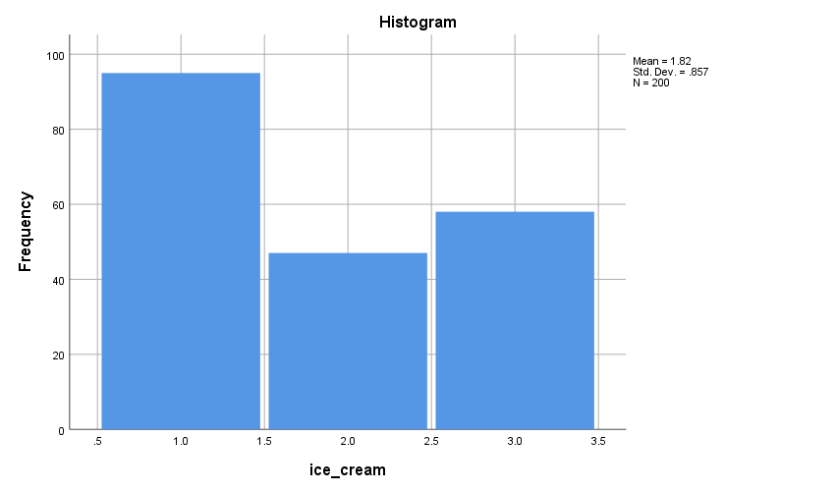

video
 |  | Frequency | Percent | Valid Percent | Cumulative Percent
Valid | 26 | 1 | .5 | .5 | .5
Valid | 29 | 1 | .5 | .5 | 1.0
Valid | 31 | 2 | 1.0 | 1.0 | 2.0
Valid | 33 | 2 | 1.0 | 1.0 | 3.0
Valid | 34 | 5 | 2.5 | 2.5 | 5.5
Valid | 35 | 1 | .5 | .5 | 6.0
Valid | 36 | 4 | 2.0 | 2.0 | 8.0
Valid | 39 | 13 | 6.5 | 6.5 | 14.5
Valid | 40 | 2 | 1.0 | 1.0 | 15.5
Valid | 42 | 12 | 6.0 | 6.0 | 21.5
Valid | 44 | 11 | 5.5 | 5.5 | 27.0
Valid | 45 | 1 | .5 | .5 | 27.5
Valid | 46 | 1 | .5 | .5 | 28.0
Valid | 47 | 11 | 5.5 | 5.5 | 33.5
Valid | 48 | 2 | 1.0 | 1.0 | 34.5
Valid | 49 | 2 | 1.0 | 1.0 | 35.5
Valid | 50 | 21 | 10.5 | 10.5 | 46.0
Valid | 51 | 2 | 1.0 | 1.0 | 47.0
Valid | 53 | 15 | 7.5 | 7.5 | 54.5
Valid | 54 | 3 | 1.5 | 1.5 | 56.0
Valid | 55 | 18 | 9.0 | 9.0 | 65.0
Valid | 56 | 2 | 1.0 | 1.0 | 66.0
Valid | 57 | 1 | .5 | .5 | 66.5
Valid | 58 | 19 | 9.5 | 9.5 | 76.0
Valid | 59 | 1 | .5 | .5 | 76.5
Valid | 61 | 14 | 7.0 | 7.0 | 83.5
Valid | 63 | 12 | 6.0 | 6.0 | 89.5
Valid | 64 | 1 | .5 | .5 | 90.0
Valid | 65 | 1 | .5 | .5 | 90.5
Valid | 66 | 9 | 4.5 | 4.5 | 95.0
Valid | 67 | 1 | .5 | .5 | 95.5
Valid | 69 | 6 | 3.0 | 3.0 | 98.5
Valid | 72 | 2 | 1.0 | 1.0 | 99.5
Valid | 74 | 1 | .5 | .5 | 100.0
Valid | Total | 200 | 100.0 | 100.0
The statistics of the video scores attained by the students have been tallied in this statistics table. For example, only one student (0.5% 0f the total students) scored 26 in the video game while 19 students (9.5%) scored 58.
puzzle
 |  | Frequency | Percent | Valid Percent | Cumulative Percent
Valid | 26 | 3 | 1.5 | 1.5 | 1.5
Valid | 31 | 8 | 4.0 | 4.0 | 5.5
Valid | 32 | 1 | .5 | .5 | 6.0
Valid | 33 | 1 | .5 | .5 | 6.5
Valid | 36 | 8 | 4.0 | 4.0 | 10.5
Valid | 37 | 1 | .5 | .5 | 11.0
Valid | 39 | 1 | .5 | .5 | 11.5
Valid | 41 | 19 | 9.5 | 9.5 | 21.0
Valid | 42 | 1 | .5 | .5 | 21.5
Valid | 43 | 1 | .5 | .5 | 22.0
Valid | 44 | 1 | .5 | .5 | 22.5
Valid | 46 | 21 | 10.5 | 10.5 | 33.0
Valid | 47 | 1 | .5 | .5 | 33.5
Valid | 48 | 1 | .5 | .5 | 34.0
Valid | 51 | 31 | 15.5 | 15.5 | 49.5
Valid | 52 | 2 | 1.0 | 1.0 | 50.5
Valid | 56 | 32 | 16.0 | 16.0 | 66.5
Valid | 57 | 1 | .5 | .5 | 67.0
Valid | 58 | 1 | .5 | .5 | 67.5
Valid | 61 | 33 | 16.5 | 16.5 | 84.0
Valid | 66 | 24 | 12.0 | 12.0 | 96.0
Valid | 71 | 8 | 4.0 | 4.0 | 100.0
Valid | Total | 200 | 100.0 | 100.0
This table displays the statistics of how many students scored what marks in the puzzle games. For example, 31 students (15.5% of the total students) got a score of 51 while 33 students (16.5%) got a score 61.

Quick Cluster

Initial Cluster Centers
 | Cluster
 | 1 | 2
female | 1 | 0
ice_cream | 2 | 1
video | 29 | 74
puzzle | 26 | 66

Iteration Historyª
Iteration | Change in Cluster Centers
Iteration | 1 | 2
1 | 21.992 | 18.403
2 | .740 | .632
3 | 1.084 | .969
4 | .215 | .219
5 | .285 | .263
6 | .000 | .000
a. Convergence achieved due to no or small change in cluster centers. The maximum absolute coordinate change for any center is .000. The current iteration is 6. The minimum distance between initial centers is 60.225.

Final Cluster Centers
 | Cluster
 | 1 | 2
female | 1 | 1
ice_cream | 2 | 2
video | 45 | 58
puzzle | 44 | 60
a. Convergence achieved due to no or small change in cluster centers. The maximum absolute coordinate change for any center is .000. The current iteration is 6. The minimum distance between initial centers is 60.225.

ANOVA
 | Cluster |  | Error |  | F | Sig.
 | Mean Square | df | Mean Square | df | F | Sig.
female | .030 | 1 | .250 | 198 | .120 | .729
ice_cream | 3.095 | 1 | .723 | 198 | 4.284 | .040
video | 8700.783 | 1 | 54.579 | 198 | 159.415 | .000
puzzle | 12815.244 | 1 | 51.116 | 198 | 250.709 | .000
The F tests should be used only for descriptive purposes because the clusters have been chosen to maximize the differences among cases in different clusters. The observed significance levels are not corrected for this and thus cannot be interpreted as tests of the hypothesis that the cluster means are equal.

Relationship between the three flavors with video game scores (video), puzzle scores (puzzle) and gender.
The correlation between the relevant variables have been done using Pearson Correlation whose results have been displayed in the correlation metrics below.
Correlations
Correlations
 |  | Gender | ice-cream | puzzle | video
female | Pearson Correlation | 1 | .014 | .052 | -.128
female | Sig. (2-tailed) |  | .847 | .461 | .071
female | N | 200 | 200 | 200 | 200
ice-cream | Pearson Correlation | .014 | 1 | .169* | .132
ice-cream | Sig. (2-tailed) | .847 |  | .017 | .063
ice-cream | N | 200 | 200 | 200 | 200
puzzle | Pearson Correlation | .052 | .169* | 1 | .465**
puzzle | Sig. (2-tailed) | .461 | .017 |  | .000
puzzle | N | 200 | 200 | 200 | 200
video | Pearson Correlation | -.128 | .132 | .465** | 1
video | Sig. (2-tailed) | .071 | .063 | .000
video | N | 200 | 200 | 200 | 200
*. Correlation is significant at the 0.05 level (2-tailed).
**. Correlation is significant at the 0.01 level (2-tailed).
This correlation metrics shows the correlation coefficient for every combination of variables. There are four rows and four columns all labelled to their respective variables. Where each row and column intersect gives the correlation coefficient between those two variables. It is important to note that every variable always correlate with itself at a +1, no matter the variable and therefore they are not of much significance. The correlation between different variables is given at the off diagonals and is always between +1 and -1 and below that is the significance level (labelled: Sig. (2-tailed)). Significance levels smaller than 0.5 are statistically significant. Below that is the sample size labelled N which for this analysis is 200. A positive correlation coefficient indicates direct relation between variables while a negative value indicates an inverse relationship. A correlation of 0 indicates no relationship between the variables being examined.

The correlation coefficient (r) between gender and ice cream flavor was found to be negligibly low positive and statistically insignificant at the 0.01 level (r=0.014, p=.847>0.5) meaning there is hardly much relationship between gender and their ice cream flavor preference. Similarly, gender and puzzle score have a markedly low positive correlation which is statistically significant at the 0.01 level (r=0.052, p=0.461<0.5) indicating that the gender of a respondent had a relationship on their puzzle score. The Pearson correlation coefficient between gender and video scores was found to be very low negative but there was strong evidence of significant relationship (r= -0.128, p=0.071<0.5) meaning that even if the relationship was inverse there existed a strong relationship between the two variables. There was found to be a very low positive correlation between ice cream and puzzle which was sufficiently significant (r=0.169, p=0.017<0.5) meaning there existed strong evidence that there was a relationship between the ice cream flavor preference of participants and their puzzle scores just as there was in video scores (r=1.32, p=0.063<0.5). Finally, the correlation coefficient and significant value of the relationship between puzzle scores and video scores were r=0.465 and p=000<0.5 meaning that there was a moderately strong direct relationship between puzzle scores and video scores which was evidently significant.

Most common data mining and text mining methods
Clustering: Clustering is the process of classifying a range of different data items according to their properties. This enables data miners to easily segment the data into subgroups, enabling better informed choices on the basis of general demographics (such as consumers or users) and their related behaviors. Example: clustering makes it easier for firms to handle their data. Retailers may use clustering models, for instance, to identify which consumers buy specific items, on which days, and how frequently. This can help merchants focus products and services to clients in a given demographic or location.
Association: It is a technique used by data miners to find unusual or intriguing correlations between variables in databases. Association is frequently used by businesses to decide their marketing research and strategy. Example: Doctors utilize association to more accurately diagnose a wide range of illnesses and ailments, and the government uses it to analyze census data and prepare for public services.
Data visualisation: Charts, graphs, maps, diagrams, and other visual representations of data can be used to convey insightful information. Example: Business managements leverage data visualisation to make data easily understandable not just to executives but to clients and customers too.

Advantages and disadvantage of using SPSS and Excel
 | Advantages | Disadvantages
Excel | - Can be used to do calculations, evaluation and visualisation of data  - Can be used to create equations for enabling provision of business functions like workflow, financial projections, inventory usage et cetera.  - Can be used to create dataset that is easy to read for usage by executives and managements to analyse projects or situations in a business. | - Excel can result to inaccuracies especially in financial analysis. Complex financial models that are designed to import data from a external sources are prone to human, programming or even capacity errors that can lead to erroneous results.  - Since excel is two-dimensional, it limits user’s ability to incorporate diverse variables simultaneously.
SPSS | - SPSS provides a quick-visual modeling environment from the simplest to the most sophisticated models.  - Enables market researchers to understand business related data, analyse trends, make forecasting, plan and make smart decisions.  - SPSS ability to focus on patterns can be utilised by education institutions to forecast chances of student’s future success. | - Cannot be used to analyse a big data set therefore not preferrable for businesses with huge trove of data  - It gives simple answers for complex issues making the software solely unreliable.

Conclusion
The main goal of having data is to evaluate it and draw conclusions from it. Some of the most effective tools for data analysis may be found in both SPSS and Excel. Excel offers a variety of tools for making charts and presenting data visually. With just one click, one may insert any of the key kinds of charts they would need to utilize to illustrate their data. Users can locate all the charts they may insert by going to the Charts group on the Insert Tab. Additionally, Microsoft Excel has an option called "recommended charts" that one may use to have it suggest the best chart to use for the data in particular worksheet. Similarly, SPSS provides a quick-visual modeling environment from the simplest to the most sophisticated models. Surveys, data mining, market research, and other activities all utilize the SPSS data.

References
Finau, G. and Prasad, A. (2015). Excel's Sumif and Sumifs function. The Fiji Accountant, 2015(May), pp.33-33.
Masoodian, M., Endrass, B., Bühling, R., Ermolin, P. and André, E. (2013), July. Time-pie visualization: Providing contextual information for energy consumption data. In 2013 17th International Conference on Information Visualisation (pp. 102-107). IEEE.
Pandey, A.V., Manivannan, A., Nov, O., Satterthwaite, M. and Bertini, E. (2014). The persuasive power of data visualization. IEEE transactions on visualization and computer graphics, 20(12), pp.2211-2220.
Sadiku, M., Shadare, A.E., Musa, S.M., Akujuobi, C.M. and Perry, R. (2016). Data visualization. International Journal of Engineering Research And Advanced Technology (IJERAT), 2(12), pp.11-16.
Waskom, M.L. (2021). Seaborn: statistical data visualization. Journal of Open-Source Software, 6(60), p.3021.
Wickham, H. (2016). Data analysis. In ggplot2 (pp. 189-201). Springer, Cham.
Zhou, H. (2022). PivotTable Data Analysis. In Mastering Excel Through Projects (pp. 169-201). Apress, Berkeley, CA.

