BA (Hons) Leadership and Management Skills for the Workplace

Module Code: BMSW 5101
Module Title: Developing Workplace Critical Thinking

Assignment On
How Individuals’ Beliefs, Attitudes and Values Impact on Workplace Behavior

Student Name: Shiraz Ahmed khan
Student ID: 2008513
Module code: BMSW 5101
Lecturer: Uwaoma Ochonogor

Table of Contents
Introduction 2
Transactional Management Theory 2
Background of Transactional Management Theory 6
The Usefulness of Transactional Management Theory at the Workplace 7
Toulmin’s Three Component Model for Effective Argument 7
Critical Reflection 10
Kolb’s Reflective Model 10
Conclusion 11
References 13

Management theories are different schools of thought propounded by researchers, philosophers, and cognitive experts to put into words what goes into the making of a leader or a manager (Antonakis, et al., 2014). School of thoughts is a technique that records diversified thoughts without regarding logical arguments. Management theories are a collection or set of ideas recommending general regulations of managing a business or a company (Morrison, 2018). There are numerous management theories, but they are not one-size-fits-all solution. Hence, different businesses adopt different theories based on their organizational cultures.

Introduction
Management theories shed light on the behaviors or traits that can facilitate the process of cultivating managerial abilities or skills (Morrison, 2018). Among these theories, Transactional Management Theory is one of the oft-used ones in business. This theory is where the manager relies on rewards or punishments to get the optimal job performance from the subordinates. The proponents maintain a role of supervision, organization, teamwork to motivate members of the workforce (Grover and Malhotra, 2013). The principle of this theory is workers can’t be self-motivated, and require a well-stated structure, instructions, and constant monitoring to get the job done. And the managers must provide employees with something in exchange for the work done. Though this theory creates fast results, it also creates lack of creativity and morality among the workers. In this report, analysis and critical evaluation would be carried out to understand the theory and its usefulness in the modern-day workplace by using Toulmin model of critical thinking. After doing a thorough research, I argue for its usefulness in the today’s workplace.

Transactional Management Theory

Each form of management entails some ways to motivate employees. Transactional management involves directing and motivating employees through appealing to their self-interest. For this theory, motivation is primarily derived from an arrangement where workers are rewarded for accomplishing goals set for them or they are reprimanded if they fail to meet deadlines (Odumeru and Ogbonna, 2013).This form of management follows a structured approach depending on rigorous checks and balances throughout an organization’s product lifecycle.
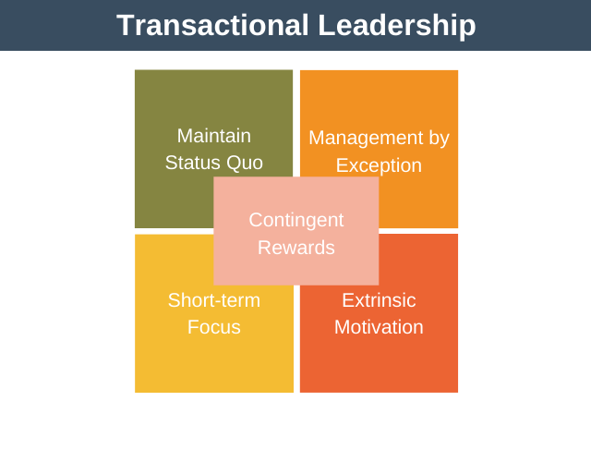
Figure 1: Transactional Leadership Model
Source: Expert Program Management, (2020)

A transactional leader values orders or structures and their sense of power comes from their formal authority and responsibility given by the organization (Laohavichien, et al., 2019). They give commands and manage an organization with sets of rules and regulations in order to meet deadlines or attain objectives on time in an organized way. The main characteristics of transactional leaders are- they are focused on short-term stretch goals, are reactive, favor hierarchy, are practical, can micromanage, lack personal connection, thrive on following rules and regulations, are very left-brained, inflexible, put an emphasis on efficiency, and are opposed to change or inflexible. The transactional managers follow a structure to motivate subordinates through a system of rewards and punishment (Tyssen, et al., 2014). If an employee does an attributed task properly on time, a reward will follow. On the contrary, if a worker does not go as per the wishes of the manager, a punishment will follow.

On the contrary, the subordinates in this model are not self-motivated. An employee following a transactional leader is given a short-term or long-term goal and is expected to work toward it under the supervision of the manager. While doing so, they are expected to adhere to the strict rules or guidelines set by the organization. The main goal of the employee is to obey the manager’s instructions (McCleskey, 2014). This style is also called a ‘telling style.’ They are closely monitored and controlled by their manager to get the work done.

In this model, an exchange takes place between managers and subordinates to attain routine performance goals (Hoover, 2017). These exchanges work in 4 distinct dimensions.

Contingent Rewards: Transactional managers set a mutually agreed upon SMART goal (Specific, Measurable, Achievable, Relevant, Time-Bound) for subordinates, link the goal to rewards, clarify what is required and expected, provide with necessary resources.

Active Management by Exception: The transactional managers actively monitor the task done by their subordinates, check whether there is any deviation from the rules and structures set previously, and take corrective measures to prevent mistakes.

Passive Management by Exception: Transactional managers get involved only if the subordinate can not meet the standards, or when the work done is not as per the requirements. In this model, managers have the authority to punish subordinates for unacceptable performance.

Laissez-faire: Transactional managers provide subordinates with opportunities to make decisions. The team often lacks proper directions as the manager abdicates responsibilities and doesn’t take part in making necessary decisions for the team.
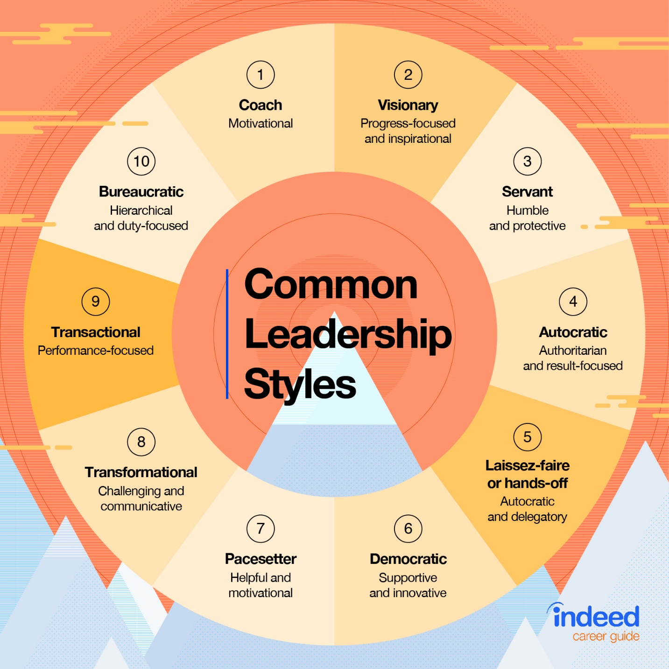
Figure 2: 10 Common Leadership Styles
Source: Indeed, (2021)

The transactional management model is not necessarily the best fit for all types of organizations. The model doesn’t work well for places where creative and innovative ideas are valued. Though this is not at all appropriate for an open structured creative environment, it works well in workplaces thriving on structural rules or guidelines. It is not true, that employees are not given autonomy here. They are allowed a certain degree of autonomy and flexibility within the confines of organizational policies. Transactional leaders build their organization on the foundation of rules, structures, and regulations. Employees who are capable of excelling in a structured environment relying on consistent company policies can be highly motivated and encouraged to work under transactional managers and realize company goals.

However, the approach can vary depending on the organizational culture. But in a proper environment, this model can lead to exceptional motivation and outstanding results for the company.

There are numerous advantages and disadvantages of transactional management. Advantages are employees get rewarded when they are motivated by self-interest to follow orders, structures, and instructions. The model provides a well-defined structure, rewards, and penalties for organizations (Munaf, 2017). It helps achieve short-term scratch goals efficiently. On the contrary, the cons are it limits creativity, doesn’t reward personal initiative, and rewards on a practical level only.

Background of Transactional Management Theory

In the transactional management model, a sort of exchange takes place where leaders give followers something they want in exchange for something they want. This model is only applicable when employees are not self-motivated and require a well-built structure, necessary instructions, and thorough monitoring to complete their works efficiently.

The transactional theory of management was first introduced by 20th-century German sociologist Max Weber and later explored by Bernard M. Bass in the early 1980s. Max Weber did a substantial study of leadership styles and divided them into 3 distinct categories: traditional, charismatic and rational-legal, or bureaucratic (Kidney, 2015).

Weber is the one to introduce the Transactional Management Theory, as rational-legal leadership. He defined it as "the exercise of control on the basis of knowledge."

This form of management was widely accepted in the USA after World War II, as the government focused on rebuilding. This process required a well-planned structure for ensuring national stability.

James McGregor Burns, a political scientist, was one of the most prominent authors who further worked with Weber’s theories. He stated transactional managers must have purpose and a high sense of moral including honesty, fairness, honoring commitments, responsibility, and many more. After him, Jane Howell and Bruce Avolio defined and developed the dimensions of transactional management theories during the 1980s to 1990s (Bono and Judge, 2014).

The Usefulness of Transactional Management Theory at the Workplace

The type of workplace that values transactional management over any other form of management includes well-established organizations. The company whose operations require little to no ongoing changes or the company with fixed operations that is performed in a specific manner prefers this form of management (Lai, 2013). This style is basically used by organizations that recognize performance by basic or monetary rewards. One of the most common parts of the workplaces that prefer this form of management is the sales team.

The usefulness of transactional theory in the workplace can be further explained by Toulmin’s three component model for effective argument to generate critical thinking.

Toulmin’s Three Component Model for Effective Argument

Evidence
Transactional Management Theory is a common form of leadership used in different organizations to maintain a specific structure. This is often applicable in a rigid work environment, where creativity is not preferred (Avolio, et al., 2019). The people involved in this style of leadership are managers or leaders and subordinates. It is mostly applicable where employees don’t speak the same language. Because it is hard to complete tasks in such environments if there is no structure or requirements clearly stated. The rules and regulations of transactional management don’t require any form of training and are very simple to learn. This is also very easy to apply in any situation, especially crisis situations, where employees know what to do under pressure. To those people, who value money and perks, and get motivated by only this, transactional management works best for them. However, today the workplaces are becoming for creative, and friendly where innovative ideas are appreciated. Modern workplaces prefer mobile workforce, effective collaboration, open communication, and most importantly flexibility. Thus, this theory is not relevant to today’s workplaces where people are satisfied and self-motivated.

Warrant
Transactional management was first introduced to establish a structured form of organization. This occurs in workplaces through creating motivation for the employees. The motivating factors in this theory are rewards and punishment (Harms and Credé, 2013). Managers set an objective for a worker, monitor them closely. If they are working properly they are getting rewards otherwise they get punished. This way employees get motivated to get the job done properly on time. Transactional managers let the group know about the tasks, articulate the rewards, consequences, and feedbacks associated with the job done. This style of management was introduced to help organizations that need to follow a structural approach to enhance productivity. Considering their needs and requirements a systemic approach was followed after assessing, planning, and evaluating to create a structural, organized transactional management theory.

However, this doesn’t work well in other sorts of organizations. So this is not the all-size-fits-all solution. The alternative to transactional leadership can be transformational leadership. In transactional leadership, the manager acknowledges that the desires or the motivating factors for the leader and the subordinates can be completely different (Silins, 2014). As a result, the manager is bound to provide some sort of extrinsic motivation for his/her subordinate to work efficiently. Without this extrinsic motivation, the followers are not capable of doing the task properly on time. On the contrary, the leaders following the transformational leadership model take a different approach to arouse motivational sense among their subordinates (Bass and Riggio, 2016). They don’t provide extrinsic motivation that appeals to the subordinate’s distinct desires (Dumdum, et al., 2013). But they focus on changing the desires of the subordinates according to the desires of the management. They focus on making the followers individual goals on per of the organizational goals. The leader transforms the follower’s desires into the leader’s visions and desires. So that, the follower himself can have a great source of motivation to pursue that goal or objective. However, it is not an easy job. Tools that can facilitate the process are- idealized influence, intellectual stimulation, inspirational motivation, and individual consideration. This style of management works for a creative work environment.

As a result, managers nowadays prefer solely transformational management or a mix of the two to achieve organizational goals, along with individual goals. The transactional management theory, on the other hand, is being obsolete in modern workplaces because of its rigid rules and regulations.

Rebuttal
Though this form of leadership is not often used nowadays in modern workplaces, there are such organizations where this form of management is necessary. Some of the best places this form of management are multinational corporations, military, police organizations, or areas where the structures are constant. In such places the implication of this theory usually motivate and persuade employees who perceive the idea of fairness while doing a task. Because the main concept of this approach is to receive rewards in exchange for their efforts. There are 2 distinct ways to recognize if an employee is treated fairly or not. One is distributive justice, it is used to determine the fairness of the outcome a worker receives. And the other one is procedural justice which is to determine the fairness of the procedures used to evaluate the outcomes (Muenjohn and Armstrong, 2018).

One of the main attributes of the transactional manager is to specify the rewards that subordinates will receive depending on their performance, this style of leadership enhances employees’ overall job satisfaction.

Transactional management can affect organizational commitment, as there are many workers who view organizational commitment as a crucial instrument to attain recognition, rewards, or add monetary value to it. Hence, these leaders or managers use economic exchanges to appraise better performance and enhance the organizational commitment of the workers.

Another way transactional leadership can help the organization positively is with the matter of trust. It doesn’t affect the trust among managers and workers, as it only emphasizes the goals and outcomes. Workers’ commitment to goals and the expectancy of goal attainment play a vital role here (Avci, 2015). The interaction between a manager and a worker depends on the exchange of work and reward or punishment. So it doesn’t affect the feeling of trust, as the workers focus on low order constructs. They are not aware of the organizational goals, rather they work on individual goals. So when they get rewarded for the job they have done, they get satisfaction, and thus this doesn’t affect the sense of trust.

Transactional management can also increase the effectiveness of the organization, increase organizational citizenship behavior, and minimize turnover. The leaders provide clarity, directions, and a sense of security to the employees. By clearing the requirements and telling them how they play a significant role in the overall success of the organization, transactional leadership can create an organizational identification among the employees, which creates a sense of belongingness in them.

Critical Reflection

This analysis and evaluation of the transactional management theory undeniably facilitated the process of developing my critical thinking skills. Now, my ability to think critically is much better than it was ever before. I know exactly what I want to do before jumping into a task, I consider the consequences of my opinion, deal with my biases, do my research, accept that I will not always be right, and do not overcomplicate things.

While doing critical analysis, Toulmin’s Three Component Model to Generate Critical Thinking has developed my critical thinking at the workplace, which I explained earlier.

Kolb’s Reflective Model

The basis for this Kolb’s reflective model is to analyze, review, and evaluate own experience systematically (Bergsteiner, et al., 2014). Through this, I’ll demonstrate how studying the module of transactional management helped me develop my critical thinking skills.

Concrete Learning
I realized I need to reflect systematically to learn how to critically think or improve my critical thinking skills. So while I was given the task I approached it in such a way to learn how to improve my critical thinking through studying transactional management theory. But I felt and sensed that I wasn’t prepared to approach it and wasn’t confirmed about the ways it will help me to improve my critical assessing skill.

Reflective Observation
After watching and reflecting, I have written down my experiences and realized it is now time to reflect more deeply on what has happened in that situation. As I didn’t have any previous knowledge of it, the situation made me nervous but more enthusiastic to work it out. After starting the work, I have had an understanding of how can I develop my workplace critical thinking, when I’ll actually join an organization.

Abstract Conceptualization
After approaching the report, I started to understand that if I join an organization as a transactional leader, what are the places I can do better, how to understand my subordinate’s desires and motivate them to work properly. Previously I used to think, creativity is the only way to manage a workplace, however, after the study I’ve got to know how a structural approach can work wonders in such organizations. Now, I know when I face any sort of crisis, how can I think critically and use the transactional management theory to solve them with predetermined structures and rules. Additionally, critically thinking also involves what to do when this style of management doesn’t work for employees. Now I know how to critically assess a situation before making any decision.

Active Experimentation
In this stage, I am now ready to practice the newly acquired theoretical knowledge, and implement it in the organization I’ll work in in the future. This will help me take my own reflection and thoughts about improving my critical thinking skills. It will also help me to practice these theories more in the real-life and try out new strategies when needed. Now I acknowledge that not all things I’ve studied will work in real life, so I must accept it and think critically again to start a new cycle. Due to this, the experiences within the active experimentation stage will turn into new concrete experiences.

Conclusion
Transactional management theories are the best fit for organizations that follow structures and rigid rules. Recently, many real-life organizations are getting good results applying this style of management. The motivating factor for this theory is also lucrative for such people who work best under close monitoring. The reward and punishment system helps them attain their goals while increasing overall productivity. Though this model is a good fit for such workplaces, nowadays, when organizations are going more flexible and creative, this style can hinder growth in the long run. So organizations shouldn’t stick to one specific model. Rather they should critically analyze situations, and then incorporate different management theories appropriate for different situations.

References
Antonakis, J.E., Cianciolo, A.T. and Sternberg, R.J., (2014). The nature of leadership. Sage Publications, Inc.

Avci, A., (2015). Investigation of transformational and transactional leadership styles of school principals, and evaluation of them in terms of educational administration. Educational Research and Reviews, 10(20), pp.2758-2767.

Avolio, B.J., Bass, B.M. and Jung, D.I., (2019). Re‐examining the components of transformational and transactional leadership using the Multifactor Leadership. Journal of occupational and organizational psychology, 72(4), pp.441-462.

Bass, B.M. and Riggio, R.E., (2016). Transformational leadership.

Bergsteiner, H., Avery, G.C. and Neumann, R., (2014). Kolb's experiential learning model: critique from a modelling perspective. Studies in Continuing Education, 32(1), pp.29-46.

Bono, J.E. and Judge, T.A., (2014). Personality and transformational and transactional leadership: a meta-analysis. Journal of applied psychology, 89(5), p.901.

Dumdum, U.R., Lowe, K.B. and Avolio, B.J., (2013). A meta-analysis of transformational and transactional leadership correlates of effectiveness and satisfaction: An update and extension. In Transformational and charismatic leadership: The road ahead 10th anniversary edition. Emerald Group Publishing Limited.

Expert Program Management., (2020). Expert Program Management. [online] Available at: https://expertprogrammanagement.com/2020/03/transactional-leadership/.

Grover, V. and Malhotra, M.K., (2013). Transaction cost framework in operations and supply chain management research: theory and measurement. Journal of Operations management, 21(4), pp.457-473.

Harms, P.D. and Credé, M., (2013). Emotional intelligence and transformational and transactional leadership: A meta-analysis. Journal of Leadership & Organizational Studies, 17(1), pp.5-17.

Hoover, N.R., (2017). Transformational and Transactional Leadership: An Empirical Test of a Theory.

Kidney, R., (2015). Transformational/transactional leadership. Wiley encyclopedia of management, pp.1-4.

Lai, A., (2013). Transformational-transactional leadership theory. AHS Capstone Projects Paper, (17).

Laohavichien, T., Fredendall, L.D. and Cantrell, R.S., (2019). The effects of transformational and transactional leadership on quality improvement. Quality Management Journal, 16(2), pp.7-24.

McCleskey, J.A., (2014). Situational, transformational, and transactional leadership and leadership development. Journal of business studies quarterly, 5(4), p.117.

Morrison, K., (2018). Management theories for educational change. Sage.

Muenjohn, N. and Armstrong, A., (2018). Evaluating the structural validity of the multifactor leadership questionnaire (MLQ), capturing the leadership factors of transformational-transactional leadership. Contemporary management research, 4(1).

Munaf, S., (2017). Relationship of transformational, transactional and passive/avoidant management style with achievement motivation of teaching faculties of selected educational institutions of Pakistan. In International Conference on E-business, Management and Economics (Vol. 3, No. 1, pp. 93-96).

Odumeru, J.A. and Ogbonna, I.G., (2013). Transformational vs. transactional leadership theories: Evidence in literature. International review of management and business research, 2(2), p.355.

Silins, H.C., (2014). The relationship between transformational and transactional leadership and school improvement outcomes. School effectiveness and school improvement, 5(3), pp.272-298.

Tyssen, A.K., Wald, A. and Spieth, P., (2014). The challenge of transactional and transformational leadership in projects. International journal of project management, 32(3), pp.365-375.

Indeed (2021). 10 Common Leadership Styles | Indeed.com. [online] Indeed.com. Available at: https://www.indeed.com/career-advice/career-development/10-common-leadership-styles.

