CONTENTS
Executive summary page 1
Introduction page 2
The Brand: - Jo & Joe page 3
Examining the framework where the company is operating page 9
The Team page 17
Ascertaining strategic possibilities page 23
Appraising and choosing excellent opportunities page 27
Conclusion page 34
Reference page 36
Appendices page 45

Executive Summary
This report has been sanctioned by Accor Senior management team to provide strategic analysis in delivering a personalised innovative and sustainable competitive advantage for the economy brand. Sébastien Bazin, CEO Accor Group says ‘Accor treats the challenge of creating immersive experiences ‘beyond the stay’ as an unprecedented opportunity. We have undertaken a dramatic transformation, culturally, technologically, and physically growing our brand portfolio’. Effective leaders such as Sébastien Bazin, set a direction for change and influence others improving internal and external alignment of ideas to reach goals set. Accor recognise the importance of satisfying the needs of the guests beyond the hotel room, believing that ‘Augmented Hospitality’ new role, changing to Lifestyle Augmented Hospitality, offering an ecosystem with transformational change. The concept is to seek a new configuration of the components, To Live, To Work, To Play (ALL), and realign the current change with the future changing environment. Following this the brand chosen is JO&JOE a new concept of accommodation offering ‘open house’ delivery. By offering the brand guests a proactive mobile app through the ALL Loyalty programme currently in place across the company the augmentation of experiences and services will bring a competitive advantage. A specialist team have been put in place to deliver the objectives and strategic analysis will be carried out using a SOSTAC marketing plan, Porters Five Forces, a Pestle and SWOT analysis to ascertain internal and external capabilities for the success of this project, to understand the importance of personalisation and industry trends in the market as part of future service expectations and for this project to be in alignment with the vision of ACCOR : ‘maximise performance, empower talent, open innovation and acting for a meaningful hospitality embracing the future’ .

Introduction
This report has been sanctioned by senior management of Accor Group and as part of an emergency project team, the lead project co-ordinator is asked to creatively enhance the organisation’s current strategic direction providing a new way forward in delivering innovative customer care linking to industry trends and demands. Ensuring future resilience and sustainable competitive advantage for the new economy brand JO&JOE with the new accommodation concept of ‘open house’, redefining hospitality bridging the gap between shared economy, hostels, and hotels in an economy brand mix. (Accor,2013). A strong Team will be part of strategic analysis using SOSTAC marketing plan, Porters Five Forces, a Pestle and SWOT analysis. To be a brand leader in a competitive market a company needs to follow strong strategies (Allahverdiyeva, 2016). Critical evaluation assessment on personalised customer care for the market segments of this brand will be given consideration and evaluation for the wider implications of other brands within Accor umbrella using the same model. Developing a new concept App designed specifically for the Brand JO&JOE will be integrated into a new ALL Loyalty programme, called ALL Loyalty (Another Step Forward) using software more fit for the purpose of proactively engaging with customers seamlessly through an App interface platform.

The Brand: JO&JOE
Accor mission statement is ‘to make the impossible possible to realize your dreams.
We're so much more than hotels, we’re creating innovative lifestyle experiences,
whether you live, work or play’, (Accor,2011). Considering the five core values of
innovation, a spirit of conquest, performance, trust, and respect are part of the
recent strategy for improving the quality of its services, positioning its products
and maintaining an environment-friendly performance for provision of mid-
scale and budget services, (Accor Group Annual Report 2013). This strategy
must support this new brand to sustain longevity, operational effectiveness to
performing better than rivals, (Dess, Lumpkin and Eisner, 2014). Stakeholders
considered are individuals, groups, and organizations who have a “stake” in
the success of the organization, including owners, employees, customers, suppliers,
and the community (Dess, Lumpkin and Eisner, 2014).
The JO&JOE brand must have a personality connecting existing and
prospective stakeholders that will be conveyed via the staff, one-of-a
kind experiences and the property. Every customer touch point should reflect
what the brand is about permeating the personality online
presence, (Hotel Industry Trends, 2021). The role of the marketing team will
be to enhance this through the application platform.
The aim of strategic planning must be analysed using methods.
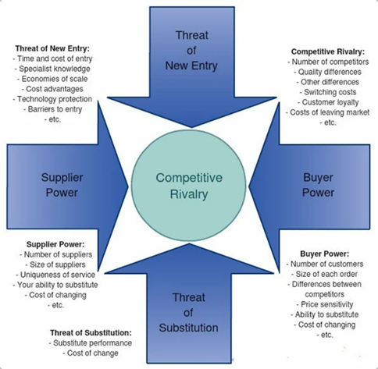
Porter suggests that there are five forces that determine industry attractiveness and long-run industry profitability.
Porter (1996) defines strategy as ‘Competitive strategy is about being different. It means deliberately choosing a different set of activities to deliver a unique mix of value’, (Porter, 1996, p.60). Understanding competitive forces, and underlying causes, reveals current profitability while providing a framework for anticipating and influencing competition. Product features, or brand image, enhances profitability because it improves customer value. Competition focused on such dimensions can improve value relative to substitutes or raise the barriers facing new entrants, (Porter, 2008). The Rivalry is high with many competitors. Established brands such as Marriott and Hilton already provide services with established loyalty programmes for economy brands for the same target markets. There are many suppliers providing advance technological opportunity of enhancing this new Loyalty programme to be more proactive instead of reactive providing a newer and greater seamless interaction.
The hospitality of the future is the ‘open house’ concept intrinsic to the lifestyle brand an exciting economy segment offering accommodation options for individuals, groups, leisure, business, a perfect place for future generations to connect, (JO&JOE, 2019). Added to this is the importance to the customer in knowing the beliefs, attitudes and behaviours of the market segment associated with the JO&JOE brand ‘What signals authenticity is something intrinsic to your brand: your origins, location, and unique features’ (Solomon, 2019). This new approach to authentic engaging guest services for Millennial and Gen Z travellers, offering value for money without compromising on the quality of their stay, will be the difference from established competitors. As described the JO&JOE brand is not just about the destination, it’s all about the experience and adventure. Jennifer Fox, President Fairmont Hotels says, ‘research indicates that younger generations are looking for us to offer experiences and amenities that are engaging and educational, reflective of the destination, and most hope that we will deliver an emotional narrative that resonates with them’ (Soloman,2019).
According to Gürel, and Tat, (2017) the creation of an effective strategy follows a three-stage procedure: examining the framework where the company is operating, ascertaining strategic possibilities, and appraising and choosing excellent opportunities.

Examining the framework: THE PROJECT: This will be named the ‘ALL Loyalty Programme (Another Step Forward)’ delivered through a proactive mobile app, enhancing services for specific target markets in a specific brand to serve the promise of enriching the guest experience with innovative thinking and creativity. Delivering experiences and emotional attachment to the brand by providing guests with unique "money can’t buy” practiced with proactive identification data collected. For a generation where immediacy is key and sharing is vital, fast, and robust providing seamless interaction on a mobile platform with shared experiences in a meaningful way, caters to modern guests’ requirements whilst also seeing significant value return, (Telecommunications, 2020).
This dynamic strategy consisting of new ideas technology will use key partnerships to build a highly sophisticated digital service function adapting and anticipating change, delivered with team members and staff who understand and anticipate customer needs to develop comprehensive individual profiles delivering personalised and tailor-made service standards. Personalised services will improve customer satisfaction during interactions that truly matter to them, evident in research on Millennials. With a customer centric company culture identifying and prioritising important cross-channel journeys and designing custom omnichannel experiences will lead to this type of intense focus being successful.
Identifying new projects and testing new concepts, of co-development and co-creation opens innovation to create more value, better experiences, and answer unmet needs of the target market. ‘We foster living innovation with "openness" as our mantra— open to new practices, technologies, and opportunities that are forging ahead in line with leadership vision’ (The new Accor strategy, 2019).
‘Let's break new ground, wherever we are, driving change to positive hospitality. Through a new 5-year plan innovation and accountability to generate wealth sustainably and limit our negative impacts’, Sébastien Bazin, Chairman and CEO of Accor. (Accor - Acting Here, 2019).
A deeper understanding of the customer shifted because of environmental, social, economic, and technological factors means the team will determine which cross-channel experiences are important and most rewarding. The consumption of experience over commodity is increasingly defining the way we live our lives as greater value is attributed to lifestyle quality versus personal possessions, (BT, 2020). Since the pandemic crisis within the hospitality industry human interaction and emotional connection plays an important role.
Meeting a new standard on digital channels, the “care of one,” focuses all decision making on serving individual customers and their personalized needs. (The care of one: Hyperpersonalization of customer care, 2020). Future services must be customised individual personalising customer care. Today’s consumers should be treated as individuals, providing deeper emotional satisfaction of personal desires, wants and needs, Hultén (2020), says that ‘companies can no longer rely on satisfying only an individual’s basic physical needs but satisfy emotional, intellectual, sensory, and experience-based needs.
Sensory marketing offers new concepts understanding how individuals react with their cognitions, emotions, and behaviours in response to different sensory cues and stimuli (Hultén 2020). The JO&JOE brand service processes and sensory strategies delivered through the App or through staff engagement is characterised by attention to detail, convenience, speed, and emotional fulfilment, providing a high quality of service tailored to customer’s specific unique needs. Availability of advanced data analytics track customer’s individual journey in real-time through the app providing individualistic access of information and knowledge, (Hultén, 2020).
Insider Intelligence has been tracking the future consumer Gen Z’s characteristics, traits, values, and trends. Meola (2020) suggests that Generations X, Y and Z demonstrate the most prominent change in attitudes, behaviours and values following the cultural value shift resulting in international and multi-cultural character of the societal culture. Common characteristics are their physical and social mobility and wanting to experience the world. New offering in the programme must be realised to accommodate this demand for food, clothing, and services across many budgets for these target groups and linked to sustainability practices such as eco fashion, entertainment linking to historical culture or festivities, travel, and education values, (Hultén, 2020).
According to Hultén (2020) the crucial question is how to meet these desires, wants and needs supporting individuals in search for new identities, social status, and self-image on a deeper personal level. Personalising communication will deepen customer loyalty and trust, beneficial to and in-line with the corporate vision, providing exemplary service by predicting needs will be an emotional connection with seamless experience across all touchpoints. This will increase revenue and recognition for the brand and link to the new strategic concepts outlined.
Hultén (2020) points out there are three main personal factors behind lifestyle individualisation as self-fulfilment, identity creation and multi-sensory brand-experiences. For experience-based brands and products, more sensory stimuli are related to sight, sound, smell, touch, and taste (Troye & Supphellen, 2012). The maturity of available technology, data integration based on behaviour, and organisational setup providing proactive issue identification determines the level of personalisation improving services. Focusing on a specific brand with a specific market will enhance more tailored products and experiences. Customer expectations have significantly changed since COVID-19 accelerating these trends, leaving the travel ecosystem in a game of catch-up, (Krishnan et al., 2021).
The JO&JOE personality should also permeate the online presence (Hotel Industry Trends, 2021) with the following action considering the brand’s identity colour yellow representing good humour and a zest for life. The psychology of colour and social media branding continually affects consumers on a deep level. The colours that a company chooses to represent their brand can affect the mood, feelings, and behaviour of target consumers and influence whether a brand will become part of their selection set (Kawamoto, 2021).
This project is augmenting a new concept with a more focused appeal. Every JO&JOE brand has its own specialism unique to the locale or culture. Activities provided by enthusiastic employees, enhance the concept. Current generation trends consider activities such as Zen and adrenaline experiences, experiential hotel stays with a novelty factor. Generations Y and Z want opportunities to undertake life-changing or life-enriching experiences, combining wellness and relaxation resulting in more environment-conscious travellers fulfilling emotional need and multi-sensory experiences aligning with corporate and brand philosophy.
Sustainability must be linked to the brands green philosophy’ Respecting the ocean and protecting the environment are part of our DNA’ (JO&JOE, 2019) Taking extreme challenges, treatments, and experiences is the future, pushing boundaries physically and mentally with one-of-a-kind challenges taking centre stage. Incorporating the Internet of Things (IoT) will offer a high level of convenience and efficiency. Apps are seeing a huge rise in usage, managing guest relationships (SiteMinder, 2021).
With this brand development, it is suggested this project begins January 2022. With partnerships, technology and services already established it should be a complete service feature by December 2022. Testing will begin a month prior to completion date, with roll out prior to the main holiday season. This focused proactive loyalty programme (Another Step Forward) will be tested in the brand JO&JOE, monitored for a year with development into other brands across the group in future. Full teams’ meetings will take place quarterly ascertaining progress. This requires the dedication of each member with focus from individuals on task completion timeously and judicious reaction of the organisation to any tentative blocks that may arise before and during implementation, (Rasiel and Friga, 2001). This team have been selected for their expertise and commitment to the future goals and strategy of the Accor brands. (See appendices).
Partnerships from John Paul, Ennismore, a creative hospitality company with a global portfolio of entrepreneurial and founder-built brands and Amadeus will play an important role, producing the timeous new loyalty programme. Creating emotional connections to associate brands providing exhilarating experiences and venues with several international collaborations, enhancing, and focusing to specific market choices (John Paul, 2017). Amadeus, powers more personalized and authentic travel experiences. Designed to enrich every stage of the traveller journey, (Amadeus Hospitality, 2019). This provides a significant opportunity to capitalise on this experience-focussed generation, combining physical retail with experiential leisure and providing avenues through which consumers can enhance, review, and share their experiences, (BT,2020). This mobile app should integrate with the existing loyalty program and provide new loyalty members easy access to their loyalty profiles, benefits, and points, (Best 10 Hospitality Apps, 2021). Apps can help to understand or drive guest behaviour. After ignoring the digital revolution and Millennial buyers, it’s critical to get ahead of Gen Z’s tendency to be always online, and meet this generation’s digital expectations, (Meola, 2020).
The innovation ecosystem introduced to provide lifestyle augmented hospitality aims to support and sustain the Group's strategy, the new concept of a proactive App will focus on a specific brand and market, creating further value contributing to a profound future transformation. Through a simple social login, rich insight on who the customers are; in-depth demographics, understanding interests and hobbies will provide a detailed profiling, tailoring customer engagement. And in a landscape where quality of experience is king, building an offer which is uniquely fitted to that guest creates an enhanced ability to drive loyalty (BT,2020).

The ‘ALL’ Loyalty TEAM
Gary Yukl (2012) defines leadership as “the process of influencing others to understand and agree what needs to be done and how to do it, and the process of facilitating individual and collective efforts to accomplish shared objectives”. The ‘ALL Team’ is selected to manage the launch as innovative colleagues with relevant industry experience and understanding of the future concepts and objectives for the company providing successful implementation. Northouse (2018) defines leadership as “a process whereby an individual influences a group of individuals to achieve a common goal”. The economy brand in the new market segments organisational reformation using technology and linking with industry trends form the future look of loyalty programmes. The following seven individuals will head up their individual teams being part of this project going forward, a plan of action will be devised by the lead project co-ordinator. The following are invited : Head of Marketing at Accor - Economy Brands, Guest Experience Programs Development Manager – Accor, Social Media Manager at Accor, SVP Guest Experience, ALL loyalty and partnerships & commercial delivery at Accor, Chief Digital Factory Officer at Accor, Group Chief Commercial Officer & the lead co-ordinator ,Head of Marketing New strategy & Development for Economy brands, this individual will be the main lead of the project and will convey direction to the team as well as produce this report. Kotter (1995) model suggests that while this guiding coalition does not have to include all senior managers, it is likely to succeed if, in terms of titles, information, experience, reputations and contacts, it is seen to signal a real commitment to change. Coordination is important and everyone in the team has expertise and knowledge needed to complete the project. Important skills would be IT literacy and understanding of innovation on a digital platform, data analytic collection and understanding of the market, marketing planning for the specific brand, partnerships, and financial considerations to drive strategy forward. When aligned, the various components of a system such as empowerment and recognition, reinforce rather than disrupt each other, which leads to organisational success, (Manzoor, 2011).
Edmond Dounias, a researcher at the Research Institute for Development (IRD), offered a definition: “In incremental adaptation, there is change, but the basic characteristics of the system are maintained. Transformation means crossing a threshold, you were A and you become B.”, (Hubert, 2014). After the 2019 Pandemic changes are inevitable and further organisational change has been introduced. “These trends are expected to persist,” said Sébastien Bazin, Chief Executive of Accor “People are very keen to travel again and with this rebound, our vision of augmented hospitality, has been confirmed with the acceleration of lifestyle and entertainment activities and takes on its full meaning.”
The Social Media Manager role introducing the new concept to the market is an important aspect to the brands image that aligns with the guests. Research has shown that Millennials are marketed to via their smartphones using social media and the internet because 87% of Millennials use two or three devices daily. Consumers are spending more time on apps research revealed that two in three will use an app frequently when it simplifies their lives engaging the audience at the right time with content that's relevant to them, (Smartphones Apps, 2014) Nine out of ten Millennials make at least one purchase using their phone per month, and three quarters compare prices online, (Truyols, 2021). The new platform, TikTok rapidly increased during the pandemic is important for younger Millennials and Generation Z. The latest statistics as of January 2021, 689 million monthly active users worldwide (DataReportal, 2021).
The Chief Digital Officer introduced new digital platforms to the group strategy prior to the changes 2019 and continues to implement new technology needed to drive this project. Using latest technology, the integration of this unique service will proactively become the central interface for the brand customer, focusing on their core needs specifically designed as customer-centric options offered as part of this new loyalty programme. Capitalising on new partnerships, relationship marketing strategies operated under white label, providing concierge services proactively to the market segments identified as brand users. With expertise the programme will create a strategic data-driven roadmap for the digital strategy framework delivering objectives tailoring the mobile application for the creation of exceptional events matching JO&JOE brand image. Automated experiences will improve customer engagement across the customer lifecycle crucial to business growth. The statistical methods to be considered will include trend projection, barometric, and econometric methods, (Litvak, 2020).
The Guest Experience programmes Development Manager, being a young Millennial, and SVP of Guest Experience, ALL loyalty and partnerships & commercial delivery will identify the experiences that align with the demands from these markets. For example, as part of the Wellness trend the App will show local city’s hotspots and most upwardly trending places or events with discounts and ticket availability. There will be links with physical, mental, spiritual wellness to the customer immediately on arrival. Supporting the sustainability initiatives of the group, the App will consider the trend as part of the guests’ preferences. Since September 2015, buying a tree Accor ALL app to support ‘Plant for the Planet’. This will satisfy sustainability, now the biggest trend within the travel industry, with travel corporations and organizations like the World Travel & Tourism Council, Accor, Iberostar Group, G Adventures, and many more signing the Glasgow Declaration on Climate Action in Tourism, (Pfalz, 2021). This is a world first and will be promoted extensively to encourage the customers to sign up.
Millennials like incentives and promotions, (Truyols, 2021) providing effective incentive programs will focus on improving the work-life balance, enabling flexible schedules of check in and check out, offering timely promotion offers based on demanded experiences and giving back to local community. Community-based tourism share their unique cultures with travellers while directly benefiting from the experience (Pfalz, 2021). Offering small relatable gestures to Millennial guests is important, they were the first generation to grow up fully immersed in the technological age (Landrum, 2017). This means that a loyalty programme designed specifically for them will be rewarded with strong support on social media platforms.
Group Chief Commercial Officer will analyse the viability of the project from a financial viewpoint and provide figures for future projections as part of the new strategy. Head of Marketing New strategy & Development for Economy role will as project leader provide analysis along with the plan of action as discussed earlier in the report.

Ascertaining strategic possibilities:
Strategic management is managing a company's resources to achieve its goals and objectives (How Strategic Management Works, 2021). Defined as a strategy choice which organisations adopt to set their objectives, (Dess, et al, 2016). The process of examining present and future environments, formulating the organization's objectives, and making, implementing, and controlling decisions focused on achieving these objectives in the present and future environments (Garry D. Smith, Danny R. Arnold, Bobby G. Bizzell). With the economy brand, the new market segments, and the new concepts this should be deliverable. Sebastien Bazin, CEO Accor, says, ‘Accor treats the challenge of creating immersive experiences beyond the stay as an unprecedented opportunity, undertaken a dramatic transformation, culturally, technologically, and physically in hotels…’
Using innovation of monitoring and analysing trends, considering type of customer, stimulate new thinking amongst the teams, imagine new concepts and experiences to transform the brand, the wider portfolios and be in alignment with changing industry demands. Investing in new experiences for this lifestyle programme, three key areas will be considered linked to the current ALL Loyalty programme To Live, To Work, To Play: a new brand architecture to synergise the overall look and feel of the whole organisation. Today’s consumers should be treated as individuals that want deeper emotional satisfaction of their personal desires, wants and needs, not as a homogeneous group of consumers with similar needs. Hultén (2020), says that ‘companies can no longer rely on satisfying an individual’s basic physical needs but must satisfy emotional, intellectual, sensory and experience-based needs.
Characterised by attention to detail, convenience, speed, and emotional fulfilment, this high-quality service offers solutions, products, and services that are tailored to customer’s specific unique needs. The individualistic approach has been strongly related to growth of digital technology as another prominent driving force, (Hultén, 2020).
Insider Intelligence has been tracking future largest cohort of consumers Gen Z’s characteristics, traits, values, and trends finding that Generations X, Y and Z demonstrate the most prominent change in attitudes, behaviours, and values, (Meola, 2020). The most common traits are physical and social mobility and global travel resulting in an international and multi-cultural character. As a new offering in this programme, it must be realised that there is further demand for food, clothing, and services of various kinds across budgets, linking to sustainability trends and entertainment like culture or festivities, travel and education linking to historical values for these generations (Hultén, 2020). According to Hultén (2020) the crucial question is how to meet these individual desires, wants and needs in supporting many individuals in their search for new identities, social status, and self-image on a deeper personal level. Hultén (2020) points out three main personal factors behind individualization as self-fulfilment, identity creation and multi-sensory brand-experiences. For Millennials and GenZers quality of life and welfare with service-related time use make up self-fulfilment. Identity creation is made up of symbolic content and meaning, experiences of shopping and consumption of brands and products as memory fulfilment and multi-sensory experiences of active dialogue and participation, emotional and rational behaviour, and physical and virtual attendance (Hultén, 2020). If we consider these three areas as part of the strategy delivering the new ALL Loyalty programme (Another step forward) App, we can deliver tailored engagement to meet the customer expectations focusing on creating impactful experiences where they matter most and provide high quality customer experience a strength of a strong brand portfolio.
With current difficulties due to social distancing, digital innovation opens new possibilities and revenue streams, and meets modern guest’s expectations improving operations. It connects the guest with the full experience offerings in real-time via personal devices. Research shows 59% of GenZers have purchased something because the offering was personalised, a key feature of app use. Guests real-time experience rating for reviews, an important part of GenZers and Millennials interaction on social media, can be beneficial by including the brand information, images in the guest’s social media interactions will enhance brand awareness. Meeting the user needs by considering the business goals is important and App users are typically task-orientated, helping the user proactively is a more valuable experience. One that is much more likely to become an integral part of their day-to-day, (Sonin Apps, 2020).

Appraising and choosing excellent opportunities.
Johnson et al, (2014) explain that conducting a SWOT analysis allows the organisation to highlight strengths and weaknesses explored in the strategic capabilities’ analysis and opportunities and threats explored in the environmental analysis. The SWOT analysis ( Fig 1) shows opportunities identified include abilities to have data analysis on current and future markets and data analytics on guest’s behaviour because of the strength of the company wide distribution network, infrastructure, and the experience of team members. This does involve further and continuous investments in IT, with the maturity of the available technology implemented for future data integration gives opportunity to use innovative technology such as proactive issue identification. Focusing on a specific brand will increase tailored products and experiences, the SWOT analysis shows this can be a threat due to established competition on price so product features, support services and brand image improving customer value specific to target markets, can improve value relative to substitutes or raise the barriers facing new entrants (Porter, 2008). An internal weakness addressed in developing staff technological skills quickly to provide immediate services. The employees must be skilled, efficient, and dedicated towards their respective company (Kumar and Pansari, 2016). Shifting customer expectations have significantly changed since COVID-19 only accelerated these trends, leaving the travel ecosystem in a game of catch-up. (Krishnan et al., 2021).
Using SOSTAC which is an acronym for six fundamental facets of marketing: situation, objectives, strategy, tactics, action, and control means there is insight providing analysis about the subsequent decisions and future tactics focusing on the new ‘open house’ concept for the brand in market segments of Millennials and GenZers.
Situation
Being open to new practices, new generations, new professions, and new business this project links to an innovative ecosystem that supports and sustains the Group Strategy, creates value to this brand, existing brands, and future brands. Currently there are established JO&JOE in Europe and the UK with plans for opening ten globally before 2023. This brand focuses entirely on Millennials currently the largest market and GenZ and GenAlpha markets the future in hospitality.
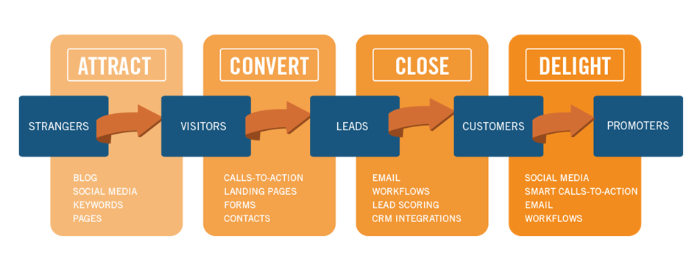

Fig: 1.6

Objectives
Considering SMART objectives is important goal, the new concept of Lifestyle Augmented Hospitality aligns with the ‘WOW’ factor adding value to the experiences for target customers. Using App technology plays an important role proactively, efficiently, and effectively. It is realistic as many systems are in place with plans for future expansion globally.
Strategy
This is an important roadmap, considering timelines and responsibilities. Through targeting, segmentation, and analysis of data, a variety of experiences and events can be adapted to attract the market using a focused and proactive integrated digital platform. Provide trained staff to implement, organise and schedule experiences with the local community is important. Staff of all types of personalities, experiences and talent will support the JO&JOE brand values and drive the new experiences for the ALL Loyalty (Another Step Forward) App programme.
Tactics
Using a marketing mix, a loyalty app will drive revenue by delivering the product to converted customers by immediate proactive interaction sent directly to guests' mobile devices, across multiple guest touchpoints with targeted messages learnt through data capture on preferences, with the price of the economy brand perceived as value for money with added experiences building guest loyalty and satisfaction. This easily gives the ‘concierge app’ opportunity to tailor offers, creating upselling opportunities and promotions, personalise guests’ services through social media interactions. Providing generated material to inform, educate and support emotional connections links to trends of experiential learning and education values. GenZers are more open to receiving new and engaging offers through direct channels, welcoming direct offers, seriously consider their value and act on them to organize new trips, (Truyols, 2021). SEO enhancement will positively impact increased brand visibility in this target market, JO&JOE design and distribution of spaces and functions makes each location an authentic design factor. Eco friendly initiatives of the brand is committed to leading environmental sustainability embraced by eco-conscious customers aligned with corporate strategy.
Action
The following action should be considered. The enhancement of current ALL Loyalty programme is to be more proactive, educational and trend conscious for specific markets for a specific brand and an App will bring the plan to life that can be actioned and measured. This will be a future template linking to current and future hospitality trends, the ‘zest for life’ concept in offering experiences and activities. Smith (2021) argues the importance of understanding the who, why and how before embarking on any plan, making it an important case for building ‘personas’ for these target segments from data. The Team selected based on specific experiences will answer this planning process to launch. Email campaigns, using existing customer database, incentivise them to recruit friends and colleagues to join the mailing enhancing brand awareness and the new loyalty app offering, (SOSTAC® planning model, 2021).
Control
The target and a performance indicator will be required from the financial department to provide this. Integrated across the customer journey touchpoints of reach, act, convert and engage, the RACE Framework will provide growth in these areas (Chaffey, 2021). (Fig 4) Integrated marketing strategy means every element of marketing strategy must contribute towards the vision for the business. (Fig 3) Through social media the target market will be reached, needs will be met with the type of loyalty programme offers, converting them to the brand by engaging them proactively. The SOSTAC ® marketing model, created by PR Smith, is a popular and widely used model for marketing and business planning, (Reed FIDM, 2021).
PESTEL analysis is conducted to provide the macro environmental situation of an organisation, typically analysing political, economic, social, technological, environmental, and legal factors. By improving the efficiency of systems and processes using a proactive app, streamlining the customer journey, a competitive advantage can be gained, (Yüksel, 2012). For Accor brands there are political risks due to broad geographical footprint and due to Covid-19 pandemic travel restrictions implemented by governments have a negative impact on tourism.
Economical fluctuations in exchange rates and rising disposable incomes across markets are impacted due to Covid-19 however, this is an economy brand realising value for money for the younger generations who are more likely to want to experience travel, (ncbi, 2020).
Social factors affecting employee and guest safety concerns due to pandemic crisis is a major concern. Using the philosophy of ‘solidarity’ the company provided new guest services such as medical advice through AXA medical for guests. Accor staff have been supported throughout the crisis meaning local communities are supported, one of the social values important to the JO&JOE brand.
Technological digitalisation leading to shared services benefit both the customer and the company. Accor have strong digital technology operations, and are committed to digital transformation, (Ey, 2020). The digital evolution means transforming interactive values for target markets successfully moving faster than competitors and gaining competitive advantage. Another characteristic is realisation of how much better the new solution is compared to the way things were previously done, (Clever Tap, 2019).
Environmentally digital platforms reduce environmental footprint, the brand’s green philosophy geared towards customers ethos and location communities. Permaculture vegetable gardens, using regional products and having beehives to supply the kitchens shows the commitment. Protecting the environment is key concern to meet sustainable goals, reduce pollution, and protect natural resources against rising demand for leisure services, (Banks, 2021). Environmental standards, which can have an impact of the profitability, can differ in different markets. (Malm, 2016).
Stefano (2020) advises that legal compliance regulatory requirements of operating economies and compliance with labour, environmental and liability laws impact performance of organisations. Consideration of legal issues from the beginning and throughout mobile app development must be considered to protect guests’ rights and minimize risks of liability from violating others' rights, (Legal Considerations Practical Law, 2021).

Conclusion
Barbosa et al, (2020) describe the contemporary industry as entering a new era identified as technology-led supply, intense competition, a decrease in demand and an increase in government pressure for example industry impact on the environment and climate change. Analysing the internal and external factors is vital before setting their strategies especially since the covid-19 crisis. Companies can no longer rely on satisfying individual’s basic physical needs but must also satisfy emotional, intellectual, sensory, and experience-based needs, (Hultén, 2020).
This new App characterised by convenience, speed, attention to detail and emotional fulfilment, offers tailored personalisation to customer’s specific and unique needs expected by modern guests. Strategic analysis for the report shows important steps can be made for this brand. Focus on core/signature services and target those guest segments who are still most likely to travel and pay for experiences. This can be achieved through marketing, IT and Guest service experiences with links to current partnerships interactive real time high-touch service increases trust and loyalty to the brand. Accor must be careful about their pricing system and advertising, a reaction to the pandemic in long term for guest services impact on brand image and the new concept ideas in a competitive market.

References
- Accor. (2013). Accor’s strategic vision.
- Accor. (2011). Accor: 2010 Annual Report: New frontiers in Hospitality.
- Amadeus Hospitality. 2019. Amadeus Selected as Business Intelligence Provider for The Leading Hotels of the World - Amadeus Hospitality. [online] Available at: <https://www.amadeus-hospitality.com/insight/the-leading-hotels-of-the-world-selects-amadeus-as-its-exclusive-provider-of-business-intelligence/> [Accessed 1 December 2021].
- Banks, C., 2021. [online] UKHospitality.org.uk. Available at: <https://www.ukhospitality.org.uk/news/news.asp?id=424393&hhSearchTerms=%22environmental%22> [Accessed 24 November 2021].
- Barbosa, F., Bresciani, G., Graham, P., Nyquist, S., and Yanosek, K. (2020) Oil and Gas after COVID-19: The day reckoning or a new age of opportunity? [online] Available at: https://www.mckinsey.com/industries/oil-and-gas/our-insights/oil-and-gas-after-covid-19-the-day-of-reckoning-or-a-new-age-of-opportunity (Accessed on: 03/11/2021).
- Barbosa, F., Bresciani, G., Graham, P., Nyquist, S., and Yanosek, K. (2021)
- Breaking Travel News. 2021. Accor sees demand pick up as recovery continues. [online] Available at: <https://www.breakingtravelnews.com/news/article/accor-sees-demand-pick-up-as-recovery-continues/> [Accessed 23 November 2021].
- Chaffey, D., 2021. SWOT analysis template examples | Smart Insights. [online] Smart Insights. Available at: <https://www.smartinsights.com/marketplace-analysis/swot-analysis/swot-analysis/> [Accessed 30 November 2021].
- CleverTap. 2019. 5 Disruptive Apps and How They Changed Their Industries | CleverTap. [online] Available at: <https://clevertap.com/blog/disruptive-apps/> [Accessed 7 December 2021].
- DataReportal – Global Digital Insights. 2021. DataReportal – Global Digital Insights. [online] Available at: <https://datareportal.com/> [Accessed 24 November 2021].
- Dess, G., Eisner, A., and McNamara, G. (2016) Strategic Management: Text and Cases, London: McGraw-Hill.
- 2020. The care of one: Hyperpersonalization of customer care. [online] Available at: <https://www.mckinsey.com/~/media/mckinsey/business%20functions/operations/our%20insights/the%20care%20of%20one%20hyperpersonalization%20of%20customer%20care/the-care-of-one-hyperpersonalization-of-customer-care.pdf> [Accessed 26 November 2021].
- 2020. [online] Available at: <https://www.youweagency.com/data-intelligence/pxm-fuel-modern-online-customer-experience> [Accessed 29 November 2021].
- Dess, G., Lumpkin, G. and Eisner, A., 2014. Strategic management. 7th ed. McGraw-Hill Education. (Accessed on: 11/12/2020).
- EY Global. (2020) Low prices and the COVID-19 demand slump make embracing and integrating technology a necessity. [online] Available at: https://www.ey.com/en_au/oil-gas/how-covid-19-could-accelerate-digital-in-oil-and-gas (Accessed on: 11/12/2020)
- Gurel, E., & Tat, M. (2017). SWOT Analysis: A Theoretical Review. The Journal of International Social Research, 10, 994-1006.
- Group.accor.com. 2021. Now, more than ever, people are at the heart of what we do. [online] Available at: <https://group.accor.com/en/Actualites/2021/11/talent-culture-vision-steven-daines> [Accessed 23 November 2021].
- Group.accor.com. 2021. Accor - Acting Here. [online] Available at: <https://group.accor.com/en/commitment/positive-hospitality/acting-here> [Accessed 23 November 2021].
- Hubert, T. 2014. Incrementalism vs. transformation: How to change in the face of climate change? - CIFOR Forests News. [online] CIFOR Forests News. Available at: <https://forestsnews.cifor.org/23456/incrementalism-vs-transformation-how-to-change-in-the-face-of-climate-change?fnl=en> [Accessed 27 November 2021].
- Hultén, B., 2020. Sensory marketing. London: Sage Publications.
- Johnson, G., Whittington, R., Scholes, K., Angwin, D., and Penger, P. (2014) Exploring Strategy text and class (10th ed). Harlow, Pearson.
- JO&JOE. 2019. Original, open, and happy house - JO&JOE. [online] Available at: <https://www.joandjoe.com> [Accessed 28 November 2021].
- Krishnan, V., Seeley, J., Scully, E., Neher, K. and Obeid, M., 2021. Rebooting customer experience to bring back the magic of travel. [online] Available at: <https://www.mckinsey.com/industries/travel-logistics-and-infrastructure/our-insights/rebooting-customer-experience-to-bring-back-the-magic-of-travel> [Accessed 23 November 2021].
- Kawamoto, R., 2021. The Psychology of Yellow Branding [infographic]. [online] ImagiBrand. Available at: <https://imagibrand.com/the-psychology-of-branding-with-the-color-yellow-infographic/> [Accessed 30 November 2021].
- Landrum, S., 2017. Incentive Programs That Motivate Millennial Employees. [online] Forbes. Available at: <https://www.forbes.com/sites/sarahlandrum/2017/11/03/incentive-programs-that-motivate-millennial-employees/?sh=766a7e2623e2> [Accessed 28 November 2021].
- Litvak, O., 2020. [online] Available at: <https://www.hotelmize.com/blog/demand-forecasting-factors-affecting-it-why-it-is-important-more/> [Accessed 24 November 2021].
- Malm, A (2016) Fossil Capital: The Rise of Steam Power and the Roots of Global Warming. London: Verso Books.
- Meola, A., 2020. Generation Z News: Latest characteristics, research, and facts. [online] Insider Intelligence. Available at: <https://www.insiderintelligence.com/insights/generation-z-facts/> [Accessed 24 November 2021].
- Nielsen.com. 2014. Smartphones: So Many Apps, So Much Time. [online] Available at: <https://www.nielsen.com/us/en/insights/article/2014/smartphones-so-many-apps-so-much-time/> [Accessed 1 December 2021].
- Northouse, P. G. (2010). Leadership: Theory and practice (5th ed.). Thousand Oaks, CA: Sage.
- Nwachukwu, C., Chladkova, H, Fedeyi, O. (2018) Strategy Formulation Process and Innovation Performance Nexus. International Journal for Quality Research. 12 (1).
- Pfalz, L., 2021. [online] Available at: <https://www.travelpulse.com/opinions/column/why-community-tourism-should-be-top-of-mind-for-travelers-and-the-industry.html> [Accessed 24 November 2021].
- Porter, M., 2008. The Five Competitive Forces That Shape Strategy. [online] Harvard Business Review. Available at: <https://hbr.org/2008/01/the-five-competitive-forces-that-shape-strategy> [Accessed 30 November 2021].
- Porter M, Kramer M (2006) Strategy and Society: The link between competitive advantage and corporate social responsibility. Harvard Business Review.,84 (12):78-92
- Practical Law. 2021. Mobile App Development: Key Legal Considerations | Practical Law. [online] Available at: <https://uk.practicallaw.thomsonreuters.com/7-525-8637?transitionType=Default&contextData=(sc.Default)&firstPage=true> [Accessed 7 December 2021]. Reed FIDM, D., 2021. SOSTAC: The guide to the perfect digital marketing plan.
- Rasiel, E. and Friga, P., 2001. The McKinsey minds. Chicago, IL: McGraw-Hill.
- Resorts, F., 2018. New research study from Fairmont shows affluent travellers want exclusive experiences and view hotels as trusted travel partners. [online] Prnewswire.com. Available at: <https://www.prnewswire.com/news-releases/new-research-study-from-fairmont-shows-affluent-travelers-want-exclusive-experiences-and-view-hotels-as-trusted-travel-partners-300745396.html> [Accessed 24 November 2021].
- Scribd. 2019. Accor Group Annual Report 2013 | PDF | Corporations | Economies. [online] Available at: <https://www.scribd.com/document/257130564/Accor-group-Annual-report-2013> [Accessed 26 November 2021].
- SiteMinder. 2019. Hotel trends: The biggest indicators in the hotel and hospitality industry. [online] Available at: https://www.siteminder.com/r/hotel-trends-hotel-hospitality-industry/ [Accessed 6 February 2021].
- SiteMinder. 2021. 2021 Hotel Industry Trends to Know | SiteMinder. [online] Available at: <https://www.siteminder.com/r/hotel-trends-hotel-hospitality-industry/> [Accessed 29 November 2021].
- Smart Insights. 2021. How to use the SOSTAC® planning model and the RACE Framework. [online] Available at: <https://www.smartinsights.com/digital-marketing-strategy/sostac-plan-example/> [Accessed 30 November 2021].
- Smith, P., 2021. The SOSTAC guide to your perfect digital marketing plan.
- Solomon, M., 2019. Heart of Hospitality. (New York): SELECT books INC.
- Sonin. 2020. Future of the Mobile App Experience | Sonin Apps. [online] Available at: <https://sonin.agency/future-mobile-app-user-experience/> [Accessed 6 December 2021].
- Stefano, G. (2020) Covid-19 and EU competition law: Bring the informal guidance on, Journal of European Competition Law and Practises [online] Available at: https://www.ncbi.nlm.nih.gov/pmc/articles/PMC7239131/ (Accessed on: 12/11/2021).
- Troye, S.V. & Supphellen, M. (2012). ‘Consumer participation in coproduction: “I made it myself” effects on consumers sensory perceptions and evaluations of outcome and input product’, Journal of Marketing, 76: 33–46
- Truyols, M., 2021. [online] Available at: <https://www.hotelmize.com/blog/millennials-travel-statistics-how-do-they-travel/> [Accessed 24 November 2021].
- Turkana Allahverdiyeva (2016) Corporate Social Responsibility; Mutual Expediency of Transnational Companies and Developing Countries. Open Journal of Business and Management.
- UNWTO. (2020) Tourism and Covid-19 – unprecedented economic impacts [online] Available at: https://www.unwto.org/tourism-and-covid-19-unprecedented-economic-impacts (Accessed on: 11/11/2021).
- Viladon, D. (2013). Accor moves towards emerging markets and away from owning hotels.
- Yüksel, I. (2012) Developing a Multi-Criteria Decision-Making Model for PESTEL Analysis, International Journal of Business and Management; (7), No. 24.
- Group.accor.com. 2019. The new Accor strategy. [online] Available at: <https://group.accor.com/en/Actualites/2019/03/strategy-all-accor-live-limitless-sebastien-bazin> [Accessed 7 December 2021].
APPENDICES
Accor Group.
Accor is a leading hotel company in Europe, and a major industry player globally consisting of more than 5,200 properties and 10,000 food and beverage venues throughout 110 countries. In operation for over 40 years employing strategic processes in its major areas of competency towards meeting the challenge of competition. The company employs its strategies towards the improvement of the quality of its services, positioning its products and services and maintaining an environment-friendly performance. With strategic changes the company’s focus on emerging markets and focusing its deployment on the provision of mid-scale and budget services. Needs to be met with several key objectives:
•Build iconic and leading Brands: Increase the appeal and reputation of our brand portfolio in all segments of the market.
•Extend our global presence and leadership: Continually innovate, assert our presence in new geographic areas with high potential
•Develop leadership potential in our more than 260,000 talented employees
•Provide a state-of-the art technology to meet guest’s expectation and answer unmet needs.
•Act for a meaningful hospitality: Strive to make positive impact both locally and globally with our Planet 21 sustainable development program and our Accor Heartist Solidarity endowment fund.
•Accor enables new ways to live, work, and play with Food & Beverage, nightlife, wellbeing, and coworking brands.
Current ALL Loyalty Programme use loyalty packages as an approach to attracting potential customers and retaining the existing consumers with 68 million members benefit from the company’s comprehensive loyalty program – ALL - Accor Live Limitless – a daily lifestyle companion that provides access to a wide variety of rewards, services and experiences The group has one of the industry’s most diverse and fully integrated hospitality ecosystems encompassing more than 40 luxury, premium, midscale and economy hotel brands, entertainment and nightlife venues, restaurants and bars, branded private residences, shared accommodation properties, concierge services, co-working spaces and more.
Accor’s unmatched position in lifestyle hospitality – one of the fastest growing categories in the industry led by Ennismore, a creative hospitality company with a global portfolio of entrepreneurial and founder-built brands with purpose at their heart. Through its Planet 21 – Acting Here, Accor Solidarity, RiiSE and ALL Heartist Fund initiatives, the Group is focused on driving positive action through business ethics, responsible tourism, environmental sustainability, community engagement, diversity, and inclusivity.
Fig 1
Strengths | Weaknesses
- Strong brand portfolio  - Innovative team members  - Wide distribution network  - Customer satisfaction  - Sustainability strategies | - Technology skills need updating quickly.  - Experience skills  - Brand perception – new concept of ‘open house’
Opportunities | Threats
- Opening of new markets  - Using innovative technology  - JO&JOE green drive  - New customers over the next 10 years  - Increase in demand for experiences  - New services & experiences  - New partnerships / alliances | - Seasonal demand of profitable products  - Rivalry / Competition – new entrants  - Price War  - COVID-19  - Currency fluctuation  - Channel conflicts

Fig 2
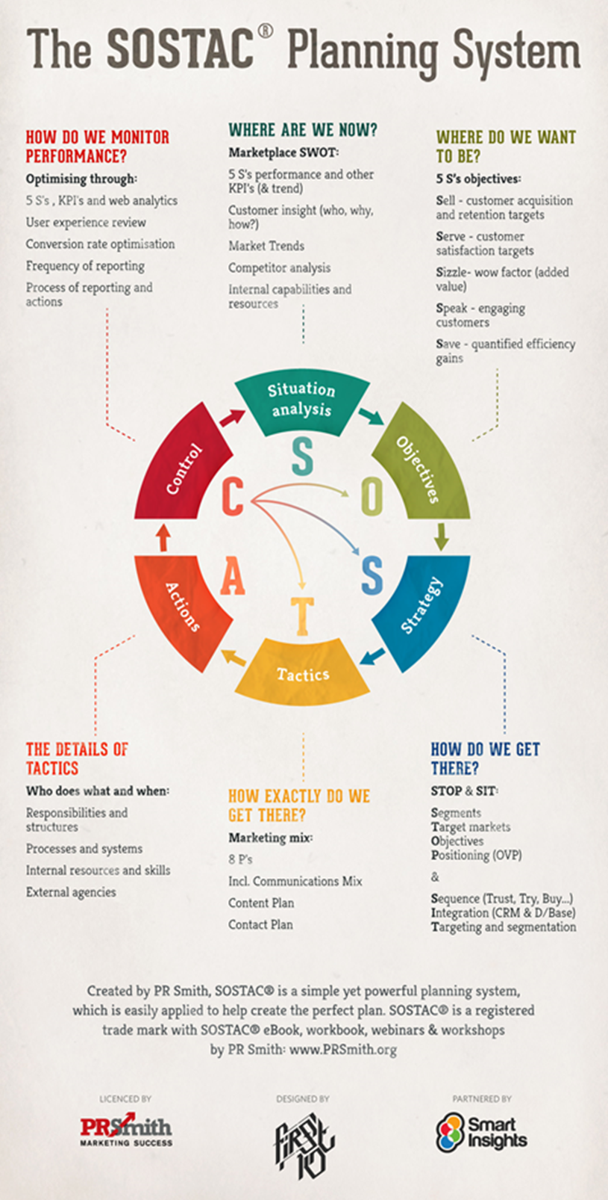
Fig 3

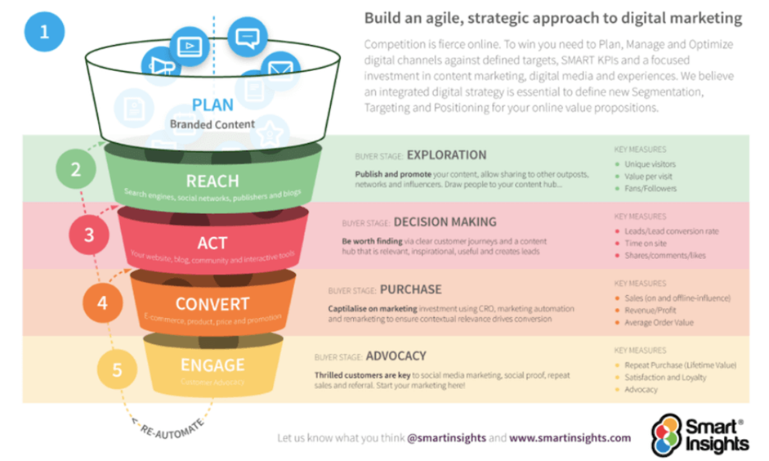
Fig 4

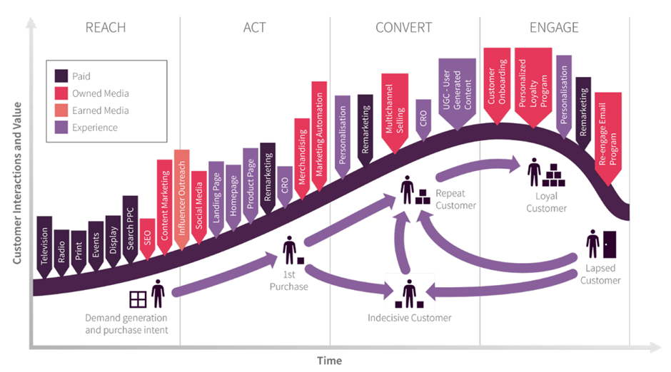
Fig 5

