Name of the Team: Team Resit
Team Members
Student Name | Student ID
Kasey Ward | 2113329
carys newing | 2014825
gareth williams | 1912085
sam comley | 2023031

1. Team Evaluation
 | Kasey | Carys |  | Gareth |  | Sam
Kasey |  |  | 2 |  | 4 |  | 0
Carys
Gareth
Sam
Rate your Teams Contribution with a scale of 1 to 5 (1 No Contribution and 5 Excellent Contribution)
Carys: Whilst in the first half of the project Carys was instrumental in setting up the group working practises, in this half of the project she seemed to just cost through and would constantly be behind on the work needing to be caught up before we could proceed. This slowed things massively in the sessions she attended, however she again did not inform the group that she was to miss sessions leaving us in some confusion.
In the final meeting of the group where the final report was constructed Carys attended, however had minimal input other than to say she was a few weeks behind the end of the project. It felt as if she was just there to bolster her marking from the group for her contributions.

Sam: I have not seen any input from Sam this whole second half of the module. Whenever group meetings were set up he was absent, mostly without notification. I saw no contributions by him to the group work and did not see him at all this second half of the semester.

Gareth: Gareth was extremely helpful in the sessions and provided trouble shooting advice for all team members where needed.
Once again Gareth was the main source of the final group report being pulled together. The screenshots are mostly his contributions, however others in the group had the same screenshots, it just happened that Gareth had been working on the document before the final group meeting to get it together.

2. Table of Contents
Contents
1. Team Evaluation 1
2. Table of Contents 3
4. Abstract 3
5. Introduction 3
6. Part 1 (Group Work ) 3
6.1. Task 1: MANAGING AND MAINTAINING NETWORK RESOURCES USING NETWORK POLICY AND SECURITY PRACTICES 3
6.1.1. NTFS 3
6.1.2. Share Permissions 8
6.1.3. Accessing the File Share from Client 1 8
6.2. Configuring User Environment and Computer Environment, ‘Network Group Policy Objects’ 9
6.2.1. GPO 1: Moderating Access to the Control Panel. 9
6.2.2. GPO 2: Removing Access to the Command Prompt. 11
6.2.3. GPO 3: Restricting Access to Removable Media Drives. 12
6.2.4. GPO 4: Restricting Software Installs 14
6.2.5. GPO 5: Enforcing Password Policy in the ‘accatask.msft’ domain. 16
6.3. Task 2: ROUTING AND PACKET FILTERING WITHIN CORE TCP/IP SERVICES AND CRITICAL FAILOVER/REDUNDANCY PRACTICES 17
6.3.1. ARP 17
6.3.2. Route 19
6.4.Deploy Core Services (FTP Server) 20
6.4.1. Test FTP Upload from Client PC 23
6.5. Installing and configuring the Routing and Remote Access Service 26
6.5.1. Verifying Remote Access 28
6.6. IP Packet Filtering 28
6.6.1. Filter 1: Stopping ‘anyone’ in PrivateNet 1 from Pinging the Router Firewall Service. 29
6.6.2. Troubleshooting RIP 29

4. Abstract
This report documents a successful group project setting up Active Directory services using a Type 2 hypervisor. Additionally, the report discusses the sharing of network resources and basic networking configuration include routing of data across subnets.

5. Introduction
A group project to install and administer active directory services on a network using a type two hypervisor solution. The project's goal is to improve understanding of active directories, type 2 hypervisors, network resource allocation, and collaborative working abilities.

6. Part 1 (Group Work )

6.1. Task 1: MANAGING AND MAINTAINING NETWORK RESOURCES USING NETWORK POLICY AND SECURITY PRACTICES

6.1.1. NTFS

On a client 1 PC a folder was setup and a simple text file created.
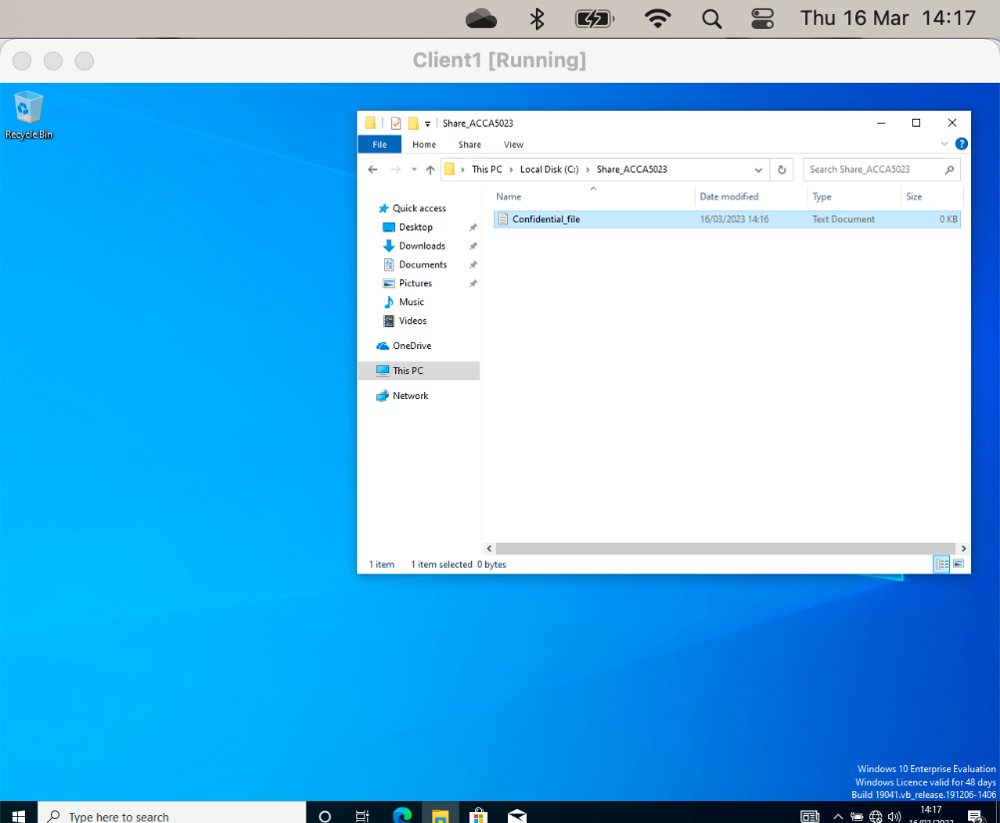

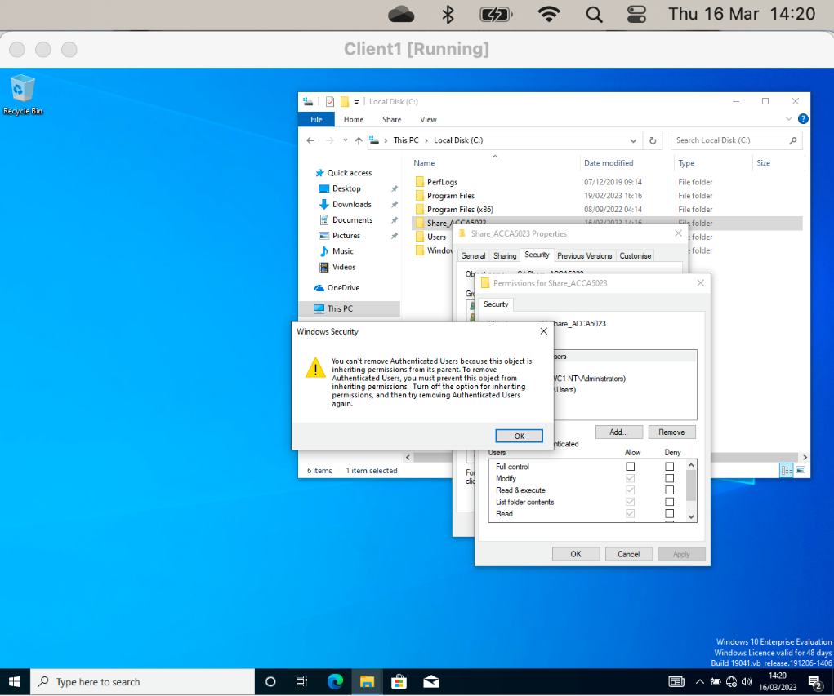
As expected, windows showed an error regarding inherited permissions.

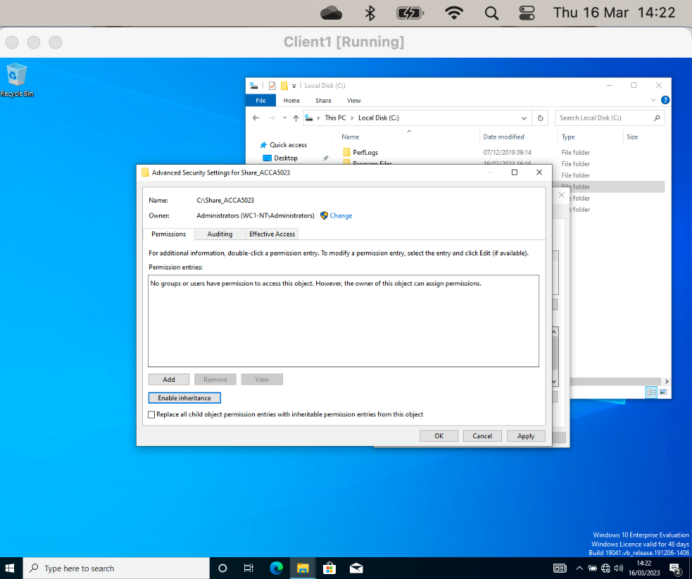
Removed the inherited permissions from the folder.
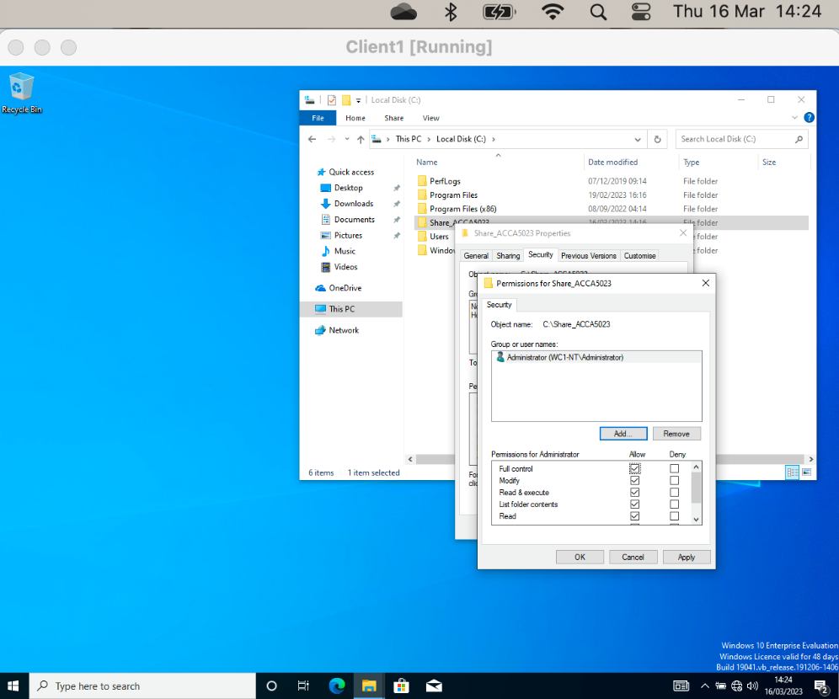

Screenshot in figure shows that the permissions can now be tailored.

The following screenshot shows the property of the files and that the permission have been inherited from the parent folder.
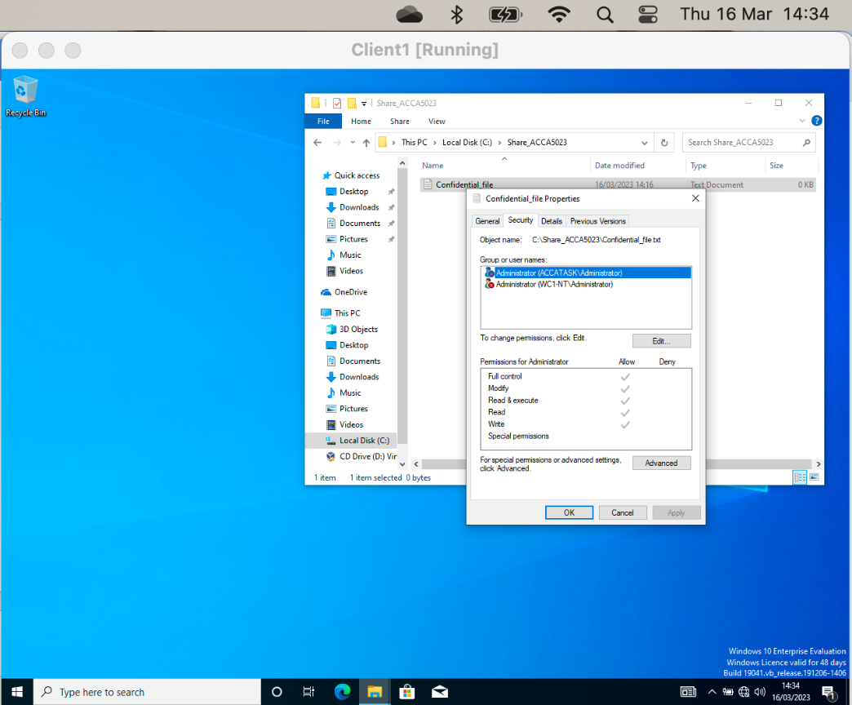

Next, the full control permission was granted for User1 on the file:
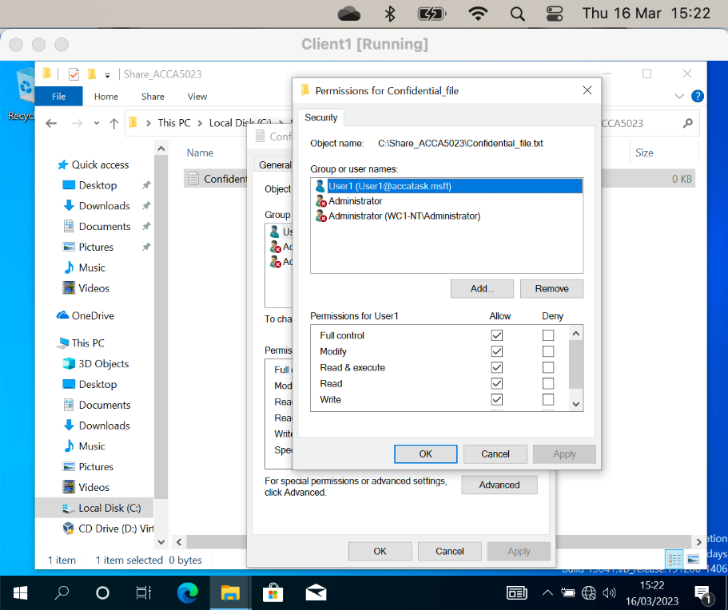

The following screenshot shows a Domain User account can still edit the file as write permission are granted. This is also true at the folder level, the Domain User can also create a new text document.

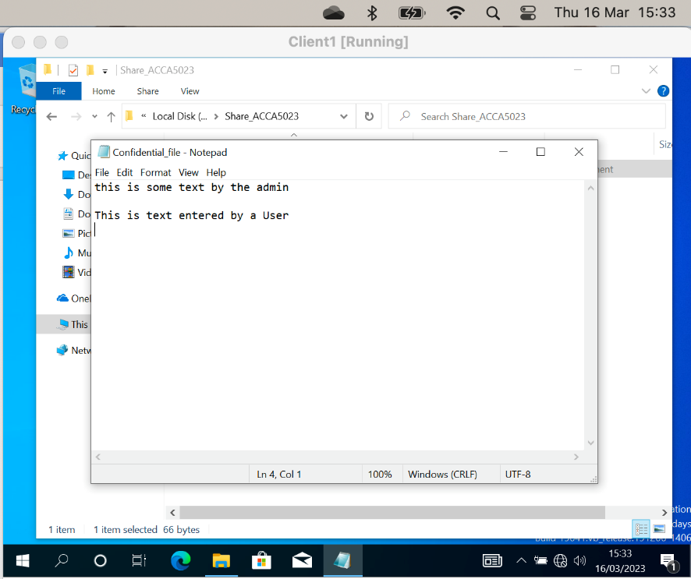

If the folder name is modified, the Domain User is correctly prompted for administrative permissions to continue, this behaviour is correct as the use does not the “modify” permission. This proves the security permission is working as expected.

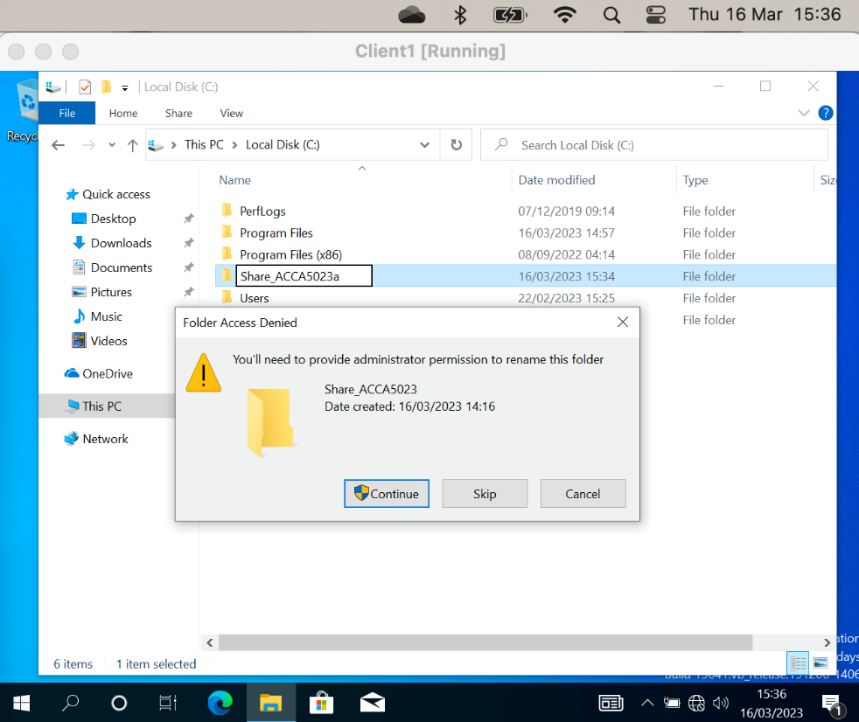

6.1.2. Share Permissions
In this section the group configured a network share:
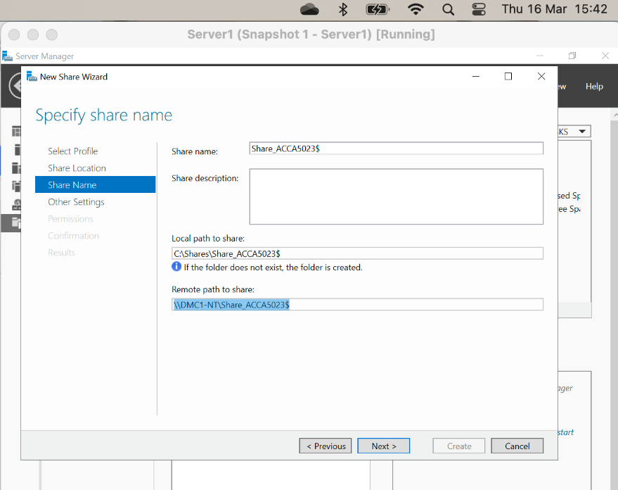

Permissions are granted on the newly created share as shown in figure n below:

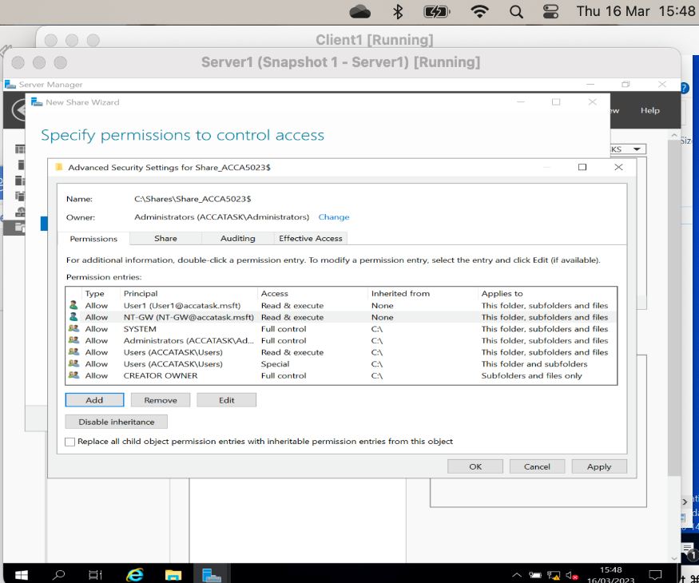

6.1.3. Accessing the File Share from Client 1
The following screenshot shows the mapped drive and the creation of a test file and folder to verify the permissions of User1 and proves the correct configuration of the share.

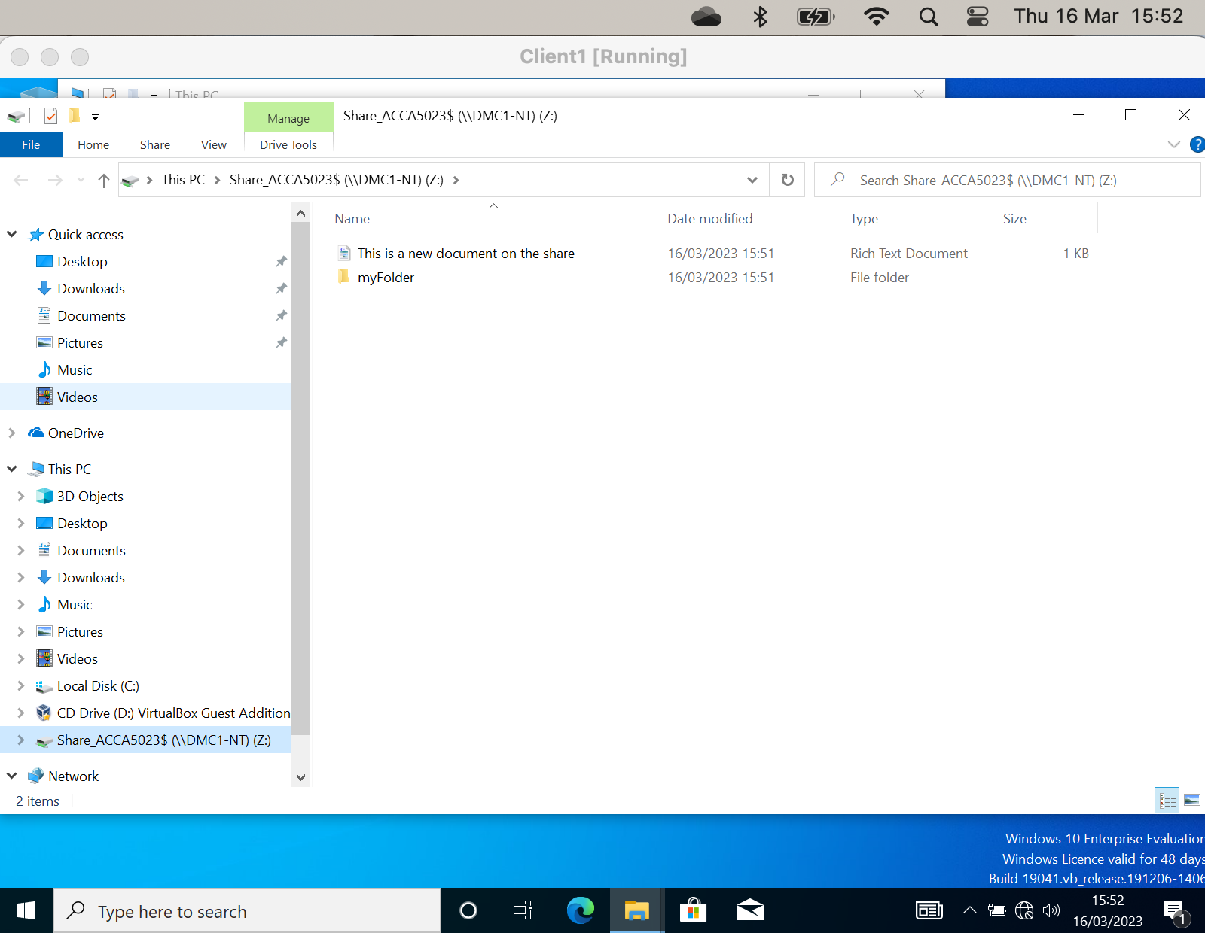

6.2. Configuring User Environment and Computer Environment, ‘Network Group Policy Objects’

6.2.1. GPO 1: Moderating Access to the Control Panel.
In this section a group policy was configured to restrict access to the control panel for Domain Users.
On Server1, two objects were created, a New Non-Admin OU (organisational unit) and a non admin domain user (User3).
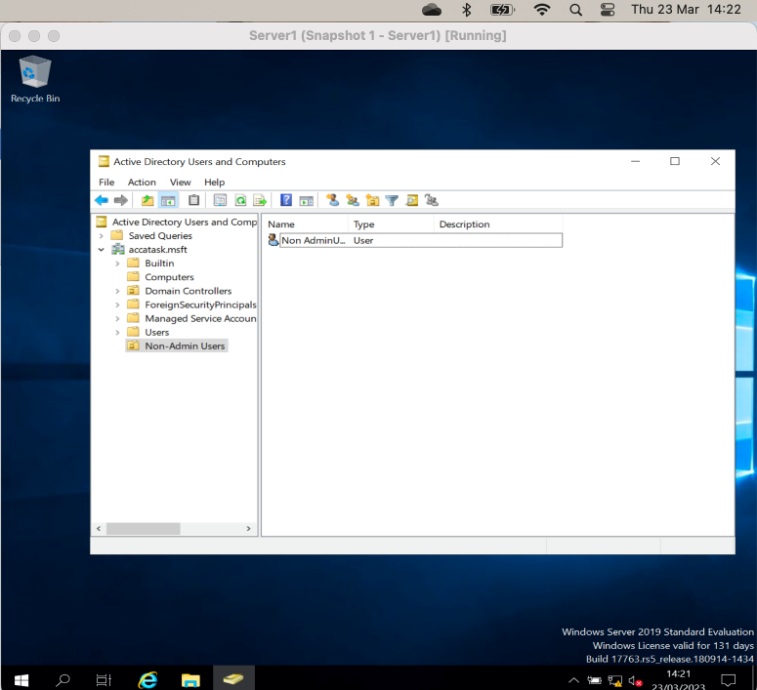

The group policy Management console was used to create the specific policy at the User Configuration level:

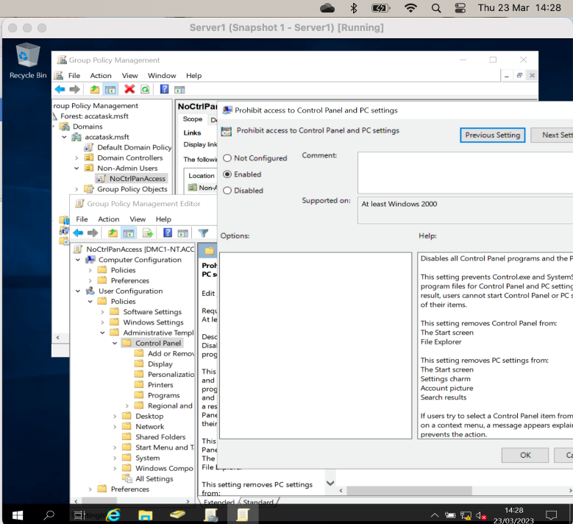
To ensure the policy is active immediately across the domain, the gpupdate /force command is executed:
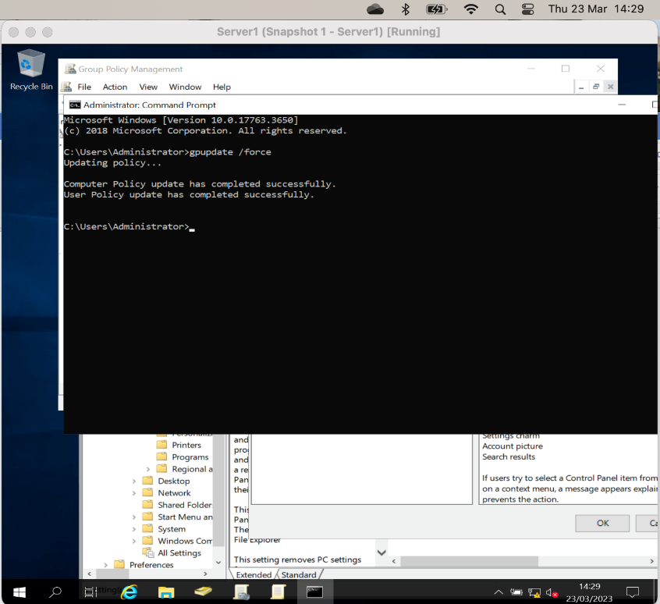

Verification that the policy has been applied successfully is tested by attempting to open Control Panel on Client 1 as the User3 domain user account:
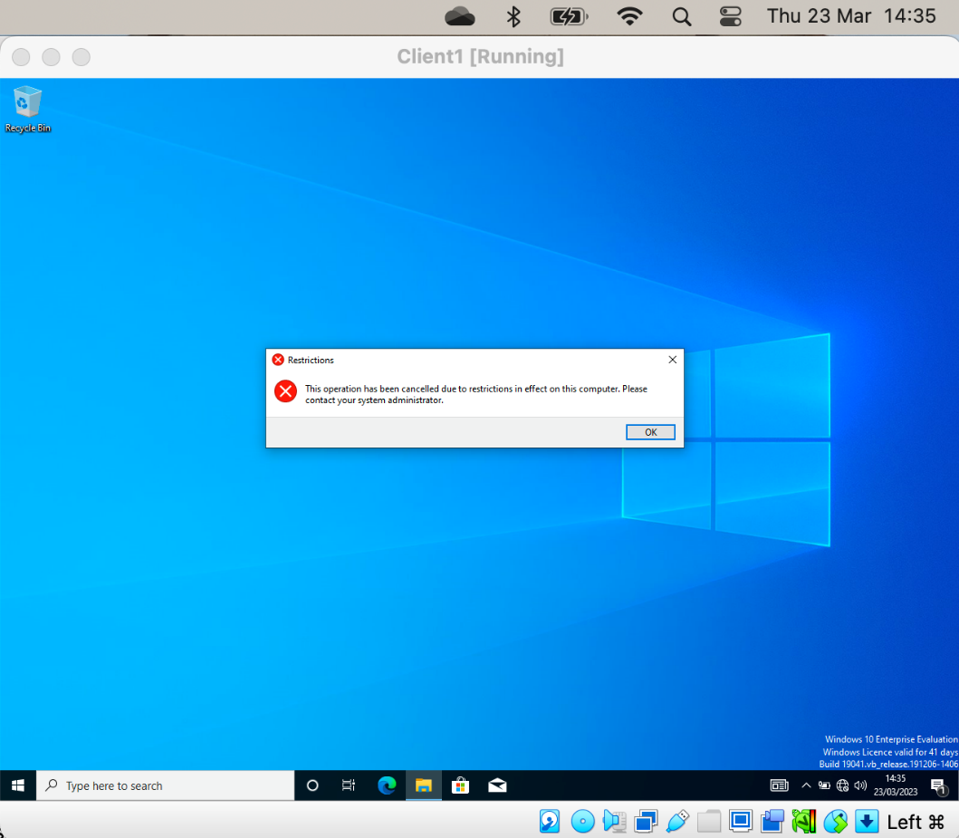

6.2.2. GPO 2: Removing Access to the Command Prompt.
An additional standard security policy is to disable access to the command prompt. To achieve this the Prevent access to the command prompt policy is set:

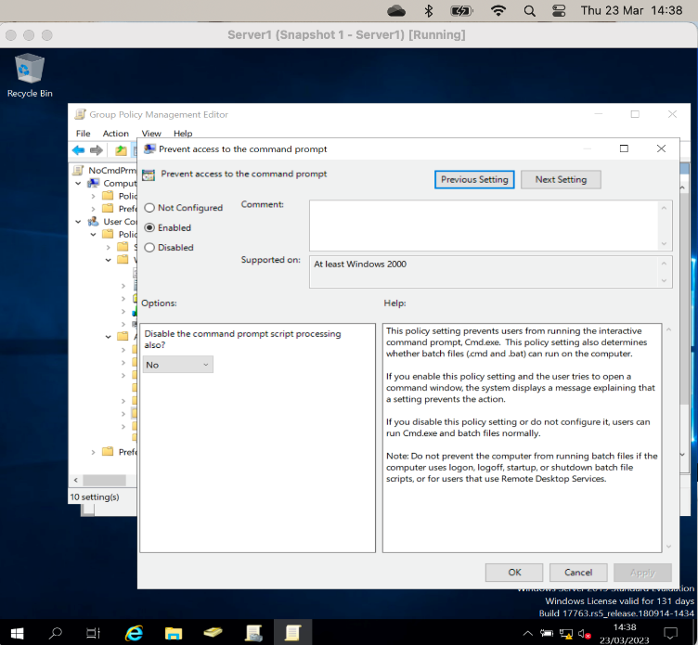

The gpupdate /force command is run, note that the effect on the client doesn’t take place until the policy is updated locally. The following screen shot shows the policy has been applied successfully.
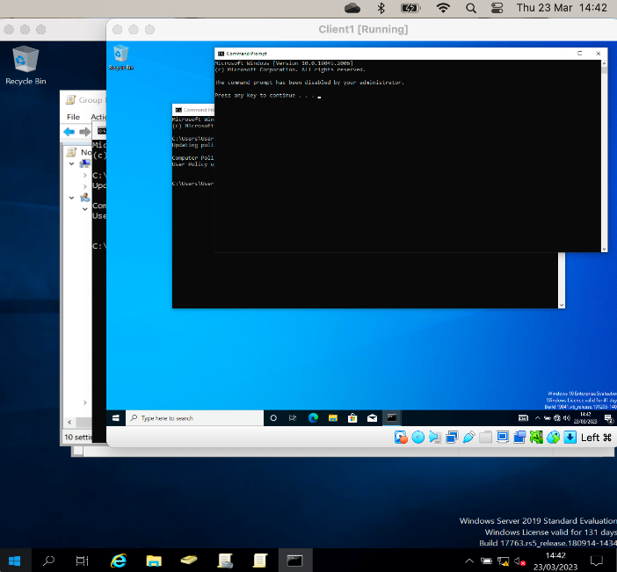

6.2.3. GPO 3: Restricting Access to Removable Media Drives.
Another policy was set to restrict Acess to Removable media drives, this policy is set at the User Configuration level:

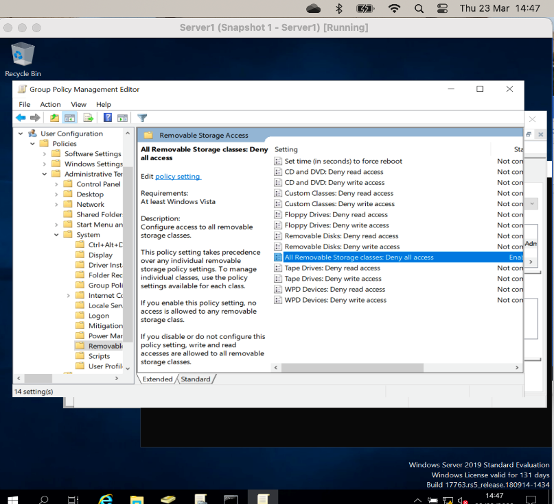
The following screen shot shows the restriction is in place when trying to access the CD drive from windows explorer.
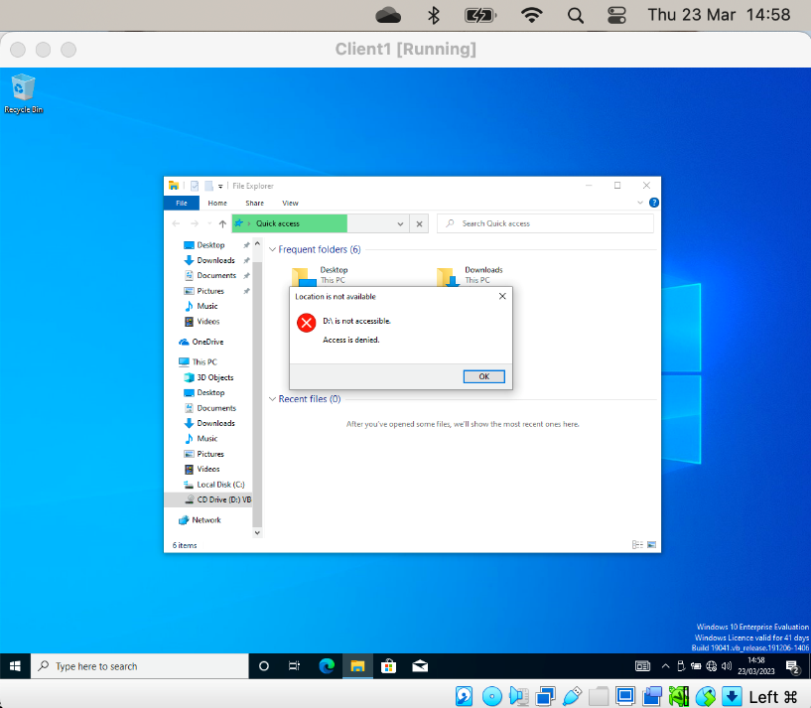

To further test the remove media policy is set correct and that it only effects normal Domain Users; logging on to Client1 as Administrator allows access to the CD volume as expected:
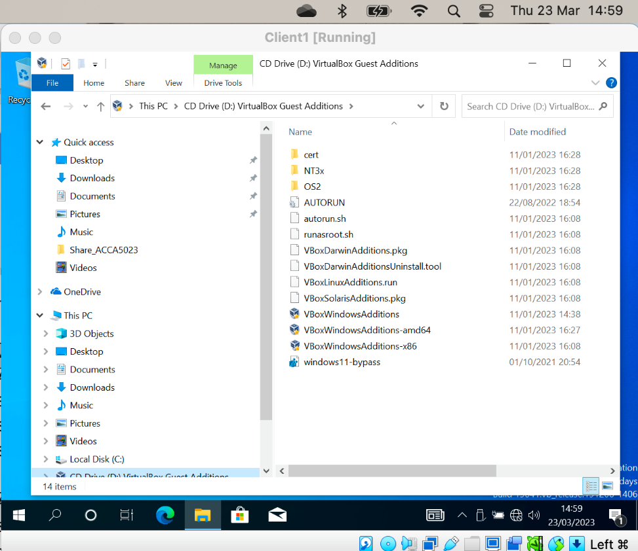

6.2.4. GPO 4: Restricting Software Installs
The difference with this policy is that it is set at Computer Level rather than User Configuration:

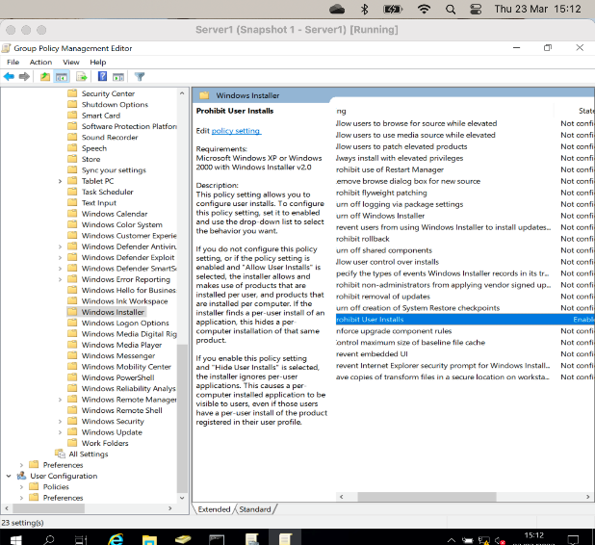

The following screenshot shows that the Administrator account will be required to install the software (the shield icon)

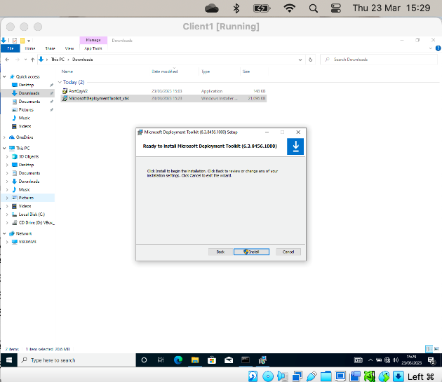

The user is prompted for administrator credentials as we need elevated privileges to install…

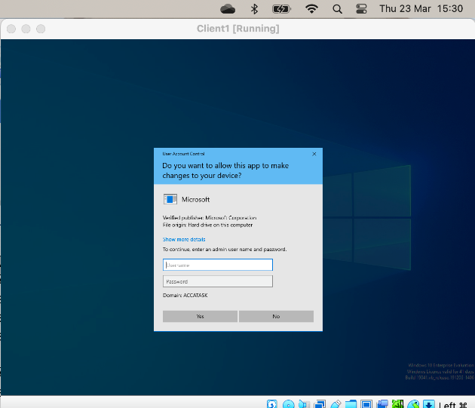

6.2.5. GPO 5: Enforcing Password Policy in the ‘accatask.msft’ domain.
Another standard tool is setting the password policy:

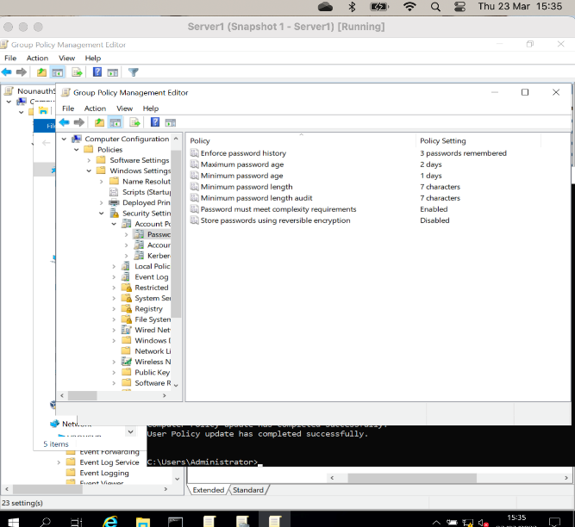

Now the password policy has been set, we get the following error when creating a new account that the password meeting the policy:

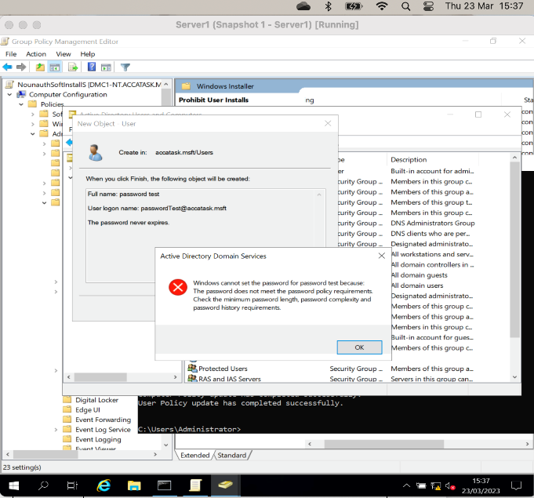

6.3. Task 2: ROUTING AND PACKET FILTERING WITHIN CORE TCP/IP SERVICES AND CRITICAL FAILOVER/REDUNDANCY PRACTICES

6.3.1. ARP
The ARP -A command will show the current routing table:
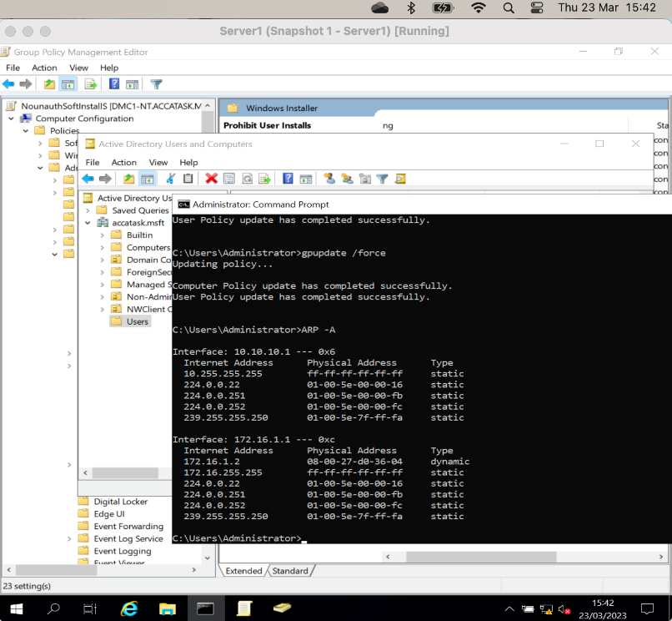

Note: that as the client1 VM only has 1 network interface:
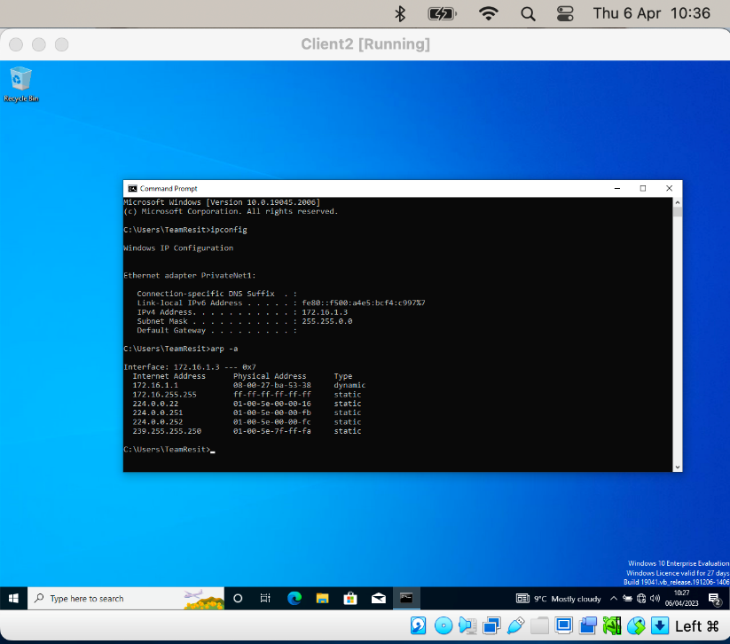

The following screenshot shows the comparison between the ARP tables before and after using the ping command, this shows how the table is dynamically built. Here we pinged two networks, this is shown in the Server2 ARP table for each interface:

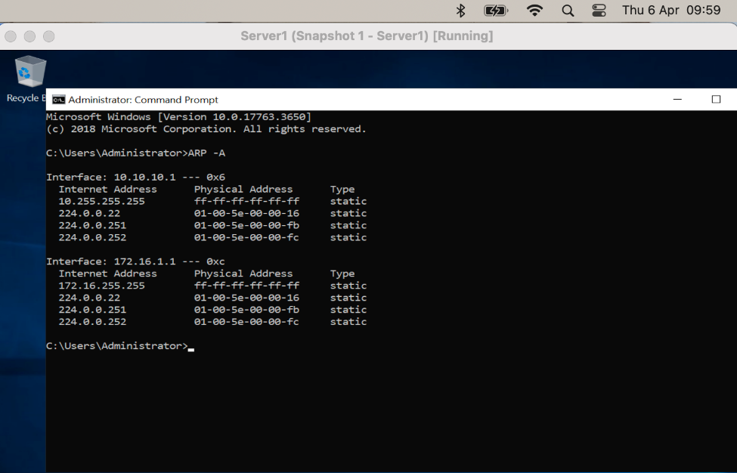

This screen shot shows the additional entries in the routing table after the ping 172.16 range and server address of 10.10.10.2:

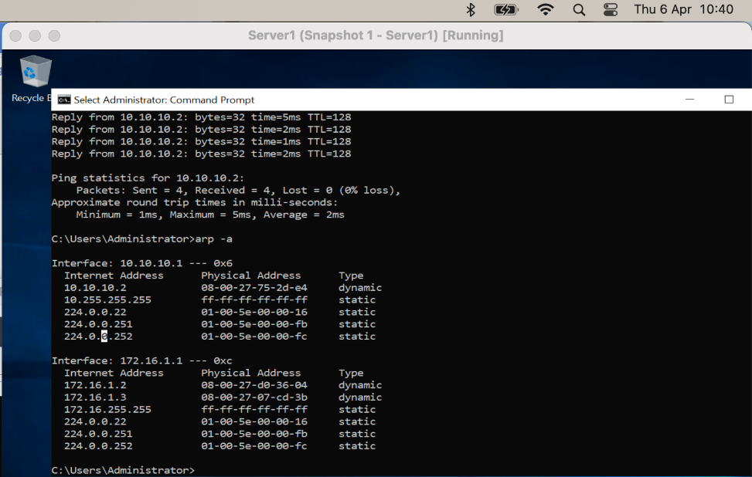

6.3.2. Route
The route print command shows the networks the host is connected to:
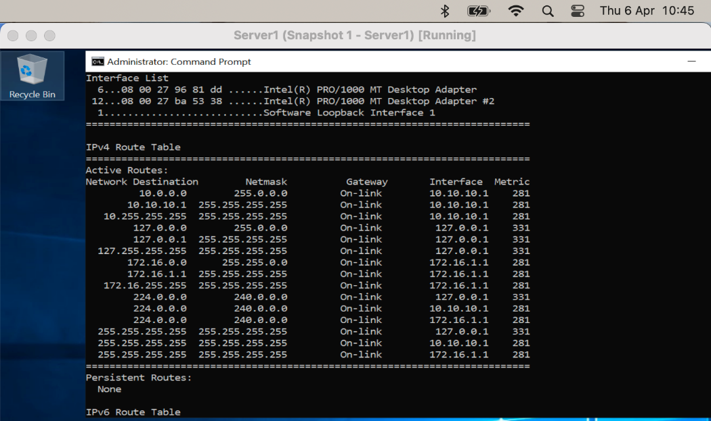

6.4.Deploy Core Services (FTP Server)
Using the Add Roles and Features action in Server Manager, the FTP service was installed:

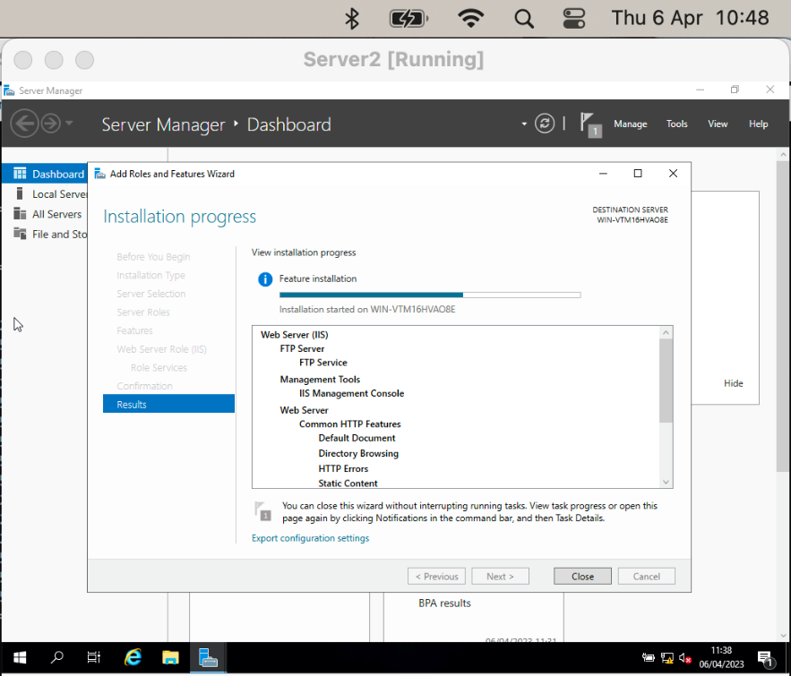
Once installed, another domain user was created to test the service:
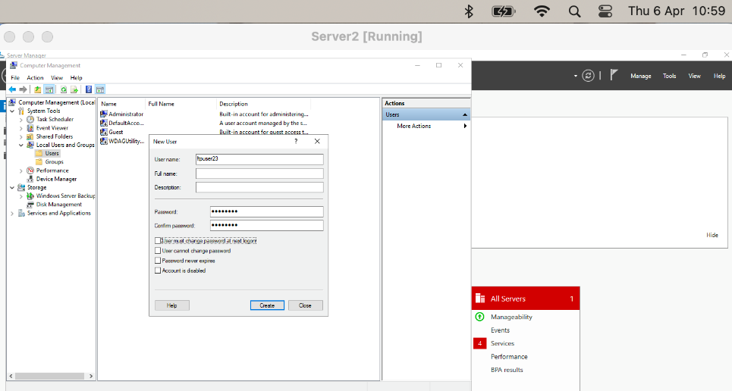

One the ftp service is installed, it needs to be configured through the IIS Management console:
In this case the default port of 21 was used. Note that Secure Socket Layer is not used – this would mean the data transported using ftp is not encrypted.
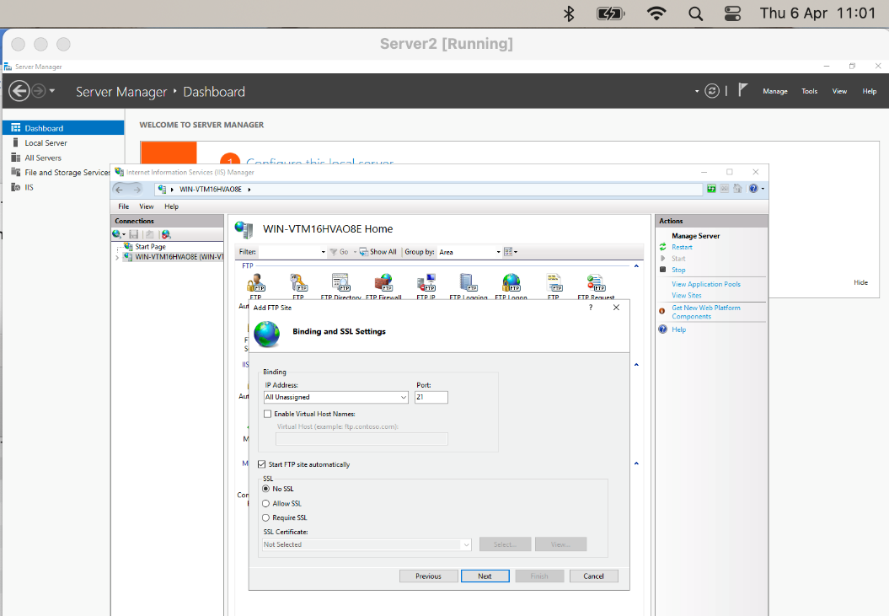

As part of the configuration the test user is granted access:

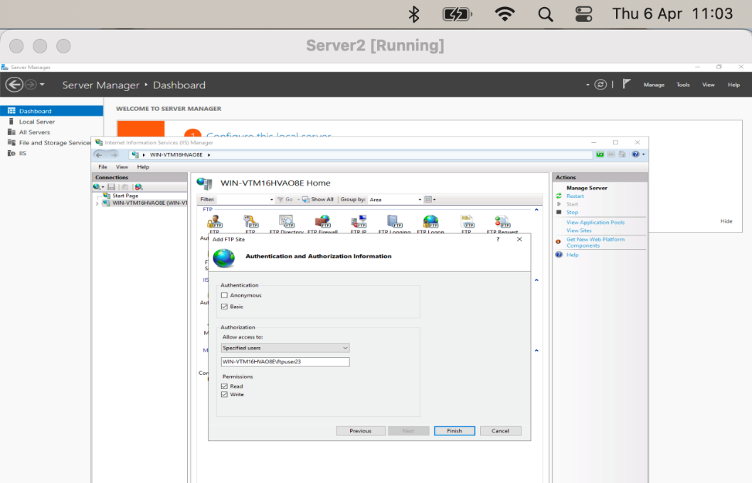

The ftp configuration allows custom banner messages that can be used to prompt users who access. These are typically used to remind users of security considerations while using the service:
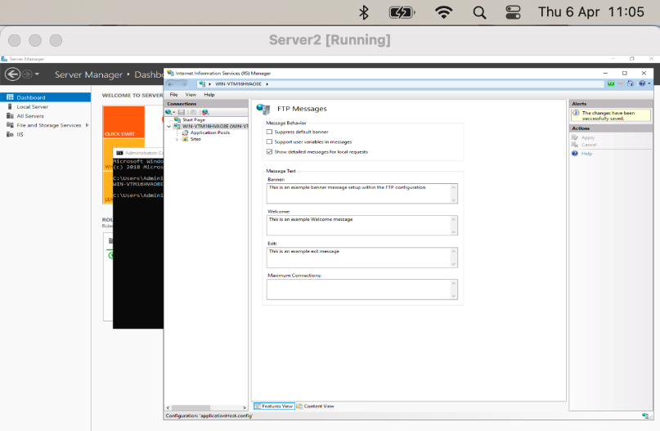

FTPUser23 permissions on ftproot folder, note that we haven’t provided write permissions therefore it is expected that any attempt to put files from the client will fail.

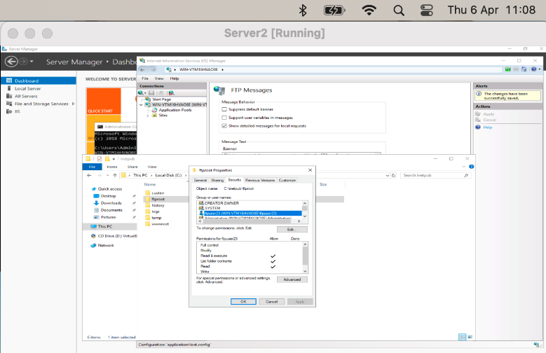

6.4.1. Test FTP Upload from Client PC
On the Client2, a folder was created and text file created for use to test the ftp. The following screenshot shows the opening of the ftp client and the custom banner configured in the ftp server. This is where the banner could warn the user regarding laws, ethics or company policy of using the service:
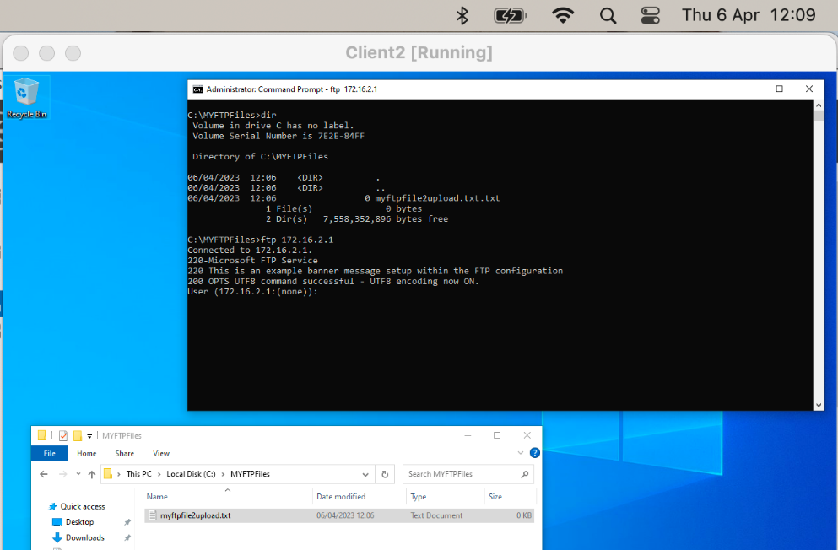

After successful login, the user is presented with the custom welcome message:
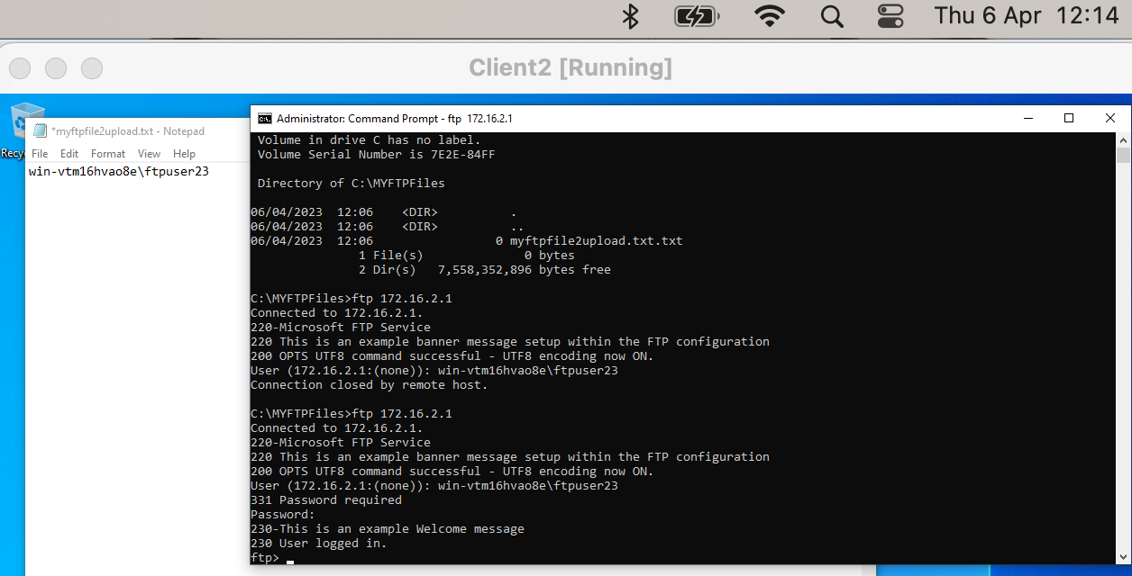

Note that, as expected, on first attempt the user does not have write permissions to the remote folder created above. This results in the ftp 550 Access is denied error:
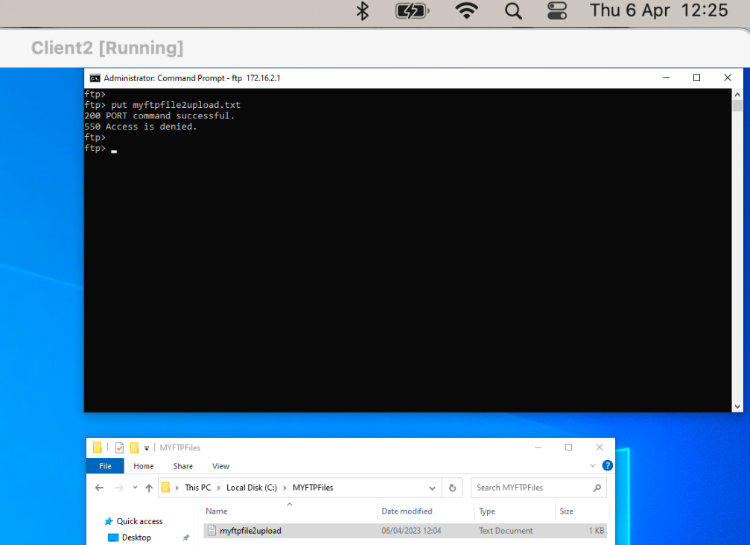

After correcting the permissions on the remote folder by adding the ability to write :
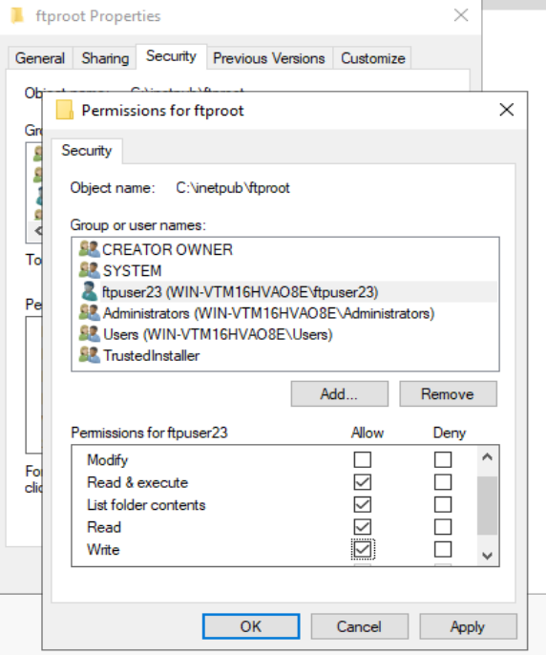

Reattempting the ftp put is now successful.

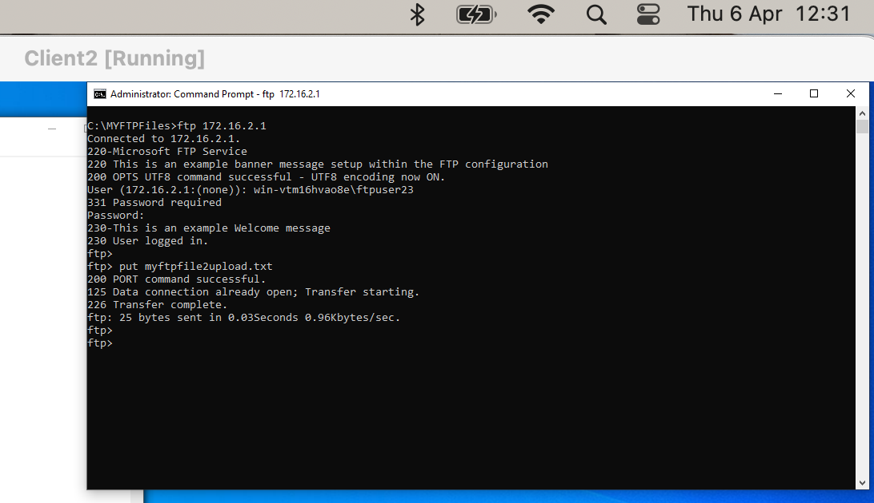

On Server2 we can see the file the was transferred using the put command:
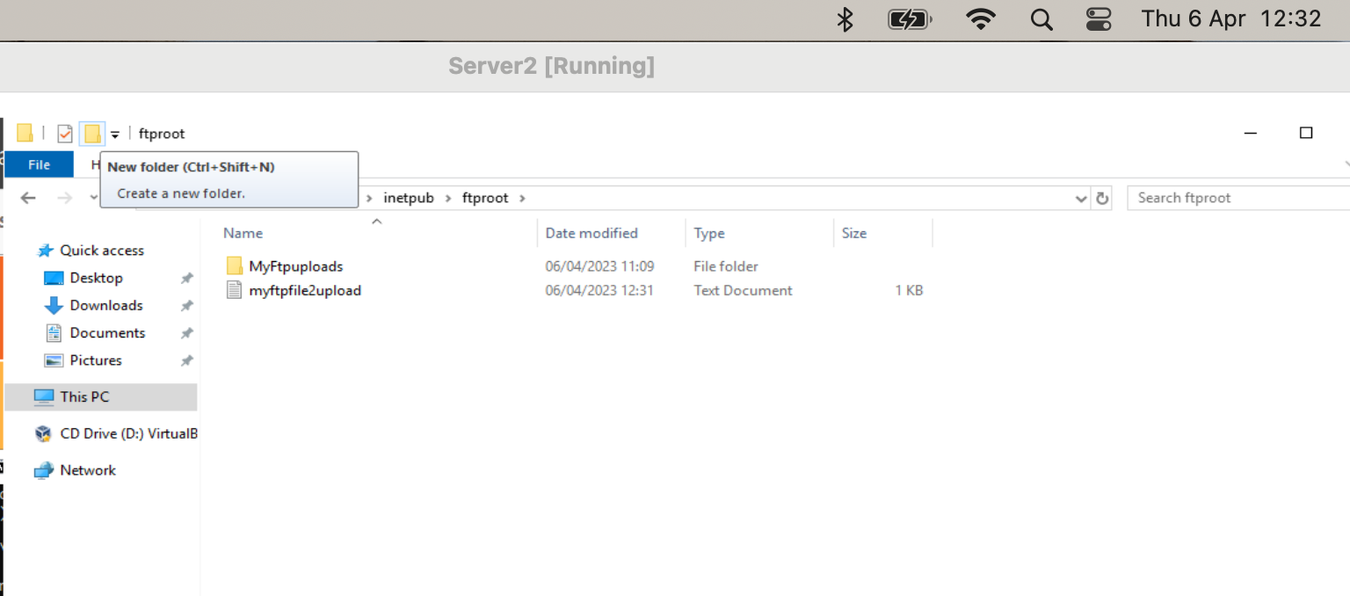

6.5. Installing and configuring the Routing and Remote Access Service

To allow two networks to communicate the DirectAccess and Routing services are installed and configured on both Server 1 and Server 2:
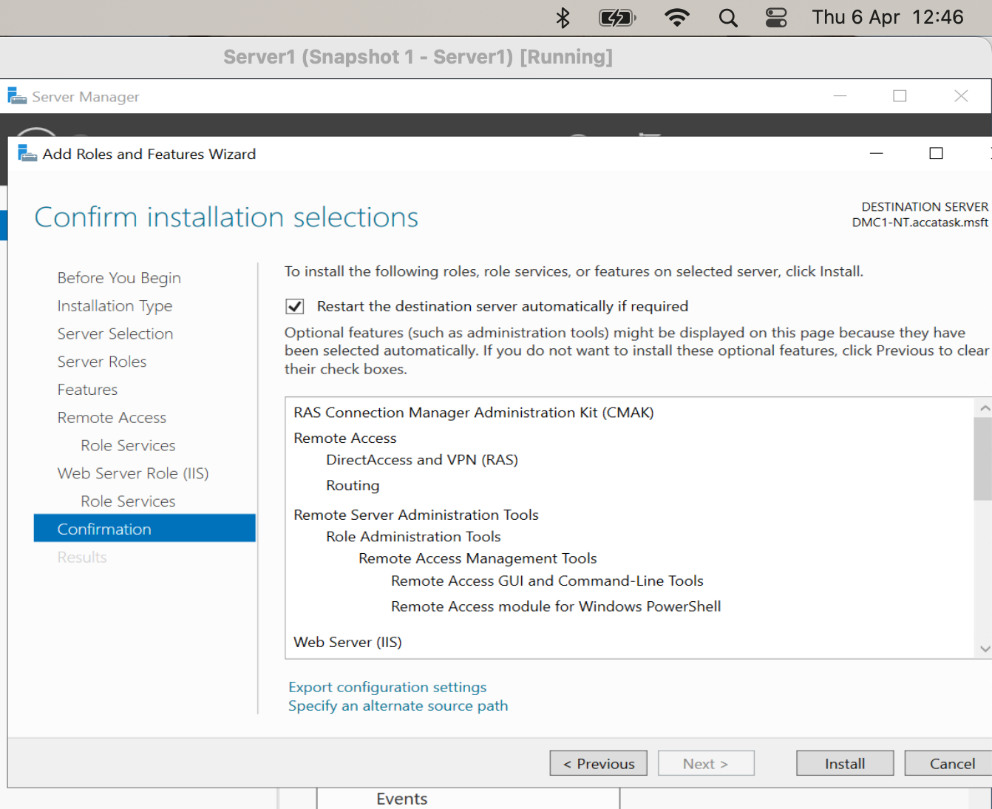

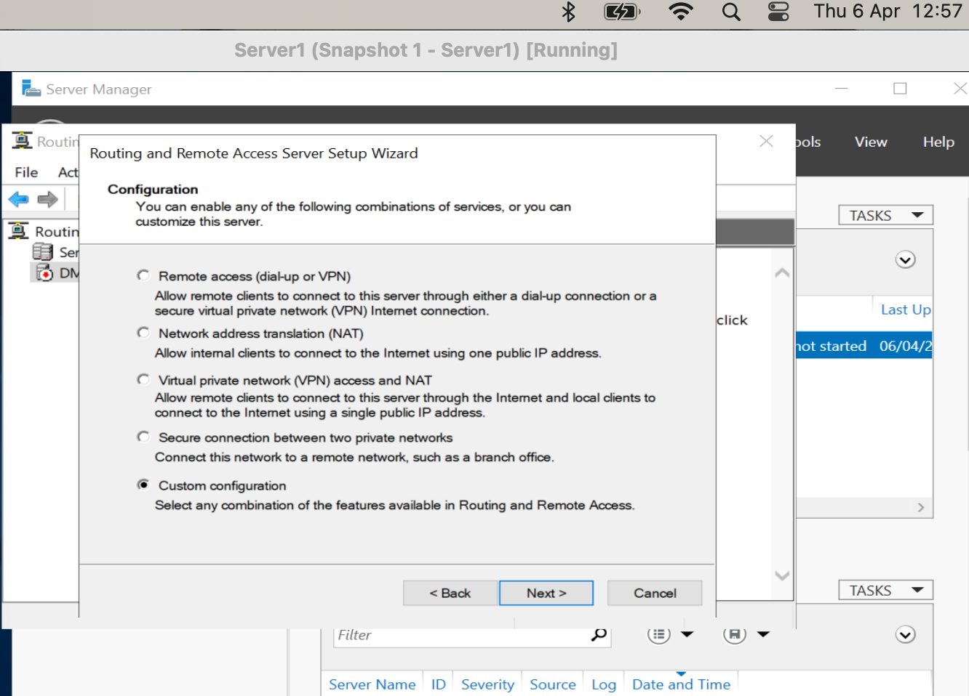

The Remote Access services was then started …
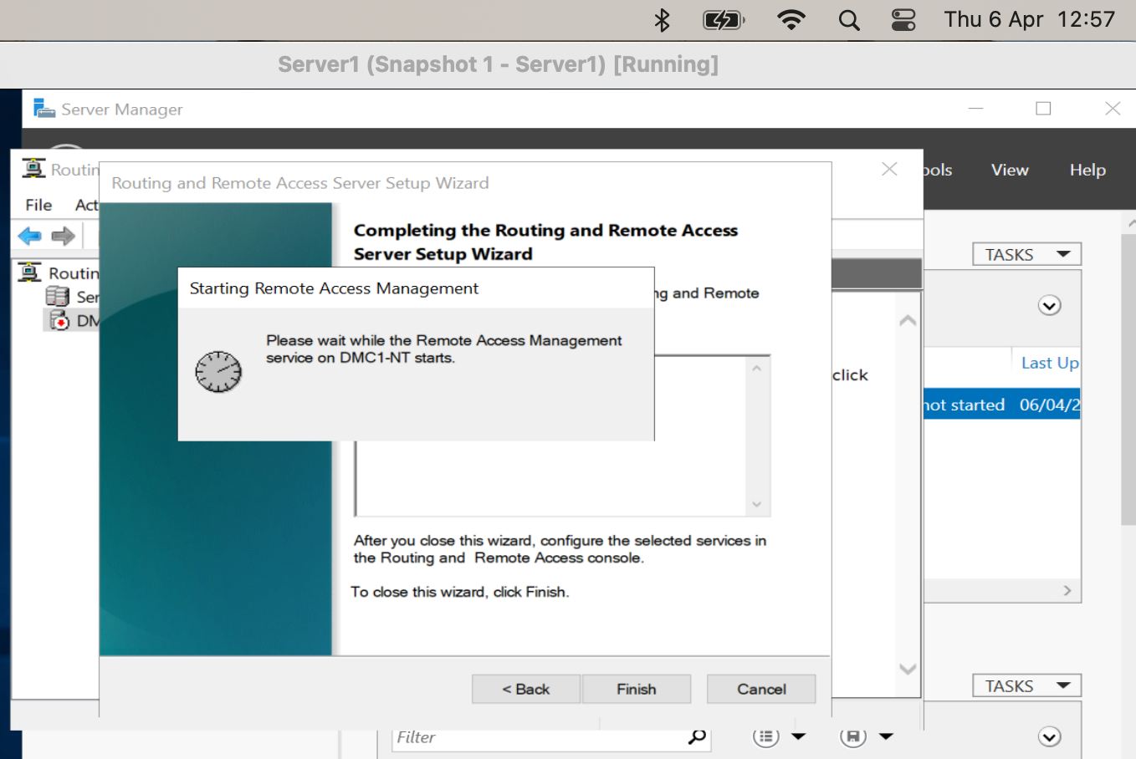

The Routing Information Protocol (RIP) was added, and both network interfaces included:

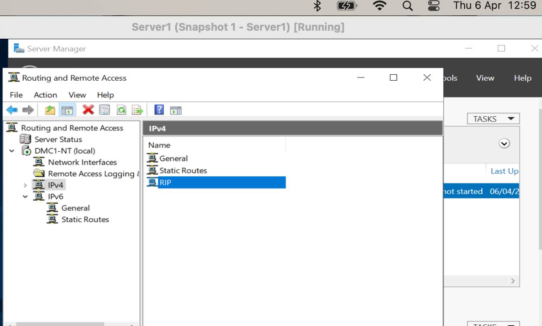

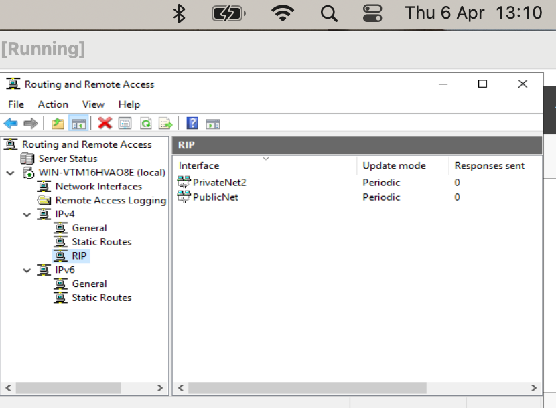

6.5.1. Verifying Remote Access

6.6. IP Packet Filtering
The following screen shot shows both Server1 and Client1. At this time, Client1 is able to ping, however, an Inbound Filter is then added and as expected Client1 is then no longer able to ping.
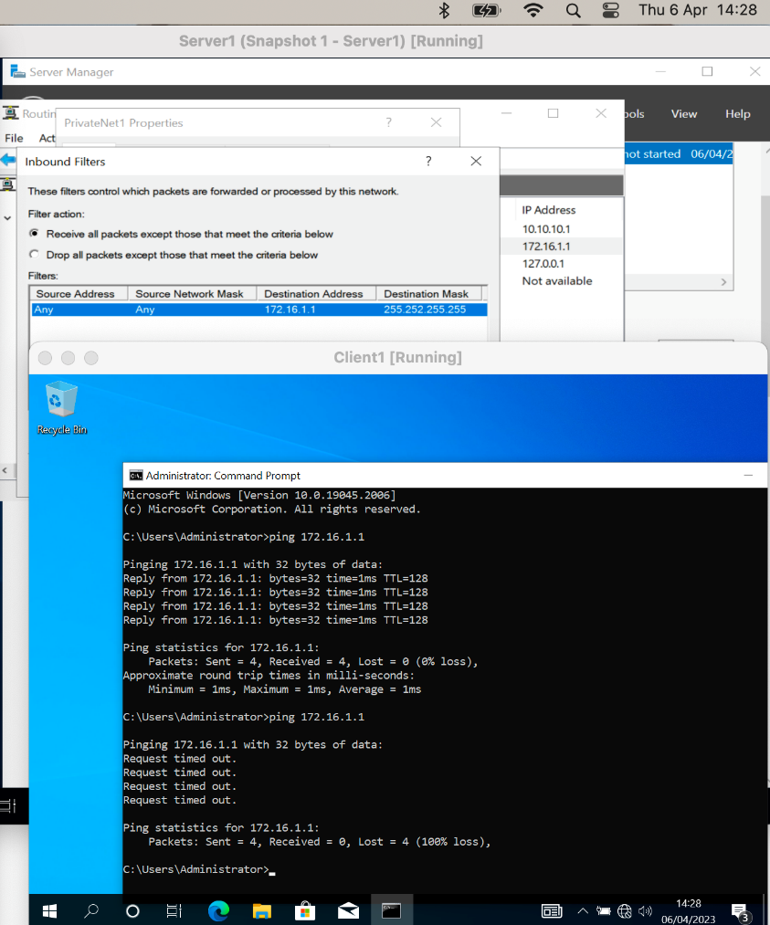

6.6.1. Filter 1: Stopping ‘anyone’ in PrivateNet 1 from Pinging the Router Firewall Service.

During the testing of this element, it was discovered that there was an issue present with the automatic configuration of the RIP which resulted in an unstable connection between the devices. Due to the nature of this issue as well as the unstable connection it provided resulted in Filter 2 and Filter 3 not being configured or tested. However, the following screen shots show some troubleshooting of the problem that shows the configuration.

6.6.2. Troubleshooting RIP
It was noted that with RRAS Stopped on the server, Client1 can ping server1 on 172.16.1.1

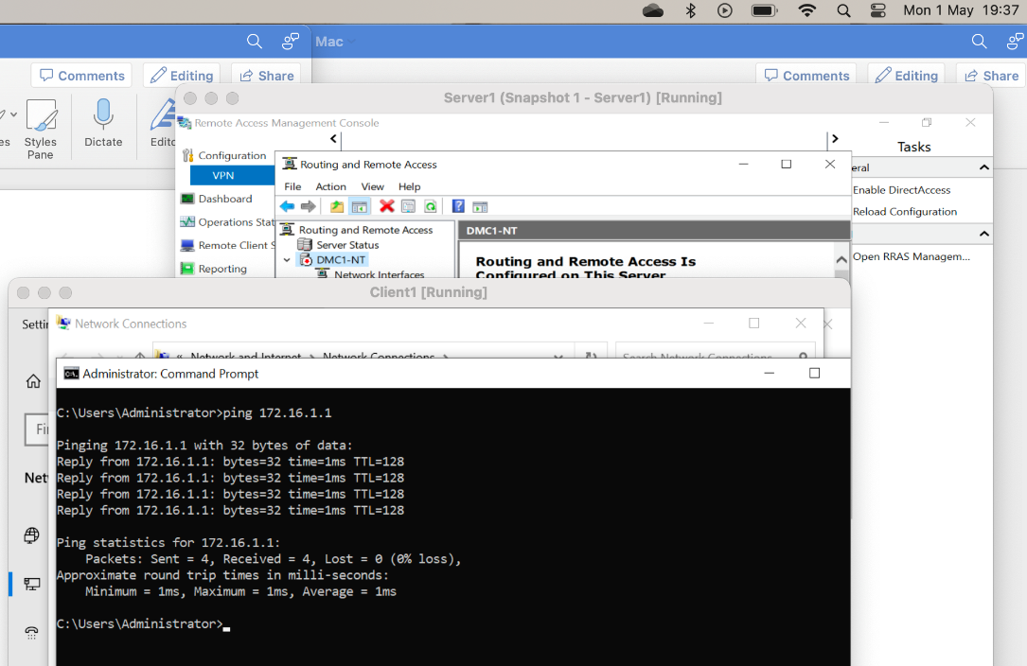

Enabling the RASS service stops the ping from Client1, however, no inbound filtering is enabled on that card:

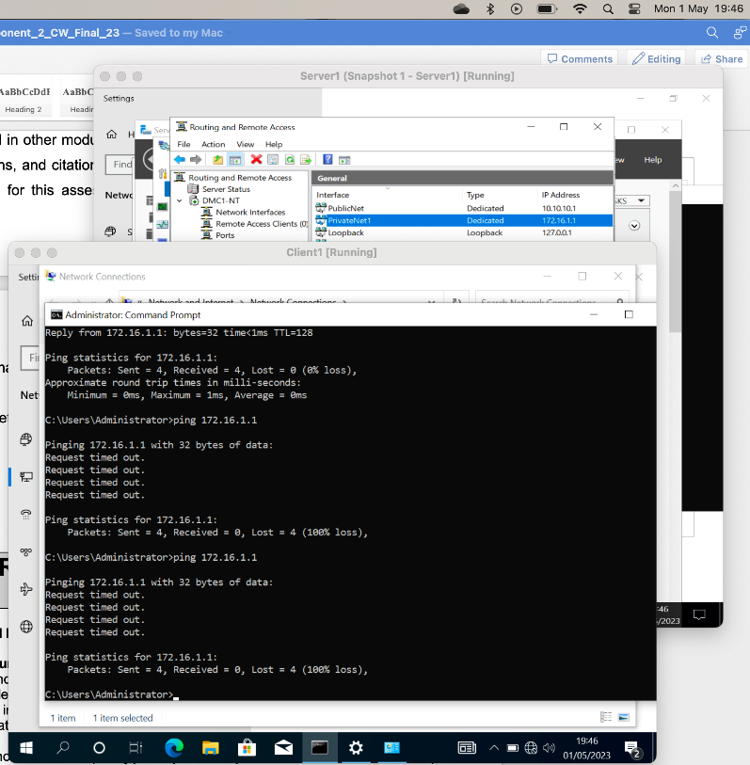

Server1 ARP -a shows client1 ip address:

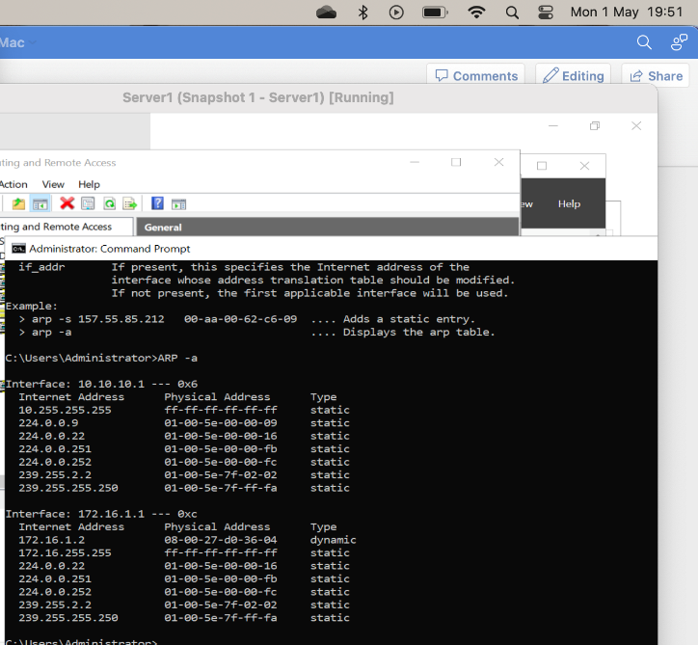

It was noted that removing both Inbound and Outbound Filters that had been setup automatically by the install wizard resolved the ping problem between network 172.16.1.0 and 10.10.10.0.

