ECAD6006:
Yr Iaith ar Daith3
Title: Portfolio

Module Lead: Catherine Morgan
Student Number: 1600932

Task 2
Welsh Government (2017, p30) states that “changes to the curriculum alone will not create our future Welsh speakers.” An essential aspect to creating a bilingual Wales is ensuring that teachers are constantly reviewing their progress in order to develop their knowledge and understanding of the Welsh language while improving their methods of teaching it (Estyn, 2013). During a university assignment last year I reflected on a Welsh lesson I taught in my second year Professional Teaching Experience (PTE) and this essay will consider how I have progressed since that reflection took place alongside what steps I intend to take in order to continue improving my Welsh linguistic skills.
One of the main issues I noticed while reflecting on the PTE2 Welsh lesson was that I often reverted back to speaking in English or immediately translating my Welsh sentences before giving the children adequate thinking time to consider what the Welsh words meant. This was due to a lack of confidence in my own abilities which can have a negative impact on the children’s learning. According to Estyn (2013, p.12) “Teachers do not devote enough time to the delivery of Welsh second language and many lack confidence in teaching Welsh, particularly to older key stage 2 pupils.” As I did not want to allow my confidence to affect key learning, since then, I have done numerous things to improve my abilities, confidence and enthusiasm for teaching the subject. I have researched into areas that I feel most unsure of, such as mutations, began conversing with fluent Welsh speakers as often as possible to develop my speaking and listening skills, and using Duolingo and dictionaries in order to expand my vocabulary.
I intend to promote Welsh at every opportunity within the classroom because being frequently exposed to a language makes it easier for learners to develop their listening, understanding, and speaking skills (Welsh Government, 2020). To ensure I am successful I intend to have a daily plan for incidental and deliberate use of the Welsh language. When creating Welsh planning sheets to coincide with specific lessons I will ensure the plans are not vague. In the past, I would occasionally only include basic patterns I intended to use, however, in future it would hep to be more prepared to expand on the areas of discussion so pupils can communicate through Welsh more to practice and develop their speaking and pronunciation. This should help me expand on things and increase my confidence which is an essential tool (Donaldson, 2015). Although participating in welsh lectures and looking over notes has improved my understanding of mutations this is still something I do not feel sure of and therefore, it could lead to me modelling incorrect language to the learners. I intend to continue developing my knowledge and understanding of mutations using practice sheets, notes from lectures, online tools, and continuing to converse with people who are fluent Welsh speakers as this challenges me to improve.
One of my targets was ensuring that learners were engaged throughout lessons taught in Welsh because if learners are motivated and enjoying the lesson it often leads to a more positive outlook on the use of another language and can promote recall (). There are numerous ways to encourage engagement and some areas I aim to do so are by using methods such as games within my lesson introductions. This is an aspect of a lesson that can result in learners using welsh vocabulary both orally and in written format, therefore, developing their listening, speaking, reading, and writing skills. It can the encourage learners to feel motivated and prepare them for tasks they would need to complete during the lesson in an upbeat way. Additionally, I intend to progress my teaching of the Welsh language by using Assessment for Learning (AfL) strategies such as lollypop sticks to keep children focused and engaged. As these strategies mean that all of the children are involved in the lessons, not just being spoken to, it is likely that they will put increased effort into speaking the welsh words and sentences correctly and with enthusiasm. Using AfL strategies and ensuring the children feel challenged or have extensions to their work can increase engagement with the work (Black and Williams, 2010).
Assessment of my skills against the Welsh Language Competency Framework (2019):
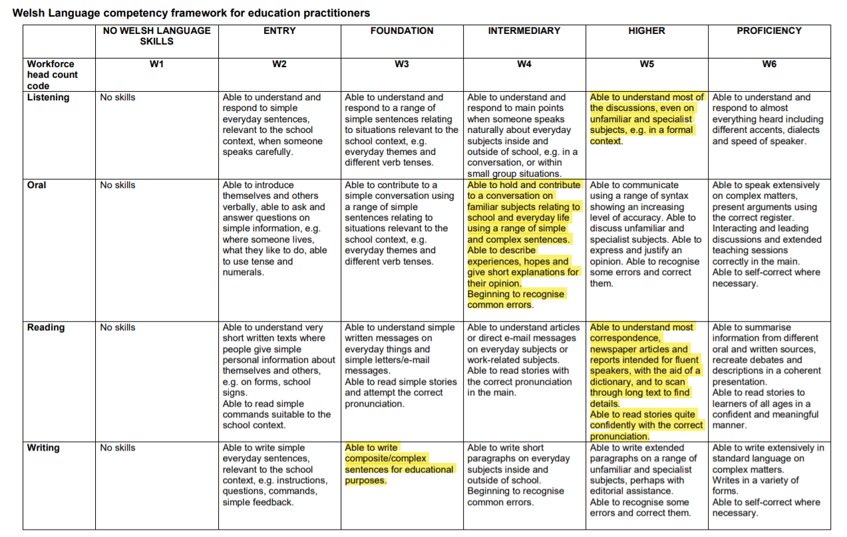

Task 2

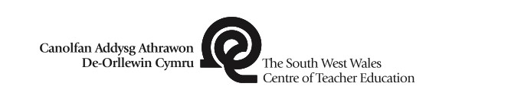 |  |  | 1B
Session Plan – Key Stage 2
Personal target(s) in relation to Use strategies such as AfL to keep children engaged with the
QTS: learning.
Year group: 5 | No. of XXXX learners: | ALN: XXXX
Additional Adults: 1
Learning objective(s):  To demonstrate the ability to understand and use appropriate Welsh questions and sentence patterns in relation to minibeasts verbally, while reading and in written form. |  | Success criteria:  To understand words and/or sentences written and spoken in Welsh used to describe mini beasts.  To pronounce new words clearly and accurately.  To communicate with peers to describe mini beasts in Welsh.
Links to previous learning: N/A
Curriculum coverage (range, skills) Current Curriculum:
- Communicate clearly and confidently and use intelligible Welsh pronunciation and intonation.
- Reinforce Welsh syntax by the accurate use of a variety of: vocabulary, phrases, questions and sentence patterns.
- Work independently, in pairs, in groups and as a member of a class.
- Spell simple words correctly, check spelling by using various methods, including ICT.

New Curriculum:
Progression Step 2
- I can respond to what I hear, read and view and express opinions in my language of choice.
- I am beginning to ask and answer questions to clarify my understanding.
- I can use an increasingly imaginative and varied vocabulary.
- I can share ideas, and express opinions and feelings using relevant vocabulary.
- I can use my knowledge of letter sounds and patterns to support my spelling.
- I can ask and answer questions and exchange ideas and information.
- I can develop my vocabulary and pronunciation through listening and reading, and can use these new words.
Key vocabulary(English/Welsh):
bwystfilod bach, araf, cyflym, bach, mawr, bert, brydferth, lliwgar, smotiog, hir, byr, meddal, caled, hedfan, adenydd, coesau, patrymau, malwoden, gwenynen, buwch goch gota, pry copyn, pili-pala, mwyden.

Session activities, organisation and management
Introduction

Begin by discussing with the class what they already know. Introduce new words related to the topic such as names of mini beasts and descriptive words that have not yet been covered in class. Activate prior knowledge by revisiting words, questions, and sentence patterns that the children have worked on previously. Use repetition and ask the class to say the words numerous times while doing an action that could relate to the word.

Fire round with key vocabulary: use lollipop sticks to call out someone to translate a word that appears on the board from English to Welsh or from Welsh to English. Child to make an action that could link to the word.
PowerPoint: give examples of questions to learners. In pairs using whiteboards, half the class to translate the question, half the class to answer it. This is repeated in rotation.

Play spot the odd one out with Welsh descriptive words in relation to certain minibeasts e.g. ‘Buwch goch gota- bach, smotiog, glas’. Learners to write out their answers on a white board. Tri,
dau, un, dangoswch i mi. Children pronounce the word they have chosen and show the whiteboards. Use lollipop sticks to ask learners why what they chose was the odd one out.
Main activities

Carousel learning activity with 3 areas where:

- Learners read sentences and mini beast names written in Welsh and connect them to the image of the correct mini beast.
- Learners will choose a mini beast. In pairs, they will take it in turns to ask each other questions about what attributes the chosen mini beast poses and answer appropriately. These questions and answers will be spoken in Welsh to practice question and answer patterns while working out what mini beast the other has chosen.
- Learners will follow the same guidelines as aforementioned in number 2, however, they will not be allowed to talk. They will write their questions and answers to each other in Welsh on a whiteboard.

Help sheets including key vocabulary and questions given to children to help them complete their work independently.

Plenary

Learners to write a Welsh sentence on a post it note stating what their favourite minibeast is and why e.g. ‘Fy hoff bwystfil bach yw… achos…’. Following this in English they should traffic light how difficult they found the lesson alongside one thing they enjoyed and one thing they found challenging.

 |  |  | 1B
Session Plan – Key Stage 2
Personal target(s) in relation to Be confident in my subject knowledge and delivery of the
QTS: lesson.
Year group: 5 | No. of XXXX learners: | ALN: XXXX
Additional Adults: 1
Learning objective(s):  To demonstrate the ability to understand and use appropriate Welsh questions and sentence patterns in relation to minibeasts verbally, while reading and in written form. |  | Success criteria:  To understand words and/or sentences written and spoken in Welsh used to describe mini beasts.  To communicate with peers to describe mini beasts in Welsh.  To use the glossary provided alongside dictionaries and ICT to write sentences about mini beasts in Welsh.
Links to previous learning: Learners have previously been introduced to vocabulary relating to minibeasts and have practiced these by listening, speaking, reading, and writing. They have also used question and answer patterns and practiced conversing and describing minibeasts using added vocabulary.
Curriculum coverage (range, skills) Current Curriculum:
- Communicate clearly and confidently and use intelligible Welsh pronunciation and intonation.
- Reinforce Welsh syntax by the accurate use of a variety of: vocabulary, phrases, questions and sentence patterns.
- Work independently, in pairs, in groups and as a member of a class.
- Spell simple words correctly, check spelling by using various methods, including ICT.

New Curriculum:
Progression Step 2
- I can respond to what I hear, read and view and express opinions in my language of choice.
- I am beginning to ask and answer questions to clarify my understanding.
- I can use an increasingly imaginative and varied vocabulary.
- I can share ideas, and express opinions and feelings using relevant vocabulary.
- I can use my knowledge of letter sounds and patterns to support my spelling.
- I can ask and answer questions and exchange ideas and information.
- I can develop my vocabulary and pronunciation through listening and reading, and can use these new words.
- I can listen to, understand and later recall what I have heard.
- I can review my work and am beginning to use a range of familiar strategies and tools to improve my speaking and writing.
- I can spell high-frequency words correctly.
- I can use my knowledge of letter sounds and patterns to support my spelling.
Key vocabulary(English/Welsh):
bwystfilod bach, araf, cyflym, bach, mawr, bert, brydferth, lliwgar, smotiog, hir, byr, meddal, caled, hedfan, adenydd, coesau, patrymau, malwoden, gwenynen, buwch goch gota, pry copyn, pili-pala, mwyden.

Session activities, organisation and management
Introduction

Recap on vocabulary, questions and sentence patterns discussed and used in the previous lesson. Activate prior knowledge by revisiting words, questions, and sentence patterns that the children have worked on previously. Use repetition and ask the class to say the words numerous times while doing an action that could relate to the word.
Think, pair, share, using whiteboards, translate sentences, questions and answers that appear on the board from English to Welsh or from Welsh to English.
Main activities

There will be two separate main activities to match the children’s abilities.

- Learners will be asked to write a paragraph about one minibeast of their choice and draw a picture to go along with it.
- There will be a Welsh question sheet on minibeasts provided. Learners should answer the questions in full sentences regarding three different minibeasts.

Help sheets including key vocabulary and questions given to children to help them complete their work independently.

Children advised to use i-pads, dictionaries, help sheets and other recourses available to them to complete their work.

Extension: Use i-pads to search for interesting facts regarding the minibeasts they chose. Write it down in English and choose key words they are unsure of, find the welsh translation in the dictionary and attempt to sound them out.

Plenary

Hot Seat:

Each table to have one person in the hot seat as a mini beast while the group asks them questions and they provide answers using the sentence patters and vocabulary learnt in Welsh.

End session with a game of kahoot on minibeasts vocabulary, questions and answers.

Reference List

Black, P. and Wiliam, D. (2010) ‘Inside the Black Box: Raising Standards through Classroom Assessment’. Phi Delta Kappan: 92(1), pp.81-90.
Donaldson, G. (2015) Successful futures, Cardiff: Welsh Government.
Estyn (2013) Welsh Language Development in the Foundation Phase, Cardiff: Welsh Government.
Welsh Government (2017) Welsh in education: Action plan 2017–21, Cardiff: Education Wales.
Welsh Government (2019) Welsh Language competency framework for education practitioners. [Online] Availible at: https://gov.wales/sites/default/files/publications/2019-06/welsh-language-competency-framework-for-education-practitioners.pdf (Accessed: 15th May 2020).
Welsh Government (2020) Curriculum for Wales guidance, Cardiff: Education Wales.

