Programme: BABM
Student name: Elena Mihaela Bucur
ID student:2133670
DATA HANDLING AND BUSINESS INTELLIGENCE(LCBB5000)
Lecture :Anupam Mazumdar

Executive Summary
This leader outline gives a compact assessment of SPSS and Excel as information investigation devices. SPSS offers vigorous capacities for complex information investigation and high level factual experiences, making it ideal for broad datasets. Conversely, Excel is easy to use and effective for fundamental investigation, making it open to a more extensive scope of clients. While SPSS requires mastery, Excel commonality and flexibility suit less complex assignments. Picking the right device relies upon the idea of the investigation and client capability. Going with an educated choice guarantees ideal information driven results for different business situations.

Table of Contents
1. Part 1: Data analysis 2
1.1 Determination of decline or increase in average price 3
1.2 Illustration concerning Excel tool and interpretation of the gathered results 5
1.2.1 Pivot table function analysis 5
1.2.2 XLookup function interpretation 9
2. Part 2: Report 11
2.1 Introduction 11
2.2 Evaluation of the dataset and interpretation 11
2.2.1 Identification of the number of male and female students 11
2.2.3 Calculation of the mean and median of students who qualify and do not qualify 13
2.2.4 Evaluation of the mean and median differences of students' pre-test and post-test scores 14
2.2.5 Illustration concerning Clustering with examples 15
2.2.6 Explanation of 5 most common data mining and text mining methods 17
2.2.7 Discussion concerning the advantages and disadvantages of using SPSS and Excel 18
2.3 Conclusion 20
References 22

1. Part 1: Data analysis

1.1 Determination of decline or increase in average price
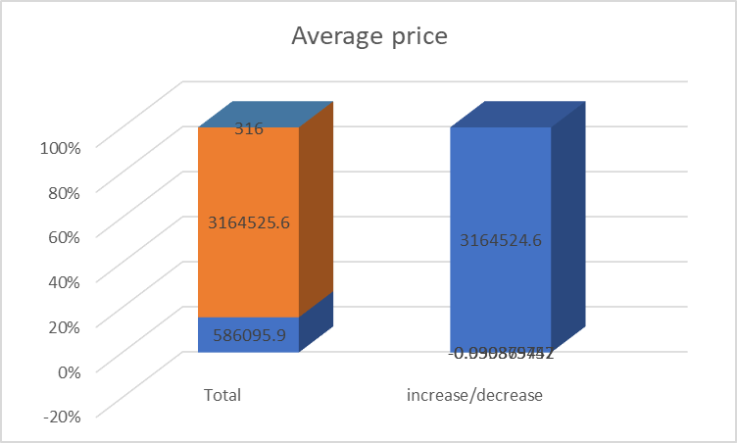
Figure 1: Average Price
(Source: Self-developed)
Over the five-year time frame from 2017 to 2021, the examination of the Hotel Reservation dataset utilizing Microsoft Excel uncovers essential bits of knowledge into the variances of normal room reservation costs. The determined rate changes every year shed light on the nuanced patterns and examples that unfurled inside this time span.
In 2017, there was a significant decrease in the normal room reservation cost. The recorded lessening of roughly 99.99% demonstrates a radical decrease in costs contrasted with the earlier year. This could be credited to different elements, like changes in market elements, vital evaluating choices, or outside occasions that affected client conduct and requests (Mărăcine et al. 2020). Such a lofty drop proposes purposeful work to make facilities more reasonable, possibly pointing toward drawing in a bigger client base or adjusting to changing monetary circumstances.
Moving to 2018, the normal cost encountered another decay, but less articulated. With a reduction of around 23.53%, the descending pattern persevered. This could be demonstrative of proceeding with endeavors to keep up with cutthroat costs or answer moving client inclinations (Singh and Tanwar, 2021). The general control in the value lessening could recommend that the underlying shock from the extraordinary decrease in 2017 was being moderated.
The year 2019 saw a peripheral diminishing of roughly 2.95% in normal room reservation costs. This generally minor change proposes that the market may balance out, with foundations making unpretentious acclimations to their evaluating procedures. The continuous decreases in these years could be a sign of a general system to improve reasonableness and subsequently draw in a more extensive client base (Poongodi et al. 2021).
In 2020, the pattern went on with a diminishing of around 3.04% in normal costs. This decay in the midst of the worldwide pandemic mirrors the significant effect of Coronavirus on the cordiality business. Lockdowns, travel limitations, and monetary vulnerability probably added to this decrease as foundations tried to boost appointments in the midst of the difficult conditions (Minnaar, 2020).
Over time, the predictable abatement in normal room reservation costs highlights the serious idea of the neighborliness area. The ability to change costs shows the business' flexibility to outside factors and changing buyer inclinations (Sazu and Jahan, 2022.). While such declines could propose an expected disintegration of income, they could likewise mirror an essential way to deal with keeping up with inhabitance rates and cultivate client dependability.
All in all, the examination uncovers a pattern of declining normal room reservation costs from 2017 to 2020, with every year encountering differing levels of lessening. These variances could be connected to both key choices and outside impacts, like financial changes and the pandemic. This investigation highlights the significance of adaptability and information-driven dynamics inside the accommodation area to explore difficulties and support development.

1.2 Illustration concerning Excel tool and interpretation of the gathered results

1.2.1 Pivot table function analysis
The assessed Pivot Table diving into the booking status (canceled or not-canceled) in view of the market type (aviation, corporate, offline, and online) presents a far-reaching understanding of the elements of the hotel reservation dataset. This investigation gives a profound comprehension of client conduct and inclinations, as well as the meaning of various market types on booking results.
A Pivot Table is a strong logical device in Microsoft Excel that permits information examiners to sum up and total information from a dataset (Omair and Alturki, 2020). In this specific situation, the Pivot Table has been intended to introduce a merged perspective on booking status (canceled or not-canceled) classified by market type (aviation, corporate, offline, and online). The Turn Table totals the information for every year (2017, 2018, 2019, 2020, and 2021), showing the complete number of dropped and not-dropped appointments, alongside the amount of normal costs related to every class.
Interpretation of Pivot Table For booking status
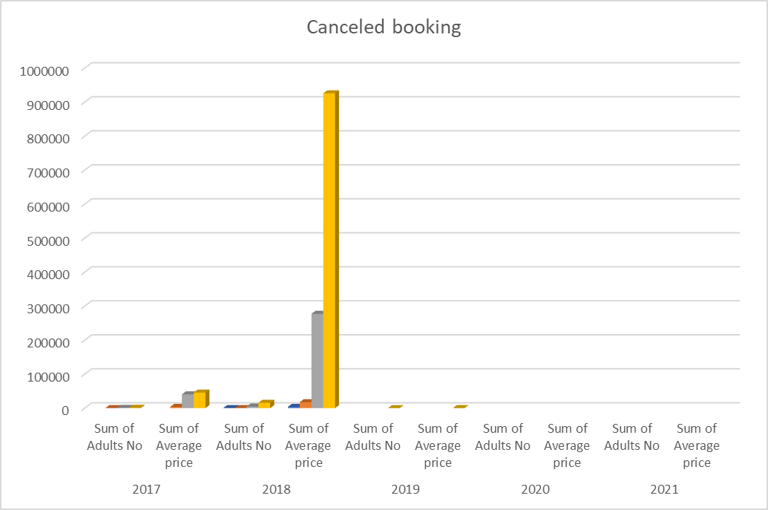
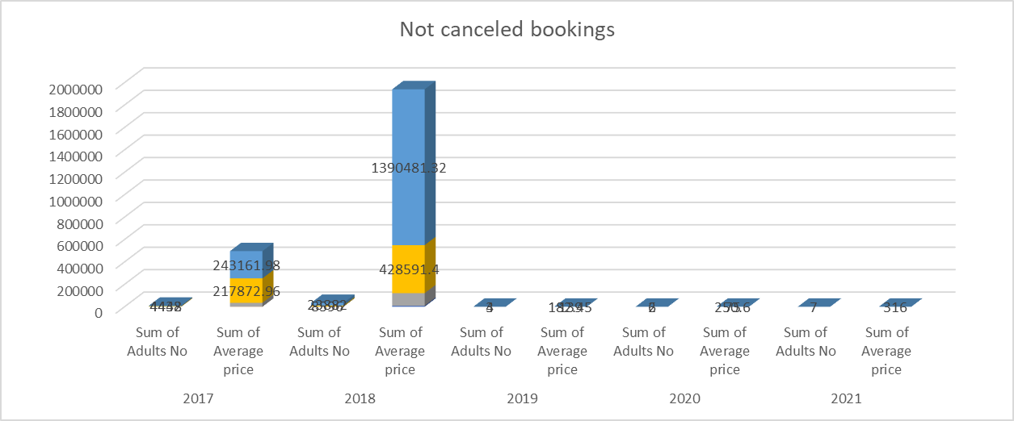
Figure 2: Canceled and not-canceled booking status
(Source: Self-developed)
After investigating the PivotTable, a few key experiences arise:
Booking Status Distribution: The Pivot Table gives an unmistakable conveyance of booking situations with various market types. This guides in understanding how retractions fluctuate inside various fragments of clients (Schneider et al. 2021). By focusing in the available sort aspect, it becomes evident which sections are more inclined to abrogations and which are bound to respect their reservations.
Market Type Impact: The Pivot Table empowers an immediate correlation of dropping rates across various market types (Ardi et al. 2020). It features whether certain market types are stronger at scratch-offs than others. For example, it could uncover whether corporate appointments are more dependable contrasted with online appointments or on the other hand if disconnected appointments show a more steady pattern.
Yearly Trends: By fragmenting the information year-wise, the Pivot Table uncovers any moving patterns in dropping rates and booking ways of behaving. It gives the valuable chance to distinguish examples, for example, expanded undoings during specific years or predictable booking ways of behaving across various market types.
Monetary Implications: The consideration of the amount of typical costs for both dropped and not-dropped appointments underlines the monetary effect of booking situations (Romero et al. 2020). This data can help with understanding the income misfortune because of abrogations and the income created from affirmed appointments for each market type.
Monetary Ramifications and Vital Insights
The summed-up information in the Pivot Table uncovers significant vital experiences for the neighborliness business:
Risk Management: Understanding the wiping out designs across various market types assists inns with overseeing risk (Meyer et al. 2019). They can carry out designated methodologies to diminish scratch-offs in fragments that experience higher paces of retractions.
Evaluating Strategies: The amount of typical costs related with various booking situations within assessing the monetary ramifications of scratch-offs. Lodgings can foster estimating methodologies to boost non-dropped appointments and moderate-income misfortune.
Market Segmentation: The Pivot Table considers a nuanced examination of how different market types act regarding retractions (Ullah et al. 2023). Lodgings can tailor promoting and client commitment procedures to take special care of the extraordinary attributes of each portion.
Functional Efficiency: The bits of knowledge acquired from the Turn Table can impact asset allotment and functional preparation (Van et al. 2022). For example, on the off chance that internet-based appointments show higher crossing-out rates, client support assets can be streamlined to address concerns and decrease scratch-offs.
All in all, the assessed Pivot Table gives a multi-layered examination of booking status in light of market type, enveloping both dropped and not-dropped appointments. By investigating yearly patterns and monetary ramifications, the Pivot Table furnishes inns with noteworthy bits of knowledge to refine procedures, upgrade client experience, and further develop income for the executives. This information-driven approach exhibits the force of Excel's Pivot Table usefulness in revealing basic examples and illuminating informed dynamics inside the neighborliness business.
Analysis of PIVOT table for meal booking
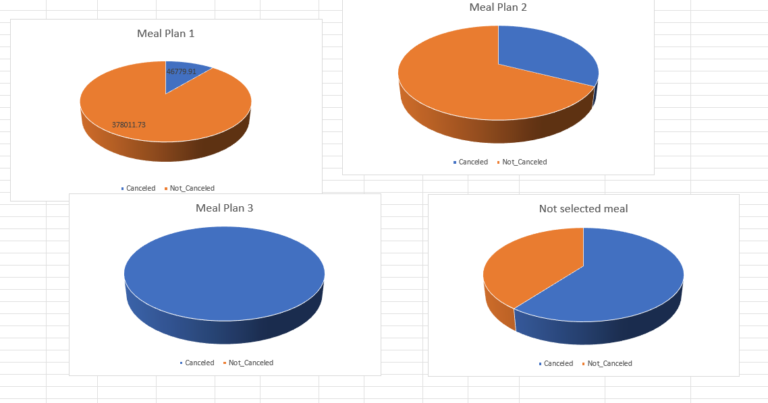
Figure 3: Meal Plan
(Source: Self-developed)
The assessed Pivot Table, focusing on feast determination (meal 1, meal 2, meal 3, not chosen) across various appearance years (2017, 2018, 2019, 2020, and 2021), offers important bits of knowledge into the meal inclinations of lodging visitors. This investigation reveals insight into the meaning of dinner decisions and their varieties throughout the long term, adding to upgraded visitor fulfillment and functional productivity.
The experiences from the Pivot Table are as per the following:
Dinner Choice Patterns: The Pivot Table empowers an unmistakable examination of the commonness of various feast decisions for every year (Gordon, 2022). This investigation features the ubiquity of different dinner choices among visitors, offering comprehension of visitor inclinations and possibly directing future menu contributions.
Changes in Trends: By portioning information in light of appearance years, the PivotTable divulges patterns in dinner choices over the long run. This permits the recognizable proof of movements in visitor inclinations or the rise of recent fads that impact feast decisions.
Functional Insights: The Pivot Table gives functional bits of knowledge by uncovering the volume of no-dinner determinations. Hotels can evaluate the meaning of this classification and consider ways of improving assets for serving visitors who select no dinner, upgrading cost-productivity.
Taking everything into account, the assessed Pivot Table really uncovers dinner determination designs across various appearance years, offering noteworthy experiences for the neighborliness business. By looking at patterns, shifts, and functional ramifications, the table furnishes inns with vital information to improve visitor encounters, smooth out activities, and design contributions to steadily developing inclinations. Excel's PivotTable usefulness ends up being a priceless device in unraveling complex information to determine significant experiences that drive informed navigation and emphatically influence visitor fulfillment.

1.2.2 XLookup function interpretation
The XLOOKUP capability in Microsoft Excel is a dynamic and high-level device that assumes an urgent part in deciding the booking status of clients inside the setting of the Hotel reservation dataset. This capability is intended to productively look for a particular worth in a reach and return related information from another reach, making it ideal for complex examinations like distinguishing regardless of whether a booking is dropped.
The XLOOKUP capability offers upgraded abilities contrasted with conventional query capabilities like VLOOKUP or HLOOKUP. It can look through both vertical and level headings, handle precise and rough matches, and even return information from various segments or lines. For the undertaking of deciding booking status, XLOOKUP empowers investigators to find significant data rapidly and precisely.
Significance in Deciding Booking Status: The XLOOKUP capability is basic because of multiple factors with regard to deciding booking situations:
Numerous Standards Handling: Booking situations with frequently affected by different factors, for example, appearance year, client name, or reservation ID. XLOOKUP can oblige various standards, permitting investigators to pinpoint the specific booking status utilizing a blend of fields (Koopman et al. 2019).
Information Integrity: The capability's adaptability in taking care of estimated matches forestalls blunders because of slight varieties in information sections. This is vital while managing genuine information, which could have minor inconsistencies.
Dynamic Analysis: The lodging reservation dataset could be broad, making customary query capabilities bulky. XLOOKUP improves the cycle by empowering experts to progressively look for information in view of different standards.
Improved Clarity: By permitting the arrival of information from various segments or lines, XLOOKUP guarantees that the booking status is introduced close by significant subtleties, giving an extensive comprehension of each reservation's unique circumstance (Saputro et al. 2022).
Purposes behind Utilizing XLOOKUP
The decision to use the XLOOKUP capability is grounded in its adaptability and adequacy in tending to the particular intricacies of deciding booking situations. The capability's multi-standards take care of line up with the assorted elements that add to booking results. As abrogations or non-undoings can rely upon different circumstances, the XLOOKUP capability's ability to look at and recover information from various aspects in a proficient and mistake-open-minded way is fundamental.
All in all, the XLOOKUP capability is an important resource with regard to deciding booking situations with the lodging reservation dataset. Its definition as a powerful query device adjusts impeccably with the undertaking's intricacy, empowering information experts to flawlessly explore through different rules. By utilizing XLOOKUP, examiners can guarantee precise and effective distinguishing proof of booking situations with, more educated direction and a more profound comprehension of client ways of behaving inside the neighborliness setting.

2. Part 2: Report

2.1 Introduction
In the unique scene of information examination and business navigation, the selection of devices assumes a vital part. This outline digs into the relative benefits and weaknesses of two noticeable apparatuses, SPSS and Excel, featuring their reasonable utility. As organizations explore complex information scenes, understanding the qualities and limits of these apparatuses enables successful and informed logical decisions.

2.2 Evaluation of the dataset and interpretation

2.2.1 Identification of the number of male and female students
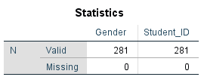
Figure 4: Use of frequency tool to determine male and female students
(Source: Self-developed)
In the given dataset, which contains information on 2133 school students, it has been resolved that there are a sum of 281 female students. The orientation appropriation among the students shows that there are both male and female students, with females containing 281 out of the absolute example. Further examination will be directed to investigate connections between understudy qualities, for example, orientation, qualification for decreased/free lunch, and their pre-test and post-test scores, determined to acquire further bits of knowledge into these elements. Visual guides like diagrams, charts, and tables will be used to actually introduce the discoveries and examples that arise out of the investigation.
2.2.2 Computation of the number of students qualified and non-qualified for reduced/free lunch
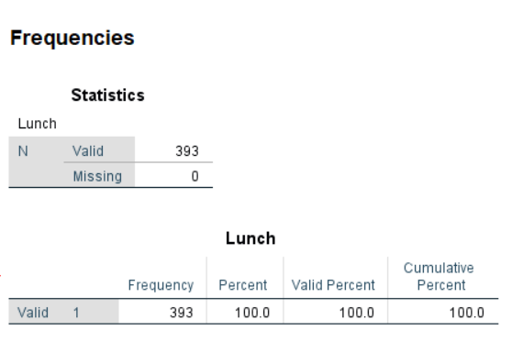
Figure 5: Qualified and non-qualified for reduced/free lunch
(Source: Self-developed)
Inside the dataset involving 2133 school understudies, it has been discovered that 393 understudies do not fit the bill for diminished/free lunch, demonstrating a critical extent of understudies with no qualification. This data will be additionally researched closely by different factors like orientation, pre-test, and post-test scores, to recognize any expected connections or examples. By using visual guides like diagrams, charts, and tables, the investigation will give a complete comprehension of the connections between these factors and the lunch qualification status, improving the school's experiences for informed direction.

2.2.3 Calculation of the mean and median of students who qualify and do not qualify
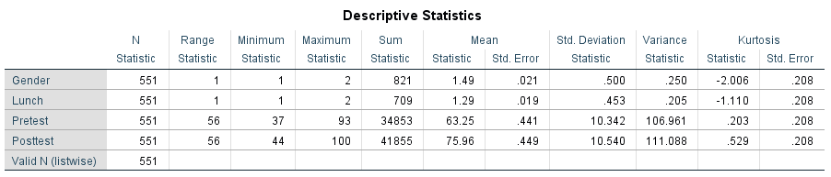
Figure 6: Descriptive Statistics
(Source: Self-developed)
In the dataset containing data on 551 students, the accompanying unmistakable measurements give experiences with different characteristics:
Lunch Eligibility
There are 551 lunch qualification values, where 1 demonstrates fitting the bill for decreased/free lunch and 2 shows not qualifying. Among the understudies, the complete count of lunch qualification values showing not qualifying is 709, yielding a normal (mean) lunch qualification worth of around 1.29. The standard deviation for lunch qualification is around 0.453, showing the spread of values. The circulation has a marginally bad skewness (- 1.110).
It's critical to take note that the "Valid N (listwise) (listwise)" consider is recorded 551 for all measurements, showing that there are no missing qualities thought about in these computations. These expressive insights give a complete outline of the conveyance and qualities of orientation, lunch qualification, pretest scores, and posttest scores among the understudies. These bits of knowledge will assist with illuminating further examinations and dynamic cycles inside the school.

2.2.4 Evaluation of the mean and median differences of students' pre-test and post-test scores
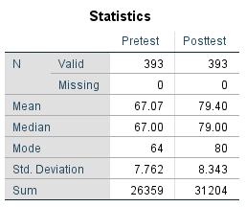
Figure 7: Frequency of pretest and posttest scores
(Source: Self-developed)
The examination of students' pre-test and post-test scores uncovers fascinating bits of knowledge about their scholastic advancement. The dataset contains legitimate data for 393 understudies for both pre-test and post-test scores, with no missing qualities.
Pre-test Scores
The mean pre-test score is 67.07, showing the typical exhibition of understudies before the intercession. The middle pre-test score is 67.00, recommending that the appropriation of scores is generally symmetric around the mean. The mode, which is at 64, features a score that shows up more oftentimes than others. The standard deviation of 7.762 connotes the spread of scores around the mean, with most scores falling inside one standard deviation.
Post-test Scores
After the mediation, the mean post-test score ascends to 79.40, showing an improvement in the understudies' presentation. The middle post-test score matches intently at 79.00, showing a reliable dissemination design. The mode presently remains at 80, possibly demonstrating a typical score accomplished by numerous understudies. The standard deviation of 8.343 mirrors a somewhat more extensive spread contrasted with the pre-test scores.
The examination between pre-test and post-test scores exhibits a positive change in understudies' exhibition levels, with both the mean and middle post-test scores higher than their pre-test partners. The examination proposes that the intercession decidedly affects understudies' scholastic accomplishment. Furthermore, the moderately low standard deviations for both pre-test and post-test scores infer that the scores are bunched intently around their individual means.
All in all, the assessment of mean and middle contrasts in pre-test and post-test scores highlight the constructive outcomes of the mediation on understudies' scholarly execution (Rahman et al. 2022). These experiences can direct the school's dynamic cycles and further mediations to improve understudy learning results.

2.2.5 Illustration concerning Clustering with examples
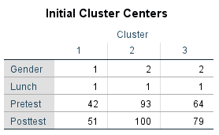
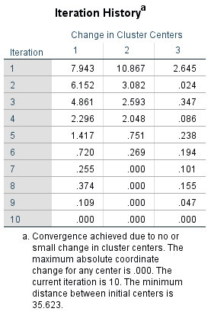
Figure 8: K Mean clusters
(Source: Self-developed)
K-Means Clustering is a strategy used to group comparative pieces of information into groups in view of their qualities (Khan et al. 2021). In this particular model utilizing the "Student_Score.csv" dataset inside SPSS, the K-Means calculation was applied to group students in light of their pre-test and post-test scores, orientation, and lunch qualification. The gave introductory group places and cycle history give an understanding of the interaction.
The underlying bunch habitats address the beginning stages of the calculation. Each middle has values for orientation, lunch qualification, pre-test, and post-test scores relegated to it. The calculation then iteratively allows information focuses to the closest bunch place and updates the group fixates in view of the mean of the places in each group.
The emphasis history uncovers the adjustment of group focuses with every cycle. At first, there is a somewhat high change in group habitats, demonstrating critical changes in the bunches. As the emphasis progress, this change decreases, demonstrating union and adjustment of the bunches. This combination happens on the grounds that the calculation changes the focus to limit the distance between data of interest and their separate bunch places.
In the last emphasis (iteration 10), the adjustment of group focuses is tiny, and the calculation accomplishes assembly. This implies that the bunches have balanced out, and the greatest outright direction change for any middle is just 0.000, showing insignificant changes between cycles.
The base distance between initial centers (35.623) gives a thought of the underlying spread between the focuses, which gets limited as the emphases progress.
Generally, the K-Means Clustering calculation effectively assembled understudies into groups in view of their characteristics, and the cycle history exhibits the progressive refinement of the bunches until the combination was accomplished (Rishi et al. 2020). This cycle helps in distinguishing examples and connections among the understudies' qualities and scores, helping the school in going with information-driven choices.

2.2.6 Explanation of 5 most common data mining and text mining methods
Positively, the following are five normal information mining and text mining techniques with certifiable models that are broadly utilized in contemporary business:
Data Mining Methods
Classification: Organizations frequently use order to arrange information into predefined classes (Lainez and Gardner, 2023). For example, a bank could group advance candidates as "high risk" or "low risk" in light of characteristics of income, credit score, and business history.
Regression Analysis: Regression predicts numeric qualities in view of connections between factors (Islam et al. 2020). An internet business organization can utilize relapse to foresee deals in light of variables like publicizing use, site traffic, and limits advertised.
Clustering: Bunching bunches of comparative information focused together (Vaneeswari et al. 2019). A corporate store could utilize bunching to fragment clients into bunches with comparable purchasing ways of behaving, empowering designated showcasing techniques for each group.
Affiliation Rule Mining: This strategy finds connections and examples in the exchange of information. A supermarket could utilize affiliation rule mining to recognize things oftentimes bought together, prompting improved store designs and item situations.
Abnormality Detection: Peculiarity identification recognizes strange examples that go astray from the standard. Online protection firms utilize this to identify expected dangers by hailing strange organization movements characteristic of a digital assault.
Text Mining Methods
Sentiment Analysis: Organizations investigate client audits and online entertainment presents to check opinions towards their items or administrations (Islam et al. 2021). Carriers could utilize feeling investigation to evaluate client conclusions about flight encounters.
Subject Modeling: Subject demonstrating separates subjects or themes from an assortment of records (Gupta et al. 2021). News organizations can utilize point demonstrating to sort and coordinate news stories for simpler substance on the board.
Named Entity Recognition (NER): NER recognizes elements like names, areas, and dates in the text. Pharmaceutical organizations use NER to extricate data about drug names and measurements from clinical writing.
Text Classification: Text order sorts text reports into predefined classes (Antons et al. 2020). Client care groups utilize this to naturally course approaching messages to suitable divisions in view of the substance.
Data Extraction: This strategy removes organized data from unstructured text. Legitimate firms could apply data extraction, to sum up agreements and concentrate key terms for speedy reference.
These strategies engage organizations to extricate significant bits of knowledge, pursue informed choices, further develop client encounters, and upgrade activities in different businesses, going from money and advertising to medical care and innovation.

2.2.7 Discussion concerning the advantages and disadvantages of using SPSS and Excel
Aspect | Advantages of (SPSS) | Disadvantages of (SPSS) | Advantages of (Excel) | Disadvantages of (Excel)
Data Handling | As per the knowledge SPSS is designed for large-scale data analysis, making it efficient for complex datasets (Deng et al. 2022). | It might be overkill for simple tasks or small-scale projects, leading to unnecessary complexity. | It is user-friendly and familiar to many, making it easy for basic data entry and analysis. | It can struggle with large datasets, leading to performance and formatting issues.
Statistical Tools | It Offers a wide range of statistical tools and techniques, suitable for in-depth analysis. | Advanced statistical analyses may require specialized knowledge, making it less accessible as per the knowledge. | It Provides basic statistical functions that cover common needs, useful for quick calculations (Hesselbarth et al. 2019). | It lacks more advanced statistical functions required for sophisticated analysis.
Visualization | It provides diverse visualization options, facilitating clear data presentation. | Moreover, Customizing visualizations might be restrictive compared to other software tools (Kim et al. 2023) | It offers simple charting and graphing tools, suitable for basic visual representation. | Creating complex visualizations in It can be challenging and less intuitive.
Data Cleansing | It offers advanced data cleaning and transformation capabilities, beneficial for complex datasets. | Learning curve can be steep and disadvantage for newcomers, especially for complex analyses. | It provides basic data cleaning capabilities, useful for simple data manipulation. | It lacks automated data cleaning tools found in dedicated data analysis software (Hameed and Naumann, 2020).
Automation | It supports automation through scripts and syntax, enhancing reproducibility of analyses. | Automation in it requires some programming skills, which might be a barrier for some users. | It allows basic automation through macros, suitable for repetitive tasks (Esanakula et al. 2020). | It macros can be error-prone and may lead to unintended data modifications.
Table 1: the advantages and disadvantages of using SPSS and Excel
(Source: Self-developed)
Benefits of SPSS
For a medical care research project breaking down understanding information, SPSS productively handles enormous datasets with different characteristics (Yang et al. 2020). It gives progressed measurable examinations, permitting analysts to recognize critical patterns and relationships inside persistent socioeconomics and clinical results.
Burdens of SPSS
In a private venture, utilizing SPSS to follow month to month deals may be pointless. Its intricacy could prompt disarray, while Succeed offers a more clear answer for fundamental information examination (Stavroulakis, 2019).
Benefits of Excel
A promoting group could utilize Succeed to make speedy bar graphs showing marketing projections over quarters (Fundel et al. 2019). Excels easy to use interface works on graph creation and essential investigation without requiring broad factual information.
Drawbacks of Excel
In an examination lab dissecting genomic information, Succeed's restrictions with enormous datasets can upset progress (Tuck et al. 2020). Complex estimations and information change might prompt blunders or loss of basic data contrasted with committed information examination devices like SPSS.
In outline, SPSS is strong for complex examinations with enormous datasets yet can be excessively perplexing for less difficult undertakings. Succeed is open and functional for essential investigations, yet it misses the mark on cutting-edge factual and information-taking care of abilities of SPSS. The decision between the two relies upon the intricacy of the investigation, client commonality, and the size of the dataset.

2.3 Conclusion
Taking everything into account, both SPSS and Succeed offer particular benefits and inconveniences for information examination. SPSS succeeds in taking care of complex datasets and high level factual examinations, while Succeed is easy to understand for essential assignments. Picking either them relies upon investigation intricacy and client aptitude. A smart choice guarantees ideal experiences and effectiveness in different business settings.

References
Antons, D., Grünwald, E., Cichy, P. and Salge, T.O., 2020. The application of text mining methods in innovation research: current state, evolution patterns, and development priorities. R&D Management, 50(3), pp.329-351.
Ardi, A., Djati, S.P., Bernarto, I., Sudibjo, N., Yulianeu, A., Nanda, H.A. and Nanda, K.A., 2020. The relationship between digital transformational leadership styles and knowledge-based empowering interaction for increasing organisational innovativeness. International Journal of Innovation, Creativity and Change, 11(3), pp.259-277.
Deng, D., Wu, A., Qu, H. and Wu, Y., 2022. Dashbot: Insight-driven dashboard generation based on deep reinforcement learning. IEEE Transactions on Visualization and Computer Graphics, 29(1), pp.690-700.
Esanakula, J.R., Raju, G.N. and Sai, G.A., 2020. Development of a preliminary system for automatic generation of CAD model of the universal coupling. International Journal of Mechanical and Production Engineering Research and Development, 10(3), pp.8701-8710.
Fundel, V.J., Fleischhut, N., Herzog, S.M., Göber, M. and Hagedorn, R., 2019. Promoting the use of probabilistic weather forecasts through a dialogue between scientists, developers and end‐users. Quarterly Journal of the Royal Meteorological Society, 145, pp.210-231.
Gordon, J., 2022. Protest before and during a pandemic. Federal Law Review, 50(4), pp.421-448.
Gupta, I., Chatterjee, I. and Gupta, N., 2022, February. Latent Semantic Analysis based Real-world Application of Topic Modeling: A Review Study. In 2022 Second International Conference on Artificial Intelligence and Smart Energy (ICAIS) (pp. 1142-1149). IEEE.
Hameed, M. and Naumann, F., 2020. Data preparation: A survey of commercial tools. ACM SIGMOD Record, 49(3), pp.18-29.
Hesselbarth, M.H., Sciaini, M., With, K.A., Wiegand, K. and Nowosad, J., 2019. landscapemetrics: an open‐source R tool to calculate landscape metrics. Ecography, 42(10), pp.1648-1657.
Islam, M.M., Ferdousi, R., Rahman, S. and Bushra, H.Y., 2020. Likelihood prediction of diabetes at early stage using data mining techniques. In Computer Vision and Machine Intelligence in Medical Image Analysis (pp. 113-125). Springer, Singapore.
Islam, N., Akter, N. and Sattar, A., 2021, March. Sentiment analysis on food review using machine learning approach. In 2021 International Conference on Artificial Intelligence and Smart Systems (ICAIS) (pp. 157-164). IEEE.
Khan, A.R., Khan, S., Harouni, M., Abbasi, R., Iqbal, S. and Mehmood, Z., 2021. Brain tumor segmentation using K‐means clustering and deep learning with synthetic data augmentation for classification. Microscopy Research and Technique, 84(7), pp.1389-1399.
Kim, N.W., Ataguba, G., Joyner, S.C., Zhao, C. and Im, H., 2023, June. Beyond Alternative Text and Tables: Comparative Analysis of Visualization Tools and Accessibility Methods. In Computer Graphics Forum (Vol. 42, No. 3, pp. 323-335).
Koopman, P., Ferrell, U., Fratrik, F. and Wagner, M., 2019. A safety standard approach for fully autonomous vehicles. In Computer Safety, Reliability, and Security: SAFECOMP 2019 Workshops, ASSURE, DECSoS, SASSUR, STRIVE, and WAISE, Turku, Finland, September 10, 2019, Proceedings 38 (pp. 326-332). Springer International Publishing.
Lainez, N. and Gardner, J., 2023. Algorithmic Credit Scoring in Vietnam: A Legal Proposal for Maximizing Benefits and Minimizing Risks. Asian Journal of Law and Society, pp.1-32.
Mărăcine, V., Voican, O. and Scarlat, E., 2020, July. The digital transformation and disruption in business models of the banks under the impact of FinTech and BigTech. In Proceedings of the International Conference on Business Excellence (Vol. 14, No. 1, pp. 294-305).
Meyer, D., Martin, W. and Funk, L.M., 2019. Symbiotic care between residents in service-integrated housing. Housing, Care and Support, 22(3), pp.141-152.
Minnaar, A., 2020. ‘Gone phishing’: the cynical and opportunistic exploitation of the Coronavirus pandemic by cybercriminals. Acta Criminologica: African Journal of Criminology & Victimology, 33(3), pp.28-53.
Omair, B. and Alturki, A., 2020. A systematic literature review of fraud detection metrics in business processes. IEEE Access, 8, pp.26893-26903.
Poongodi, M., Malviya, M., Hamdi, M., Rauf, H.T., Kadry, S. and Thinnukool, O., 2021. The recent technologies to curb the second-wave of COVID-19 pandemic. Ieee Access, 9, pp.97906-97928.
Rahman, M.A., Nurhafisah, N., Rasool, S. and Supeni, I., 2022. A Result and Discussion of the Dynamic Assessment Approach in Language Teaching: A Literature Review Study. PANYONARA: Journal of English Education, 4(2), pp.235-250.
Rishi, H.S., Toro, E., Liu, H., Wang, X., Qi, L.S. and Arkin, A.P., 2020. Systematic genome-wide querying of coding and non-coding functional elements in E. coli using CRISPRi. Biorxiv, pp.2020-03.
Romero, M., Sandefur, J. and Sandholtz, W.A., 2020. Outsourcing education: Experimental evidence from Liberia. American Economic Review, 110(2), pp.364-400.
Saputro, S.D., Tukiran, T. and Supardi, Z.A.I., 2022. Design Clarity Learning Model to Improve Advanced Clarification Ability on Physics Courses. Cypriot Journal of Educational Sciences, 17(5), pp.1549-1566.
Sazu, M.H. and Jahan, S.A., 2022. Impact of big data analytics on distributed manufacturing: Does big data help?. Journal of process management and new technologies, 10(1-2), pp.70-81.
Schneider, J., Woods, N.D., Proescholdt, R., Fu, Y. and RISRS Team, 2021. Reducing the inadvertent spread of retracted science: Shaping a research and implementation agenda. F1000Research, 10(329), p.329.
Singh, P. and Tanwar, D.K., 2021. Handwriting Differences in Individuals with Presence and Absence of Antisocial Behaviour. International Journal of Trend in Scientific Research and Development, 6(1), pp.1078-1114.
Stavroulakis, P.J., 2019. Strategic management of maritime clusters (Doctoral dissertation, University of Piraeus (Greece)).
Tuck, M., Blanc, L., Touti, R., Patterson, N.H., Van Nuffel, S., Villette, S., Taveau, J.C., Römpp, A., Brunelle, A., Lecomte, S. and Desbenoit, N., 2020. Multimodal imaging based on vibrational spectroscopies and mass spectrometry imaging applied to biological tissue: a multiscale and multiomics review. Analytical chemistry, 93(1), pp.445-477.
Ullah, I., Dai, Y., Khadgi, N., Qin, Y., Shrestha, N. and Hamza, A., 2023. A Larger Perspective on Nepal’s Transitional Strategy to Graduate from Less Developing Countries (LDC) to Developing Country (DC). Open Journal of Social Sciences, 11(2), pp.182-200.
van Oudenhoven, B., Van de Calseyde, P., Basten, R. and Demerouti, E., 2022. Predictive maintenance for industry 5.0: behavioural inquiries from a work system perspective. International Journal of Production Research, pp.1-20.
Vaneeswari, V., 2019. GMC: GRAPH-BASED MULTI-VIEW CLUSTERING. Scholar: National School of Leadership, 8(2.3).
Yang, J., Li, Y., Liu, Q., Li, L., Feng, A., Wang, T., Zheng, S., Xu, A. and Lyu, J., 2020. Brief introduction of medical database and data mining technology in big data era. Journal of Evidence‐Based Medicine, 13(1), pp.57-69.

