Network Programmability
Author: Kes Sumner (2015409)
Network Programmability (ACCB5029) CW1
School of Applied Computing
Wales Institute of Science and Art
Date and Time of submission: 05/05/2023 0900

Table of Contents
1 Abstract 4
2 Introduction 4
3 Part A – The Project 5
3.1 The Basic Application 5
3.2 Phase One 5
3.3 Phase Two 6
4 Part B –Project Activity Sheet 7
4.1 Stage 1 – Introduction and Team Formation 7
4.1.1 Team Name: “Team Unknown” 7
4.1.2 Team Member Roles 7
4.1.3 Ice-breaker Questions 7
4.2 Stage 2 – Agile Team Formation 8
4.2.1 Scrum Leader Selection 8
4.2.2 Agile team roles 8
4.2.3 Communication Tools 8
4.3 Stage 3 – Implementation 8
4.3.1 Option Selection Reasoning 8
4.3.2 Application and Deliverables 9
4.3.3 Team member roles and skillsets 9
4.3.4 Project Plan 9
4.3.5 GitHub Repository 9
4.3.6 List of future enhancements 10
4.4 Stage 4 – Reflection/Conclusion 11
4.4.1 Individual Reflection 11
5 Appendices 11
5.1 Project GitHub Repository 11
5.2 Testing the Application 13
5.2.1 Positive Testing 13
5.2.2 Negative Testing 13
5.2.3 Boundary Testing 14
5.2.4 Load Testing 14
5.3 Trello 15
5.4 Python Code 16

Table of Figures
Figure 1: Output from the original python code. 5
Figure 2: Output from the first revision of the python code. 5
Figure 3: Output from the second revision of the python code. 6
Figure 4: Team roles. 7
Figure 5: Ice breaker questions. 7
Figure 6: Communication tools used. 8
Figure 7: Team roles and skills. 9
Figure 8: The GitHub client application. 12
Figure 9: Test results for positive testing. 13
Figure 10: Output from incorrect post code being entered. 13
Figure 11: Boundary testing. 14
Figure 12: The Trello board used during the project. 15

Abstract

Application programming interfaces (APIs) have grown hugely in popularity and use over the last decade or so. An API allows one service or product to interface or communicate with other existing services in order to gain access to data or information. The API is the intermediary meaning that the requesting service does not need to understand how the responding system or service is implemented. The requesting service uses the API interface to access the specific data that it requires from another, separate, service.
Python is a popular choice of programming code to use to build applications that interact with API interfaces. This project demonstrates an example use of both python coding of an application and a typical REST API, MapQuest.

Introduction

This report details a project that the team undertook as part of the Network Programmability topic at University of Wales Trinity St David (UWTSD). It involved forming a team of four people from the course and initially familiarising each other with our skills, abilities and interests. From the early discussion, team roles were assigned to each member.
The goal of the project was to use a basic Python application that uses a REST API to extract information from the MapQuest directions API and develop it to introduce additional functionality. This report details the final application functionality and how it was developed using agile project development and various technical tools.
The final revision of the Python code is in an embedded ‘py’ file in Appendix 5.4

Part A – The Project

The end result Python-based application was developed from a basic application using MapQuest REST API to include additional features. Screenshots showing the output out of the application from the different phases of the project are shown below.

The Basic Application

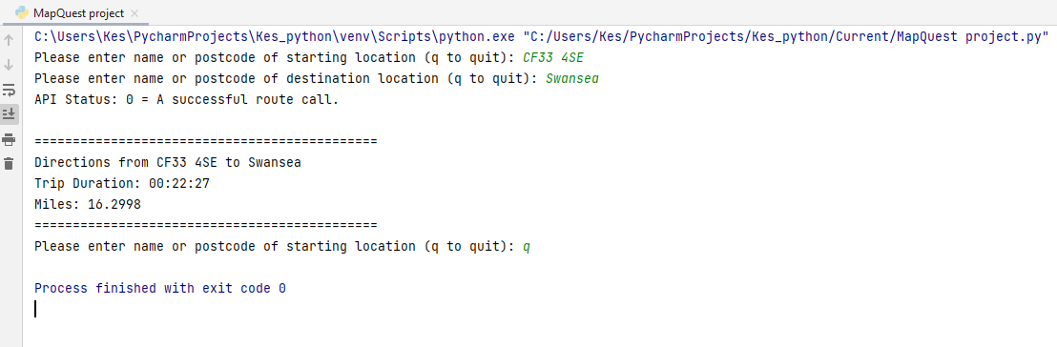
Figure 1: Output from the original python code.
This figure shows the original application, that uses the MapQuest REST API, that was built and tested prior to the development of the later revisions of the code.

Phase One

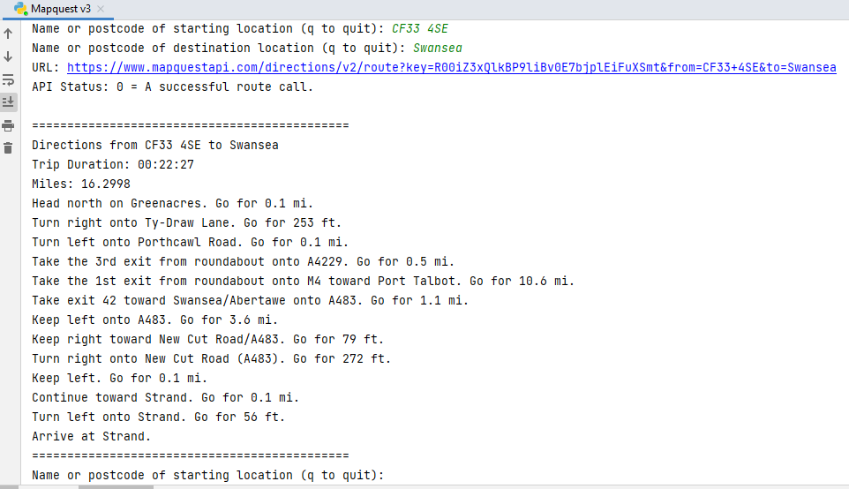
Figure 2: Output from the first revision of the python code.
The first revision of the application expands on the original code to include full turn-by-turn directions. The summary information is still included in the out, as seen above.

Phase Two

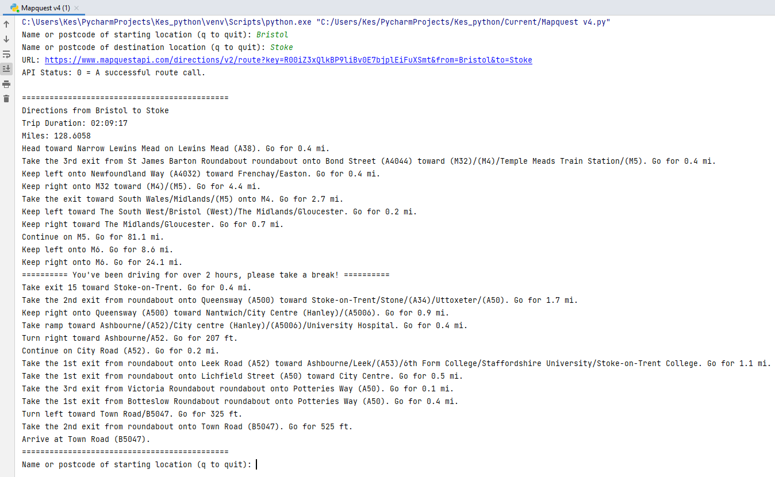
Figure 3: Output from the second revision of the python code.
The second revision of the application adds a break reminder to the detailed directions. The purpose is to remind the driver to take a break after every two hours of driving.

Part B –Project Activity Sheet

Stage 1 – Introduction and Team Formation

Team Name: “Team Unknown”

Team Member Roles
Below is the list of roles we discussed and assigned.
 | Name | Skillsets, Interests
Facilitator | Kes Sumner | Security Architect. Interest: running
Recorder | Carys Newing | Cyber Security Analyst. Interest Forensics
Team Member | Sam Jackson | Cloud Computing, Power Platform and Security, Interest Food
Team Member | Peter Holdstock | Desktop Support, Interest Aviation
Figure 4: Team roles.

Ice-breaker Questions
At the team initiation meeting we discussed the below ice-breaker questions and answers.
Question | Kes | Carys | Pete | Sam
You're trapped in the last TV show/movie you watched. What show are you stuck in and will you survive? | Matrix.  Of course! | Aggretsuko. Yes I'd probably survive | Homes under the Hammer! Yes, I would be able to survive | Rabbit-Hole – Properly not.
You've magically gained a skill to perfectly cook any cuisine, what cuisine would you choose? | Sainsbury's Meal Deals | Japanese | Italian  (Especially Pizza) | Tia Food
If you could see any band, who would you see? | Metallica | As December Falls | Scouting for Girls | Pink Floyd
What's your favourite ice cream? | Raspberry | Hazelnut | Vanilla | Vanilla
Figure 5: Ice breaker questions.

Stage 2 – Agile Team Formation

Team name: “Team Unknown”
Scrum Leader: Kes Sumner

Scrum Leader Selection
There was a group discussion about who would be interested in doing the role and who each member thought would be capable. There was a preference within the team for Kes to pick up the role as he is considered to be organised, is approachable for any issues or assistance and keen to progress work in an agile manner.

Agile team roles
The only other role assigned is the facilitator for notes, arranging workability and assigning tasks through applications such as Teams and Trello with approval from the scrum leader. Carys volunteered for the role and has been excellent at the facilitating function, sharing documents, organising access appropriate to various toolsets etc.

Communication Tools
Some of the tools/methods for communication used by the project team.
Tools | Purpose
Microsoft Teams | To communicate and facilitate team working remotely
Microsoft SharePoint and OneDrive | To share files related to the groupwork for easy access via mobile or laptop devices
In person | To communicate and facilitate team working in person
Trello | To Structure tasks needed to be complete
Figure 6: Communication tools used.

Stage 3 – Implementation

Option Selection Reasoning
As we are all on the Digital Degree Apprenticeship (DDA) pathway and work alongside the university course, and time available as a group is limited, we opted to create a program for use with MapQuest API. This helped provide the team with a foundation platform to start with and to build ideas off and as our team has a good fundamental understanding of python programming this was better suited for our team skills.

Application and Deliverables
As aforementioned we are basing our API in MapQuest API and from investigating the currently available APIs for MapQuest, we decided to set our goal as printing the full turn-by-turn directions from the “from destination” to the “to destination”.
An additional goal will be to advise for waypoints to be set if the journey time is over 130 minutes as typically a driving rest is recommended after 2hrs of driving. This will force the user to set a stopping point until there is no more than 2hrs between each stop.

Team member roles and skillsets

Team Member | Role/ Knowledge/ Skillset
Kes Sumner | Facilitator | Basic coding, API and documentation.
Carys Newing | Recorder | basic knowledge of python and Github
Pete Holstock | Team Member | Basic Knowlegde of Python
Sam Jackson | Team Member | Basic Knowledge of API and Python.
Figure 7: Team roles and skills.

Project Plan
For the project, research is the first element as it allows us to identify the API’s that already utilise MapQuest to ensure that our API will be different.
Once research was complete, we brainstormed concepts that were viable and set goals for the project. We then will utilise agile sprints for regular contact and a Trello board to track tasks and their progression as well as any problems that are encountered.
The final elements will consist of the regular testing and the development cycle which fits in quite well with the agile sprint sessions.

GitHub Repository
The GitHub repository used for the project is here: https://github.com/FindoGask9/NP-CW1
GitHub was used in conjunction with the local Git application in order to manage version control and allow us to go back to specific points in time prior to code updates.
A branch was created each time a new function was being worked on to allow parallel coding and to protect the original code in the master branch. Some team members were invited from one of the group’s GitHub accounts to collaborate on the coding work in the dedicate repository. A standard pattern was followed once the initial code was local committed and pushed to the GitHub instance:
• Ensure that the current area is clean.
• Get (pull) the latest version from the remote. Avoids merging issues later.
• Create a new local branch.
• Edit files and make changes.
• Add the changed files to the staging area.
• Make new commit (merge).
• Push changes up to the remote.

List of future enhancements
Some of the more interesting ideas for future enhancements for extending the code utilising the MapQuest API, which were generated via group discussion, include the following:
• Integration of a Graphical User Interface (GUI) map which would enable the application to be more accessible and usable.
• Add the capability for walking /running routes to allow for non-drivable routes and give distances and times for runners and walkers. This could include some other statistics such average calories used over the distance based on some standard calculations.
• Verbal directions was another suggestion, would require quite a bit of thought around how that would need to be used and controlled.
• Adding avoidance options such as toll roads and motorways, would be an easier element to add as we would change the request to query with the different avoidance options.
• Speed camera notifications, this would include the locations of speed cameras along the queried route.

Stage 4 – Reflection/Conclusion

Individual Reflection

Although the team structure has remained the same throughout the project, I found this group work assignment very challenging. As all team members are DDA students, and so working full time, it was very difficult to gain the commitment of a couple of the team members to spend time together as a team. We ended up doing a considerable amount of the work at the very end of the timescale due to this which I found quite stressful.
My main contributions to the work were acting as the scrum master and trying to coordinate the team resources and workloads. On the actual work execution side, I did most of the Python design/coding work and most of the Git/GitHub preparation and usage.
One of the main things that I learned from this project is that programming is a lot more involved and complex than just writing code. There are many other aspects to be considered, planned and completed, before you even start writing code such as assigning roles and responsibilities to each team member, requirements gathering, design work and so on.

Appendices

Project GitHub Repository

We ended up utilising GitHub Desktop as we all found this easier to work with than the command line/terminal version of Git.
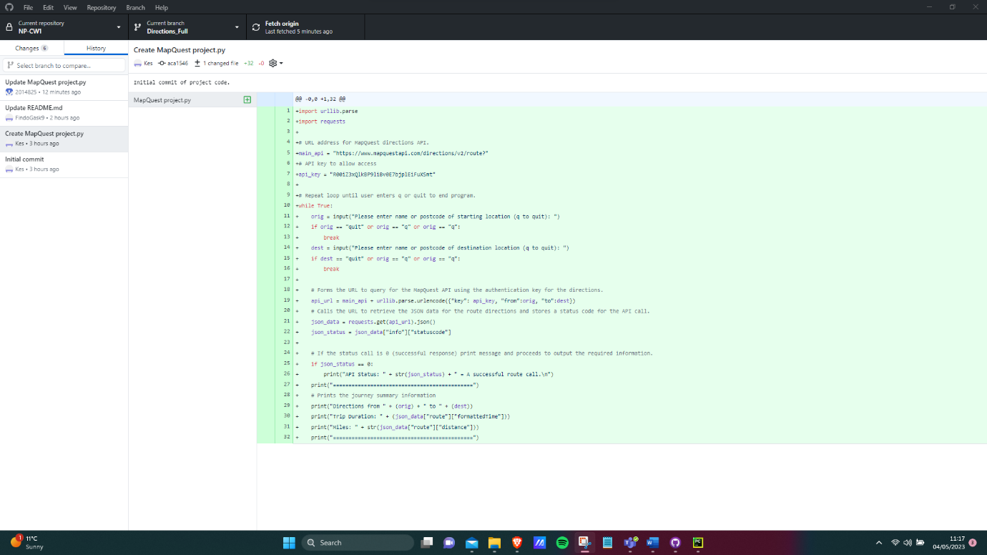
Figure 8: The GitHub client application.

Testing the Application

Positive Testing
We have tested expected inputs, for example correct standard Postcodes (a standard 7-character and 6-character) alpha numeric postcode) and the API outputs the correct results. We have fact checked the results with another direction tool (Google Maps).

Figure 9: Test results for positive testing.

Negative Testing
When API is presented with an incorrect postcode the results are as follows:
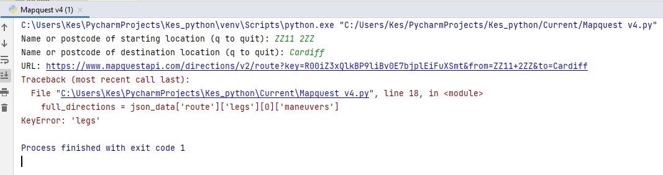
Figure 10: Output from incorrect post code being entered.
This could be improved up on by testing the MapQuest API call result for an unsuccessful return code and handling it appropriately using python code.

Boundary Testing
This is the testing of extreme acceptable values, for example postcodes are at the furthest points of the UK. Testing showed no errors as shown below:
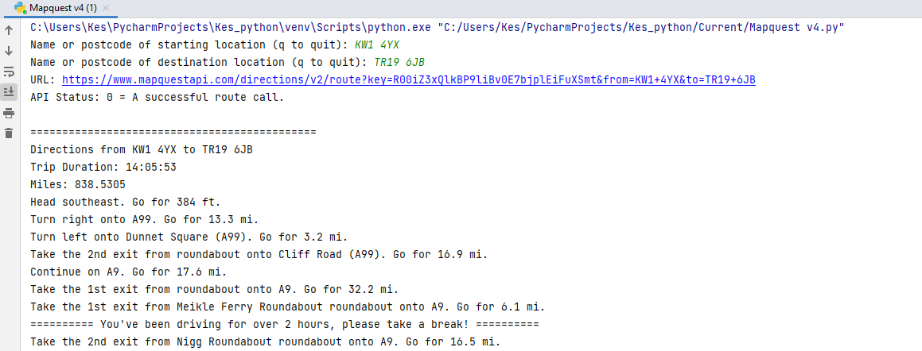
Figure 11: Boundary testing.

Load Testing
Due to the limitations of members of the group the largest load that could be tested was four unique users requesting the API at once, the outcome of this was no impact to service. No screenshot evidence needed.

Trello

Trello was used as a kanban board as part of the agile development cycle. The board used can be found here: https://trello.com/invite/b/Ge8udJy7/ATTIe076a4b072242c972a6ce5147bc88d824510962C/network-programmability
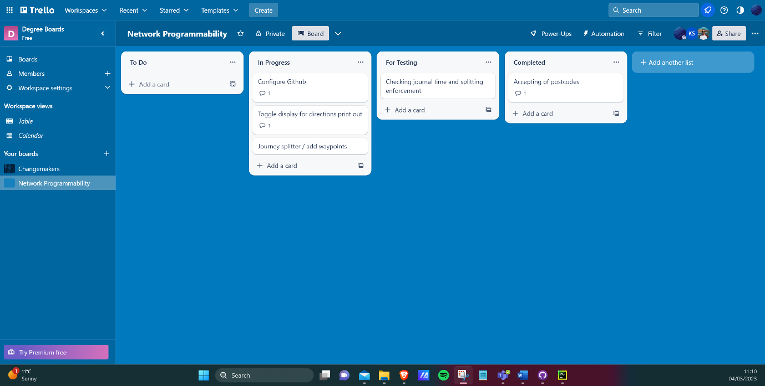
Figure 12: The Trello board used during the project.

Python Code

The final revision of the Python code is in this ‘py’ file:

