Appendix 1
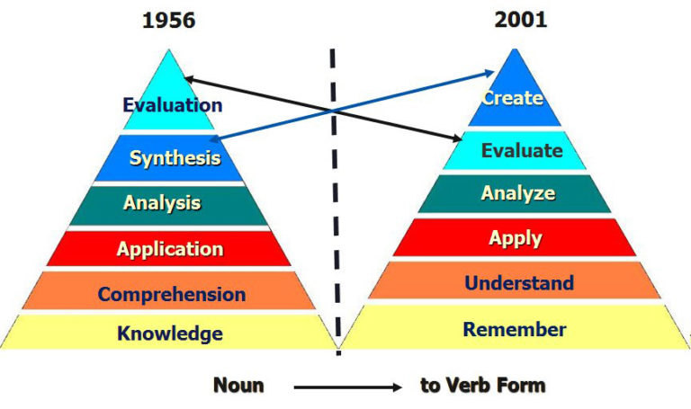

Bloom vs. Anderson/Krathwohl by Wilson, Leslie O. 2001 available at:
https://thesecondprinciple.com/teaching-essentials/beyond-bloom-cognitive-taxonomy-revised/

Appendix 2
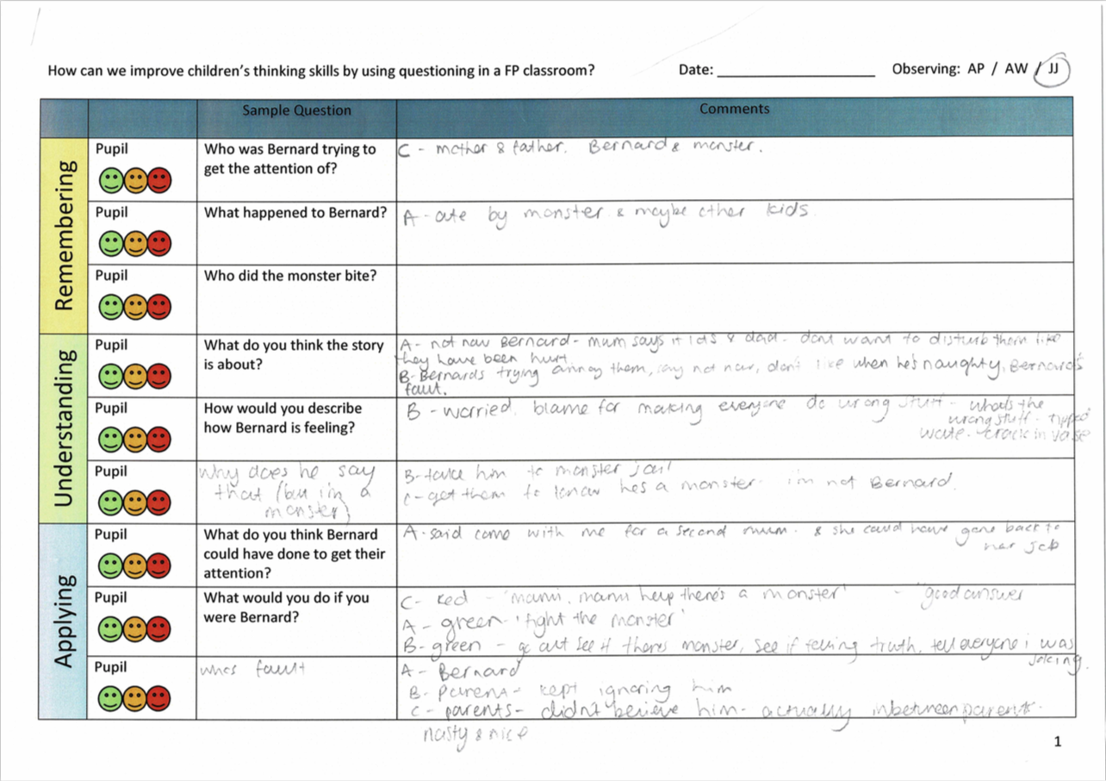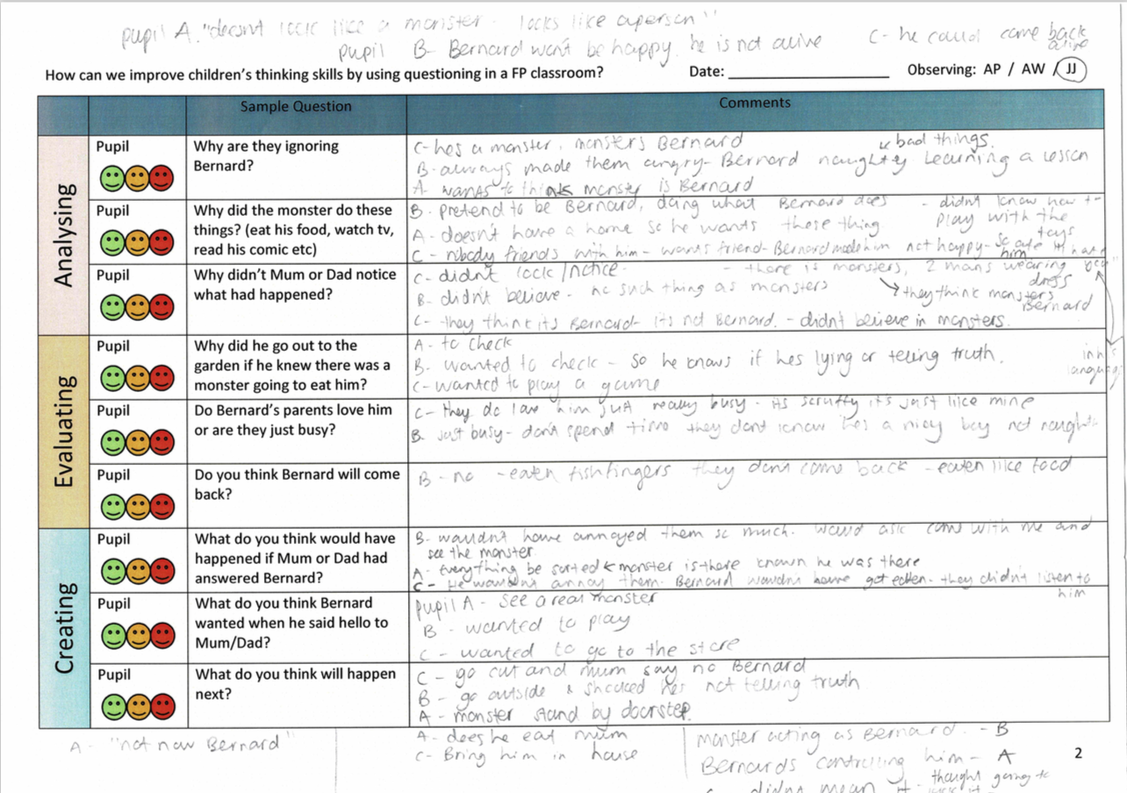

Observational notes from research lesson 2.

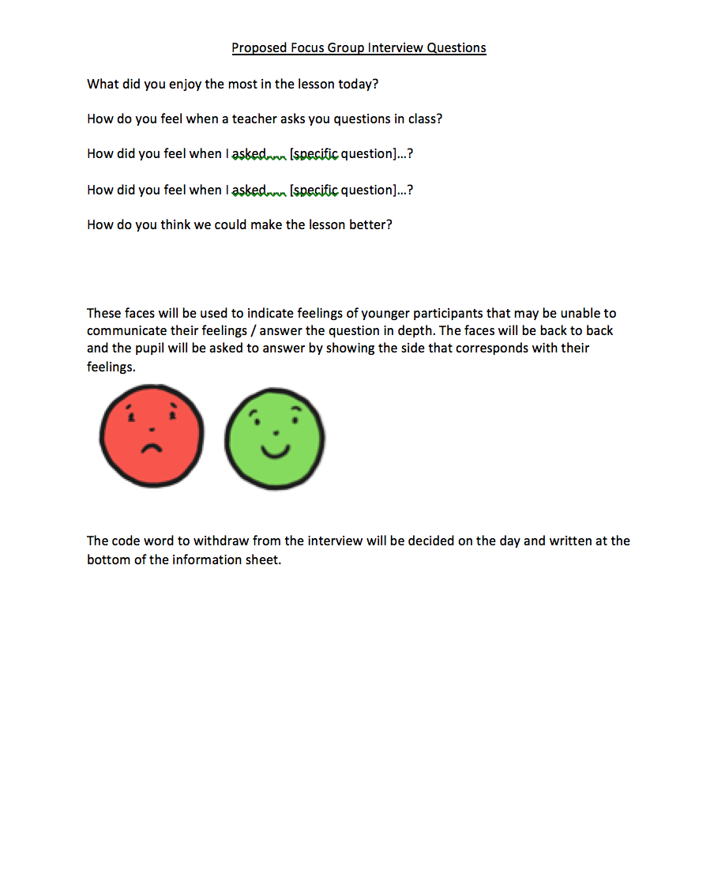
Appendix 3

List of interview questions created by the trainee students (2019).

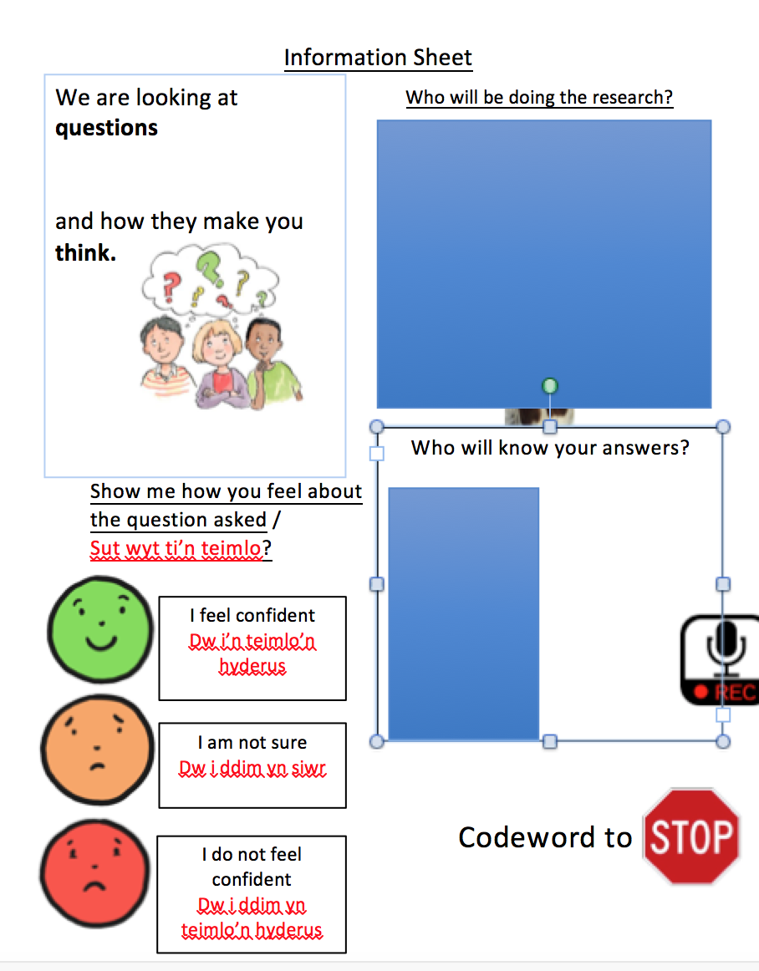
Appendix 4

(Images removed for anonymity).
Information sheet created by the trainee teachers (2019).

Additional Appendices

Lesson 1

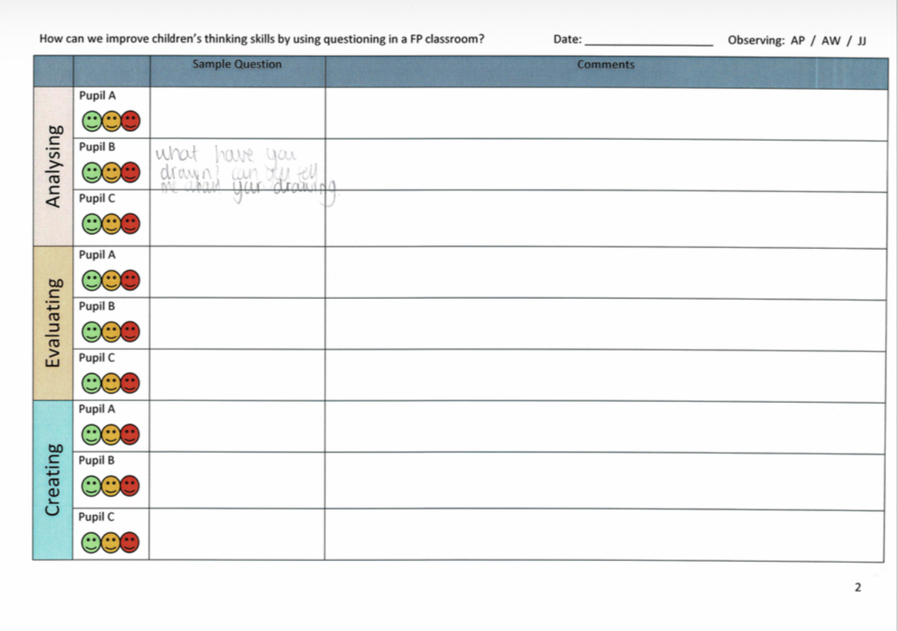
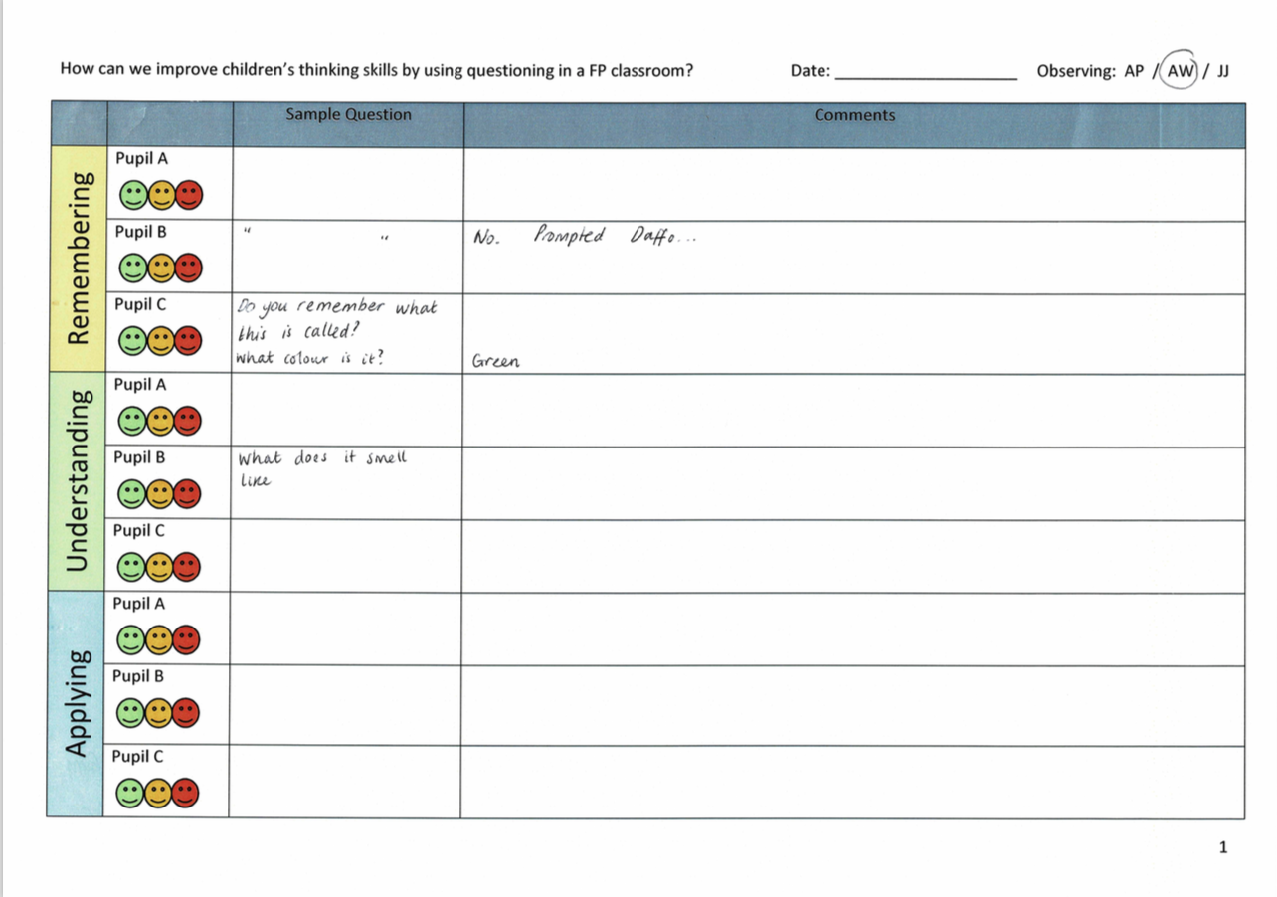

Observational notes (2019)
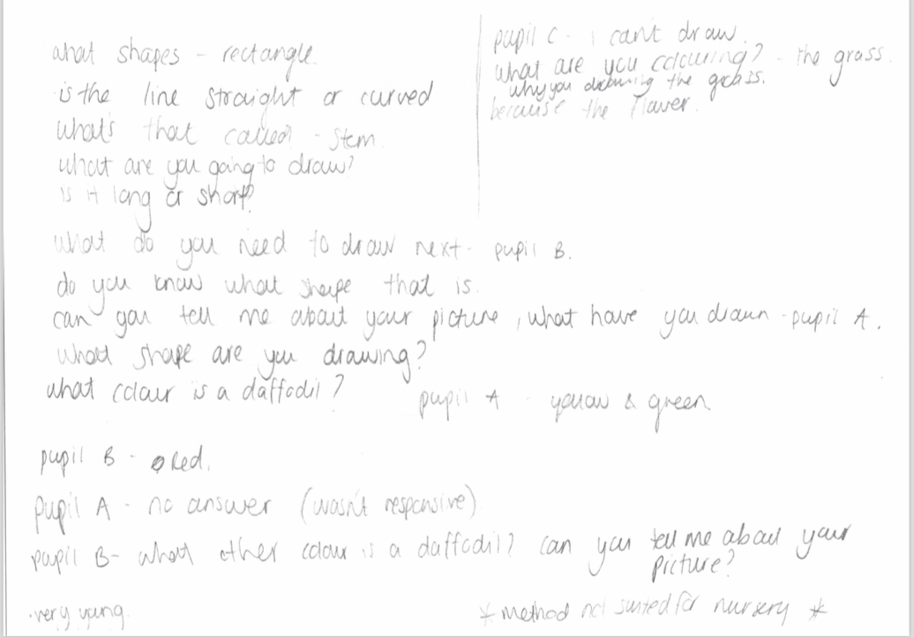
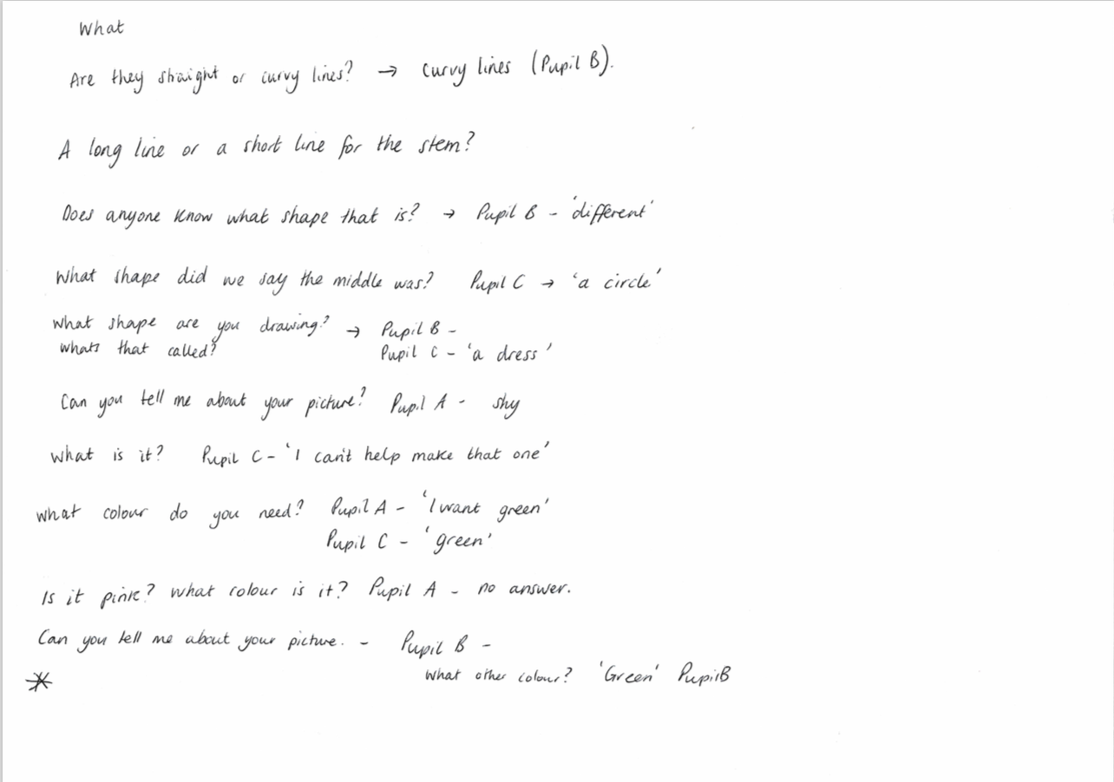

Observational notes (2019)

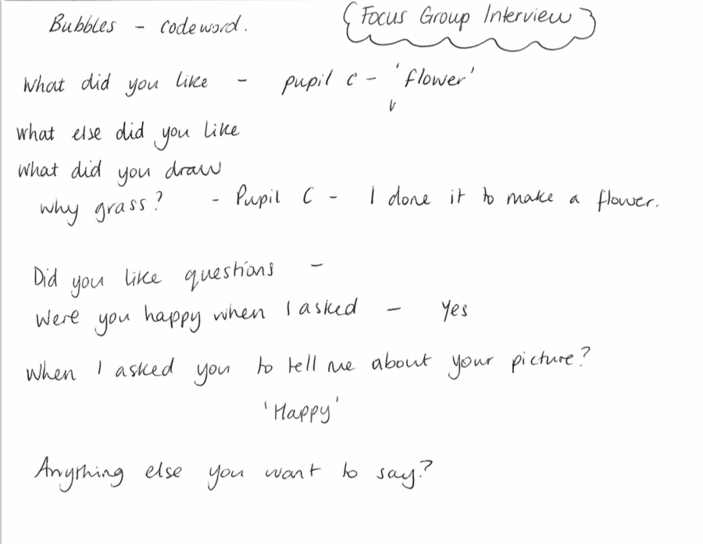

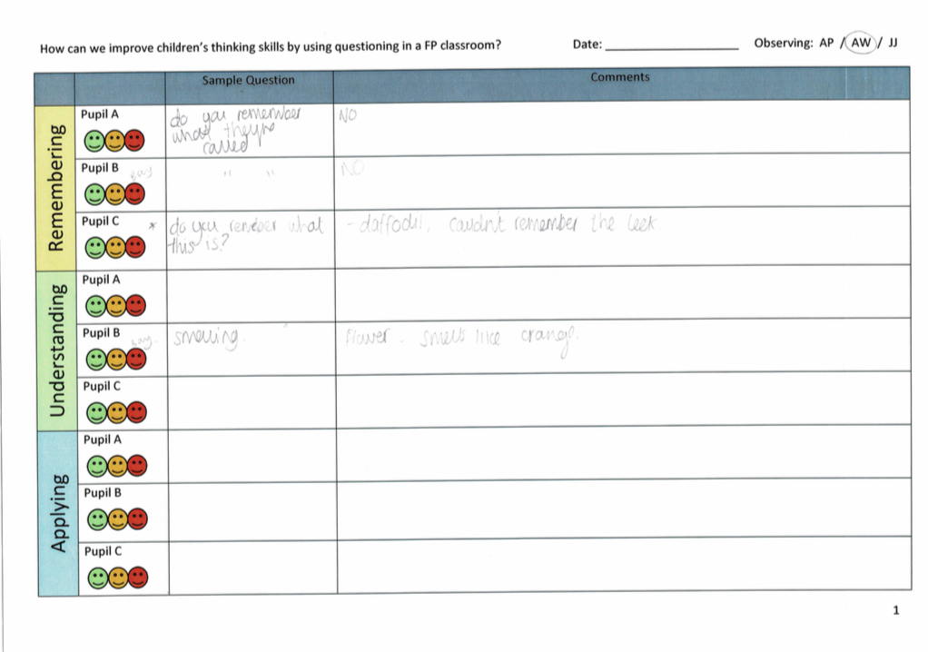
Interview conversation 2019.

Observation notes (2019)
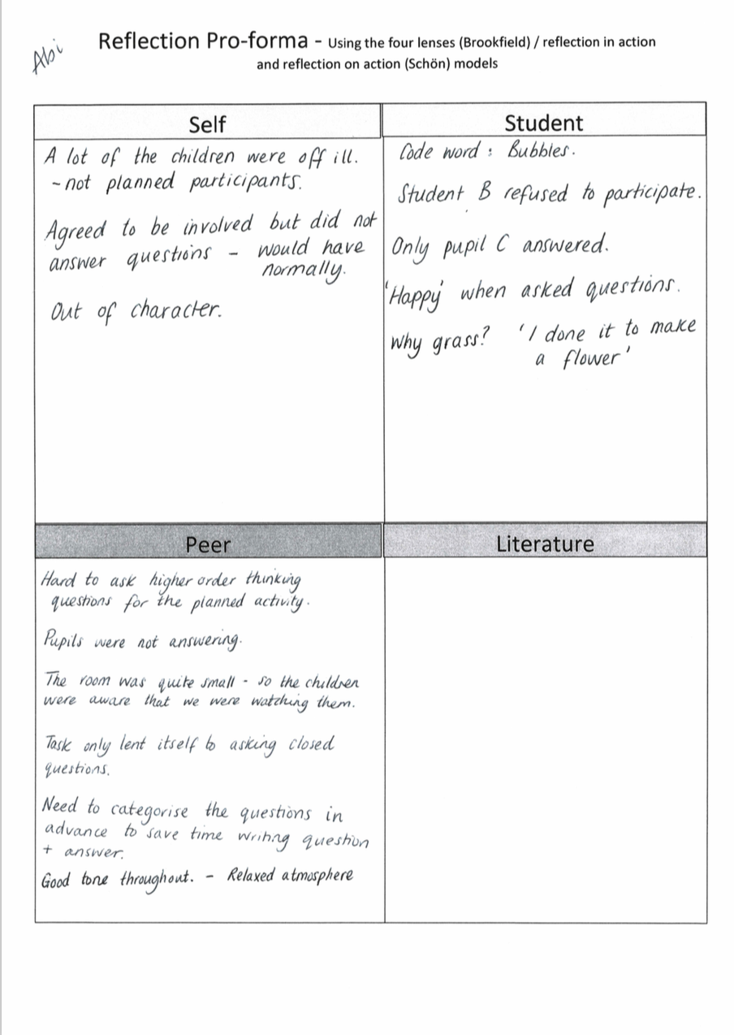

Reflection sheet (2019)

Lesson 2
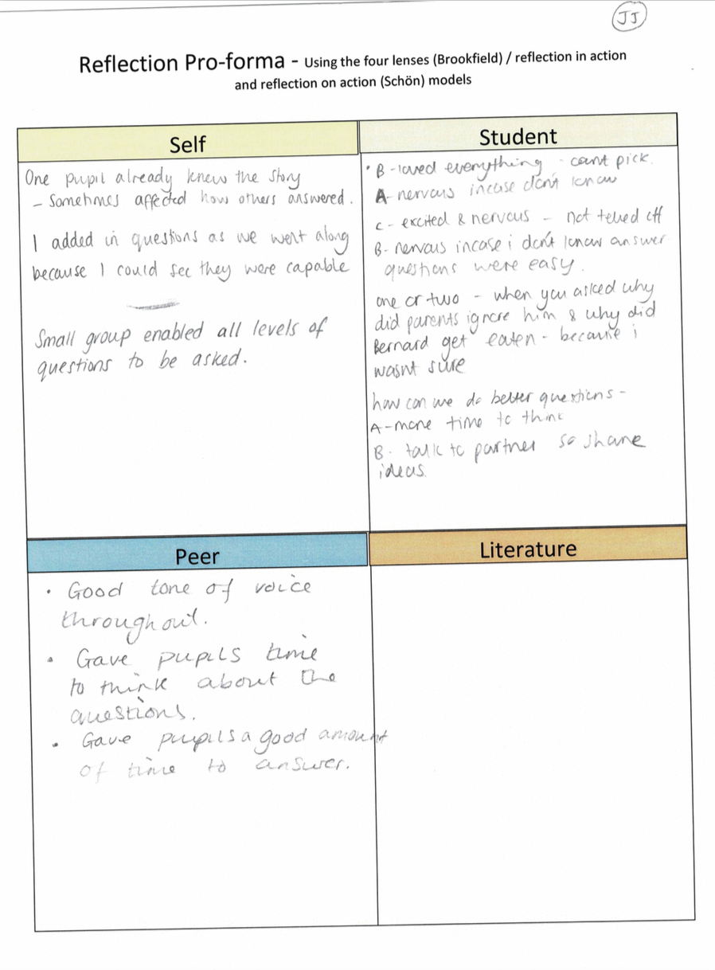
Reflection sheet (2019)
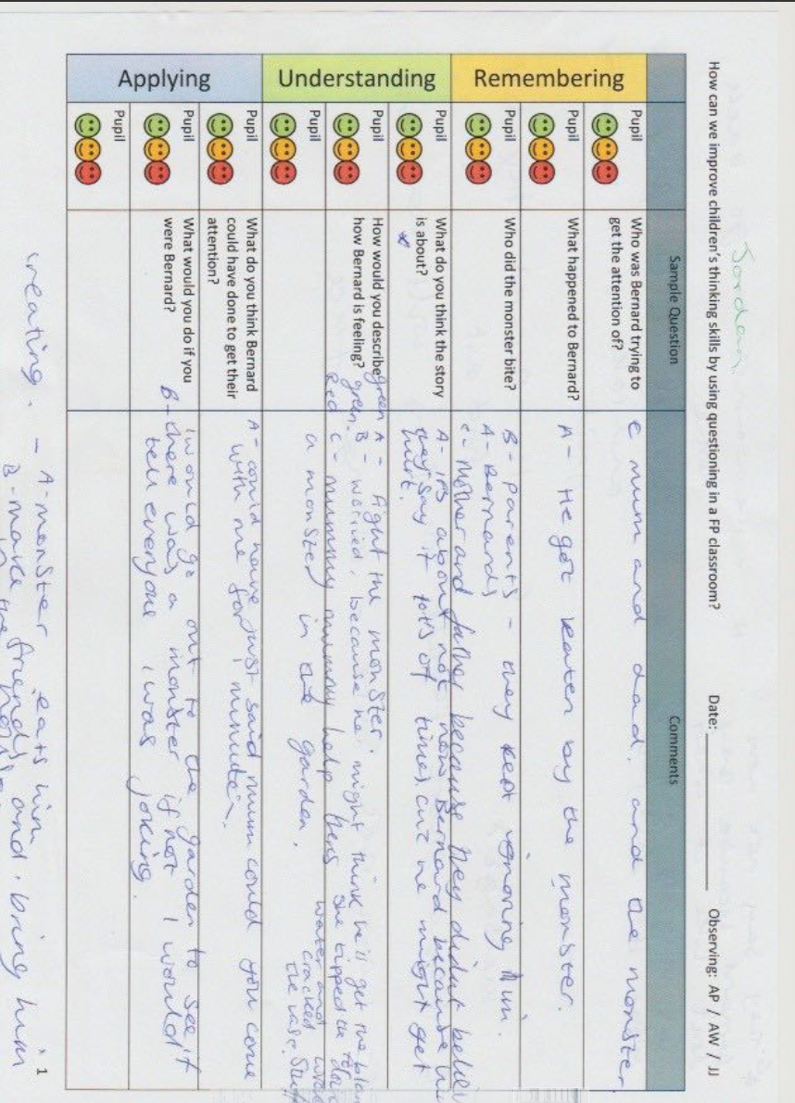

Observational notes (2019)

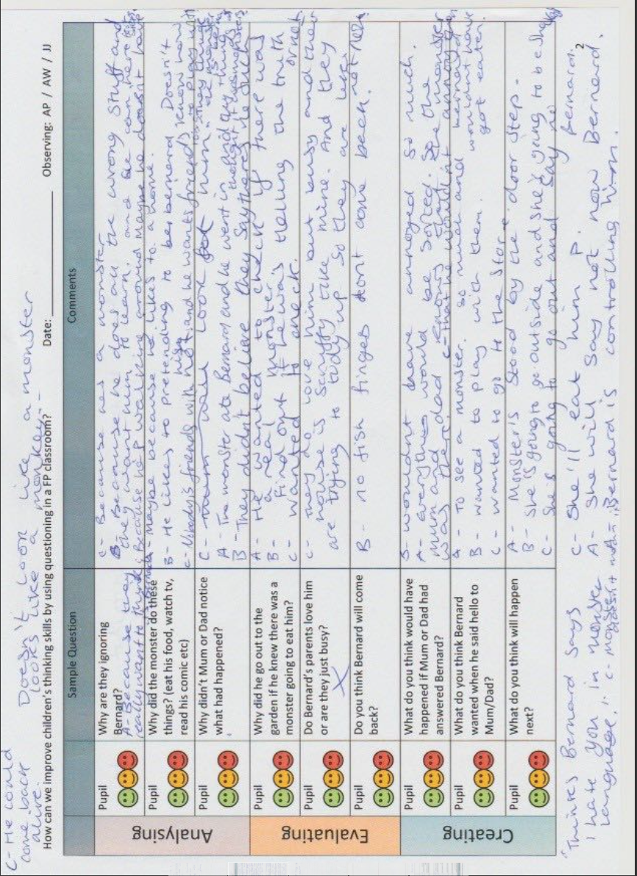
Observation notes (2019)

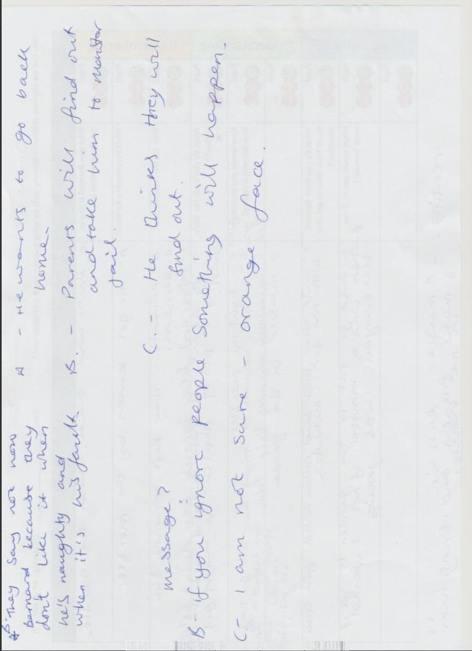

Observation notes (2019)

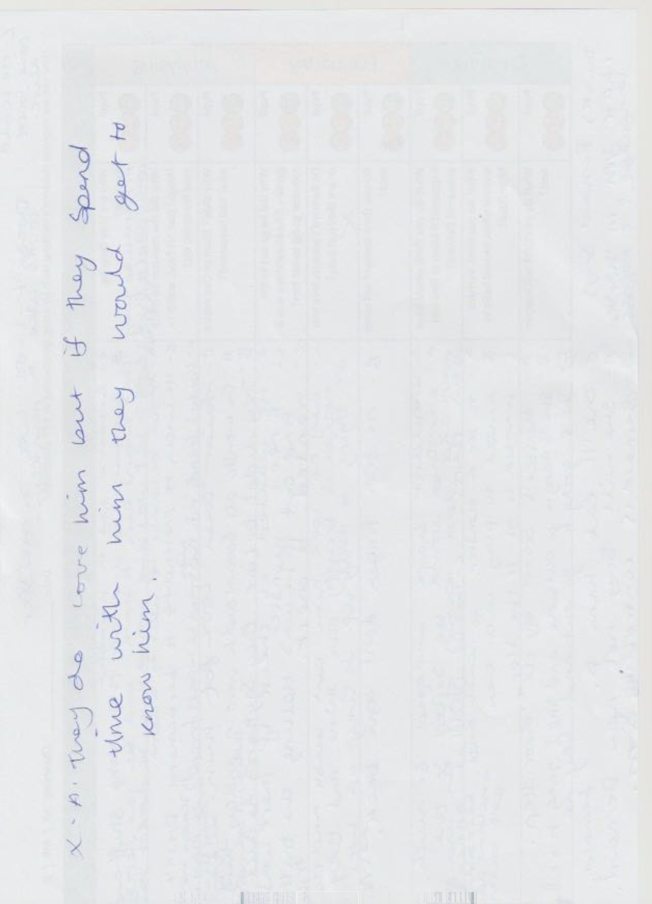

Observation notes (2019)

Lesson 3 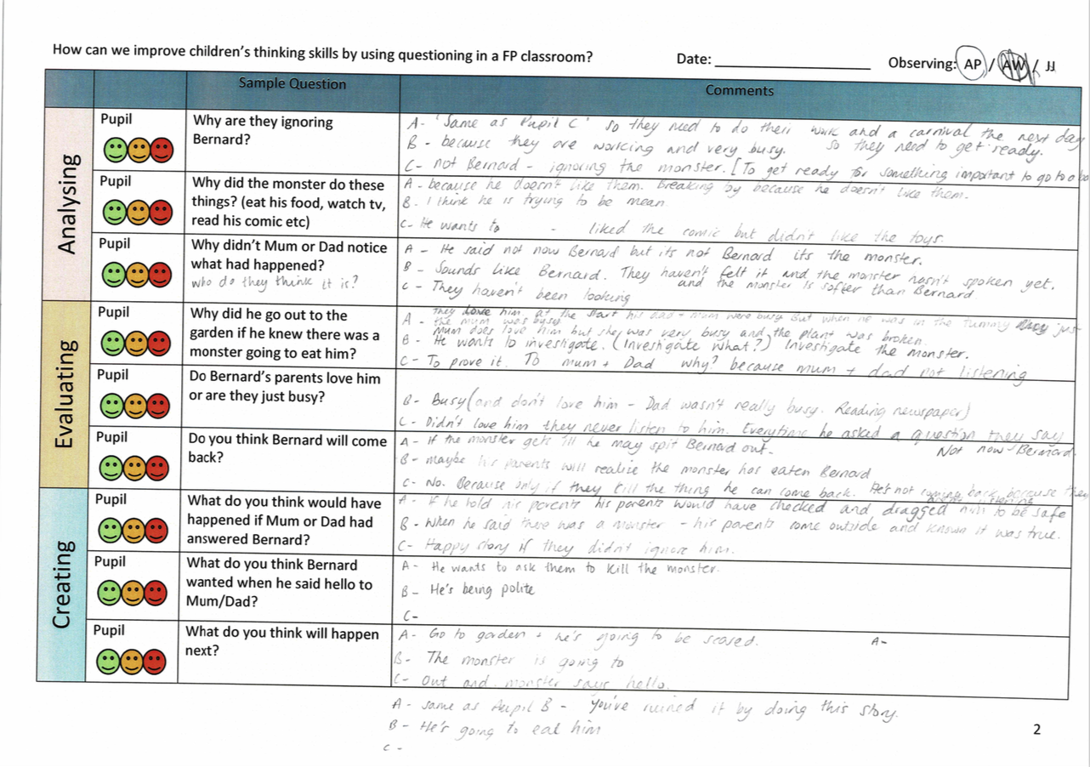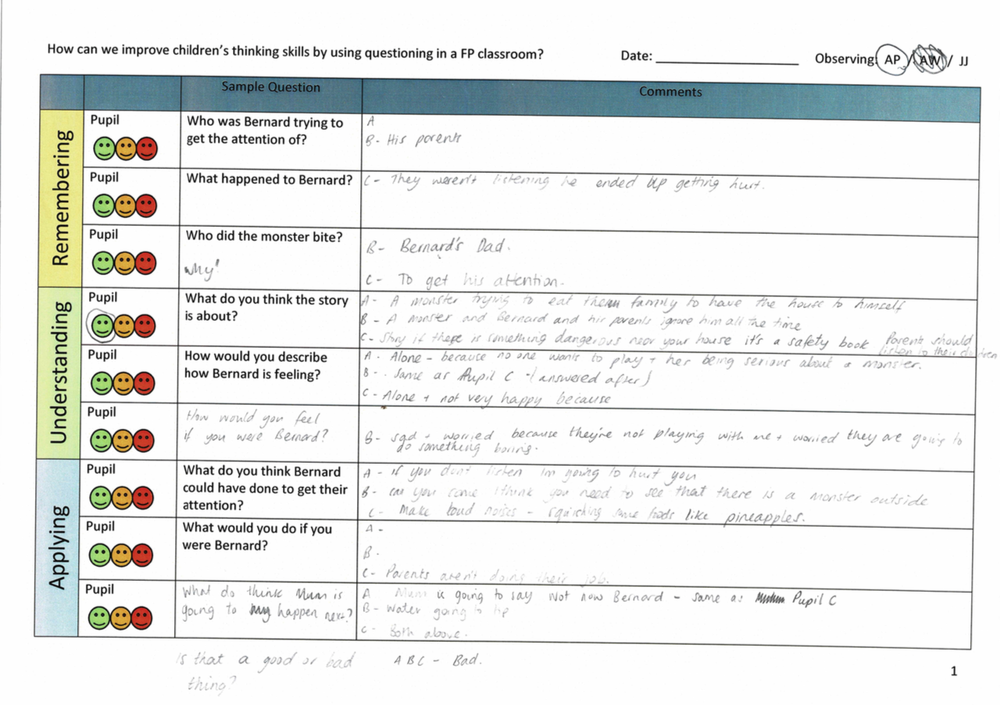

Observation notes (2019)

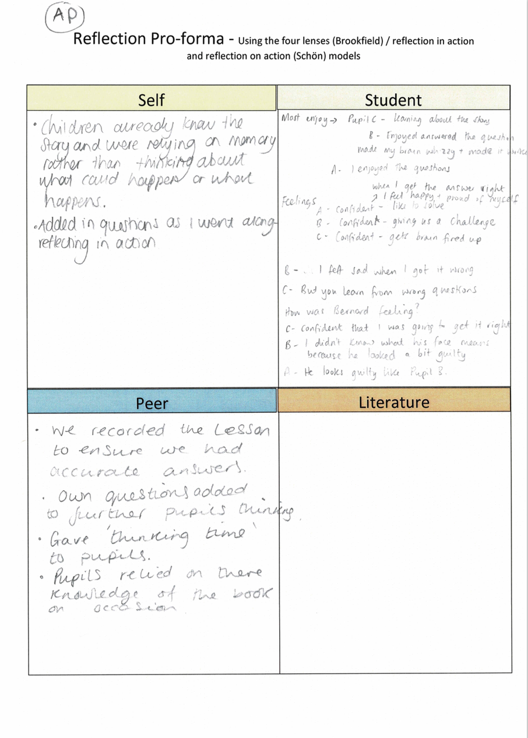

Reflection sheet (2019)

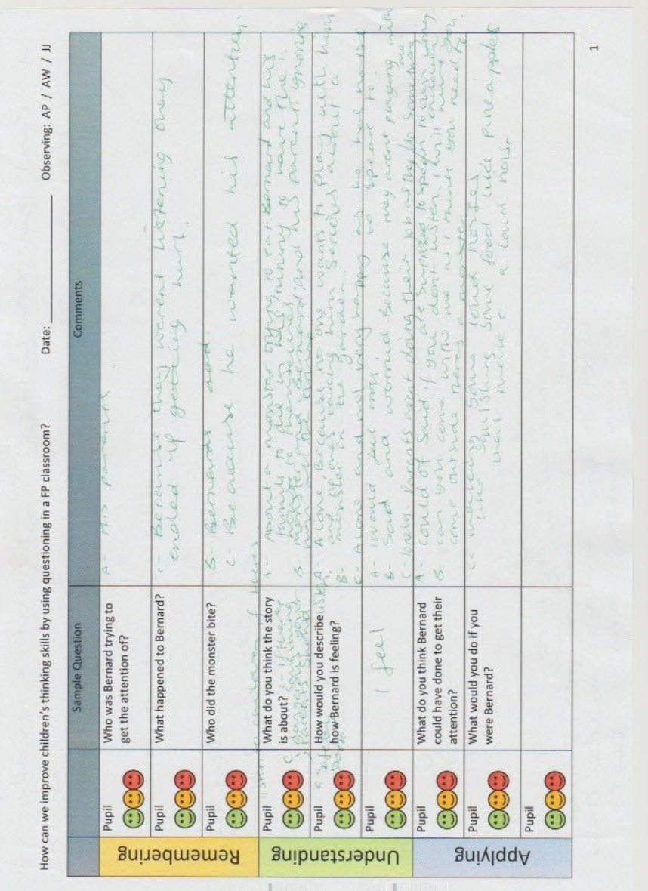

Observation notes (2019)

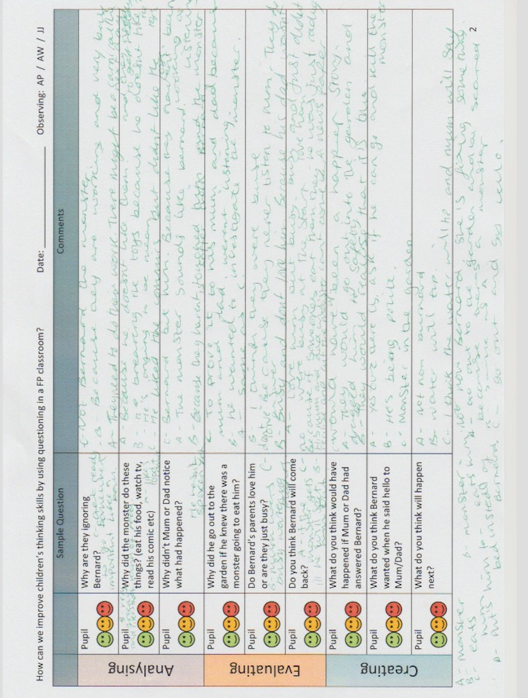

Observation notes (2019)

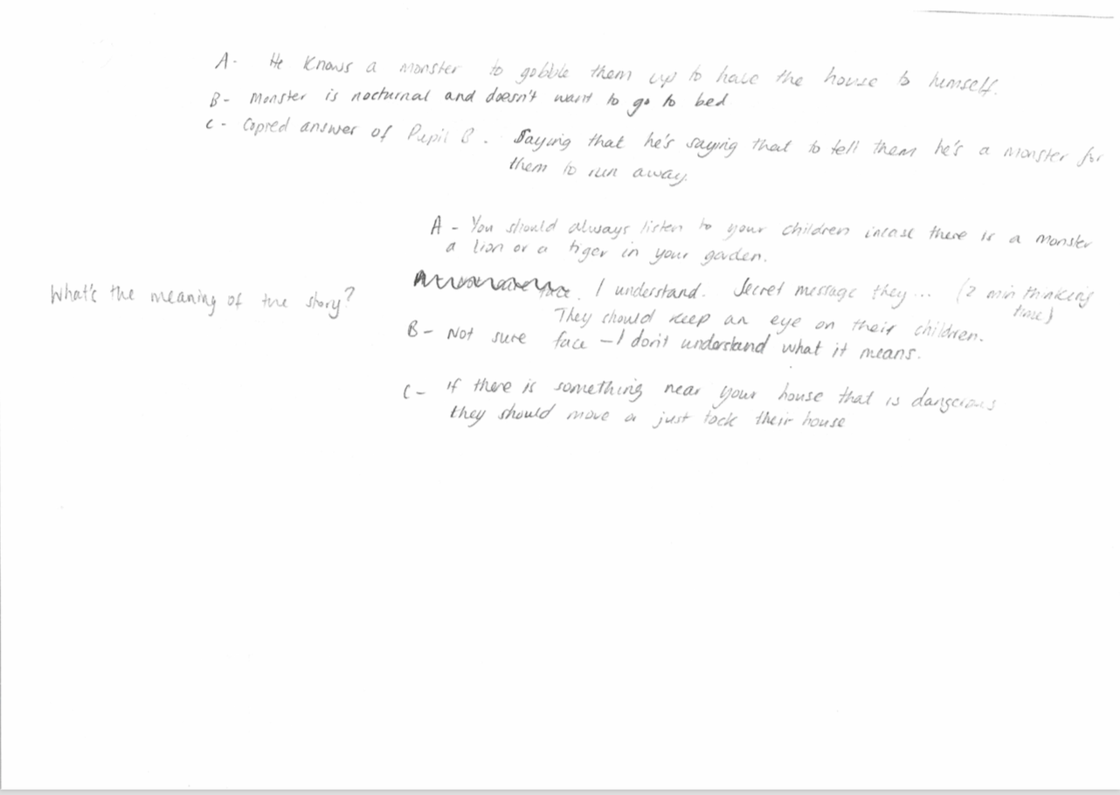
Observation notes (2019)
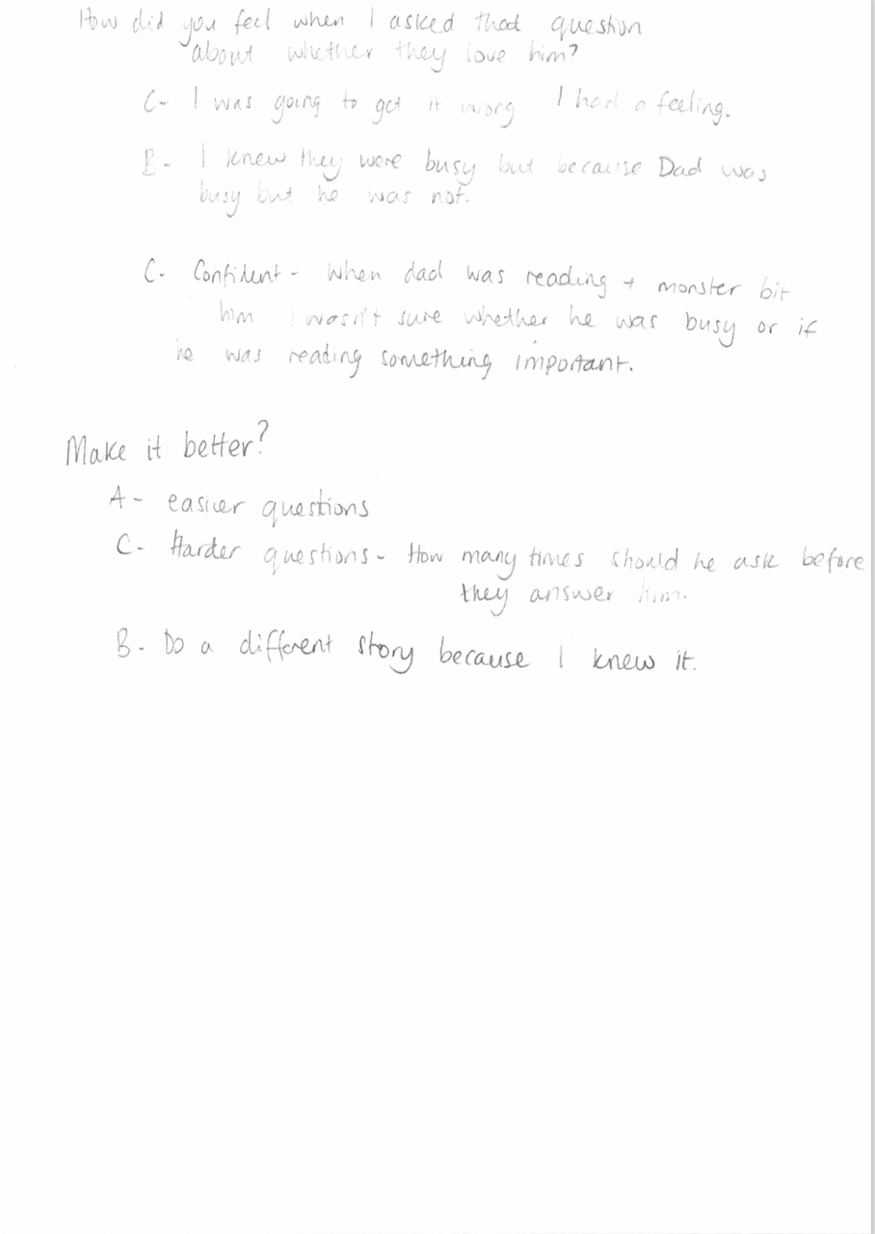

Interview notes (2019)

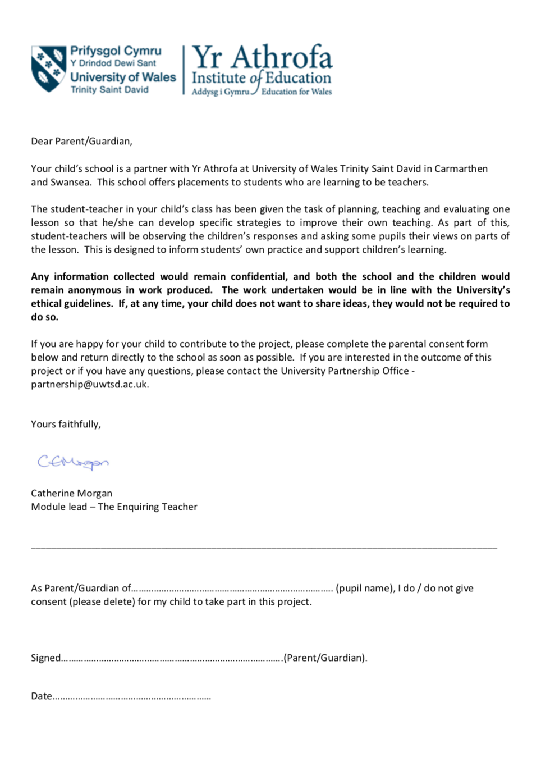
Consent form- Signed consent forms have been removed for anonymity.

