Opening of Ford Dagenham Restaurant for Ford Dagenham Company Staff

Course Title – Managing Projects in the Organisation – BMSW5104_Lon
Student’s Name Andreea Scorpie -2030448
Instructor’s Name : Alfred Mensah
Date : 02/05/2023
Opening of Ford Dagenham Restaurant for Ford Dagenham Company Staff
Introduction
According to Maylor & Turner (2022), project management is the use of skills, knowledge, experience, techniques, and tools effectively and efficiently to meet the expectations of a project’s stakeholders. Project management is important because it facilitates the identification of project requirements, balancing the demands of cost, time, quality, and scope, establishing achievable and clear project objectives, and adapting to the expectations of the project’s stakeholders. Therefore, project management is vital in ensuring that a project is completed successfully. The purpose of this assignment is to describe the project management plan that will be used to complete the Ford Dagenham Restaurant project. The report structure includes various sections. The first section will be an overview of the project outline followed by communication strategy, stakeholder analysis, work breakdown structure, cost/resource use, consideration of resources, Gantt chart, and risk assessment, respectively. Project managers and team members can use various project management techniques and tools to manage all project activities effectively, leading to successful project completion within the deadline. The main project management tools that will be used in the Ford Dagenham Restaurant project are Work Breakdown Structure, Gantt Chart and Communications management plan. A Gantt chart is used to track the project schedule, identify any deviations from the project plan and delays that could impact the project’s success. A work breakdown structure is used to plan every aspect of the project based on the stages of the project. A communication management plan ensures a relevant and regular flow of information among the project teams, stakeholders and clients. According to van Dokkum & Ravesteijn (2016), communication is essential for project success because it facilitates the exchange of ideas and suggestions that can be used to complete the project tasks effectively. Therefore, it is vital to have a clear communication plan before the project begins. A Gantt chart helps create the change programmer at the manufacturing organisation because it will enable the project team to prevent delays that could cost the organisation more resources and limit the project’s success. A work breakdown structure is helpful in the project because it will enable the project team to assign the right amount of time for each activity within the project leading to success. A communication management plan is useful because it will enhance collaboration among the project stakeholders, leading to successful completion and meeting the organisation’s expectations.
Project Outline
The project entails planning for the opening of a restaurant for employees at the manufacturing company to provide onsite catering to reduce the movement of staff from the work setting during the lunch breaks because the movements are creating congestion issues in the local area and help the staff develop a healthy lifestyle that the organisation believes it of its corporate social responsibility and will reduce absenteeism. The project’s scope will be limited to the organisation’s work setting because the restaurants will only serve the staff. One of the project’s objectives is to develop a 6-month plan for establishing Ford Dagenham Restaurant to reduce congestion issues caused by Ford Dagenham staff. The second objective is to create an engaging experience for Ford Dagenham staff to easily satisfy their nutritional needs for health benefits. The third objective is to achieve Sponsor/Client satisfaction after the project’s completion. The project will start on 1st April 2023 and end on 9th September 2023 with a total budget of £200,000. Its success will be determined by the acceptance of the project by the sponsor. This will be facilitated by the availability of all metrics for measuring performance and quality assurance checklists for all deliveries.
Communication strategy
Communication goals | Communication method | Audience | Frequency | Owner
To norm the project team members about the project’s objectives | Verbal and written communication | Project team members | Once  (During the project launching stage) | Project managers
To inform the project stakeholders about the progress of the project | Written communication | All project stakeholders | Weekly | Project manager
To inform the project team members whether they are completing assigned tasks as expected | Verbal and written communication | Project team members | Weekly | Project manager
As the table above indicates, the communication plan will include various communication methods based on the audience and communication goal. One of the communication goals will be to inform the project team members about the project’s objectives. The communication methods that will be used to achieve this goal will be verbal be written communication. The project manager will meet with all team members to communicate the project objectives and address any questions the members may have about the project. The project manager will also send a memo outlining the project objectives to all team members through email to ensure they understand them. The project objectives will only be communicated once during the project launch. The second communication goal is to inform stakeholders about the project’s progress. The project manager will email all project stakeholders to inform them about the project’s progress every week. The third communication goal is to inform the project team members whether they are completing tasks as expected. Weekly meetings will be conducted where the project manager will verbally point out the mistakes the team members may be making and appreciate the members’ efforts towards completing the project. The project manager will then send a follow-up email addressing individual concerns about the team member’s performance.
Stakeholder Analysis
According to Crawford (2021), stakeholder analysis is essential in project management because it enables the project team to understand and identify the expectations and needs of the project stakeholders. It is also used to understand the interrelationships and attributes of the project stakeholders, thus facilitating effective strategic planning (Eskerod & Larsen, 2018). The main stakeholders in the Ford Dagenham in-house catering project are the project director, project sponsor/owner, project manager, project planning officer, budget and finance officer and operations officer. The project sponsor/owner requires the project team to complete the project based on the agreed-upon plan. The project sponsor/owner’s requirements include reviewing and approving the project charter and plan deliverables and being acknowledged as the decision maker on the changes within the project. The project director’s requirements include the appropriate planning of the project, including the project milestones and schedule. He expects to be involved in any vital changes, review and approve the project expenditure and budget and lies between the project manager and sponsor. The project manager requires the project to be carried out based on the project plan specifications and the plan that all team members have agreed on. He expects daily updates and communication on the project and any emerging issues. The project budget and finance officer require that all costs are provided before the budget is prepared. He expects reports on project and individual status and the authority to perform all project activities as needed and develop the project budget requirements. The project planning officer requires all details about the project before preparing the project plan and the authority to report the project and individual status to the project manager. He expects that all project activities are performed as expected and the chance to develop scheduling requirements, communicate important dates and deadlines to the operations officer and other team members and interact with support personnel as needed. The operations officer requires the project planning officer to provide all details within a reasonable time frame, set up the project as scheduled, report project and individual status to the project manager, and be responsible for coordinating project materials and personnel. He expects that all activities within the project are performed as needed and is responsible for the setup of the entire project.
Work Breakdown Structure
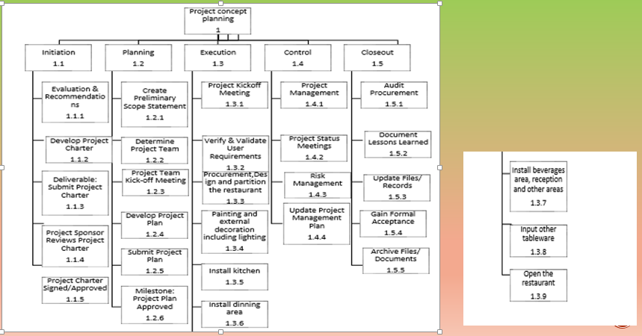
The first phase of the project will include initiation, evaluation of the project and recommendations, project charter development, submission, review by the project sponsor and approval. According to Cordell & Thompson (2018), a project cannot commence before the project charter is approved. The charter includes the project’s scope, objectives and responsibilities. Therefore, the project charter has to be convincing enough to get the approval of the stakeholders. After the project charter has been approved, the project will move to the second phase, which will include planning, creating a preliminary scope statement, selecting the project team, holding the project team kick-off meeting, developing the project plan, submitting the project plan and the approval of the project plan.
After the project plan is approved, the project will move to the third phase, which will include project execution, holding the project kick-off meeting, verifying and validating user requirements, procurement of resources, designing and partitioning the restaurant, painting and external decoration, including lighting, installing a kitchen and installing a dining area. The fourth phase will include project status meetings, project management, risk management and updating the project management plan. The fifth phase will consist of close-out, auditing procurement, documenting the lessons learned, updating files/records, gaining formal acceptance and archiving the project files/documents. Other activities may be considered after the project is closed, such as the installation of a beverages area, reception and other areas, inputting other tableware and opening the restaurant.
Costs/resource use
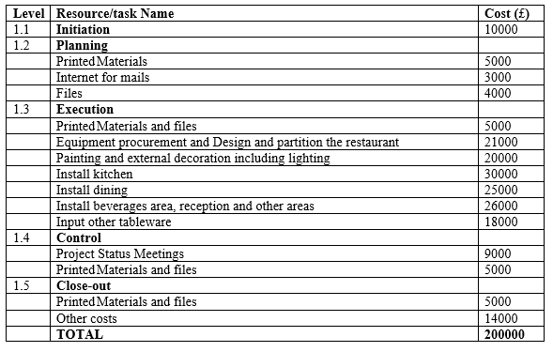
As indicated above, each project stage will require incurring a specific cost. Most of the project costs will be covered in the execution stage because it includes many activities. Various cost control measures will be taken. For example, the project budget and finance officer will be accountable for cost management. He will provide tracking sheets with every quote and invoice the project team generates and be in charge of adding each expense to the cost baseline. He will also be expected to use earned value management to track budgeted, earned, and actual spending. The final cost plan for the Ford Dagenham Restaurant will be delivered on 9th September 2023. It will include a description of all the resources, space, material, and equipment required to finish the project. As a baseline, we’ve allocated £200,000 for this project. A system will be put in place to track all costs.
Consideration of resources
The resources will be divided into product and project deliverables. The project deliverables will include the resources needed for project planning and initiation. They include project charter, project requirements management plan, budget, schedule, responsibility assignments/charts, human resource plan and communications management plan, scope statement, work breakdown structure, scope management plan and scope baseline and other management reports and plans such as quality management plan, process improvement plan, weekly progress reports and procurement management plan. The product requirements will include the resources needed for the execution of the project. They include décor, clothing and uniform, equipment, consumables, kitchen appliances, tableware and catering equipment. The table below shows a breakdown of the project resources.
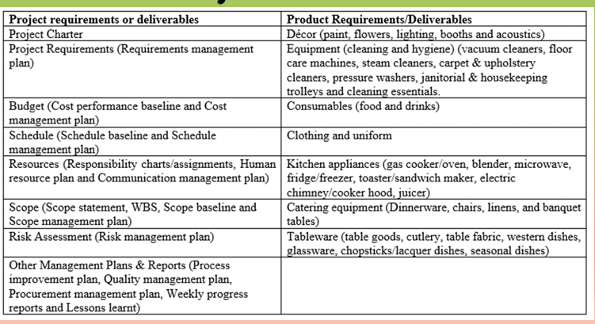

Gantt chart
Activity | Period
Activity | 1st to 3rd April | 4th to 26th April | 27th April to 22nd May | 23rd May to 3rd August | 4th August to 19th August | 20th August to 9th September
Project concept planning
Initiation phase
Project planning
Project execution
Project control
Close-out
The project has been broken down into various activities. The first activity will be project concept planning. This will take three days, from the 1st to the 3rd of April 2023 and will be led by the project director. The initiation phase will take 23 days and will be led by the project manager from 4th to 26th April. The project planning phase will take 32 days, from 27th April to 22nd May and will be led by the project manager and project director. The project execution phase will take 73 days, from 23rd May to 3rd August 2023 and will be facilitated by the project manager, budget & finance officer, planning officer and Operations officer. The project control phase will take 16 days, from the 4th to the 19th of August 2023 and will be led by the project manager. The Close-out phase will take 21 days, from 20th August to 9th September 2023 and will be led by the project manager and budget and finance officer.
Risk Assessment
Risk assessment is essential in every project because it prepares the project team members on how to mitigate the risks that could affect the project’s success (Masár & Hudáková, 2019). We will follow various steps when conducting risk assessments during the project. The first step will be identifying the risks that could arise during the project based on the project’s limitations, such as permits, tight schedule and budget limitations. The second step will be deciding who might be harmed by the risk and how they might be harmed. The third step will be evaluating the risks and deciding on the measures that will be taken to mitigate them. The fourth step will be recording and implementing the risk assessment findings in decision-making. The fifth step will be reviewing the risk assessment and updating it based on the recommendations made by the project team members on how to address them. We will use the probability matrix to assess risk in every project stage.
According to Bladt & Nielsen (2017), a probability matrix visualizes the risks impacting a project. It is created by following four steps. The first step is risk identification. This step includes identifying risks that may affect the project, such as increased costs and scope creep. Ajmal et al. (2021) defines scope creep as what occurs when changes are made to a project’s scope without change requests. The changes impact the project budget, schedule, and allocation of resources, costs and deadline. The leading causes of scope creep include unclear project requirements, poor project management, poor communication, unrealistic goals and the lack of prioritization of the tasks within the project. The second step is risk analysis. This step comprises analysing the anticipated damage that the risk can have on the project and developing measures to minimize the damage. The third step is assessing the level of impact the risk will have on the project. The fifth step is ranking the risks based on the influence of the risk on the project.
Risks can be prioritized as high priority or critical risks, moderate, major and minor risks. Critical or high-priority risks require quick or prompt responses because they considerably impact the project. Major risks also significantly affect the project, but their impact is low compared to the effect of high-priority risks. Different colours are used on the probability matrix to classify the risks into different zones. For example, yellow is used for acceptable risks with a low impact on the project, green is used for risks with a moderate effect on the project and red is used for risks with a major impact on the project. After conducting a risk assessment, a risk register will be used, including the people responsible for each risk.
Based on the information that we have gathered about the project and the issues that may arise during its execution, we anticipate that one of the risks that we may encounter is failing to meet the project deadline because we will be working with a tight schedule. The likelihood of this risk occurring is high because many stakeholders must be consulted when making decisions concerning the project. The risk can be mitigated by creating a strict schedule for the completion of each activity and using technological tools to ease communication among project stakeholders. The second anticipated risk is budget constraints. We must work with a tight budget, thus increasing the likelihood of insufficient funds to purchase the resources needed to execute the project effectively. We will mitigate this risk by using available funds to buy essential resources that are critical to the project’s success. Another risk is delays in getting the permits needed to open and operate a restaurant. The likelihood of this risk occurring is high because our company is registered as a manufacturing company and has not ventured into any firm of food vending. We will mitigate this risk by collaborating with legal experts to get advice on speeding up the permit acquisition process. We may also experience scope creep because of additional requests from the project stakeholders. We will mitigate this risk by constantly communicating with all stakeholders and updating the project requirements based on stakeholder feedback. Risk owners will be assigned based on the capabilities of the project team members in addressing the risks and their experience in project management.

References
Ajmal, M. M., Khan, M., Gunasekaran, A., & Helo, P. T. (2021). Managing project scope creep in construction industry. Engineering, Construction and Architectural Management, 29(7), 2786–2809. https://doi.org/10.1108/ecam-07-2020-0568
Bladt, M., & Nielsen, B. F. (2017). Some applications to risk theory. Matrix-Exponential Distributions in Applied Probability, 581–626. https://doi.org/10.1007/978-1-4939-7049-0_11
Cordell, A., & Thompson, I. (2018). Project charter. The Category Management Handbook, 7–9. https://doi.org/10.4324/9781351239585-2
Crawford, J. K. (2021). Project Stakeholder Management. Project Management Maturity Model, 137–144. https://doi.org/10.1201/9781003129523-12
Eskerod, P., & Larsen, T. (2018). Advancing project stakeholder analysis by the concept ‘shadows of the context.’ International Journal of Project Management, 36(1), 161–169. https://doi.org/10.1016/j.ijproman.2017.05.003
Masár, M., & Hudáková, M. (2019). The current state of Project Risk Assessment and education needs in Project Risk Management. CBU International Conference Proceedings, 7. https://doi.org/10.12955/cbup.v7.1363
Maylor, H., & Turner, N. (2022). Project Management. Pearson.
van Dokkum, E., & Ravesteijn, P. (2016). Managing project communication. Strategic Integration of social media into Project Management Practice, 35–50. https://doi.org/10.4018/978-1-4666-9867-3.ch003

Appendix
Task 1 Group Presentation
Slide 1
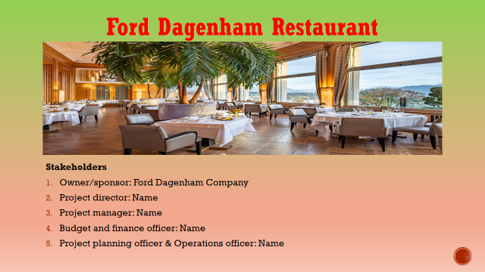
Slide 2
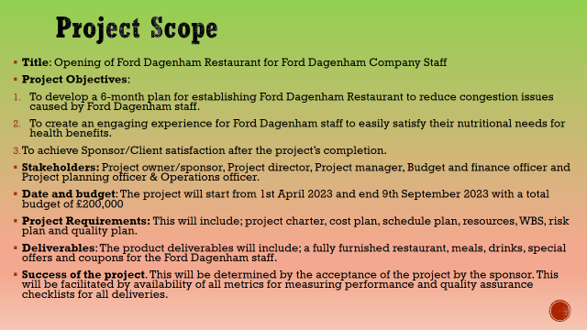
The title of this project is “Opening of Ford Dagenham Restaurant for Ford Dagenham Company Staff.” The project will have three objectives. The first objective is to develop a 6-month plan for establishing Ford Dagenham Restaurant to reduce congestion issues caused by Ford Dagenham staff. The second objective is to create an engaging experience for Ford Dagenham staff to sample the restaurant's food and drinks for health benefits. The last objective is to achieve Sponsor/Client satisfaction after the project. This project will involve opening Ford Dagenham Restaurant starting 1st April 2023 and ending 9th September 2023 with a total budget of £200,000. At the end of the project, we will have the restaurant’s sample meals, drinks, special offers and coupons provided by the sponsor/stakeholder. The restaurant will allow the Ford Dagenham staff to comfortably enjoy their breakfast and lunch to reduce congestion in the local area and the high absenteeism rate.
Slide 3
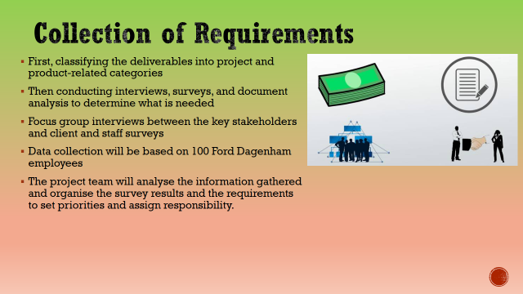
For the launch of the Ford Dagenham Restaurant, we will implement a strategy to collect requirements by first classifying the deliverables into project and product-related categories, then conducting interviews, surveys, and document analysis to determine what is needed, and finally putting that need into action. The tools and techniques utilised to get crucial understanding of the project and product requirements will include focus group interviews between the key stakeholders and client and staff surveys with a sample population of one hundred Ford Dagenham employees (Cook et al., 2021). The project team will analyse the information gathered and organise the survey results and the requirements in order to set priorities and assign responsibility.
Slide 4
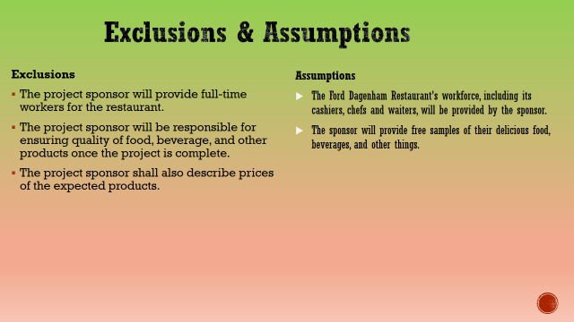
It will be assumed that the Ford Dagenham Restaurant's workforce, including its cashiers, chefs and waiters, will be provided by the sponsor. This means that we need to quickly recruit and train new employees. It will also be assumed that the sponsor will give free samples of their delicious food, beverages, and other things. However, if we need more materials for the project, we will have to make a purchase from a separate firm, which is counter to the project's goals. It's possible that we can use the space of the competing eatery.
Slide 5
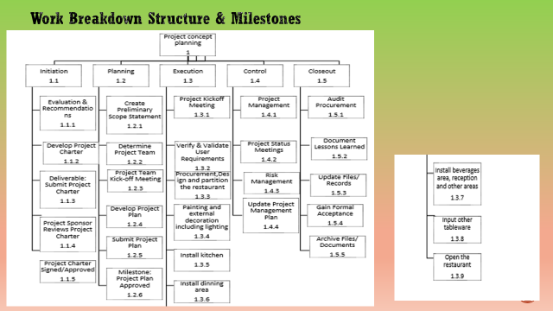
We will use the above WBS to facilitate the Ford Dagenham Restaurant's delivery successfully. The WBS will ensure the alignment of project plan through integration of scope, cost and schedule baselines (Burghate, 2018).
Slide 6
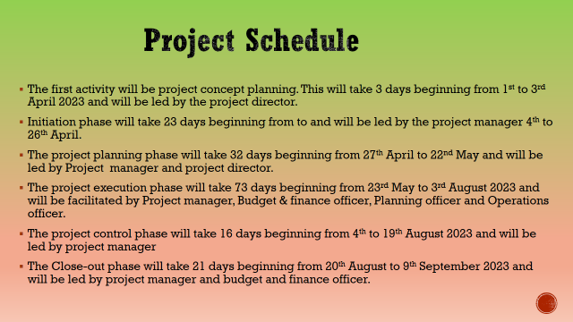
The schedule will provide the timeframe for the milestones outlined in the WBS, as well as when they are expected to get underway and wrap up. The schedule will be planned as linkages between activities and dependencies, based on resource allocation and duration. Timeline components are tightly linked to the WBS for getting the work done.
Slide 7
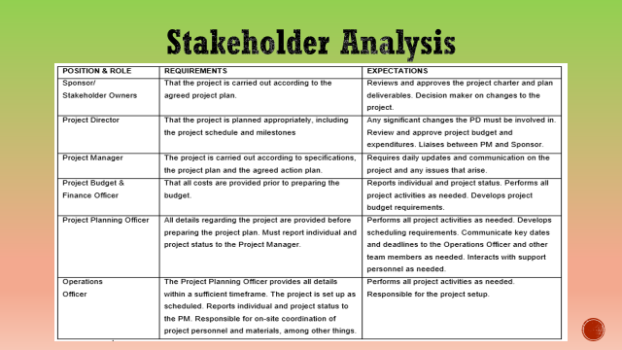
The project’s stakeholder analysis process will help identify, assess, and prioritise the people affected by the project. In this project, we shall use a stakeholder register to analyse the stakeholders based on their roles, responsibilities, requirements, expectations, level of influence, power of influence, and at which stage. For example, the sponsor stipulates that the project must be carried out as per the plan that has been agreed upon for the project. The sponsor must review and approve the project charter and plan deliverables. He or she will also decide on changes to the project. The sponsor shall be relevant at all project stages; however, he will be considered an external stakeholder. His or her influence and power level in the project are high. The other project stakeholders' analysis is shown in the table above.
Slide 8
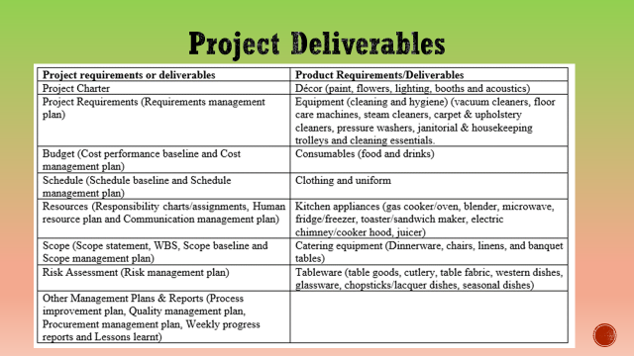
The project deliverables shall be divided into two categories: project and product. Some of the project deliverables will include the provision of the project charter, the requirements management plan, the budget plan, the schedule provision of the resource plan, and the risk assessment plan. The other project deliverables will include the provision of the scope statement, WBS, procurement plan, quality plan, scope baseline process improvement plan, weekly progress reports and lessons learnt. Some of the product deliverables will include décor equipment, cleaning and hygiene equipment, consumables, kitchen appliances, catering equipment and tableware.
Slide 9
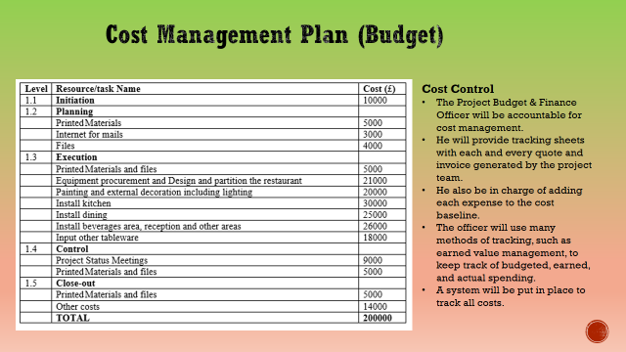
The final cost plan for the Ford Dagenham Restaurant will be delivered on September 9th, 2023 and will include a description of all the resources, space, material, and equipment required to finish the project. As a baseline, we've allocated £200,000 for this project. The Project Budget & Finance Officer will be accountable for cost management. He will provide tracking sheets with each and every quote and invoice generated by the project team. He is in charge of adding each expense to the cost baseline. The officer will use many methods of tracking, such as earned value management, to keep track of budgeted, earned, and actual spending. A system will be put in place to track all costs.
Slide 10
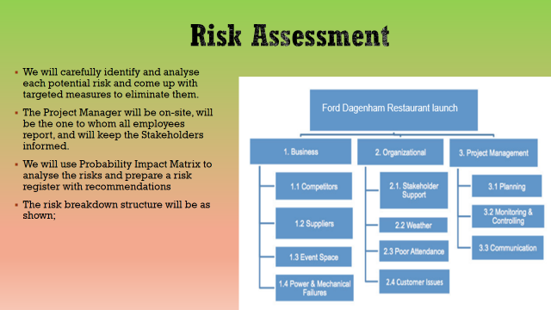
The goal of the Risk Management Plan is to identify possible problems that might delay or thwart the opening of the Ford Dagenham Restaurant and then create a strategy to deal with them (Rodrigues-da-Silva and Crispim, 2014). Using what we learned from previous similar projects, we sat down with key players to interview, then used that information along with a combination of brainstorming and discussion to identify the most pressing risks that needed to be factored into the project's final outline. After carefully identifying and analysing each potential risk, we came up with targeted measures to eliminate them. Should the threats materialise, we will do all in our power to ensure adequate measures are implemented to counteract them. Every member of the staff has been briefed on the necessary procedures and reminded that they must be completed on time as it has been determined that all potential threats will materialise on the day of the event. The Project Manager will be on-site, will be the one to whom all employees report, and will keep the Stakeholders informed. We will use Probability Impact Matrix to analyse the risks and prepare a risk register with recommendations.
Slide 11
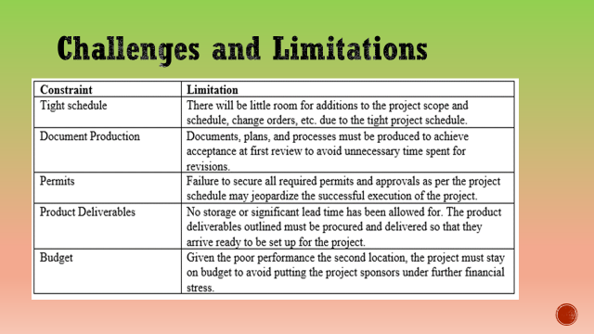
Although the project is expected to be completed in six months however, it might face several constraints, including tight schedules, a long process of document production, a long process of obtaining permits, product deliverables and a limited budget. The good news is these limitations will be managed and controlled within the limits of the triple constraints (time, scope and cost).
Slide 12
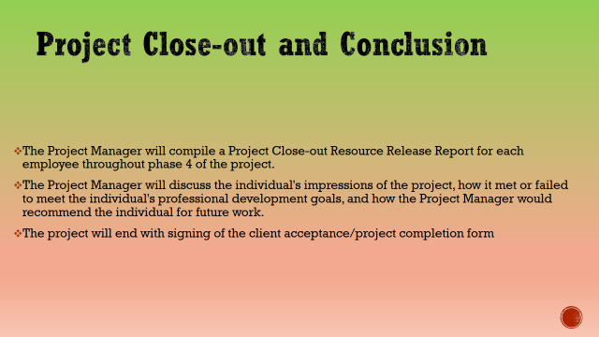
The Project Manager will compile a Project Close-Out Report for each employee throughout the last phase of the project. The Project Manager will utilise this report as an opportunity to provide helpful feedback to team members based on their performance throughout the phase of the project lifecycle being reported on. The specific needs for this input will be discussed in further depth in the next paragraph. The Project Manager will discuss the individual's impressions of the project, how it met or failed to meet its professional development goals, and how it would recommend the individual for future work. The project will end by signing the client acceptance/completion form.
Slide 13


