Operating Systems and Command Line Interface Report
Student Name: PELE WINDROSS
Student Number: Your Student ID
Module Name: Operating Systems
Assignment Title: Operating Systems, Command Line Interfaces and Scripting Report

Table of Contents
- Introduction
- Key Functions of General Operating Systems
- Use of Windows OS CLI Commands
- Use of Linux OS CLI Commands
- Use of Windows OS Scripts
- Use of Linux OS Scripts
- Conclusion
- References
- Appendices
1. Introduction
Operating systems are one of the most important parts of any computer system because they allow the hardware and software to work together efficiently. Without an operating system, users would not be able to interact with applications or manage files, hardware devices, or system resources. Modern operating systems provide a user-friendly environment while also carrying out complex tasks in the background, such as memory management, process scheduling, and security.
This report explores the main functions of modern operating systems before demonstrating the use of both Windows and Linux command-line interfaces. The report also includes examples of Batch and Bash scripting to show how repetitive tasks can be automated. Throughout the report, practical examples and command outputs are used to demonstrate an understanding of how operating systems work in real-world environments.

2. Key Functions of General Operating Systems
General-purpose operating systems are designed to manage computer hardware while providing services that allow software applications to be executed efficiently. Popular operating systems include Microsoft Windows, Linux distributions such as Ubuntu and Fedora, and Apple's macOS. Although these systems differ in design, they all perform similar fundamental functions that enable computers to operate effectively [1], [2].
2.1 Process Management
One of the primary responsibilities of an operating system is process management. A process is an instance of a running program. The operating system allocates processor time, schedules tasks, and switches rapidly between processes using multitasking techniques. Modern operating systems use scheduling algorithms to maximize CPU utilization while maintaining responsiveness for users [2].
Windows allows users to monitor running processes using Task Manager, where CPU, memory, disk and network usage can be viewed. Linux systems provide equivalent functionality using commands such as top, htop, or ps.
Screenshot 1: Windows Task Manager showing running processes. 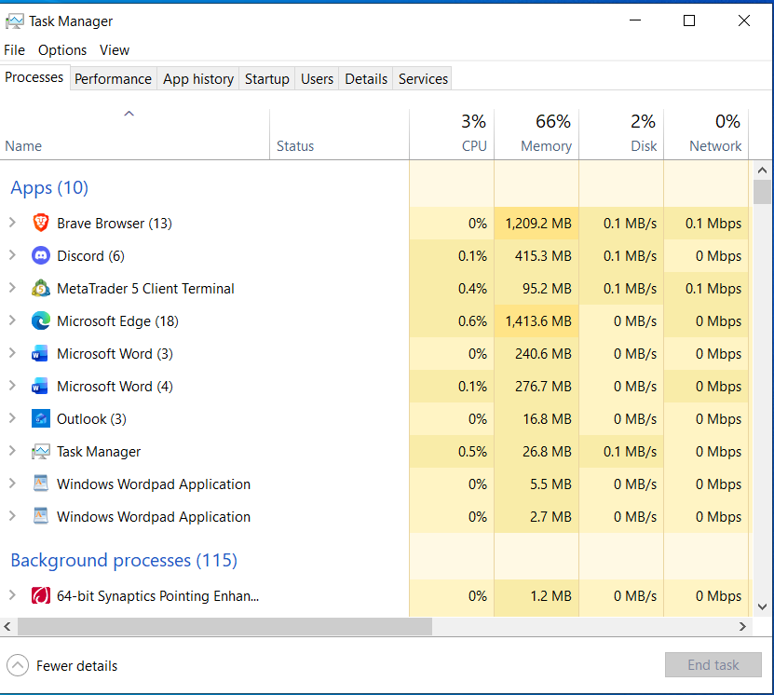

2.2 Memory Management
Memory management ensures that applications receive sufficient RAM while preventing one program from accessing another program's memory. The operating system allocates memory dynamically and uses virtual memory when physical RAM becomes limited. Paging and swapping techniques allow applications to continue operating even when RAM usage is high [3].
Windows users can monitor memory usage through the Performance tab of Task Manager, while Linux users can use the free or vmstat commands.
Screenshot 2: Windows Task Manager – Memory tab.
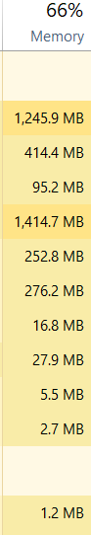

2.3 File System Management
Operating systems organise data using file systems. They create directories, manage permissions, allocate storage space and ensure files can be read and written correctly. Windows commonly uses NTFS, while Linux typically uses ext4 or XFS [4].
Users can create, move, rename and delete files using graphical tools such as File Explorer or terminal commands like mkdir, cp, mv and rm.
Screenshot 3: Windows File Explorer showing folders and file properties. 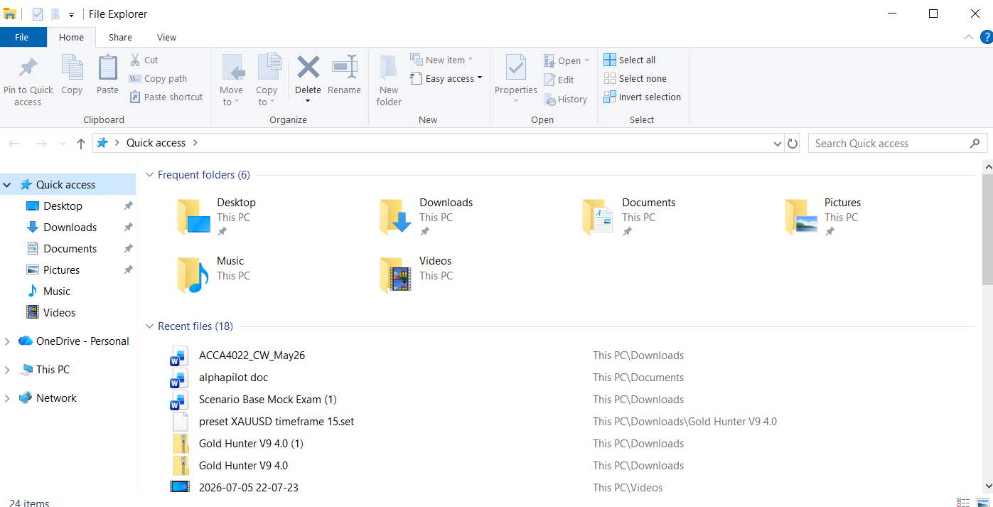
2.4 Device Management
The operating system communicates with hardware devices using device drivers. These drivers allow the operating system to interact with printers, keyboards, graphics cards, storage devices and network adapters. Device management ensures that hardware resources are shared efficiently among applications [5].
Windows Device Manager enables administrators to update, disable or troubleshoot hardware devices.
Screenshot 4: Windows Device Manager.
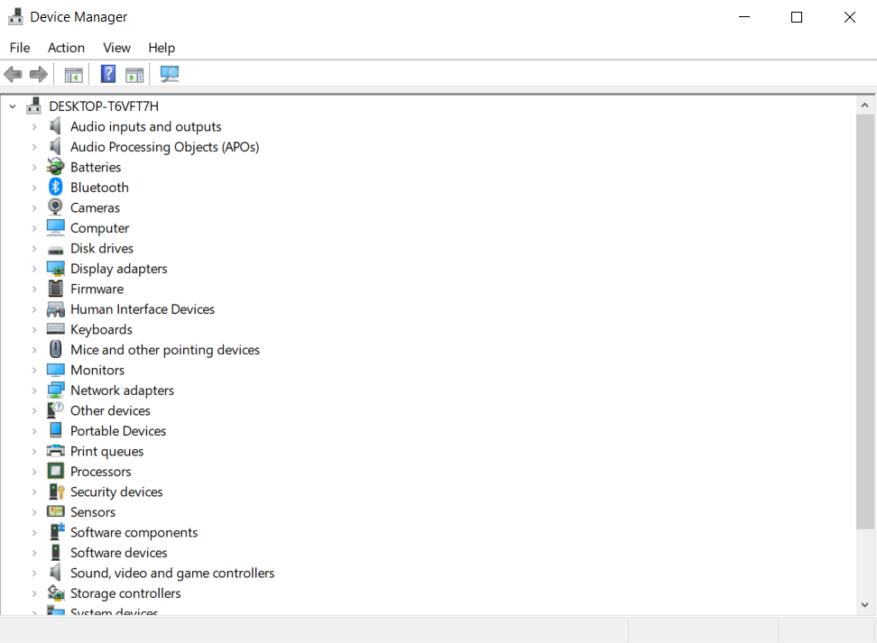

2.5 User Management and Security
Operating systems provide authentication and access control to protect sensitive information. User accounts, passwords, permissions, and encryption help prevent unauthorized access. Administrators can assign different privilege levels depending on user responsibilities [6].
Windows includes the Local Users and Groups management console, while Linux stores user account information in the /etc/passwd and /etc/shadow files.
Screenshot 5: Windows Local Users and Groups. 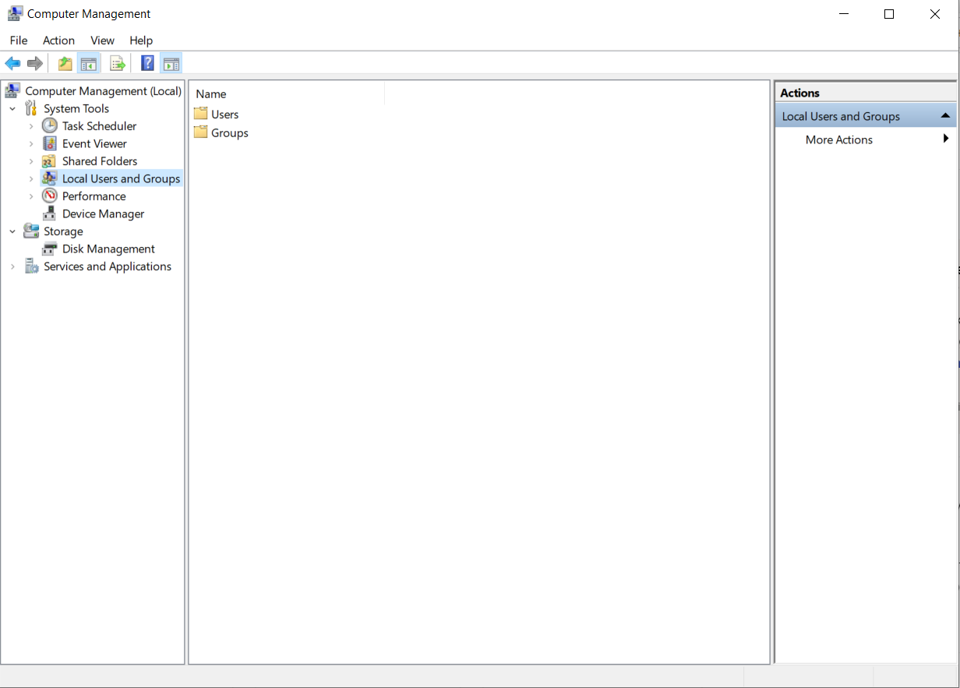

2.6 Networking
Modern operating systems include built-in networking functionality that enables communication across local networks and the Internet. Network services include IP configuration, DNS resolution, wireless connectivity and file sharing. Administrators often diagnose connectivity using commands such as ping, ipconfig, ifconfig and netstat [7].
Windows provides network information through the Network and Sharing Centre and PowerShell networking commands.
Screenshot 6: Output of ipconfig /all in Command Prompt. 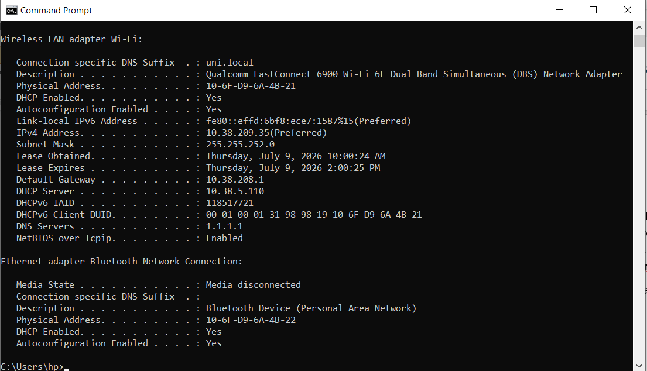

2.7 User Interface
Most operating systems provide both graphical user interfaces (GUI) and command-line interfaces (CLI). GUIs simplify everyday tasks through icons, menus and windows, while CLIs provide greater control and automation capabilities. System administrators frequently rely on PowerShell and Bash because complex administrative tasks can be completed more quickly using commands and scripts [8].

Summary
Overall, operating systems perform many essential tasks that allow computers to operate efficiently. Features such as memory management, multitasking, and security improve both system performance and user experience. Windows is popular because of its ease of use and compatibility with commercial software, while Linux is widely used on servers because of its stability, security, and flexibility. Although each operating system has different strengths, they all perform the same core functions required to manage computer hardware and software effectively.

3. Use of Windows OS CLI Commands
The Windows Command Line Interface (CLI) allows users and system administrators to perform tasks without relying on the graphical user interface (GUI). Using Command Prompt and PowerShell can improve efficiency by automating tasks, troubleshooting problems and managing system resources. Many organisations use CLI tools because they are faster than navigating through multiple menus, especially when managing multiple computers.
The following commands demonstrate common administrative tasks carried out using the Windows command line.

3.1 Process Management
Command 1: tasklist
Purpose: Displays all currently running processes.
Example
tasklist
Example with filter
tasklist /FI "IMAGENAME eq chrome.exe"
Description
The tasklist command lists all active processes currently running on the computer. The /FI switch applies a filter so that only selected processes are displayed. This command is useful when checking whether an application is running or diagnosing performance issues.
Screenshot 7: CMD showing the tasklist command and its output.

Command 2: taskkill
Example
taskkill /IM notepad.exe /F
Description
The taskkill command terminates a running process. The /IM switch specifies the image name of the application, while /F forces the process to close immediately. This command is commonly used when an application stops responding.
Screenshot 8: taskkill command successfully closing Notepad.

3.2 File and Directory Management
Command 3: dir
Example
dir /O:N
Description
The dir command displays files and folders within the current directory. The /O:N option sorts the results alphabetically by filename, making files easier to locate.
Screenshot 9: Output of the dir /O:N command.

Command 4: mkdir
Example
mkdir Coursework
Description
The mkdir command creates a new directory. It is commonly used to organize files or prepare folders before copying or creating data.
Screenshot 10: Creating the Coursework folder.

Command 5: copy
Example
copy report.txt Coursework\
Description
The copy command duplicates files from one location to another. It is useful for creating backups or moving coursework into organised folders.
Screenshot 11: File successfully copied.
3.3 Network Testing and Monitoring
Command 6: ipconfig
Example
ipconfig /all
Description
The ipconfig command displays detailed network configuration information, including IPv4 addresses, MAC addresses, DNS servers and default gateways.
The /all switch provides complete network information.
Screenshot 12: Output of ipconfig /all.

Command 7: ping
Example
ping google.com -n 4
Description
The ping command tests communication between the local computer and another host. The -n 4 option sends four packets before stopping. It is frequently used to verify Internet connectivity and troubleshoot network problems.
Screenshot 13: Successful ping results.

Command 8: netstat
Example
netstat -ano
Description
The netstat command displays active network connections and listening ports. The -a option shows all connections, -n displays numerical addresses, and -o includes the Process ID (PID) associated with each connection.
Screenshot 14: Active network connections displayed.

3.4 User Management
Command 9: net user
Example
net user
Description
The net user command lists all local user accounts configured on the computer. System administrators use this command to manage user accounts.
Screenshot 15: List of local users.

Command 10: whoami
Example
whoami
Description
The whoami command displays the username of the currently logged-in account. It is useful when verifying which account is executing administrative tasks.
Screenshot 16: Output showing the current user.

3.5 Task Scheduling
Command 11: schtasks
Example
schtasks /Query
Description
The schtasks command displays scheduled tasks configured on the computer. System administrators use scheduled tasks to automate maintenance jobs such as backups, updates and system scans.
Screenshot 17: List of scheduled tasks.
Command 12: PowerShell Get-ScheduledTask
Example
Get-ScheduledTask
Description
This PowerShell cmdlet displays all scheduled tasks stored within Windows Task Scheduler. PowerShell provides more advanced filtering and automation capabilities than the traditional Command Prompt.
Screenshot 18: PowerShell showing scheduled tasks.

Summary
Windows command-line tools provide administrators with efficient methods for managing system resources and troubleshooting problems. Commands such as tasklist, taskkill and netstat allow monitoring of running processes and network activity, while dir, mkdir and copy simplify file management. Networking commands including ipconfig and ping assist in diagnosing connectivity issues, whereas net user, whoami and schtasks support user administration and task automation. Together, these commands demonstrate the flexibility and power of Windows CLI environments for routine system administration.

4. Use of Linux OS CLI Commands
Linux provides a powerful command-line interface known as the Bash shell, which allows users and system administrators to perform system administration tasks efficiently. Unlike graphical interfaces, Bash enables users to automate repetitive tasks, manage files, monitor system resources and configure the operating system through simple commands. Linux command-line tools are widely used in enterprise environments because they consume fewer system resources, support scripting and allow remote administration through Secure Shell (SSH). This section demonstrates twelve Bash commands covering process management, file and directory management, network monitoring, user management and task scheduling.

4.1 Process Management
Command 1: ps
Example
ps -aux
Description
The ps command displays information about active processes running on the system. The -aux options show all running processes together with the user, process ID (PID), CPU usage and memory consumption. This command is commonly used to identify processes that are consuming excessive resources.
Screenshot 19: Output of ps -aux.

Command 2: top
Example
top
Description
The top command provides a live view of system performance, including CPU usage, memory usage and running processes. Unlike ps, the display updates continuously, making it useful for monitoring system performance in real time.
Screenshot 20: top command displaying running processes.

Command 3: kill
Example
kill -9 1234
(Replace 1234 with an actual Process ID.)
Description
The kill command terminates a running process. The -9 option sends the SIGKILL signal, forcing the process to stop immediately. System administrators often use this command when applications become unresponsive.
Screenshot 21: Killing a process using its PID.
4.2 File and Directory Management
Command 4: ls
Example
ls -la
Description
The ls command lists files and directories. The -l option displays detailed information, while -a includes hidden files beginning with a period (.).
Screenshot 22: Directory listing with hidden files.

Command 5: mkdir
Example
mkdir Newfolder
Description
The mkdir command creates a new directory. It is frequently used to organise project files and store coursework.
Screenshot 23: Creating the Newfolder directory.

Command 6: cp
Example
cp report.txt Coursework/
Description
The cp command copies files from one location to another. It is commonly used to create backup copies or duplicate important documents.
Screenshot 24: File copied successfully.

4.3 Network Testing and Monitoring
Command 7: ip
Example
ip addr show
Description
The ip command displays detailed network interface information, including IPv4 and IPv6 addresses. It replaces the older ifconfig command on modern Linux distributions.
Screenshot 25: Network interface information.

Command 8: ping
Example
ping -c 4 google.com
Description
The ping command checks network connectivity by sending Internet Control Message Protocol (ICMP) packets to another host. The -c 4 option limits the test to four packets.
Screenshot 26: Successful ping output.
Command 9: ss
Example
ss -tuln
Description
The ss command displays active network sockets. The options -t, -u, -l and -n show TCP sockets, UDP sockets, listening ports and numerical addresses respectively. It is the preferred replacement for netstat on modern Linux systems.
Screenshot 27: Open network ports displayed.
4.4 User Management
Command 10: whoami
Example
whoami
Description
The whoami command displays the username of the currently logged-in user. This command is useful when confirming user permissions before executing administrative commands.
Screenshot 28: Logged-in user.

Command 11: id
Example
id
Description
The id command displays the user's UID (User ID), GID (Group ID) and group memberships. Administrators use this information when troubleshooting file permissions and access rights.
Screenshot 29: User ID information.
4.5 Task Scheduling
Command 12: crontab
Example
crontab -l
Description
The crontab command lists scheduled cron jobs for the current user. Cron is one of the most widely used scheduling tools in Linux and enables automated execution of maintenance tasks such as backups, software updates, and system monitoring.
Screenshot 30: Existing cron jobs.

Summary
The Linux Bash shell provides powerful command-line utilities that allow administrators to manage processes, monitor system performance, organize files, configure networks, and automate routine tasks. Commands such as ps, top and kill simplify process management, while ls, mkdir and cp assist with file management. Networking commands including ip, ping and ss enable effective troubleshooting of network connectivity and listening services. Finally, commands such as whoami, id and crontab demonstrate Linux's comprehensive support for user administration and task scheduling. Together, these commands illustrate why Linux remains one of the most popular operating systems for servers, cloud computing and cybersecurity environments.

5. Use of Windows OS Scripts
Windows Batch scripting enables users to automate repetitive tasks using Command Prompt. Batch files consist of a sequence of commands stored in a text file with the .bat extension. They are widely used by system administrators for automating maintenance, file management and user interaction. Batch scripting reduces the time required to perform routine administrative tasks and minimizes the risk of human error. This section demonstrates two practical Batch scripts that utilize variables, user input, arithmetic operations, loops and conditional statements.

Script 1 – Student Grade Calculator
Purpose
This script requests three assessment marks from the user, calculates the total and average score, and determines whether the student has passed or failed. The script demonstrates variables, user input, calculations and conditional statements.
Batch script on notepad -
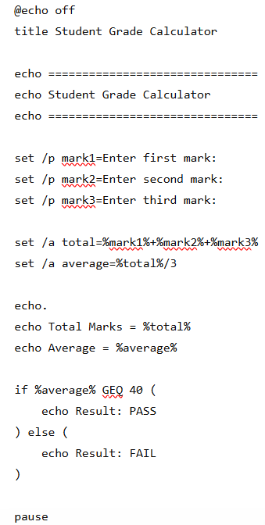
Screenshot of script running on command prompt.
The script begins by requesting three marks from the user using the set /p command. The entered values are stored as variables and added together using the set /a arithmetic operator. The average mark is then calculated by dividing the total by three. An IF...ELSE statement compares the average score against the pass mark of 40. If the average is greater than or equal to 40, the script displays "PASS"; otherwise, it displays "FAIL". This demonstrates how Batch files can automate simple decision-making processes.
Script 2 – Folder Backup Automation
Purpose
This script creates a backup folder if it does not already exist, copies all text files into the backup directory and displays progress messages. The script demonstrates variables, loops and conditional statements.
Batch script on notepad-
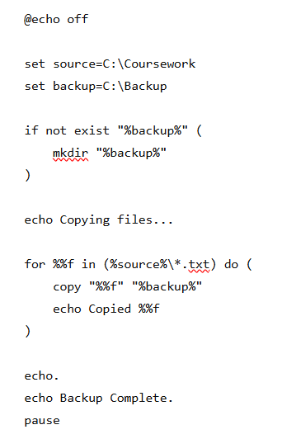
Screenshot of script running on Command Prompt.
The script first stores the source and backup locations as variables. It checks whether the backup directory exists using an IF NOT EXIST statement. If the folder is missing, it is created automatically with the mkdir command. A FOR loop then processes every text file found in the source folder and copies each file into the backup location. Progress messages are displayed throughout execution, allowing the user to monitor the operation. This script demonstrates how Batch programming can automate repetitive backup tasks that would otherwise require manual copying of files.
Summary
Both Batch scripts show how Windows command-line automation can make common tasks easier. The first script uses user input, calculations and decisions, while the second script automates folder creation and file backups using loops. These examples show how Batch scripting can save time and reduce manual work for system administrators.
6. Use of Linux OS Scripts
Bash scripting is one of the most powerful features of Linux operating systems. A Bash script is a text file containing a sequence of shell commands that can be executed automatically to perform repetitive tasks. System administrators use Bash scripts to automate backups, monitor system resources, manage users and schedule maintenance tasks. Compared with performing each command manually, Bash scripting saves time, improves consistency and reduces the likelihood of human error. This section presents two practical Bash scripts that demonstrate variables, user input, arithmetic operations, loops and conditional statements.
Student Grade Calculator
Purpose
This script asks the user to enter three assessment marks, calculates the total and average score, and determines whether the student has passed or failed.
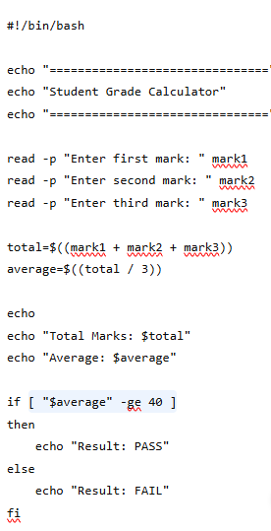 The script begins by requesting three marks from the user using the read command. These values are stored in variables and added together using Bash arithmetic expansion. The average mark is then calculated by dividing the total by three. An if statement checks whether the average is greater than or equal to 40. If the condition is true, the script outputs "PASS"; otherwise, it displays "FAIL". This example demonstrates variables, user input, arithmetic calculations and conditional statements within a Bash script.

File Backup Automation
Purpose
This script creates a backup directory if it does not already exist, copies all text files from the current directory into the backup folder and displays confirmation messages for each copied file.
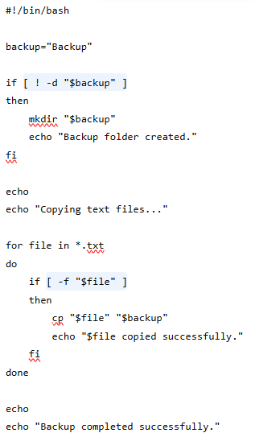 The script stores the backup folder name in a variable and checks whether the directory already exists. If it does not, the script creates it automatically using the mkdir command. A for loop processes each text file in the current directory. The script checks that the item is a regular file before copying it into the backup directory using the cp command. Throughout execution, status messages are displayed to keep the user informed. This script demonstrates variables, loops, conditional statements and practical file automation in Linux.
Summary
Together, these examples highlight the flexibility and efficiency of Bash scripting for Linux system administration and reinforce the importance of automation within modern operating systems.

7. Conclusion
Operating systems are a vital part of modern computing because they control hardware resources and create the platform that allows applications to run effectively. Throughout this report, the main responsibilities of operating systems were explored, including process management, memory management, file systems, device management, networking, user management and security. While operating systems such as Windows, Linux and macOS have different designs and features, they all aim to provide a stable and efficient environment for users and applications.
The practical work with Windows Command Prompt and PowerShell showed how command-line tools can make system administration tasks easier and more efficient. Commands such as tasklist, taskkill, ipconfig, ping, net user and schtasks demonstrated how administrators can view running processes, manage files, troubleshoot network issues and automate tasks. Compared with using only graphical interfaces, command-line tools can provide quicker solutions, more control and better opportunities for automation.
The Linux Bash activities also highlighted the importance of command-line administration. Commands including ps, top, ls, cp, ip, ping, ss and crontab showed how Linux users can monitor system performance, manage files, check network connections and schedule automated tasks. Learning both Windows and Linux command-line environments demonstrates that these skills are useful across different operating systems and are highly valuable in professional IT environments.
The scripting activities further showed how automation can improve everyday system management. The Windows Batch scripts and Linux Bash scripts used variables, user input, calculations, loops and conditional statements to complete tasks automatically. The Grade Calculator scripts helped process results quickly, while the Backup scripts demonstrated how files can be organized and copied without repeated manual effort. These examples show how scripting can save time, improve accuracy and reduce human mistakes.
In conclusion, this report has shown that operating systems provide the essential foundation for modern computers, while command-line tools and scripting provide powerful ways to manage and automate systems. Developing practical experience with Windows and Linux administration tools is an important skill for IT professionals, cybersecurity specialists and network administrators. As technology continues to develop, efficient system management and automation will remain key areas of importance within the computing industry.

8. References (IEEE)
[1] A. Silberschatz, P. B. Galvin and G. Gagne, Operating System Concepts, 10th ed. Hoboken, NJ: John Wiley & Sons, 2018.
[2] W. Stallings, Operating Systems: Internals and Design Principles, 9th ed. London: Pearson, 2018.
[3] A. S. Tanenbaum and H. Bos, Modern Operating Systems, 5th ed. Harlow: Pearson, 2022.
[4] M. Russinovich, D. Solomon and A. Ionescu, Windows Internals, 7th ed. Redmond, WA: Microsoft Press, 2021.
[5] Microsoft, "Windows Commands," Microsoft Learn. Available: https://learn.microsoft.com/windows-server/administration/windows-commands
[6] Microsoft, "PowerShell Documentation," Microsoft Learn. Available: https://learn.microsoft.com/powershell/
[7] Microsoft, "Task Scheduler Documentation," Microsoft Learn. Available: https://learn.microsoft.com/windows/win32/taskschd/
[8] Microsoft, "PowerShell Get-Help," Microsoft Learn. Available: https://learn.microsoft.com/powershell/
[9] Ubuntu Documentation, "Ubuntu Server Guide." Available: https://ubuntu.com/server/docs
[10] GNU Project, "Bash Reference Manual." Available: https://www.gnu.org/software/bash/manual/
[11] Red Hat, "Red Hat Enterprise Linux Documentation." Available: https://access.redhat.com/documentation
[12] Linux Foundation, "Linux Documentation." Available: https://www.linuxfoundation.org
[13] Cisco Networking Academy, "Linux Unhatched."
[14] Skills for All, "Operating Systems Basics."
[15] Microsoft Learn, "Automate Administrative Tasks Using PowerShell."
[16] The Linux Documentation Project, "Linux Documentation." Available: https://tldp.org
[17] IEEE Computer Society, "Operating Systems Overview."
[18] Open Group, "POSIX Standard Documentation."
[19] Oracle, "Linux Administration Guide."
[20] Ubuntu Manual Pages. Available: https://manpages.ubuntu.com

