Financial Management For the Hotel Industry
Student Name: Oana-Lavinia Puravet
Student ID: 2129004

Table of Contents
Introduction 3
Evaluate the Financial Performance of the business over the preceding Three Years 4
Discuss the Key Cause of the Business's unprecedented decline in Profits 8
Elucidating Substantial Business Reviving Strategy for the Business 10
Conclusion 13
References 14

Introduction
This case study has elucidated the evaluation of the income statement, cash flow and overall balance sheet of the organisation. The three-year financial analysis can be elucidated based on the overall elucidation of current liabilities, debt-equity for the long term and other extra-financial information. The business has the best location including the premium services availability but the overall negative costs of business operation from the year 2020 to 2022 have gone through multiple challenges of the business. Elucidated data of the business finance can underline the business condition based on profit margin, current assets and problems related to lay off of the business. The resort business owner can develop an overall substantial strategy related to the financial health of the organisation and an indicated strategy related to the organisation’s amenities of the business. The elucidation related to the overall rate of occupancy rate can elucidate the business capital that needs to be revived. The discussion lastly elaborates on the overall elucidation related to reviving the condition of the business.

Evaluate the Financial Performance of the business over the preceding Three Years
Evaluation of Income Statement
Total Revenue
The organisation’s revenue declined from approximately five million twenty thousand British Pounds to £430,000 in 2022. The suggestion downloads the obstacles regarding the market declination revenue.
Operating Expenses
The enhanced costs of operation from three lakh ninety thousand in the year 2020 to a significant decrease in the year £450,000 for the year 2022. The inclination of the expenses can be underlined based on the costs including marketing, functions of administration and overall production.
Gross Profit
The consistency of the gross profit can be underlined with an approximate figure of One million thirty thousand pounds from the year 2020 to the negative drop in the year 2022 with £80,000. The gross profit consistency can be inclined in the year 2020 with £130,000 and drop with the same level declination. The gross profit stagnant process can be underlined by pressures of pricing, inefficiencies of the cost and overall production mix transformation.
Loss of Net Profit
Declination of Net Profit from £78,000 to in the year 2021 it was £40,000. The further decline was seventeen thousand five hundred British Pounds in the year 2022. The indication of the decreasing of the net value can suggest the management cost obstacles of the business to achieve business profit.
Net Profit Margin
The margin of net profit expressed the overall business revenue percentage in the three years. The figure in the year 2020 was 15% and that further elaborates declination with 4% in the year 2022. The margin suggests the organisation’s profitability including eroded revenue over time.
Interpretation: The business went through multiple obstacles within the three-year time frame including negative revenue, expense inclination and profit striking process. The profit margin drop has indicated the management cost inefficiencies. To enhance the efficiency in operation, the organisation needs to control costs, and strategies of revenue development. Several reasons including pressure of competition, dynamics of the market and other business internal factors need to be analysed (Seal et al., 2008).
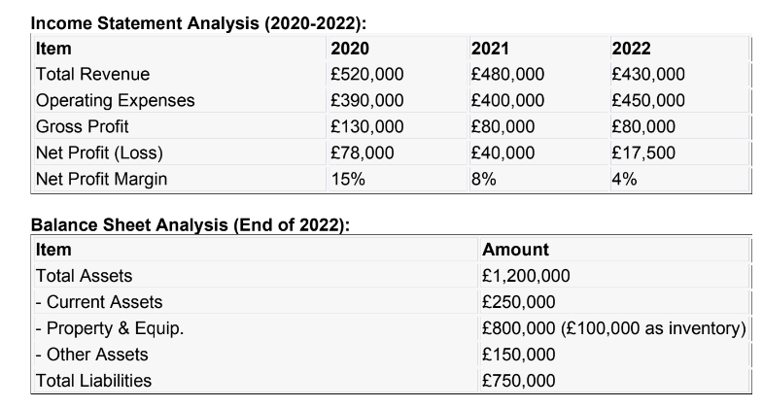
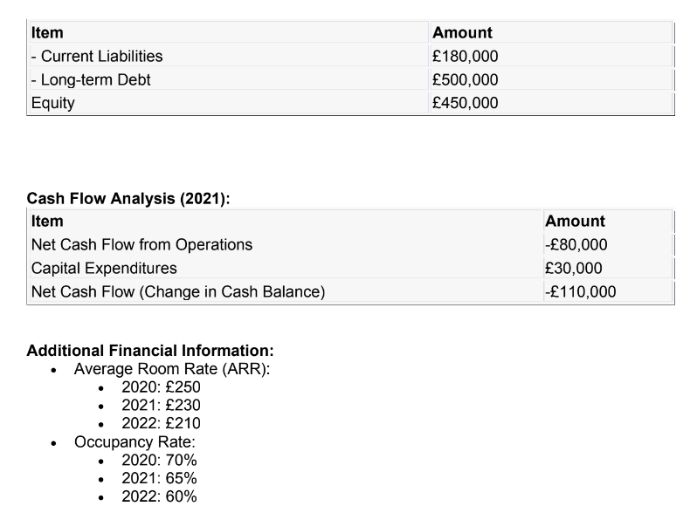
Figure: Financial Information for 2020 to 2022 of Seaview Resort
Evaluation of Balance Sheet
The organisation needs to provide financial position data, asset dealing process and overall organisation’s financial position snapshot related to the equity balance of the organisation. There are several breakdowns of the organisation (Tranter, 2014).
Total Assets
The representation of the total assets includes the overall owned resort value. The overall asset value of the organisation at the end of 2022 was £1,200,000. The overall asset is divided based on three divisions. Overall divisions-related assets’ short-term analysis can be underlined based on current Assets, Equipment and property of the business and other assets. The assets’ short-term analysis can be underlined with current assets and the figure after 2022 was £250,000 which includes receivable accounts, cash and inventory. Equipment and property of the business underlined with the cost of £800,000 includes buildings, equipment and furniture. The business includes £100,000 as inventory attributes.
Total Liabilities
Representation of the liabilities within the organisation can be obligated based on the debt of the business. Total liabilities for the business include £750,000. The resorts’ borrowing for the long-term represents the amount of £500,000 including the bonds or mortgages.
Equity
Representation of equity can be underlined with the organisation’s interest. The calculation can be different from total liabilities and assets. The resorts’ business can be underlined with an overall stand of £450,000. The business has faced overall obligations related to the process of accounting.
Interpretation: The balance sheet indicates the comprehensive including of the property including the measures of inventory. The crucial liabilities include long-term and overall current debts. The equity representation of the resort includes shareholders’ availability for value orienting process of the business including obligations of the organisation (Jagels, 2007).
Evaluating the Business Cash Flow
The evaluation of the cash flow indicates the operation of the business by indicating the process of negative cash flow assessment with the expenditures of capital. The negative costs of the operation include the expenditure of capital that includes the cash flow transformation. The negative cash flow of the company indicates activities related to production, administration and cash flows. The expenditure of the business indicates £30,000 with property investment, infrastructure and equipment costs. This reflects the cash balance of the resort with -£110,000. The suggestion for the financial obstacles of the business include the leaving cash significance than the business entering process. The crucial significance of the resort indicates assurance related to the operation of sustainability and liquidity assurance.
Additional Features of Finance
The representation of the average rate of rooms includes the sales of resorts. The indicated trends of the room prices have suggested the overall business challenges that make an impact on attracting guests of high-paid. The room price has dropped from £250 to £210. The rate of occupancy can indicate the guest occupied preferences for the hotel rooms. The occupancy rates can incline from seventy per cent to sixty per cent. The lower rate of occupancy can create an effect on the overall profitability and revenue (Atrill et al., 2021).
Interpretation: The financial performance of the business reflects the trends that make worries related to decreasing trends of the ARR and the rate of occupancy with challenging indications of the businesses' replacement pricing power and demand of the guests. To enhance the overall profitability the organisation needs to implement multiple strategies (Bhimani, 2006).

Discuss the Key Cause of the Business's unprecedented decline in Profits
Fierce Competition: The market resembling industry for coastal resorts can be underlined with harbouring bustling processes, rival vessels’ presence, competitive resorts' presence nearby the dock and promising atmosphere related to amenities of the contemporary world, design of cutting-edge processes including experiences of Instagram-worthy environments. The Seaview resort had a monopolistic market situation, although the constant new business emergence made the market divert from the innovative offerings of the tourists from other new businesses (Guilding, 2014).
Consumer Preferences’ Transformation: The transformed wind of the preferences of the consumers has intrigued the hospitality industry. The immersive experiences can be craved with practices of eco-friendliness and compassing this with preferred choices of the organisation. The practices of the business are outdated and that makes the traditional offerings more aligned with the desires of the travellers. The coastline offerings can be neglected with the coastline of once-pristine (Guilding, 2014).
Ageing Amenities and Erosion of Service Qualities: The consumers’ review related to revealing tales of the organisation can be served with quality preferences of the organisation. The struggles of the business can be underlined with guest experiences that include struggling of the crew who were experienced with conventional hospitality practices. Creaky floorboards, deck chairs that are faded and other outdated amenities can create hindrance to attract the consumers. It overshadows the past sweet memories of the guests as the overall areas are low-maintained (Drury, 2021).
Tradition’s Anchor of Complacency: Leadership of sea view resorts including the gentle lapping of the wave that failed to swiftly adapt. The conventional anchoring process including innovative weighing down can be interlinked with complacency. The standard of the services is overhauled with reluctant contemporary amenities' absence. The dissatisfaction of the guests because of the bad infrastructure of the area can be included in the overall elucidation of the complacency of the tradition (Wild, 2018).

Elucidating Substantial Business Reviving Strategy for the Business
Seaview Resort, once a jewel on the coast, now faces turbulent waters. To restore its financial health and regain its premier status, we propose a multifaceted turnaround strategy. Let’s unfurl the sails and navigate toward sunnier shores.
Guest-Centric Transformation:
Overhaul of Guest Experience: The analysis of the guest journey needs to be conducted for the business. The pain point recognition of the business needs to be enhanced. Introduce services that are personalised including departure of check-in to orders. Arranging surprises for the guests and giving thoughtful gestures to them will enhance the experiences of the guests. Including these the business needs to decor the interiors of the room, comfort assuring process and include the amenities of the contemporary world (Breier et al., 2021).
Experimental Offerings: Yoga on the beach, sunset from cruises and immersion of local culture need to be introduced. The natural beauty leveraging process includes coastline beauty such as guided walks within nature, kayaking and other procedures to give full satisfaction to the guests.
Eco-Friendly Practices: The waste of plastic reduction, water conservation and sustainable tourism promotion can include the practices of tourism. The native tree plantation, clean-up and organise the beach and give proper education to the guests for the stewardship of the environment.
Branding and Strategic Marketing
Rebranding Campaign: The narrative compelling process of the craft including the transformation of the Seaview resort. The rich history of the place needs to be introduced to gain proper direction. The influencer's engagement can be underlined with the spread of words of travel bloggers.
Enhancement of Online Presence: The resort and website revamp can create a mobile-friendly appeal based on the optimisation of the information including organic attraction of traffic. The platforms of social media, and SEO optimisation based on engagement and storytelling process need to be included within the business.
Cost Control and Efficiency in Operation
Assessment of Financial Health: The business needs to conduct a detailed process of financial orientation and needs to recognise the inefficiencies and leakages. Cost reduction based on the priorities without eliminating the guest experience compromising process (Seal, 2019).
Inventory Management: Optimise the level of inventory that adds the perishables. The robust inventory implementation needs to include the tracking system process of inventory. The suppliers’ deal needs to be underlined based on the dealing process of negotiation (Dimitrios et al., 2020).
Revenue Diversification
Event Hosting: The Seaview’s attractive view needs to be utilised based on conferences, weddings and exhibitions of art. The custom package creation includes the organisation of the events.
Spa Services and Wellness: Develop the service for the spa including the overlooking of the oceans. The diversification needs to include yoga sessions and a holistic programme for wellness including the offering of massage (Fenitra et al., 2022).
Financial Outcomes
Goals of Short-term: The organisation's short-term analysis for the break-even point needs to be analysed with a twelve-month process, occupancy rate can be enhanced with a ten per cent inclination. The profit margin enhancement techniques can include the eight per cent enhancement.
Goals of Long-Term: The Seaview establishment can be underlined with resorts on the coast. The adjacent properties include franchise exploration with positive contributions including the environment and local community process (Fenitra et al., 2022).

Conclusion
The revival process of Seaview Resort includes innovation, adaptive features and guest experiences. The transformation of the embracing process includes the sustainability process method and experience of delivering exceptions. The prosperity of the business includes the enhancement process of the coastal process including the generation process. Businesses need to include the overall upgradation of the resorts including decorating and training of the staff. The business also needs to enhance the loyalty programme of the consumers including the overall revitalization of the strategy to gain financial health of the business. The viable outcomes of the finance need to be included to generate positive revenue for the business. Overall business reviving strategy can be underlined with the process of long-term and short-term objectives and achievements of the business.

References
Atrill P, McLaney E (2021) Management Accounting for Decision Makers, FT Prentice Hall
Bhimani A, (Ed) (2006) Contemporary Issues in Management Accounting, Oxford
Breier, M., Kallmuenzer, A., Clauss, T., Gast, J., Kraus, S. and Tiberius, V., (2021). The Role of Business Model Innovation in the Hospitality Industry during the COVID-19 crisis. International Journal of Hospitality Management, 92, p.102723.
Dimitrios, B., Christos, P., Ioannis, R. and Vasiliadis, L., (2020). Strategic management in the hotel industry: proposed strategic practices to recover from COVID-19 global crisis. Academic Journal of Interdisciplinary Studies, 9(6), pp.130-130.
Drury, C . (2021) (11th Ed) Management and Cost Accounting, London, Prentice Hall
Fenitra, R.M., Abbas, A., Ekowati, D. and Suhairidi, F., (2022). Strategic intent and strategic leadership: A review perspective for post-COVID-19 tourism and hospitality industry recovery. The Emerald Handbook of Destination Recovery in Tourism and Hospitality, pp.23-44.
Guilding, C.(2014) (3rd Edition) Accounting Essentials for Hospitality Managers, London, Routledge
Jagels, M. (2007) Hospitality Management Accounting, London, Wiley.
Seal, W. (2019) (6th Ed) Management Accounting, London, McGraw Hill
Seal, W. Garrison RH, Noreen E (2008) Management Accounting, McGraw Hill
Tranter, K. Stuart-Hill, T. Parker, J. (2014) Introduction to Revenue Management for the Hospitality Industry, London, Pearson
Wild, J. (2018) Fundamental Accounting Principles, New York, McGraw Hill

