2020
Connor Rossiter
1708659
1/12/2020
The Culture and Heritage Tourism Sector and its Management Machu Picchu
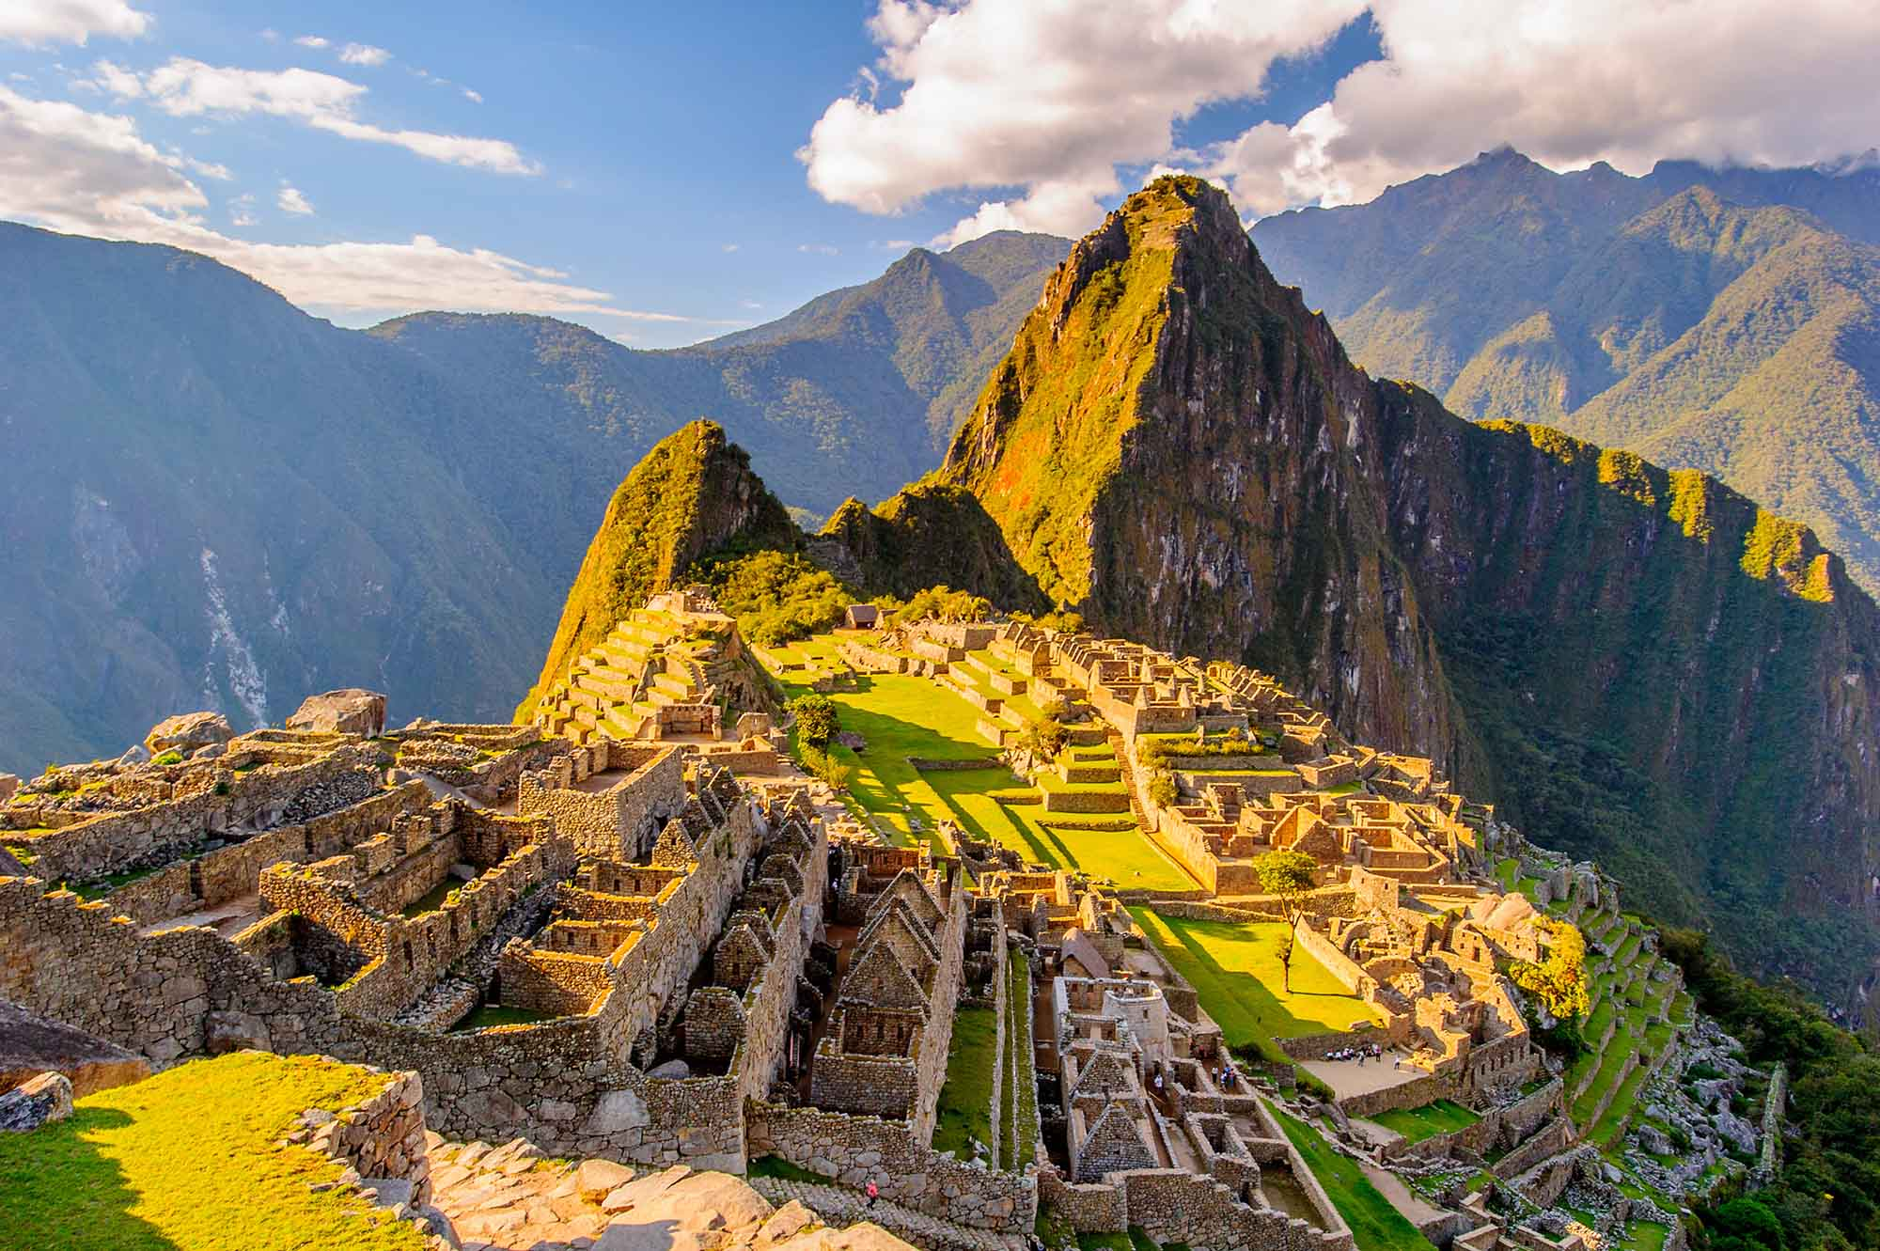
Lonely Planet – (2013)
Contents
Introduction 2
Tourism 3
The Four P’s 3
Preservation 3
Presentation 4
Promotion 4
Profit 5
Conclusion 6
Reference List: 7

Introduction

Machu Picchu is an ancient citadel located in the Andes mountains in Peru. Machu Picchu gained world heritage status in 1983 and become one of the seventh wonders of the world in 2017, UNEP (2008). What was the Inca citadel has become one of the world’s beacons for heritage tourism, due to sites mysterious and drastic location and past, (Deforges, 2000). The sites witness around 2500 guests every day, which is putting major strain on the government and developers who plan to increase tourism at Machu Picchu, (Leffel, 2005). Over tourism at the destination has caused Machu Picchu to become the quickest deteriorating heritage site in the world, (Hawkins, Chang & Warnes, 2009).
UNESCO (2009), have major concerns over the mass tourism at the site and have and still are constantly negotiating with the Peruvian government to decrease the number of guests and set conservation tasks in place.

Tourism

Before 1990, Peru contributed to less than 5% of tourism in South America, (Aguilar, Milla, Hinojosa & Nordt, 1992). However, after the 1990’s, when Peru lost its violent reputation and its infrastructure was improved tourism came in its masses for the country’s cultural features and nature, (Casado, 1998). “El turista es su amigo” – The tourist is your friend. This was the marketing campaign used by the government to persuade locals to have positive views towards the tourist, (Desforges, 2000). World Economic Forum, (2011) state that from 2000 to 2010 tourism doubled in Peru and has ever since been Peru’s fastest growing economy sector, (Mitchell & Eagles, 2015).
The closest city to Machu Picchu is Cusco, which has both rail and airline connections to the capital, Lima. Cusco hosts over 90% of all international trips to Peru, Solano (2015).
Machu Picchu’s visitor numbers are increasing every year by 6 – 10%, which could see destination increase its visitor compacity from 2500 people per day, which would cause more over tourism and decay at the site, UNESCO (2018).

The Four P’s

Preservation

Local farmers started to move out of the Machu Picchu area in 2006, as noise pollution became unbearable and frightened livestock. Collyns, (2006) believes this because of the bus trips back and forth the site and helicopter usage for tours. Peru has made it illegal to fly over Machu Picchu to bring back the local alpaca farmers to the region. By cancelling all flights over the site helicopter tours have been banished with tour operators losing money.
With the expansion of tourism and the population of the local towns and villages around the site modern infrastructure is a threat to habitats of many endangered species living within the forests and migration corridors are at threat of being blocked, (IUCN, 2011).
UNESCO and the Peruvian government have come up with different strategies to make sure that the site is free from decay, with the first being in 2005 which saw the site have a daily capacity cap of 2500 guests. In 2017 the government would only allow visitors to book trips in the morning and afternoon to see the site, with the evening being left to control visitor numbers. The site is open every month other than February, where the site is given a month’s rest with conservation work, Baker (2018).

Presentation

Machu Picchu is shown all round the world for its links with the ancient Inca people. However, many locals believe that builders and tourist facility staff come from outside the local towns, creating no jobs for the locals, Van Den Berghe, (2000).
The local people and government of Cusco have reached out to museums and universities around the world to return artefacts taken from Machu Picchu over a century ago, (Cornwell, 2006). Yale University were the first to return all artefacts they had from the area, which are now spread through-out Cusco, (Regalado, 2011). This has made a small impact on the footfall at Machu Picchu, with tourists spreading themselves around the mountain and the museums.
To give the tourists a unique and authentic experience at the site, farmers have been employed to perform rituals at the site for guests to see. This fake authenticity, as the farmers are not connected to the people that once lived there, (McGrath, 2004).
McCannell, (1973) – “The phenomena of “staged authenticity”, where native people adopt a contrived culture to appeal to tourists’ interests, is slowly pervading the Peruvian highlands”.
Cohen, (1988) – “The Subsequent re-invention of tradition and cultural change precipitated by the tourism-meditated commercialization of Inca Culture”.

Promotion

Many tour operators in Cusco promote Machu Picchu as the perfect place for a “selfie”. Machu Picchu should be promoted to connect with Inca community that once lived there to get the sense of heritage on the local area. Machu Picchu could learn a thing or two from following the steps in which Stonehenge is promoted. Thomas, (2018) states that the attraction is promoted to educated on the Druids and spark interest in mythology.
Ochoa, (2004) - “Tour operators, particularly members of the Cusco urban elite, have therefore been able to capitalize on incanismo as a marketable tourist commodity”
Ochoa, (2004) goes on to state that many people in the city of Cusco have applied jobs to act as Inca people to perform shows for tourists. This not only loses the authenticity of the site but the passionate delivery. Forbes, (2017) believe that hiring Local staff will only benefit an organisation/attraction.
- Emotional attachment
- First-hand Experience
- Sense of community
- Passionate

This could deliver a more authentic experience for guests, as the local staff would be more passionate, because of the ancestry and connections they have to the site. Following this recommendation could see a threat, the local people may not be trained in customer service or basic language, which could cause conflict between them and the tourists. However, this gives the locals the perfect opportunity to be trained in these fields to develop themselves and possibly lead to higher and more skilled job roles.

Profit

(Andean Travel Web, 2011; Barcelona Field Studies Centre, 2007) Machu Picchu has an entry fee of $45 dollars for foreign guests, which has seen a $35 dollar increase from 2000 to 2007. However, to promote Machu Picchu to Peruvians, the government has lowered the price to $22 for Peruvians to attend, with occasional free days for the local farmers and villagers to perform rituals.
The Bolivian Government came to the solution of putting in place cable cars from the capital (El Paz) to nearby city El Alto, situated high in the Andes, to cut down on congestion in the cities and mountain land, (BBC, 2014). The cable cars cost a total of $234 million, however, within the first 60 days of the cars being set in place they have regenerated $1.2 million back, which has cut the proposed payment plan from 40 years to 25 years.
The cable cars are making their money back in quick concession, which could possibly lead to an overall profit. Machu Picchu could follow suit, as the only ways to get to the “Abandoned city” is by a 20-minute bus journey or a 55-mile trail walk. The cable cars would not only generate income but cut the emission and noise pollution from the buses. The cable cars are 10-person capacity which would get people to and from the site quicker resulting in less congestion. This would also create a perfect opportunity to create a link with the rail station, providing a quicker and clearer route for not only the tourists but the locals themselves.

Conclusion

To conclude, Machu Picchu faces many problems regarding tourism, whether it be over tourism or staging authenticity. To avoid over tourism Machu Picchu could promote themselves as more of a heritage or dark tourism site, rather than a mass tourism “selfie” site. If promoted more as a heritage or a dark tourism site. Machu Picchu could market themselves on the dark history of when the Spaniards invaded Peru, making themselves a niche market and educating the guests on the dark history.
As a heritage site if the site invested more in the local community, employing locals and providing education tours, instead of paying and then the tourist doing their own thing. This would provide tours, lower mass tourism but increase group bookings and school/college trips. By hiring locals the guests also have the opportunity to experience authenticity within the site to gather a primary feel to what it was like back with the Inca people and the meanings behind the site.

Reference List:

- Aguilar, V., Hinojosa, L., Milla, C. and Nordt, W. 1992. Turismo y desarrollo: Posibilidades en la region Inka, Cuzco, , Peru: CARTUC y CERA.
- Andean Travel Web. 2011. Machu Picchu tourist information Retrieved April 13, 2011, from http://www.andeantravelweb.com/peru/destinations/machupicchu/index.html
- Baker. (2018). Tourism pressures: Five places tackling too many visitors. Available: https://www.bbc.co.uk/news/world-43700833. Last accessed 05/01/2020.
- BBC . (2014). World's highest urban cable car proves 'a success'. Available: https://www.bbc.co.uk/news/world-latin-america-28658826. Last accessed 03/01/2020

- Casado, M. A. 1998. Peru's tourism industry: Growth, setbacks, threats. Cornell Quarterly: Hotel Restaurant and Administration,, 39(1): 68–73.
- Cohen, E. 1988. Authenticity and commoditization in tourism. Annals of Tourism Research,, 15: 371–386.
- Collyns, D. 2006, September 8. Peru bans flight over Inca ruins. BBC News, Retrieved from http://news.bbc.co.uk/2/hi/americas/5326042.stm
- Cornwell, R. 2006, February 3. Peru tells Yale it wants its Machu Picchu treasures back (after 100 years). The Independent, Retrieved from http://www.independent.co.uk/news/world/americas/peru-tells-yale-it-wants-its-machu-picchu-treasures-back-after-100-years-465452.html
- Desforges, L. 2000. State tourism institutions and neo-liberal development: A case study of Peru. Tourism Geographies,, 2(2): 177–192.
- Forbes. (2017). 5 Benefits Of Hiring Locally. Available: https://www.forbes.com/sites/williamcraig/2016/09/13/5-benefits-of-hiring-locally/#4522b0754c1b. Last accessed 02/01/2020.
- Hawkins, D. E., Chang, B. and Warnes, K. 2009. A comparison of the National Geographic Stewardship Scorecard Ratings by experts and stakeholders for selected World Heritage destinations. Journal of Sustainable Tourism,, 17(1): 71–90.
- Instituto Nacional de Cultura (INC). 2011. Plan maestro del santuario historic de Machupicchu, Cusco, , Peru: Instituo Nacional de Cultura, Instituo Nacional de Recursos Naturales y Dirección Regional de Cusco.
- Leffel, T. 2005, November. Saving Machu Picchu: Responsible tourism is a 3-way deal. Transitions Abroad, Retrieved from http://www.transitionsabroad.com/publications/magazine/0511/saving_machu_picchu.shtml
- Lonely Planet – (2013)
- MacCannell, D. 1973. Staged authenticity: Arrangements of social space in tourist settings. American Journal of Sociology,, 79(3): 589–603
- McGrath, G. 2004. Including the outsiders: The contribution of guides to integrated heritage of tourism management in Cusco, Southern Peru. Current Issues in Tourism,, 7(4): 426–432.
- Mitchell, R. E. and Eagles, P. F.J. 2001. An integrative approach to tourism: Lessons from the Andes of Peru. Journal of Sustainable Tourism,, 9(1): 4–28
- Ochoa, J. A. 2004. “Contemporary significance of Machu Picchu”. In Machu Picchu: Unveiling the mystery of the Incas, Edited by: Burger, R. L. and Salazar, L. C. 109–123. New Haven, CT: Yale University Press.
- Regalado, A. 2011, February 14. Yale agrees to return Machu Picchu artifacts to Peru. ScienceInsider, Retrieved from http://news.sciencemag.org/scienceinsider/2011/02/yale-agrees-to-return-machu-picchu.html
- Solano, P. 2015. La esperanza es verde: Areas naturales protegidas en el Peru, Lima: Sociedad Peruana de Derecho Ambiental.
- Suzie Thomas. 2018. Stone, Peter G.. Encyclopedia of Global Archaeology, pages 1-3.
- United Nations Environment Programme (UNEP). 2008. World Conservation Monitoring Centre, Protected Areas and World Heritage Sites: Historic sanctuary of Machu Picchu, Peru. Retrieved from http://www.unep-wcmc.org/medialibrary/2011/06/29/91fbcd4e/Machu%20Picchu.pdf

- United Nations Educational, Scientific & Cultural Organization (UNESCO). 2009. Decision: 30COM 7B.42. Retrieved from http://whc.unesco.org/en/decisions/4150
- [Google Scholar]

- van den Berghe, P. L. and Flores Ochoa, J. 2000. Tourism and nativistic ideology in Cuzco, Peru. Annals of Tourism Research,, 27(1): 7–26.

- World Conservation Union (IUCN). 2011. The IUCN Red List of threatened species Retrieved from IUCN: http://www.iucnredlist.org/

