

COURSE NAME: BA (HONS) BUSINESS MANAGEMENT – SKILLS FOR THE WORKPLACE
MODULE CODE: LCBB4005_BIRM
MODULE TITLE: GLOBAL BUSINESS MANAGEMENT
MODULE LEADER: DR. ESSA BAH
ASSIGNMENT TITLE: INDIVIDUAL PROJECT REPORT

Student Name: Mihaela Madalina Boicu
Student ID: 2223393

Subbmision date : 06/03/23
“I declare that this assignment is all by my own work and that I have acknowledged all materials used from the published or unpublished works of other people. All references have been duly cited.”

Executive Summary
The external and internal factors of a firm are dealt with in the global business environment. Multinational corporations that assist in enhancing an organisation's business strategy are referred to as being in an international business environment. This report offers a comprehensive overview of how the global business environment is being implemented. The data was written by British Airways, the national carrier of the United Kingdom. Following a PESTLE investigation of British Airways, Porter's Five Forces model is the main emphasis of this research.

Table of Contents
Introduction 3
Overview of the Airline Sector 3
Main Body 4
PESTLE Analysis 4
Porter’s Five Forces Analysis 8
Conclusion 11
References 12

Introduction
The global business environment is an ever-evolving landscape in which organisations must make strategic decisions to remain competitive. This report will focus on British Airways, the national carrier of the United Kingdom, and will analyse the effects of external and internal factors on its business strategy (Kassem, Salama, and Ganepola, 2023). Using the PESTLE analysis and Porter's Five Forces Model, this report will examine the various forces affecting the airline sector in the UK and how British Airways must adjust to them in order to remain successful. This will include a discussion of the impact of the coronavirus pandemic on the industry, the importance of airports and air travel to the UK economy, and the strategies British Airways has implemented to remain competitive. Ultimately, this report will provide an analysis of the current state of the global business environment and how British Airways is dealing with it.

Overview of the Airline Sector
The airline sector in the UK has been significantly impacted by the COVID-19 pandemic, with many airlines having to cease operations and make large-scale job cuts. Despite this, the UK airline sector remains a major industry, with a number of regional, domestic, and international carriers operating out of the country (Amankwah-Amoah, Khan, and Osabutey, 2021). The UK has a number of major airports, such as London Heathrow, Manchester Airport, Edinburgh Airport, and Glasgow Airport, which are all important hubs for international airlines. In addition, there are a number of smaller airports, such as Cardiff Airport, Edinburgh Prestwick Airport, and Leeds Bradford Airport, which serve a variety of destinations. The sector is also a major contributor to the UK’s GDP, as well as its balance of payments.
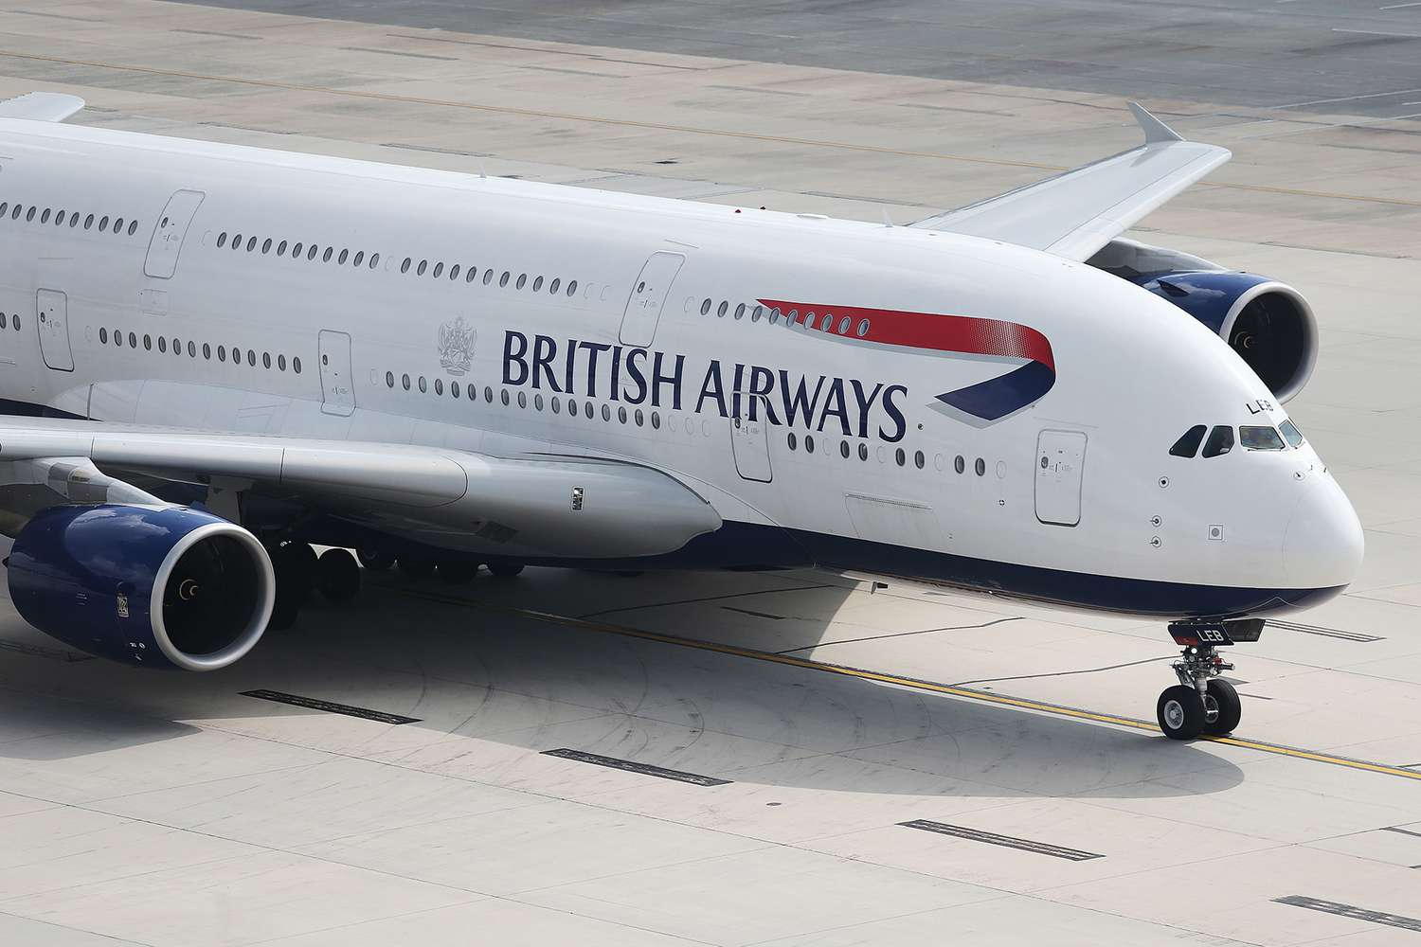
Figure 1: Illustration of the corporate logo of British Airways
(Source: British Airways, 2023)

Main Body
The interplay of numerous forces has moulded the global business landscape (Nyamoh, 2022). A handful of them is crucial to the development of the business environment. Some of these are listed among the significant issues that have an impact on the global business environment below:

PESTLE Analysis
The PESTLE study is a method for analysing a company's external pressures. British Airways performs a PESTLE analysis to comprehend the organisation's external pressures (Dube, Nhamo, and Chikodzi, 2021). PESTLE analysis takes into account the political, economic, social, technical, legal, and environmental factors.
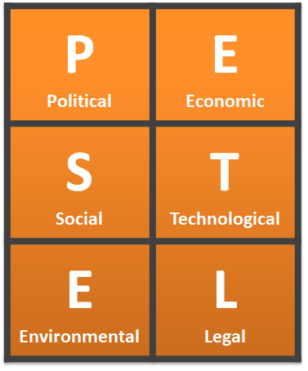
Figure 2: Indicates the Pestle Analysis Framework
(Source: Array, 2021)
Political Factors
Politics is undoubtedly becoming the aviation industry's most crucial focus, and the degree of political consistency for advancing events, government strategies regarding market allure, and encouraging a business-friendly environment are a few reasons behind the rising importance of political elements. In addition, government oversight and guidelines have an impact on the overall flight market in a district (Hamawandy et al., 2021). The UK and the US, the two biggest markets for aviation on earth, are significantly impacted by unofficial legislation.
The benefit of the aviation brands is also directly impacted by the UK's political climate and degree of political credibility. The aviation industry in the UK was adversely affected by EU laws, particularly in the areas of supervisory authorisation, traffic privileges, security requirements, and work permission (Bernier, 2022). In the UK, the Common Aviation Authority is the principal agency in charge of handling the aviation area methodology. Nevertheless, notwithstanding the express power's control over the airline sector and other political issues, the weakened position brought on by Brexit has a substantial impact on the producers of aeroplanes. Queue, customs, and portability barriers are some of the primary Brexit issues that will affect flight travel.
The UK government has also acknowledged a few travel routes that are advantageous for visitors going to countries with thriving financial sectors, such as the US and other Western countries (Effendy, 2021). Travel between the two places was not, however, restricted when the UK was a member of the EU. Character or cultural difficulties were non-existent. When Brexit, which took place on January 31, 2020, is over, these things will alter (Hamlet, 2021).
Economic Factors
Changes in the global economy and its structure can have an immediate effect on business operations in the UK. How well wireless service providers succeed in a given nation or area is directly impacted by its currency situation. This part of GDP's workload has an effect on both flight management personnel and air travel. The financial impasse is significantly hindering Brexit. When the UK economy is weak, a number of well-known organisations also relocate their base camps to the European Union. The value of the British Pound also affects British Airways (Hamlet, 2021). When the Pound costs are low, it makes the airline's tickets more expensive for foreign customers, as they must pay more in their own currency to purchase the same ticket. This can reduce the number of international customers, leading to lower profits. On the other hand, a stronger Pound can make the airline more competitive in foreign markets. Lastly, the state of the global economy can have a major impact on British Airways (Budd, Ison, and Adrienne, 2020). During times of economic growth, more people are willing to fly and the airline can benefit from this increased demand. On the other hand, during a recession, demand can drop, leading to fewer customers and lower profits.
Social Factors
The aviation industry is also becoming significantly more influenced by social factors, such as sector changes. The twenty to thirty-year-olds, whose travel habits are distinctive compared to earlier times and who appear to spend more on flights than those born after World War II, are the carrier brands like British Airways' primary target market in the centre of Western business sectors (Prassl, 2018). The social status and reputation of the aircraft organisations have likewise developed into crucial factors that affect commercial benefit, even as the comfort and well-being of customers have come to be the concentrate of consideration for flight managers and administrative bodies. In a similar vein, British Airways continues to place a high priority on operational efficiency, unwavering quality, and its social reputation in addition to the client experience.
A few carriers in the UK have been significantly impacted, in addition to a few airports across the world being closed. Due to Covid-19, airlines had to cease operations. Additionally, a few flights have been cancelled by other flight operators, such as Ryanair and British Airways. According to the BBC, because of the flare-up of the covid pandemic, British Airways will cancel 216 departures from March 16 to March 28 (Akbar and Kisilowski, 2020). Due to underlying issues, British Airways is reducing service to a number of destinations, including New York, Italy, France, Austria, Belgium, Germany, and Ireland. People have begun to limit their movement due to new objections as the fear of the coronavirus has permeated throughout society. The workload and revenue of flight administrators like British Airways would surely be affected by this.
Technological Factors
Technological innovation has benefited both the growth of the carrier organisations' clients and their capacity to successfully market themselves. British Airways is also investing in innovation to enhance the customer experience for its customers and to make its aircraft more environmentally friendly (Moro Visconti, 2019). In order to ensure increased productivity, superior services, and increased profit, British Airways has also decided to spend more on innovation as a part of its main strategies for the future. The organisation also intends to implement a computerised transformation in order to completely utilise integrating innovation in its daily duties across the globe.
Over the past few years, the company has made innovative changes to a few areas, including its website, to smooth out the booking process and revitalise the BA application. In the field of aviation, development is essential for enhancing functional viability and fostering customer loyalty. Regarding improved employee competence and client reliability, BA is well-known for its advantages (Sanctions, FAMY, and HORTON, 2020). The parent company of British Aviation lines, the IAG family, is not only bringing a brand-new, eco-friendly jet but is also looking for further ways to reduce its carbon footprint because doing so has become crucial for operational effectiveness and the reputation of the association.
Legal Factors
The main challenges in the aviation industry as a whole, including the UK market, are probably legal ones. All airlines, particularly British airlines, are required to uphold consistency because doing otherwise might result in costly fines and harm to the company's reputation. Along with providing for customer needs, ensuring traveller safety, and dealing with natural calamities, British Airways must adhere to employment regulations as well as a few other operating requirements both domestically and internationally (CHARTERS, FAMY, and HORTON, 2020).
The UK carrier industry is subject to a few laws; however, until Brexit, much of it was overseen by EU regulations. While CAA serves as the primary managing consultant in the UK, there are additional managing consultants from other countries that oversee the business operations of several foreign carrier brands. British Airways is significantly impacted by employment laws in addition to operational laws. The organisation faced a big challenge in 2019 due to a pilot's strike (Adrienne, Budd, and Ison, 2020). In order to prevent disruption, the organisation had to accept a compensation settlement because it was unable to put an end to the planned walkout.
Environmental Factors
Airline administrators and aviation specialists agree that environmental considerations are currently their top priority. Concerns regarding the shipping industry's environmental impact are particularly prevalent among administrative professionals worldwide. In order to lessen the approach's natural impact and boost its sustainability, British Airways has already made some noteworthy progress in this area. Sustainability is one of the company's current top priorities, and it continuously invests resources in making its fleet more environmentally friendly and lowering its carbon footprint (Bagshaw, Irvine, and Davies, 2020). British Airways' parent company, IAG, has worked very hard to achieve carbon neutrality. In accordance with its Flight Path Net Zero plan, the organisation has set a target to achieve continuous net-zero CO2 emissions by 2050. The organisation's goal for its net CO2 emissions by 2030 is to constantly lower them by at least 20%. British Airways also planned to balance its use of fossil fuels for domestic flights within the UK by 2020 and achieve net-zero carbon emissions (Davies, Irvine, and Bagshaw. 2020)

Porter’s Five Forces Analysis
A rational approach for analysing a competitive workplace environment is Porter's Five Powers Analysis. The threat of new competitors, the negotiating power of consumers, the negotiating strength of suppliers, the threat of alternative products, and the competition amongst competing companies are the five elements that affect a company's competitive environment (Bergquist, 2019). In order to help British Airways, make informed decisions, this study helps to identify potential opportunities and dangers in the competitive landscape.
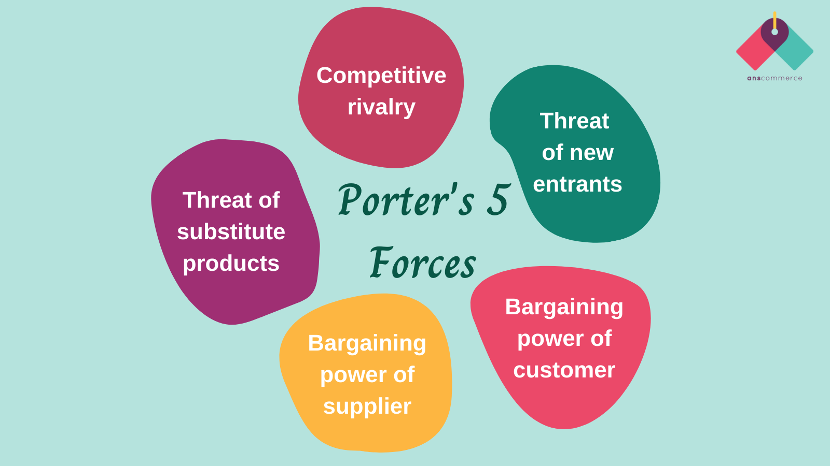
Figure 3: Indicates Porter's five forces analysis framework
(Source: Bernier, 2022)
Threat from New Entities: With a strong brand name and a large customer base, British Airways has created a competitive advantage over new entrants. The high capital costs required to set up a new airline, and the difficulty in obtaining the necessary licences, are major entry barriers for potential new entrants. The high cost of marketing and advertising to create a competitive presence in the market is also a major barrier for new entrants (Boshkoska and Jankulovski, 2020). The strength of the existing customer base, and the close relationships with suppliers and other partners, create further entry barriers. Additionally, the government has granted British Airways certain privileges that make it difficult for new entrants to compete. These include tax exemptions and other state subsidies. Overall, the threat of new entrants is low for British Airways, due to the entry barriers, the government's support, and the strong brand name and customer base.
Suppliers' bargaining power: British Airways faces strong bargaining power from its suppliers. This is primarily because there is a limited number of suppliers that can provide the quality of service required by the airline. Furthermore, British Airways is a major customer for many of its suppliers, thus giving it a degree of leverage when negotiating prices and terms. Additionally, suppliers have significant bargaining power due to the fact that they have access to the latest technological advancements, which can give them a competitive edge in the market (Macilree and Duval, 2020). British Airways must also remain mindful of the potential threat of substitute products and services, as this could lead to decreased demand and bargaining power.
Buyer's bargaining power: British Airways has a large bargaining power with its buyers. This is because of the high demand for their services and their brand recognition. The company has a large customer base and is able to leverage its position to negotiate favourable deals with its buyers. Furthermore, the company has a long-term relationship with its customers, which also gives them an edge in negotiations (Choi, 2020). The airline is also able to use its influence in the industry to secure favourable terms. In addition, the company has a strong legal team that is able to protect it from any unfair practices by buyers. This enables the company to maintain its bargaining power.
Substitute products or services threat: British Airways faces high threats from substitute products or services. Companies such as EasyJet and Ryanair have been successful in providing low-cost alternatives to traditional air travel, and have been gaining market share. This could have a major impact on British Airways' market share and profitability (Nyamoh, 2022). Additionally, increasing competition from other airlines could further reduce the number of passengers British Airways is able to attract. The company must therefore focus on keeping costs low and providing superior customer service in order to remain competitive.
Competitive threat from already existing companies: The competitive landscape of the British Airways industry is rapidly changing. As the market becomes increasingly saturated with new entrants and existing players, competition among firms is becoming more intense. As a result, firms are looking for new and innovative ways to differentiate themselves from the competition. British Airways is no exception, taking steps to ensure that its services remain competitive (Dube, Nhamo, and Chikodzi, 2021). The airline is investing in new technology, expanding its fleet, and launching new routes. Additionally, British Airways is also leveraging its brand to create loyalty amongst its customers, offering perks such as rewards programs and discounts. Meanwhile, the company is also investing in digital marketing to boost its visibility and reach new customers. Ultimately, British Airways is looking to create an unbeatable combination of price, quality, and service. By doing so, the company hopes to remain competitive and keep its customers satisfied.
This analysis has demonstrated that British Airways has several competitive advantages that make it difficult for new entrants to compete. These include the high capital costs, the difficult licensing process, the strong customer base, and the government's support. Additionally, the suppliers have strong bargaining power due to the limited number of suppliers that can provide the necessary services, the leverage British Airways has as a major customer, and the access to the latest technological advancements. These factors make the threat of new entrants low and the bargaining power of suppliers high for British Airways. Therefore, British Airways is in a position of strength in the competitive landscape and is well-placed to continue its success in the future.

Conclusion
The global business environment is an ever-changing landscape, and the airline sector is an important component of it. This report has demonstrated that the airline sector in the UK has been significantly impacted by the coronavirus pandemic, resulting in job losses and reduced air travel. However, despite this, the sector remains an important contributor to the UK's economy and balance of payments. Porter's Five Forces model has provided a comprehensive overview of the competitive forces that the sector faces, and the PESTLE analysis has identified the external influences that affect it. It is important to remain aware of the ever-evolving global business landscape, in order to effectively develop and implement successful business strategies that can help organisations succeed in this challenging environment.

References
Adrienne, N., Budd, L. and Ison, S., 2020. Grounded aircraft: An airfield operations perspective of the challenges of resuming flights post COVID. Journal of Air Transport Management, 89, p.101921.
Akbar, Y.H. and Kisilowski, M., 2020. To bargain or not to bargain: Airlines, legitimacy and nonmarket strategy in a COVID-19 world. Journal of air transport management, 88, p.101867.
Amankwah-Amoah, J., Khan, Z. and Osabutey, E.L., 2021. COVID-19 and business renewal: Lessons and insights from the global airline industry. International Business Review, 30(3), p.101802.
Array, F., 2021. British Airways PESTEL Analysis - Research-Methodology. [online] Research-Methodology. Available at: https://research-methodology.net/british-airways-pestle-analysis
Bagshaw, M., Irvine, D. and Davies, D., 2020. Exposure to cosmic radiation of British Airways flying crew on ultra-long-haul routes. Occupational and Environmental Medicine, 53(7), pp.495-498.
Berenbak, J., 2018. The "British Airways London Eye" the greatest observation wheel in the world (Das "British Airways London Eye" - der Welt größtes Riesenrad). Stahlbau, 71(4), pp.278-284.
Bergquist, A.K., 2019. Business and Sustainability. In The Routledge Companion to the Makers of Global Business (pp. 546-563). Routledge.
Bernier, L., 2022. The 2008 economic crisis and the rebirth of public enterprises. The Economy of the Collective Interest: 75 years of scientific research, p.281.
Boshkoska, M. and Jankulovski, N., 2020. Coronavirus impact on the global economy. Annals of the „Constantin Brâncuşi” University of Târgu Jiu, Economy Series,, 4, pp.18-23.
British Airways: Book flights, holidays, City Breaks & Check-in online (2023) British Airways | Book Flights, Holidays, City Breaks & Check In Online. Available at: https://www.britishairways.com/travel/home/public/en_in/ (Accessed: February 6, 2023).
CHARTERS, P., FAMY, L. and HORTON, W., 2020. AIRWAYS RE-REVISITED. British Journal of Anaesthesia, 63(1), p.128.
Choi, J.P., 2020. Competition law and economics: international cooperation and convergence in competition policy. In Competition Law and Economics (pp. 13-28). Edward Elgar Publishing.
Douglas, R., 2018. Bargaining power of suppliers. Veterinary Record, 174(S1), pp.6-6.
Dube, K., Nhamo, G. and Chikodzi, D., 2021. COVID-19 pandemic and prospects for recovery of the global aviation industry. Journal of Air Transport Management, 92, p.102022.
Effendy, J., 2021. The Impact Of Organizational Culture And Work Environment On Employee Performance Through Leadership In Corporate Security Unit Of PT Garuda Indonesia (Persero) Tbk. INTERNATIONAL JOURNAL OF ECONOMICS, MANAGEMENT, BUSINESS, AND SOCIAL SCIENCE (IJEMBIS), 1(1), pp.1-10.
Hamawandy, N.M., Ali, R., Bewani, H.A.W.A., bdulmajeed Jamil, D., Rahman, S.K. and Othman, B.J., 2021. The financial Impacts of (COVID-19) on financial reporting quality Airlines Companies: British Airlines. Journal of Contemporary Issues in Business and Government Vol, 27(2).
Hamlet, J., 2021. British Airways SWOT & PESTLE Analysis | SWOT & PESTLE.
Kassem, R., Salama, A. and Ganepola, C.N., 2023. CSR, credibility, employees' rights and legitimacy during a crisis: a critical analysis of British Airways, WizAir, and EasyJet cases. Employee Relations: The International Journal, 45(1), pp.1-20.
Macilree, J. and Duval, D.T., 2020. Aeropolitics in a post-COVID-19 world. Journal of Air Transport Management, 88, p.101864.
Moro Visconti, R., 2019. PPP versus Traditional Healthcare Procurement in Italy: Assessing Value for Money with PESTLE and SWOT Analysis. SSRN Electronic Journal, pp.12-14
Nyamoh, G., 2022. Strategies Pursued by Kenya Airways Corporation During Covid-19 Pandemic Period (Doctoral dissertation, University of Nairobi).
Prassl, J., 2018. To Strike, to Serve? Industrial Action at British Airways. British Airways plc v Unite the Union (Nos 1 and 2). Industrial Law Journal, 40(1), pp.82-91.

