Business Report-
Comparison of Two Hospitality Organisations

Student name: Md Farhad Chowdhury
Student ID number: 2233893
Programme: BA International Hotel Management
Module: Financial Management for the Hotel Industry
Module code: BMIH5007
Lecturer: Tristan Hawkins

Table of Contents
Introduction 3
Total Revenue Analysis 4
Market Position 6
Bowman’s Strategic Clock 8
Growth Potential 9
Supply and demand aspects of the Hotels 11
Financial Commitment to CSR 12
Recommendations 14
Shangri-La Hotels 14
Travelodge 14
Conclusion 15
Reference list 16

Introduction
This report will compare and contrast Shangri-La Hotel Group and Travelodge Hotels in terms of their financial management strategies and practices. An in-depth examination of total revenue will discuss Shangri- La Hotels and Travelogue hotels' revenue sources, trends, and elements that affect revenue growth or decline. This report will examine Shangri-La Hotels and Travelodge Hotels’ market positioning, including target demographics, brand perceptions, and competitive positioning in their respective markets. The analysis will also assess Shangri-La Hotels and Travelodge Hotels' financial commitment to CSR programmes like sustainability, community engagement, and ethics. The report also presents recommendations for Shangri-La Hotels and Travelodge Hotels to improve competitiveness, growth, and sustainability.

Total Revenue Analysis
Shangri-La Hotels
Shangri-La Hotels has continually generated revenue in recent years due to its premium hospitality position. Shangri-La’s fiscal year 2023 Consolidated Revenue were £1706M (Shangri-La Group, 2024). Food and beverage, spas and wellness centres, and events generate revenue for Shangri-La Hotels.
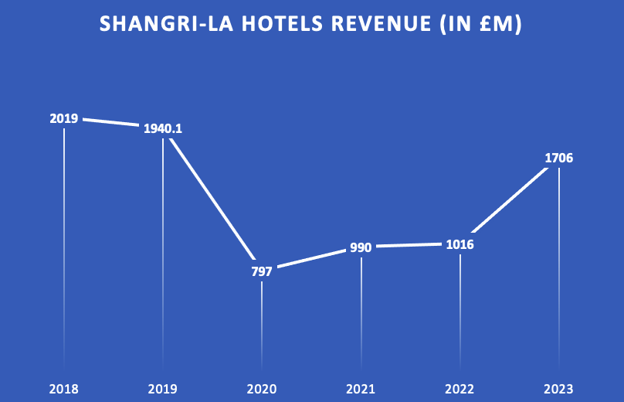
Fig 01: Shangri-La Hotels' revenues
Source: (Companies Market Cap, 2024)
According to Companies Market Cap (2024), Shangri-La began the period with a significant revenue number of £2019 million in 2018, demonstrating its important prominence in the premium hospitality category. The income in the year 2019 was £1940.1M. However, as travel restrictions and lower consumer spending affected the hospitality industry globally, the COVID-19 pandemic in 2020 caused a sharp decline in revenue, falling to £797 million. Notwithstanding this setback, Shangri-La quickly recovered, demonstrating tenacity and flexibility by generating a remarkable £1706M in revenue in 2023, indicating successful recovery tactics and efficient adjustment to changing market conditions (Shangri-La Group, 2024a).

Hotel Travelodge:
Shangri-La Hotels has gained revenue faster than Travelodge Hotels, a budget company. Travelodge made £1000 million in 2023 (Statista Research Department, 2024).
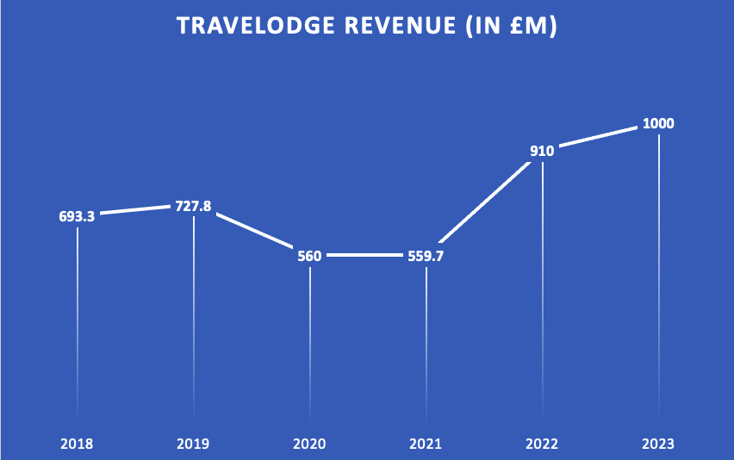
Fig 02: Travelodge Hotels' revenues
Source: (Statista Research Department, 2024)
According to Statista Research Department (2024), Travelodge Hotels, on the other hand, started the year with a more moderate revenue number of £693.3 million in 2018, which reflected its positioning as an affordable lodging provider serving a wider population. Travelodge's revenue fluctuated little throughout the years, but in 2023 it gradually increased to £1000 million. Although this growth trajectory shows attempts to maintain performance stability in the face of market fluctuations, the rate of expansion was more moderate than Shangri-La's strong rebound. Travelodge's emphasis on affordability and accessibility is reflected in its sales figures, which are consistent with its strategy of offering reasonably priced lodging to a larger market segment.

Market Position
Shangri-La Hotels
Premium hospitality provider Shangri-La Hotels targets wealthy tourists wanting luxury and individual service. The brand guarantees unsurpassed luxury experiences at all its places worldwide to emphasise its premium image. Shangri-La Hotels’ luxury brand is a strength. Diners want exclusivity and sophistication like this image. The visitors of Shangri-la.com is 51.77% female and 48.23% male. The majority of visitors are between the ages of 25 and 34 (Similarweb, 2024a).
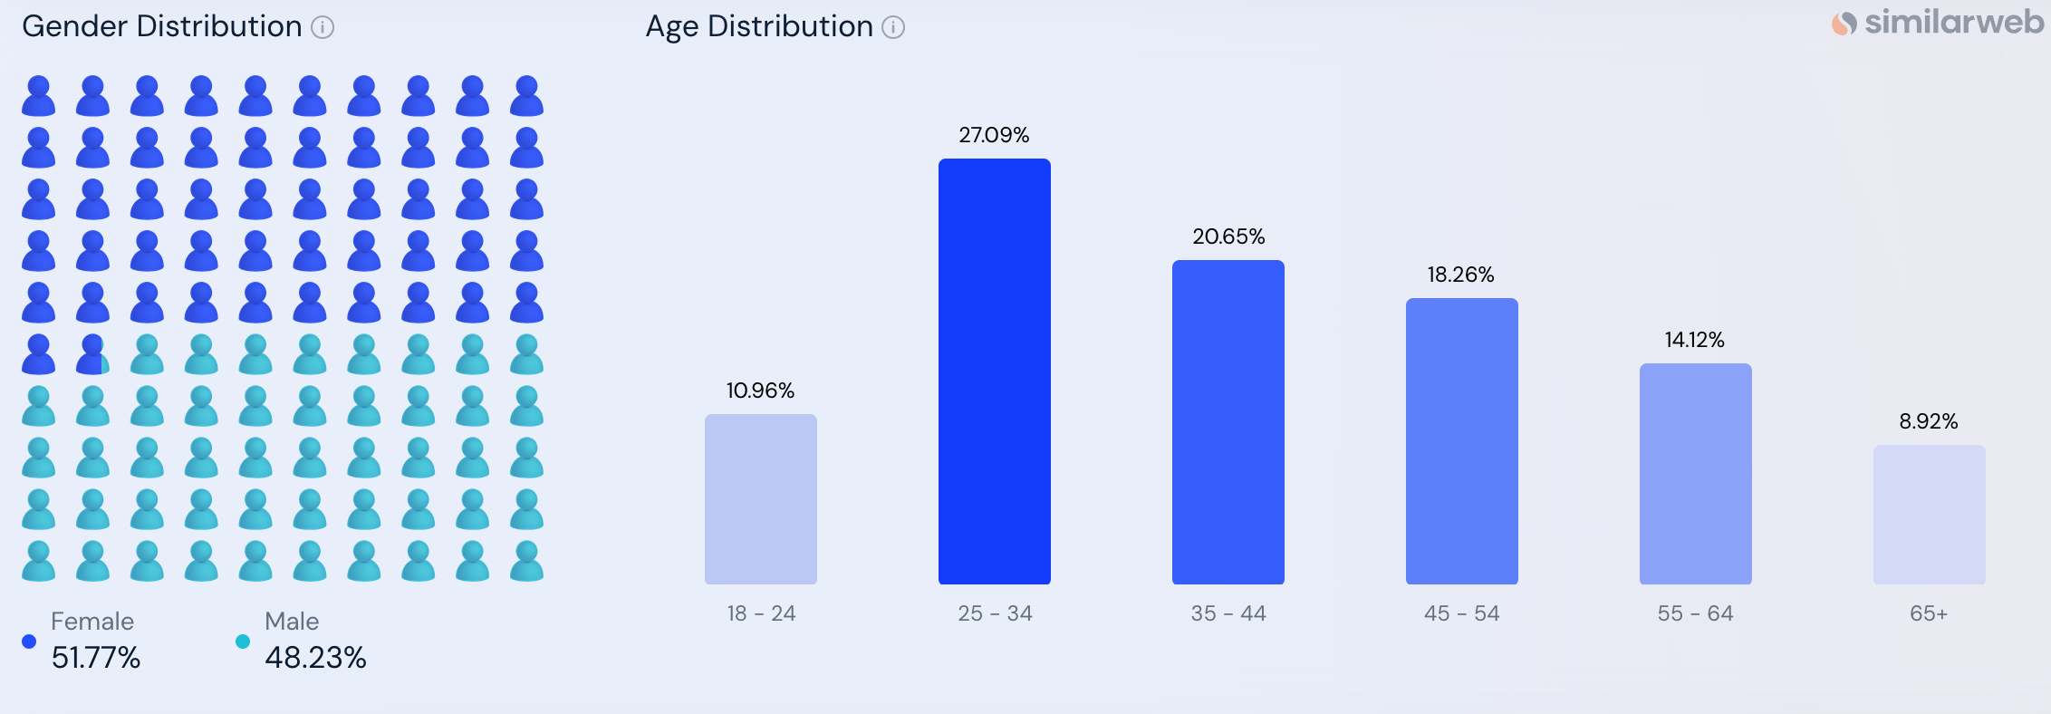
Figure 03: Demographic analysis of Shangri-La Hotel
Source: (Similarweb, 2024a)
With a significant market valuation of £6.60 billion Shangri-La prioritises providing its customers with exceptional experiences above primarily competing on pricing (YahooFinance, 2024). The business's average 7.2% growth rate highlights its dedication to increasing value through exclusivity and quality as opposed to pursuing cost leadership tactics (Finbox, 2024).
Hotel Travelodge
Travelodge Hotels targets budget-conscious tourists with minimal services and handy locations (Thakur, 2024). Travelodge competes with other budget friendly hotels. Here, budget hotels compete. Businesses compete for budget travellers by offering affordable lodging and value-added services. The audience of Travelodge UK is 45.47% female and 54.53% male. The majority of visitors are between the ages of 25 and 34 (Similarweb, 2024b).
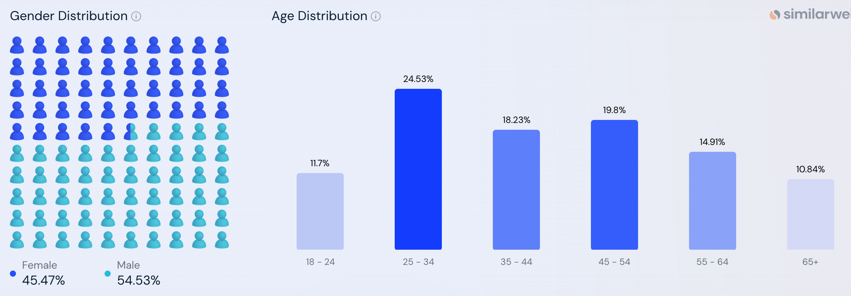
Figure 04: Demographic analysis of Travelodge
Source: (Similarweb, 2024b)
In the United Kingdom, 91% of hotel patrons are aware of the Travelodge brand. Respondents were shown the brand's written name and logo as part of the poll, which was carried out utilising the idea of assisted brand identification. Overall, 34% of hotel guests in the UK say they enjoy using Travelodge. In reality, though, 37% of the 91% of UK respondents who are familiar with Travelodge prefer the brand.
Overall, Travelodge is used by 27% of UK hotel patrons. This indicates that 30% of the 91% that are familiar with the brand use it (Kunst, 2023).

Bowman’s Strategic Clock
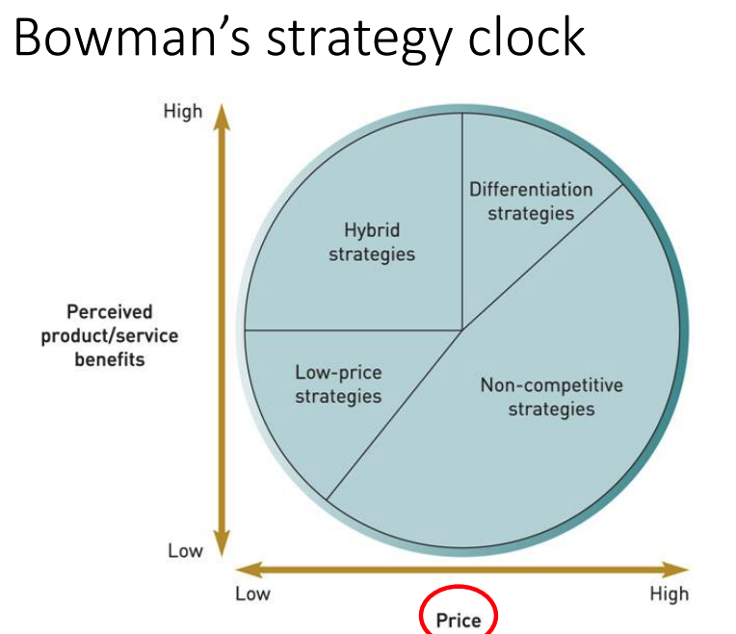
Figure 05: Bowman’s Strategic Clock
Source: (Saleh, 2021)
Bowman’s Strategic Clock was introduced by Bowman (1995) as an advancement to Porter’s generic strategies because it offers finer strategy positioning for firms in competitive industries.
For Shangri-La Hotels, differentiation strategies (Figure 05) are key since it targets the differentiation market segment through providing luxurious services and experiences. To maintain customer loyalty and insist upon higher quality, Shangri-La gives an extraordinary level of quality as well as a distinct experience. If competitors start copying, then, Shangri-La may decide to continue with the hybrid strategies which will offer luxury while pursuing the low-price segment, where applicable.
Whereas, Travelodge employs the low-price strategy that targets the preservation of cost for the average customers. The company targets the consumers with low price sensitivity hence offering the product at cheaper rates at the expense of extra perimeters (Figure 05). However, a threat arising from low-cost strategies is that boundaries get elasticated, mainly because rivals are most likely to match the costs. In such cases, it may be useful for Travelodge to lean towards mixed strategies (Bowman, 1995).

Growth Potential
Shangri-La Hotels:
Strategy for Diversification: Shangri-La Hotels and Resorts focus on markets involving new tourist destinations particularly the Asia Pacific countries such as China, India, Asia as well as some Middle Eastern countries (Kolesnikova, 2019). The major audience which visits Shangri-la.com consists of 25-34 years old individuals, and thus there is a clear shift towards the youth which is willing to pay for the luxury traveling experience (Similarweb, 2024a).
Growth strategies: Shangri-La Hotels’ future development plans incorporate gaining a presence in new regions with big tourism markets like South East Asia and the Middle East. Accordingly, it has the opportunity strategically invest and cooperate through the geography of nascent affluent travelers, especially in emerging regions with growing levels of urbanization and disposable income.
Objects that hinder growth: Shangri-La Hotels has growth potential but may face various obstacles. Currency exchange rates, GDP growth rates, and geopolitical events can alter consumer confidence, travel patterns, and investment mood, which can affect luxury hospitality demand (Martins et al., 2017).
Hotel Travelodge
Travelodge Hotels’ expansion is limited by budget hotel saturation in many markets. Travelodge, an economy hotel chain, confronts market saturation, pricing issues, and limited expansion in its usual markets.
Strategy for Diversification: Travelodge may diversify into similar industries or business techniques to maintain growth and avoid market saturation. In terms of expanding and to ensure consistent growth without jeopardizing on market share, Travelodge should consider partnering with cheap airlines to provide packaged services for travel as well as accommodation. This strategy is targeting their demographic base of travelers aged 25-34 years who are mostly price sensitive travelers seeking easy access to services and products.
Growth strategies: Travelodge’s strategic management involves venturing into other related sectors, hence leveraging on partnerships with low-cost airlines to offer cheap holidays. This approach is geared towards its main target market which is young adults in the age group of 25-34 years people who are always in search for cheap modes of transport (Similarweb, 2024b).
Objects that hinder growth: Travelodge Hotels struggles to expand despite diversification. Market saturation, pricing difficulties, and competition from traditional hotel chains, vacation rentals, and shared stays are these issues. Many cheap hotel businesses compete on pricing, location, and service (Kim et al., 2018). Travelodge’s ability to charge premium rates and grow revenue is limited by fragmentation.

Supply and demand aspects of the Hotels
Supply and demand are a critical factor in most of the hospitality industry aspects, including the room rates, the extent of space occupancy, and the revenue control mechanisms (StudySmarter, 2019). In the case of Travelodge, which is a cheap hotel, the demand is usually occasioned by people who are money wise and are willing to book in cheap hotels especially in places with high traffic of tourists. Travelodge records high occupancy and high prices during certain times of the year or events
(such as summer and holidays), and thus has high demand for rooms during those periods (Hello Shift, 2024). Nevertheless, during low demand, Travelodge sometimes lowers its room prices to acquire customers, which allow the hotel chain to have more pricing freedom due to demand volatility.
Shangri-La Hotels, on the other hand, a luxury hotel that aims at the upper end anywhere in the world from the budget conscious leisure travelers, high-end income earner’s locals and business travelers who prioritise premium experiences. While booking Shangri-La, some people are not very sensitive to prices; more often, they are influenced by such conditions as the global economy and the tourism niche of luxury accommodation. There are high demands of the foreigners in places like London and Paris and it as well has high demands during festivals, holidays and business events (Noonan, 2022). The limited supply could be a constraint in supply yet Shangri-La has ensured that its rooms are of good quality and has set certain privileges that are acceptable by the market risks.

Financial Commitment to CSR
CSR is growing more significant for many companies, including hotels. Travelodge and Shangri-La Hotels must prioritise CSR as significant hospitality companies. This programme should encourage sustainability, community involvement, and business ethics. The analysis of financial commitment to CSR will be done using the Triple Bottom Framework.
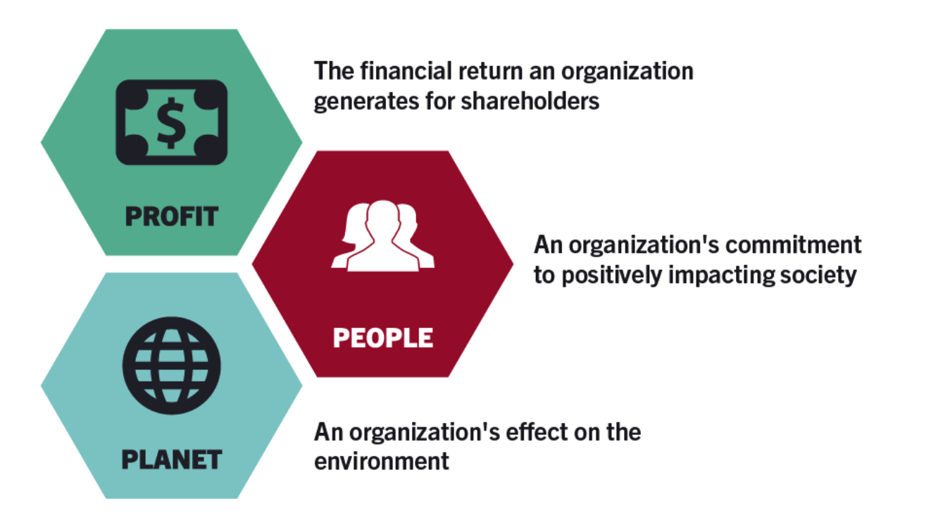
Fig 06: Triple Bottom Line Framework
Source: (Miller, 2020)
People: Shangri-La care about its employees and provides the health and safety ISO 45001 in all its properties and covers mental health like EAP (Shangri-La Group, 2023). Likewise, Travelodge has its Employee Assistance Program that provides personnel and their families with a 24/7 helpline and the “Thrive” app, which focuses on mental health and well-being at work (Travelodge, 2024).
Planet: Shangri-La also adopted its Triple S strategy focused on Environment, Social, and Governance, impacting all its businesses. The enhancement of responsible sourcing has been another strategic priority due to $3.9 billion green loan; the company has been trying to minimize procurement risks (Shangri-La, 2024b). Travellodge, with its net zero direct emission plans by 2050, has made profound changes towards energy utilization having decreased energy use by 16% by LED lighting techniques and smart heating systems and has planned to reduce energy utilization by 34% by 2030 (Travelodge, 2023).
Profit: Despite the impacts of the pandemic, key financial indicators of Shangri-La have also highlighted its excellent performance, which has increased the revenue from £797 million in 2020 to expected £1706 million in 2023 indicating successful market adaptation strategies (Shangri-La Group, 2024a). The total asset values of Travelodge increased gradually, reaching £1000 million in 2023 and kept a stable financial condition for providing budget accommodation which suits its business strategy (Statista Research Department, 2024).

Recommendations

Shangri-La Hotels
Shangri-La should extend on the luxury hospitality in the emerging markets, especially in Middle East where the new class of wealthy consumers is rapidly emerging, and the market for luxury goods in the Middle East is now valued at around $15.85 billion (Habachi, 2024). This strategy will enable it to use its existing strengths of luxury accommodation and would also diversify its revenues base by expanding to areas with high tourism prospects. Also, using its brand power, Shangri-La could extend differentiated wellness programmes and luxurious products, which are suitable for young wealthy people focusing on luxury and wellness. Purchasing services from regional airlines to create joints promotional packages of luxury travel could also help swell Shangri-La’s customer base and assure potential patrons that it serves a product of sheer quality.

Travelodge
In a premise crowded with rival budget hotels, Travelodge’s revenues should be diversified and sustained by accordions with budget airline companies in order to create low cost of travelling packages. This would be widely appreciated by its target clients; young, tourists on a tight budget, and those within the age of 25-34 years. Moreover, it adapts to take advantage of existing prospects for developing new extended-stay or low-cost co-living buildings in large cities that are consistent with the tendencies in affordable housing.

Conclusion
Shangri-La Hotels and Travelodge Hotels have distinct market advantages and potential. Shangri-La’s upscale hospitality and brand image position it for expansion into emerging markets and partnerships with luxury travel agents and lifestyle brands. Shangri-La and Travelodge can flourish and provide outstanding guest experiences while creating long-term value for their stakeholders by implementing the suggestions recommended.

Reference list
Bowman, C. (1995). The Influence of Functional Experience on Perceptions of Strategic Priorities. British Journal of Management, 6(3), pp.157–162. doi:https://doi.org/10.1111/j.1467-8551.1995.tb00091.x.
Companies Market Cap (2024). Shangri-La (0069.HK) - Revenue. [online] companiesmarketcap.com. Available at: https://companiesmarketcap.com/shangri-la/revenue/.
Finbox (2024). Revenue Growth for Shangri-La Hotel Public Company Limited Currency Join now and get access to the full platform Your email Get Started. [online] Finbox.com. Available at: https://finbox.com/SET:SHANG-R/explorer/cogs_growth/.
Habachi, M. (2024). The Middle East is one of the biggest luxury markets. What about sustainable luxury? [online] Fast Company Middle East | The future of tech, business and innovation. Available at: https://fastcompanyme.com/impact/the-middle-east-is-one-of-the-biggest-luxury-markets-what-about-sustainable-luxury/.
Hello Shift (2024). Occupancy Rate: Hotel Term Explained. [online] Helloshift.com. Available at: https://www.helloshift.com/hotel-term/occupancy-rate/.
Kim, M., Lee, S.K. and Roehl, W.S. (2018). Competitive price interactions and strategic responses in the lodging market. Tourism Management, 68(2), pp.210–219. doi:https://doi.org/10.1016/j.tourman.2018.03.013.
Kolesnikova, T. (2019). Shangri La Hotel Competition and Business Analysis. [online] StudyBay. Available at: https://studybay.com/blog/shangri-la-hotel-competition-and-business-analysis/.
Kunst, A. (2023). Travelodge brand profile UK 2022. [online] Statista. Available at: https://www.statista.com/forecasts/1335657/travelodge-hotels-brand-profile-in-the-uk.
Martins, L.F., Gan, Y. and Ferreira-Lopes, A. (2017). An empirical analysis of the influence of macroeconomic determinants on World tourism demand. Tourism Management, [online] 61(7), pp.248–260. doi:https://doi.org/10.1016/j.tourman.2017.01.008.
Miller, K. (2020). The Triple Bottom Line: What It Is & Why It’s Important. [online] Harvard Business School Online. Available at: https://online.hbs.edu/blog/post/what-is-the-triple-bottom-line.
Noonan, L. (2022). The role of culture as a determinant of tourism demand: evidence from European cities. International Journal of Tourism Cities, 5(9). doi:https://doi.org/10.1108/ijtc-07-2021-0154.
Saleh, P. (2021). How does Ryan Air’s Cost Leadership Strategy Play a Role in the Way Customers Perceive the Level of Service in Relation to Benefits and Price? [online] doi:https://doi.org/10.13140/RG.2.2.15499.92962.
Shangri-La (2023). SUSTAINABILITY REPORT 2023. [online] Shangri-La. Available at: https://sitecore-cd.shangri-la.com/-/media/Project/Shangri-La-Group/Sustainability/Images/Sustainability-Report/2023_SustainabilityReport.pdf.
Shangri-la (2024). Wellness Escape. [online] Shangri-la.com. Available at: https://www.shangri-la.com/london/shangrila/offer-detail/rooms-suites/wellness-staycation/.
Shangri-La Group (2024a). SHANGRI-LA GROUP- FINAL RESULTS ANNOUNCEMENT. [online] Shangri-La Group. Available at: https://sitecore-cd.shangri-la.com/-/media/Project/Shangri-La-Group/Investor/Files/Public-Disclosures/Latest-Top-Publications/2024-03-22-Final-Results-Announcement_E.pdf.
Shangri-La Group (2024b). Sustainability. [online] Shangri-la.com. Available at: https://www.shangri-la.com/group/sustainability/.
Similarweb (2024a). Shangri-la.com Website Analysis for September 2024. [online] Similarweb.com. Available at: https://www.similarweb.com/website/shangri-la.com/#demographics.
Similarweb (2024b). Travelodge.co.uk Website Analysis for September 2024. [online] Similarweb.com. Available at: https://www.similarweb.com/website/travelodge.co.uk/ [Accessed 30 Oct. 2024].
Statista Research Department (2024). Annual revenue of Travelodge UK from 2013 to 2023. [online] Statista. Available at: https://www.statista.com/statistics/429089/travelodge-total-revenue-united-kingdom-uk/.
StudySmarter (2019). Demand-Supply Balance: Hospitality & Tourism | StudySmarter. [online] StudySmarter UK. Available at: https://www.studysmarter.co.uk/explanations/hospitality-and-tourism/tourism-economics/demand-supply-balance/.
Thakur, A. (2024). Travelodge: Pioneering Affordable Hospitality. [online] Medium. Available at: https://medium.com/@amazingthakur12/travelodge-pioneering-affordable-hospitality-e713888c4d2a.
Travelodge (2023). Better Future Report. [online] Travelodge. Available at: https://travelodgecorp.wpenginepowered.com/wp-content/uploads/Better-Future-Report-2024.pdf.
Travelodge (2024). Sustainability. [online] Travelodge Corporate Website. Available at: https://www.travelodge.co.uk/our-business/sustainability/.
Tripadvisor (2019). Review of Shangri-La Hotel. [online] Tripadvisor. Available at: https://www.tripadvisor.co.uk/ShowUserReviews-g23814826-d302117-r697791872-Shangri_La_Barr_Al_Jissah_Muscat-Bandar_Jissah_Muscat_Governorate.html.
YahooFinance (2024). Shangri-La Hotel Public Company Limited (SHANG.BK). [online] YahooFinance. Available at: https://finance.yahoo.com/quote/SHANG.BK/key-statistics/?guccounter=1&guce_referrer=aHR0cHM6Ly93d3cuZ29vZ2xlLmNvbS8&guce_referrer_sig=AQAAABmynNs4CwMA3Hp4lTR9etViR5HsdY3sIKZTuy1jvvrhp1xGG0QtPrAl72czveFfB8ZLJsGGpZdlNS2WjkvZu08xEXzCabXXEJ1izvcqN6em8o3Q8LAiqQWW-pk5AnmLa0S8y0fNVYITZZ4EoYC7m7VsKu6L8zHxEO--YT6lzh-R.
Yang, H.-P. (2014). Case Study 12: Shangri-La Hotels Expanding to Non-Asian Markets. Marketing Cases from Emerging Markets, 5(7), pp.113–116. doi:https://doi.org/10.1007/978-3-642-36861-5_16.

