James Cawte (2313853)

Fault Tree Analysis
James Cawte

Contents
Table of Figures 2
Table of Tables 2
Table of Equations 2
Introduction 3
Calculations 3
Human Factors 7
Conclusions 8
References 9

Table of Figures
Figure 1 – Process Flow for Making Hot Drink 5
Figure 2 – Fault Tree for making hot drink (Probabilities) 6
Figure 3 – Fault Tree Making Hot Drink at Night 7

Table of Tables
Table 1 – Event Probabilities 4

Table of Equations
Equation 1 – $A∪B=AB$ 3
Equation 2 – $A∩B=A+B-A∪B$ 3
Equation 3 –$A=1-A$ 3

Introduction
A fault tree is a way of expressing probabilities through a series of events. The likelihood of any event occurring can be calculated based on the prerequisite events. Fault trees can be useful tools for discerning critical points of failure in a process which may need additional mitigation. As a tool it can be used to identify events which cause undesired events [1].
Fault tree analysis can contribute to risk assessment [2] either qualitatively by logically reasoning out the hazards and failures step by step or quantitively by calculating probabilities of failures for each step. An exhaustive fault tree will ensure that all moments leading up to a failure are considered and mitigated.
Fault trees use logic gates to illustrate whether faults need to occur together or individually to trigger the failure they are associated with. These are usually OR gates and AND gates. There are also more specialised gates to denote situations that may exist such as an XOR to show exactly 1 of the events must take place. For more robust systems an AND gate with a number may be used to denote a minimum number of events that must take place together to progress.
One con of using fault tree analysis is that when a system is reasonably complex the fault tree becomes enormous and could take entire teams of engineers months or even years to meaningfully complete. In eventualities like this it should be targeted at processes where failure could have significant consequences [3].
Historically, fault tree analysis was first majorly utilised by the nuclear industry as a more comprehensive means of assurance that the likelihood of a failure resulting in a severe consequence would occur. This proliferated internationally through the nuclear industry eventually making its way into commonplace use.

Calculations
Equation 1 – $\left(A∪B\right)=AB$
Equation 2 – $\left(A∩B\right)=A+B-\left(A∪B\right)$
Equation 3 –$\overline{A}=1-A$

To calculate the probability values of an event you need to know the probability values of the events required for it to be taking place. If the event requires only one event occur, then the probability is the same as the previous event. If the event requires that 2 or more events all occur, then the probability of each event is multiplied (Equation 1). If it requires only 1 of 2 or more events take place, then the probability is calculated by adding the probability of all the events and taking away the likelihood of multiple events occurring (Equation 2). If the requirement is that an event does not take place, then the probability of that event is taken away from 1 (Equation 3).

For the proposed scenario, the following are the probabilities of each event succeeding:
Table 1 – Event Probabilities
Event | Probability
Tea availability | 0.98
Coffee availability | 0.98
Chance of leaky Kettle | 0.001
Chance of water supply failure | 0.01
Kettle reliability | 0.99
Plug in operation reliability | 0.89
Switch on reliability | 0.89
Mains supply failure chance | 0.01
Cup availability | 1
Cup reliability | 0.99
Milk availability | 0.95
Milk freshness | 0.95
Sugar availability | 0.88
Sweetener Availability | 0.99

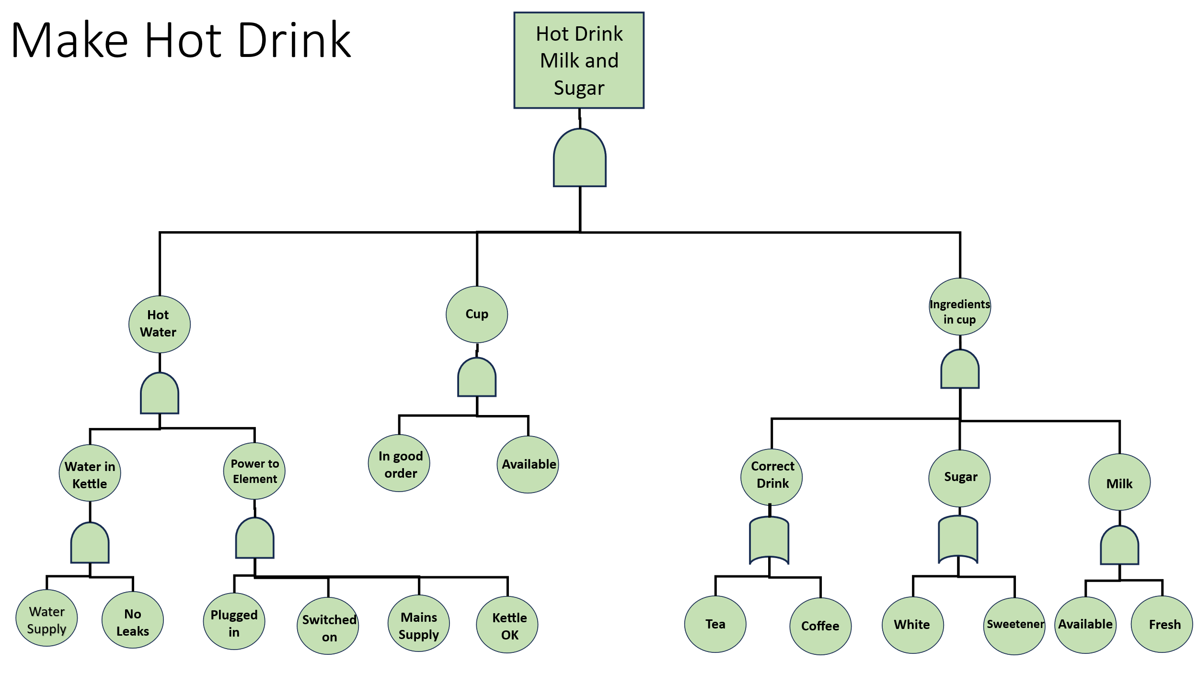
Figure 1 – Process Flow for Making Hot Drink

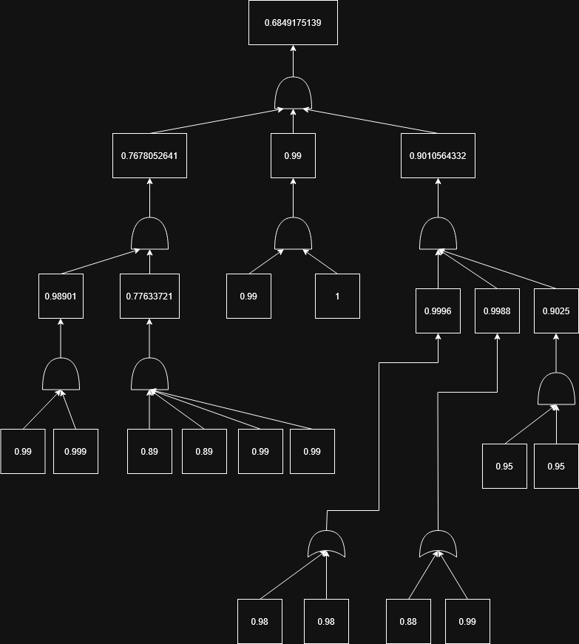
Figure 2 – Fault Tree for making hot drink (Probabilities)
Figure 2 shows the probabilities for each event in Figure 1. Any values which point into an AND gate are multiplied together (Equation 1) and any values pointing into an or gate are added then have their product taken away (Equation 2). This provides the values for the next events in the sequence until the final goal of a hot drink with milk and sugar/sweetener is achieved.
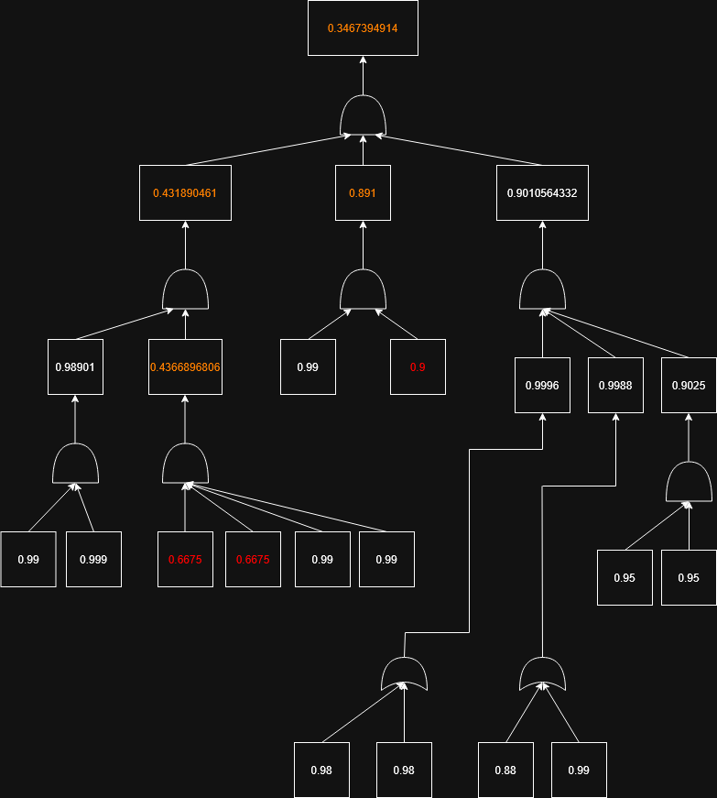
Figure 3 – Fault Tree Making Hot Drink at Night

Human Factors
Human Factors are a noise that are present in any activity involving a human. However, these can affect probability of failure differently depending on a variety of factors such as whether the human is under supervision, if they are familiar with their task or if they are negatively affected by their environment [4].
Figure 3 shows the revised probability of all events leading to a successful hot drink at nighttime. This reduction in probability of plugging the kettle in, switching the kettle on and selecting a cup are all human errors introduced by Bill’s state of less awareness due to having just woken up. These reductions actually manifest as a failure to complete the process first time as none of these events failing are catastrophic to the process and once the error has been noticed it can be rectified with no extra effort.

Conclusions
Figure 2 shows that, in ideal conditions and assuming that there are no other prerequisites to completion of the task, the probability of creating a hot drink with milk and sugar/sweetener at any given time is 0.685 (3.d.p).
The data provided comes with some assumptions. The scope of the operation ends with the creation of the drink but there may be factors preventing use of the drink after it has been made. One example is the loose terminology of ‘cup’. This could refer to a thin plastic cup unsuitable for this use case. The original process also makes the assumption that there will always be a cup (due to the cup availability probability being 1). This may be an unrealistic expectation as in the real-world cups break and get lost.
For the scenario of Bill getting up to make the hot drink at night with reduced kettle and cup based capabilities, the probability of success is 0.347 (3.d.p). This is almost half the chance of success from some minor reductions in root cause probability. This demonstrates how an increased chance of failure at the root cause will resonate up through the fault tree, damaging the overall chance of success. Mitigations could be put in place to improve the chances in the adverse scenario such as leaving the kettle plugged in overnight therefore removing the human interaction in this situation. This could come at a safety concern of electrical fire which would need to be considered in a risk assessment.

References

[1] | C. Ii, “Fault Tree Analysis,” 09 2000. [Online]. Available: https://web.archive.org/web/20170810090534id_/http://www.thecourse.us/5/Library/FaultTreeAnalysis2.pdf. [Accessed 20 04 2026].
[2] | E. R. a. M. Stoelinga, “Fault tree analysis: A survey of the state-of-the-art in modeling, analysis and tools,” Computer Science Review, Vols. 15-16, pp. 29-62, 2015.
[3] | R. R. a. A. B. B. Ahmed Ali Baig, “Reliability Analysis Using Fault Tree Analysis: A Review,” International Journal of Chemical Engineering and Applications, vol. 4, no. 3, pp. 169-173, 2013.
[4] | F. K. R. A. a. V. G. R. Islam, “Human Error Probability Assessment During Maintenance Activities of Marine Systems,” Safety and Health at Work, vol. 9, pp. 42-52, 2018.

This is a copy of Figure 1 with the descriptions replaced with the probability values either pulled from Table 1 or calculate from those values using Boolean logic.

