DS 1 Assignment

My Screenshots/Photos
- Please add 4–6 screenshots or photos of your digital life.
- You can use your phone or laptop.
- For each screenshot, write one or two sentences explaining what it shows.

Screenshot/Photo 1

I use my laptop to study and work. I often have a coffee while I am working.

Screenshot/Photo 2

When I am sick, I can work from home using my laptop. It helps me continue my work.

Screenshot/Photo 3
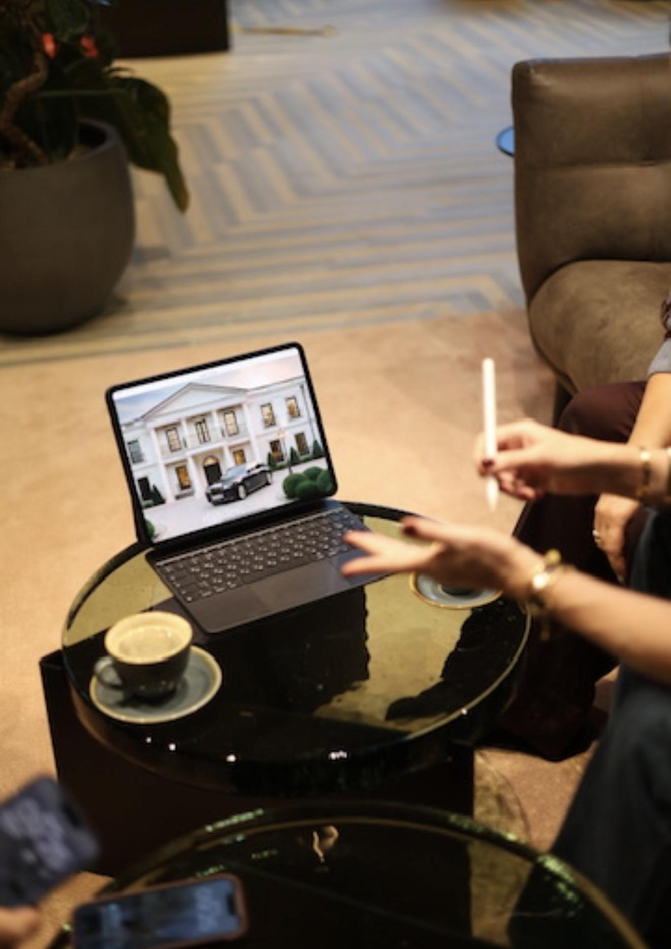
I am preparing a work report on my laptop. I use digital tools to organise and complete my work.

Screenshot/Photo 4
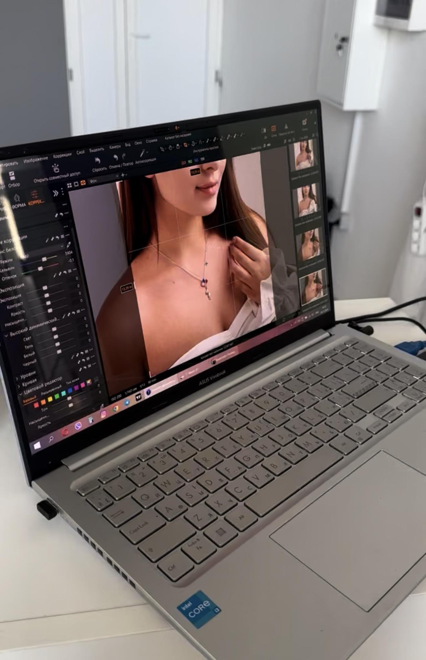
I use editing software to edit photos. Digital tools help me create better content.

Screenshot/Photo 5

I use a computer every day. My dog likes to sit next to me while I work.

Screenshot/Photo 6
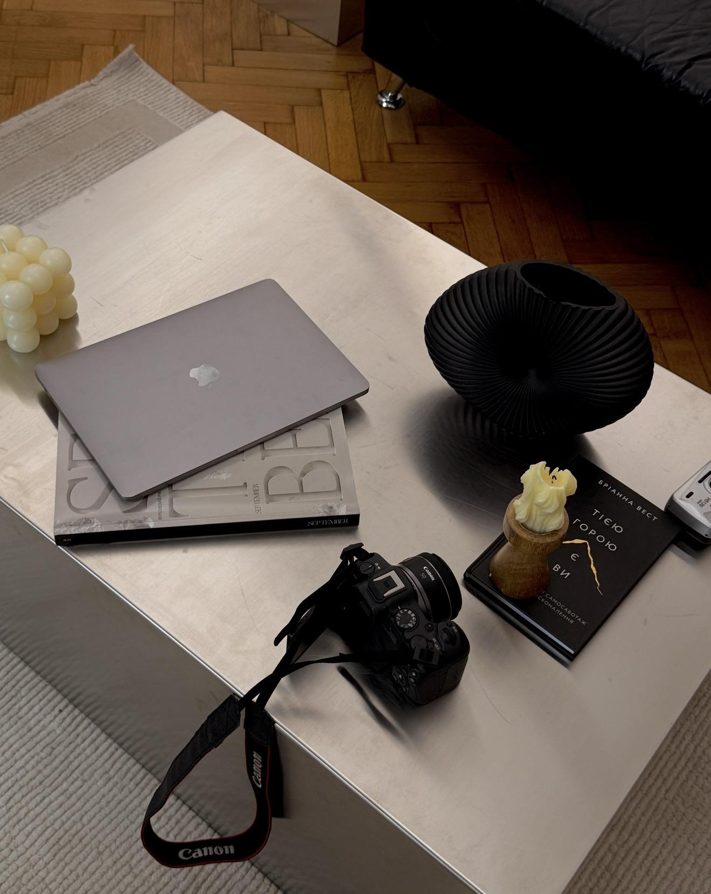
I use a laptop and a camera for my work. These tools help me create photos and videos.

My Short Reflection
- Write 5–8 simple sentences about your digital life.
- You can use the sentence starters below if helpful.
I use digital tools to work and study every day.
I feel confident when I use Canva and CapCut to edit photos and videos.
I want to improve my computer skills.
I often use these tools: Word, PowerPoint, Excel, Canva and CapCut.
I hope this module will help me learn more digital skills.
Digital skills are important for me because they help me organise my work and learn new things.

Sentence starters
- I use digital tools to …
- I feel confident when I …
- I want to improve …
- I often use these tools: …
- I sometimes feel nervous about …
- I hope this module will help me …
- Digital skills are important for me because …
You can write more if you want.

Submission Checklist
Before you submit, please check:
​​​ ☐ I added 4–6 screenshots
☐ I wrote short sentences for each screenshot
☐ I wrote my short reflection
☐ My work is my own
☐ My file opens correctly
​​☐ My file opens correctly

