
Project Management Plan

Module: Managing Projects in the Workplace
Module code: BMSW5104
Student name: Corina Berco
Student ID: 1918420
Lecturer name: Daminabo Pokubo

Lecturer name: Daminabo

Table of Contents
Introduction 3
Scope of the project 3
Project Deliverables 3
Challenges and Limitations of the project 4
Analysis of the stakeholders 4
Gantt Chart 5
Project Network 6
Work Breakdown Structure 7
Cost/Resource use 7
Risk Assessment 8
Project Success Criteria 9
Conclusion 9
References 10

Introduction
The presentation aims to pitch the idea of opening a nursery for providing service to working parents.
The project is very smart as the increase in the rates of day-care facilities and unavailability has been severe in the cities. This project will provide a good service and would generate revenue for the entrepreneur.

Scope of the project
The project will help the business to flourish and increase the chances of success. The project needs to be delivered within
- a timeframe of 78 days and
- a total cost of about £99,000.
The increase in the costs of childcare and unavailability of suitable places for keeping the kids safe and engaged is a major concern of the working parents. This has led to the development of a nursery for the kids. The nursery business is a smart business that will focus on keeping the kids in a nursery and help the parents to focus on their work without worrying about their kids.

Project Deliverables
There are several deliverables included in the project that includes
- Delivering a proper scope and a feasibility study
- Delivery of a project initiation document
- Delivering a thorough project plan with all the major risks analysed and mitigated.
- Delivery of a work breakdown structure
- Delivering a cost and resource analysis
- Delivery of a framework to measure the success of the project.
In addition to this, the project will require the setting up of an overall business in the official areas of the city to attract more parents to enroll their children in the nursery especially when they are not available. The development of the will helps the parents to ensure the safety of their kids when they are working and can help in the development of their careers. It is a service to the companies that will provide better day-care solutions to the parents at very affordable rates. It would also require hiring personnel and installing all safety devices to arrange a kid safety area (Jaber et al. 2018).

Challenges and Limitations of the project
There are several limitations and challenges to the accomplishment of the project. The project management plan addresses the challenges and creates suitable plans and methods to ensure the negative impacts can be reduced.
The use of the project management plan has enabled the business organisation to understand the major constraints like time and cost of the project (Ul Musawir et al. 2017). It has made use of various tools and techniques to optimise the time and cost constraints in the project. Furthermore, the use of the project management plan has also enabled the business to optimise the flow of cash and work into the project. It has also optimised the flow of work and enhanced the benefits to the businesses and improved the engagement of the stakeholders of the project to optimise the overall functionality and operations in the nursery making project. The project also makes use of a straight waterfall methodology to increase the chances of employee engagement and get enhanced profits and control over the project.

Analysis of the stakeholders
Stakeholders | Category | Power | Interest | Communication
Employees | Internal | High | High | Email and Phone Calls
Suppliers | External | High | High | Phone Calls
Police Officials | External | High | Low | Permits and Emails
Local Authority | External | High | Low | Permits and Emails
Parents | External | Low | High | Phone calls and Emails
Investors | External | Low | High | Email and Phone Calls
Admin | Internal | Low | Low | Email and Phone Calls
Receptionist | Internal | Low | Low | Phone calls
Table 1: Stakeholders Analysis
(Source: Created by Learner)
The analysis of the stakeholders has been done to evaluate their power and benefits over the project. Based on the analysis of the project outcomes, business organisations can understand the power and influence of the stakeholders (Assiri et al., 2021). This evaluation will help the managers to understand the impact and engagement of each stakeholder and create better possibilities to improve the structure and functions of the project. The project plan creates communication strategies to increase the engagement of the stakeholders in the project and create scope for enhanced benefits in the project. This will improve the quality of communications and engage the stakeholders smartly and efficiently to assure enhanced benefits to the development of the nursery.

Gantt Chart
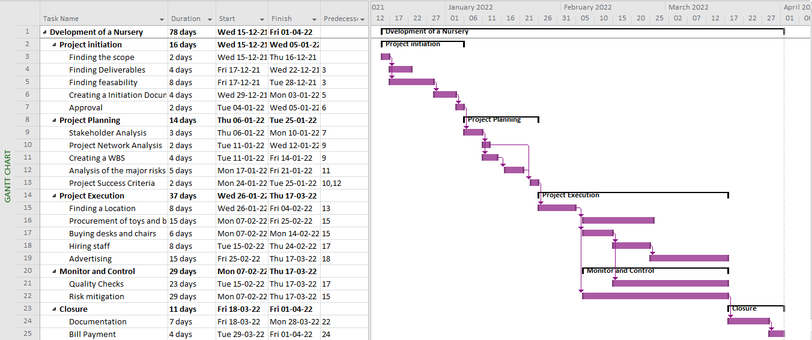
Figure 1: Gantt chart
(Source: Created by Learner)
The Gantt chart depicts that the project activities are scheduled and categorised according to the project lifecycle. The activities are scheduled, and the tasks are optimised to a total time of 78 days.
The Gantt chart is a set of connected stacked bar charts that can enable the managers to establish a timeline and create the required flow of tasks in the project. It is comprised of bars and relates to arrows to determine the flow of work in an overall timeframe (Sharon and Dori, 2017). In the Gantt chart presented, the managers can establish the flow of tasks and arrange them according to the sequence of the task in the project. in addition to this, the use of the stacked bar chart also helps to understand the initial and final durations of the project. In addition to this, the Gantt chart will also be used to increase the delivery of the project and increase the chances of success in the project. The deadlines of the tasks are properly scheduled and the efficiency of the nursery making project can be monitored and controlled easily with the help of the project. Additionally, the Gantt chart can also be used to allocate resources and tasks in the project.

Project Network
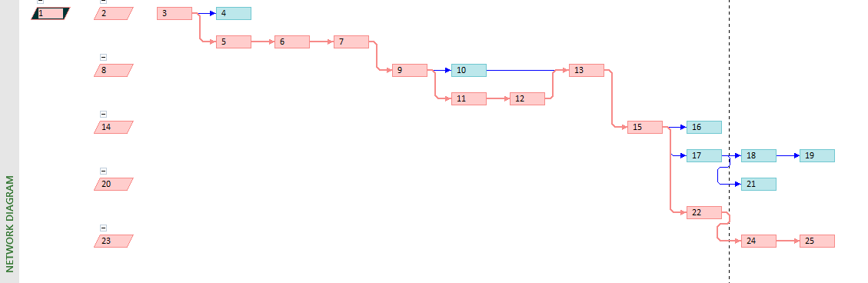
Figure 2: Critical Path Network
(Source: Created by Learner)
The network diagram in a project serves as a guide map as it establishes the sequence of tasks. The use of the network diagram is very useful as it provides the idea of the next milestone in the project. It also helps to identify the critical path in the project.
In the views of Lock, (2017), the use of the project management tool is extensive in major projects as it helps to identify the critical path and optimise the overall flow of work in the project. The critical tasks are identified and controlled to ensure that the project is completed within the estimated timeframe.

Work Breakdown Structure

Figure 3: Work Breakdown Structure
(Source: Created by Learner)
The development of a nursery is a critical task and several in the project will be running simultaneously. To prevent overlapping and ensure proper task allocation, the managers can make use of the work breakdown structure.
With the help of the work breakdown structure, the managers usually break down a large task into smaller and achievable objectives. This enables them to easily complete all the tasks in the project and easily allocate tasks to the project employees. According to Burghate (2018), The use of the work breakdown structure will help the project managers to deliver all the outcomes of the project with the help of the development of the nursery.

Cost/Resource use.
There are several activities in the project and the costs are calculated according to the needs and estimates of the project. The total estimated cost of the project is calculated to be £99,000 which also includes a contingency cost of £10,000.
The cost estimates are created based on the current market prices and in case of hiring activities indicated in the cost plan, the salary of a single month is also calculated within £18,000. The costs will help to complete the tasks within specific costs and help the managers to optimise the flow of cash into the project. it will also become a parameter to measure the success of the project concerning cost efficiency (Safapour et al., 2020). Additionally, the project also considers several other resources that will come in handy during the various phases of the project. The use of the resources will also enable the management to reduce the risks and enhance the chances of success in the project. The collection of data and project information needs to be in perfect condition to improve the reliability and quality of the deliverables in the project.

Risk Assessment
Risks Involved | Probability | Impact
- Risk of project Delay | High | High
- Risk of extra cost incurred | High | High
- Risk of hazards to the kids | Low | High
- Risk related to human errors | Low | High
- Risk of poor efficiency | High | Low
- Risk of improper marketing | High | Low
- Risk of compliances and permits | Low | Low
- Operational Hazards | Low | Low
Table 2: Risk Assessment
(Source: Created by Learner)
The major risks in the project are evaluated based on the probability of occurrence and the impact of the project. In the views of Moshtaghian et al., (2020), the analysis of the risk will help the management to understand the major areas of improvement and prioritise the risks. The project management plan has also created the possibility to reduce the chances and impact of the risks. This will enhance the safety and reliability of the project.
Moreover, the project is a major priority as the nursery will take care of young children and toddlers and keep them engaged. The management must take extra care and make efforts to reduce the hazards that can, directly and indirectly, affect the kids. Thus, the evaluation of the risks in the project becomes a major factor that can impact the overall success of the project.

Project Success Criteria
The success of the project is determined if the project constraints are met and the negative impacts on the project can be effectively reduced. This will lead to improved benefits to the end-users and stakeholders of the project.
The implications in the project management plan will enhance the overall quality of the deliverables and help the managers to easily set up the nursery. The use of a proper project plan will help the managers to ensure that the success of the project and create scope for increased usage and better benefits to the project (Davis, 2017). Moreover, in this project, all the major tasks and scopes are created to gain a better understanding of the areas that require improvement. Following the project management plan will help the managers to enhance the control over the various aspects of the project and make it reach all the success parameters.

Conclusion
From the above project, it can be concluded that the project management plan can be very helpful to the managers to make the project reach its desired outcomes.
Following the project plan will enhance the chances of success and allow the project managers to optimise the flow of cash and work in the project and increase the benefits and chances of success in the project.

References
1. Assiri, K.H., Alaamer, F.F., Alnefaie, K.A. and Almutairi, N.L. (2021) The Impact of Stakeholders Experience on PM.
2. Burghate, M. (2018) ‘Work breakdown structure: Simplifying project management’, International Journal of Commerce and Management, 3(2).
3. Davis, K. (2017) ‘An empirical investigation into different stakeholder groups perception of project success’, International Journal of Project Management, 35(4), pp.604-617.
4. Jaber, H., Marle, F., Vidal, L.A. and Didiez, L. (2018) ‘Criticality and propagation analysis of impacts between project deliverables’, Research in Engineering Design, 29(1), pp.87-106.
5. Lock, D., 2017. The essentials of project management. Routledge.
6. Moshtaghian, F., Golabchi, M. and Noorzai, E. (2020) ‘A framework for dynamic identification of project risks’, Smart and Sustainable Built Environment.
7. Safapour, E., Kermanshachi, S. and Jahan Nipa, T. (2020) Analysis of Cost Performance Indicators in Reconstruction Projects: A Comparative Study of Low Vs High-Level Damages. In Creative Construction e-Conference 2020 (pp. 2-10). Budapest University of Technology and Economics.
8. Sharon, A. and Dori, D. (2017) ‘Model‐Based Project‐Product Lifecycle Management and Gantt Chart Models: A Comparative Study’, Systems engineering, 20(5), pp.447-466.
9. Ul Musawir, A., Serra, C.E.M., Zwikael, O. and Ali, I. (2017) ‘Project governance, benefit management, and project success: Towards a framework for supporting organizational strategy implementation’, International Journal of Project Management, 35(8), pp.1658-1672.

