Throughout history people have always treated animals differently as we would our own though until very recently this has been relatively accepted due to limited proof that animals are sentient or if they can even feel pain, speciesism is a new term that has come about because of the acknowledgment of this treatment. Speciesism as defined by Peter Singer is the “prejudice or attitude of bias in favour of the interests of members of one’s own species and against those of members of other species.” (Singer, 1975, p. 704), this definition of speciesism is debatably an accurate description of the human relations with animals especially regarding meat production. Speciesism unlike racism and sexism is largely an afterthought in most nations around the world and is hindered in the spread of its awareness as it is a relatively new concept that is overshadowed by an enormous industry with a global influence. The treatment of animals and thus the perspective of speciesism is globally varied due to religious, cultural and ethical reasons. This doesn’t complicate the definition of speciesism however the application of it as a result of these factors won’t be entirely consistent throughout all nations.

The global meat industry (see image 1) is the largest contributor to the idea of speciesism being present in human society due to the volume of animals that are exploited for human consumption. The quantity of animals being used for human consumption is growing exponentially alongside the constantly growing human population to meet demands, however the distribution and production of meat still appears to be disproportionate in several ways. Between 1980 and 2009 the number of animals slaughtered per capita every year doubled from under 5 to 10 (Journal of Cleaner Production, 2015) which is largely due to the global north having a very processed and high in fat diet which on a surface level would show that the global north or the ‘western world’ is more speciesist than elsewhere. This is reflected with the global distribution of food insecurity as 780 million of 795 million people estimated to be suffering from food insecurity were from developing nations (Perspectives on Global Development and Technology 16, 2017). One reason for this major insecurity is the large scale animal farms that are commonplace in the global north whereas developing nations rely on a more natural and nomadic lifestyle including their methods of raising animals which is much more unreliable for some this justifies speciesism as it provides a more consistent source of food. Intensive farming carried out by the global north is now also known to cause damage to the natural farming practices of developing nations through damage caused by climate change that puts the environment at risk. The high demand for meat production in the global north also impacts animals outside of factory farms in many ways, it is now common for large scale deforestation to take place to be used for grazing and to produce soy-feed (Energy and Health 5: Food, livestock production, energy, climate change, and health, 2007) this is thus highly destructive for animal habitats to produce food for cattle which is a very wasteful process. This would do little to justify speciesism due to the various ways it can cause needless damage to the environment and even animals outside of the meat production industry.

However many other cultures around the world operate their meat production industries with different perspectives on animals and how they should be treated, some with more ethical practices than the global north/western world while others can be viewed as even more speciesist. In terms of culture, religion and thus the perspective of animals India is very different from elsewhere in the world, the second most populous nation on Earth only consumes 3 kilograms of meat per capita each year which is largely down to 3 in 10 people in India being vegetarian (Appetite volume 149, 2020). Obviously because of the small quantity of meat being consumed in India production of meat is on a smaller scale for domestic consumption however India has great influence and a high level of meat production for foreign nations. Despite the cow being considered a sacred animal within Indian society it is still slaughtered for the global meat industry, as India reopened following the covid-19 pandemic its beef export increased by 12% mostly to Middle Eastern and Southeast Asian nations (OECD-FAO Agricultural outlook; Paris, 2022, 6.2.1.). It is clear that due to the profitability of the global meat industry nations would disregard their principles set for animals which is a clear example of unjustified speciesism, despite this the conditions of many animals in India is more considerable than elsewhere in the world.

China is another global super power with a very different culture and ideas of how the meat industry can be used and which animals can be viewed as morally suitable for consumption. Similarly to India the Chinese domestic meat industry can differ heavily from what it produces for trade to foreign nations. China is debatably the most significant player in the global meat industry both in imports and exports due to its large population and landmass, China alone consumes 4987.9 Mt of pork which is equal to 47% of all pork consumed world wide (China's meat industry revolution: Challenges and opportunities for the future, 2012). This high rate of consumption within China requires an intensive level of farming, however like elsewhere in the world they have a reliance on the intensive practices in other nations and which makes a very valuable industry. As the United States has little laws surrounding intensive farming practices to restrict the volume of animals produced and the ethical conditions that they are produced in many nations they have very high profit margins to sell cheap meat in large volumes to nations with high demands such as China. This industry has only been getting bigger in recent years as US pork exports to China increased from 57,000 metric tons in 2003 to 430,000 in 2012 (Philpott, Tom, 2013). As of 2020 the pork export industry between the United States and China is worth $2.3 billion (USDA, 2020), this industry being used for profit in unethical conditions is a clear example of speciesism that places the interests of human corporations over the lives of animals. The biggest difference in the meat industry within China from the rest of the world is the presence of wild and domesticated animals available for slaughter in certain parts of the country. China is one of few remaining countries in the world where the slaughter and consumption of dog meat is still legal and practiced, it is most prevalent in the Southern regions of the country and especially in Guangxi province which is known for its annual Yulin festival each summer where an estimated 3,000 dogs are killed (see image 2) over a ten day period for stew but the national figure is even higher with estimates of 10 million dogs and 4 million cats being slaughtered (CBS News, 2020). The perspectives of most nations around the world would believe that these practices are a clear example of unjustified speciesism not only because of the difference in relationships that people have to these types of animals but also the way that they are slaughtered which is typically more inhumane than typical farm animals.

As previously mentioned the United States is a major economic player in the global meat production industry because of the conditions that are often found in many farms across the States. Farming in the United States is on a significantly larger scale (see image 3) than the rest of the world and has the largest influence of any nation in the global North, the United States is now home to over 50,000 concentrated animal feeding operations (CAFOs) which are commonly referred to as mega farms (The Guardian, 2017). This volume of intensive farming facilitates the aforementioned international trade that the United States which it benefits so heavily from. These mega farms fit the definition of speciesist as the interests of the animals are not taken into account as they are often without grazing and put the animals into very confined conditions and some using genetically modified animals to increase production and thus profit.

Despite the industry being largely dominated by speciesist practices there is a growing level of public awareness of this fact that puts pressure on the industry to implement more humane conditions which often find their ways into the laws of nations around the world. The United Kingdom has increased legislation to prevent these practices, since 2006 the animal welfare act has made the unnecessary harm to farm animals illegal and it demands that the animals welfare needs are met (GOV.UK, 2022). With this act the popularity of cruelty free and free ranged products increased and an emphasis on valuing British products domestically over products imported from abroad for ethical reasons. Despite a large quantity of British farms being distanced from any speciesist practices there are often loopholes in these laws which can allow for practices that many would consider to be speciesist such as not allowing livestock to graze in an open environment. These loopholes in laws that allow such practices do limit the extent that the interests of farm animals can really be taken into account and it would likely take several years to pass further acts that fully recognise the interests of animals due to the difficulties in classifying those interests legally which is also the case for many other nations around the world.

However it can also be said that some areas around the world would benefit from cheap factory farmed meat in areas that are under nourished and where their traditional farming practices have been put at risk. Several regions in the continent of Africa faces a great risk to its rural communities that are restricted in what they can produce because of current environmental conditions and possible restrictions in movement such as nomadic people groups that have been put at risk in recent times. Currently 140 out of 1000 children in Africa are at risk of dying before the age of 5 due to being undernourished (British Journal of Nutrition Cambridge, 2012) which is why an emphasis is needed to find a more efficient food source in large quantities for these areas. If the focus of the meat industry in its intensive form was to feed those who are really in need of nutrients then it could be seen as justifiable, but as there would be little to no profit for producing meat for these communities nothing has been done.

Despite the various ways the meat industry appears all over the world as well as the attitudes of treating animals it is evident that the practice is speciesist, the main focus of farming globally is not to meet the needs of people around the world as the meat industry in terms of animal feed alone is a very wasteful practice, but to maximise profits for the corporations that dominate the global market. This also makes it difficult to justify as a practice though due to the size of the market and the substantial influence it has world wide in terms of its cultural presence and the livelihoods it provides for many.

References:
Allievi, F. and Vinnari, M. and Luukkanen, J. (2015) Journal of Cleaner Production: Meat consumption and production - analysis of efficiency, sufficiency and consistency of global trends. Available at: https://www-sciencedirect-com.ezproxy.uwtsd.ac.uk/science/article/pii/S0959652614013729

GOV.UK (2022) Guidance: Animal welfare. August 10. Available at: https://www.gov.uk/guidance/animal-welfare

Harvey, Fiona and Andrew Wasley and Madlen Davies and David Child (2017) The Guardian: Rise of mega farms: how the US model of intensive farming is invading the world. 18 July. Available at: https://www.theguardian.com/environment/2017/jul/18/rise-of-mega-farms-how-the-us-model-of-intensive-farming-is-invading-the-world?CMP=Share_iOSApp_Other

Khara, T. and Ruby, M.B. (2020) Appetite volume 149: “We have to keep it a secret”-The dynamics of front and backstage behaviours surrounding meat consumption in India. Available at: https://www-sciencedirect-com.ezproxy.uwtsd.ac.uk/science/article/pii/S0195666319314278

Kick, E.L. and Tiezzi, F and Pena, D.C. (2017) Perspectives on Global Development and Technology 16: Food Production or Food Distribution: The Key to Global Food Security? Available at: https://web-s-ebscohost-com.ezproxy.uwtsd.ac.uk/plink?key=100.69.46.110_8000_1803614167&site=ehost&scope=site&db=bth&AN=126707424&crl=f

McMichael, A.J. and Powles, J.W. and Butler, C.D. and Uauy, R. (2007) Energy and Health 5: Food, livestock production, energy, climate change, and health. Available at: https://www.proquest.com/docview/199006239?accountid=130472&parentSessionId=hOBCMWwo8WdWrqXMehkn7eTFzNw4kIUQNeptXdHXQCI%3D&pq-origsite=primo

OECD-FAO Paris (2022) OECD-FAO Agricultural outlook; Paris, 6 Meat. Available at:https://www.proquest.com/docview/2689221435/71FB1A6645824956PQ/11?accountid=130472

Philpott, Tom (2013) Are we becoming China’s factory farm? Volume 38 issue 6. Available at: https://www.proquest.com/docview/1444646540?accountid=130472&parentSessionId=JOGQd1oeyvJEc8owmL%2FtU1rhsMGqxXxDu3zgQrjRuzU%3D&pq-origsite=primo

Qi, Grace (2020) CBS News: China’s annual dog meat festival is underway, but activists hope it will be the last. June 24. Available at:https://www.cbsnews.com/news/dog-meat-festival-china-underway-in-yulin-but-activists-hope-it-will-be-the-last-amid-coronavirus/

Schönfeldt, Hettie Carina and Nicolette Gibson Hall (2012) The British Journal of Nutrition; Cambridge: Dietary protein quality and malnutrition in Africa. Available at: https://www.proquest.com/docview/1137341995?accountid=130472&parentSessionId=cIHE2kgxRiOq9zx%2BTY%2BiI%2Bh7t5A03HM0r5GijVMei%2FU%3D&pq-origsite=primo

Singer, P. (1995) Animal Liberation, 2nd Ed. London, Pimlico

United States Department of Agriculture (2020) Foreign Agricultural Service: Pork 2020 export highlights. Available at: https://www.fas.usda.gov/pork-2020-export-highlights

Zhou Guanghong and Wangang Zhang and Xinglian Xu (2012) China's meat industry revolution: Challenges and opportunities for the future (in Meat Science volume 92 issue 3 pages 188-196). Available at: https://www-sciencedirect-com.ezproxy.uwtsd.ac.uk/science/article/pii/S0309174012001374

Image appendix:

Image 1:
Example of a standard farm in Greece.
Milos Bicanski/ we animals media. (2022) Available at: https://stock.weanimalsmedia.org/
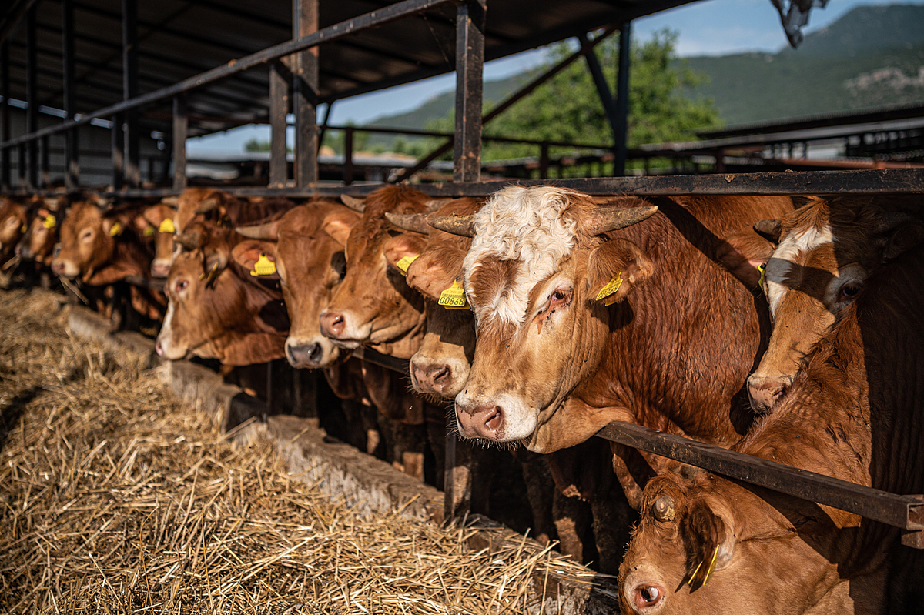
Image 2:
A shop during the Yulin festival in China selling dog meat.
Johnnes Eisele/AFP/Getty images.(2015) CBS NEWS. Available at: https://www.cbsnews.com/pictures/china-dog-meat-eating-festival/2/
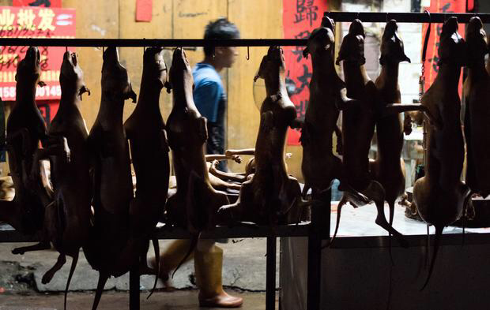

Image 3:
A large scale chicken farm in the United States.
Rob Stothard.(2017) The Guardian. Available at: https://www.theguardian.com/environment/2017/jul/18/rise-of-mega-farms-how-the-us-model-of-intensive-farming-is-invading-the-world?CMP=Share_iOSApp_Other


