ACADEMIC REPORT

Introduction;
What is a skill
A skill is the potential to carry out a duty with the intention to be successful within a given amount of time, skills can many times be divided into domain–general and domain– specifics skills. Kills often need certain environmental stimuli and situation to assess the level of skills being shown and used. Skills can also be defined as personal experiences that enable an individual to complete tasks, skills can be achieved through learning and can entail physicality, these are skills that shows what you can do, these are seen as your strengths, Skills are the abilities or talents that need you to perform a job.
[Skill–Wikipedia]
A kill is a kind of work or activity which call for special training and knowledge. Most individual at a point in their lives would want to have a skill in carpentry or fashion, people need a wild scope of skills to enable them to give back to modern day economy. Skills are the expertise or talent required in order to do a job or to complete a range of tasks Job skills enable you to undertake a certain job and life skills that will assist you all the time to complete day to day task. there are various kind of skills that enable you attain success at all aspect of life,
What are Employability Skills?
Employability Skills can be defined as transferable skill needed by an individual to make them employable. Along with good technical understanding and subject, knowledgeable, employers often outline a set of skills that they want from an employee. Employability skills are skills you can transfer from person to person which are good verbal and written communication, effective team player, good time management skills, positivity, and adaptive skills these are some of the skills that makes you employable.
What are soft skills? What are hard skills?
Soft skills are shared and transfer to the benefit of the workplace, in your career you need soft skills to set the tone of how people regard you. These are example of soft skill
- Communication
- Teamwork
- Problem solving
- Adaptability
- Conflict resolution [https;//www.monster.com>article
Hard skills are teachable and assessable ability such as writing and reading, hard skills implies you are trained for a specific job , it connotes mastery and an expertise within a person to complete a task, possession of hard skills is essential to ensure a workplace success, workers hard skills are critical to preventing catastrophic result. Hard skills include computer programming, typing, writing, these skills learned and can be defined, evaluated and measured. [https;//www.thebalancecareers.com>
Soft or transferable skills- In my workplace I have developed soft skills which I have been able to share with colleagues. I can communicate effectively both in verbal and written communication, passing information to staff and management, writing and documenting is essential. I can read and understand information, have listening kills, this is giving other people chance to express their opinion and ideas. I can work in a team, helping and supporting each other to achieve a shared goals or outcome in an effective way making sure everyone is having a say and sharing responsibility I am a good time keeper, I can manage my time to fit into my daily routine I plan ahead, prioritize wisely setting goal to be achieve this has improve my work performance and at the university.
Another employability skill I have is punctuality and using time effectively. I am on time to work so that hand over is done with plenty of time, this also help me at school even in social event punctuality and using time efficiently setting limit to each task is my priority.
SWOT ANALYSIS and PERSONAL DEVELOPMENT PLAN[PDP]
SWOT analysis refers to your strengths, weaknesses, opportunities and threats analysis, is a framework for identifying and analysing the internal factor that have an impact on the viability of a project, product, place or a persons.[https;//searchcio.techtarget.com
Personal Development Plan
Personal development plan is the procedure to produce an action plan build on awareness, values, reflection, goal settings and planning for personal development within the context of a career, education, relationship or for self improvement. Personal development plans are often requirement for employee CVs [en.m.wikipedia.org]
Academic Skills
Academic skills is the process of enabling a person to be successful in learning, these skills reflect on who you are and how other people will value who you are. Academic skills give student the confidence to achieve their full potential, it uplift a persons ability to study, retain and recall information which aid in and passing an exams, academic skills include time management, reading skills, verbal communication, written communication and critical thinking, these skills are required to be able to succeed in an academic settings. Those are
skills we require to function effectively, academic skills enhance good grades, and enable people to be useful throughout one’s life.
General Transferable
*Time management
Time management enable an individual to be organize, this can assist you to keep going about what you want to finish, by so doing you need an up to date calendar, Time management help you to prioritize what you desire to achieve first, student can perform well when they are able to manage their time effectively. Those who manages their time well achieve better success. Reflecting on my experiences, I have been able to manage work and school, I am able to plan ahead time to enable me meet up schedule this has been possible through effective time management.
*Team working [collaborating with others]
Team working, and working in collaborating with others is essential in the work-
place. This
Enhances performance. It brings people together and understand each other. And enable to build warm friendships. In my work- place team- work helps us to accomplish our goals faster everyone knows what their responsibilities are. When you work in collaboration with others, it gives the understanding of their idea of how you can work together efficiently without conflict. Working in collaboration with others helps to know their different backgrounds, age, religion and their political views. identifying the strength and weakness helps to allocate tasks accordingly and effectively.
At the workplace, we work in collaboration with not only staff, but also nurses and doctors as care provider, with this we are committed together to promoting the well being of the people we work with.
- Communication
Communication is the action of sending and receiving information to a group or an individual, this can be through verbal, non- verbal written and facial expression.
Communication is very important in an organization because it enable people to spread understanding and information among people, communication helps to develop relationships with others. Communication enable you to transport your messages to other people as comprehensible, It is also regarding receiving information that others are sending to you as the receiver, communication is only successful when both parties understand the same infotmation.
Specifics
Research and Note-taking and gathering relevant information.,
Research and Note–taking is the process of writing down key point when in a lecture hall, it enables student to flash back to remember what has been thought in class. It is an important part of research process. Notes taken in class can sometimes be regarded as study aids this is practical when recording information taking from another root. By taking notes, the writer can record the importance of the information freeing their mind having to recall everything
According to Paul and Ross J.Q. Owens , How to study in college; states that note taken is a proven system , effectively recording information before putting it together.
Academic Writing is a clear report that has focal point, organized, and is backed up with evidence, this enable the reader to understand. Academic writing is centred around being formal in tone and style and appropriate use of language which the reader can understand.
Essays
The purpose of an essay is to be able to transfer certain information to an audience, a written essay is to show how well you have understood what you have learnt in class and you are able to answer questions. Academic essay has an introduction that provide the reader an idea of what they are about to learn, it also contains description of event and result of research. https;//unilearning.uow.edu.au>report
Referencing and the avoidance of plagiarism
It is essential in an academic report to reference the source of information, ideas from any published or unpublished sources, internet based, or somebody’s thinking, if you use the word or idea of other without referencing , this would be considered as plagiarism and this is an offence. Referencing is very important because it enable the reader to access your sources of research as quickly as possible in other to verify.
Paraphrasing is when you use the work which someone has written to making it your own by changing the words in the way that make sense, this also implies that when paraphrasing, you should be able to understand and translate an other person’s idea in a reduced formation, the words are changed to make it different from the original production.
Summarising is the process where a student chooses the most essential part of idea in the subject, which allows student to disregard immaterial information and how to combine the central ideas to make it relevant. Instructing people or student to sum up their work improve their memory. [readingrocket.org]
Communicating and presenting information.
To communicate effectively, you are required to be able to present your information clearly in the best way people can understand and feedback. This is very important in the work place and training sections, communication helps management and employee to perform effectively in their jobs and responsibilities , it is a tool of building and maintaining strong and lasting working relationships in any organisation, it helps to build trust between people and enhance productivity.
When communicating and presenting, you should be able to explain your point, even if you can set a power point slide, it is important to capture and connect with the people in other to get across to them, the importance of communicating and presenting can not be over emphasized.
Summary
The report shows how important it is to have academic skills that will make you employable, these skills equip you to advance to get a good job. Academic skills include communication, team– work, listening, and good time management. Reading and writing, these are also known as hard skill which are transferable. The report shows how you can avoid plagiarism this implies that when you copy someone original work by word to word is term as crime. If you need to copy. You are required to paraphrase using own word to make a report different from the original. We need academic skills to become more efficient in critical thinking and note taken are also highly transferable therefore vital sources in any career
References:
Identifying your Skills & Attributes
Retrieved 5 December 2016
Sommerville, Kerry [2007]. Hospitality
Employee Management and Supervision
Concept and Practical Applications. Hoboken,
NJ; John Wiley & Sons, Inc. P. 328.
ISBN 9780471745228.
https;//www. Skills you need.com.
https;//unilearning.uow.au>report
https;//en.m.Wikipedia.org.

Appendix- in class work to be uploaded
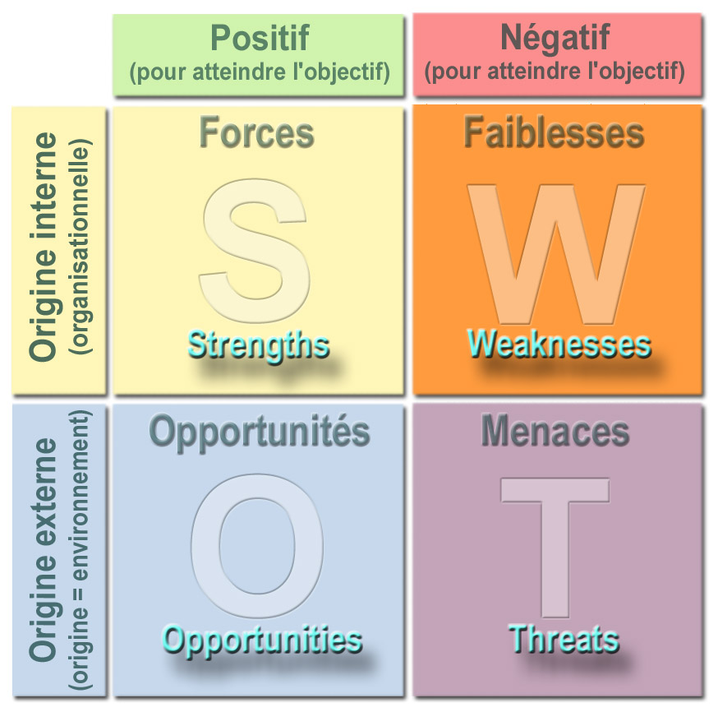
This Photo by Unknown Author is licensed under CC BY-SA
SWOT Analysis

.
Personal Development Plan [PDP]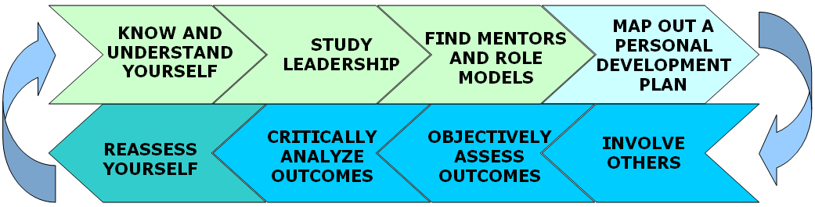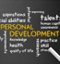
This Photo by Unknown Author is licensed under CC BY-SA-NC
This Photo by Unknown Author is licensed under CC BY

