
University of Wales Trinity Saint David
School of Engineering

ACMA6012
2D transient Heat Equation Solved with The Explicit Finite Difference Method (Report)

Steffan Rhys Lloyd
2220589
02/02/2026
Table of Contents
1. Introduction 4
2. Governing Equation 5
2.1 Background and Importance of the Heat Equation 5
2.2 Mathematical Definition for a Two-Dimensional Plate 5
2.3 Relevance to the Present Study 6
3. Finite Difference Method 7
3.1 Discretisation of the Heat Equation 7
3.2 Explicit Finite Difference Formulation 7
3.3 Implementation in MATLAB 8
4. Initial and Boundary Conditions 9
4.1 Initial Condition 9
4.2 Boundary Conditions and Enforcement in MATLAB 9
5. Stability and the Fourier Number 10
5.1 Stability of the Explicit Scheme 10
5.2 Application to the MATLAB Simulations 10
6. Code Structure and Implementation 12
6.1 Overall Program Structure 12
6.2 Time Marching & Visualisation 12
7. Analytical Steady-State Solution 14
7.1 Steady-State Heat Conduction 14
7.2 Implementation for Numerical Validation 14
8. Validation of the Numerical Model 16
8.1 Validation Methodology 16
8.2 Discussion of Validation Results 17
9. Sensitivity Analysis 19
9.1 Aim and Relevance to Model Reliability 19
9.2 Summary of the Three MATLAB Cases 19
9.3 Sensitivity to Grid Spacing, Time Step, and Fourier Number 21
9.4 Sensitivity to Domain Size and Boundary Temperature 22
10. Limitations and Suggested Improvements 23
10.1 Limitations of the Numerical Method 23
10.2 Suggested Improvements 23
Conclusion 24
References 25
Appendix 27

Introduction

In many engineering systems, from insulation design and electronic cooling to manufacturing procedures like heat treatment, heat transmission by conduction is a crucial factor.
The work's goal is to create and apply a numerical model that can solve the two-dimensional transient heat equation and forecast how long it will take the system to reach equilibrium. It is assumed that the plate has constant material properties, is homogenous, isotropic, and does not produce heat internally. The thermal diffusivity, which controls the pace at which heat moves through the domain, is calculated using the characteristics of aluminium. A uniform Cartesian grid is used for spatial discretisation, and an explicit finite difference approach is used to advance the temperature over time. Although it acknowledges that it limits the permitted time step to preserve numerical stability, this method is chosen for its simplicity and straightforward use.
The model uses Dirichlet boundary conditions, where the upper edge of the plate is kept at a constant raised temperature and the three edges of the plate are kept at zero temperature. Corner nodes are treated independently to meet the necessary specification.

2. Governing Equation

2.1 Background and Importance of the Heat Equation

One essential physical mechanism controlling the movement of thermal energy within solid materials is heat conduction. Predicting thermal performance, structural integrity, and energy efficiency in engineering applications requires an understanding of how temperature changes with position and time. The heat equation, which simulates the diffusion of heat across a material and is frequently used in mechanical and thermal engineering studies, provides the mathematical description of this process (Unknown, 2011).

2.2 Mathematical Definition for a Two-Dimensional Plate

The transient heat conduction equation for a two-dimensional solid domain with constant material parameters and no internal heat creation is expressed as
$$\frac{∂^{2}T}{∂x^{2}}+\frac{∂^{2}T}{∂y^{2}}=\frac{1}{α}\frac{∂T}{∂t}$$
where (x and y) are the spatial coordinates, t is time, and T (x,y,t) is the temperature distribution inside the plate. The material's thermal diffusivity is represented by the parameter α, which is defined as
$$α=\frac{k}{ρc}$$
where c stands for specific heat capacity, ρ density, and k for thermal conductivity. The rate at which heat moves through a substance is known as thermal diffusivity. In this work, aluminium characteristics are employed, leading in a thermal diffusivity of 6.42×10^(-5) “"m" ^2/"s", which is implemented directly in the MATLAB model (Becker & Kaus, 2016).

This standard formulation of the heat equation, which includes thorough derivations and physical interpretations of each term, is frequently used in university-level heat transfer teaching materials for transient conduction problems (Becker & Kaus, 2016).

2.3 Relevance to the Present Study

The governing equation demonstrates that the spatial curvature of the temperature field determines the rate of temperature change at any given position. Regions with significant temperature gradients suffer rapid diffusion, while regions of almost uniform temperature evolve more slowly. As the system gets closer to thermal equilibrium, the governing equation becomes Laplace's equation, and the temperature field stops changing over time. A helpful reference for verifying numerical answers is this steady-state condition (Ramšak, M. 2022).

3. Finite Difference Method

3.1 Discretisation of the Heat Equation

The finite difference method is used to find a numerical solution to the governing heat equation. This technique replaces the continuous spatial and progressive results in the governing equation with algebraic approximations evaluated at discrete grid points. Temperature readings are recorded at each grid node after the two-dimensional plate is divided into a uniform Cartesian grid with equal spacing in both directions.
For the spatial derivatives, second-order central difference approximations are employed, and for the temporal derivative, a first-order forward difference approximation. This combination results in a forward-time, central-space (FTCS) system that is explicit. Because of its conceptual simplicity and ease of application, the FTCS approach is frequently employed for transient heat conduction problems, especially for structured grids (Aditya Bijoy & Dr.Singh, 2022).

3.2 Explicit Finite Difference Formulation

The temperature at a certain interior node at the subsequent time step depends on its present value and the values of its four closest neighbours, according to an explicit update rule that is produced by applying the finite difference approximations to the governing equation. In broad terms, this can be stated as,
$$T^{n+1}=T^{n}+F_{0}$$

where the heat diffusion strength every time step is determined by the dimensionless Fourier number F_0. This formulation allows the temperature field to be advanced in time without solving a system of simultaneous equations, making the method computationally efficient per iteration ‌(Itasca Consulting Group, 2024.

3.3 Implementation in MATLAB

The MATLAB code uses stacked loops to apply the finite difference update solely to inside grid points. To enforce the specified boundary requirements, border nodes are handled independently and are not included in the update process. Two temperature matrices are utilised to record values at successive time steps, guaranteeing that all changes are based on values from the preceding iteration.

4. Initial and Boundary Conditions

4.1 Initial Condition

To specify the temperature field over the domain at the beginning of the simulation, a transient heat conduction model needs an initial condition (Unknown, 2011). In this investigation, the initial temperature is adjusted evenly to 0 °C across the entire plate by initialising the temperature matrix to zeros in MATLAB. This serves as a clear baseline for tracking diffusion as heat enters the area and represents a cold plate prior to heating. To obtain a unique transient solution in diffusion problems, the initial temperature at t = 0 must be prescribed as part of the initial boundary value problem.
Because the interior starts at a single temperature, any subsequent gradients are only caused by boundary forcing, which further supports the interpretation of the data. The only modifications to the initial condition in the three simulations are those brought about by varying boundary temperatures and discretisation parameters, guaranteeing that the outcomes are consistent across scenarios (Schmitt, 2018).

4.2 Boundary Conditions and Enforcement in MATLAB
Boundary conditions are required to represent how the plate interacts thermally with its surroundings. Dirichlet boundary conditions are used in the MATLAB model: the north boundary is set at a temperature T = (°), while the west, east, and south boundaries are maintained at 0 °C. To produce various constant temperature levels while maintaining the same physics, the value of T = (°) is changed throughout the three runs (60 °C, 75 °C, and 45 °C).
Since boundary edges meet at corners, prescribing competing values at a single node can lead to uncertainty. This is why corner handling is handled explicitly. By performing fixed border assignments in a predetermined order, the code prevents this and guarantees constant values at boundary intersections (Schmitt, 2018).

5. Stability and the Fourier Number

5.1 Stability of the Explicit Scheme
The transient heat equation is solved using an explicit finite difference method that is conditionally stable. This indicates that the link between the time step and the spatial grid spacing determines numerical stability. For diffusion problems, this relationship is often stated using the dimensionless Fourier number, which measures the amount of heat diffused every time step (Weisstein, Eric W. 2017)..
For a two-dimensional heat conduction problem, the Fourier number is defined as
$$F_{0}=\frac{αΔt}{h^{2}}$$
where $α$ is the thermal diffusivity, $Δt$is the time step, and $h$is the grid spacing. The explicit forward-time, central-space scheme's stability analysis reveals that numerical stability is only preserved when (Ike , 2024)
$$F_{0}≤0.25$$
Numerical errors increase exponentially if this condition is broken, producing oscillating and non-physical temperature fields. University-level courses of diffusion equations go into great depth about this stability requirement, which is a standard result for explicit finite difference solutions of the heat equation. (Unknown, 2011).

5.2 Application to the MATLAB Simulations
The stability requirement is immediately enforced prior to the start of time marching in the MATLAB implementation. Any time step that exceeds the maximum permitted time step which is determined by the selected grid spacing and material characteristics is discarded. This guarantees the stability of any simulation during its execution.
Fourier numbers of 0.2493, 0.2313, and 0.1927 are used in three simulations. When compared to the analytical solution, the first instance has the most numerical error but also operates very close to the stability limit, permitting huge time steps. Although they need more time steps to reach equilibrium, the second and third examples show better numerical accuracy and operate farther from the stability limit.
These findings highlight the change off present in specific schemes: while increasing the time step increases efficiency, it decreases numerical resilience.

6. Code Structure and Implementation

6.1 Overall Program Structure
The finite difference method's theoretical formulation is closely reflected in the MATLAB program's structure. The code defines the material attributes for aluminium after starting with workspace management instructions to provide a clean execution. Thermal diffusivity is calculated once at the start of the program and utilised consistently throughout the simulation, guaranteeing that all results are based on the same physical characteristics.
The plate dimensions, grid spacing, boundary temperature, and time step size are then implemented into the codes window. To make sure that every value is both correct, input validation tests are used. Specifically, the checks that the generated grid has at least one layer of inner nodes and that the grid spacing splits the plate dimensions within a given tolerance. By doing these tests, errors are avoided.

6.2 Time Marching & Visualisation
Two temperature matrices, which reflect the current and time step solutions, are used to progress in time. Inner nodes are updated using the finite difference equation, whereas border nodes are removed from the update loop and reset manually after each iteration. This guarantees the consistent maintenance of Dirichlet boundary conditions during the simulation.
The code uses MATLAB's plotting tools to visualise the temperature field in real time to help with interpretation. This gives instant input on numerical stability and merging behaviour then permits the observation of the solution's evolution. Additional plots are created to show the final temperature distribution and make comparison after convergence is reached.
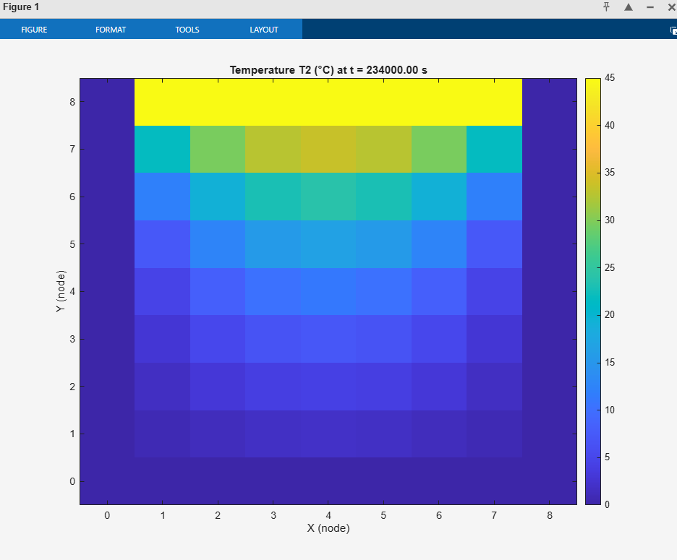
Figure 1:- Transient temperature distribution for the 8 × 8 plate with a north boundary temperature of 45 °C.
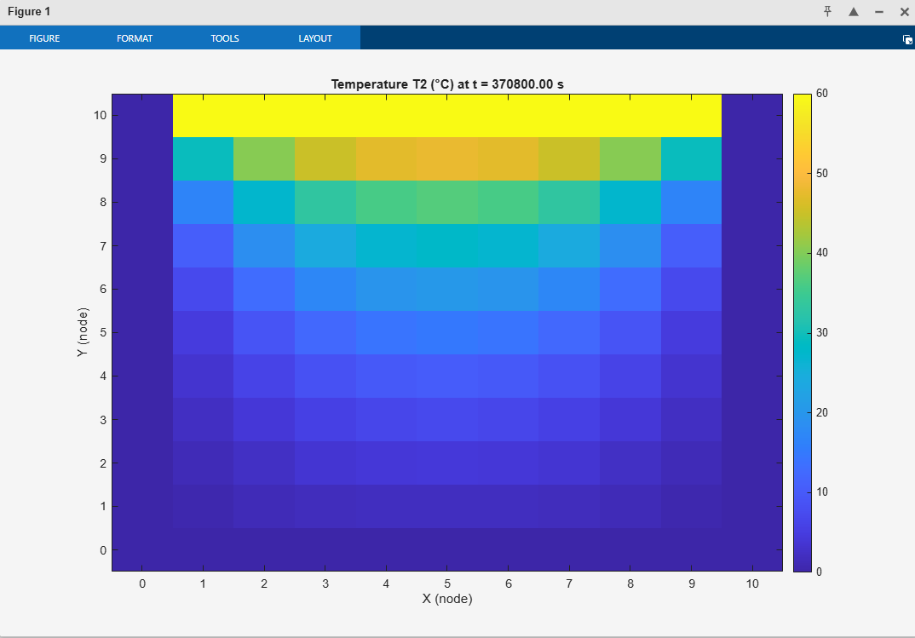
Figure 6:- Transient temperature distribution for the 10 × 10 plate with a north boundary temperature of 60 °C.

7. Analytical Steady-State Solution

7.1 Steady-State Heat Conduction

The temperature field inside the plate progressively gets closer to a steady state as the transient heat conduction mechanism develops. The temperature stops changing with time at thermal equilibrium, and the governing equation's time-dependent term drops to zero. so Laplace's equation, which defines steady-state heat conduction in solids, becomes the governing equation (unknown, 2020). A mathematical approach that can serve as a standard for verifying numerical results is derived from this reduction.
A Fourier series solution can be used to depict the steady-state temperature distribution on a rectangular plate with defined temperature bounds (Weisstein, Eric W. 2017). Both Laplace's equation and the specified Dirichlet boundary conditions are satisfied by this solution.

7.2 Implementation for Numerical Validation
The analytical steady-state solution is directly constructed in MATLAB in this study to serve as a reference solution for the explicit finite difference model's validation.
To precisely match the numerical boundary treatment, boundary values are explicitly imposed in the analytical temperature matrix, especially at the corner nodes. This guarantees that any discrepancies between the numerical and analytical solutions are only the result of numerical discretisation mistakes and not inconsistent boundary conditions (Gorji, M., Duvigneau, F. and Juhre, D. 2023).
After thermal equilibrium is established, the analytical solution is utilised to evaluate the accuracy of the numerical solution rather than to move the simulation forward in time. In heat conduction modelling, comparing numerical and analytical solutions in this manner is a common validation technique that gives assurance that the numerical implementation accurately captures the underlying physical issue. (L. Braun, J. and H. Olson, D. 2019)

8. Validation of the Numerical Model

8.1 Validation Methodology

In contrasting the explicit finite difference solution at thermal equilibrium with the analytical steady-state solution presented in the preceding section, the numerical model is validated. This method is suitable because, for the same geometry and boundary conditions, the eventual equilibrium state should agree with the analytical solution of Laplace's equation even if the numerical model solves the transient heat equation.
Once the numerical solution satisfies the convergence criteria, a direct comparison is made between the equilibrium temperature field and the analytical temperature field at corresponding grid sites. Both qualitative and quantitative methodologies are used for comparisons. Temperature distributions and centreline profiles are qualitatively examined to see if the numerical solution reproduces the expected geographical behaviour. The maximum absolute error and root mean square error (RMSE) are statistically calculated to provide objective precision metrics. This method is commonly used in heat conduction modelling to compare transient numerical answers with steady-state analytical solutions (Haque, M.N. and Akter, R. 2025).
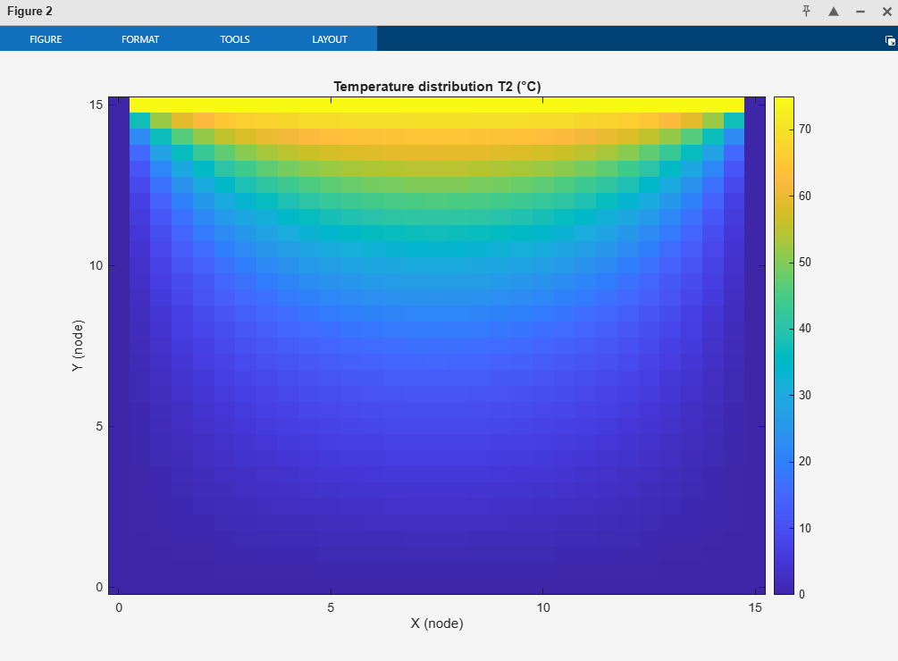
Figure 3:- Numerical steady-state temperature field for the 75 °C case.

8.2 Discussion of Validation Results

In all three simulations, the validation findings demonstrate a high degree of overall agreement between the analytical and numerical answers. The first scenario, which works extremely near the stability limit and has the finest grid spacing, exhibits the biggest differences. In this instance, the RMSE is 0.88 °C and the highest absolute error is roughly 1.82 °C. Operating close to the stability threshold increases numerical error even while spatial resolution is enhanced.
Errors are much smaller in the second and third simulations. The RMSE is 0.15 °C in the second scenario and 0.13 °C in the third. These scenarios have more resilient numerical behaviour since they operate farther from the stability limit while using coarser grids. The contour of the centreline temperature profiles for each case closely matches, indicating that the prevailing diffusion behaviour is well depicted. Overall, the validation verifies that differences are compatible with anticipated discretisation and stability effects.
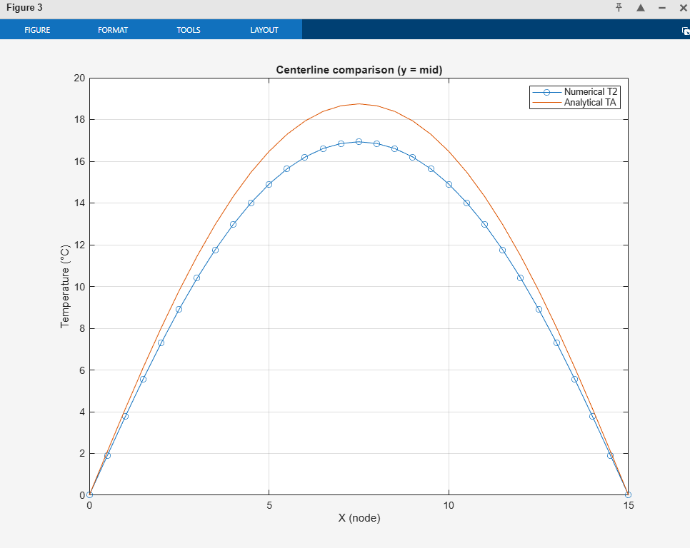
Figure 8:- Comparing numerical and analytical centreline temperatures graph for the 75 °C case.

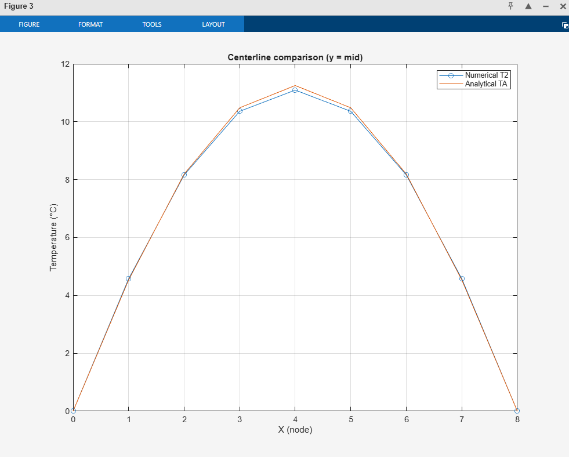
Figure 7:- Comparing numerical and analytical centreline temperatures graph for the 45 °C case.

9. Sensitivity Analysis

9.1 Aim and Relevance to Model Reliability
Sensitivity analysis is used to investigate how changes in numerical parameters affect computing efficiency, stability, and solution accuracy. This section is very significant since it shows how modelling choices impact the reliability of outcomes, demonstrating a comprehension of the numerical approach beyond basic implementation. Sensitivity analysis is crucial for explicit finite difference methods used in transient heat conduction because of the method's conditional stability and reliance on discretisation parameters.
Careful parameter selection is necessary to prevent numerical instability or excessive inaccuracy because explicit approaches for the heat equation are known to be sensitive to the interaction between grid spacing and time step size (Becker & Kaus, 2016).
Three MATLAB simulations with different plate dimensions, grid spacing, time step size, and boundary temperature are used in this work to examine sensitivity while keeping the same governing equation and numerical updating scheme. This makes it possible to systematically evaluate the impact of specific numerical parameters.

9.2 Summary of the Three MATLAB Cases
The three completed simulations are summarised in Table 1 to compare the change in behaviour of each plate when different elements are applied.

Case | Plate (m) | h (m) | T₀ (°C) | Fo | Steps | RMSE (°C) | Max error (°C) | t_eq (days)
1 | 15 × 15 | 0.5 | 75 | 0.2493 | 514 | 0.8811 | 1.8175 | 5.77
2 | 10 × 10 | 1.0 | 60 | 0.2313 | 103 | 0.1475 | 0.4851 | 4.29
3 | 8 × 8 | 1.0 | 45 | 0.1927 | 78 | 0.1266 | 0.3989 | 2.71

There are two obvious trends. The largest plate takes the longest physical time to reach thermal equilibrium, while the scenario operating closest to the stability limit has the largest numerical inaccuracy.
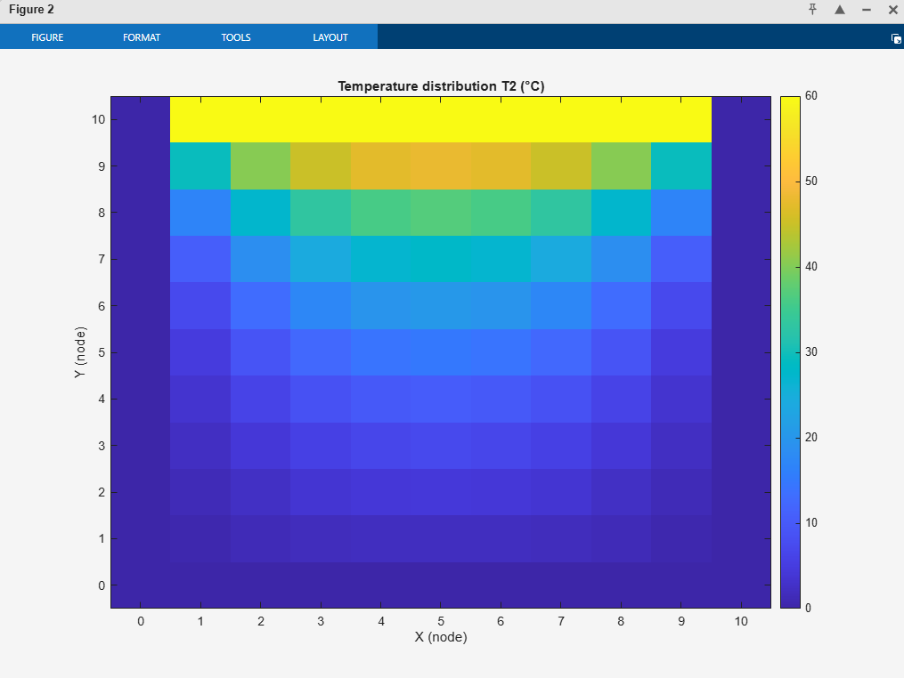
Figure 5:- Numerical steady-state temperature field for the 60 °C case.

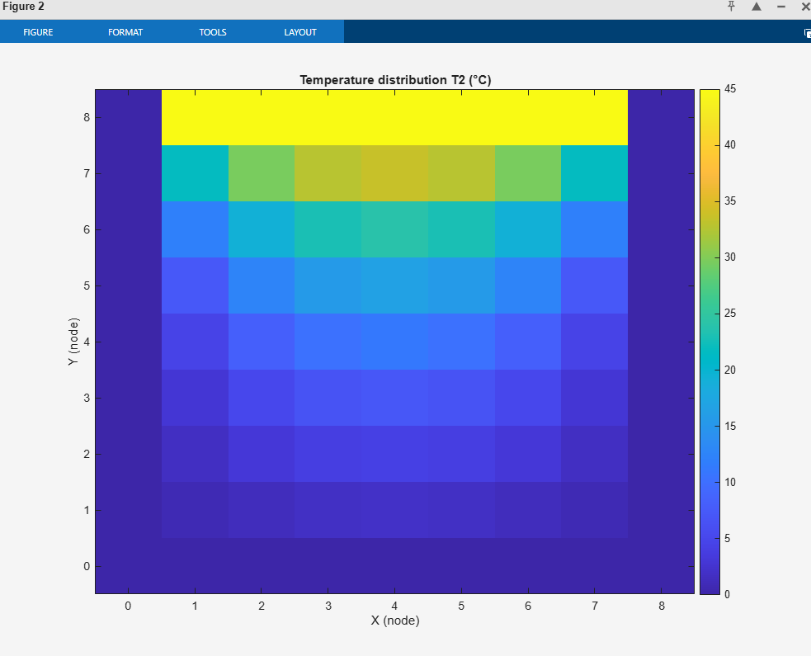
Figure 4:- Numerical steady-state temperature field for the 45 °C case.

Figure 3:- Numerical steady-state temperature field for the 75 °C case.

9.3 Sensitivity to Grid Spacing, Time Step, and Fourier Number

Time step size regulates numerical stability, whereas grid spacing affects spatial resolution and truncation error. The Fourier number connects these two parameters for explicit finite difference systems. Numerical solutions are more susceptible to discretisation and round-off errors as the Fourier number gets closer to its stability limit.
In Case 1, this behaviour is clear. The time step yields a Fourier number of 0.2493, which is quite close to the two-dimensional stability limit even though the grid spacing is the smallest. Consequently, despite increased spatial resolution, numerical robustness is diminished, resulting in the highest RMSE and maximum error. This result aligns with conventional discourse regarding stability in explicit heat conduction methods (unknown. 2011)
Cases 2 and 3, on the other hand, use smaller Fourier numbers. These cases show much better agreement with the analytical solution, despite the poorer spatial resolution. This demonstrates that preserving a stability margin has a greater impact on explicit systems than grid refinement alone.
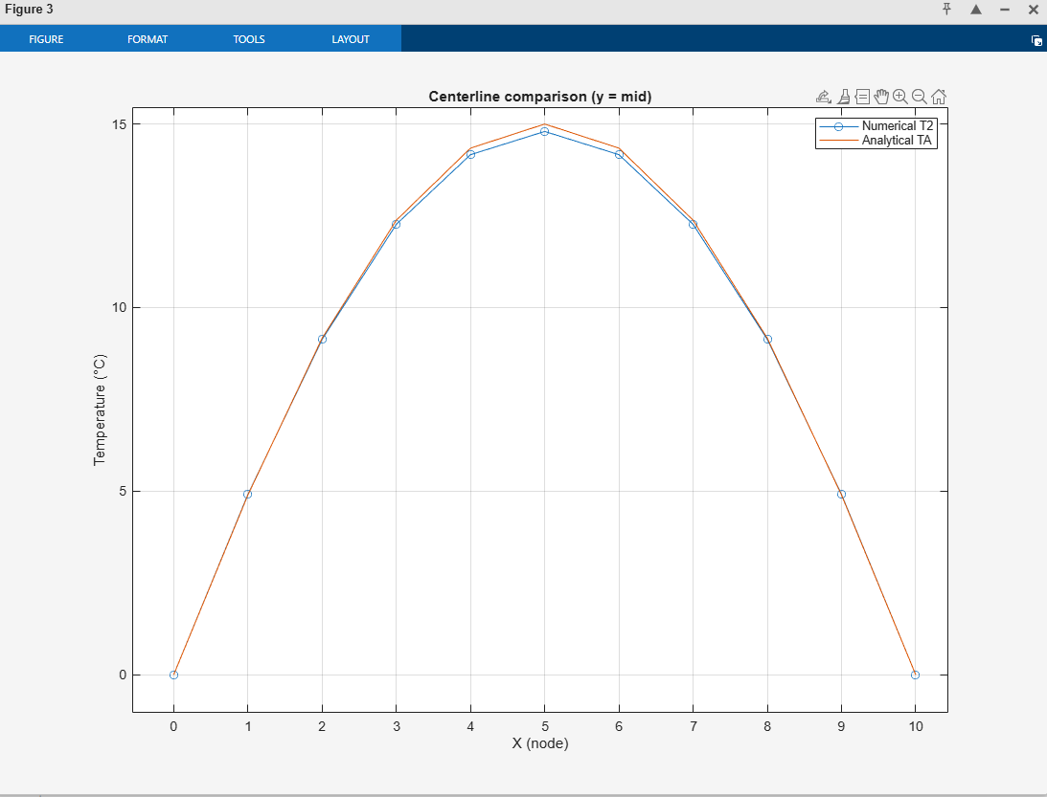
Figure 9:- Comparing numerical and analytical centreline temperatures graph for the 60 °C case.

9.4 Sensitivity to Domain Size and Boundary Temperature

The physical time needed for heat to diffuse over the plate is influenced by domain size. As seen in Case 1, larger plates take longer to attain equilibrium due to their longer diffusion routes. Because the heat equation is linear, boundary temperature mainly adjusts the temperature field's magnitude and has no effect on convergence behaviour.
Overall, the sensitivity analysis shows that the explicit finite difference model is most sensitive to the Fourier number, which expresses the combined choice of grid spacing and time step size. Compared to aggressive refining, conservative parameter selection below the stability limit yields more accurate and dependable outcomes. This demonstrates that sensitivity analysis is essential for evaluating the dependability of explicit numerical solutions.

10. Limitations and Suggested Improvements

10.1 Limitations of the Numerical Method

Although the explicit finite difference method offers a straightforward and understandable way to represent transient heat conduction, it has several basic drawbacks. Its stringent stability requirement is its biggest drawback. This study shows that the time step needs to meet a Fourier number requirement of F0≤0.25. Grid refinement's ability to increase precision is limited by this limitation, which gets more severe when grid spacing is decreased. This problem is seen in the first simulation, where operating near the stability limit results in more numerical error and longer equilibrium durations despite the use of a finer grid.

10.2 Suggested Improvements

The model's accuracy and efficiency could be increased in a few ways. Larger time steps could be employed using implicit or semi-implicit techniques, like the backward Euler or Crank-Nicolson methods, which would eliminate the stringent stability condition. These approaches are frequently more effective overall for diffusion-dominated issues, even though they need solving systems of equations.
Additional enhancements include using adaptive time stepping to maximise convergence during early transient stages and vectorising the MATLAB code to save execution time. These methods are frequently suggested in the literature on numerical heat conduction.

Conclusion

The study used an explicit finite difference method developed in MATLAB to explore the transient two-dimensional heat conduction problem. Under specified Dirichlet boundary conditions, the numerical model effectively replicated the diffusion of heat inside a rectangular aluminium plate. By carefully choosing the time step based on the Fourier number requirement, non-physical behaviour during time marching was avoided, ensuring the stability of the explicit scheme.
The accuracy of the numerical implementation was confirmed by validation against an analytical steady-state solution, which showed good agreement in every case. The sensitivity study showed that, rather than only spatial resolution, the relationship between grid spacing and time step size has a significant impact on solution correctness. Specifically, it was demonstrated that even with tighter grids, operating near the stability limit increased numerical error.

Overall, the findings show that when stability restrictions are adhered to and numerical parameters are chosen correctly, explicit finite difference methods can yield precise and trustworthy solutions for transient heat conduction issues.

References

Aditya Bijoy & Dr.Singh(2022) Solution Of One-Dimensional Heat Equation By Finite Difference Method JPNR+-+S10+-+739.pdf(Accessed: 31 January 2026).
Becker & Kaus. (2016). Excerpt from GEOL557 Numerical Modeling of Earth Systems. Institute for.Geophysics. https://wwwudc.ig.utexas.edu/external/becker/teaching/557/problem_sets/problem_set_fd_2dheat.pdf(Accessed: 31 January 2026).
Gorji, M., Duvigneau, F. and Juhre, D. (2023) Code verification of immersed boundary techniques using the method of manufactured solutions - computational mechanics, SpringerLink. Available at: https://link.springer.com/article/10.1007/s00466-023-02411-x#:~:text=To%20view%20a%20copy%20of%20this%20licence%2C%20visit%20http://creativecommons.org/licenses/by/4.0/. (Accessed: 01 February 2026).
Haque, M.N. and Akter, R. (2025) Journal of Applied Mathematics and Physics, 2025, 13(5), 1780-1788, Scientific research Publishing. Available at: https://www.scirp.org/pdf/jamp_1724164.pdf (Accessed: 30 January 2026).
Ike ,(2024) Fourier series method for the stability solution of simply supported thin beams on two-parameter elastic foundations of the pasternak, filonenko-borodich, Hetenyi or Vlasov Models , Extrica. Available at: https://ww.extrica.com/article/23913(Accessed: 01 February 2026).
‌Itasca Consulting Group, (2024) Numerical Thermal Formulation. 3DEC 7.0 documentation, 2025. Available at: https://docs.itascacg.com/pfc700/3dec/docproject/source/options/thermal/thermal_numerical.html
L. Braun, J. and H. Olson, D. (2019) A steady-state thermoreflectance method to measure thermal conductivity | Review of Scientific Instruments | AIP publishing, Review of Scientific Instruments . Available at: https://pubs.aip.org/aip/rsi/article/90/2/024905/361757/A-steady-state-thermoreflectance-method-to-measure (Accessed: 01 February 2026).
‌Laplace, P.-S. (2008) The finite difference method. Available at: https://www.ljll.fr/~frey/cours/UdC/ma691/ma691_ch6.pdf (Accessed: 31 January 2026).
Ramšak, M. (2022) ‘On numerical solution stability of the Laplace equation in absence of the Dirichlet boundary condition: Benchmark problem proposal’, Engineering Analysis with Boundary Elements, 144, pp. 475–481. Available at: https://doi.org/10.1016/j.enganabound.2022.08.028. (Accessed: 29 January 2026).
Schmitt, (2018) Lecture notes on pdes, part I: The heat equation and the eigenfunction method, The University oh Utah. https://www.math.utah.edu/~golden/resources/clara/Notes-PDEs1.pdf
unknown (2020) 3 laplace’s equation. Available at: https://www.damtp.cam.ac.uk/user/dbs26/1BMethods/Laplace.pdf (Accessed: 01 February 2026).
unknown. (2011). HEAT CONDUCTION EQUATION. College of Engineering and Computer Science. https://cecs.wright.edu/~sthomas/htchapter02.pdf
Weisstein, Eric W. (2017) Fourier series, Wolfram MathWorld. Available at: https://mathworld.wolfram.com/FourierSeries.html (Accessed: 29 January 2026).

Appendix

clc
clear
%Aluminium Properties
k = 143;
p = 2800;
c = 795;
alpha = k / (p * c);
fprintf('Thermal diffusivity alpha = %0.2e m^2/s\n',alpha)
tol = 0.01;
while true
X = input('Enter plate X dimension (positive): ');
Y = input('Enter plate Y dimension (positive): ');
h = input('Enter grid spacing h (positive): ');
if isempty(X) || isempty(Y) || isempty(h)
fprintf('Empty input detected — please provide numeric values.\n');
continue;
elseif any([X,Y,h] <= 0)
fprintf('All inputs must be positive values. Try again.\n');
continue;
elseif abs(X/h - round(X/h)) > tol || abs(Y/h - round(Y/h)) > tol
fprintf('Grid spacing h must divide both X and Y (within tolerance). Try again.\n');
continue;
else
break;
end
end
%Total number of rows NR and columns NC calculation
NR = round(Y/h) + 1;
NC = round(X/h) + 1;
%Min grid size check
if NR < 3 || NC < 3
error('Grid too coarse: need at least 3 nodes in each direction (reduce h).');
end
%Initialise Matrix T1
T1=zeros(NR,NC);
%Add boundary conditions
T0=input('Please enter the North boundary condition temperature: ');
T1(1,2:NC-1)=T0;
%East, West and South boundaries set to 0°C
T1(:,NC) = 0; % East (last column)
T1(:,1) = 0; % West (first column)
T1(NR,:) = 0; % South (last row)
%Temporal consideration (Stability check: Fo <= 1/4)
dT_max = h^2/(4*alpha);
TS = input(sprintf('Enter time step dT (<= %.6g s): ', dT_max));
while TS <= 0 || TS > dT_max
fprintf('Invalid dT. Must be > 0 and <= %.6g s\n', dT_max);
TS = input(sprintf('Enter time step dT (<= %.6g s): ', dT_max));
end
Fo = alpha*TS/h^2;
fprintf('Accepted: Fo = %.4f\n', Fo);
%keep Dirichlet boundary conditions constant
T2 = T1;
T2(1,2:NC-1) = T0;
T2(:,1) = 0;
T2(:,NC) = 0;
T2(NR,:) = 0;
%Convergence Criterion and explicit update until convergence is met
CC = 0.01;
maxDiff = inf;
step = 0;
maxSteps = 1e6;
%Step by step Live display of numerical temperature
x = 0:h:X;
y = Y:-h:0; %Row 1 corresponds to y=Y
figure;
hImg = imagesc(x, y, T2); colorbar;
set(gca,'YDir','normal');
xlabel('X (node)'); ylabel('Y (node)');
while maxDiff > CC && step < maxSteps
step = step + 1;
%Finite Difference update (interior nodes)
for i = 2:NR-1
for j = 2:NC-1
T2(i,j) = T1(i,j) + Fo*( ...
T1(i+1,j) + T1(i-1,j) + T1(i,j+1) + T1(i,j-1) - 4*T1(i,j) );
end
end
%Dirichlet boundaries constant in T2
T2(1,2:NC-1) = T0;
T2(:,1) = 0;
T2(:,NC) = 0;
T2(NR,:) = 0;
%Convergence check
maxDiff = max(abs(T2(:) - T1(:)));
%Update live plot
set(hImg,'CData',T2);
title(sprintf('Temperature T2 (°C) at t = %.2f s', step*TS));
drawnow;
T1 = T2;
end
if step >= maxSteps
warning('Did not converge within maxSteps = %d steps', maxSteps);
end
fprintf('Converged in %d steps. Max difference = %.4f\n', step, maxDiff);
%Temp Plot for distribution T2
figure;
imagesc(x, y, T2);
set(gca,'YDir','normal');
colorbar;
title('Temperature distribution T2 (°C)');
xlabel('X (node)');
ylabel('Y (node)');
%Analytical solution
[Xg, Yg] = meshgrid(x, y);
Nterms = 200; %Number of terms in the series (increase for accuracy)
TA = zeros(NR, NC);
for n = 0:Nterms-1
kterm = 2*n + 1;
num = exp( (kterm*pi*(Yg - Y))/X ) - exp( (-kterm*pi*(Yg + Y))/X );
den = 1 - exp( (-2*kterm*pi*Y)/X );
TA = TA + (1/kterm) * sin(kterm*pi*Xg/X) .* (num ./ den);
end
TA = (4*T0/pi) * TA;
%Enforce boundaries exactly
TA(1,2:NC-1) = T0;
TA(:,1) = 0;
TA(:,NC) = 0;
TA(NR,:) = 0;
%Comparison on a centerline slice
E = T2 - TA;
fprintf('\n--- Code Validation (T2 vs TA) ---\n');
fprintf('Max |T2 - TA| = %.4f °C\n', max(abs(E(:))));
fprintf('RMSE(T2 - TA) = %.4f °C\n', sqrt(mean(E(:).^2)));
midRow = round(NR/2);
figure;
plot(x, T2(midRow,:), 'o-'); hold on;
plot(x, TA(midRow,:), '-');
grid on;
title('Centerline comparison (y = mid)');
xlabel('X (node)');
ylabel('Temperature (°C)');
legend('Numerical T2','Analytical TA');
%Thermal Equilibrium time
t_eq = step * TS; %Time takes to reach thermal equilibrium (s)
if t_eq < 60
fprintf('Time to thermal equilibrium: %.2f s\n', t_eq);
elseif t_eq < 3600
fprintf('Time to thermal equilibrium: %.2f min\n', t_eq/60);
elseif t_eq < 86400
fprintf('Time to thermal equilibrium: %.2f h\n', t_eq/3600);
else
fprintf('Time to thermal equilibrium: %.2f days\n', t_eq/86400);
end
Figure 9:- Comparing numerical and analytical centreline temperatures graph for the 60 °C case.

Figure 8:- Comparing numerical and analytical centreline temperatures graph for the 75 °C case.

Figure 7:- Comparing numerical and analytical centreline temperatures graph for the 45 °C case.
Figure 6:- Transient temperature distribution for the 10 × 10 plate with a north boundary temperature of 60 °C.

Figure 5:- Numerical steady-state temperature field for the 60 °C case.

Figure 4:- Numerical steady-state temperature field for the 45 °C case.

Figure 3:- Numerical steady-state temperature field for the 75 °C case.
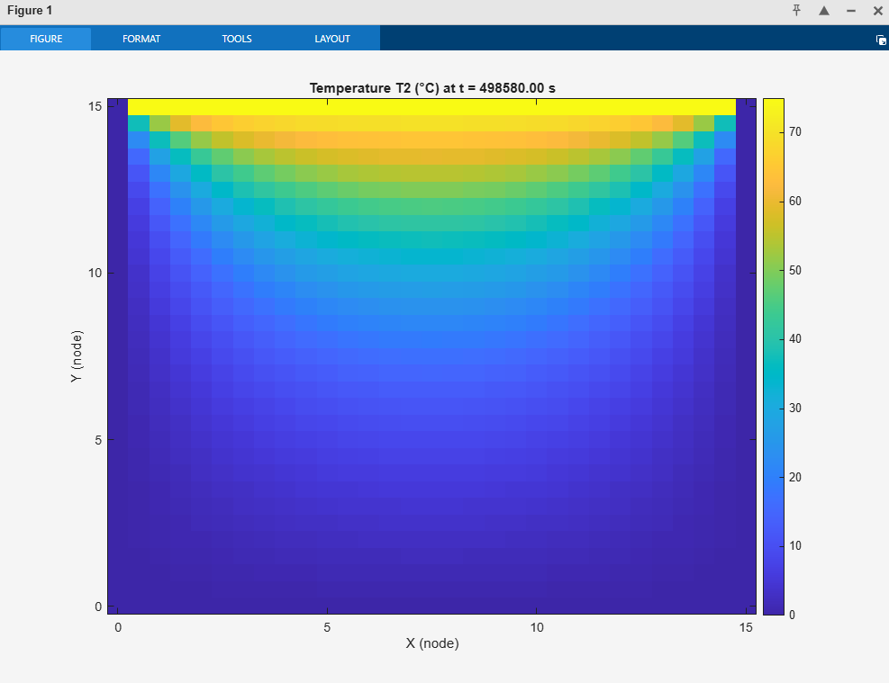
Figure 2:- Transient temperature distribution for the 15 × 15 plate with a north boundary temperature of 75 °C.

Figure 1:- Transient temperature distribution for the 8 × 8 plate with a north boundary temperature of 45 °C.

