Name: Paul Richards

Student No: 0251968

Course: Applied Computer Networks and Cybersecurity

Module: Network Operating Systems and Services
(ACCA5023)

Date: 30/04/2021

Contents

Introduction 3

Task 1: Utilising ARP and Routing Tables 4

Task 2: Deploy core services (FTP Server) 8

Task 3a: Installing and configuring the Routing and Remote Access Services 31
Server 1 31
Server 2 45

Task 3b: Routers 58
Routing Tables 58

Task 4 62
Filter 1 : IP packet filtering 62
Filter 2: Restrict Access to FTP service running on Server 2 to only hosts in Private Net 2 67
Filter 3: Only allow specific host in PrivateNet1 to access the FTP service running on Server 2. 72

Task 5: Failover Clustering for high availability systems/services 76
Failover clustering 76

Task 6: Network Policy 79
High Availability Policy. 79
Security Policy 80

Bibliography 82

Introduction

The worksheet covers the following:

- ARP and Routing tables.

- Installing and configuring an FTP server. Uploading files to the FTP server.

- Setting up Routing and Remote Access. Using inbound and outbound filters in Routing and Remote Access to block network traffic.

- High availability and failover clustering.

- Network policy.

Task 1: Utilising ARP and Routing Tables

Step 1: Logged into Server 1, as nwtraders\administrator.

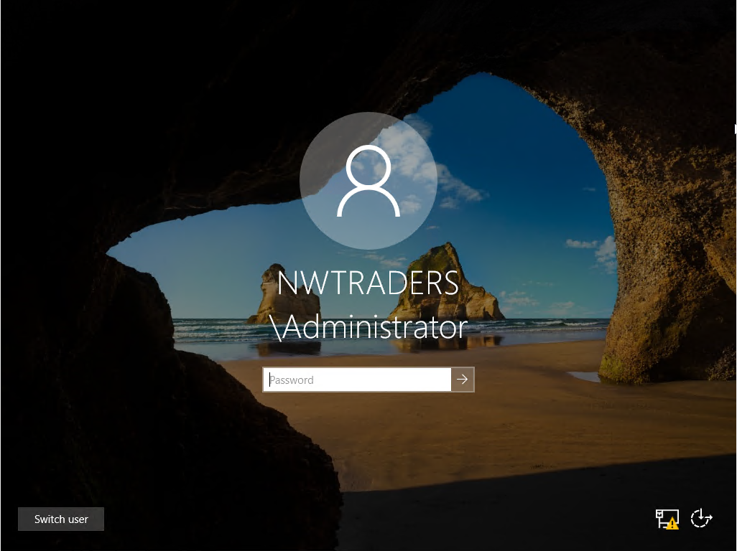

Step 2: Did a search for command prompt. Clicked on the search results

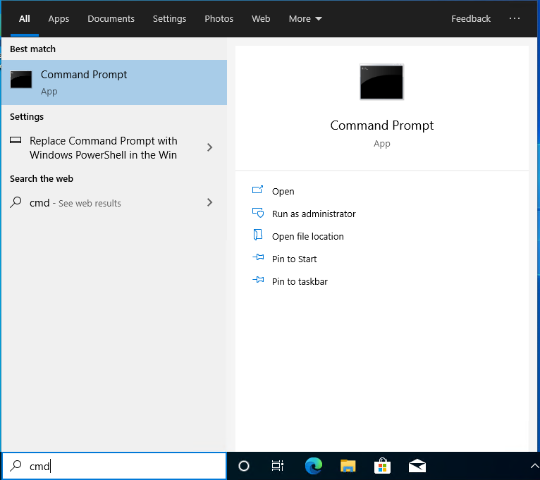
Step 3: In ‘Command prompt’ typed in ARP-A. Got the following result.

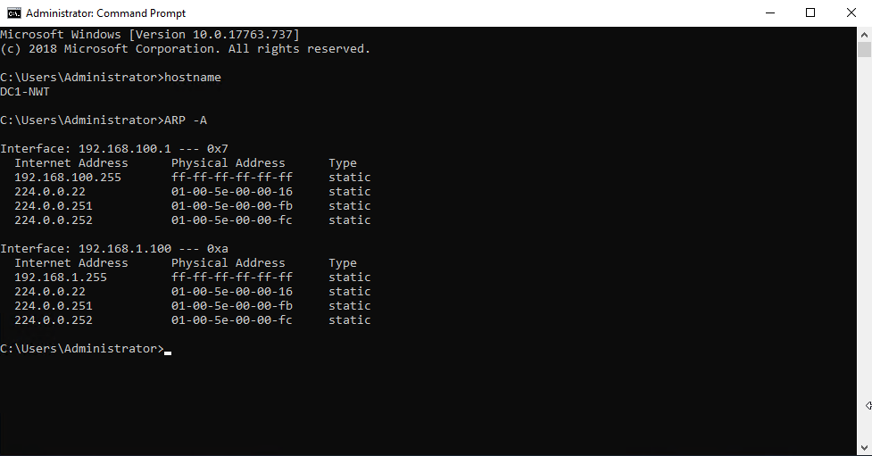

Step 4: Closed the ‘Command prompt’, and opened ‘Command prompt’ again. Pinged server 2’s PublicNet connection (192.168.1.101) and PrivateNet2 connection (192.168.101.1)

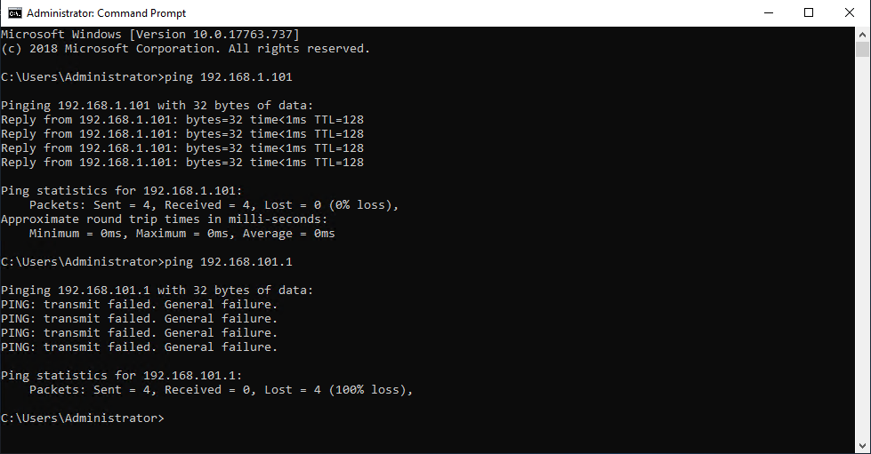

Step 5: Pinged client 1 (192.168.100.2) from server 1.
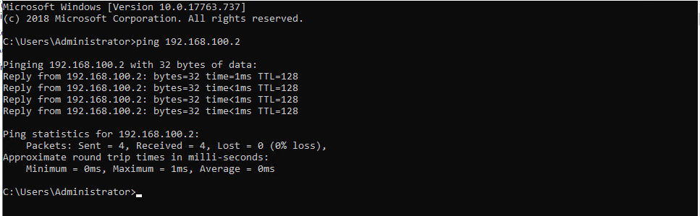

Sep 6: Closed and opened up ‘Command prompt’. In the ‘Command prompt’, enter ARP-A. Noticed more entries had been entered in the ARP table. There were two more IP address e.g. 192.168.100.2 and 192.168.1.101.
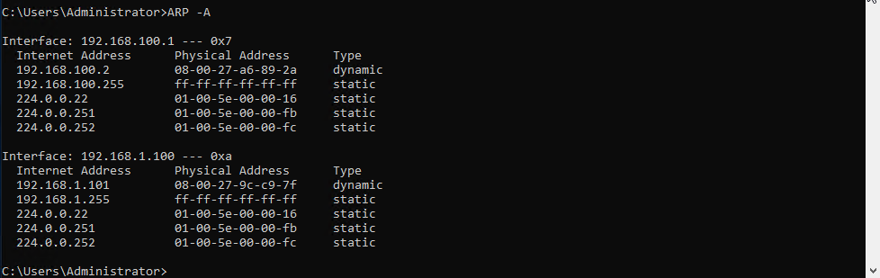

Step 7: Closed and opened ‘Command prompt’. Run the route print command.

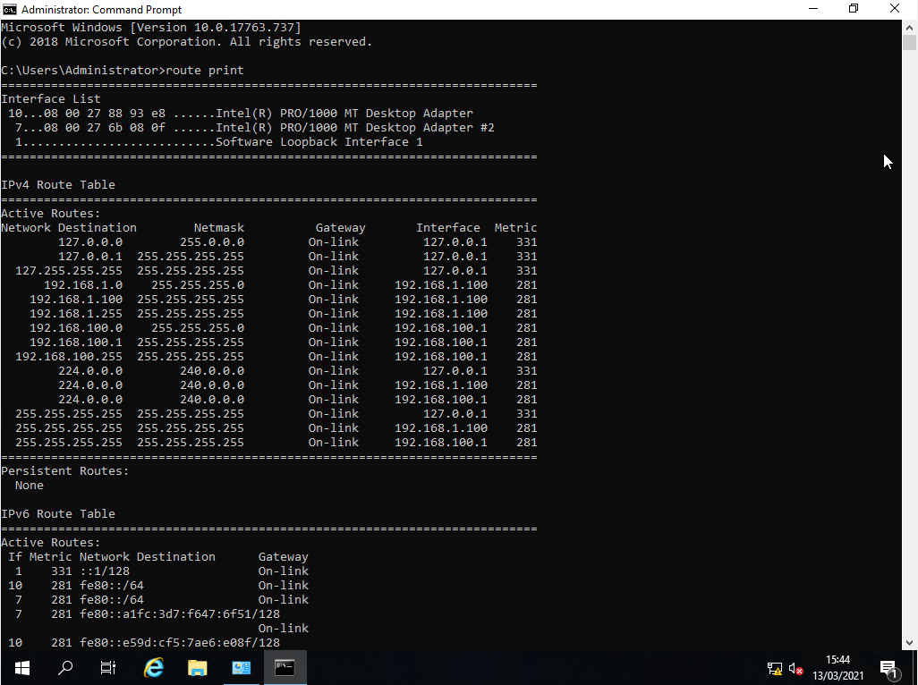

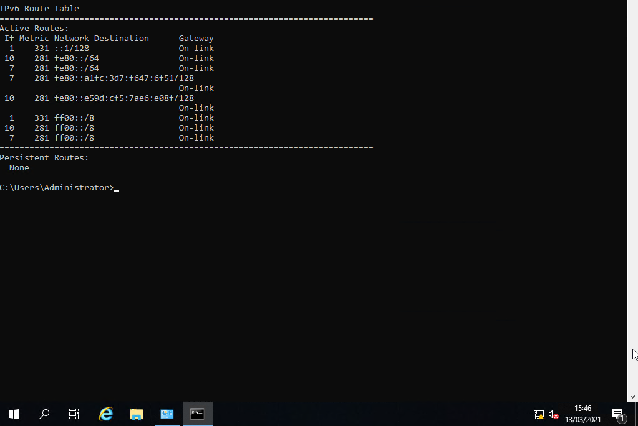

Task 2: Deploy core services (FTP Server)

Step 1: Logged into server 2 as administrator

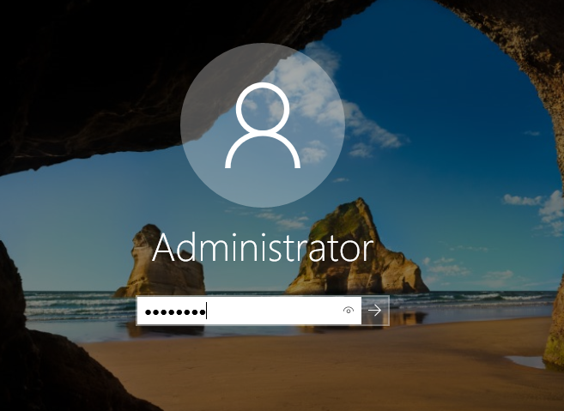

Step 2: In the search box entered Server Manager and click on the result of the search

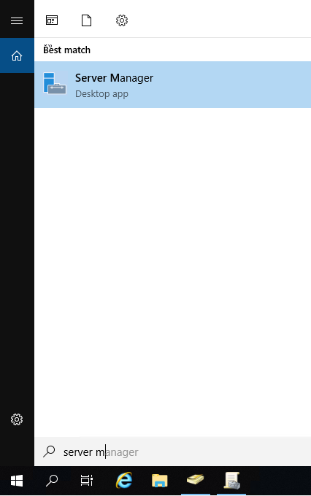
Step 3: In ‘Server Manager’, clicked on add roles and features.

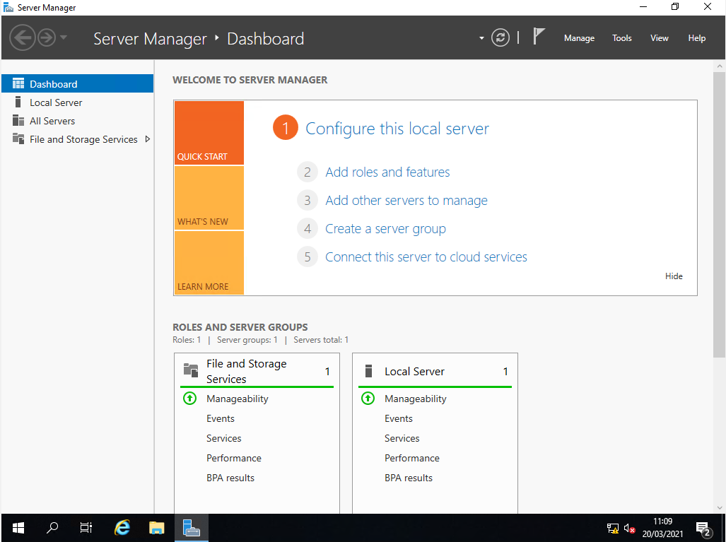

Step 4: On the initial screen ‘Add roles and Feature Wizard’, clicked on next.
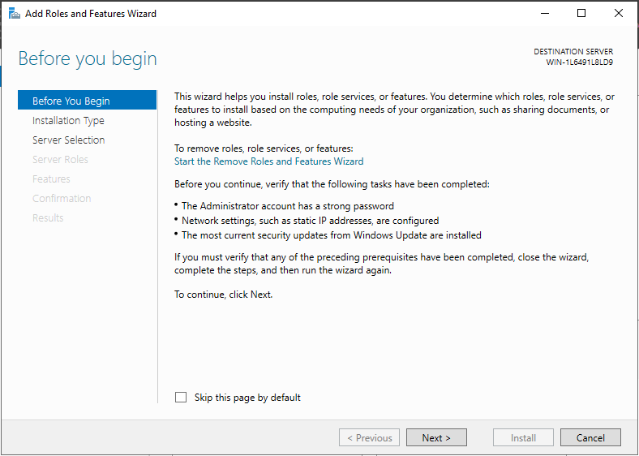
Step 5: On the ‘Installation type’ screen, used the default setting, ‘Role-base or feature-based installation’. Clicked next.

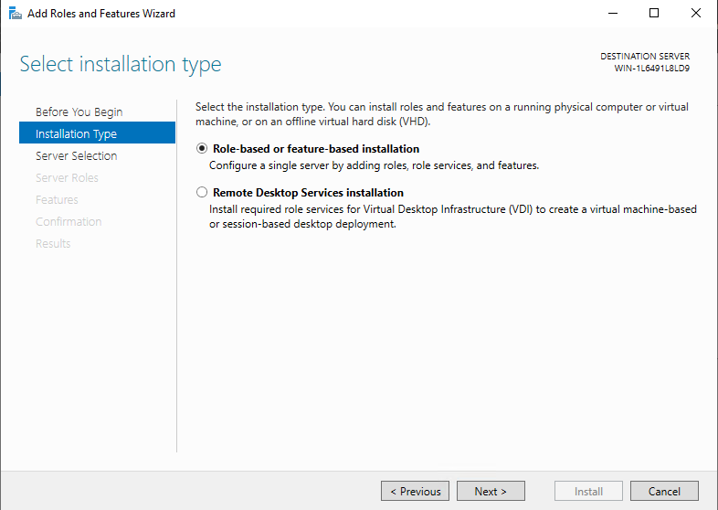

Step 6: Accepted the default entry on the ‘Server selection’ screen, which was the name of server 2, WIN-1L6491L8LD9. Clicked next.
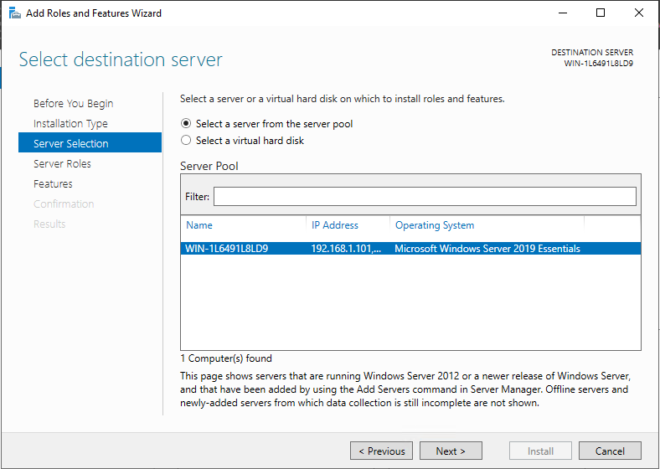
Step 7: On the ‘Server roles’ tab, selected Web Server IIS. Clicked next.
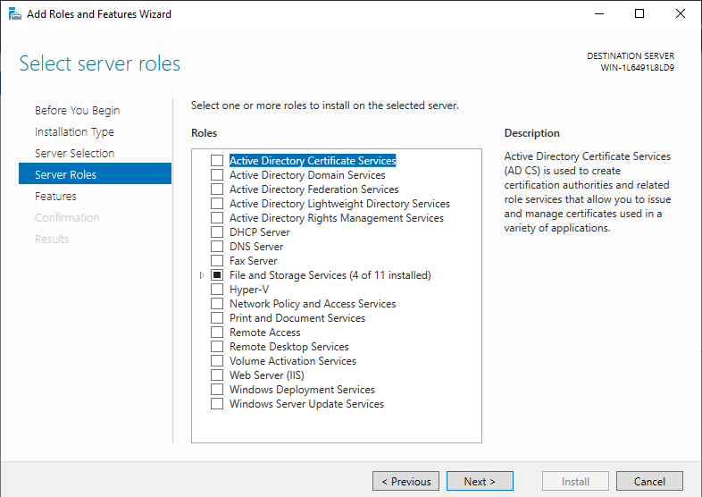

Step 8: A pop up appeared about ‘Adding features that are required for Web Server (IIS)?’, clicked add features.
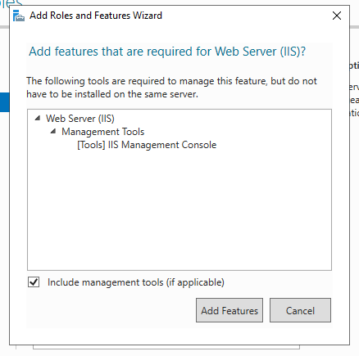

Step 9: Clicked next when returned to the ‘Server roles’ screen.

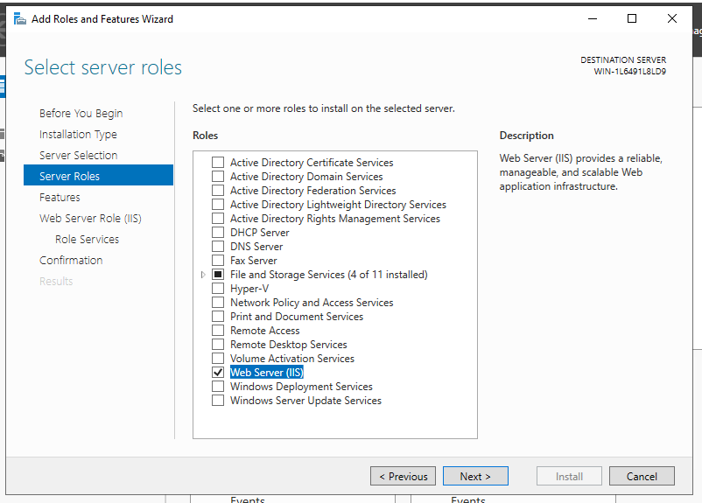
Step 10: On the ‘Features’ screen, clicked next.
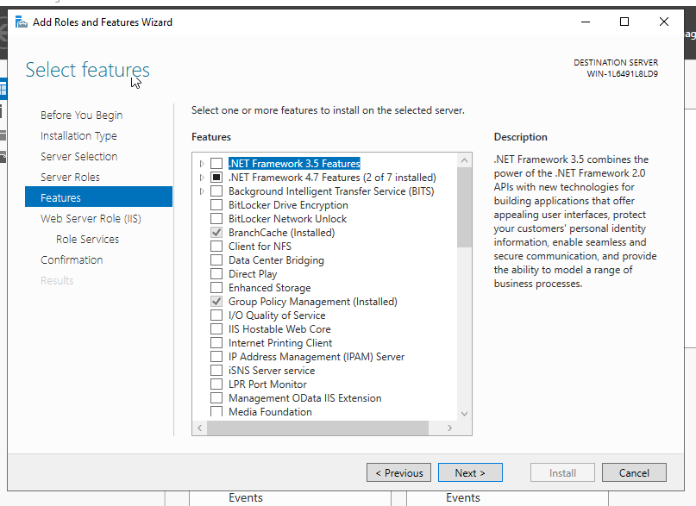
Step 11: Clicked next on the ‘Web server role (IIS)’ screen.
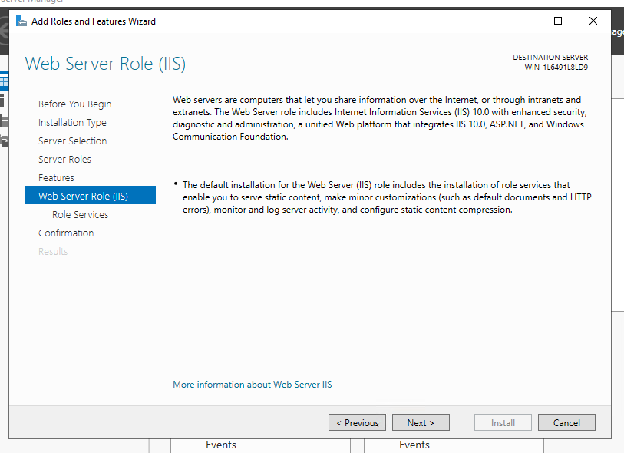

Step 12: On the ‘Role services’ screen, check the FTP server and FTP services checkboxes. Clicked on next
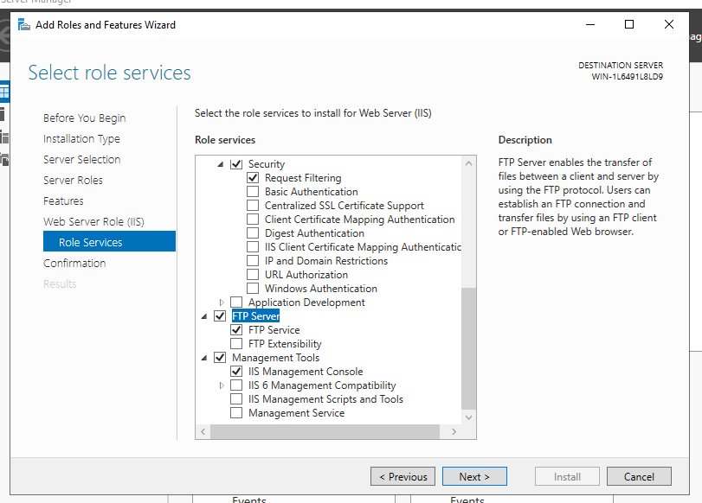

Step 13: On the ‘Confirmation’ screen, clicked on install.
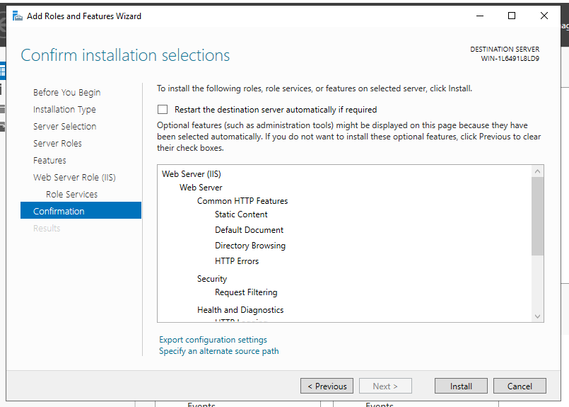

Step14: Once installation had completed, clicked on close.
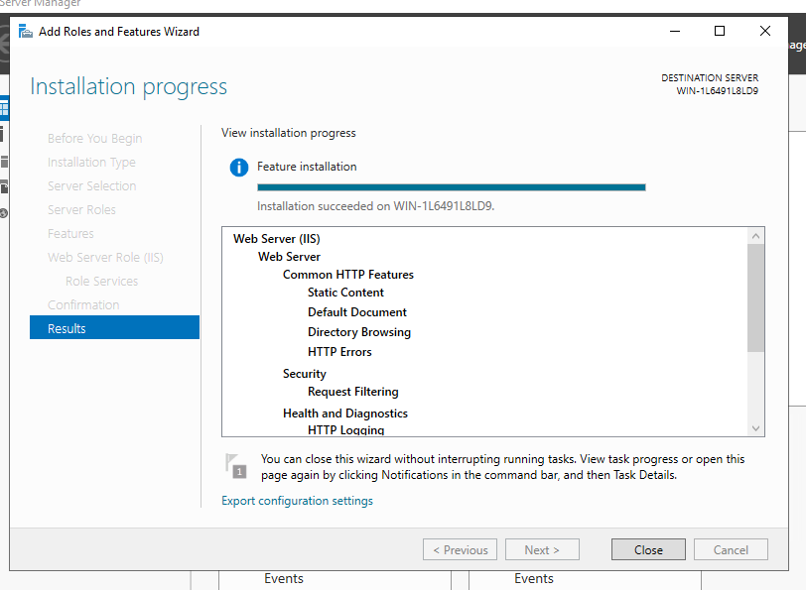
Step 15: In ‘Server manager’, clicked ‘Tools’ and ‘Computer manager’.

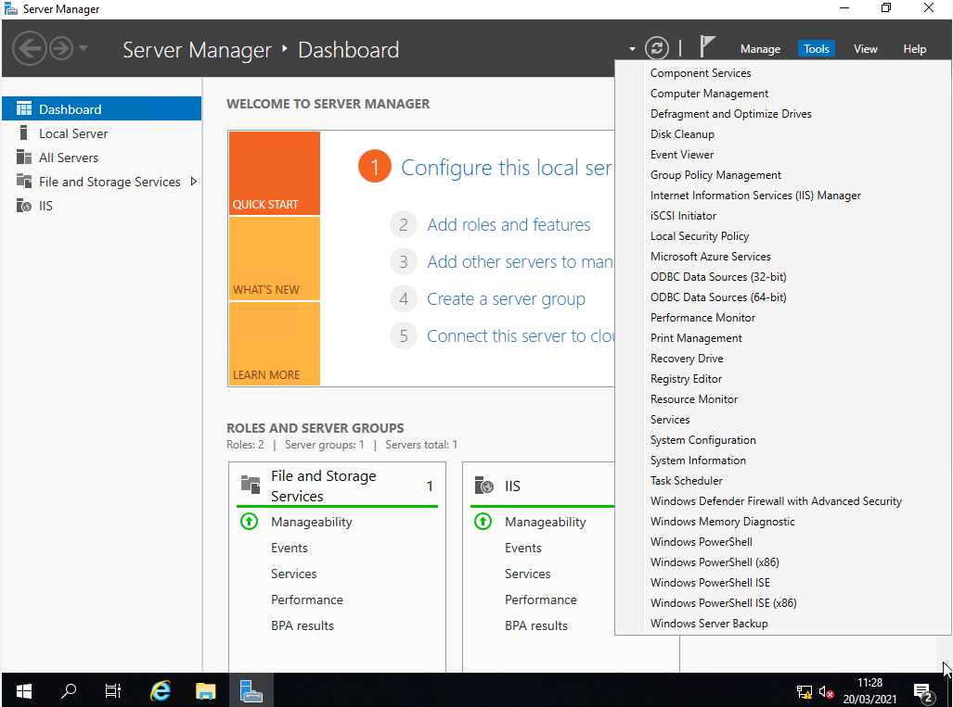

Step 16: In ‘Computer management’, expanded local user and computers.
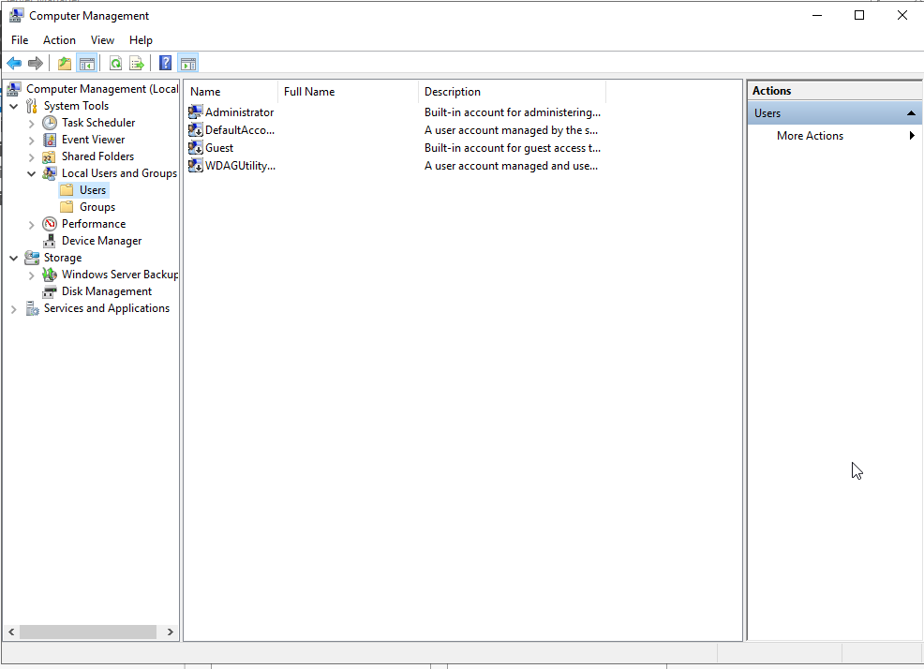
Step 17: Right click on ‘Users’ and selected ‘New user’.

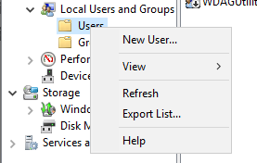

Step 18: In the ‘New User’ wizard, in username entered ftpuser and in password P@ssw0rd. Unchecked ‘User must change password at next logon’. Clicked on the create button to create user account.

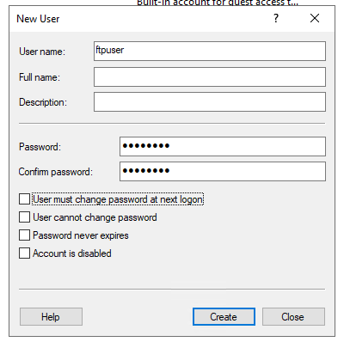

Step 19: Confirmed that ftpuser was stored local users.
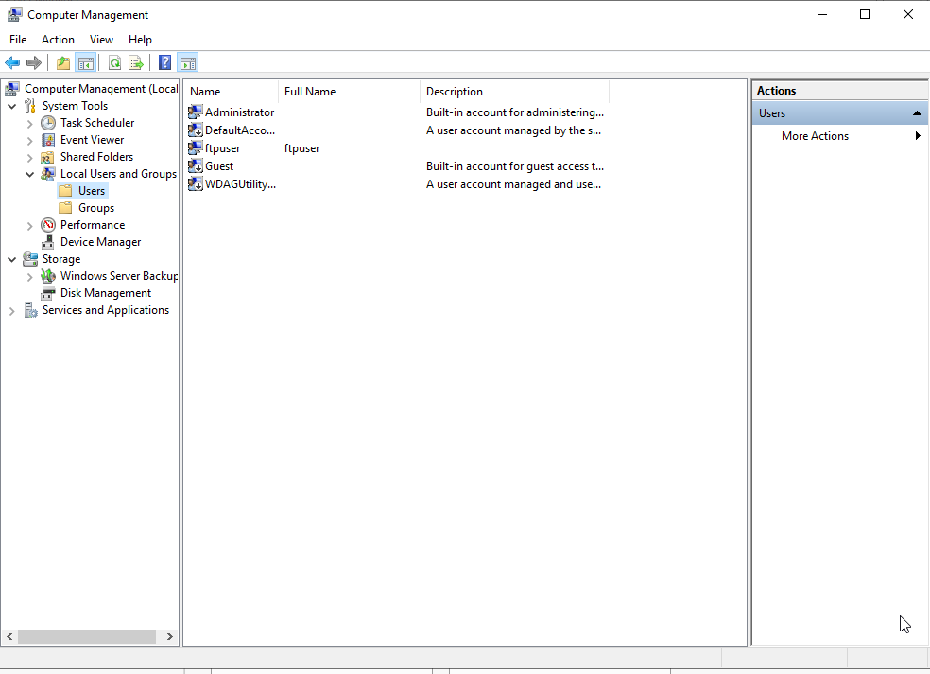

Step 20: Closed down computer management. Opened up ‘Server Manager’, clicked on ‘Tools’ and ‘Internet Information Services (IIS) Manager’.
Step 21: In ‘IIS’, expanded the name of server 2 (WIN-1L6491L8LD9), right click on site and selected ‘Add FTP site’.

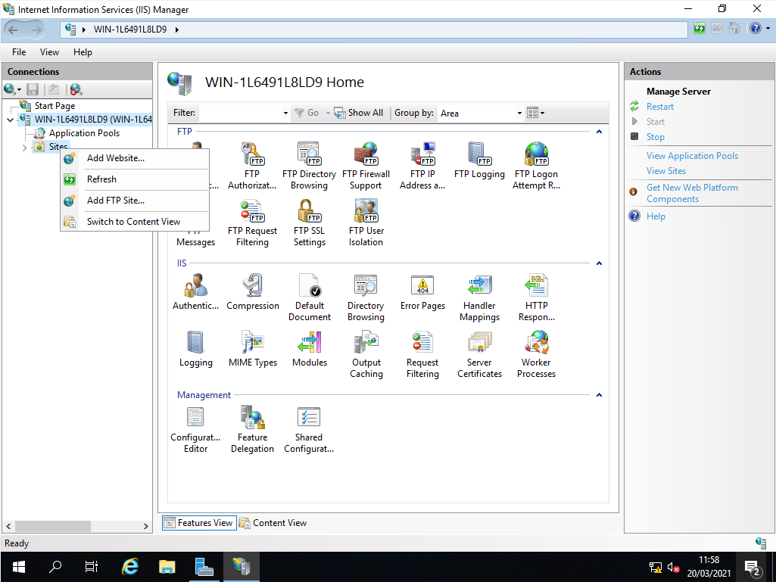

Step 22: On the ‘Site information’ screen, named the FTP site 1STFTPSITE. Click the ‘Browse’ button next to the physical path textbox.

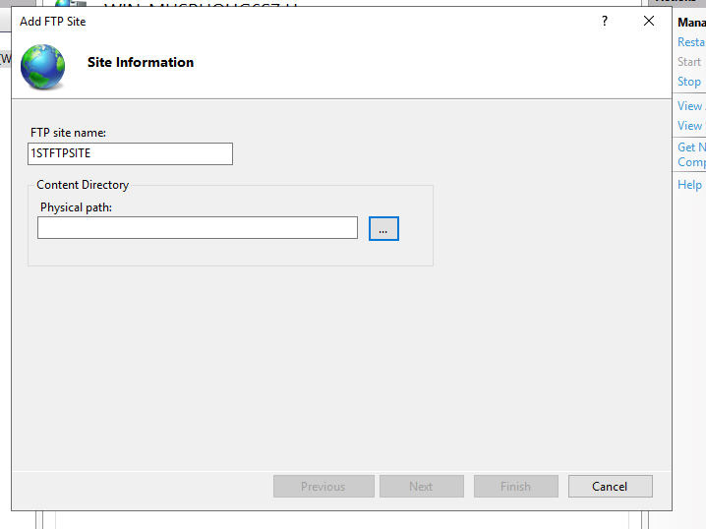

Step 23: The ‘Browse for Folder’ screen pop up, browse to local disk (C), inetpub and ftproot. Clicked ok.

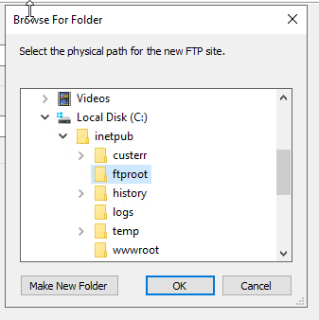

Step 24: When returned to the ‘Site information’ screen, clicked on next.
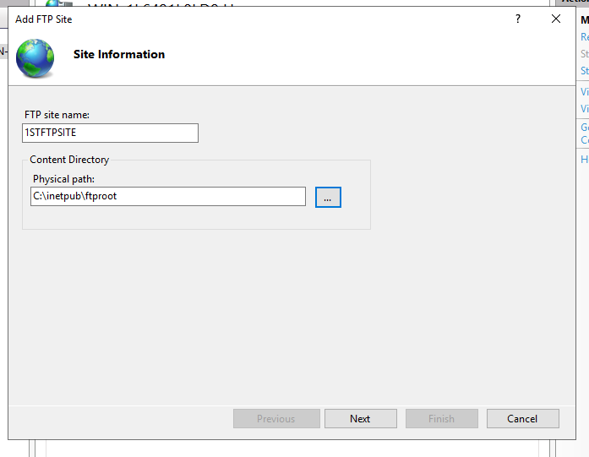

Step 25: On the ‘Binding and SSL Settings’ screen, selected no SSL and clicked next.
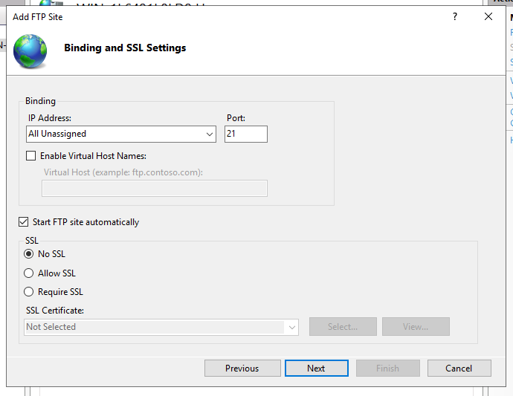

Step 26: On the ‘Authentication and Authorization Information’ screen, selected ‘Basic’ authentication. Specified the ftp user and granted them read and write permissions. Clicked finish.
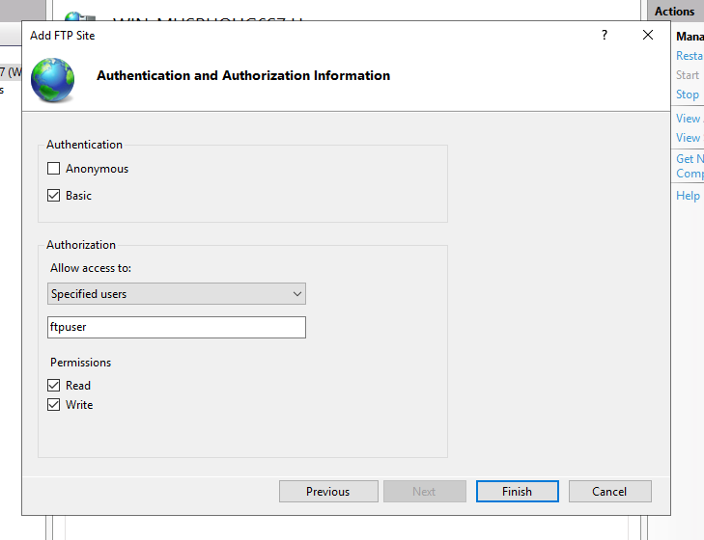

Step 27: In ‘IIS’, clicked on 1STFTPSITE and double click on ‘FTP Messages’.
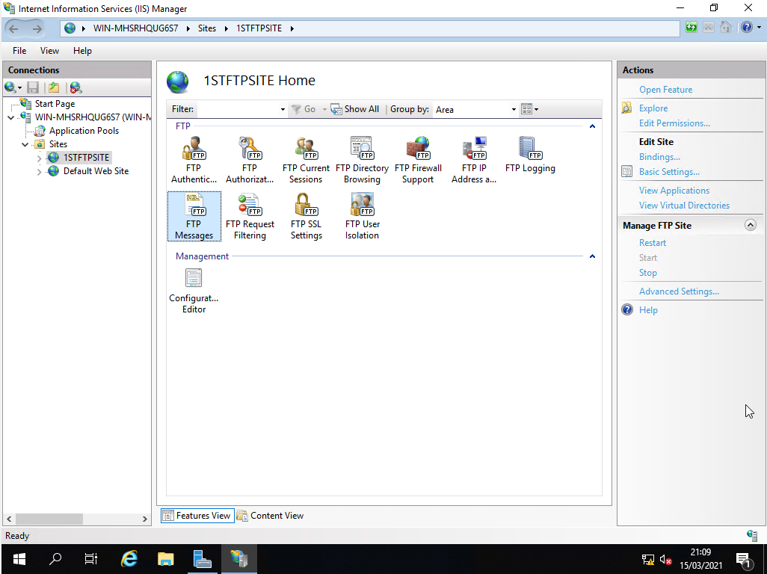

Step 28: In the ‘Banner’, typed ‘Welcome to PAUL’s FTPSSERVER’. Clicked on ‘Apply’ to save changes.
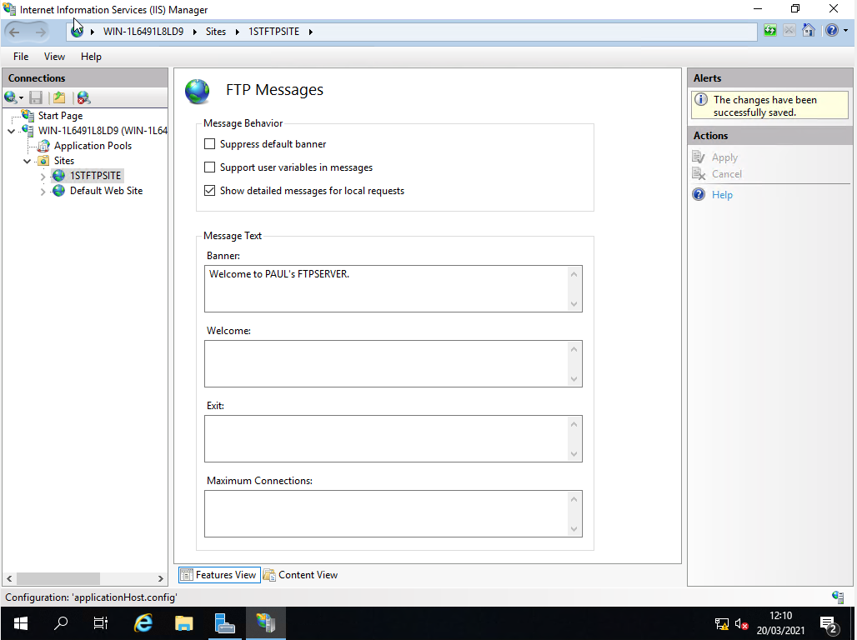
Step 29: Closed ‘IIS’ and opened ‘File explorer’. Navigated to local disk (C), inetpub and ftproot. Right clicked on ftproot, and selected ‘Properties’. Clicked on the ‘Security tab’ and ‘Edit’ button.
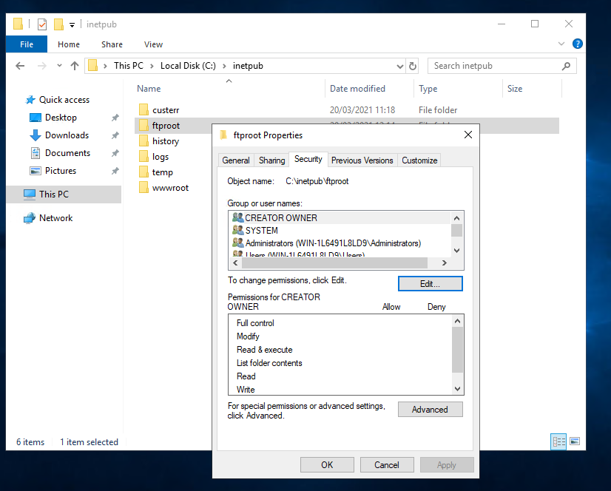

Step 30: In the ‘Permissions’ screen, clicked on the ‘Add’ button.
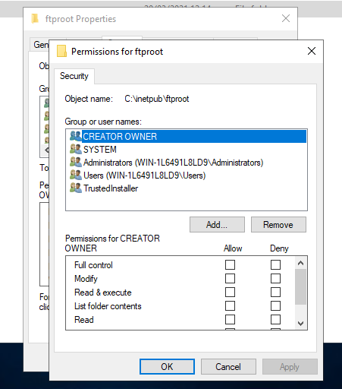
Step 31: In the ‘Select user or groups’ screen, entered ftpuser. Clicked on ‘Check names’ and ok.
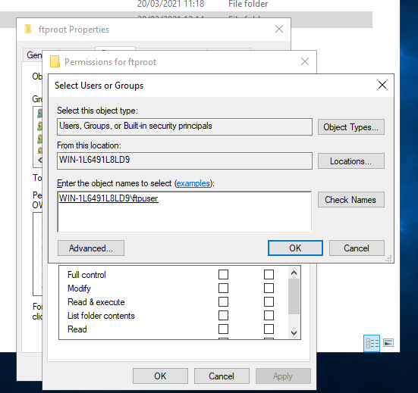

Step 32: In the ‘Permissions’ screen, accepted the default permissions granted to the ftpuser. Clicked on apply and ok to complete changes. Clicked ok to exit ftproot properties.
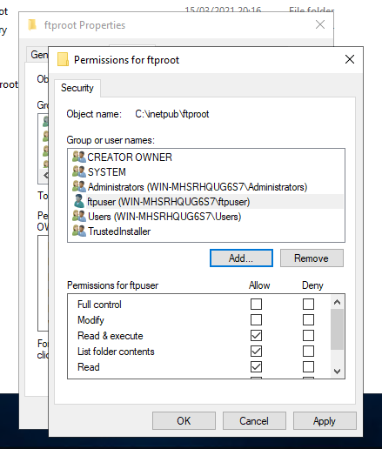
Step 33: In ‘File explorer’, opened up ftproot and right click on the blank empty space, selected ‘New’ and ‘Folder’.
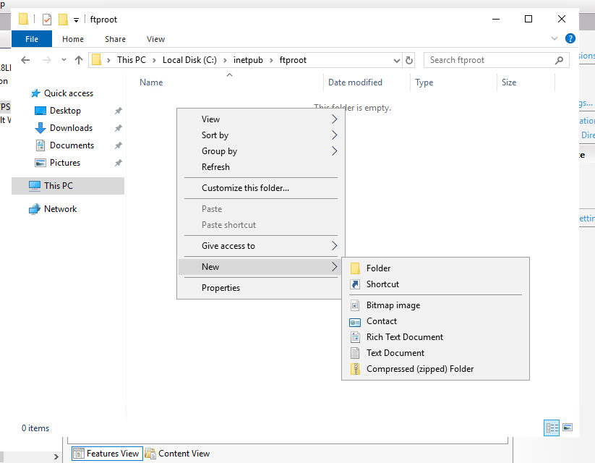

Step 34: Right clicked on the new folder and selected ‘Rename’. Called the folder FtpUploads.
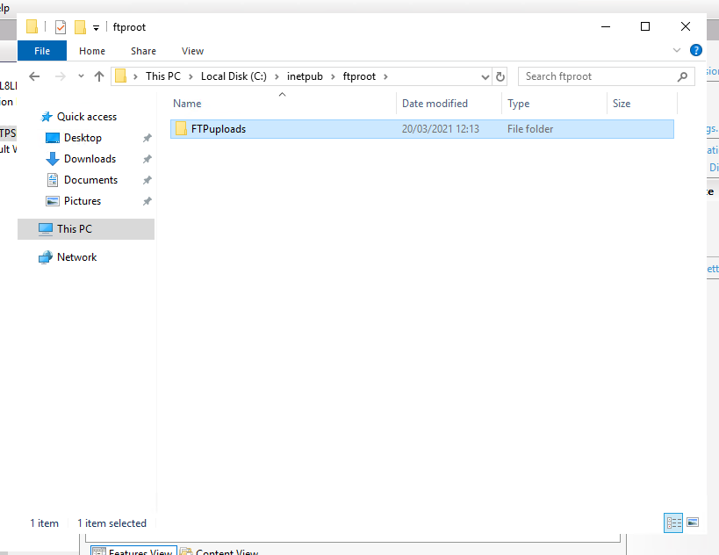

Step 35: Opened up the ‘Windows firewall’ on server 2. Checked that the firewall was turned off.
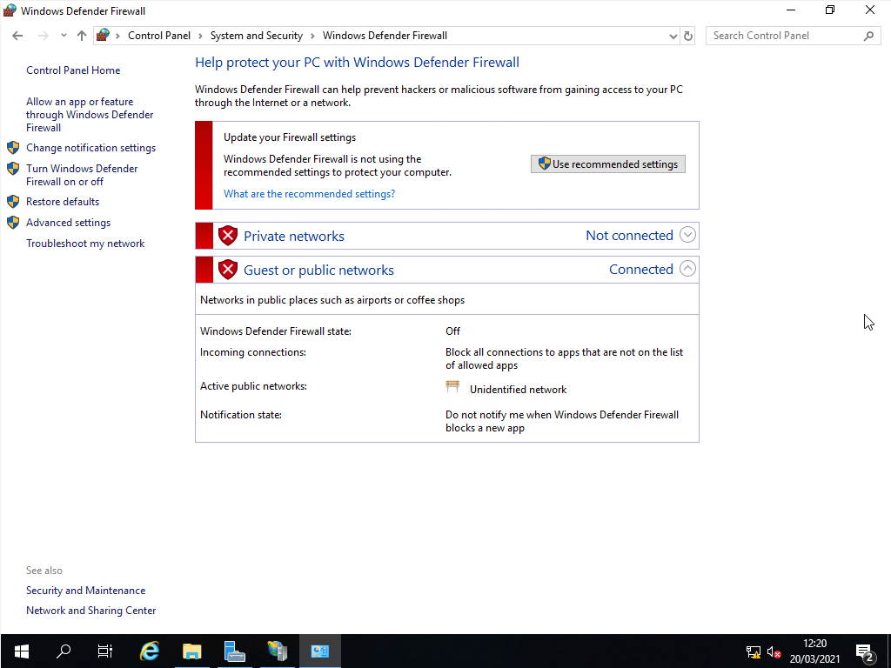
Step 36: Logged into Client 1 as administrator.
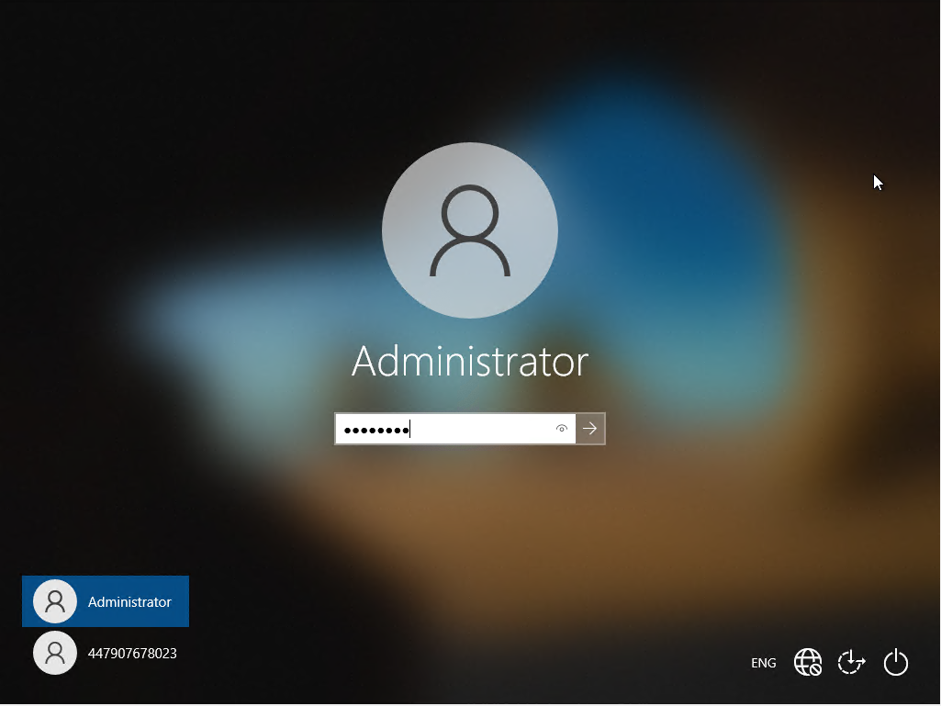
Step 37: Opened up ‘File explorer’.
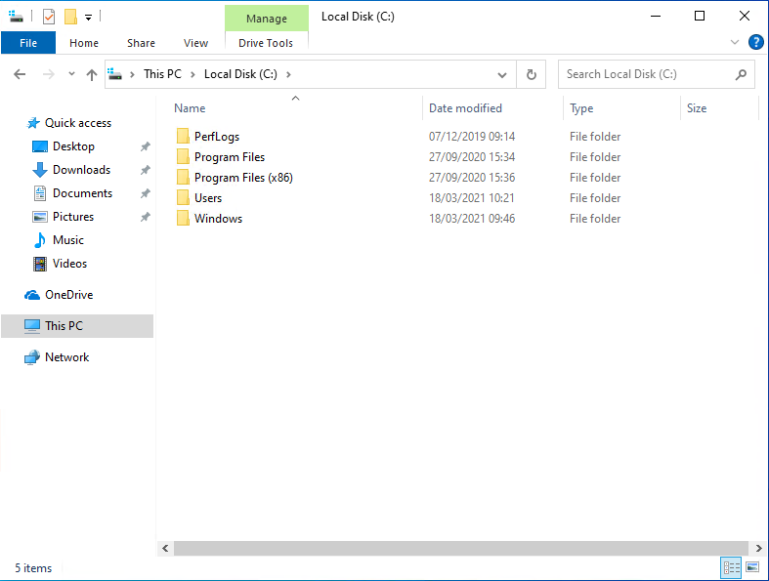

Step38: Right click on blank white space, selected ‘New’ and ‘Folder’.
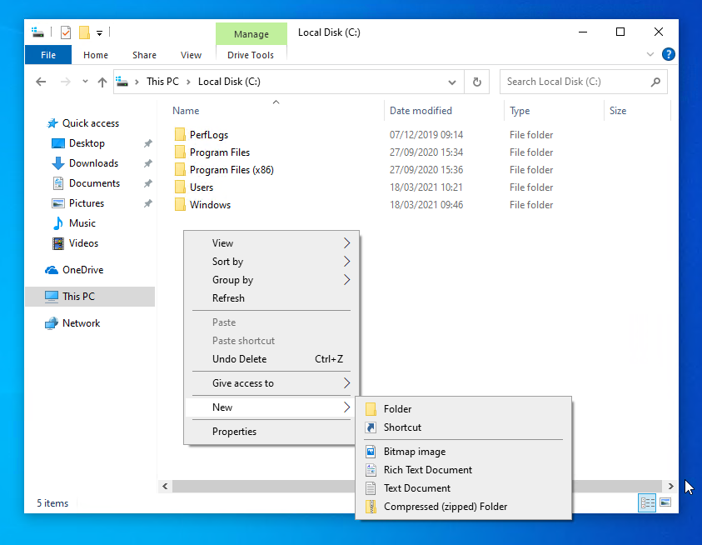

Step 39:Right clicked on the folder and selected ‘Rename’, called the folder FTPFiles.
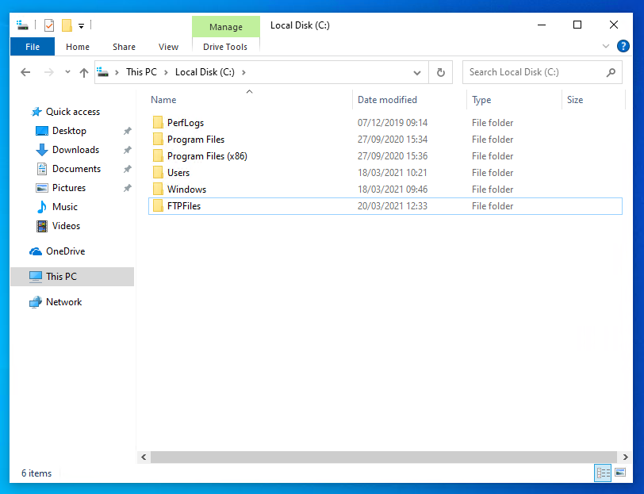
Step 40: Opened up FTPFiles. Right click on blank empty space, selected ‘New’ and select ‘Text Document’.
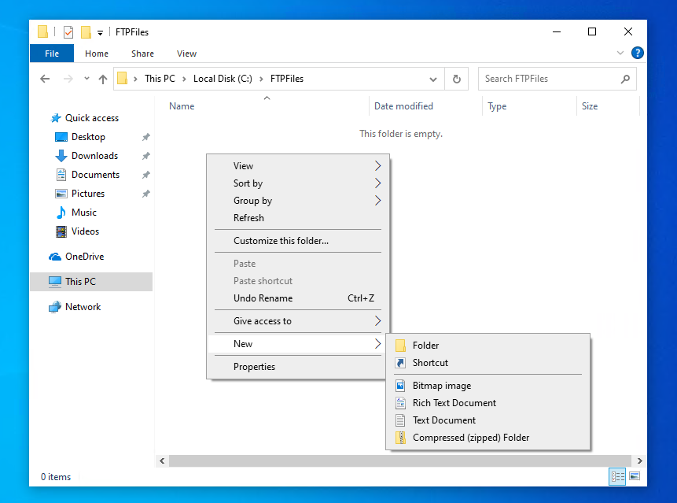
Step 41: Right clicked on the text document and selected ‘Rename’. Named the file ftpfile2upload.
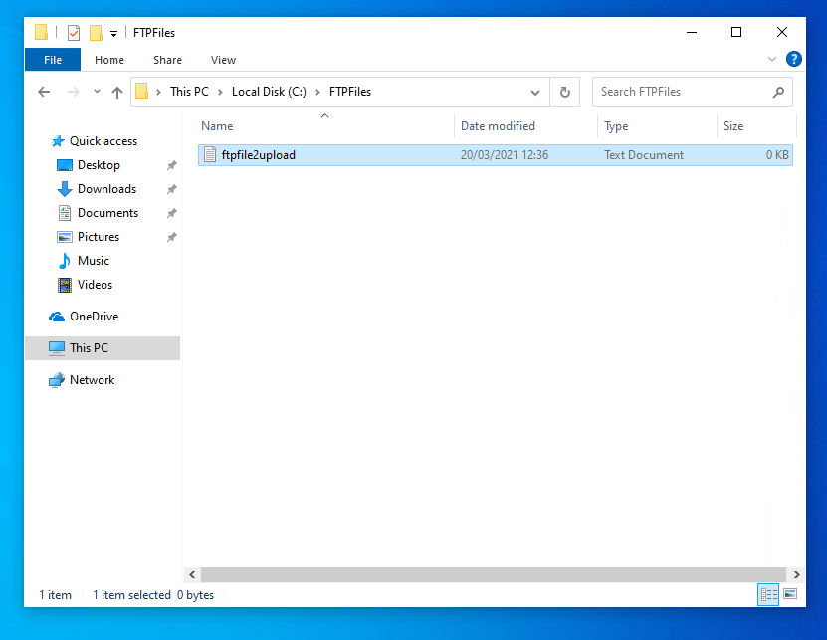

Step 42: Closed ‘File explorer’ and opened a command prompt. Ftp to server 2 (192.168.101.1). Entered the user credentials for ftpuser. Navigated to the directory where ftpfile2upload was stored on client2. Then tried uploaded the file to server 2, using the put command, but it failed, stating access denied.
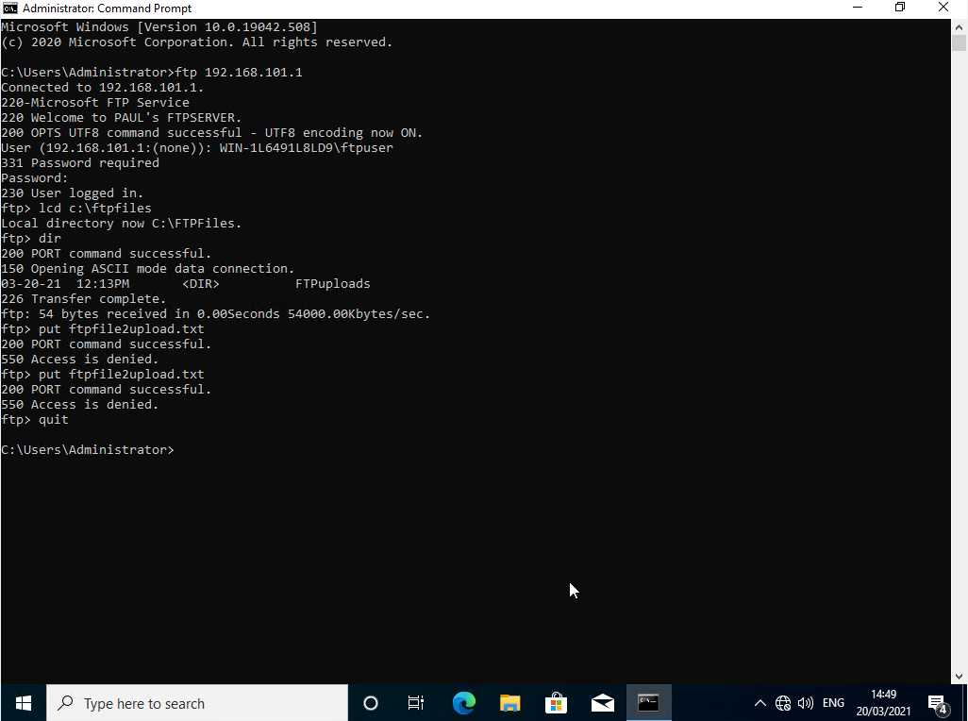

Step 43: Logged back into Serve2. Went into the properties and security tab of ftproot. Clicked on edit and granted the ftp user full control. Clicked on apply and ok. Click ok to exit the properties of ftproot.
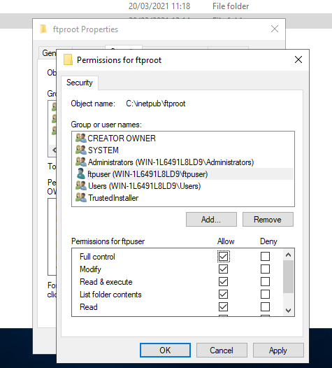
Step 44: Tried uploading the ftpfile2upload to server2 from client 2. File transferred successfully.
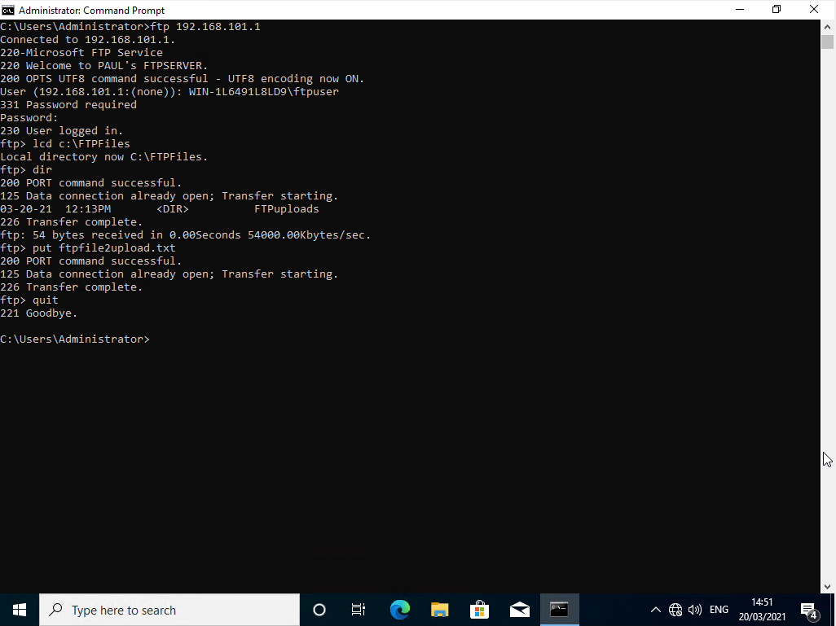
Step 45: Opened up file explorer on Server 2 and navigated to the ftproot folder, could see that the ftpfile2upload file had uploaded successfully.

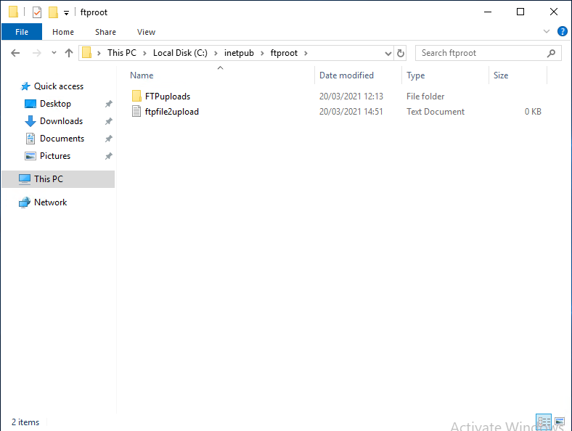

Task 3a: Installing and configuring the Routing and Remote Access Services

Server 1

Step 1: Opened up Server Manager on Server 1. Clicked on add roles and features.
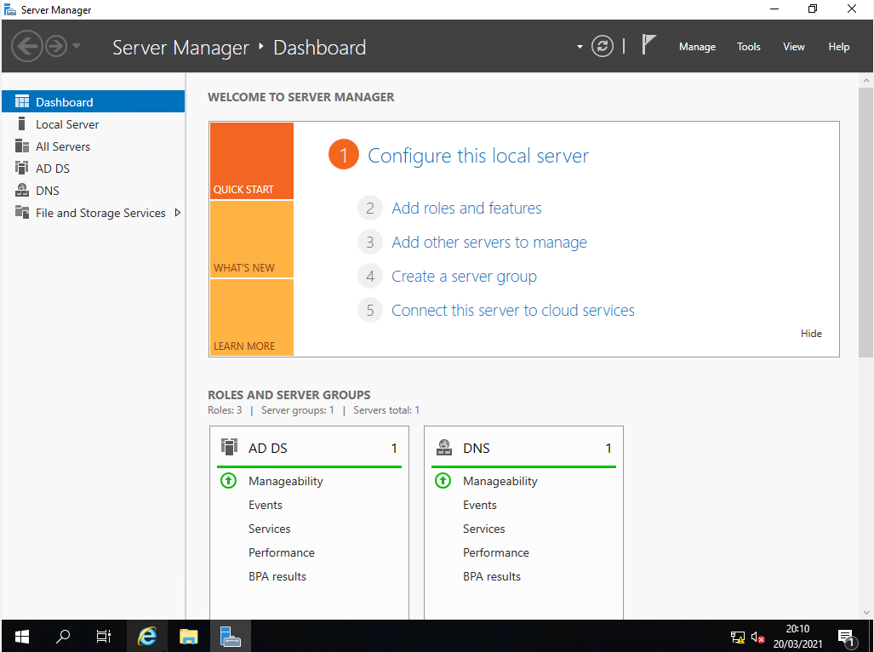

Step 2: On the initial screen of the Add Roles and Features Wizard screen, clicked on Next.
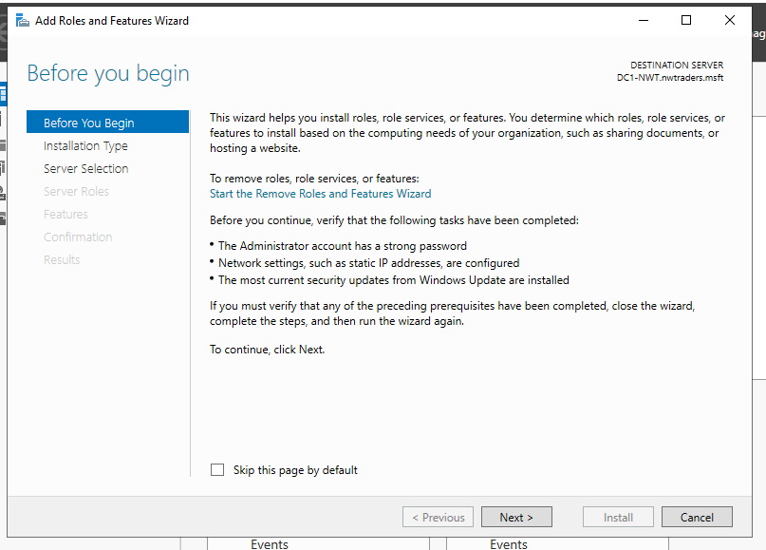
Step 3: In installation type screen, accept the default option, role-based or feature based installation. Clicked on next.
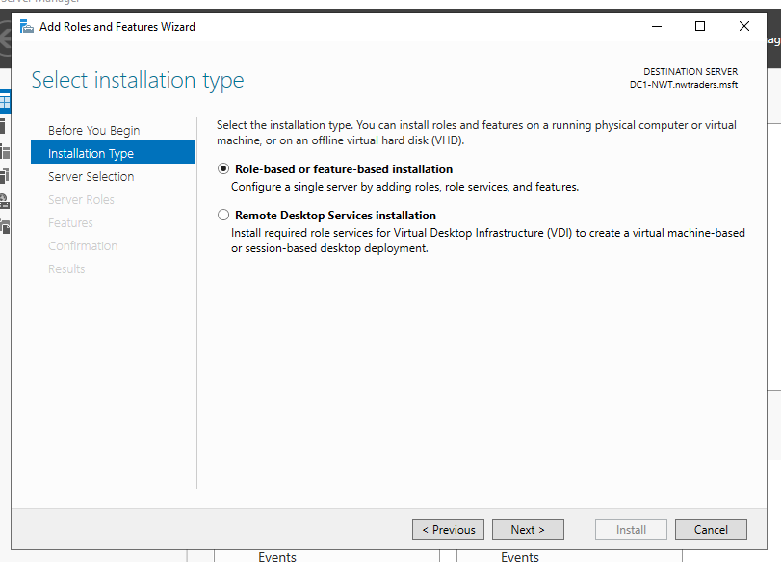

Step 4: Accepted the default entry on the server selection screen, which was the name of server 1 (DC1-NWT). Clicked next.
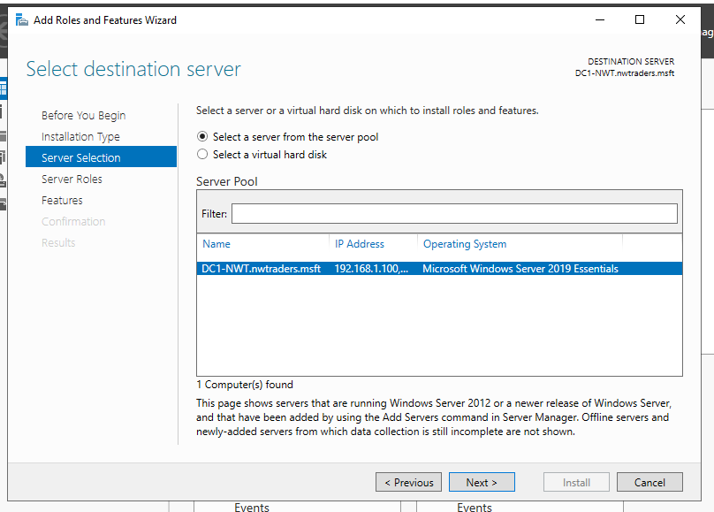
Step 5: In the server roles screen, checked the remote access checkbox and clicked next.
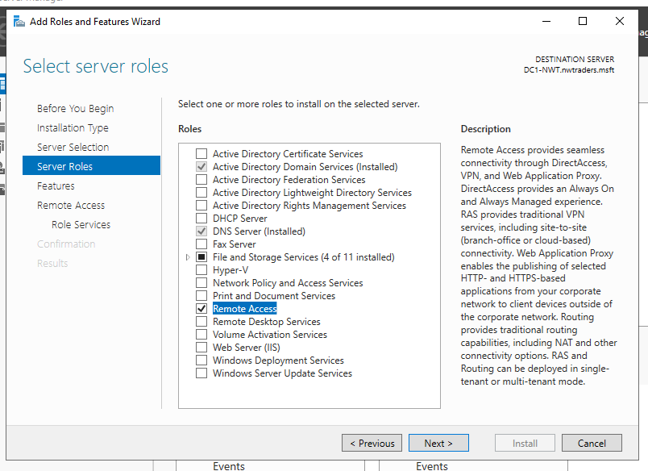

Step 6: In the features screen, clicked on next.
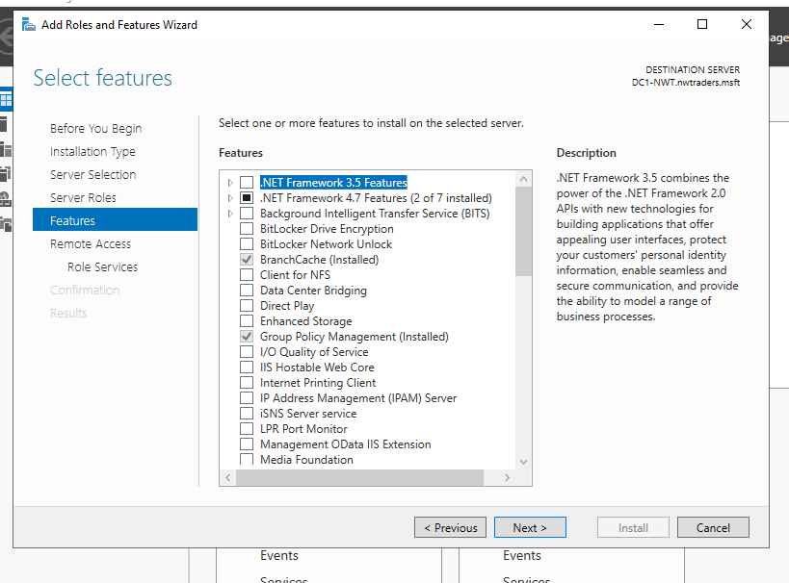
Step 7: In the remote access screen, clicked on next.
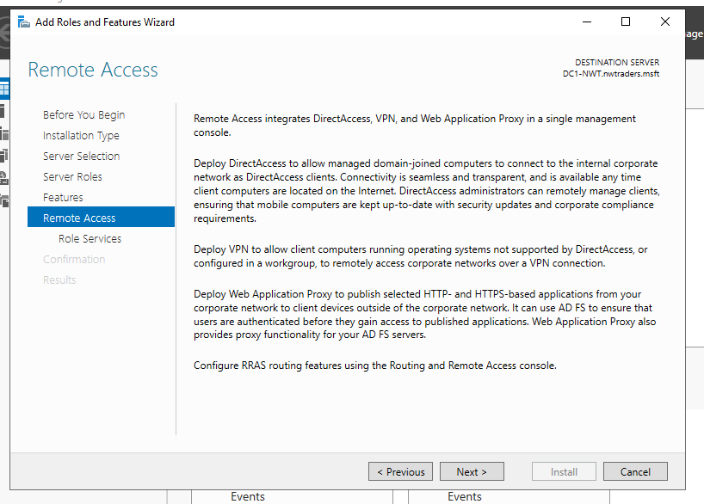

Step 8: A message popped up to ‘Add features that are required for Direct Access and VPN (RAS)?’Clicked on Add feature. Clicked Next when returned to remote access screen.
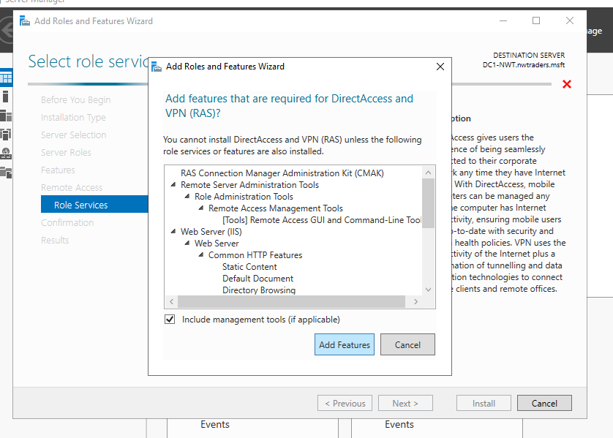

Step 9: On the role services screen. Selected DirectAccss and VPN. Clicked next.
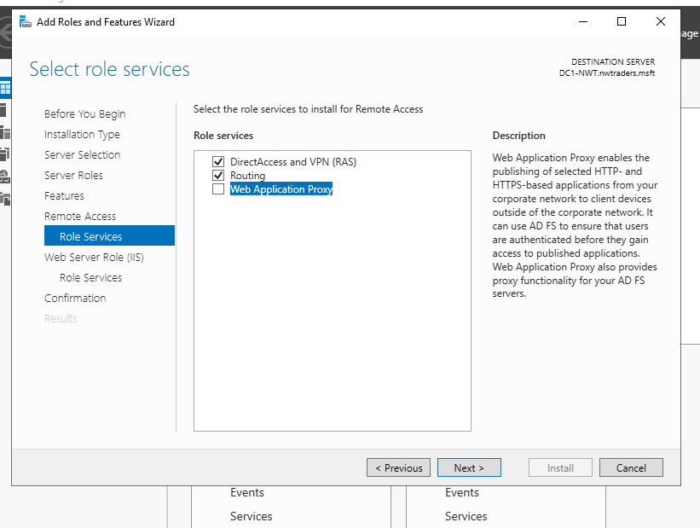

Step 10: Clicked next on the web server role screen.
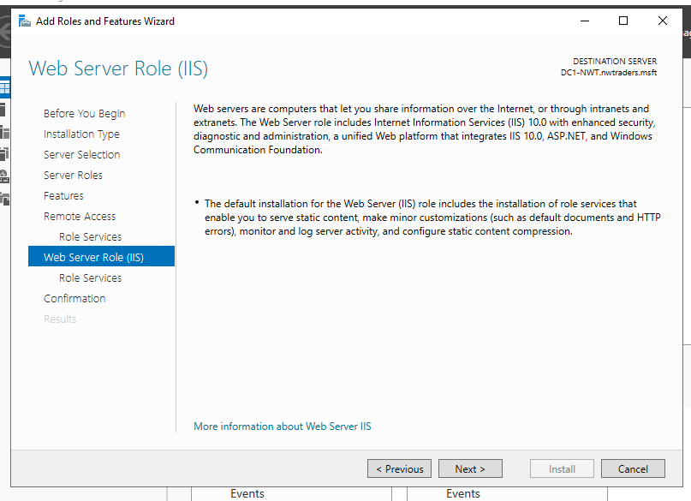

Step 11: Clicked next on the role services screen.
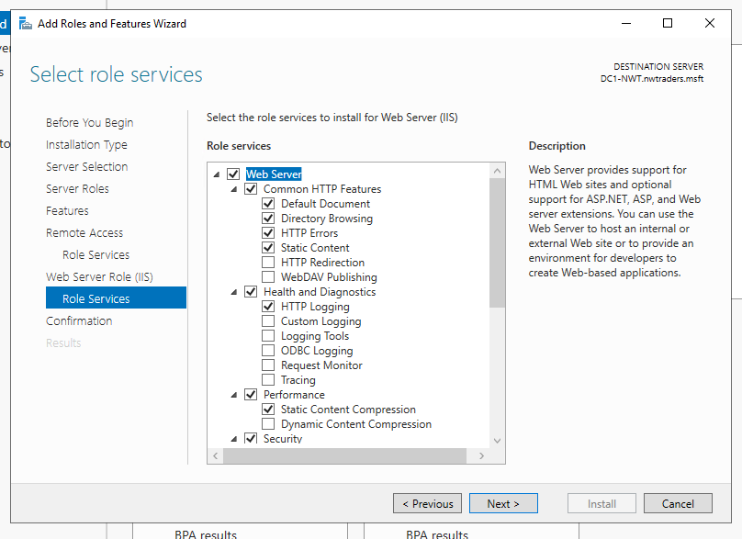

Step 12: Clicked install the confirmation screen.
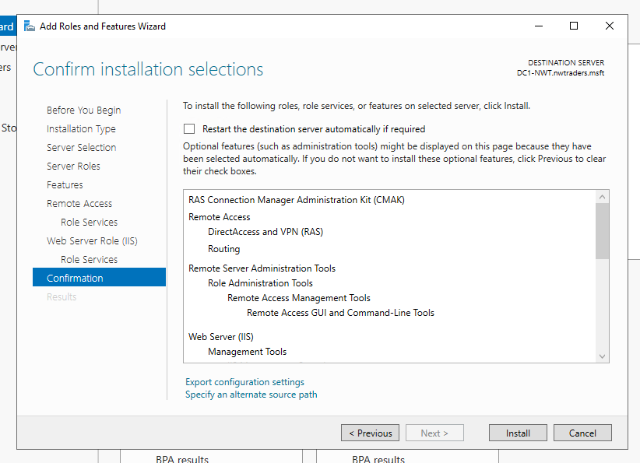
Step 13: Once installation had completed, clicked on ‘open the getting stared wizard’
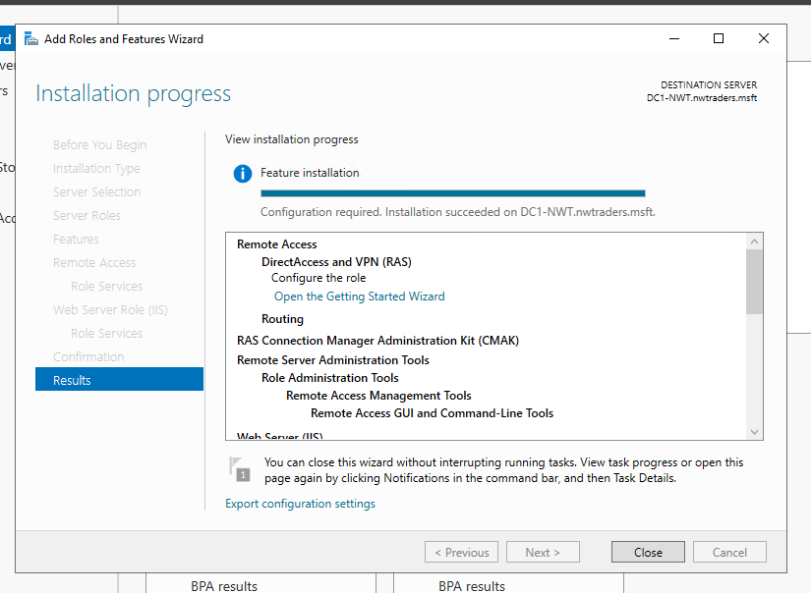

Step 14: On the configure Remote access screen, selected Deploy VPN only.
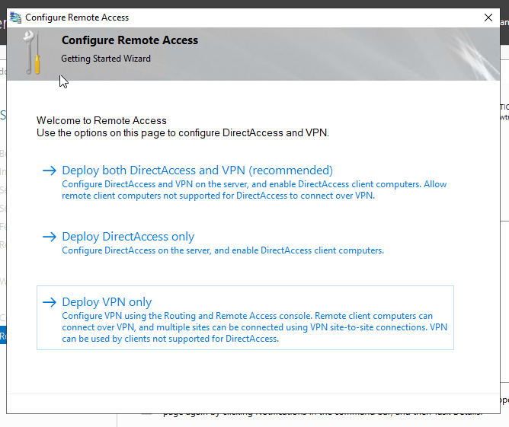
Step 15: In routing and remote access, right clicked on DC1-NWT and selected configure Routing and Remote access.
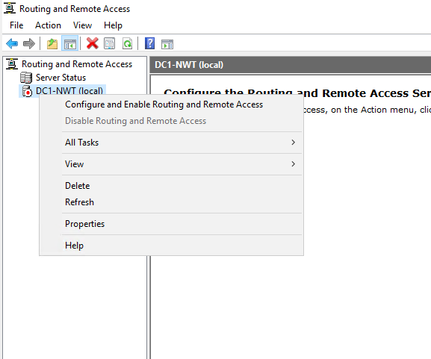

Step 16: On the initial routing and remote access server setup wizard screen, clicked on next.
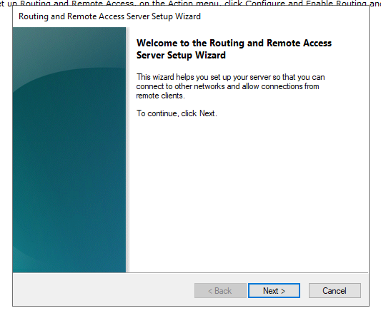
Step 17: On the configuration screen, selected custom configuration and clicked on next.
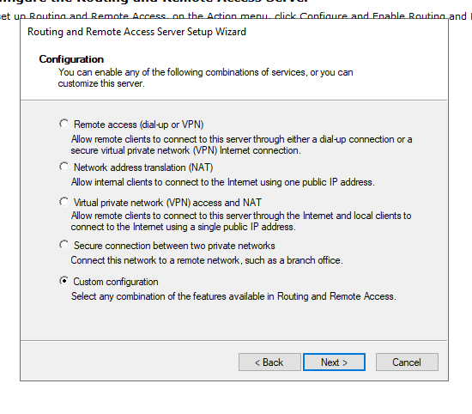
Step 18: On the custom configuration screen, selected LAN routing and clicked on next.
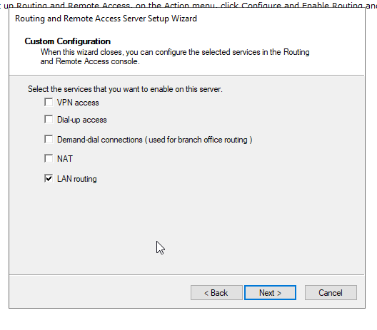

Step 19: Clicked finish on the final screen of the routing and remote access server setup wizard.

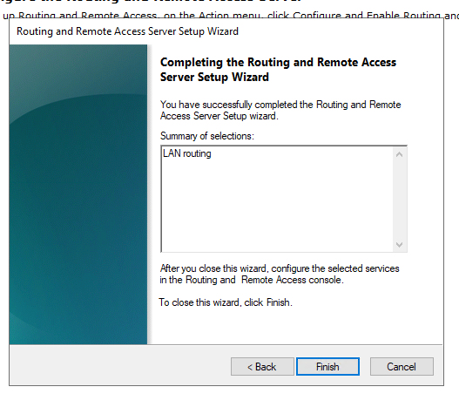
Step 20: A start the service message popped up. Clicked on the start the service button.
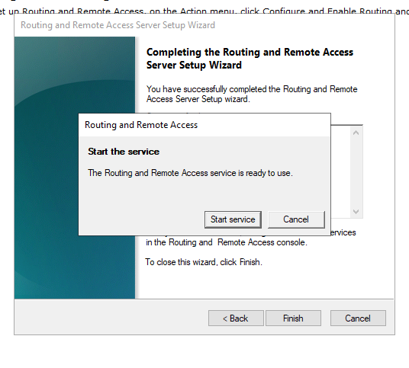
Step 21: Waiting for initialization to complete.
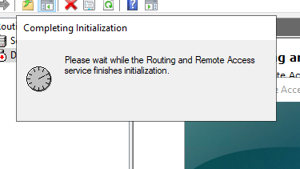

Step 22: In routing and remote acdcess expanded IPV4 and right clicked on general and selected new routing protrocol.

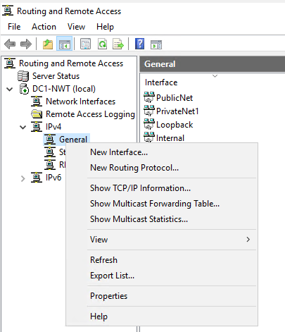

Step 23: In new routing protocol screen, selected RIP Version 2 for Internet Protocol and clicked ok
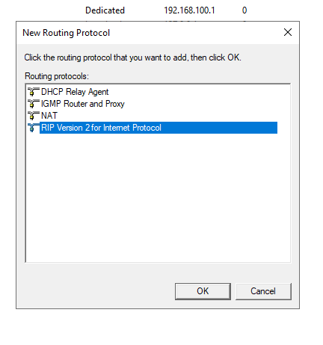

Step 24: In routing and remote access, right click on RIP and selected new interface.
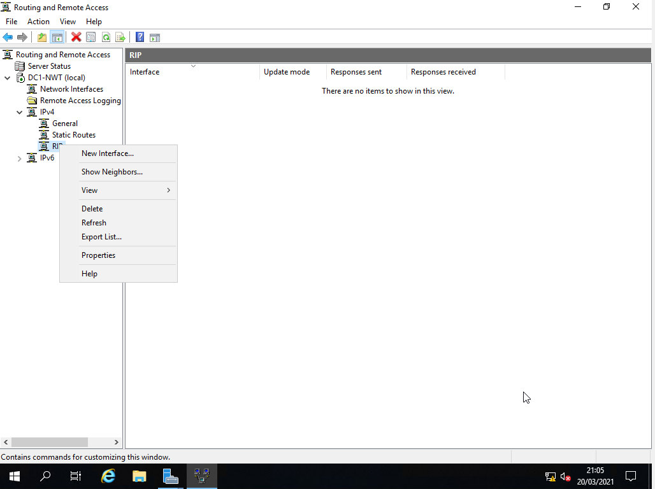

Step 25: On the new interface screen, selected PrivateNet1 and clicked ok.
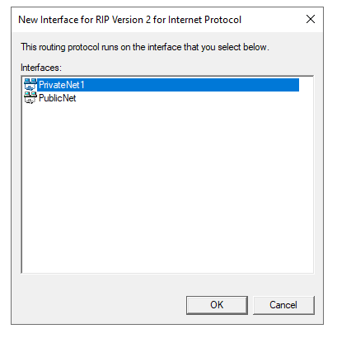

Step 26: Repeated the process for PublicNet. Right click on RIP and selected new interface and selected PublicNet and ok.
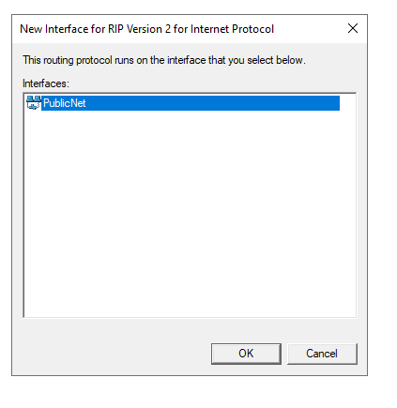
Step 27: After adding PublicNet, returned to Routing and Remote Access, where PublicNet and PrivateNet1 were displaying in RIP.

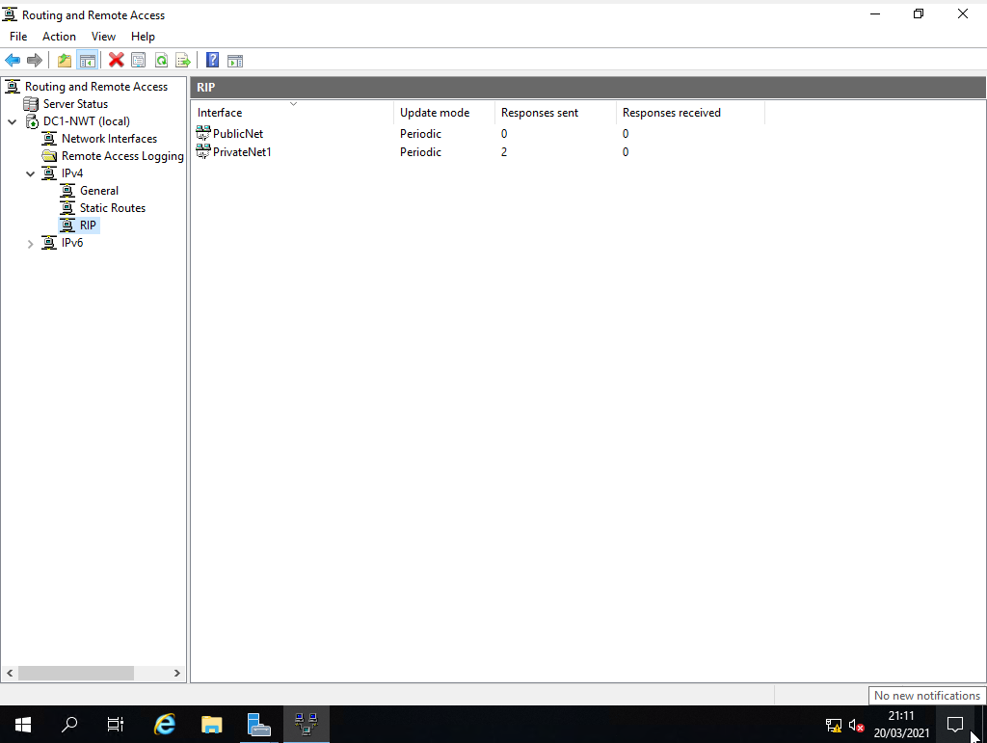

Server 2

Step1: Logged into Server 2 and launch server manager. In server manager click on add roles and features.
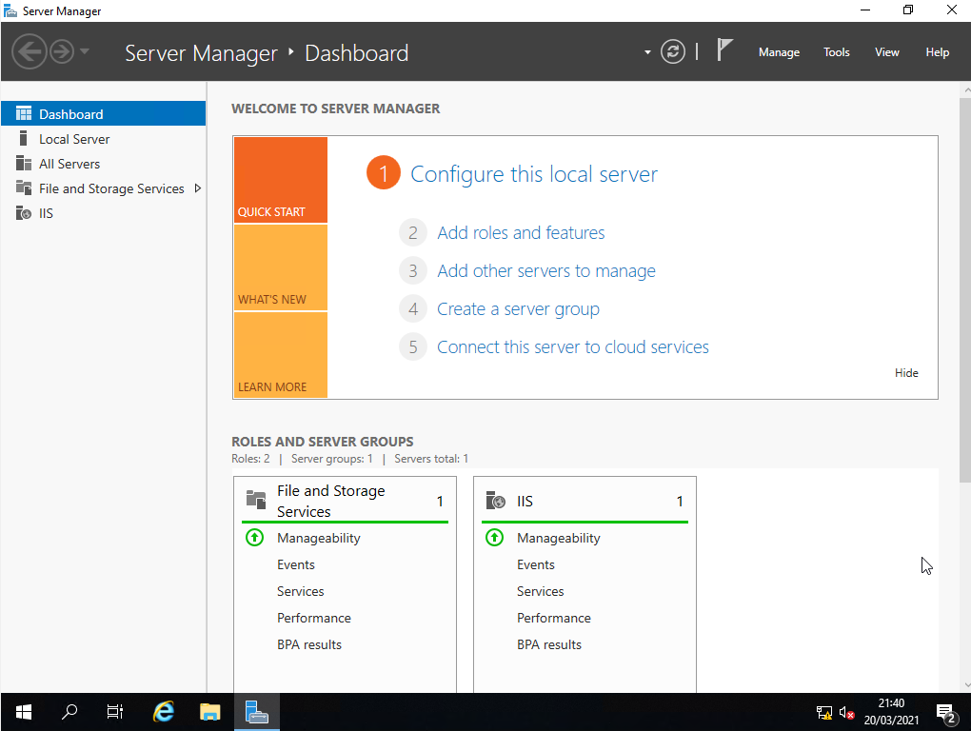
Step 2: On the initial screen of the Add Roles and Features Wizard screen, clicked on Next.
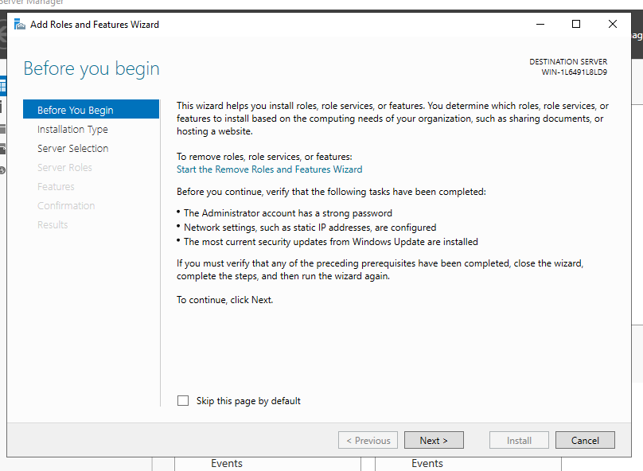

Step 3: In installation type screen, accept the default option, role-based or feature based installation. Clicked on next.

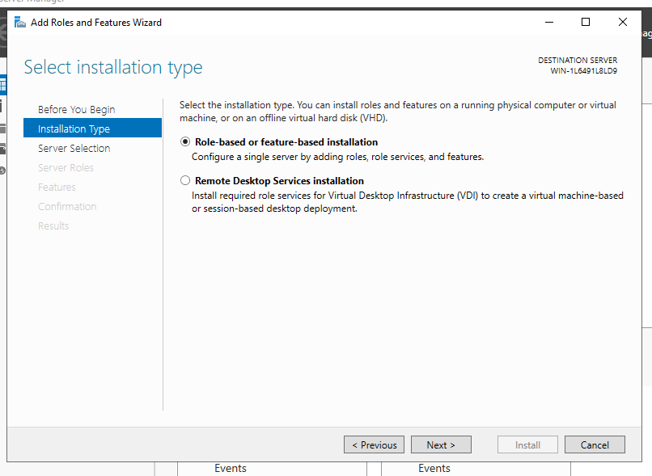
Step 4: Accepted the default entry on the server selection screen, which was the name of server 2, WIN-1L6491L8LD9. Clicked next.
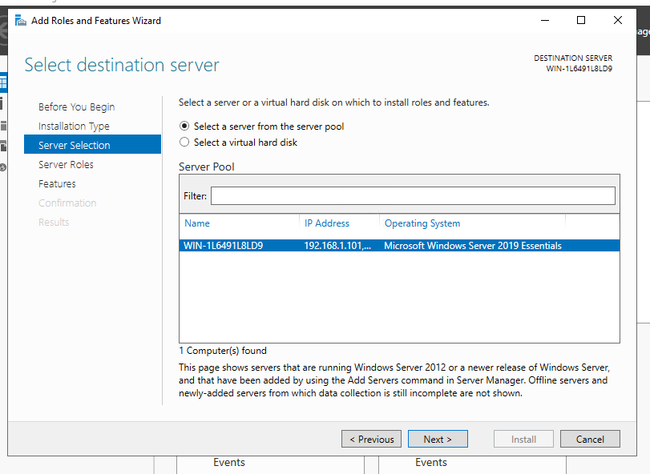
Step 5: In the Server Roles screen, checked the remote access checkbox and clicked on next.
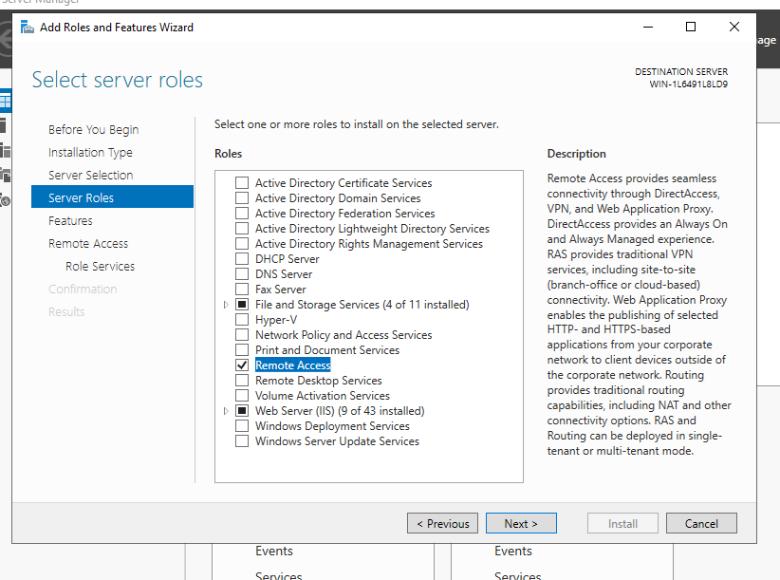

Step 6: In the features screen, clicked on next.
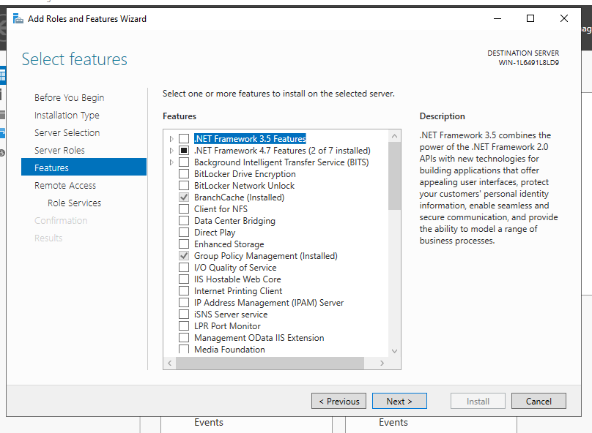
Step 7: In the Remote Access, screen clicked on next.
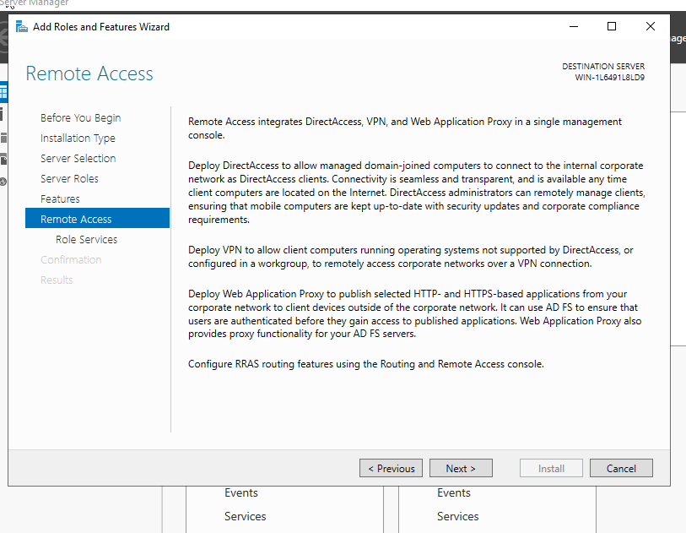
Step 8: A message popped up to ‘Add features that are required for Direct Access and VPN (RAS)?’Clicked on Add feature. Clicked next when returned to remote access screen.
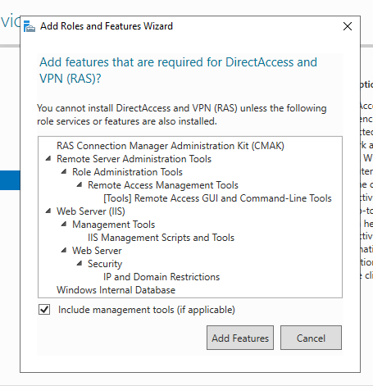

Step 9: On the role services screen., selected DirectAccss and VPN. Clicked next.
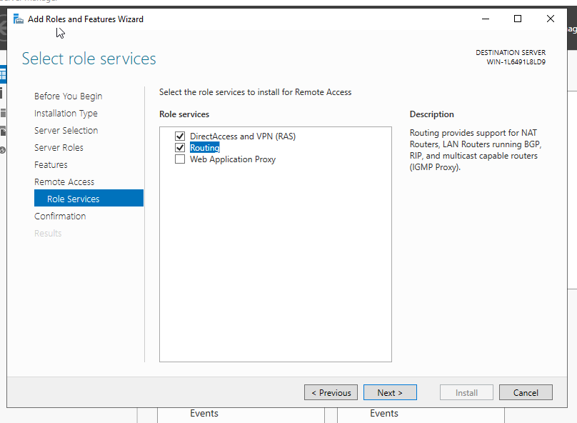

Step 10: Clicked install on the confirmation screen.
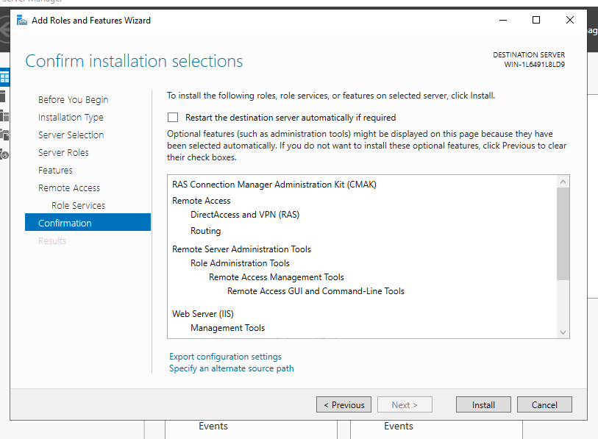
Step 11: Once the installation had completed, clicked on ‘open the getting stared wizard’.
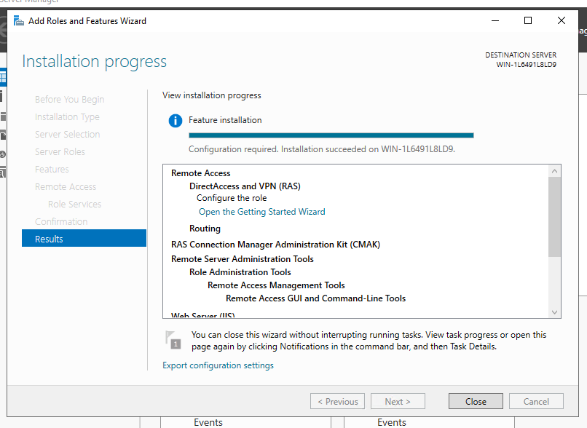

Step 12: On the configure Remote Access screen, selected VPN only.
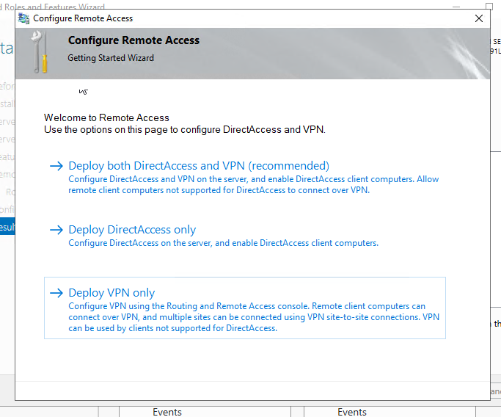
Step 13: In routing and remote access, right clicked on DC1-NWT and selected Configure Routing and Remote access.
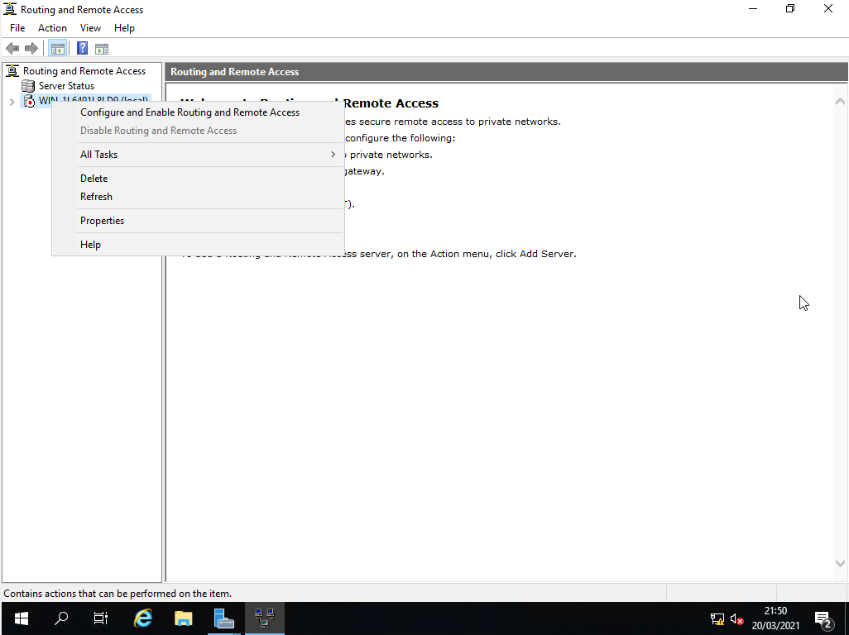

Step 14: On the initial routing and remote access server setup wizard screen, clicked on next.
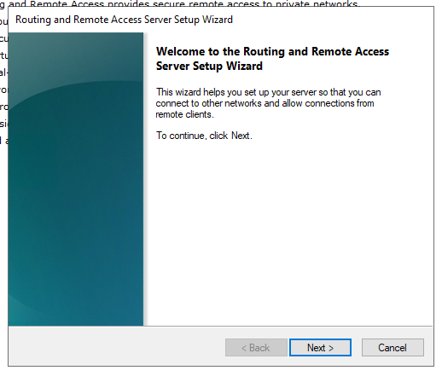
Step 15: On the configuration screen, selected Custom Configuration and clicked on next.
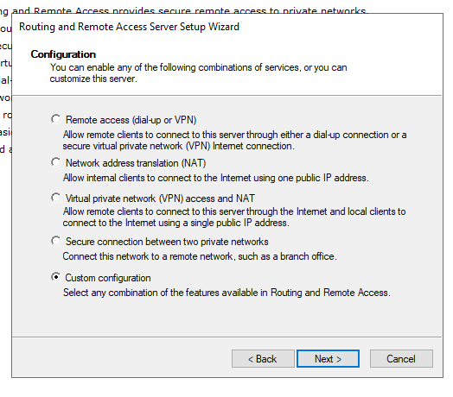

Step 16: On the custom configuration screen, selected LAN routing. Clicked on next.
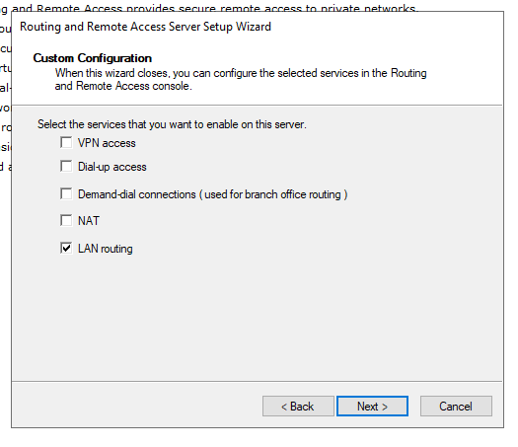

Step 17: Clicked finish on the final screen of the routing and remote access server setup wizard.
. 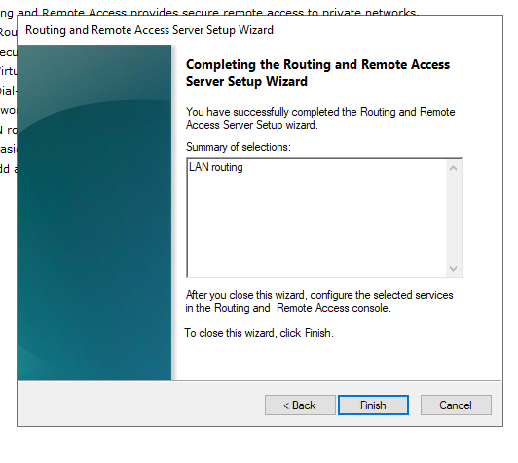
Step 18: A start the service message popped up. Clicked on the start the service button.
Step 19: Waiting for initialization to complete.

Step 20: In routing and remote access, expanded IPV4 and right clicked on general and selected new routing protrocol.
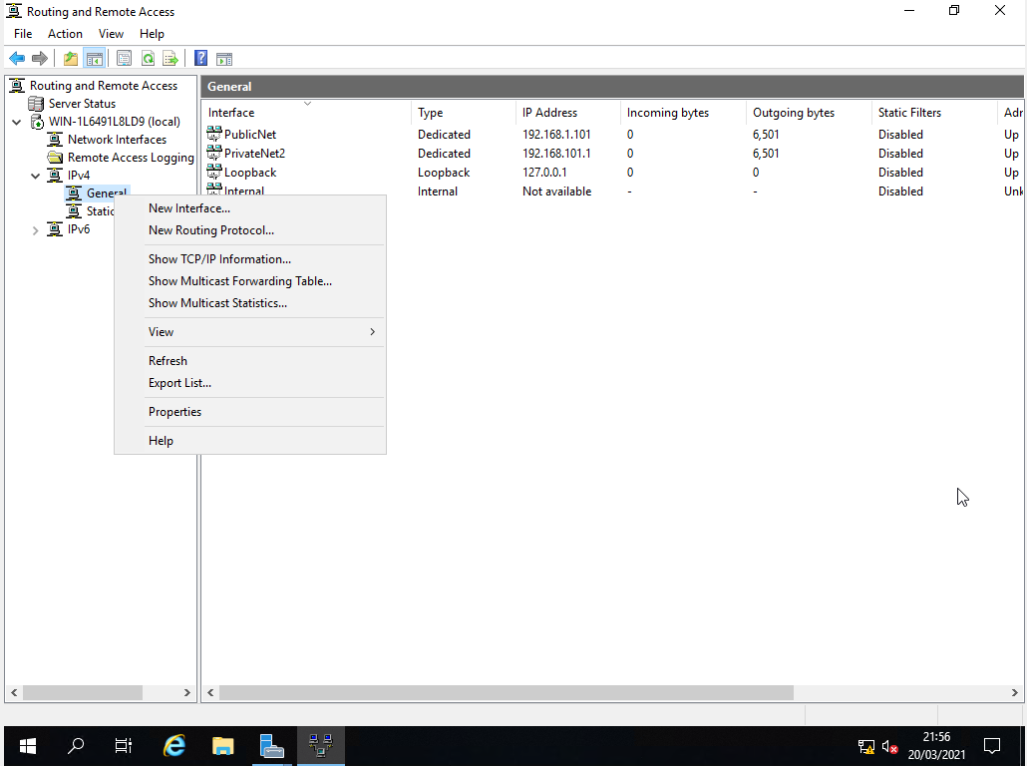

Step 21: In new routing protocol screen, selected RIP Version 2 for Internet Protocol and clicked ok
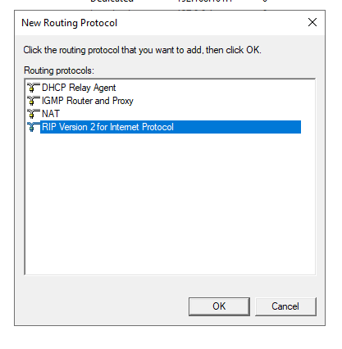
Step 22: In routing and remote access, right click on RIP and selected new interface.
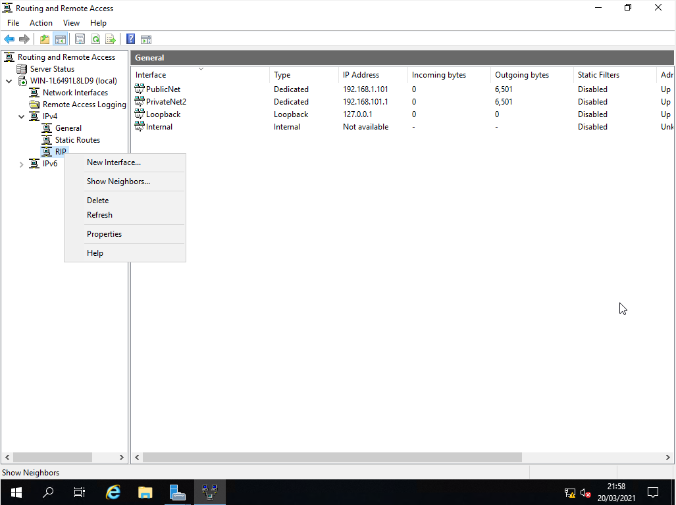

Step 23: On the new interface screen. Selected PrivateNet2 and clicked ok.
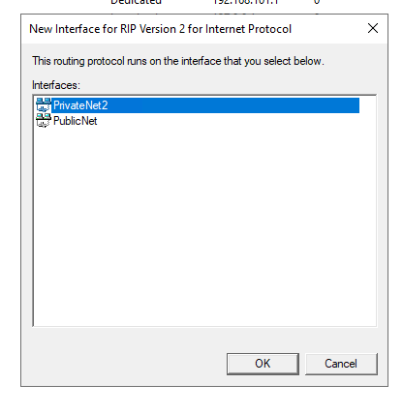
Step 24: Repeated the process for PublicNet. Right click on RIP and selected new interface and selected PublicNet and ok.
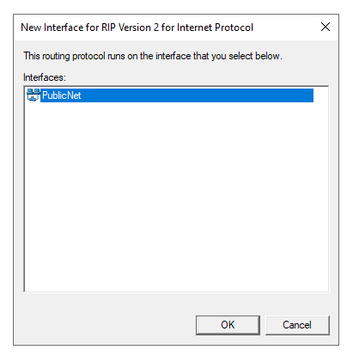

Step 25: After adding PublicNet, was returned to Routing and Remote Access, where PublicNet and PrivateNet2 were displaying in RIP.
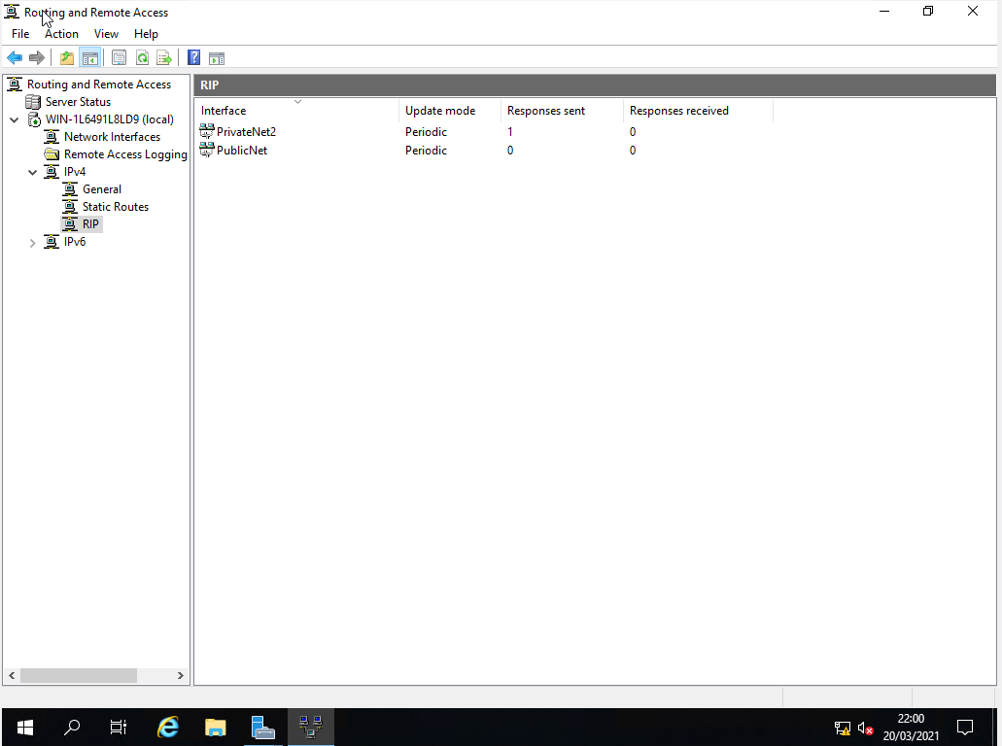

Task 3b: Routers

Routing Tables

According to Todd Lammle [1] The router learns about remote networks from neighbouring routers or from an administrator. The router then builds a routing table (a map of the internetwork) that tells them how to find these remote networks. If a network is already connected to a router, it is already aware of the network. If the network is not connected to a router, the router must learn about how to connect to the network. There are two ways in which a router can learn about a remote network;
- Static routing. This is where a network administrator adds the path to the remote network.

- Dynamic routing. This is where a protocol on one router communicates with a protocol on a neighbour router. The routers then update each about all the networks they know about.

The way in which a routing table is used to route network traffic is shown in the diagram and steps below.

PC 1 wishes to send packet to PC 2. The two PCs are on different subnets and they are separated by 3 routers. Let’s trace the path and see what happens. PC1 determines through the IP address of PC2 that it not on the same subnet. It sends the packet to the default gateway, which is router 1.

Router 1 has a IP address of 192.168.1.3. Router 1 will check the FCS(Frame Check Sequence) in the Ethernet frame to check for errors. It will strip of the layer 2 frame to check the IP address in the layer 3 packet. The router finds out the IP address of PC2 and compares the IP address to the IP routing table. Router 1 has one entry of subnet 192.168.2.0, an interface of s0, and a next hop of 10.10.2.1. The entry in the routing table matches the destination IP address.

Router 1 knows that it needs to send that data out to interface s0. The next-hop IP address matches the s0 interface of router 2.

Router 1 will encapsulate the packet with layer 2 encapsulation and sent it out through the serial interface.

Router 2 receives the packet. Router 2 will check the FCS(Frame Check Sequence) in the Ethernet frame to check for errors. It will strip the layer 2 frame to check the IP address in the layer 3 packet. The router finds out the IP address of PC2 and compares the IP address to the IP route table. Router 1 has one entry of subnet 192.168.2.0, an interface of s0, and a next hop of 10.10.3.1. Router 1 has a subnet of 192.168.2.0, which PC2 falls within the subnet. The entry in the routing table matches the destination IP address.

Router 2 knows that it needs to send that data out to interface s0. The next-hop IP address matches the s0 interface of router 3.

Router 2 encapsulate the packet with layer 2 encapsulation and sent it out through the serial interface.

Router 3 receives the packet and realises that the packet is meant for the subnet the router is connected too. It sends the packet out to the Ethernet interface. There are no more hops, because the packet has arrived at the subnet that PC 2 is on. There is no need to send the packet to anyone further. Router 3 will need to find out the layer 2 mac address. It will use the ARP (Address Resolution Protocol) to find the mac address. Got ahead the layer packet into Ethernet fame and send out onto the network, and finally PC 2 receives the frame and then it will go ahead and process that frame.

Task 4

Filter 1 : IP packet filtering

Step 1: Before configuring routing and remote access to prevent anyone from pinging PrivateNet1, checked that the windows firewall on both server 1 and client 1 was turned off. Checked on server 1 and client 1 and noticed after joining both computers to the domain. The domain section of the windows firewall was turned on.
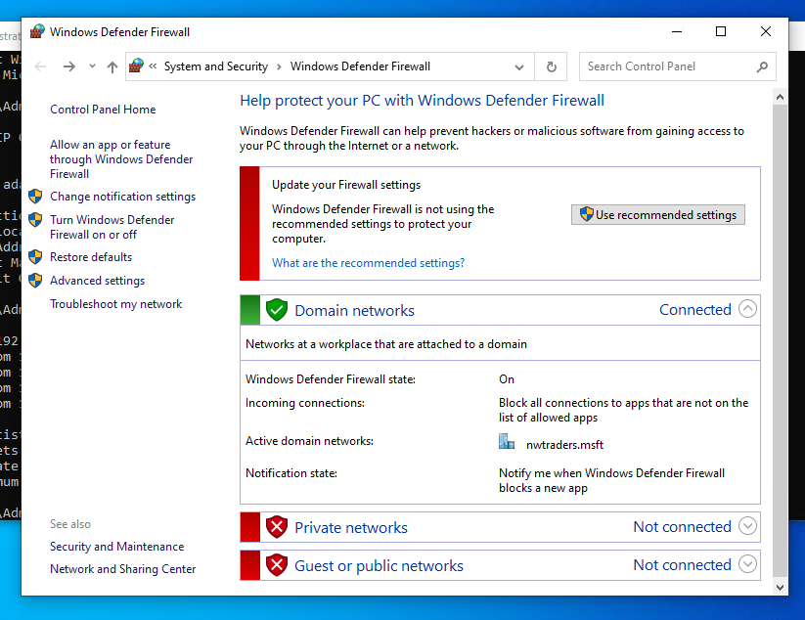

Step 2: Turned off the domain section of the window firewall on both server1 and client1 by clicking on the domain section of the firewall, and clicking on turn off.
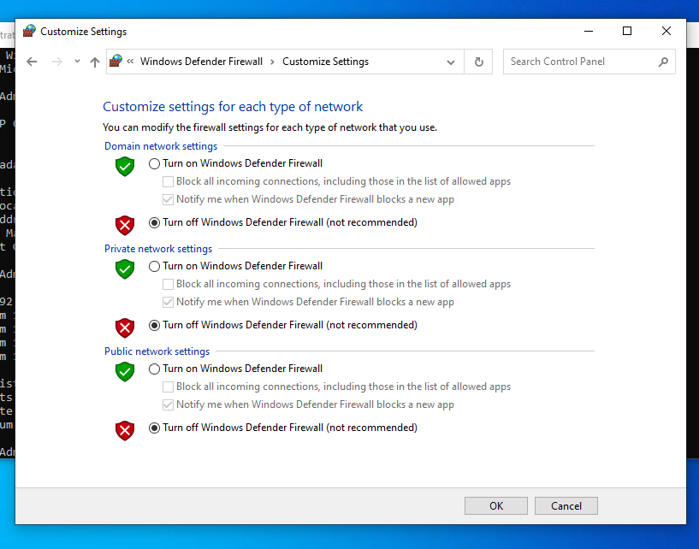
Step 3: Opened up server manager on server 1, clicked on tools, routing and remote access.
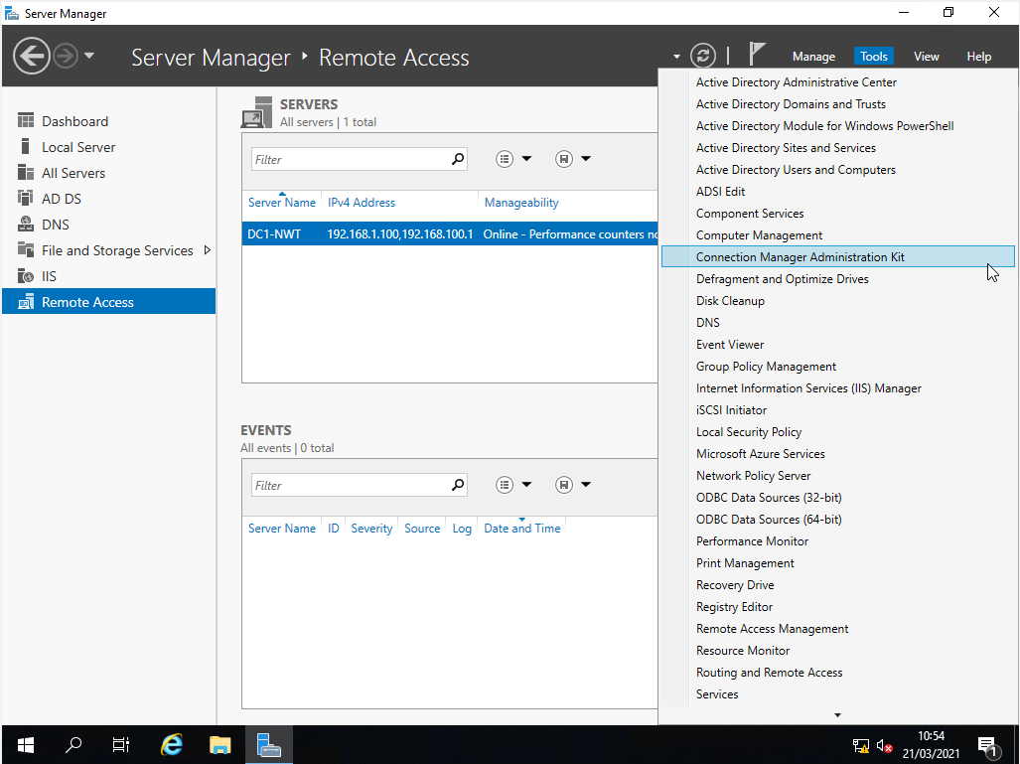

Step 4: In routing and remote access, expanded IPv4 and clicked on general. Right clicked on PrivateNet1 connection and select properties.
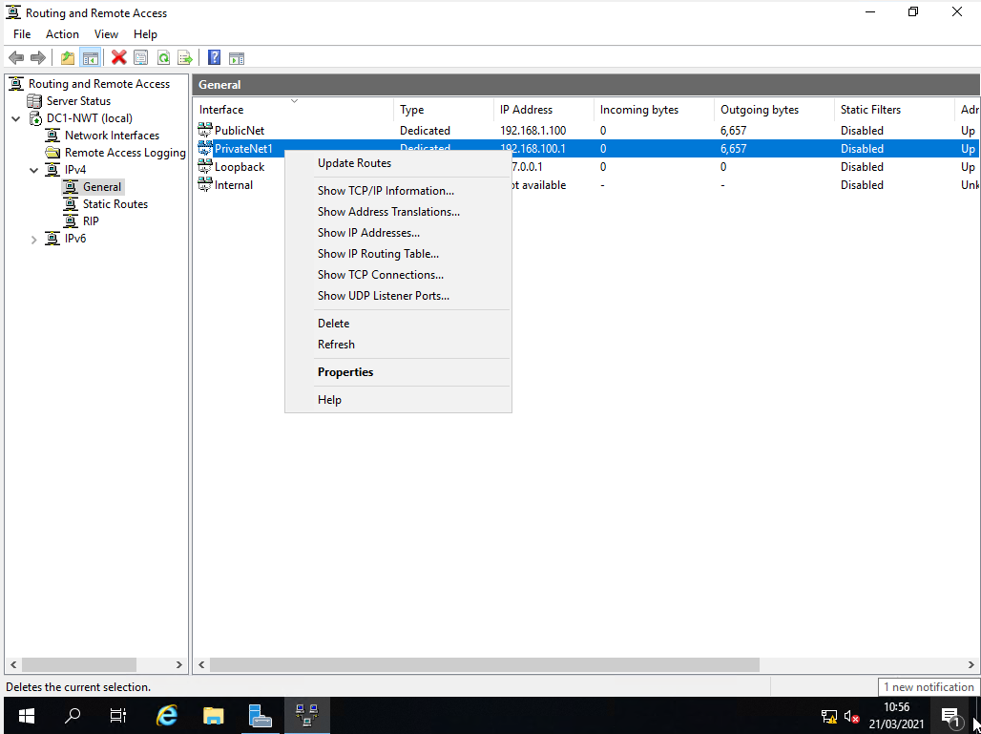
Step 5: In PrivateNet1 properties, clicked on inbound filters.
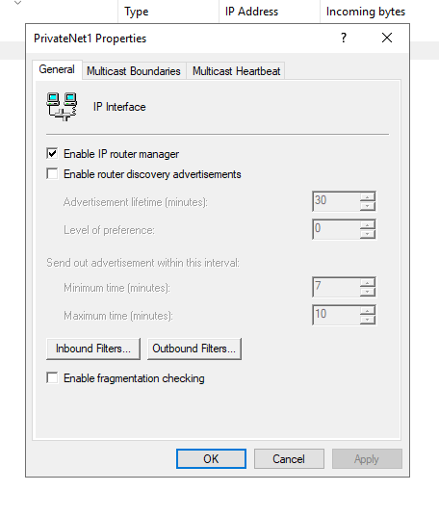

Step 6: In the inbound filter screen, clicked on the add button

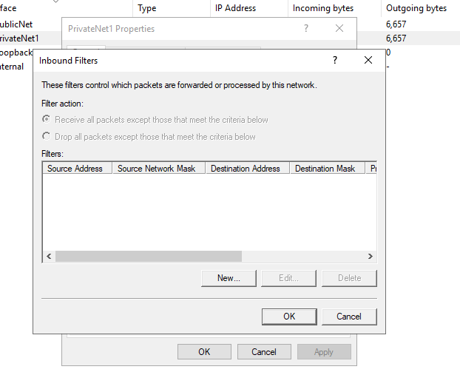
In the add filter screen, checked the destination network checkbox and enter the following details:

IP address: 192.168.100.1

Subnet mask:255.255.255.255

Protocol: ICMP

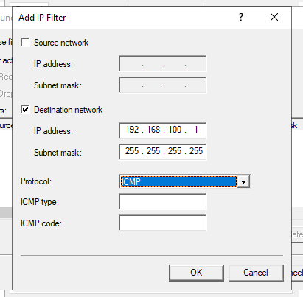
Clicked ok after entering the details.

Step 7: In the inbound filter screen, accepted the default value of ‘Receive all packets those that meet the criteria below’. Clicked on ok to confirm change.
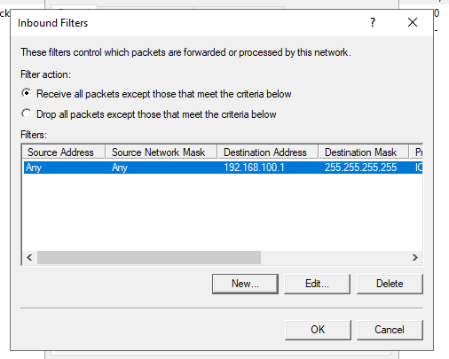

Step 8: Logged into client 1 and pinged privatenet1(192.168.100.1) and got a request timed out. Pinged client 2(192.168.101.2), and got a reply. This confirms the inbound filter worked in PrivateNet1.

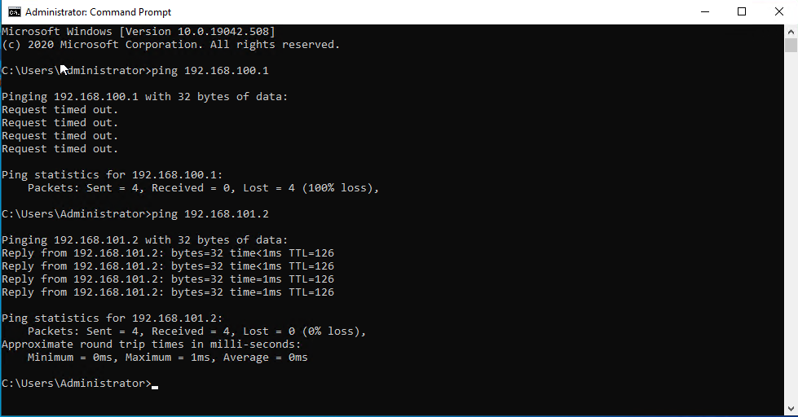

Filter 2: Restrict Access to FTP service running on Server 2 to only hosts in Private Net 2

Step 1: On server 1 in routing and remote access, expanded IPv4, clicked on general and right click on Public Net and selected properties.
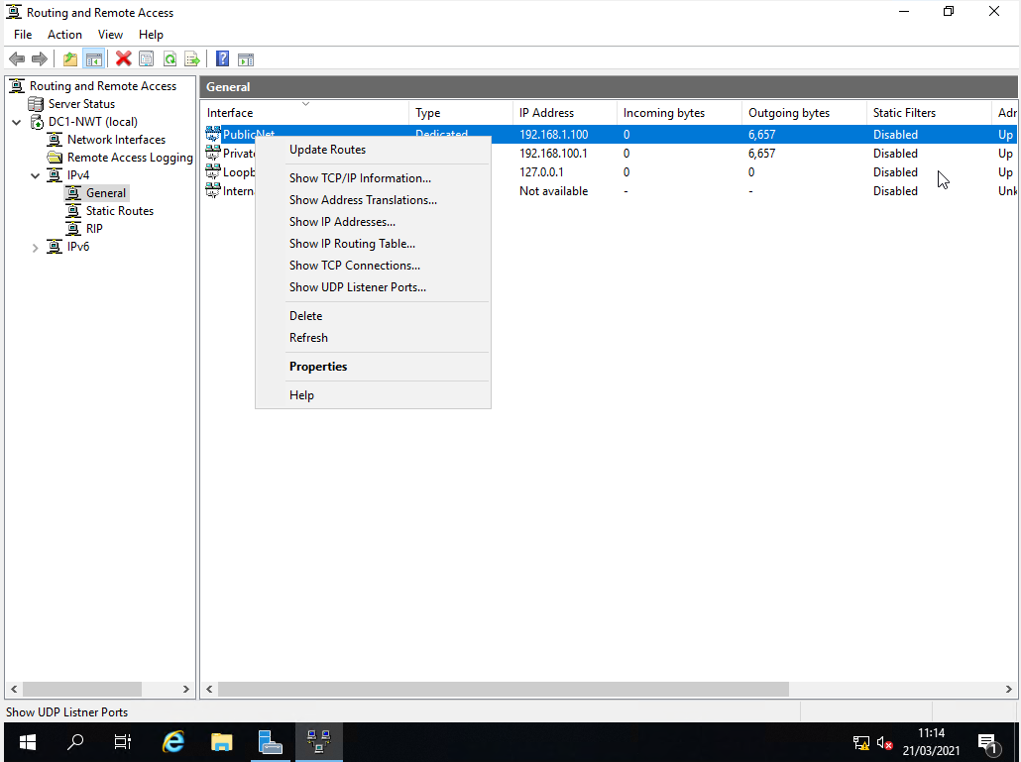

Step 2: In Public Net Properties, clicked on outbound filters.
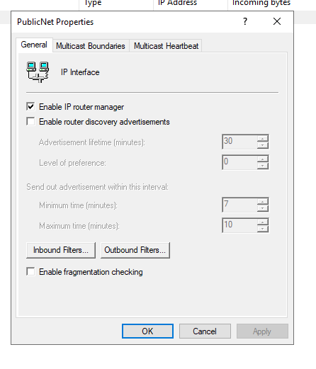
Step 3: In outbound filters, clicked on new.
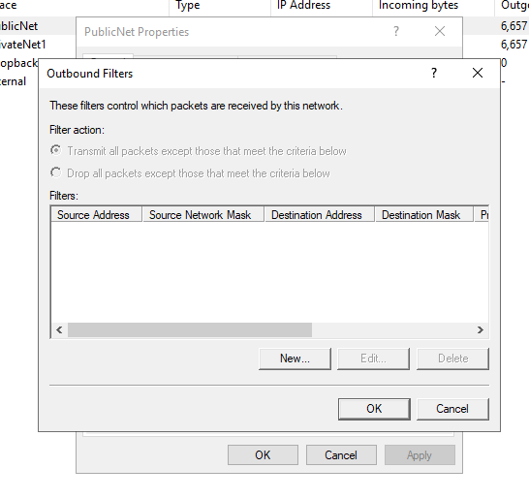

Step 4: In the Add IP filter screen, checked the destination network checkbox.

Entered the following details:

IP address: 192.168.1.101

Subnet mask 255.255.255.255

Protocol: TCP

Destination Port: 21

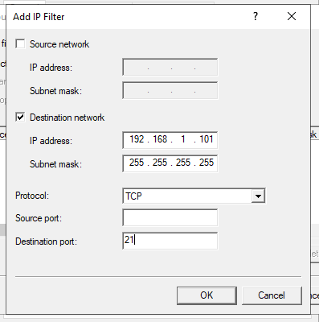
Clicked ok after entering the details.

Step 5: In the inbound filter screen, accepted the default value of ‘Receive all packets those that meet the criteria below’. Clicked on ok to confirm change.
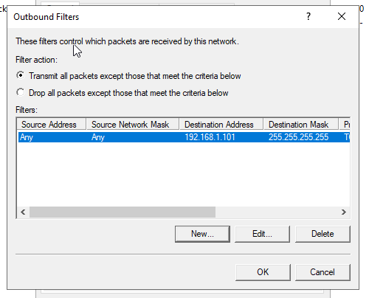

Step 6: Opened up a command prompt on Server1. Tried access the FTP service on server 2 (192.168.1.101), got connection timed out.

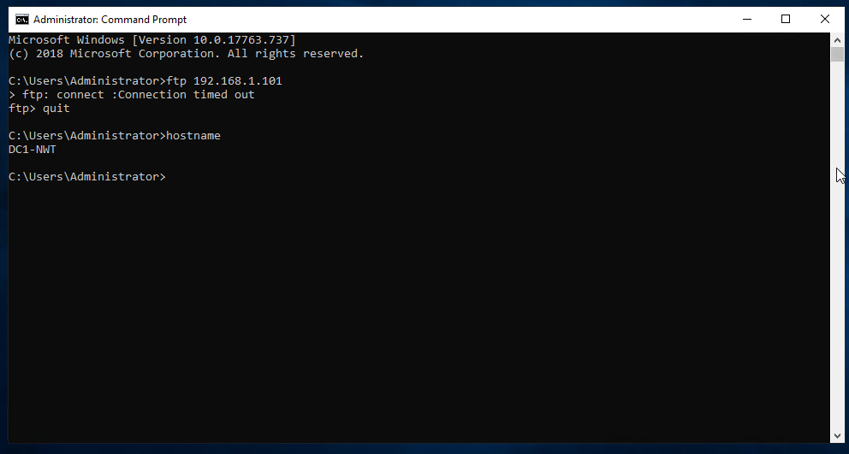

Step 7: Logged into Client 1 and opened a command prompt. Tried access the FTP service on server 2 (192.168.1.101), got connection timed out.

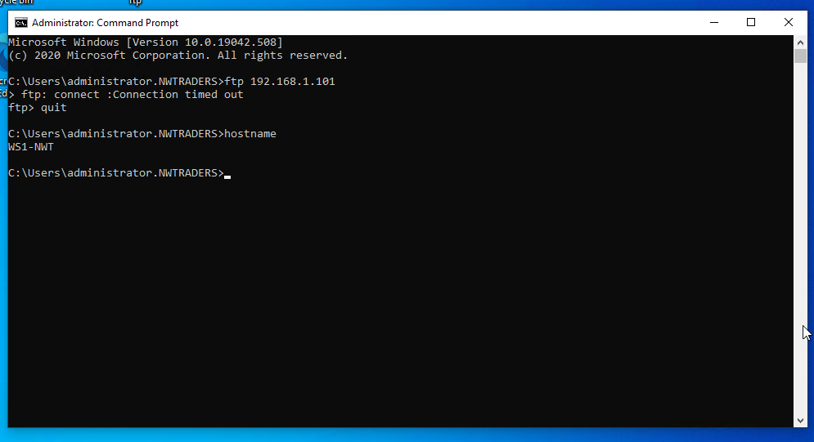

Step 8: Logged into Client 2 and opened a command prompt. Tried access the FTP service on server 2 (192.168.1.101), connection went through successfully.

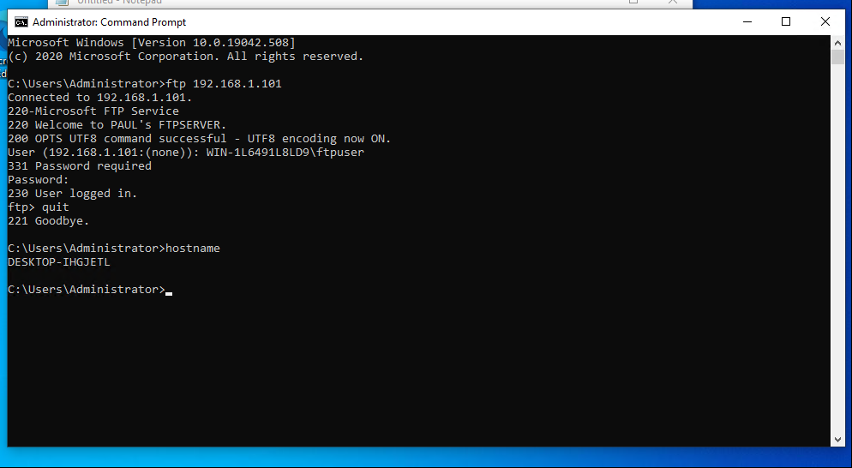

Filter 3: Only allow specific host in PrivateNet1 to access the FTP service running on Server 2.

Step 1. On server 1, opened up routing and remote access. Expanded IPv4 and clicked on General. Right clicked on PublicNet and selected properties.
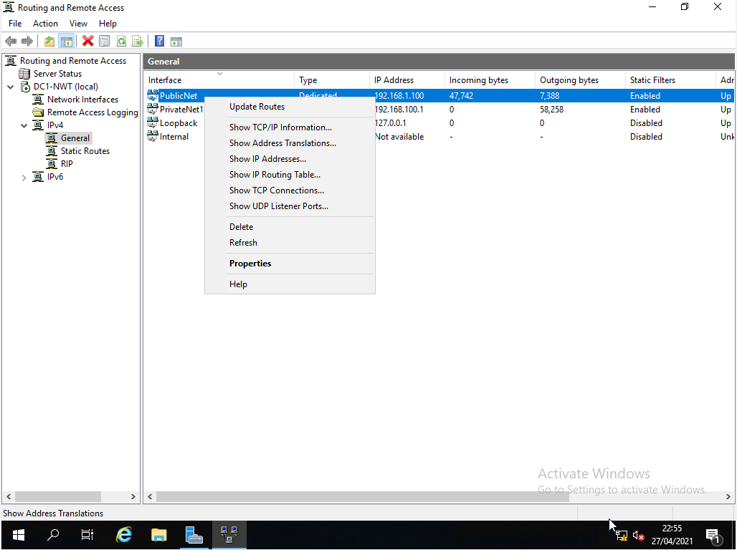

Step 2: In Public Net Properties, clicked on outbound filters.

Step 3: In outbound filters, clicked on new.
Step 4: Checked both the source network and destination network checkboxes. Enter the following details:

IP address: 192.168.100.2

Subnet mask: 255.255.255.255

IP address: 192.168.1.101

Subnet mask:255.255.255.255

Protocol: TCP

Destination Port: 21

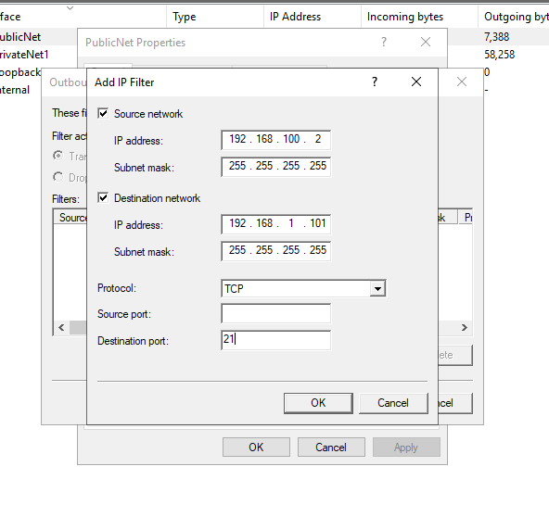
Clicked ok after entering the details.

Step 5: clicked on the ‘Drop all packets except those that meet the criteria below’. Clicked ok and ok again to exit Public Net properties. By specifying only client 2 (192.168.100.2) in the source IP address, and dropping all packets except from those included in the filter, will ensure that only client 2 can access the FTP server and no other machines can access the FTP server.
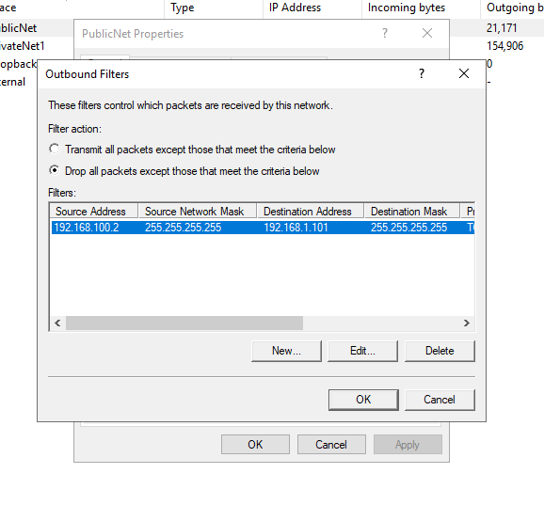
Step 6: Logged into Client 1. Tried access the FTP service on server 2 (192.168.1.101), connection went through successfully.

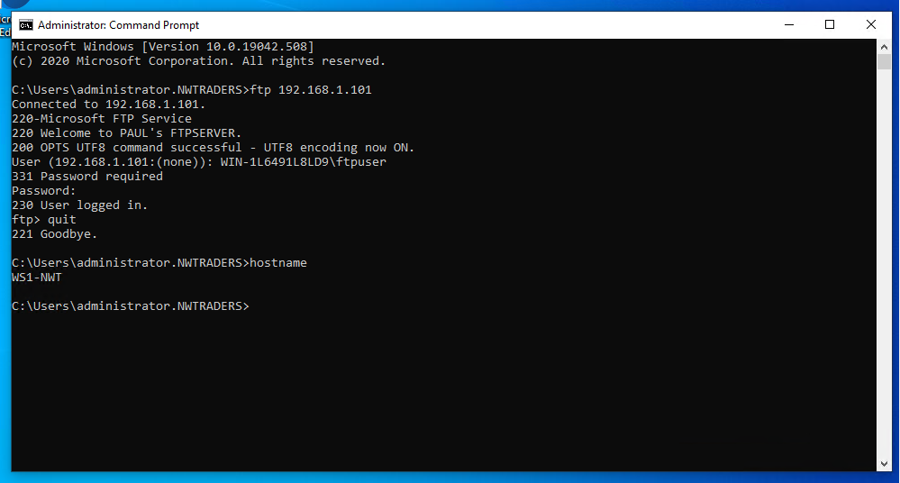

Step 7: Logged into Server1 and opened a command prompt. Tried access the FTP service on server2 (192.168.1.101), connection timed out.

Task 5: Failover Clustering for high availability systems/services

Failover clustering

According to Microsoft [2] Failover clustering is a collection of servers that work in unison with each other to provide high availability of applications and services to users. Each node in the cluster should have the configuration and capabilities. There can be slight variances, however, you want the same processor, the same amount of memory, the same access to storage, and the same access to the networks. If they are not the same, this could impact the service to users. When a node fails and another node takes over, e.g. if a server fails over to another server which does not have the same storage or network access, this could have impact on the performance of the service provided to users. It is advisable to use failover. Windows Server offers failover clustering as part of the operating system. Failover Cluster can be installed through add\features in server manager, as shown in the screenshot below.

Figure 5.1
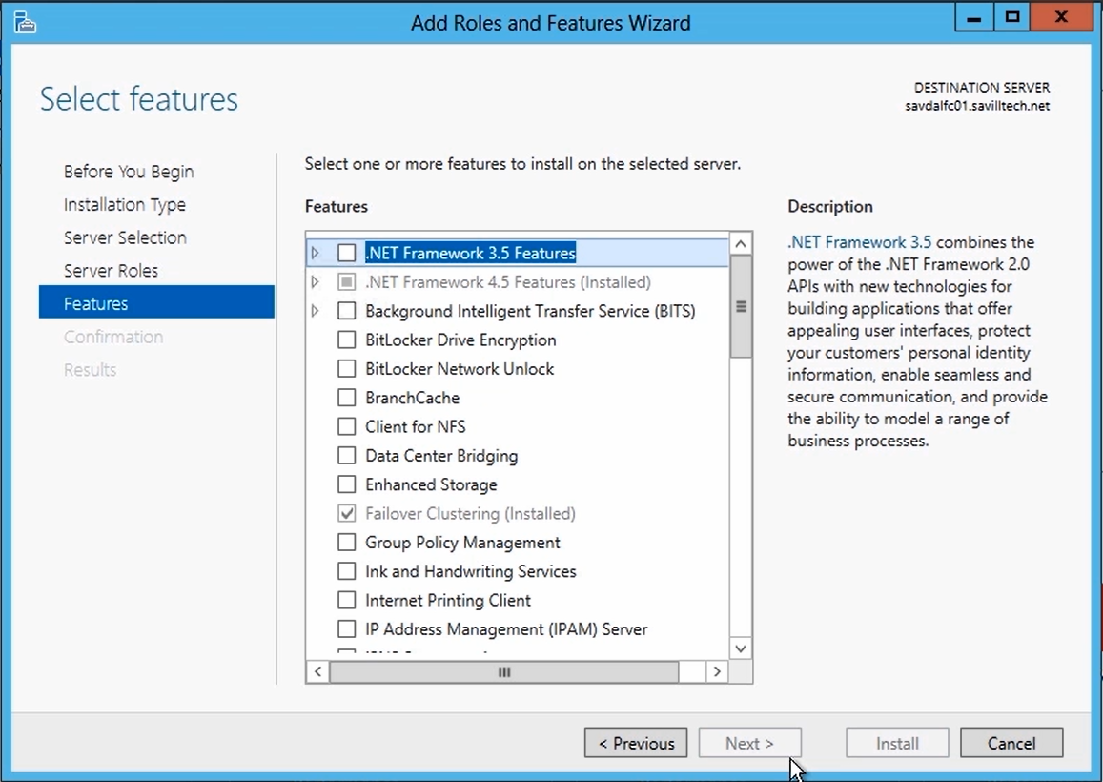

In windows server, the failover cluster can be accessed through the Failover Cluster Manager. As shown in the screenshot below.

Figure 5.2
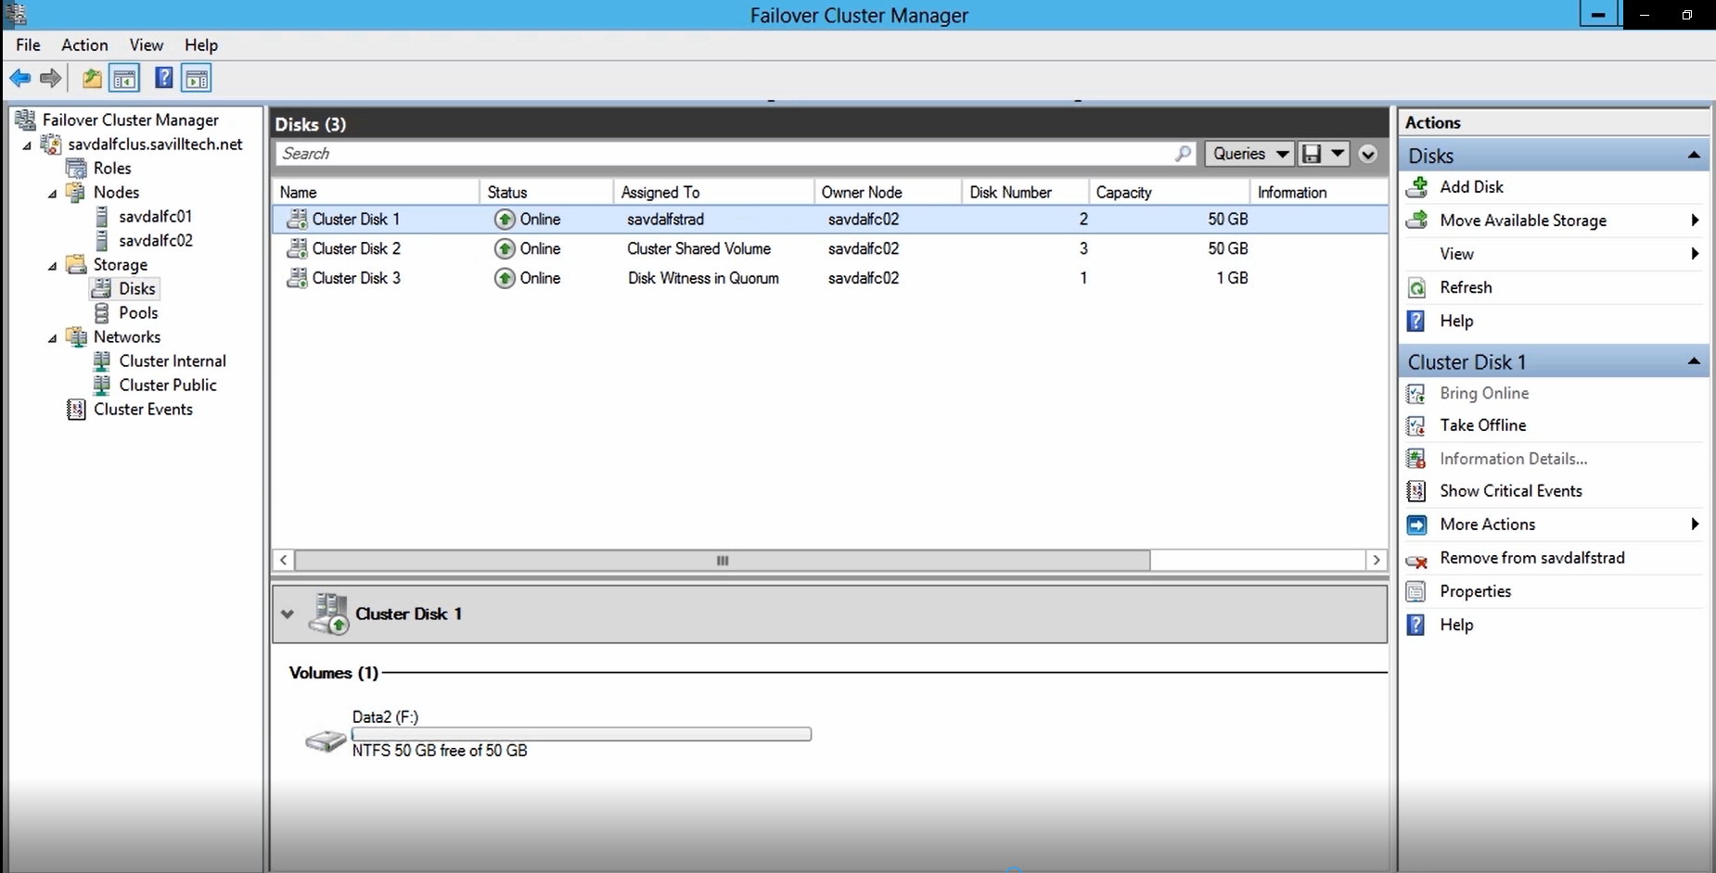

Failover cluster manager allows you validate and create clusters.

Another consideration when implementing failover cluster is how many nodes to include in the cluster, e.g. if you have a 2 node cluster, if one node has been taken down for planned maintenance, and another fails. There are no servers in the cluster to provide services or applications to users. In this case it would have been better to have 3 nodes in the cluster, to avoid the problem above.

When implementing failover clustering, servers may be located in different locations and data centres. If there is a break in communication, you do not want the servers trying access the same storage or SQL database, because this could corrupt data or cause any problems. The way Microsoft has overcome this problem is through the use of a system called Quorum. Quorum ensures that if there is break in communication, that specific servers can access the storage, and no other servers can access the storage. The way Quorum achieves this is through node majority. The part of the cluster that has the most node votes will gain access to the storage. Each node or server in a cluster has a vote. E.g. if there are five servers in a cluster, if 3 servers outvote the other 2 servers in the cluster, the 3 servers will continue to access the storage, while the other 2 server will not be able to access the storage. This is great if you have an odd number of servers. If you have even number of servers, this system is not very effective. This is where you have to implement a witness disk, which has a vote in the cluster. Whichever part of the cluster obtains the witness disk vote, will achieve node majority and only those nodes will have access to the storage. If witness disk cannot be allocated, you can use a file share as witness, which performs the same role as the witness disk. When creating a cluster in windows server, it will detect if you have an odd number of nodes and automatic implement node majority. If there are even number of nodes, it will automatically. Setup a witness disk, using the smallest disk in the cluster. The witness disk, can be viewed in cluster manager by clicking on disks under storage, as shown in the screenshot below.

Figure 5.3
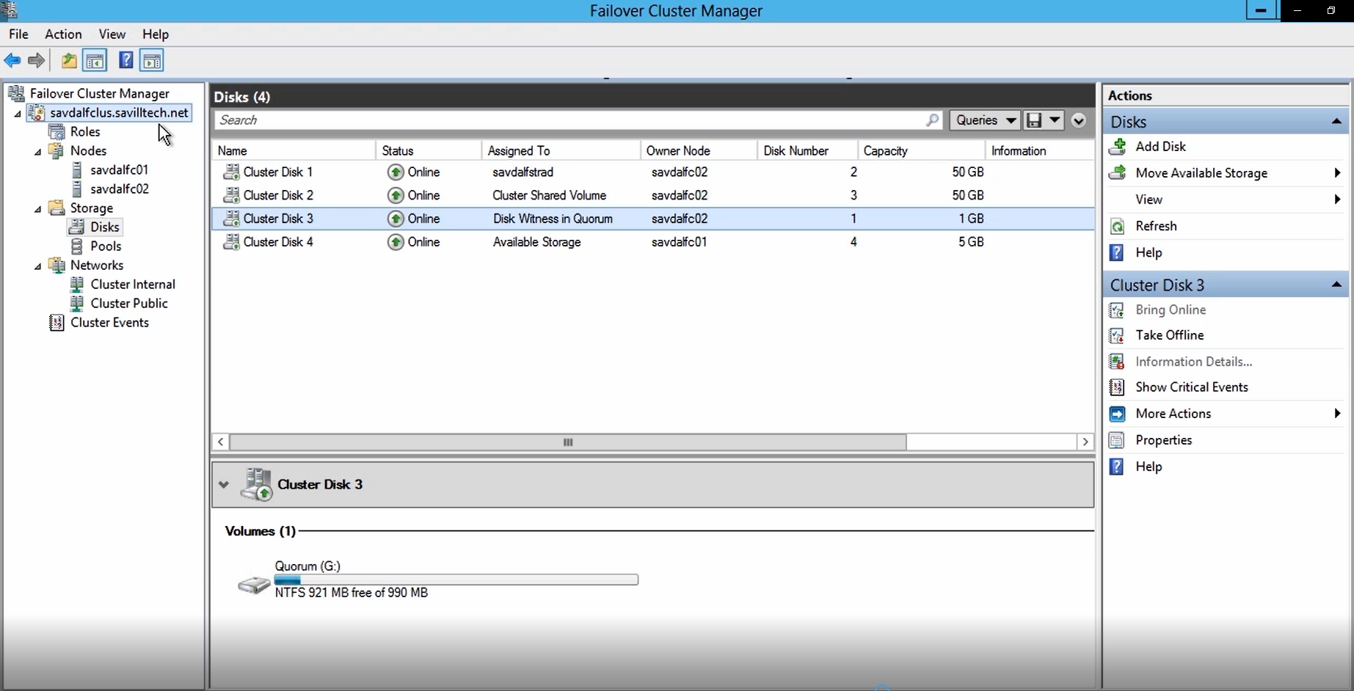

If you wish to change from a witness disk to a witness folder, you can run the configure cluster quorum wizard. The wizard can be accessed by clicking on the cluster name in Failover Cluster Manager and selecting more actions. A screenshot of the quorum wizard is shown below:

Figure 5.4
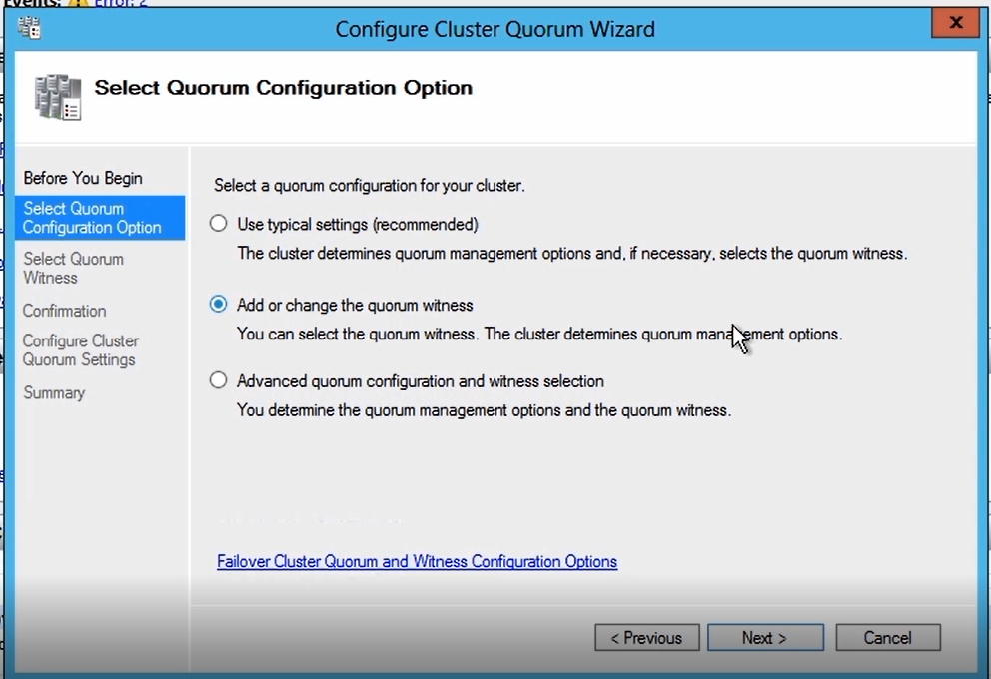

Task 6: Network Policy

According to Mike Chapple [3], the network policy should be split into two sections high availability and security.

High Availability Policy.

According to Gerardus Blokdyk [4], below are the types of high availability technology we should be using.

Web servers or stateless applications (servers that do not contain data) we will use load balancing. Network traffic and user workloads will be spread across different servers before the same functionality. This can be implement in a round robin system e.g. user 1 is directed to server 1, because it is first in the list of servers to be contacted, user 2 is directed to server 2 because it is the second server on the list to be contacted. If this is not satisfactory, the network traffic can be directed on which servers are least busiest. E.g. If server 1 is very busy and server 2 is less busy, further network traffic can be diverted to server. Also load balancing will be applied to routers and switches, because they do not contain data.

For stateful applications that contain data for example SQL servers, failover clustering will be used. For example, server 1 will deal with all network traffic and user requests and server 2 will be on standby. If server 1 fails, server 2 will take over.

To protect against disk failure we will user RAID (Redundant Array of Independent Disks). There are many different types of RAID systems. E.g. RAID 0 (Stripping), RAID 1 (Mirroring) etc. RAID 6 is the RAID system we will be using. RAID 6 uses 4 disks. RAID 6 stores parity on two disks and data on another two disks. The parity stores what the data consists of. The data and parity is switched between disks, every time data is written. A different disk is used for parity, every time data is written. If one disk fails, then you can still access and recover the data. RAID 6 protects against two disk failures, whereas other RAID system like RAID 0 (Stripping) offer no fault tolerance or RAID 1 (Mirroring) only offer protection against one disk failure. RAID 6 offers this greatest protection, by protecting against two disk failures.

SAN (Storage Area Network) will be coupled with RAID to offer more high availability. SAN is a high speed dedicated network that stores and provides access to large amounts of data. It contains multiple disk arrays to store data, switch to access the data on the network, and servers which are used to facilitate access to the data. It will use multiple disk arrays, switches and server, because it uses more than one of these devices. It is fault tolerant, because if one of these device fails, another device will take over. We will be implementing RAID with SAN, to ensure the best fault tolerance.

SANS are not effected by bottlenecks in the LAN (local area network), because they are partitioned off into separate network. This also make them an ideal solution, when users are accessing data from different locations, because they are not going through the LAN to access the data.

Maintenance and Monitoring

According to Gerardus Blokdyk [4], a dedicated network and server team will be created to maintain and update the servers and storage systems. They will monitor the servers for a potential problems e.g. disk failures. Then take action to correct, to correct these issue, by replacing the fault disk.

Security Policy

According to Ian Neil [5] below are the types of security technology we should be using.

Technical Controls

Firewalls will control network traffic between LAN and the internet. We will use state full firewall. It only allows traffic that originates from the network, or has a firewall rule only allowing certain external trusted sources to access the network. We will use firewalls which contain web security gateway features. This enables the firewall to check the content of the packets at an application level. E.g. if someone was attempting a cross scripting attack the firewall, could stop the attack, by closing the network session.

Anti-virus software will be stored on end devices and servers. To ensure that virus are not installed on clients pcs and servers. The antivirus will detect and block virus infecting a machine.

Proxy servers will be used to control access to websites. Proxy servers can be used to prohibit users accessing certain websites e.g. gambling websites. Proxy server can block access based on content (content filtering) or based on a URL (URL filtering).

VPN (virtual private networks) will be setup to allow users to access the data outside of the network. The VPN concentrator will be used on the firewall to allow users to access the network. The VPN will only allow authorised users to access the network and will encrypt all network traffic between the network and the user.

Non-technical controls.

According to Hadnagy [6], user education is very important in protecting your network. Make sure users are aware of how to protect data on the network. Advising users how to lock their machines, if they are not by them. Educating them about phishing and social engineer attacks and not to give their user details freely to the wrong person and that they should not reveal their user credentials to anyone.

Network security and enforcement
According to Ian Neil [5], a security team will need to be setup that are familiar with the hardware controls so they can take action if a security breach occurs. They will monitor security logs on servers, e.g. to see if someone has failed to login into server etc. They follow why that user failed to logging into that server, were they trying to access a server they did not have permissions to access? Apart from monitoring for security breaches, the security team will be responsible for setting up users accounts and setting up their permissions to access resources e.g. setting up a user in active directory and grant them access to a network share, to created and stored word documents. The security team will also update server, clients pc, network hardware to make sure there are no software vulnerabilities that can be exploited. The security team will also be used to report security issues. If a user comes across a security issue, they can report it to the team who will take action to fix the security issue.

Bibliography

[1] | T. Lammle, CCNA : Cisco Certified Network Associate: study guide, Sybex, 2007, pp. 327-415.
[2] | Microsoft Official Academic Course, 70-412 Configuring Advanced Windows Server 2012 Services R2, Wiley, 2014, pp. 17-60.
[3] | M. Chapple, CompTIA Security+ Study Guide: Exam SY0–601, Sybex, 2021, pp. 511-535.
[4] | G. Blokdyk, High Availability Architecture A Complete Guide, 5STARCooks, 2021, pp. 132-134.
[5] | I. Neil, CompTIA Security+: SY0-601 Certification Guide, Packt Publishing, 2020, pp. 178-226.
[6] | Hadnagy, Social Engineering: The Science of Human Hacking, Wiley, 2018, pp. 277-287.

