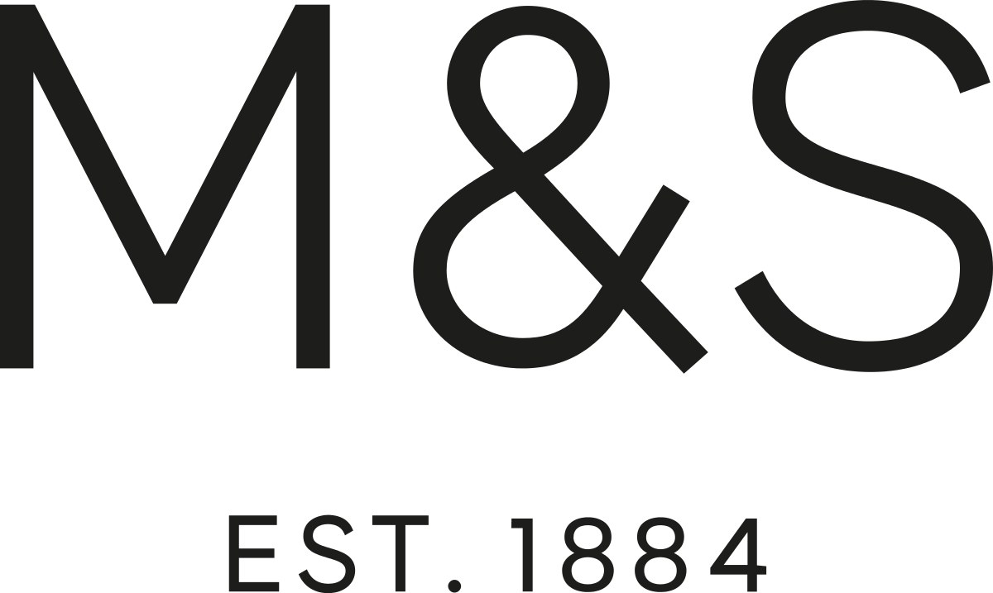  THE DECLINE OF MARKS AND SPENCER | PROBLEM SOLVING AND DECISION MAKING  University of wales trinity saint david  MILDA JANKAUSKAITE  STUDENT ID 2020751

Contents

Abstract 2
Introduction 3
Main Findings 4
Background of Marks & Spencer 4
Impacts of the main problem 4
Nature 5
Scope 6
Impact 6
SWOT (internal) analysis 7
PESTLE (external) analysis 8
Conclusion 9
Appendices 10
SWOT analysis 10
PESTLE analysis 11
Reference List 12
References 12

Abstract

This report analyses the decline of an iconic brand Marks & Spencer, in today competitive market. The report includes the nature, scope and impact insights of the problem faced by M&S. The broad summary of the retailer is supported using a PESTLE analysis tool that overviews the macro business environment. A detailed SWOT analysis that highlights both the internal and external environment according to the corresponding article issued.

Word count: 1950

Introduction

M&S is one of the leading multichannel retailers of general merchandise and food. The company has a comprehensive portfolio of products and is known as an iconic international multichannel brand. The company has an impressive development history, unfortunately in recent years have been highly criticised due to their poor management decisions. Efforts made to attract the younger generation has ended with faded identity and lost customers. Noticeably, the business fails to invest in the physical stores, and therefore shopping at M&S is no longer a pleasant experience. The company constantly closing their branches and, more importantly, has announced the plan of volunteer redundancies.
However, in terms of lockdown, the company has succeeded in opening online stores. The management team has been supported by experienced members and have intentions to implement changes through new projects.

Main Findings

Background of Marks & Spencer

The company can offer their customers clothing and home goods, and food, carefully selected from various suppliers across the globe. In addition to that, the company offers services such as cafes, credit cards, home and travel insurance, personal loans, and banking services. According to the company's profile, they have over 1,519 department stores in 62 countries as of 1,038 stores in the UK (MarketLine, 2021). However, the statistics have shown that M&S contains only a 3.1% market share of a grocery store in the UK, while the leader Tesco manages 27% of the market (Statista, 2021). The business has been running since 1884, counting two survived world wars and therefore is considered an iconic and trustworthy brand (MarketLine, 2021).

Impacts of the main problem

In contrast, in recent years, the reputation and sales of the High Street giant have enormously dropped. The global pandemic has been brutal, and all sectors have suffered distinctively, and therefore business has been forced to find new solutions and change their plans. However, experts highlight those M&S problems date back much further, as they have constantly been making terrible decisions (Russon, 2020).
M&S in 2016 announced a new management structure in order to empower rapid decision-making and get the management team closer to its customers. The changes have been introduced by reducing the links between the top managers and the employees who dealt with clients (Marks & Spencer Company: Organisational Structure, 2020). The business also formed an operating committee responsible for daily business running and the growth and implementation of the strategy. Additionally, they highlighted that initial attention would be paid to fixing the company’s homeware and fashion sectors (Geoghegan, 2016). Retailer experts emphasise that shopping at M&S is no longer an enjoyable experience pointing to: “Old men's clothes, next to men's suits, next to pants, next to childrenswear makes no sense anymore” (Russon, 2020). It concludes that the iconic retailer ignores analysing their customers and their needs. As a result, business is not able to compete in an intensively competitive retail market. Furthermore, shopping is associated with a treasure hunt, and search itself is fascinating to most people (UKEssays, 2018).
Additionally, introducing an integrated online business was one of the several goals of a three-year change programme called Never the Same Again (“NTSA”) (Major, 2020). The purpose of the programme is to become a flexible, fast-moving and more digitally-focused business. Steve Rowe, the CEO of M&S, wishes to come through the crisis tougher and set up to win in the new world. Therefore, they have strengthened the central leadership team. As relaunched digital loyalty scheme Sparks grown by 8 million members, the transformation has been effective so far. Furthermore, the focus will be paid to reshaping Clothing & Home, reflecting lower demand items and shifting to high demand mainstream products. Clearly, ambitions set under the NTSA programme, together with continued underlying business transformation, shows that M&S restructured its business model (LLP, 2020).

Nature

M&S has failed to invest in its stores, and therefore has been facing a loss in customers and consequently profit. However, some retailer experts highlight that M&S got burned many times for their own victory. During the 80s and 90s, an entire generation of customers became connected to the brand, and they loved brick and mortal experience. However, it would be unrealistic to expect that the next generation will be attached to the retailer. The situation has switched, and their entire desire to be loved by everyone ended up being nothing. People used to fancy the retailer and what they stood for. They hid on that emotion, but people get annoyed and disappointed that M&S have not invested in the brand for too long. Since their iconic breaking times, even the loyal customers attached to the company find that stores became confusing and messy. The difference between a limited collection and an autograph is barely seen; even a sale section does not engage in buying for less, and people get lost to understand what the business is offering (Gale & Jones, 2019).

Scope

The company’s drop has been a long-time coming because of its inability to adapt to progressively challenging high street circumstances. The high streets used to experience a high volume of shoppers every day, while now many consumers are now choosing the convenience of online shopping. Therefore, when the demand for online shopping seeks the peak, M&S stands back due to their apparent absence of forecasting the market. Suddenly, the shopper has more choice than ever before, and it is up to the producer and the retailer to offer the consumer what and when they want it (3 Growth Lessons from M&S, 2019).
Another problem naturally flows out, that M&S fails to understand their target audience. If the Sparks digital card was working from its launching time, it might be helped to analyse the demographic of customers, their needs, and expectations. The business underperforms If the image does not match the target audience; what had happened to M&S when they released an advertising campaign with 25-year-old models wearing conservative garments targeted at 65-years-old (Russon, 2020). It is vitally important to match the retailer’s message to what the customers want to hear. From the M&S experience, it can clearly be seen that they do not have a tight match between their message and their customers. Therefore, it could be catastrophic to business as consumers have an extensive choice to find a retailer to match their believes and anticipations (Qamar, 2018).

Impact

The M&S brand is highly known, and its history and present problems can be traced back to the brand itself. Precisely, M&S has been facing strategic issues, which forced the gradual weakening of competitiveness due to failure to recognise and react to changes in the market.
However, M&S did not get an image of an older consumer demographic at their start. The brand image had possibly been formed by the clients who have grown up with the brand. M&S has not been able to follow a fast fashion pace, failing to appeal to the younger generation. While precisely trying to be loved by both loyal, core consumers and gain new, younger shoppers, M&G got stuck somewhere in between. Being boring and no longer popular results lost customers’ interest in the brand.
M&S has jumped on online platforms in the very heart of online shopping times. Some brands have already been dominant and highly trustworthy by consumers, which has resulted in lower footfall and, consequently, a drop in in-store sale. The internet gives a chance to compare prices and find the most reasonable prices easily. Thus, it impacts the profit margins that an individual store can make, and accordingly, the business must reconsider its physical stores' viability (Qamar, 2018).
All the above issues have brought voluntary redundancies to the company’s horizons. M&S has decided to close 100 stores in the UK by 2022, which is 30% of physical stores. Unfortunately, the market experts report that these substantial closures will not help, and further downsizing should be considered in order to survive. The shortfalls will mainly be customer assistants. However, M&S is willing to advertise roles for its online part in its new food warehouse (Knapman, 2020).

SWOT (internal) analysis

Nowadays, consumer expectations are higher than ever before, and people are looking for an enjoyable experience while shopping rather than collect the necessary groceries. While everything becomes innovative and smart, noticeably, M&S tends not to invest in its physical stores. Therefore, the retailer loses the interest of its customers. Additionally, it is hard to understand the image and identity that M&S broadcasts. Thus, young models wearing conservative clothes discourages their loyal customers, who have grown up with the brand. Therefore, the company has come across to decision to transform around 30 stores into food-only stores (Nazir, 2021). These areas influence the main problem, which is weak operational execution. The seller is not able to provide returns to its shareholders and consequently attract new investors. The decrease in revenue proves the absence of attention on cost management.
However, the company remains a solid international player in the retail market; as of FY2020, M&S operated 1519 stores in 62 different countries and served 31 million customers around the world every year (Marks and Spencer Group, 2020). Furthermore, M&S has strengthened its influence in the retail market by making its products available online. It allows to choose different delivery options and offers reasonable prices based on customers’ preference. Additionally, M&S has a broader consumer group as the company provides a diversity of service (Qamar, 2018).

PESTLE (external) analysis

M&S used to have an online shopping platform, and the company admits that it was not precise and fast enough. People who are not technology aware could not complete their shopping without a call to customer support, which negatively impacts people shopping experience (McDonnell, 2014). People tend to comfort themselves by shopping online in terms of the global pandemic and national lockdown (Dawson, 2021). During the lockdown, people were increasingly forced to rely on the internet to get their retail dopamine hits (Dizik, 2016). Experts negatively evaluate the M&S business model by saying that new business starters who has intentions to launch a retail business should not follow the M&S pattern. In addition to that, Covid-19 has changed shoppers’ habits, and attention has been switched to online shopping (Russon, 2020).
In contrast, the global pandemic has been favourable to business in terms of successfully launching the M&S products accessible online for the first time at Ocado.com. As a result, Ocado Retail produced a 47.9% year on year revenue increase for the 26 weeks in August 2020. This has been an exceptional period for business, helped by corresponding Covid-19 increase and initial return on investment (LLP, 2020).

Conclusion

To sum up, M&S has unsuccessfully adapted their products in line with the latest fashion trends. In order to change their older customer demographic, they tried to attract a younger generation by sub-brands. Unsuccessfully, the campaign has brought a lot of confusion to the target market and resulted in poor quality issues. These unsuccessful projects have led to losing a solid identity and customer interest in the brand. The shifted focus to the online platform, combined with the unattractive appearance of their outdated clothing stores, have impacted M&S to experience challenges in maintaining the execution of their high street stores. Therefore, the brand has to announce store closures, as well as massive redundancies.
Customers' requirements are constantly changing, and the global pandemic has even sharpened the situation and created conditions of sink or swim. However, M&S is not the only brand facing challenges in the retailing market. It is important to highlight their willingness to change the business model through the “Never the Same Again” program. Finally, management has concentrated on their business gaps rather than desperately trying to implement new projects and hope they will work.

Appendices

SWOT analysis

Strengths (INTERNAL) | Weaknesses (INTERNAL)
International brand.  M&S remains a strong retailer in the food industry.  Online platforms.  Varied service is available. | Customers do not get an enjoyable experience.  Fails to invest in its physical stores.  The clothing sector does not fit in any generation.  Declining financial performance.
Opportunities (EXTERNAL) | Threats (EXTERNAL)
Online retailing opportunities.  Willing to embrace changes in the fashion sector.  The new upcoming projects (“Never the same again”).  The business strengthens its position through a variety of partnerships. | Changes in consumer habits.  Radical and untested business model changes.  Changes in fashion trends.  Extensively competitive market.

PESTLE analysis

Element | Factor | Impact
Political | Free trade  Brexit | Free trade agreements allow foreign products to import much easier, and lower prices help maintain profit margin. Brexit might impact a loss of free trade policies with EU suppliers (Marks And Spencer PESTLE Analysis, 2019).
Economical | Competitive market | Numerous new budget retailers reduced the market share from more premium brands such as M&S (Qamar, 2018).
Social | Non-trendy brand | The brand fails to fit in any generation, and the brand is often associated with the past due to its long-standing reputation (Qamar, 2018).
Technological | Online shopping | M&S has fulfilled a need for an online shopping platform and offers the whole spectrum of its goods (News, 2021).
Environmental | Green policy | M&S works towards a carbon-neutral, zero-waste to landfill, ethical-trading, sustainable-sourcing, health-promoting business (M&S, 2017).
Legal | N/A | Not identified - constantly changing factor.

Reference List

References
3 Growth Lessons from M&S (2019) ContactPigeon.
Dawson, C., 2021. Tamebay. [Online]
Available at: https://tamebay.com/2021/02/lockdown-shopping-habits-see-93-of-uk-online-shoppers-buy-on-amazon.html
[Accessed 17 May 2021].
Dizik, A., 2016. BBC News. [Online]
Available at: https://www.bbc.com/worklife/article/20161123-shopping-a-sale-gives-you-the-same-feeling-as-getting-high
[Accessed 31 May 2021].
Gale, A. & Jones, S., 2019. Managment Today. [Online]
Available at: https://www.managementtoday.co.uk/m-s-blame-its-own-decline/reputation-matters/article/1414881
[Accessed 18 May 2021].
Geoghegan, J., 2016. Drapers. [Online]
Available at: https://www.drapersonline.com/news/update-ms-announces-new-management-structure
[Accessed 16 May 2021].
Knapman, H., 2020. The Sun. [Online]
Available at: https://www.thesun.co.uk/money/12430189/marks-and-spencer-job-losses-axe-shop-floor-workers/
[Accessed 20 May 2021].
LLP, D., 2020. Robust performance in unprecedented times as transformation accelarates, London: Deloitte LLP.
M&S, 2017. M&S. [Online]
Available at: https://corporate.marksandspencer.com/media/press-releases/2017/plan-a-2025
[Accessed 31 May 2021].
Major, M., 2020. News & Star. [Online]
Available at: https://www.newsandstar.co.uk/news/18424558.marks-spencer-reveal-plans-change-shopping-experience/
[Accessed 31 May 2021].
MarketLine, 2021. Marks and Spencer Group plc, s.l.: MarketLine Advantage.
Marks & Spencer Company: Organisational Structure (2020) StudyCorgi.
Marks and Spencer Group, 2020. Annual Report & Financial Statements, s.l.: Marks and Spencer.
Marks And Spencer PESTLE Analysis (2019) Thomas Bush .
McDonnell, K., 2014. Econsultancy. [Online]
Available at: https://econsultancy.com/where-did-the-marks-spencer-website-relaunch-go-wrong/
[Accessed 2 June 2021].
Nazir, S., 2021. Retail Gazette. [Online]
Available at: https://www.retailgazette.co.uk/blog/2021/05/ms-to-shutter-some-stores-after-swinging-to-201m-loss/
[Accessed 31 May 2021].
News, B., 2021. BBC News. [Online]
Available at: https://www.bbc.co.uk/news/business-56327257
[Accessed 31 May 2021].
Qamar, A., 2018. City REDI Blog. [Online]
Available at: https://blog.bham.ac.uk/cityredi/the-2018-retail-crisis-catches-up-with-marks-and-spencer/
[Accessed 19 May 2021].
Russon, M.-A., 2020. BBC News. [Online]
Available at: https://www.bbc.co.uk/news/business-53478403
[Accessed 16 May 2021].
Statista, 2021. Market share of grocery stores in Great Britain from January 2017 to May 2021, s.l.: Daniela Coppola.
Tingle, R. & Deane, L., 2020. DailyMail. [Online]
Available at: https://www.dailymail.co.uk/news/article-8540029/Marks-Spencer-announce-hundreds-job-cuts-days.html
[Accessed 17 May 2021].
UKEssays, 2018. UKEssays. [Online]
Available at: https://www.ukessays.com/essays/management/challenges-faced-by-marks-and-spencer.php
[Accessed 2 June 2021].

