
Assignment Title | Principle of health and social care practice
Assignment | 1
Module Code | BMHP5002
Tutor | Dr Gulnar Ali
Student Name | Nordia Patrice Baker
Student Number | 1813361

Title page
Content
Introduction
Task descriptor
- Case study for Mr & Mrs T
Delivering Services
- Care providers
- Charity's
- GP's
- Social services
- Integrated pathways
End of Life
- Wills
- Hospice
- Funeral
- Family
Regulators and policy for social care in England
- Care Quality Commissions (CQC)
- Care Act 2014
- Nice Guidelines
- Safeguarding in adult/vulnerable people
Recommendations
Conclusion
Appendix
Reference

Introduction
In 2018 it was estimated that there were 12 million (11,989,322) people aged 65 or over in the UK. If we break down this figure, it means 5.4 million of the 12 million is aged 75+ and 1.6 million are aged 85+ which shows we are living in a society of ageing population (Later life in the United Kingdom 2019, 2019). With life expectancy going up, it means there is a broader community of people who will need long term care as there will not be family members who can afford to or look after them. With life expectancy and healthy life expectancy functioning at different rates, this will also be a factor as to long term problems faced by the elderly are supported within the care system. There are many factors which affect the elderly population and the care they will receive, and there are many social determinants that can arise when older people need assistance from social care settings. A few factors we must consider are:
- Community and social links
- Environment
- Food production
- Individual lifestyle
- Age, sex and hereditary factors
- Living conditions
These social determinants will also affect the care they received, due to attitude, social preference, and how the individual responds to care itself. In this assignment, I will be looking at a case study and determining factors that will arise when an elderly couple are under strain from injury and dementia. What services are available to help, for example, the NHS, Age UK or Dementia UK can provide to support and maintain independent living and an overall plan to help them for years to come. I will also look at the limitations in their situation and evaluate the functionality of systems that are widely available to help them. I will also look at long term recommendations that can help them for years to come in terms of treatment and living.

Task Description
Case Study
Mr and Mrs T are both over 85 years old. Mr T has progressive dementia and other chronic conditions. They have always been very independent and able to care for one another until recently. Mrs T had a fall recently and was hospitalised following a hip operation and returned home with a mobility frame. When they reached this crisis point, Mrs T realised that they needed help if they were to carry on living independently. She was interested in information and support on how to manage their lives better. It includes assistance with personal care, how to improve her mobility, domestic chores and if any social events that would help them live independently for as long as possible.

Delivering Services
- Local Councils
- Charity's
- General Practitioners (GP's)
- Social services
- Integrated pathways

Within the case study above we see there are a few themes, we must consider in the case of Mr, and Mrs T. Mrs T has recently had a fall and broken her hip and was sent home with a walking frame. Her partner Mr T has the onset of dementia, and other chronic conditions, one of Mrs T's main focuses is to stay living independently for as long as it is possible. One of the main concerns I have for Mrs T living and looking after her husband is how well she will be able to move around in her current home, she is living is a house it may be difficult for her to go up and down the stairs and she may require a stairlift. This problem is present in the case for Mr T, and he may also feel isolated in the house with his many chronic conditions it may be time they think about downgrading their home to a bungalow or a ground floor flat. Living on one level will make it easier for them to move around and reduce any slips, trips or falls. The NHS estimates that one in three elderly adults who live at home will have fallen over at least once in the year, causing injury to themselves. Most falls do not result in severe injury and can cause the older person to lose confidence and become withdrawn, which in turn results in a loss of confidence and independence (Falls, 2018).
Age UK is a charity that provides information and advice on a wide range of services to help the elderly; they provide information on how to adapt or modify homes, making them fit for purpose and comfortable. They advise people to first get into contact with their local council. They can do this over the phone or via the Internet (2. What is an assessment, 2020). On the local authority's website, they will assist individuals with filling in forms so they can have an evaluation which assesses how they can maximise their independence by using their:
- Strengths
- Capabilities
- Opportunities within the community
- Support networks
The assessment is to inform the council on what help and support the individual may need and determine if the individual is eligible for funding from adult social care (Regaining your independence, 2020). They will also do a financial assessment Which will help them to calculate how much budget you are entitled to this is based on:
- income
- savings
- assets
If they are successful, they will get modifications like:
- Ramps and handrails outside the home - Replace any stairs going up to the front door.
- Key safe or entry door system - This allows family members or carers to have access for themselves to the individuals home.
- Kitchen mobility accessories - Which help if they struggle to reach things high up or lifting something.
- Toilet frame - this is to help the individual lower themselves or get up from the toilet.
- Stairlift and 2nd handrail - Will allow the individual to use the stairs independently and make it easier for them to get up and down.
- Adjustable bed - makes it easier for the individual to get in and out of bed unaided.
- Motion sensor lights - when getting out of bed, the lights will automatically come on to stop falls in the night.
- Easy shower access and shower seat – there is no longer a bathtub, it is replaced by a walking shower which has a shower seat for those who may get tired standing for an extended period.
More examples are shown in appendix 1, to afford these adaptations people who are disabled, on pension benefits, or lower-income can apply for a grant.
To support Mr and Mrs T to live independently, I would like to refer them to the enablement team. The enablement team are given other names, for example, re-enablement or re-ablement group depending on which borough or organisation works with them. Depending on the need of the individual, it can take the enablement team six weeks assist the person who needs help. The enablement team focuses on :
- Helping the individual to become more independent.
- They are improving the quality of life for the individual.
- They are helping individuals regain Skills that they may have lost due to illness, disability, impairment, long spells in hospital, or problems within the home.
The enablement team can assist the individual further. They will need to contact them, and they will give the individual more time to work on their goals, for example, maintaining good nutrition, personal hygiene, good toilet habits, among other things. Individual, when assessed, will have the option for help, this comes in the form of home care. If the individual would prefer the person to be someone, they know they can choose direct payment to have that person paid to help them. Otherwise, it will be some who has been appointed by the local authority that will assist the individual. They will help with a task like:
- They are aiding the individual to get in and out of bed.
- Bathing the individual
- They will Prepare or prep meals for the individual.
- Cleaning.
If the condition of Mr and Mrs T get any worse and Mrs T finds it hard to cope, I would recommend assisted living also known as extra-care housing. There is two option for getting this accommodation the first is to rent it from local authorities, or they can buy the flat outright themselves. With both options, there are financial implications, but this would be the best option as care quality commission (CQC) Regulates assisted living in the UK (Homecare: How to find the care you need at home, 2020). The most common features of living in an assisted living complex are you get:

- Help from the Warden or support staff.
- 24-hour emergency help alarm is available in every flat.
- Arrange social activities for the building complex.
- The flat is self-contained, which keeps the individual independent.
- A communal lounge so you can socialise with your peers.
There will be many factors Mr and Mrs T will face an example of this is:
- Loneliness
- Social isolation
- Depression
- Dementia
These conditions above can present themselves as Mr T's health deteriorates. They may both find it hard to cope, according to All the Lonely People: Loneliness in Later Life ( 2018) The best way to combat loneliness is to keep ties to the community and the people you trust. But more needs to be done, as many people do not identify themselves as lonely or depressed. According to the National Health Service (NHS), 850,000 people are living with dementia in the UK (About dementia, 2020). With this condition as with loneliness, it can lead to people feeling isolated and alone. With the right intervention, Change can take place and lead them into a place where they will ask for more help in dealing with these problems. People should seek early intervention and get tested earlier, and having dementia, and any other health problems monitored regularly will help. But most of all Mr and Mrs T need to remember throughout this Mr T is:
- Still the same man she married even when he has his episodes.
- Everyone experiences dementia differently, and it progresses at different rates.
- They should stay positive and focus on the things he can still do.
In turn, this will help them to get through tough times ahead. They should exercise both physically and mentally as this will help to keep them both agile and fit.
There are services which work together to provide care for the elderly, the two types I will draw light to is General Practitioners (GP's) and Social services they both use Integrated pathways to help their patients get the best care and treatment. They will advocate for those who do not have a strong voice or family members to support them. The role of the GP is to advise and send the patient for testing or assist them with getting the help they need from other services (GP services for older people: a guide for care home managers - GPs' role in relation to the resident, the home and the wider NHS - The GP as point of access to primary and secondary care, 2020) if we go by this premise elderly patient if very It will be visited by GP or given an urgent appointment and then depending on the urgency of follow up will then be referred to other service or appointed a social worker if needed. The integrated pathways work together between service making intervention or further care easier.

End of Life
- Wills
- Hospice
- Funeral
- Family
When There is a long-term illness, a plan needs to be in place, and specific measures to ensure the individuals are financial and mentally ready for that time. It can be hard to start the discussion, but it is a discussion that is needed. Mr T has the onset of dementia this conversation needs to take place before his condition deteriorates further, Mrs and Mrs T should get some legal advice and sort out their wills, to make it clear what will happen once they pass away.
According to (Planning ahead, 2018) Not enough people have planned, for instances of death or illness. In the case of Mr and Mrs T, I would advise they think about where they want to spend the end of their life because in 2018 2.1% of people died elsewhere
When planning for death, there can be a lot that will need to be discussed, for example, where they would like to die If it is at home, in a hospital or a hospice. They should inform family members of this and discuss what they want to happen in the case of being admitted to hospital for, example whether they have plans for resuscitation so their final wishes can be put in place. Plans for funeral arrangements can be made before death to reduce the stress of family fighting and give the individual peace of mind. If they cannot afford the cost of burial, they may want to consider having a look at various charities or local authority which can help with the value of the funeral arrangements.
They should discuss a power of attorney, also known as lasting power of attorney, this would mean they need to appoint a next of kin who is trustworthy and will do what best where they cannot.

Regulators and policy for social care in England
- Care Quality Commissions (CQC)
- Care Act 2014
- Nice Guidelines
- Safeguarding in adult/vulnerable people
Many policies surround social care in the UK; they are put in place to protect the most vulnerable people at risk from harm and neglect.
The Care act of 2014 Has four chapters in which contain many subchapters the Care act of 2014 came in to protect vulnerable people. It gives the individual more freedom in how they interact with care settings enabling them to get the treatment they need. It helps to cut costs for those who could not afford to access care previously. It highlighted the duties and the power services must provide adequate care.
The care quality commission (CQC) is an independent regulator Who registers health and adult social care service providers. They inspect and monitor the standard of practise and make sure all services are meeting them.
Below is and exert of the CQC's fundamental standards are:
- "care and treatment must be appropriate and reflect service users' needs and preferences.
- Care and treatment must only be provided with consent.
- Care and treatment must be provided in a safe way.
- All premises and equipment used must be clean, secure, suitable and used correctly.
- Complaints must be appropriately investigated and appropriate action taken in response.
- Sufficient numbers of suitably qualified, competent, skilled and experienced staff must be deployed.
- Persons employed must be of good character, have the necessary qualifications, skills and experience, and be able to perform the work for which they are employed (fit and proper person requirement).
- Registered persons must be open and transparent with service users about their care and treatment (the duty of candour)." (Publishing of the new fundamental standards | Care Quality Commission, 2014)
Safeguarding is a vital part of care, and it means putting the measure in place to protect those at risk who are vulnerable. There are six points to safeguarding:
- Empowerment
- Protection
- Prevention
- Proportionality
- Partnership
- Accountability
It helps to give patients support and allows them to make a formed choice when it comes to their care. It protects from abuse and helps to avoid risk. Staff within care settings must look at the individual when dealing with abuse or neglect. They will need to show respect to each person so they can assess fairly the risk presented to the individual. By working together with all aspect of community services, they give patients better options for protection and care if they are at risk. Safeguarding is everyone's responsibility, what we see to what we say in a care setting could save a person at risk whether it is from domestic abuse or general abuse, self-harm or neglect.

Recommendations
We are living in an ageing society, because of this iron-clad measures should be in place to truly protect this vulnerable group. Even with the policy and regulation, the help need is not directed correctly at this group, meaning many older people are dying desolate and neglected. 85% of older adult wants to stay in their own homes, and the best way for them to do so is by having adaption done to their homes which could take away barriers and allow them to stay active and within their communities and peers. In an article by Zhou et al., 2019, they say the walls the older people are facing with getting the modification on their homes are waiting times. People are going for long periods, not being able to do simple things in their own homes, and this makes it difficult also to get back their independence. We also risk missing a lot of older people because they do not use modern technology, and therefore cannot get help with modification they need. I would recommend the uptake of more job roles in this area which would give the elderly more face to face contact with a human rather than a phone or machine. The government needs to find new and invigorating ways to prevent isolation.

Conclusion
It is hard to gauge the needs of the elderly as many suffer in silence. They do not know who or where they can access the help needed. With the switch of paper forms becoming electronic and most elderly individuals not having the competencies need to use modern technology, and this opens them to a grey area where all the needs of an individual cannot happen. Access to health care has become more challenging, and more assistance is needed to aid this group to become genuinely independent in older age. Public Health England needs to have better campaigning to high light the plight of the elderly and help them in their fight for equality. The elderly need to have access to high-quality services, and this would help to shape their future better and let them lead a more comfortable, productive and independent life.

Appendix
Appendix 1
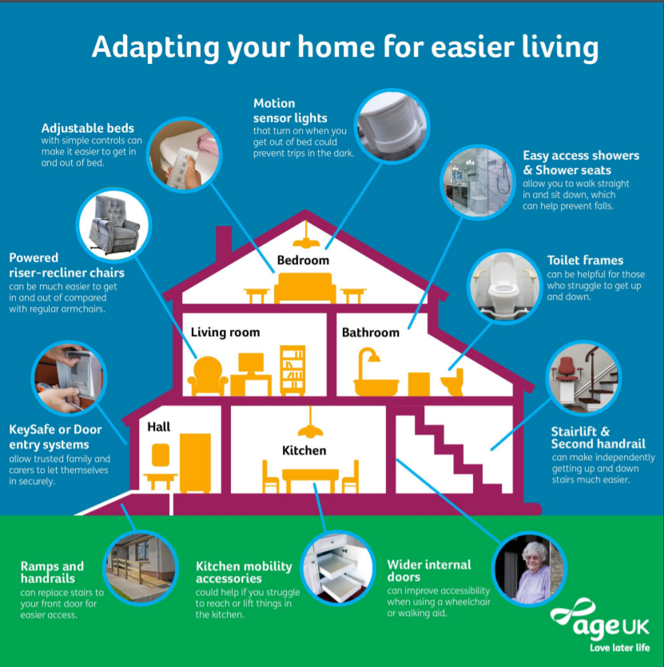
(Adapting your home for easier living, 2020)

Reference
Adapting Your Home For Easier Living. [ebook] London: PDF. Available at: <https://www.ageuk.org.uk/globalassets/age-uk/media/infographics/home-adaptations-for-easy-living.pdf> [Accessed 31 August 2020].
Adultsocialcare.newham.gov.uk. 2017. Home Adaptations. [online] Available at: <https://adultsocialcare.newham.gov.uk/Pages/home-adaptations.aspx> [Accessed 31 August 2020].
Adultsocialcare.newham.gov.uk. 2020. Regaining Your Independence. [online] Available at: <https://adultsocialcare.newham.gov.uk/pages/enablement.aspx> [Accessed 31 August 2020].
Adultsocialcare.newham.gov.uk. 2020. 2. What Is An Assessment? [online] Available at: <https://adultsocialcare.newham.gov.uk/pages/what-is-an-assessment.aspx> [Accessed 31 August 2020].
Age UK. 2020. Homecare: How To Find The Care You Need At Home. [online] Available at: <https://www.ageuk.org.uk/information-advice/care/housing-options/assisted-living-and-extra-care-housing/#> [Accessed 31 August 2020].
All The Lonely People: Loneliness In Later Life. [ebook] London: Age UK, pp.8,12,13. Available at: <https://www.ageuk.org.uk/globalassets/age-uk/documents/reports-and-publications/reports-and-briefings/loneliness/loneliness-report_final_2409.pdf> [Accessed 31 August 2020].
Alzheimer's Society. 2020. Facts For The Media. [online] Available at: <https://www.alzheimers.org.uk/about-us/news-and-media/facts-media#:~:text=There%20are%20currently%20around%20850%2C000,age%20of%2080%20have%20dementia.> [Accessed 31 August 2020].
Cpa.org.uk. 2020. Centre For Policy On Ageing - Policies On Ageing -. [online] Available at: <http://www.cpa.org.uk/cpa/policies_on_ageing.html> [Accessed 30 August 2020].
Cqc.org.uk. 2014. Publishing Of The New Fundamental Standards | Care Quality Commission. [online] Available at: <https://www.cqc.org.uk/news/stories/publishing-new-fundamental-standards> [Accessed 1 September 2020].
Dying Matters. 2018. Planning Ahead. [online] Available at: <https://www.dyingmatters.org/page/planning-ahead> [Accessed 1 September 2020].
Everink, I., van Haastregt, J., Tan, F., Schols, J. and Kempen, G., 2018. The Effectiveness Of An Integrated Care Pathway In Geriatric Rehabilitation Among Older Patients With Complex Health Problems And Their Informal Caregivers: A Prospective Cohort Study. [online] Available at: <https://bmcgeriatr.biomedcentral.com/articles/10.1186/s12877-018-0971-4#:~:text=Integrated%20care%20pathways%20describe%20a,interventions%20and%20activities%20%5B14%5D.> [Accessed 1 September 2020].
Fundamental Facts About Mental Health 2016. [ebook] Mental Health Foundation, pp.7-82. Available at: <https://www.mentalhealth.org.uk/statistics/mental-health-statistics-older-people> [Accessed 30 August 2020].
GOV.UK. 2020. Falls: Applying All Our Health. [online] Available at: <https://www.gov.uk/government/publications/falls-applying-all-our-health/falls-applying-all-our-health#:~:text=Falls%20and%20fractures%20are%20a,at%20least%20once%20a%20year.> [Accessed 29 August 2020].
GOV.UK. 2019. 7. Living Well In Older Years. [online] Available at: <https://www.gov.uk/government/publications/better-mental-health-jsna-toolkit/7-living-well-in-older-years> [Accessed 30 August 2020].
Landeiro, F., Barrows, P., et al. Reducing Social Isolation And Loneliness In Older People: Systematic Review Protocol. [ebook] oxford: BMJ Open, pp.1-5. Available at: <https://bmjopen.bmj.com/content/7/5/e013778.abstract> [Accessed 29 August 2020].
Later Life In The United Kingdom 2019. [ebook] England: Age UK, pp.3-17. Available at: <https://www.ageuk.org.uk/globalassets/age-uk/documents/reports-and-publications/later_life_uk_factsheet.pdf> [Accessed 30 August 2020].
Legislation.gov.uk. 2020. Care Act 2014. [online] Available at: <https://www.legislation.gov.uk/ukpga/2014/23/contents/enacted> [Accessed 1 September 2020].
Moneyadviceservice.org.uk. 2020. Help Paying For A Funeral. [online] Available at: <https://www.moneyadviceservice.org.uk/en/articles/help-paying-for-a-funeral> [Accessed 1 September 2020].
nhs.uk. 2020. About Dementia. [online] Available at: <https://www.nhs.uk/conditions/dementia/about/> [Accessed 1 September 2020].
nhs.uk. 2018. Falls. [online] Available at: <https://www.nhs.uk/conditions/falls/#:~:text=Falls%20are%20a%20common%2C%20but,not%20result%20in%20serious%20injury.> [Accessed 31 August 2020].
Older People Social Care. [ebook] NICE, pp.7-26. Available at: <https://www.nice.org.uk/guidance/ng22/resources/older-people-with-social-care-needs-and-multiple-longterm-conditions-pdf-1837328537797> [Accessed 30 August 2020].
Royal College Of Nursing Response To Local Government Association Green Paper For Adult Social Care And Wellbeing In England. [ebook] England: RNC. Available at: <https://www.rcn.org.uk/about-us/policy-briefings/conr-4418> [Accessed 30 August 2020].
Scie.org.uk. 2020. GP Services For Older People: A Guide For Care Home Managers - Gps' Role In Relation To The Resident, The Home And The Wider NHS - The GP As Point Of Access To Primary And Secondary Care. [online] Available at: <https://www.scie.org.uk/publications/guides/guide52/gp-roles/point-of-access.asp> [Accessed 1 September 2020].
The State Of Ageing In 2019 Adding Life To Our Years. [ebook] London: The Health Foundation, pp.1-42. Available at: <https://www.ageing-better.org.uk/sites/default/files/2019-03/The-state-of-ageing.pdf> [Accessed 29 August 2020].
Who.int. 2017. Mental Health Of Older Adults. [online] Available at: <https://www.who.int/news-room/fact-sheets/detail/mental-health-of-older-adults> [Accessed 30 August 2020].
Zhou, Wusi, Oyegoke, Adekunle Sabitu, and Sun, Ming. "Causes of Delays during Housing Adaptation for Healthy Aging in the UK." International Journal of Environmental Research and Public Health 16.2 (2019): 192. Web.

